- Teams has built-in closed captioning you can turn on from the meeting controls.
- Go to your meeting controls and select More options via … and scroll to Turn on live captions

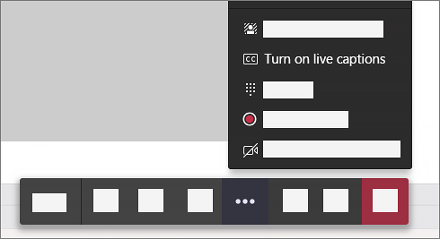

- To stop using live captions, go to the meeting controls and select More options … > Turn off live captions

Get the most out of your captions
To make sure your live captions are as accurate as possible try to follow these best practices:
- Speak clearly, slowly, and directly into the mic. As your distance from the mic increases, captions may become less accurate.
- Avoid locations with background noise
- Avoid having multiple people speak at the same time
- Use the highest-quality Teams compatible equipment available to you.

- WebEx has built-in closed captioning you can turn on from the meeting controls.
- Go to More option via at the bottom right side of your screen and click on Captioning.
- The bottom left side of your screen allow you to toggle on and off Closed Captions.

