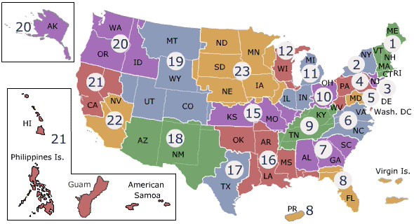
Veterans Health Administration (VHA)

VISN Number | VISN Name | LR Specialist
1 ,2,3,6 | VA New England HCS  VA Healthcare Network Upstate NY  VA NY/NJ Veterans Healthcare Network  VA Mid-Atlantic Health Care Network | Edson Morales  Ryan Fulcher (Alternate)
4, 5, 7, 8  VACO | VA Stars & Stripes Healthcare Network  VA Capitol Health Care Network  The Southeast Network  VA Sunshine Healthcare Network  VA Central Office (Washington, DC) | Larry Bennett  Mark Frassinelli (Alternate)
10, 11, 12, 20 | VA Health Care System of Ohio  Veterans in Partnership  VA Great Lakes Health Care System  Northwest Network | Richard Watkins  Doug Katcher (Alternate)
9, 15, 19, 21 | VA Mid-South HealthCare Network  VA Heartland Network  Rocky Mountain Network  Sierra Pacific Network | Douglas Huth  Mauricio Ponce (Alternate)
22 | Desert Pacific Health Care Network | Mauricio Ponce  Douglas Huth (Alternate)
16 | South Central VA Health Care Network | Doug Katcher  Richard Watkins (Alternate)
17, 18 | VA Heart of Texas Health Care Network  VA Southwest Health Care Network | Mauricio Ponce  Douglas Katcher (Alternate)
23 | VA Midwest Health Care Network | Ryan Fulcher  Edson Morales (Alternate)

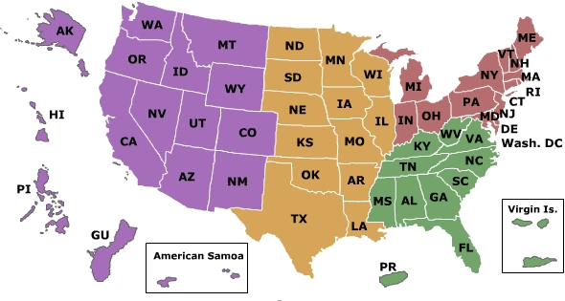

Western Area Office
Southern Area Office
Central Area Office
Eastern Area Office

Veterans Benefits Administration (VBA)

Area | LR Specialist
Eastern | Edson Morales  Richard Watkins (
Eastern | Richard Watkins
Southern | Larry Bennett
Southern | Douglas Katcher
Central | Douglas Huth
Central | Ryan Fulcher
Western | Mauricio Ponce

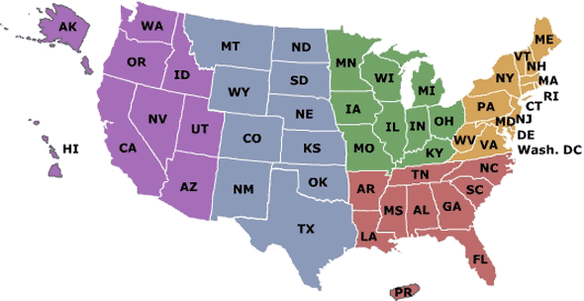

National Cemetery Administration (NCA)
Atlanta Memorial Service Network
Denver Memorial Service Network
Indianapolis Memorial Service Network
Oakland Memorial Service Network
Philadelphia Memorial Service Network

*Please direct all questions to Robert Kline at Robert.Kline@va.gov.

