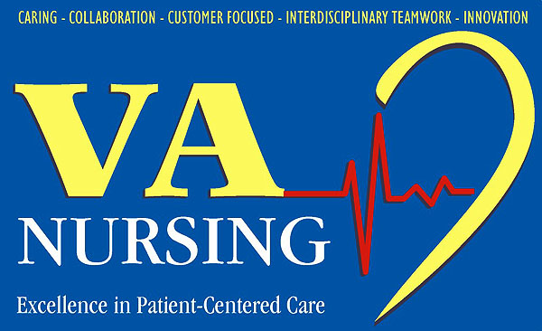

Announcement of Top 10

2009 Office of Nursing Services Innovations Awards

The Office of Nursing Services (ONS) is pleased to announce the 2009 winners of the prestigious Nursing Services Innovations Award! The Top 10 innovations including the title, primary author, contributors, facility, VISN, and their accompanying narratives are attached.

Forty-seven entries were submitted from across VHA utilizing this year’s theme, Improving Programs And/Or Access To Services For Specified Populations: OEF/OIF, Rural Communities or Mental Health. While the Top 10 represent the “best of the best”, all entries described valuable programs and initiatives led by VA nurses.

All award recipients will be recognized in multiple venues, including the VHA Hotline Call, the National Nursing Conference Call, and the annual VA Clinical Executive Conference in 2010. During this conference, each team’s primary author will be formally recognized and presented with a plaque for their achievement. In addition, each of the award recipients will receive a team award of $10,000 to be divided equally among members.

The Office of Nursing Services recognizes all 47 teams for their submissions, and applauds each of them for their innovation and commitment to quality patient care! We also extend a sincere “thank you” to the individuals who volunteered as reviewers during this important selection process.

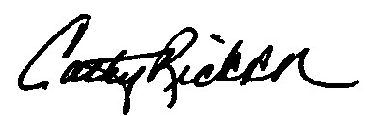

Cathy Rick, RN, NEA-BC, FACHE
Chief Nursing Officer

Attachment: 2009 Innovations Awards for Improving Programs And/Or Access To Services For Specified Populations: OEF/OIF, Rural Communities or Mental Health

2009 Office of Nursing Services Innovations Award Recipients

Title of Submission | Primary Author | Contributors | VISN/Facility | Submission
A DoD/VA Collaborative Initiative: Development, Implementation, & Evaluation of a Nursing Electronic Hand-Off Communication Tool | Laureen Doloresco | Brenda Stidham  Margaret Veneman  Lea Rashka  Maureen Merkl | 5 & 8  DC & Tampa | 
Grow Our Own RNs - Improved License Staffing in Mental Health Units | Sharon Valente | Ileen Wright  Michelle Kendall | 22  Los Angeles, CA | 
The Veteran's Resource Book: An Individualized, Interactive, Evidenced-Based Educational Tool for Mental Health Recovery | Carol Hawthorne Rumpler | William D. Burmeister  Scott Hutton  Joyce Seltzer  John M. Backscheider  Darcel Bolser  Constance Boehner  Patricia Bender  Charlene Bradley  Sandra S. Brown  Mary Blunt  Amy L. Carter  Darrell Cooper  Richard Cohen  Sheila Cowherd  Cynthia Doherty  James Faddis  Stacy Fischer-Samano  Sharra Harper  Peter Hess  Jennifer Hosler  Jeanette Larry-Dillard  Claudia McRoberts  Ahmad Namakydoust  Jeffrey Osborne  Alan L. Rowekamp  Constance Schitoskey  Bobbie J. Sloan  Suzanne Simon  Mainerd Sorenson  William Tomko  Jane A. Wansky  Linda Wood  Joyce Williamson | 10  Cincinnati, OH | 
The Iowa City MOVE! Program Goes Country | Joyce Kron-Chalupa | Krista Kazembe  Barb Amende-Evans  Steve Mallinger  Joseph Dillon | 23  Iowa City, IA | 
Teleconference Support for Family Caregivers of Veterans with Dementia | Kathleen Warren | Jill Bormann  Arlene Klinefelter  Laura Regalbuto  Robert West | 22  San Diego, CA | 
Delivering High Quality Preventive Health Care for Rural Veterans | Denise Boehm | Mary Virginia Rudy  Timothy R. Burke  Deborah Mitchum | 4  Pittsburgh, PA | 
Expanding Rural Home Care: Point of Care Testing for Anticoagulation Management | Debra Walls | Jennifer Wengryn  Judy Plowman  Jodi Guzik  Robin Westlake  Jill Meyers | 4  Pittsburgh, PA | 
Metabolic Assessment Group Intervention Clinic (MAGIC) | Lori Cranwell | Stephanie Baynton  Tammy Richardson  Elizabeth O’Connor  Carolyn Tucker | 6  Salem, VA | 
Road to Hope - Transition from Battlefield to Homefront: Nursing Led Initiative to Provide Seamless Transition for OEF/OIF Veterans Combating Homelessness | Mary F. Pilarski | Susan Byerly  Frances Dannenberg  Thomas Matusky  Joseph Savino | 4  Pittsburgh, PA | 
The Patient Access Center | Dennis Ellis | Divina Abella  Chris Kawakami  Linda Morn  Marcia Muskrat  Sarah Nuttbrock  Tammy Pidde  Georgia Shaw-Holden  Shirley Taylor  Kathy Jones-Sublette | 20  Seattle, WA | 

