Department of Veterans Affairs
Senior Executive Biography

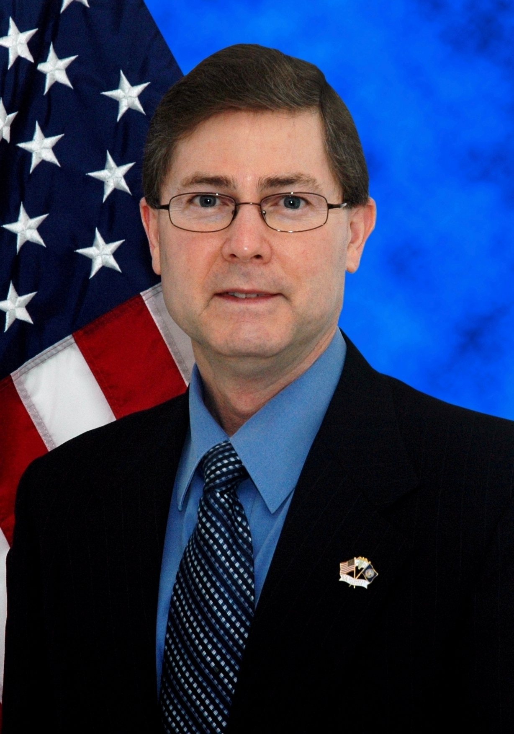
<Insert Picture Here>
John Townsend, OD, FAAO
Director, Optometric Service
Office of Patient Care Services

Since becoming Director, Optometric Service for the Department of Veterans Affairs (VA), Dr. Townsend has greatly contributed to the VA mission improving access to and quality of optometric primary eye care and low vision rehabilitation services for our Nation’s Veterans. He is responsible for leading VA’s nationwide optometry programs and in that role has greatly contributed to VA strategic planning and policy development.

Prior to becoming Director, Optometric Service, he had a distinguished career as a clinical educator and scholar at the West Los Angeles VA Healthcare System where he taught optometry residents and student externs. He was a Professor with Tenure at the Southern California College of Optometry and has published a textbook on visual fields, several chapters in textbooks as well as over forty articles in peer-reviewed journals. He co-developed the Optometric Grand Rounds Clinical Conference and was a sought after lecturer at local, regional, national, and international conferences. For these contributions to the optometric profession, Dr. Townsend was inducted as a Distinguished Practitioner, National Academy of Practice in Optometry within the National Academies of Practice.

In selected highlights regarding service to the optometric profession, Dr. Townsend served as Chair, Clinical Guidelines Coordinating Committee for the American Optometric Association, Representative to the American National Standards Institute (ANSI) Committee Z80 for Ophthalmic Standards, Affiliate Member of the Association of Schools and Colleges of Optometry as well as Planning Committee Member, National Eye Health Education Program, National Eye Institute, National Institutes of Health, U.S. Department of Health and Human Services. He has served on the Editorial Boards of numerous prestigious professional journals including Optometry of the American Optometric Association, the VA Journal of Rehabilitation Research and Development, and Optometry and Vision Science.

CAREER CHRONOLOGY:

2000 – Present Director, Optometric Service for the Department of Veterans Affairs
1996 – 2000 Chief, Optometry, VA Greater Los Angeles Healthcare System, Santa Barbara
Ambulatory Care Center, Santa Barbara, California
1991 – 1996 Chief, Optometry Service, West Los Angeles VA Medical Center
1985 – 1991 Assistant Chief, Optometry Service, West Los Angeles VA Medical Center
1984 – 1985 Optometrist, Family Health Plan, Long Beach, California
1980 – 1983 Chief, Ocular Disease Diagnosis and Special Testing Service, Southern California
College of Optometry, Fullerton, California

EDUCATION:

1979 – 1980 Residency in Hospital-based Optometry, Kansas City VA Medical Center
1979 O.D. University of Houston, College of Optometry (Summa Cum Laude)
1975 B.S. University of Florida (with Honors)
PROFESSIONAL CERTIFICATIONS:

American Board of Certification in Medical Optometry (ABCMO), Honorary, 2009
Advanced Competence in Medical Optometry (ACMO), 2005
Treatment and Management of Ocular Disease (TMOD), 1986 and 1996
Fellow, American Academy of Optometry (FAAO), 1982 to present
National Board of Examiners in Optometry (NBEO), 1977, 1978, 1979

AWARDS AND HONORS:

Certificate of Appreciation, National Eye Health Education Program, National Eye Institute, National
Institutes of Health, U.S. Department of Health and Human Services, 2011
Recipient, Distinguished Service Award for VA Optometric Service, Vision Rehabilitation Section, American
Optometric Association, 2011
Certificate of Recognition, National Eye Institute – National Eye Health Education Program, National
Institutes of Health, U.S. Department of Health and Human Services, 2008
Service Award, National Association of VA Optometrists (NAVAO), 2006
Association of Military Surgeons of the United States (AMSUS) Optometry Outstanding Service and
Recognition Award, 2005
Selected Member, Who’s Who in Medicine and Healthcare, Marquis Who’s Who, 2004 to present
Distinguished Editorial Board Service Award, Optometry and Vision Science, American Academy of
Optometry, 2003
Distinguished Practitioner, National Academy of Practice in Optometry, National Academies of Practice,
2003
Distinguished Optometry Alumnus Award, University of Houston – College of Optometry, 2001

PROFESSIONAL MEMBERSHIPS AND ASSOCIATIONS:

American Academy of Optometry; Member, Editorial Board - Optometry and Vision Science, 1998 - 2004
American National Standards Institute (ANSI) Z80 Accredited Standards Committee for Ophthalmic Optics;
Member, 2000 to present
American Optometric Association; Chair, Clinical Guidelines Coordinating Committee, 2000 - 2005
American Public Health Association
Armed Forces Optometric Society; Member, Executive Council, 2001 - 2008
Association of Military Surgeons of the United States; Member, Executive Advisory Council, 2010 - 2011 &
2005 - 2006
Association of Schools and Colleges of Optometry; Affiliate Member, 2000 to present
Center for Disease Control and Prevention, U.S. Department of Health and Human Services; Member,
National Vision Program: Expert Panel, 2006
Journal of Rehabilitation Research & Development, Rehabilitation Research & Development Service,
Department of Veterans Affairs; Member, Editorial Board, 2001 to present
National Academy of Practice in Optometry, National Academies of Practice
National Association of VA Optometrists; President, 1991 - 1993
National Eye Health Education Program, National Eye Institute, National Institutes of Health, U.S.
Department of Health and Human Services; Planning Committee Member, 2006 - 2011

MAJOR PUBLICATIONS:

Townsend JC, Selvin GJ, Griffin JR, Comer GW. Visual Fields: Clinical Case Presentations. Butterworth-Heinemann, Boston, 1991

