1 Pain Clinical Reminders Main Menu

Clinical Reminders for pain have been divided into four areas:
- Clinician/providers
- Nursing
- All clinical staff
- Web links
Assessments, plans of care, and reassessments reminders/ templates are provided for clinician/ provider groups and nursing groups separately. (For those facilities where state law or facility Scope of Practice does not permit LPNs or nursing assistants to conduct assessments, a separate reminder to provide “observations and re-observations” is included to comply with these regulations while still allowing LPNs and NAs to work with pain patients.)
Each reminder can be separated out and installed individually, arranged as facility pain and informatics workgroups determine to be most suitable. As written, these reminders may assist in meeting Joint Commission standards and providing quality care to veterans in pain.
Most of the reminder sections are not designed with health factors already included, as each facility may already have defined health factors for pain.

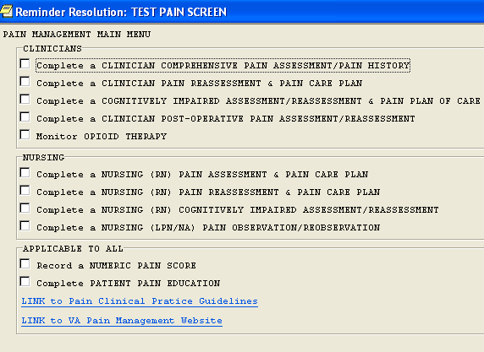
To open any reminder in the pain menu, click on the box. CACs may want to install the reminders individually in order to make reminders available to only certain clinical services.

2 Clinician Assessment and Pain History

This reminder template can be used by Primary Care and specialty care providers, generally for initial pain assessments. It has been designed by pain experts to be comprehensive and compatible with features regularly used in CPRS.
Clicking on Clinician Comprehensive Pain Assessment / Pain History opens the reminder template.
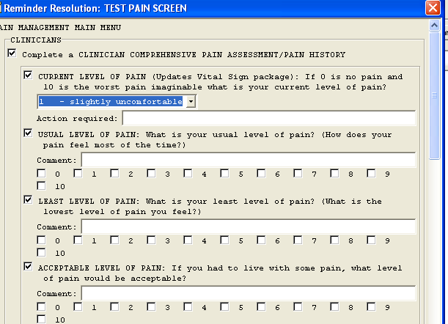
Entering a current level of pain inserts the 0-10 score in the Vitals Package.

Asking patients about usual levels of pain is probably a better indicator of actual pain (as pain scores are often higher during medical visits) experienced regularly—particularly if the patient keeps a pain journal.

Least level of pain gives some indication of how interventions are working.

Acceptable level of pain gives some idea of the patient’s goals in treatment.

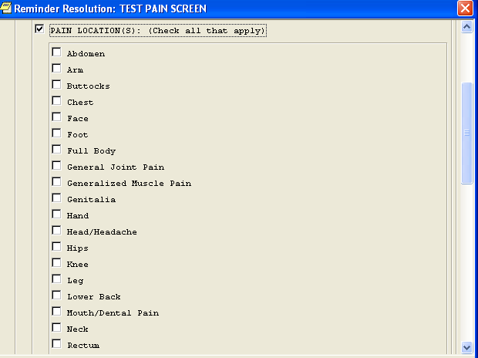
The reminder now allows recording of pain in multiple sites without having to complete the entire template for each area of pain.
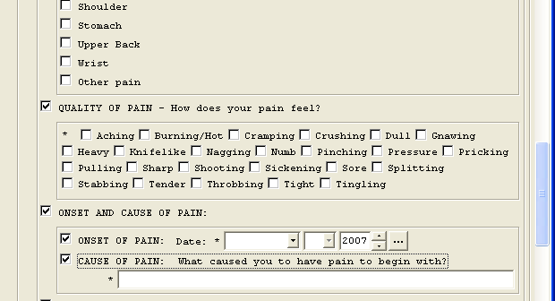
Ask the patient to describe his /her pain first. If unable to verbalize sensations accurately, list can be read to the patient. Multiple qualities can be entered.
Month & year are generally known. If date is not, enter “1” for the first of the month.
Cause of pain is a free text box. If patient is uncertain, enter “unknown.”

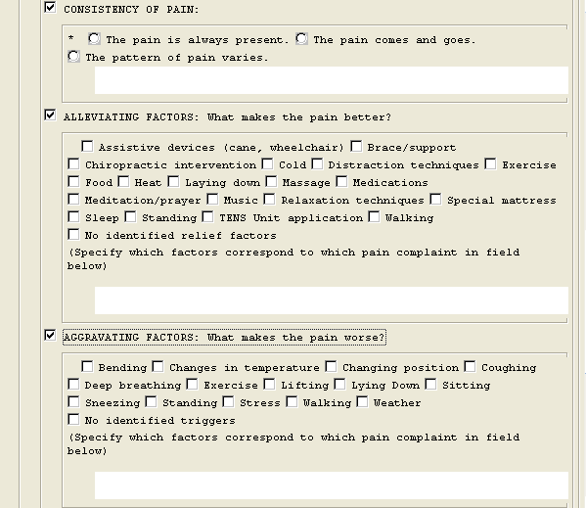
Constant, intermittent, diurnal variations. Free text in comment box for clarification.
Most chronic pain patients know what lessens their pain. Multiple methods can be checked off, and may help determine treatment.
New to this reminder. Factors not specified can be entered in the free text comment boxes.

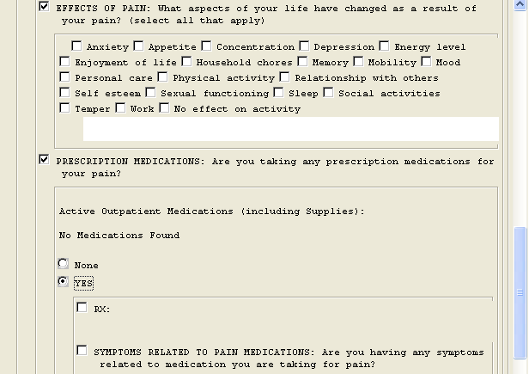
All active outpatient meds from CPRS will drop in here. Pain meds can be chosen from list of all meds and copied to text box.
Unlisted “effect” can be free-texted in comment box.
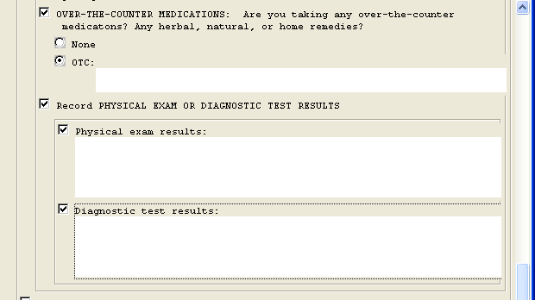
OTC meds are free text entered here.
Free text area for PE results
As so many lab and radiology test reports are often not related to the pain condition, the entire lists will not be dropped into this reminder template. Appropriate tests can be added here.

3 Clinician Reassessment and Plan of Care

Clinician reassessments are critical to pain patient care. The frequency of reassessments is likely determined by facility policy.
What is an “acceptable” level of pain to the patient will be determined and documented in the initial pain assessment and/or facility policy.

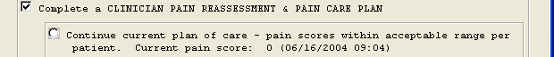
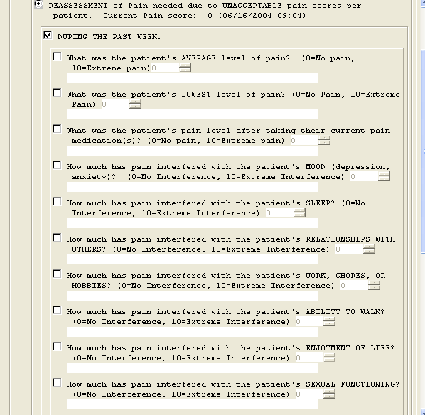
Responses to these questions should assist in treatment planning.
Responses to these questions may assist in making appropriate consultation requests to Mental Health, Physical, Occupational, and Recreation Therapies, as well as to sleep and sexual dysfunction clinics.

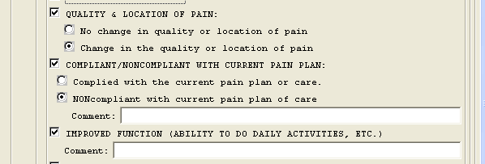
Changes may indicate a new pain, an increase in disease, or that the treatment plan is appropriate.
May suggest that it is time to change the treatment plan or to make appropriate consultation requests.
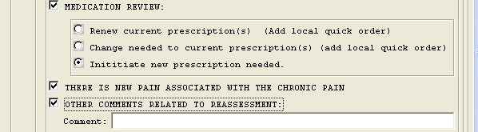
Increases/decreases in current medications and/or adding adjuvants.
If a new pain is identified, a free-text note may be written here to indicate that a full assessment of the new pain will be completed.
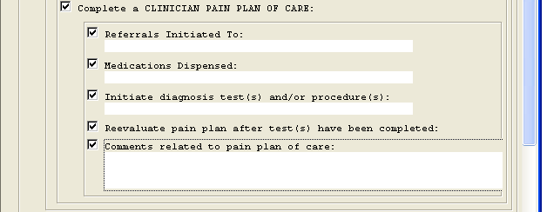
To services noted earlier

New tests / procedures
Free text box for any additional plan of care items not mentioned in reminder.

CR 4 Clinician Assessment/ Reassessment Cognitively Impaired
There is no validated instrument to assess pain in patients with significant cognitive impairment or communication difficulty. Some patients with milder impairments are able to use the Wong-Baker (Faces) or visual analog scales. The following reminder template may be used with pain patients with chronic or acute communication or cognitive impairments
The assessment descriptors do not add up to a 0-10 score intentionally. To indicate that an assessment or reassessment has been completed, it is recommended that a score of “99” is entered in the Vitals Package—in order to document that reassessment policy has been adhered to. Patients who do not state their 0-10 pain score (or point to it on a visual scale) cannot have a 0-10 score entered in the Vitals Package.

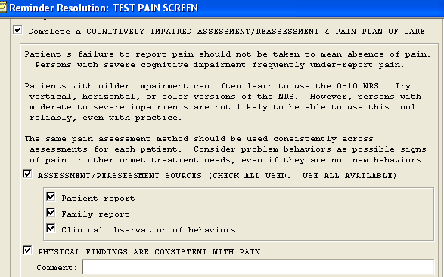
It is critical that the same assessment method be used for each reassessment in order to note changes in behaviors (suggesting a change in pain.) The same scales appear in the RN and LPH/NA reminders.
Some pain research suggests that families tend to over-estimate a patient’s pain, and that clinicians tend to under estimate it in cognitively impaired patients.
Physical findings such as arthritic swelling can be entered here.

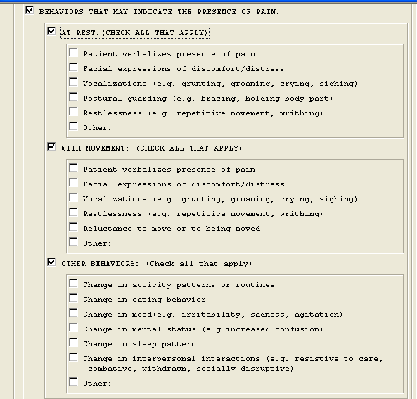
Checking “other” in any of the three assessment areas will open a free-text box. Enter observations not listed in the reminder in these text areas.
The direction of the change can be entered in the free-text box that appears after checking “other”.

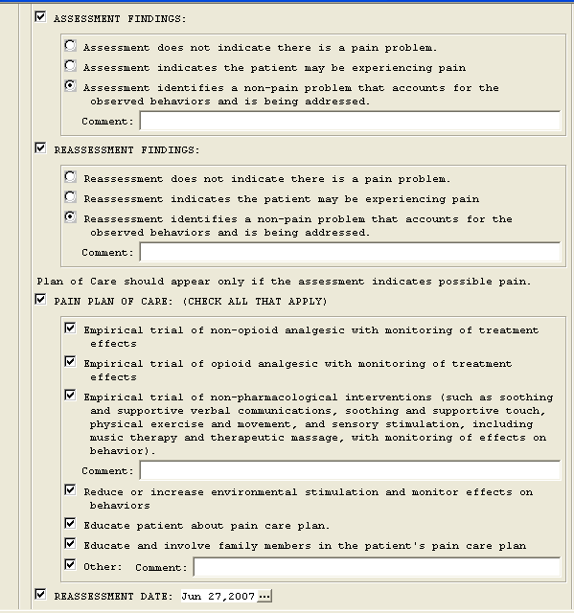
Choose at least one of the first three items, and any of the remaining four as appropriate.
Patient and/or family member should be informed of plan of care.
Behaviors noted may be consistent with depression or dementia, for example.
Assessment / reassessment intervals are per local policy, e.g., whenever full vital signs are taken.
NOTE
Reassessment date calendar.

CR 5 Clinician Post-Operative Assessment / Reassessment
This reminder can be used in recovery rooms or on wards or units.

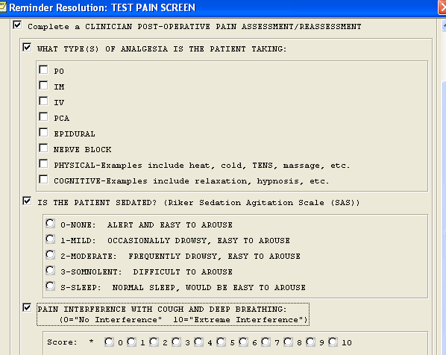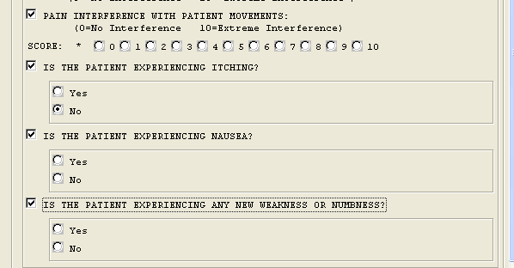
More than one type of analgesia may be selected. Note that non-pharmacological analgesia are options.
Ricker Scale
Clinician judgment call on 0-10 scales
“Yes” responses to these three questions open free text boxes. Interventions can be entered in these text areas.

CR 6 Clinician Monitor Opioid Therapy

The frequency of monitoring pain patients on opioid medication is determined by local policy. A sample opioid agreement is found in this manual’s appendix.

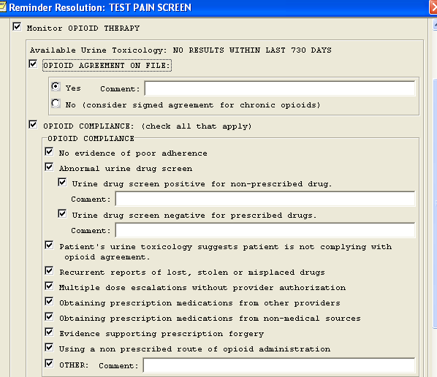
If monitoring opioid compliance with urine tox screens, the most recently completed one (results and date) will appear here.
Comment boxes can be used to include details of abnormalities.
If local policy requires an opioid agreement, date of agreement can be included in comment box.

Checking any of the boxes suggestive of noncompliance may indicate the need for a change in the treatment plan, which can be documented in the comment box.

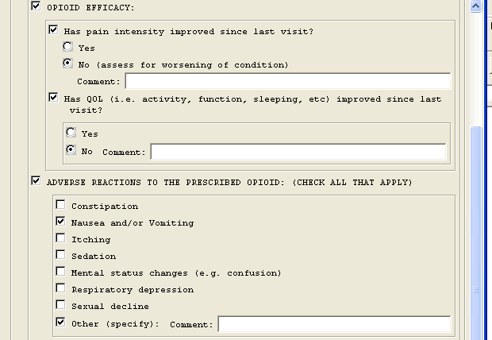
Per patient report with 0-10 score or behavioral factors.
Side effects may suggest the need for a change in the treatment plan, or additional patient education followed by making some shared decisions.
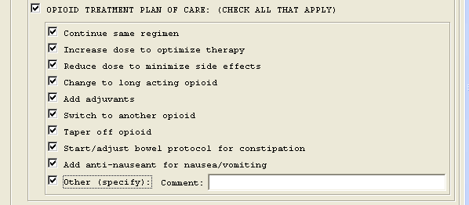
Checked text will drop into CPRS note.

CR 7 Nursing RN Assessment and Plan of Care

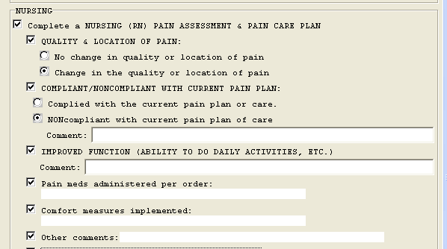

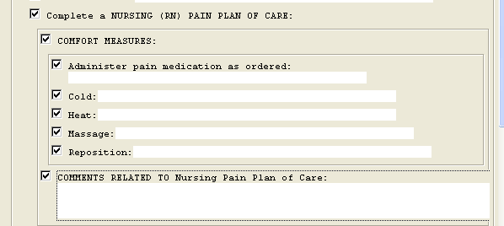

CR 8 Nursing RN Pain Reassessment
Nursing reassessments need to be completed as frequently as local policy indicates, but must be completed at least as often as vital signs are taken and the previously reported pain score is > 4/10.
“Acceptable range, per patient” will be known from the initial assessment. Most recently entered pain score will appear here on the reminder. If plan is working, check “continue current plan of care.”

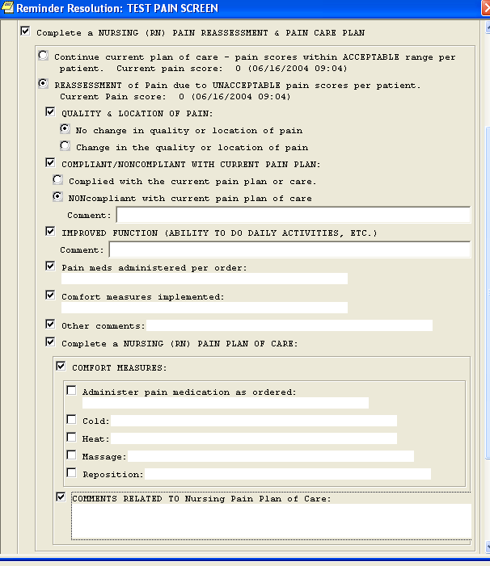
Document if there is a change in the quality or location of the pain, possibly indicating a new pain or increased disease.
Document on pain meds administered and other measures implemented for pain.
Free text box for any additional comments in care plan.
Document and comment on compliance or lack of compliance with current plan and with functioning.
Click to open to complete a nursing plan of care.

CR 9 Nursing RN Cognitively Impaired Assessment Reassessment
Assessment and reassessment for patients who are cognitively impaired or have communication difficulties that do not allow them to use the Visual-Analog or the Wong-Baker (Faces) Scales can be completed utilizing the following reminder. Completion of this reminder does NOT result in a 0-10 pain score. To indicate in the CPRS record that a pain assessment or reassessment was completed, a score of “99” may be entered in the Vitals Package, depending on local policy. However, this reminder should also be completed to clearly chart patient behaviors possibly indicating pain, and the treatment of that pain.
After opening the reminder by clicking on “Complete a Nursing Cognitively Impaired..”, click on “Behaviors That May Indicate The Presence Of Pain Behaviors” to see lists of possible pain behaviors

At Rest

With Movement

or Other Behaviors

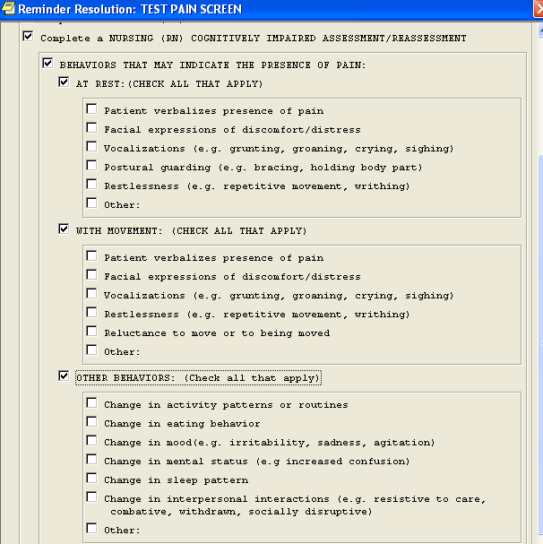
Clicking on any of the three boxes above (Rest; Movement; Other) open the lists of behaviors shown.
Behaviors selected will appear in the CPRS progress note.

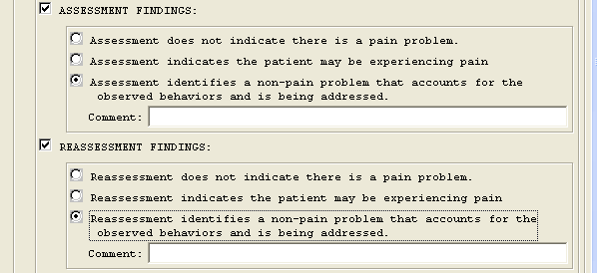
The same reminder can be used for either an

initial assessment

or

reassessment

depending on which box is checked.

There is not currently any validated and reliable instrument used to measure pain in cognitively impaired patients. Some clinicians use such non-validated scales—many of which ‘add up’ to a 0-10 score.

A VHA consensus statement permits the use of such scales, but only as one part of a pain assessment or reassessment. Entering a 0-10 pain score derived from use of these instruments in the Vitals Package is NOT permitted.

CR 10 Nursing LPN NA Observation Re-observation

For sites where LPNs and NAs are not permitted to assess, the assessment/ reassessment reminder for cognitively impaired patients has been modified. If local policies permit, LPNs and NAs can enter 0-10 pain scores and complete the following reminder template.
First, click on “Complete a Nursing (LPN/NA)…” to open the reminder template.
Second, click on “Behaviors that may…” to see behaviors “At Rest”, “With Movement”, and “Other Behaviors”.
Third, by clicking on any one of those, this screen appears. Checking any of the boxes suggestive of possible pain inserts that description in the CPRS note.

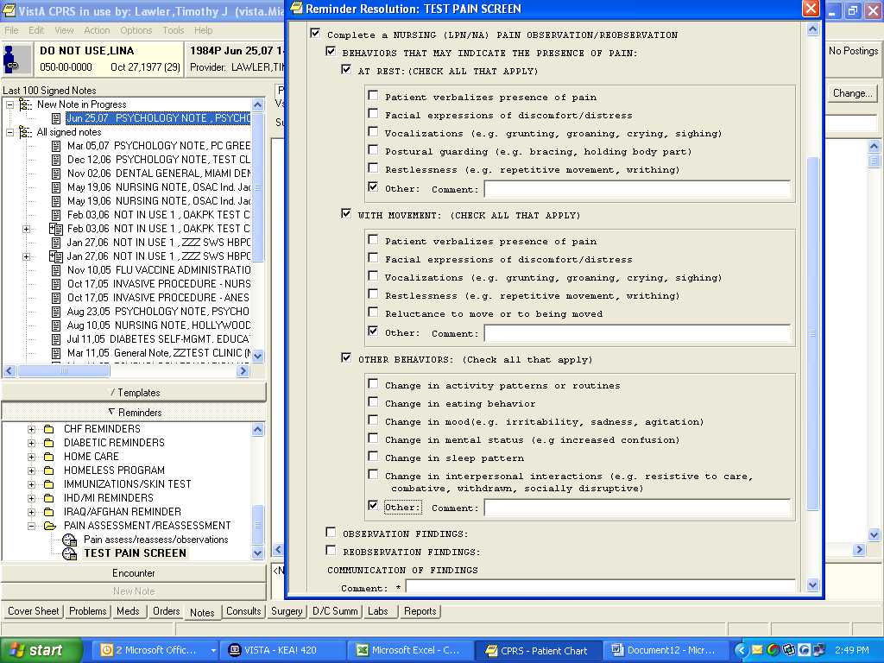

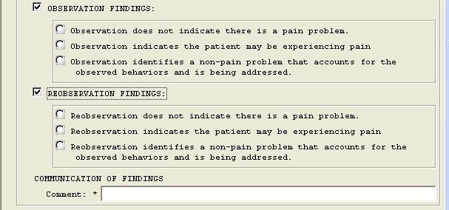
This reminder can be used for either
initial observation or for a follow-up

re-observation, depending on which box is clicked

Whether an initial or a follow-up observation is performed, the “Communication of Findings” comment box opens. The LPN or NA is required to type in who (e.g., the RN or prescribing provider) is notified regarding the findings.

CR 11 Record a Numeric Pain Score

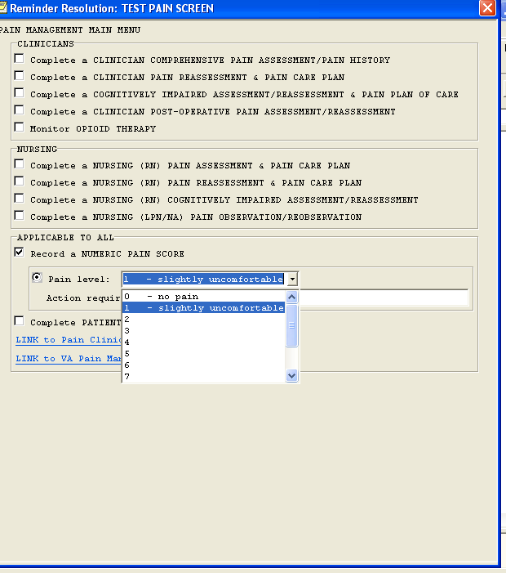
Any clinician may enter a pain score. By entering it through this piece of the reminder (Record a Numeric Pain Score), the score is automatically entered in the Vitals Package. The “Action required” comment box also opens automatically for a free text response—critical if the patient’s score is >3/10 (or whatever score your facility has set in its pain policy.

Remember: If assessing or reassessing pain in a cognitively impaired patient, only a score of “99” is entered in the Vitals Package. The assessment or reassessment reminder for cognitively impaired patients should be used to describe presumed pain and its treatment.

CR 12 Pain Patient Education

This reminder was designed for any type of patient education, but with the education topics specifically suited to pain education. Joint Commission-required items (listed at the beginning of the reminder) must be completed in order to close the reminder. Checked items appear in the comment boxes and then in the CPRS note.

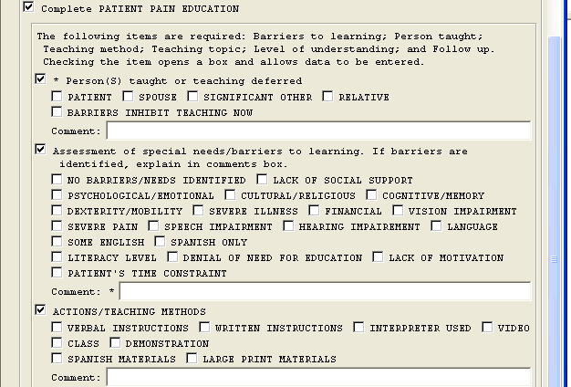
Click on “Person(s) taught,” then the person or persons receiving the education.
Special needs/barriers must be noted.
If Severe Pain” is selected, educator may need to address education at a better time for the patient.

Actions/Teaching Methods should be consistent with any barriers noted. If “Class” is selected, no assessment of learning is formally evaluated.
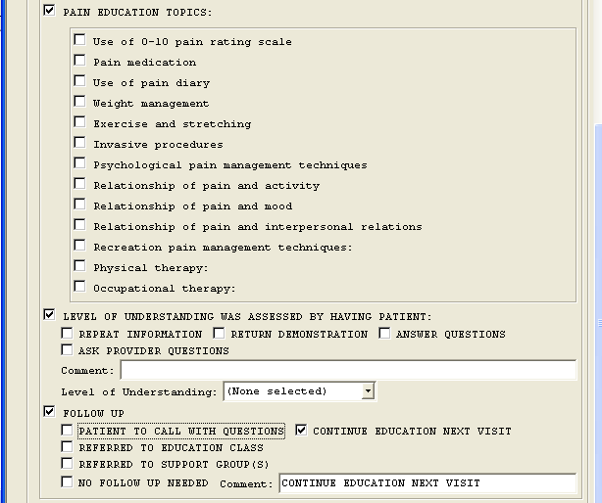
Members of a multidisciplinary team have requested the pain Education Topics included, as staff from multiple clinical services should conduct pain education. Clicking on Recreation, Physical, and Occupational Therapy open comment boxes for topics to be entered in free text.
Four ways of assessing understanding are listed, with multiple checks permitted. A drop-down box allows the educator to note his/her perception of the patient’s understanding.
The final Joint Commission education requirement is Follow –up. As with other Comment Boxes, the items checked appear on the screen and in the CPRS note.
Note: If writing “free text” in a comment box, be sure to do so after checking any item in that section of the reminder. Checking an item after writing free text will erase all free text.

CR 13 Intranet Pain Links

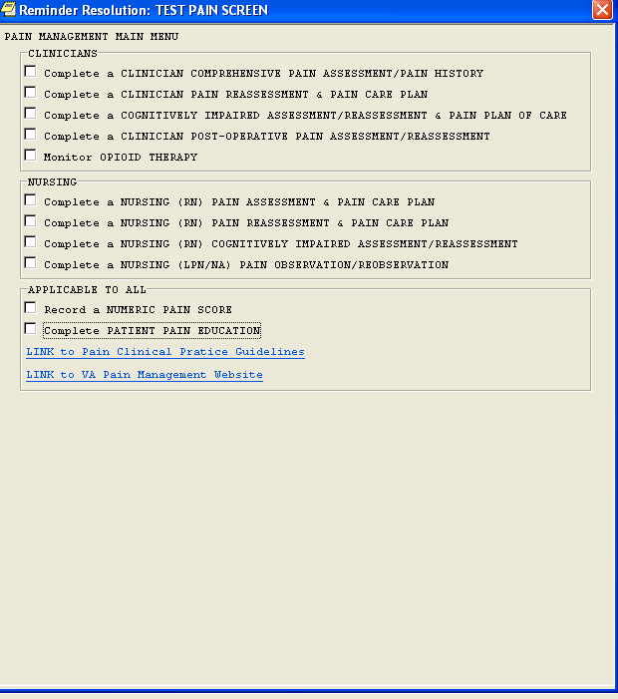
Links to VHA/DoD websites are included for “just-in-time” training.

Individual facilities might also consider linking to other documents specific to each site. For example, linking to facility algorithms for treatment of different types of pain might be helpful to clinicians.

