**VA’s Guide to**

**The Application Process**

Table of Contents

Part 1: USAJOBS “My Account”

Part 2: Application Manager

Why Have an Account

Application Process

Part 1: USAJOBS “My Account”

“My Account” in USAJOBS is the area within USAJOBS where applicants begin the application process. For VA, Application Manager, which is a feature associated with USA Staffing, is the internal application system that applicants are transferred to after completing the first steps of the application process through USAJOBS.

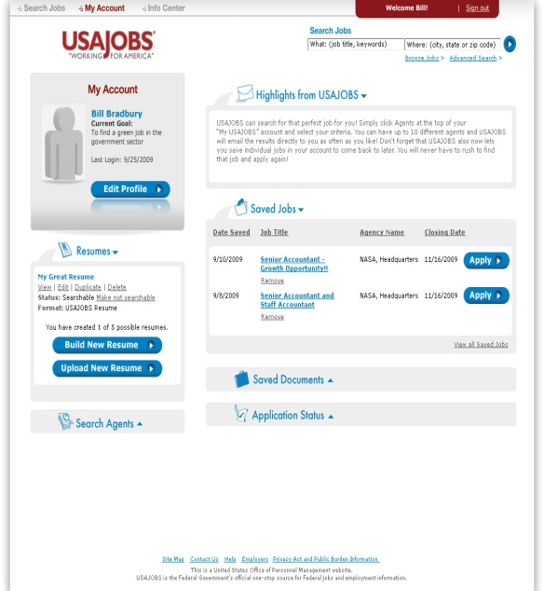

**Functions within USAJOBS**

At My Account, the applicant has the option to do several things:

* Create or upload a résumé
* Set up a job search query
* Assemble an application
* Upload supporting documents
* Edit account profile information

Résumés

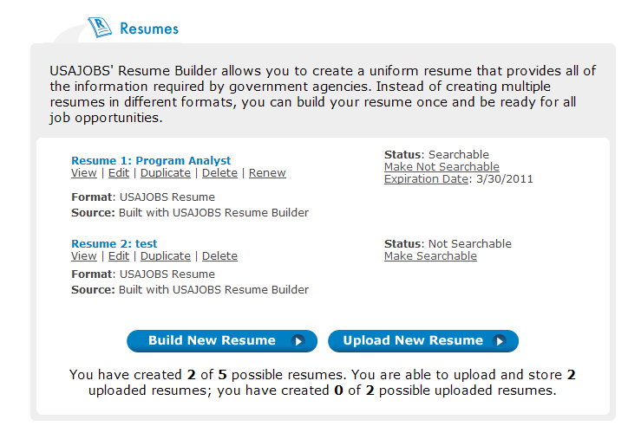My Account allows the applicant to view, delete, rename, edit or upload existing résumés. The applicant can also create a new résumé using Résumé Builder. Applicants are urged to use Résumé Builder to ensure their résumés contain all the required information (i.e. start and end month/year). If applicants upload résumés, they need to check the document to make sure all this information is included.

Creating the résumé in Résumé Builder is a simple 4-step process:

* Identify basic information
* Describe experience
* List education and training
* Save (either for later or in the USAJOBS searchable candidate database)

Applicants can store up to five different résumés; these can be created through Résumé Builder or uploaded.

***Note:*** Personal, uploaded résumés cannot be larger than 3MB.

Notice that one of the résumés listed in the illustration above is identified as searchable, while the other is not. This means that the first résumé can be viewed in the USAJOBS résumé bank. The résumé bank is a large pool of saved résumés that recruiters can browse online when looking for applicants. The second résumé was marked “Confidential” when the résumé was built. It is not included in the résumé bank. The second résumé will still be completely visible to the manger when submitted for a specific vacancy announcement.

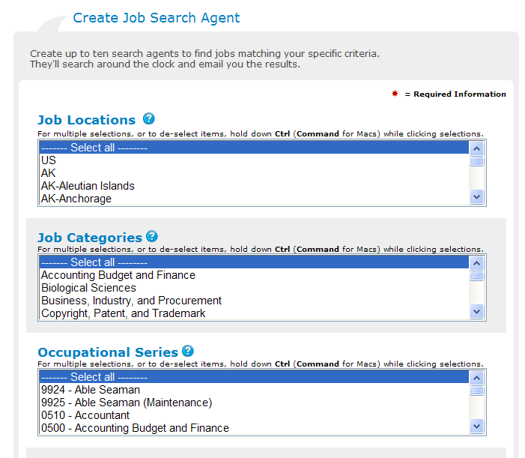

Job Search Agents

Applicants can also create job search agents. In the agent, the applicant specifies what type of job they are interested in applying for, the duty location, etc. Applicants can build up to ten of these searches. Then, whenever a job is posted that is a match of what the applicant has entered, an email is automatically sent to the applicant with a link to the vacancy’s announcement.

***Note:*** Internal merit promotion postings cannot be found in searches through USAJOBS.

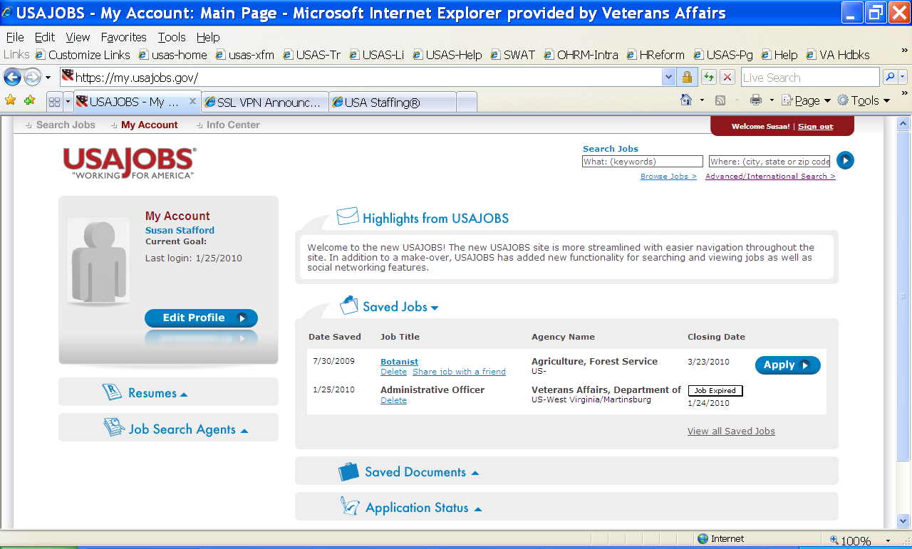Application Tracking

My Account tracks applications that were submitted by clicking the “Apply Online” within the last 18 months.

Save Jobs

The “Saved Jobs” feature (see illustration at right) allows applicants to save links to announcements that are of interest. When applicants want to refer back to the announcement, they simply click on the link listed in their account.

To save a link, the applicant simply clicks the “Save job” link at the USAJOBS search list. After the link has been saved, the pale gray “Save job” changes to “Saved” in bold type.

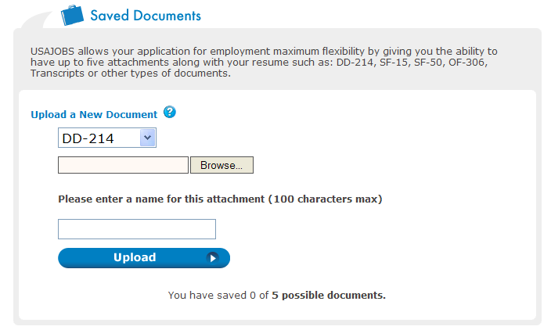

Saved Documents

Using the “Saved Documents” feature, applicants can upload several documents to their account to submit with applications. Up to ten documents such as the DD-214, SF-50, SF-15, transcripts and others can be stored in the account.

***Note:*** The size limit for these uploaded documents is 3MB. To avoid too-large files, applicants should save documents in PDF (Adobe Acrobat) format.

Uploading is a simple process of choosing the file category that will be uploaded (such as DD-214), browsing the computer for the saved file, assigning a name for the saved document, and clicking “Upload.”

Now the applicant is ready to find a vacancy for which online applications are accepted.

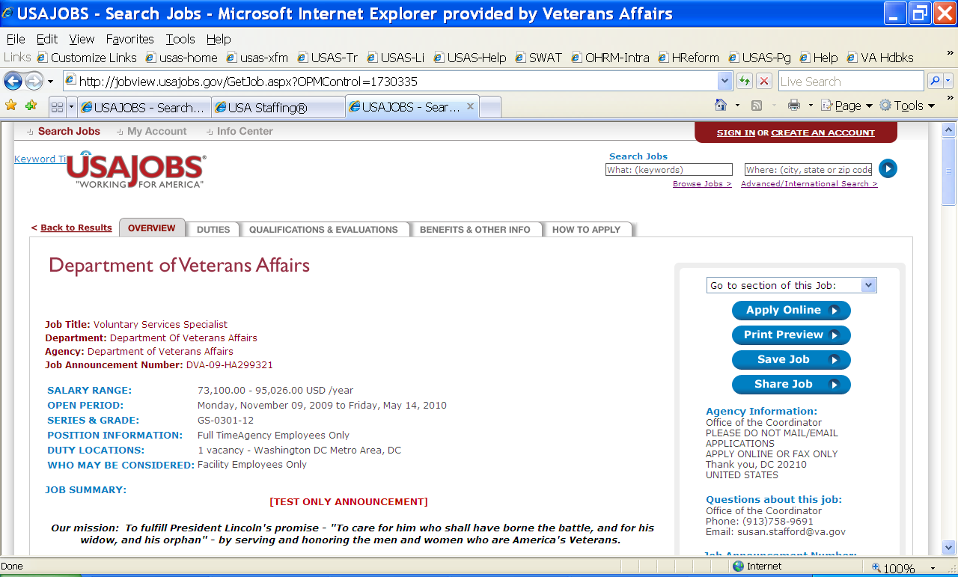

Part 2: Application Manager

## **Why have an Application Manager account?**

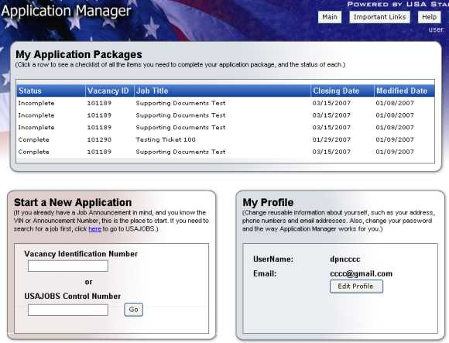Applicants need an account to complete the assessment questionnaire online. In addition, the system protects applicant’s personal information and ties the application in USA Staffing to the applicant’s USAJOBS account for status updates.

* **Security:** A Social Security Number is not used for logging in, as in previous systems. The applicant must only type their Social Security Number when applying the first time within Application Manager, and then never again, nor is it ever displayed in Application Manager.
* **Convenience:** When logging into an Application Manager account, applicants can do the following for greater ease and convenience when applying for jobs:
  + Track the application progress on a checklist.
  + See at a glance the status of all Application packages for all the jobs for which has been applied to within Application Manager.
  + View and print supporting documents.
  + View and print questions and answers.
  + Read status notifications sent in response to all Application packages.
  + Store supporting documents in Application Manager to be easily reused when applying to additional vacancies.

## Creating a Application Manager Account

Creating an account is easy and only takes a minute. First time users must create a User Name and password. As well as pick a Secret Question and answer, in case the password is ever forgotten.

### ***User Name***

The User Name must be unique and can be between 6-20 characters in length. It may include letters either capitalized or lowercase, and/or numbers 0-9. Spaces and these symbols are not allowed:"#", "<" and ">".

### ***Password***

##### Do's – The password must be between 8 and 20 characters in length and must include at least 3 of the following 4 attributes:

* Upper Case (A-Z)
* Lower Case (a-z)
* Numbers (0-9)
* Any of these Special Characters only: @, $, %, &, *, +, =, ?, {, }, [, ], :, ”

##### Don’ts – The password must not contain:

* The User Name or any part of the applicant’s full name.
* These symbols are ***not*** allowed: #, <, >, comma,!, (, )

### ***Secret Question***

In this step, applicants will select a Secret Question for the system to ask if the password is forgotten. After the question is selected, an answer must also be entered. The answer is case sensitive.

Things to consider as when selecting the Secret Question:

* It is best to select a question to which the answer is not likely to change, is easily typed correctly, and that you can remember or easily look up when you need to.

**The Application Process**

The applicant clicks on the “Apply Online” button while on the announcement and accesses their USAJOBS account. If the applicant has already logged in at My Account in this session, the applicant does not have to log in again. The first screen the applicant sees after accessing My Account gives the applicant the opportunity to select a stored résumé and other files that will be needed in the application package. Then the applicant clicks on the “Apply for this Position Now” button at this screen.

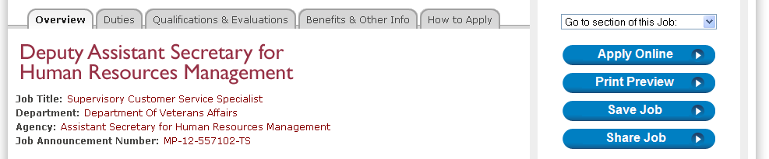

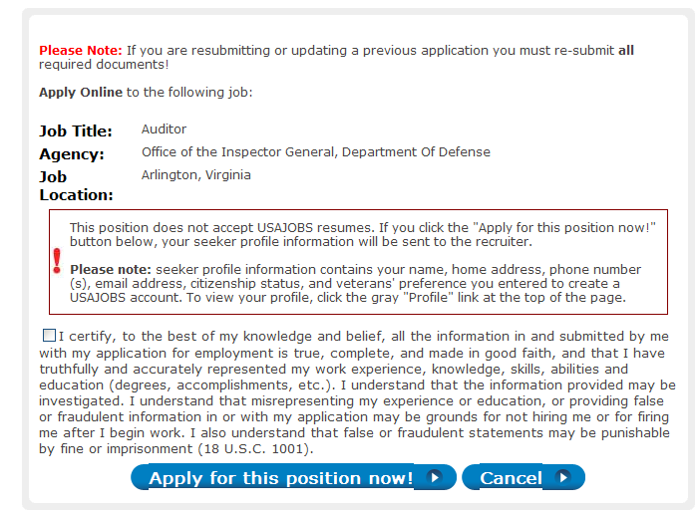Before applicants can submit their applications, they must click the statement in the illustration to the left to certify that their applications are accurate.

After clicking on the “Apply for this Position Now” button, the applicant is taken to Application Manager to complete the Questionnaire and submit the required application materials.

***Note:*** Files selected for an application in the USAJOBS My Account automatically transfer to Application Manager. The applicant can also select files to attach while in Application Manager.

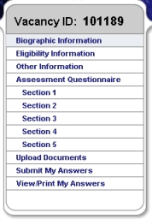When in Application Manager, the announcement questionnaire is displayed within the navigation box at the left of the screen, to guide the applicant through the application process.

If an assessment questionnaire is marked as “All responses are required”, Applicants will see a red Requiredmessage when they skip an assessment question.

Questions in the assessment questionnaire are often presented in more than one page (shown as “sections” in the Navigation Box). The applicant clicks Next as each page is completed. The applicant’s work is saved when Next or Previous is clicked.

***Note:*** Information is not always saved when the applicant selects an item in the Navigation Box.

***Tip:*** Applicants may want to leave and come back to the Questionnaire at a later point in time, before the application is submitted. When in USAJOBS My Account, click on “Apply Online” at the announcement, then “Apply for This Position Now”, this will take the applicant automatically to the unfinished questionnaire.

At the “Upload Document” page, the system will display the documents that were brought over from the USAJOBS My Account. The “Upload Document” page allows the applicant to copy electronic files (such as a PDF copy of a transcript) to Application Manager. The uploaded files will be added to the applicant’s package for that vacancy. These documents are also stored within Application Manager to be easily added to other application packages in the future.

***Tips to keep in mind:***

* Applicants should keep a copy of their SF-50 (Notification of Personnel Action), DD-214 (Certification of Discharge from Military Service), and transcripts in their USAJOBS account Then the documents will always be easy to locate and attach to an application.
* 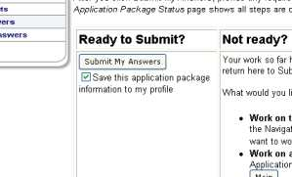If the Application package is later changed or updated, the applicant must return to the “Submit My Answers” page and complete that step again.

To fully complete the application process, the applicant must click the “Submit My Answers” button.

Instead of displaying the “Ready to Submit” option, the system will inform applicants that required items are missing and will not allow applicants to submit their answers if the following situations occur:

* Narrative responses marked as required, are not completed by the applicant. The applicant must return to those items to complete the required narrative responses. (Application Manager will identify the section in which narratives have not been completed.)
* Assessment questionnaires marked as “All responses required”, are not completed by the applicant. The applicant must return to any unanswered questions to complete the questionnaire. (Application Manager will identify the section in which answers to questions have not been completed).

Applying Online

Applicants may apply electronically or by faxing their application materials. Applicants should be strongly encouraged to apply electronically. The process is much easier, more secure, and less prone to error than faxing materials.

* Fax materials do not have the same image quality, must be verified by the OPM processing center manually, can become separated from each other, and are more likely include errors in the Vacancy Identification Number (meaning the document cannot be matched up with the announcement).
* Status notifications are more limited.
* USAJOBS allows applicants to store documents such as the DD-214, SF-50 and transcripts in their online account. Copies can then be easily attached to applications whenever needed, instead of locating and uploading the files again.

***Facility Computer Workstations***

Where possible, facilities should establish a computer workstation (preferably a personal computer with an all-in-one printer/scanner/fax or the equivalent) in each HRO or other secure area for use by employees applying for USA Staffing recruitments. Employees should use the workstation during non-duty work hours (break, lunch, etc.). The workstation is intended to assist current VA employees with the transition to a new application system. The computer system should not be used for personal purposes unrelated to the USA Staffing application process.

***Tip:*** These workstations may also be used by HR Staff or employees to access e-Quip, VetPro, e-OPF, and/or other HR automated programs. In fact, a computer already being used for these purposes may be converted into a consolidated workstation so that the computer may also be used for USA Staffing.

Tips for Faxing Materials

* Use *only* the OPM Form 1203-FX as a coversheet - do not use an additional cover sheet.
  + If requesting the OPM Form 1203-FX via phone, press 1 after the introduction on the recording, then listen for instructions to request the form.
* Applicants may submit multiple documents for the same vacancy announcement using one cover page.
* If the applicant has uploaded documents using Application Manager, the applicant **SHOULD NOT FAX** the same documents to the Processing Center.
  + To verify that uploaded documents have been processed, inform the Applicant to wait one hour to ensure they have cleared the virus scan. Then check the Details tab in the Application Manager account for the vacancy announcement, where the documents should be displayed.

## Linking an Application Manager account to a USAJOBS account

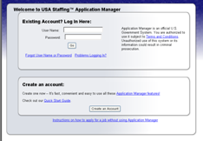If the applicant was logged into a USAJOBS account when arriving at Application Manager, the Application Manager account will automatically link to the USAJOBS account. Then, in subsequent visits where the applicant is already logged in at USAJOBS, the applicant will not be asked to log in to Application Manager.

## Logging into Application Manager

Normally applicants arrive at Application Manager from USAJOBS and will not be asked to log in.

## Uploading Documents in Application Manager

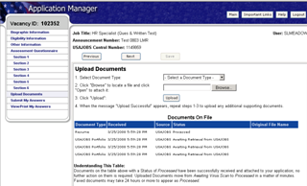Documents may be uploaded directly from an account in USAJOBS or may be uploaded directly into Application Manager. In the case above, “Documents On File” includes documents already transferred from My Account within USAJOBS. To upload documents directly into Application Manager:

1. Select the type of document to be uploaded (i.e., Résumé, Transcript, Qualifications, Veterans Documents, Miscellaneous, etc.).
2. Browse to find the file to be uploaded.
3. Click the **Upload** button; repeat to upload other documents, one at a time.
4. When finished, click **Next**.

***Note:*** the maximum file size for each is 3MB.

The document upload screen displays *all previously submitted documents* from the original application forward. This clearly informs applicants which documents have been already attached and submitted with a particular application (by displaying them in the "Documents on File" table of the Upload Documents section). This should minimize the number of duplicate documents that applicants upload every time they change their answers for a specific VIN, trying to be sure their documents are submitted with the application.

## Using “My Application Packages”

The “My Application Packages” section within Application Manager contains:

* All information about all Application packages that are currently being completed or have been submitted
* Any notifications sent to the applicant by the HR Staff.

The types of information in this box are:

* **Vacancy ID:** The Vacancy Identification Number (or VIN) is the six-digit unique number associated with each position managed by USA Staffing.
* **Job Title:** This is the job title that appears on the job announcement under which is applied.
* **Status:** This is the Status for the total Application package.  Possible statuses and their meanings are:
  + **Complete:** All necessary steps have been completed and the application will be (or has been) processed. No further action is needed unless notified otherwise.
  + **Incomplete:** The applicant needs to take further action. To find out what needs to be done, consult the Checklist tab and the Details tab, and complete any items that are not yet complete.
  + **Replaced by later submission:** More than one set of answers to the Assessment Questionnaire was submitted. The one with this designation has been replaced by a more recent one.
  + **Duplicate - not allowed - not processed:** The applicant attempted to submit more than one set of answers, but the job announcement for which they applied does not permit this. The original application is still in effect, and the one with this status designation is on file but will not be used.
  + **Screened out online:**  One of the answers given to the questionnaire led to an immediate not qualified determination, and the application process automatically ended at that point.
  + **Expired:** Eligibility for the position ended because the period of consideration elapsed and either the applicant did not request an extension or no extension was allowed.
  + **Not Submitted:** The Submit My Answers button was not clicked; the Application package has not yet been processed. This must be done during the open period of the announcement in order to receive a Complete status for this Application package.
  + **Pending HR Staff Action:**  A final determination cannot yet be made about the application status until the HR Staff responsible for the job announcement takes some action. No action on the applicant’s part may be needed, but until this status changes to Complete, the applicant should remain alert in case a message is sent asking to take some action.
  + **Closing Date:** The date the announcement for this position has closed or will close.
  + **Modified Date:** The last date a modification was made to the Application package.
  + **USAJOBS Control Number:**  This is the designation in USAJOBS for this job announcement.

“Application Package Status”

The Application Package Status page provides a powerful center from which the applicant can:

* check the status of all parts of the most recent version of an application package for a job announcement
* work on those parts that are not complete
* update an application package (see “CAUTION” in that section below)
* view documents or add new ones
* view or print questionnaires and answers
* review messages that have been sent about an application package

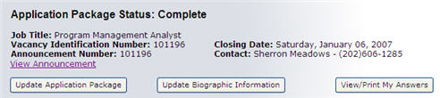The Application package Status page has two major sections: the summary information and actions box at the top, and two tab-controlled views -- Checklist and Details. Each is explained below.

* **Application package Status:** The Status for the total Application package.  Possible statuses are:
* **Complete:**  No further action is needed at this time.
* **Incomplete:** Action must be taken.
* Questionnaire answers may not have been submitted. Go to Submit My Answers to follow up.
* Additional assessments may need to be completed. Consult the Checklist and Details views, the job announcement, and any correspondence sent.
* Required supporting documents may be missing. Go to Upload Documents to follow up.
* **Replaced by later submission:** No further action is needed at this time.
* **Duplicate - not allowed - not processed:** No further action is needed at this time. The original application package will remain the one of record.
* **Screened out online:** No further action is needed at this time.
* **Expired:** The period of eligibility has elapsed and the applicant will no longer be considered for this application package.
* **Not Submitted:** “Submit My Answers” must be selected.
* **Pending HR Staff Action:**  No further action is needed at this time, but check back at a later point to see if the status changes to one that does require action.
* **Vacancy Identification Number:** The Vacancy Identification Number is the six-digit unique number associated with each position managed by USA Staffing.
* **Job Title:** This is the job title that appears on the job announcement under which an application is submitted.
* **Announcement Number:** This number is assigned by the HR Staff and may or may not differ from the Vacancy Identification Number.
* **Closing Date:** The date the Job Announcement has or will close.
* **Contact:** The hiring agency point of contact for this position, usually the HR Staff managing the announcement and application process.

The Application package Summary Information area also includes a link and three buttons.



**View Announcement:** If the Job Announcement is still open at [www.USAJOBS.gov](http://www.usajobs.gov), clicking this link will open the job announcement in a new window.  If the Job Announcement is not currently open at USAJOBS, this link will not appear.

**Update Application package:** By clicking this button, the system begins a new Application package that must be completed and submitted again in its entirety.  ***Documents are not attached, and they must be attached again.***

When updating an application, always go to the USAJOBS account first and ***reapply***. This is the only way an applicant will be able to see new updates in the status area of My Account. When reapplying, Application Manager will adjust the “Application package Status” accordingly. Updates at both My Account in USAJOBS and Application Manager will continue to occur.

From that time on, the Checklist and Details displays pertain to the ***new*** version of the application package, ***not*** to the earlier completed one that appears in Application package History as either ***Complete*** or ***Replaced by later submission***.

**Checklist:** This shows the steps an applicant has completed.

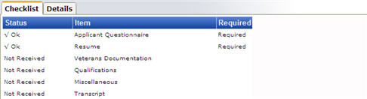

* **Status:** Possible statuses are the following:
  + **OK:**  No further action is needed at this time.
  + **Incomplete:**  Incomplete assessments have been started but have not been submitted.
  + **No Results Yet:** An assessment with this status must be completed outside of Application Manager.
    - **If the assessment** **has NOT yet been taken,** instructions should be sent in the near future indicating when, where, and how to do complete the assessment.
    - **If the assessment HAS been taken**, check the system later to see the results.
  + **Not Received:**  This Supporting Document has not yet been received. Note, it may not be a required document. In this case, refer to the vacancy announcement to ensure all required documents have been received. To add a document at this point, click Add Documents on the “Details” View.
  + **Pending HR Staff Action:** An Assessment that is in Pending requires attention from the HR Staff.  The HR Staff will be alerted to the status and take action, depending on the particular issue.
  + **Pending** (for a document): A supporting document in Pending status is being scanned for viruses and converted to PDF format.
  + **Processed:** This status indicates the document you submitted has been scanned and converted to PDF.
* **Item**: Possible Items are the following:
  + **Assessment types:** Possible items include Assessment Questionnaires, Accomplishment Records, Written Tests and other Assessment Types.
  + **Supporting Documents:** Items include Résumé, Veterans Documentation, Qualifications, Transcripts and Miscellaneous documents.  The Job Announcement will indicate what specific documents are required or accepted and what Document Type they should be uploaded to (Miscellaneous, Transcript, etc.).
* **Required:** An item marked Required must be included in the Application package before it can be in "Complete" status.

***Tip:*** Documents marked as Required are *required for everyone* and must be received and processed, in order for the application package to be rated and used for referral. However, some people need to submit additional documents that are *not* marked as required.  For example, if claiming Veterans' Preference, always submit the Veterans' Preference documentation even though it is not marked as Required for everyone. Applicants should always consult the Job Announcement to see if they must submit any documents beyond those that are Required for everyone.

**Details:**  This lists all questionnaires and documents in the application package. Also, detailed status information, submitted documents and any messages sent by the HR Staff may be viewed here.

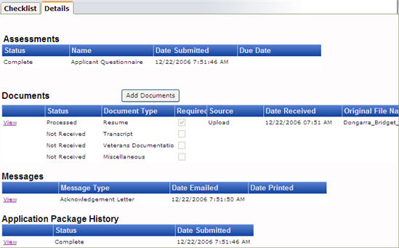

* Assessments: This list contains any Assessments associated with this position -- including the Assessment Questionnaire. For each one, the Assessment status, the date the Assessment was submitted and the due date, if any is assigned, is all viewable.
* Documents: This list shows the Supporting Documents that are being accepted, some of which may be required. For each one that has been received, the status, source (Upload, Fax, USAJOBS Résumé), date received, original file name (if there was one), are all viewable here.
* Messages: This lists shows any Letters, Notices of Results or other USA Staffing generated correspondence HR Staff has sent, together with the Message Type and the date the message was either emailed or printed for hard-copy mailing.
  + Viewing messages: A copy message can be seen by clicking the View link in the first column. Messages will be displayed as PDF files.
* **Application package History:** This list shows application packages that have been submitted for this position and the received date.
* **Viewing Questionnaire Answers:** The questions and corresponding answers may be viewed by clicking the View link in the first column; a new window will open.

For more information about the Application Manager, please visit

<http://eshelp.opm.gov/robo/projects/appman001/Quick_Start_Guide.htm>

For USAJOBS My Account tutorials and guides, please visit:

<http://www.usajobs.gov/ResourceCenter>

VA USA Staffing Program Office has also created these additional resources:

- [Applying Online with USAJOBS and Application Manager](http://vaww.va.gov/hiringreform/USA-Staffing/ET-PamphletApplyingOnlineWithUSAStaffing.pdf) Pamphlet

- [Uploading Documents Aid](http://vaww.va.gov/hiringreform/USA-Staffing/ET-UploadingAndUsingDocumentsOnline03-31-10.doc)