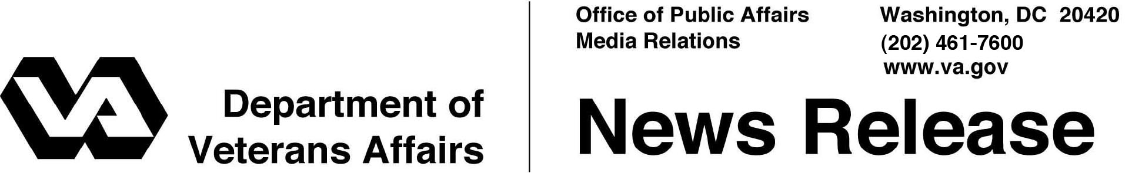

FOR IMMEDIATE RELEASE
September 8, 2011

VA Streamlines Online Applications for Health Benefits Renewal
Automated 10-10EZR Form Simplifies Updates

WASHINGTON – The Department of Veterans Affairs (VA) has automated its online Health Benefits Renewal (10-10EZR) form as part of its ongoing effort to streamline access to benefits.
“This action dramatically reduces the time it will take for enrolled Veterans to submit updates to their demographic information and further reduces access barriers to needed care for Veterans,” said Secretary of Veterans Affairs Eric K. Shinseki.
Previously, Veterans filling out the online 10-10EZR were required to print a copy, sign it and send it to their local medical center before updates to their personal, insurance or financial information could occur. Veterans may now submit these updates online.
For additional information, go to www.va.gov/healtheligibility or call VA’s toll-free number at 1-877-222-VETS (8387). The online form is available at https://www.1010ez.med.va.gov/sec/vha/1010ez/Form/1010ezr.pdf.

# # #

