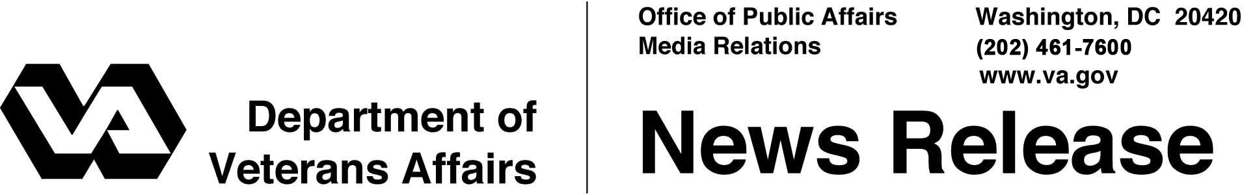

FOR IMMEDIATE RELEASE
March 27, 2012

VA Grant Supports Improvement at California Veterans Facility
Home in Yountville to Receive $1Million in VA Funding
WASHINGTON – To ensure California’s State Veterans’ Home in Yountville remains a comfortable and safe residence for Veterans, the Department of Veterans Affairs is awarding a grant to the state of $1,043,522 for a new fire alarm system.
“Our federal-state partnership helps to provide comfortable and safe housing in a caring community for California Veterans who have served their country,” said Secretary of Veterans Affairs Eric K. Shinseki.
VA’s grant will cover approximately 65 percent of the estimated $1,605,000 cost of the project.
In fiscal year 2010, VA spent more than $9 billion to serve California’s nearly two million Veterans. VA operates 10 major medical centers in the state, with outpatient clinics and Vet Centers across the state, plus nine national cemeteries.
California operates six state Veterans homes and is planning two more. These homes are residential care facilities offering medical, dental, pharmacy and rehabilitation services and social activities. Veterans age 55 and older, discharged from active military service under honorable conditions, may apply for admission. The age requirement is waived for disabled or homeless Veterans needing long-term care.
More information about California state Veterans home is available on the Internet at www.calvet.ca.gov/VetHomes/Default.aspx

# # #

