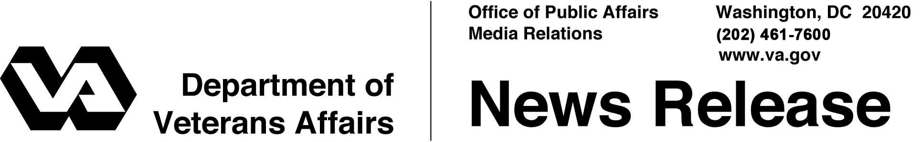
FOR IMMEDIATE RELEASE
January 29, 2014

Automation Speeds Benefits Processing for Post-9/11 GI Bill Students
Students see improvement in turn-around time for education claims

WASHINGTON – The Department of Veterans Affairs (VA) decreased the time it takes to process requests for GI Bill and other education benefits for returning students by nearly 50 percent compared to fiscal year 2012. VA attributes the faster process in large part to improved claims automation that uses rules-based, industry-standard technologies to deliver Veterans’ benefits.
“We are happy to report that our students are seeing a reduction in the amount of time it takes to process their education claims thanks to an automated, digital process making it easier for Veterans, Servicemembers and their families to attend post-secondary education and enroll for continuing semesters,” said Under Secretary for Benefits Allison A. Hickey. “This automation has not only improved education benefits processing, it has allowed us to shift resources to other priorities, like improving timeliness of disability compensation decisions. It’s a great example of how technology is helping us to transform the way we do business and better serve Veterans.”
The Post-9/11 GI Bill builds on the great legacy of the original GI Bill, giving Iraq and Afghanistan Veterans and their families the opportunity to reach their educational goals, find a good job and improve their lives. The automation technology, part of VA’s Post-9/11GI Bill processing system called “Long Term Solution” (LTS), was implemented in September 2012. This technology has more than 1,700 calculations and rules that support benefits delivery for eligible Veterans, Servicemembers, and dependents. Up to six distinct payments per beneficiary can be calculated automatically per term, including: housing, books and supplies stipend, tuition and fees and Yellow Ribbon payments.
In addition, a variety of different types of education and training programs are supported by the automated technology, including: graduate, undergraduate, non-college degree, correspondence, licensing and certification, apprenticeship and on-the-job training.
The improvement in timeliness was achieved despite a 27 percent increase in incoming education claims – 3.4 million in fiscal year 2013 compared to 2.7 million the prior year. Currently, VA is processing initial claims for new students in an average of less than 20 days, and supplemental claims for returning students in less than 8 days, down from 33 days and 16 days respectively since LTS was first fielded.
VA has provided more than $35.6 billion in Post-9/11 GI Bill benefit payments to over 1.1 million Veterans, Servicemembers, and their families, and to the universities, colleges, and trade schools they attend. In 2014, VA will continue to improve education benefits delivery, through additional automation, tracking of beneficiary graduation rates, and the release of new tools to help beneficiaries best utilize VA education benefits, including the Choosing a School Guide, and CareerScope.
For more information about VA education benefits, visit www.benefits.va.gov/gibill.

