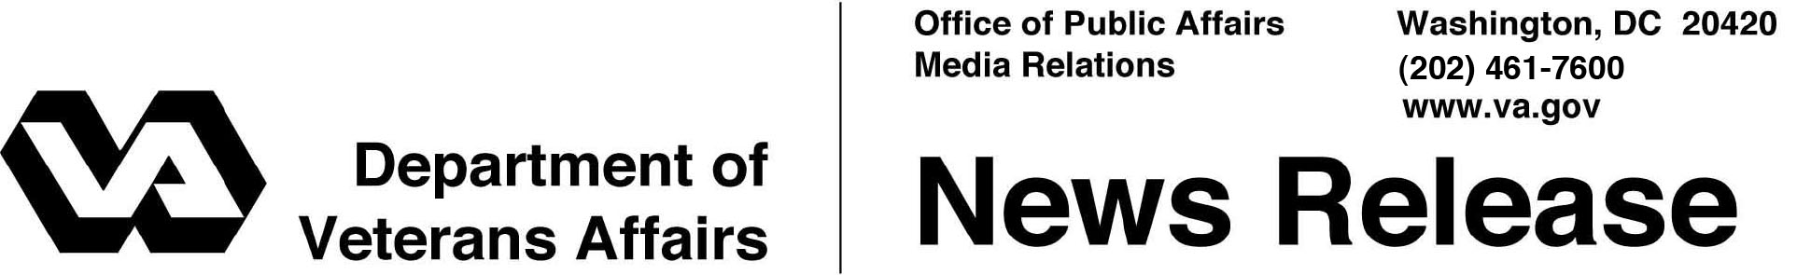

FOR IMMEDIATE RELEASE
January 12, 2012

VA Announces Changes to Emergency Care Payment Policy
WASHINGTON – The Department of Veterans Affairs announced today a change in regulations regarding payments for emergency care provided to eligible Veterans in non-VA facilities.
“This provision helps ensure eligible Veterans continue to get the emergency care they need when VA facilities are not available,” said Secretary of Veterans Affairs Eric K. Shinseki.
The new regulation extends VA’s authority to pay for emergency care provided to eligible Veterans at non-VA facilities until the Veterans can be safely transferred to a VA medical facility.
More than 100,000 Veterans are estimated to be affected by the new rules, at a cost of about $44 million annually.
VA operates 121 emergency departments across the country, which provide resuscitative therapy and stabilization in life-threatening situations. They operate 24 hours a day, seven days a week. VA also has 46 urgent care units, which provide care for patients without scheduled appointments who need immediate medical or psychiatric attention.
For more information about emergency care in non-VA facilities, visit www.nonvacare.va.gov.

# # #

