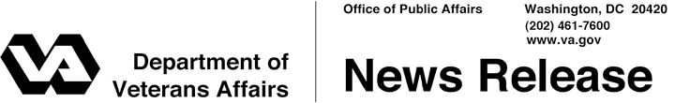

FOR IMMEDIATE RELEASE
February 22, 2012

VA Launches Personalized Health Benefits Handbook
WASHINGTON – Veterans enrolled in the health care system of the Department of Veterans Affairs have begun to receive personalized booklets that explain their health care benefits and contain other useful information.
“VA is committed to providing our Nation’s Veterans with consistent, clear information about the services available to them,” said Secretary of Veterans Affairs Eric K. Shinseki.
The new booklet, called a Health Benefits Handbook, will provide a personalized listing of health benefits based on each Veteran’s specific eligibility. The handbook will also have contact information for their local VA medical facilities, appointment scheduling information, guidelines for communicating with their clinical team and, as applicable, information about copays.
Distribution of the handbooks began this month, with all 8.5 million Veterans enrolled in VA’s health care system scheduled to receive their handbooks by 2013. Veterans will receive updates to their handbook to reflect changes to their benefits or eligibility.
VA operates 152 medical centers and more than 800 community-based outpatient clinics. Last year, inpatient facilities treated more than 690,000 patients, while outpatient clinics registered more than 79 million visits.
For more information about the Health Benefits Handbook, visit www.va.gov/healthbenefits/vhbh or call VA’s toll-free number at 1-877-222-VETS (8387).

# # #

