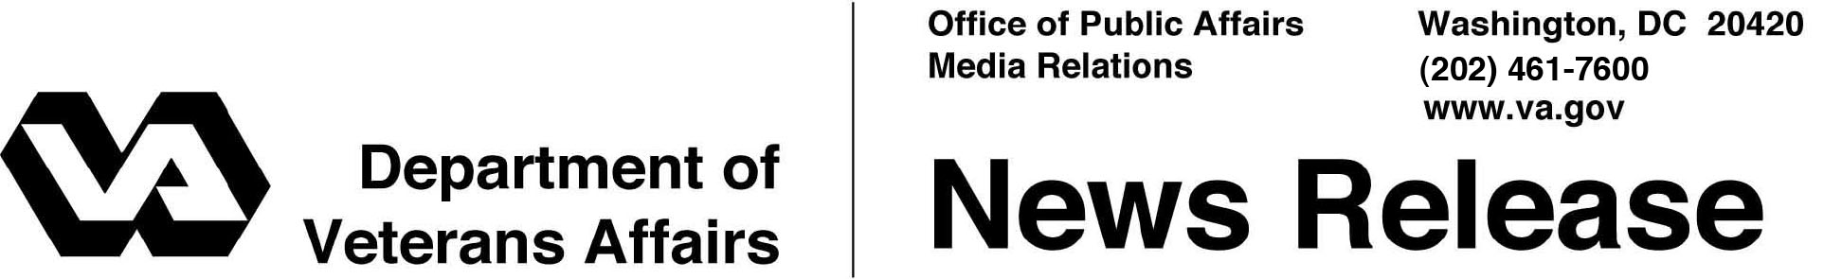

FOR IMMEDIATE RELEASE
February 14, 2012

Veterans Canteen Service Keeps Kitchen Waste Out of Landfills
WASHINGTON – The Veterans Canteen Service (VCS) of the Department of Veterans Affairs is piloting two initiatives that should keep nearly 600,000 pounds of kitchen waste out of U.S. landfills in 2012.
“VA is committed to cutting our waste in half by 2015, and these initiatives will be a big step toward achieving that goal,” said VCS Director Marilyn Iverson. “Recycling and conservation benefits VA, the Veterans we serve and our environment.”
A cooking oil recycling pilot program began Jan. 18 and will continue for 30 days. VCS is partnering with Quest Recycling, based in Frisco, Texas, to recycle used cooking oil generated at the VCS’s Patriot Cafés located in several locations -- West Palm Beach, Fla.; St. Louis; and Houston, Dallas, San Antonio, and Temple, Texas.
VCS estimates it will be able to recycle approximately 583,000 pounds of cooking oil per year and will also realize some safety benefits as new equipment will minimize food associates’ contact with hot oil and kitchen equipment. Used cooking oil recycling will also support VA’s Sustainability goals of 50 percent waste diversion rate by 2015 and 30 percent reduction in Green House Gas emissions by 2020.
The pilot results will be analyzed promptly in anticipation of an aggressive national roll out to 170 additional locations at a rate of 20 locations per month.
VCS and the Martinsburg VA Medical Center’s Nutrition and Food Service Group have also partnered in a composting pilot at the VCS Martinsburg Patriot Café location. The pilot composts kitchen waste from the preparation of VCS food products. The pilot began Dec. 19, 2011 and ended Jan. 31. Early reports revealed positive results, with VCS composting about 30 pounds of kitchen waste per week.
-More-

VCS Waste 2/2/2/2

The Martinsburg VA Medical Center developed the original composting system and received a VA Sustainability Achievement Award and a GreenGov Presidential Award in 2010 for the system’s design and the sustainability results.
The Martinsburg composting design will be used to create standard composting policies and procedures for future VCS Patriot Cafés. VCS is actively pursuing composting pilots with VA medical centers in West Palm Beach, Fla.; and San Francisco, San Diego, and Palo Alto, Calif.
VCS employees provide retail, food and vending services at VA facilities across the country. Proceeds within VCS are used to support many VA initiatives, including VA’s National Rehabilitation Special Events, the homeless initiative, Fisher Houses and programs for Veterans of Operation Iraqi Freedom, Operation Enduring Freedom and Operation New Dawn.

# # #

