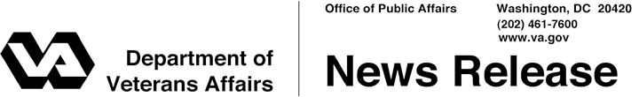

FOR IMMEDIATE RELEASE
October 17, 2013

VA Resuming Normal Operations as Government Shutdown Ends
WASHINGTON – Employees at the Department of Veterans Affairs are working to resume normal operations as quickly as possible. Veterans Benefits Administration (VBA) regional offices are re-opening their doors and resuming public contact services for Veterans today.
“With the shutdown over, we are all very grateful that the Nov. 1 benefit checks will go out to approximately 5 million Veterans and other beneficiaries as scheduled,” said Secretary of Veterans Affairs Eric K. Shinseki. “We at VA are working quickly to resume normal operations in order to fulfill our solemn obligation – to ensure that Veterans receive the benefits and services they have earned through their service. I want to thank all of our VA employees for their dedication and resolve during this difficult period.”
During the government shutdown, VA medical centers, clinics, and other health services remained open. Due to the shutdown, VA claims processors were unable to continue working 20 hours of overtime per month to reduce the backlog of claims, overtime that has helped VA significantly reduce the disability claims backlog by more than 190,000 claims over the last six months. Mandatory overtime will resume immediately and will continue as planned through Nov. 16, at a minimum.
“In the coming weeks and months, we will fight hard to regain ground lost as a result of the government shutdown,” said Shinseki. “We remain committed to eliminating the disability claims backlog in 2015.”

# # #

