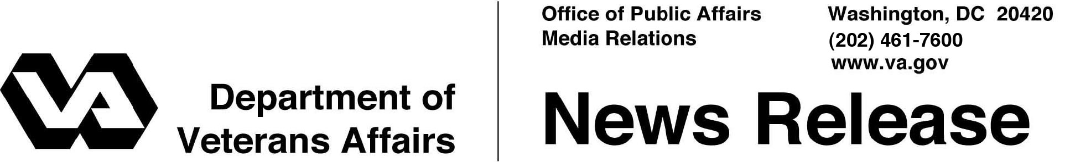

FOR IMMEDIATE RELEASE
July 29, 2013

Post-9/11 GI Bill Celebrates Fourth Anniversary
Nearly 1 Million Veterans, Servicemembers and Families Benefit
WASHINGTON – Thursday, August 1, marks the fourth anniversary of the Post-9/11 GI Bill. VA has issued approximately $30 billion in Post 9/11 GI-Bill benefit payments since its inception in August 2009 and helped nearly 1 million Servicemembers, Veterans, and their families pursue their education.
“The Post-9/11 GI Bill has helped many of our Nation’s Veterans pursue their education and successfully transition to civilian life,” said Secretary of Veterans Affairs Eric K. Shinseki. “We’re proud that the Department of Veterans Affairs can administer this important benefit that makes such a big difference in the lives of nearly a million Veterans and their families.”
The Post-9/11 GI Bill is the most extensive educational assistance program since the Serviceman’s Readjustment Act of 1944, more commonly known as the GI Bill, was signed into law.
The Post-9/11 GI Bill provides comprehensive educational support through tuition, books and housing allowance to people with at least 90 days of total service after September 10, 2001, or people discharged with a service-connected disability after 30 days.
Approved training under the Post-9/11 GI Bill includes graduate and undergraduate degrees, vocational and technical training, on-the-job training, flight training, correspondence training, licensing and national testing programs, entrepreneurship training, and tutorial assistance.
VA is now processing benefit payments for currently enrolled students in an average of seven days, largely as a result of VA’s ongoing transformation to electronic claims processing. The delivery of Post-9/11 GI Bill benefits has been automated and processing time cut in half through implementation of VA’s Long Term Solution, an end-to-end claims processing system that uses rules-based, industry-standard technologies.
“Since the end of World War II, GI Bill programs have shaped and changed the lives of Veterans, Servicemembers, their families and their survivors by helping them reach their educational and employment goals,” said Allison A. Hickey, Under Secretary for Benefits. “That is still true today.”
In April 2012, President Obama signed Executive Order 13607 which established the Principles of Excellence, offering guidelines that promote student success under the program and ensure accurate information about institutions and their courses. Over 6,000 educational and training institutions have agreed to comply with these principles.
“The Principles of Excellence, further strengthened by Public Law 112-249, provide future student Veterans with greater consumer education” said Michael Dakduk, executive director of Student Veterans of America. “It is extremely important to have the right tools and information before making a decision on a post-secondary credential, degree program, or institution of higher learning.”
VA is working with schools, community organizations and other partners to ensure beneficiaries have all the information they need to use their education benefits, including:
- Education plans for all military and Veteran education beneficiaries;
- A designated point of contact for academic and financial advice at each school; and
- An end to fraudulent and aggressive recruiting techniques and misrepresentation.
This summer, VA is launching new tools to help beneficiaries learn more about their vocational aptitudes and select an education institution.
- The ‘Factors to Consider When Choosing a School’ guide offers future students steps to take when researching, choosing, and attending a school.
- CareerScope® is a free, new tool featured on http://www.gibill.va.gov that measures a student’s aptitude and interests through a self-administered online test, identifying potential career paths.
- The new GI Bill® Comparison Tool allows students to research and compare schools, including key indicators like average student loan debt and graduation rates.
“We will continue to work hard to improve VA’s benefits delivery process for Post-9/11 GI Bill beneficiaries and to ensure that Veterans and their families have the tools they need to choose the right education institution to help them build a foundation for the future,” Hickey added.
For more information on the Post-9/11 GI Bill and other Veteran education programs, visit http://www.gibill.va.gov.

# # #

