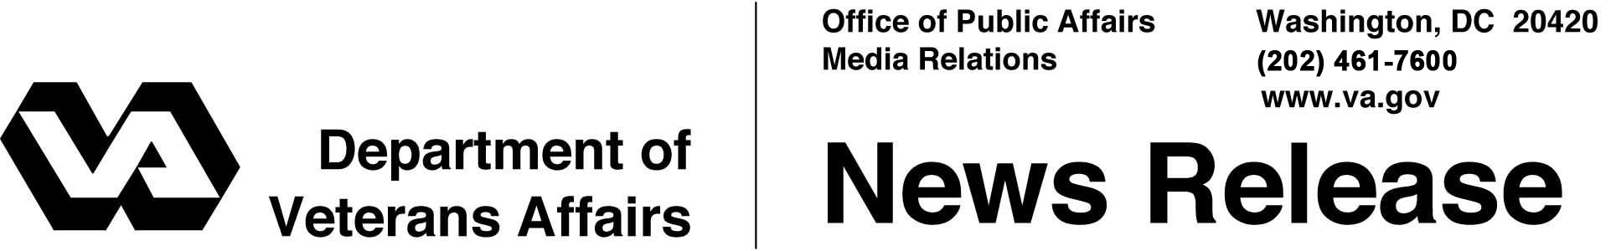

FOR IMMEDIATE RELEASE

October 21, 2011

Draft Gulf War Task Force Report Is Released
Report Redefines How Care and Services Are Provided
to Gulf War Veterans

WASHINGTON – Today, Secretary of Veterans Affairs Eric K. Shinseki announced that the Department’s Gulf War Veterans’ Illnesses Task Force has completed the draft of a comprehensive report that will outline how the Department of Veterans Affairs (VA) addresses the concerns of Veterans who deployed during the Gulf War in 1990 and 1991.
“This report provides a roadmap for our continued enhancements in our care and services we provide to Gulf War Veterans,” said Shinseki. “We will be applying lessons learned from this report to Veterans of all eras.”
Notification of the draft written report is published in the Federal Register, and the draft written report addresses seven areas where VA provides services for this group of Veterans.
Over the past year, the task force has examined, evaluated, designated and adjusted the initial roadmap outlined in last year’s report. VA has designated steps to improve care and services to Gulf War I Veterans and these improvements are becoming a part of our culture and operations.
This year’s report focuses on improvements in the delivery of health care for Gulf War Veterans. One of the most substantial additions is modifications to clinical care models used for Gulf War Veterans, which is the most critical point of service VA provides. There are better linkages between specialty knowledge and services at the basic point of care. Clinical research and development is significantly contributing new concepts and methods to clinical practice and clinical education throughout VA.
- More -

Gulf War Task Force 2/2/2/2

Two new positions were established in the Office of Research and Development for deployment and Desert Shield and Desert Storm health-related issues. Both positions have been filled and are enhancing research efforts for Gulf War Veterans and will continue to do so in the coming years.
VA is also strengthening partnerships and medical surveillance to address the potential health impacts on Veterans from the environmental exposures on today's battlefield. Additionally, VA continues to use social media to improve communication with Gulf War Veterans.
The Chairman of the Gulf War Veterans’ Illnesses Task Force is John R. Gingrich, chief of staff at VA, a retired Army officer who also served in the Gulf War.
“To ensure we are tracking the needs of our Veterans, we want to get feedback from Gulf War Veterans on this draft report,” said Gingrich. “Their feedback is critical to our efforts to understand and serve their specific needs. Therefore, we hope they take advantage of one of the different opportunities to provide feedback that we have created for them.”
As a first step, VA is seeking public comments on the draft written report before final publication. The public notice and instructions for how to submit electronic and comments via postal mail will be posted at www.regulations.gov, and the draft written report will be open for comment for 30 days. In addition, VA recognizes that a great number of Gulf War Veterans use the Internet on a daily basis to share their ideas and concerns, so VA has also created a public discussion board on the seven recommendations at: http://vagulfwartaskforce.uservoice.com/. To view the report without making recommendations, please visit VA’s website at http://www.va.gov/opa/publications/Draft_2011_GWVI-TF_Report.pdf.
# # #

