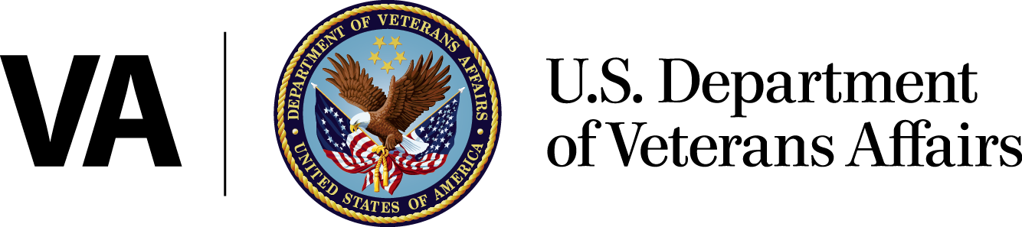
Office of Public Affairs
Media Relations
Washington, DC 20420
(202) 461-7600
www.va.gov
News Release

FOR IMMEDIATE RELEASE
June 2, 2014

Message from the Acting Secretary of Veterans Affairs Sloan D. Gibson

“Not all Veterans are getting the timely access to the healthcare that they have earned. Systemic problems in scheduling processes have been exacerbated by leadership failures and ethical lapses. I will use all available authority to swiftly and decisively address issues of willful misconduct or mismanagement.
“VA’s first priority is to get all Veterans off waiting lists and into clinics while we address the underlying issues that have been impeding Veterans’ access to healthcare. The President has made clear that this is his expectation.
“Even as we implement these immediate actions, we will work with Veterans Service Organizations, members of Congress, academia, public and private organizations, and with all other agencies and institutions that can help us move forward.
“We will also continue to depend on the faithful service of VA employees and leaders who place the interests of Veterans above their own, those who serve Veterans with dignity, compassion, and dedication, and who live by VA’s core values: Integrity, Commitment, Advocacy, Respect, and Excellence.
“Finally, as we accelerate our access to care, we will not lose sight of the fact that the quality of VA healthcare remains strong. Ten years of external validations have consistently shown that, on average, Veterans who use VA healthcare rate our hospitals and clinics as high or higher in customer satisfaction than patients give most of the Nation’s private sector hospitals.
“On behalf of all Veterans, I express my appreciation to Secretary Shinseki for his leadership of VA. For decades to come, Veterans will benefit from the transformation begun in the past five years.
“Thank you for your support and dedication to Veterans and our mission to serve them.”

###

