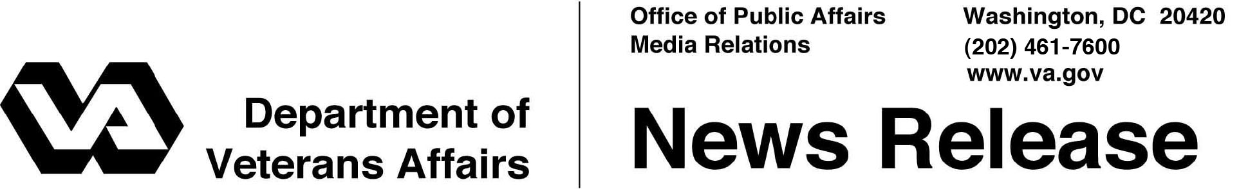

FOR IMMEDIATE RELEASE
June 8, 2011

VA to Expand Housing for Homeless Veterans and Their Families

Unused & Underused VA Buildings to Be Developed

WASHINGTON – The Department of Veterans Affairs (VA) continues to develop housing opportunities for homeless and at-risk Veterans by adding 34 VA locations across the country. This strategy will increase the Department’s available beds by over 5,000. VA currently has 15,000 transitional beds available to homeless Veterans.
“This initiative will significantly support our efforts to eliminate Veteran homelessness and improve quality of life for Veterans,” said Secretary of Veterans Affairs Eric K. Shinseki. “We have a moral obligation to ensure that Veterans and their families have access to affordable housing and medical services that will help them get back on their feet.”
Culminating two years of work to end homelessness among Veterans, a recent strategic study, the Building Utilization Review and Repurposing (BURR) initiative, identified unused and underused buildings at existing VA property with the potential to develop new housing opportunities for homeless or at-risk Veterans and their families through public-private partnerships and VA’s enhanced-use lease (EUL) program. Under the EUL program, VA retains ownership of the land and can determine and control its reuse.
Additional opportunities identified through BURR will include housing for returning Iraq and Afghanistan Veterans and their families, assisted living for elderly Veterans and continuum of living residential communities.
The project will support VA’s goal of ending Veteran homelessness by providing safe, affordable, cost effective, and sustainable housing for Veterans on a priority basis.
VA will hold a one-day national Industry Forum in Washington, D.C., for interested organizations on July 13. For information regarding the forum or registration please visit: http://www.va.gov/assetmanagement/burr/. If you have questions please email VA_BURR@va.gov.

- More -
Homeless Veteran Housing 2/2/2/2

Supportive housing projects are planned for homeless Veterans and their families at 23 VA sites: Tuskegee, Ala.; Long Beach and Menlo Park, Calif.; Bay Pines, Fla.; Dublin, Ga.; Hines, North Chicago and Danville, Ill.; Fort Wayne, Ind.; Leavenworth, Kan.; Perry Point, Md.; Bedford, Brockton and Northampton, Mass.; Battle Creek, Mich.; Minneapolis and St. Cloud, Minn.; Fort Harrison, Mont.; Castle Point, N.Y.; Chillicothe and Dayton, Ohio; and Spokane and Vancouver, Wash.
Under the enhanced-use lease agreements, Veterans will receive senior and non-senior independent living and assisted living at eleven VA sites: Newington, Conn.; Augusta, Ga.; Marion, Ill.; Topeka, Kan.; Togus, Maine; Grand Island, Neb.; Big Springs and Kerrville, Texas; Salem, Va.; Martinsburg, W.Va.; and Cheyenne, Wyo.

# # #

