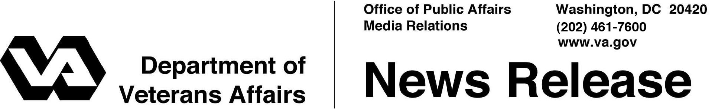

FOR IMMEDIATE RELEASE
August 24, 2011

VA Program That Boosts Safeguards for Research Participants
Wins Approval from Accrediting Body

WASHINGTON – The Department of Veterans Affairs (VA) Human Research Protection Program (HRPP), which helps ensure high ethical and scientific standards for multi-site research projects involving Veterans or their health information, has been accredited by the nonprofit Association for the Accreditation of Human Research Protection Programs (AAHRPP).
A key component of the HRPP is the Department of Veterans Affairs Central Institutional Review Board (IRB), launched in 2008 by VA’s Office of Research and Development. VA’s Central IRB oversees large clinical trials and other human research projects conducted at multiple VA medical centers and often involving hundreds or even thousands of Veterans. More than 100 VA sites have approval to conduct human research projects, and often collaborate on projects. VA’s Central IRB is able to ensure that local issues also are addressed.
Recognition from AAHRPP means the VA Central IRB meets the highest standards for human subject research, surpassing what is required under Federal policies and regulations. According to AAHRPP, “through the rigorous accreditation process, organizations must demonstrate that they have built extensive safeguards into every level of their research operation and that they adhere to the highest standards for research.”
“The new accreditation gives Veterans who take part in VA studies reassurance of the protections they are afforded,” said Dr. Joel Kupersmith, VA’s chief research and development officer. “Veterans who volunteer for VA research can expect the highest level of protection.”
-More-

HRPP 2/2/2/2

Based in Washington, D.C., AAHRPP uses what it calls a “voluntary, peer-driven, educational model.” The organization says its process “typically results in system-wide improvements that enhance protection for research participants and promote high-quality research.” In addition to its recognition of the VA HRPP and the VA Central IRB, AAHRPP has accredited the local human research protection programs at the more than 100 VA sites nationwide.
For more information on VA’s research program, visit www.research.va.gov.

# # #

