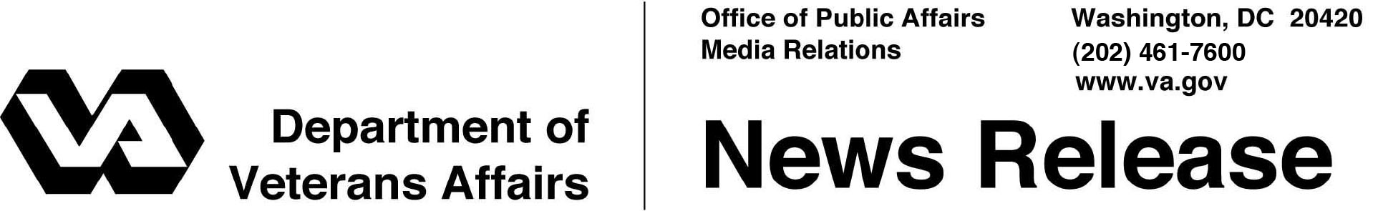

FOR IMMEDIATE RELEASE
December 10, 2012

Report Reveals Further Reduction in Veterans Homelessness
VA Also Announces $300 Million to Expand Homeless Prevention Program
WASHINGTON – The Departments of Veterans Affairs and Housing and Urban Development (HUD) today announced that a new national report shows that homelessness among Veterans has been reduced by approximately 7 percent between January 2011 and January 2012. The decline keeps the Obama Administration on track to meet the goal of ending Veteran homelessness in 2015.
“This report continues a trend that clearly indicates we are on the right track in the fight to end homelessness among Veterans. While this is encouraging news, we have more work to do and will not be satisfied until no Veteran has to sleep on the street,” said Secretary of Veterans Affairs Eric K. Shinseki. “The success we have achieved is directly attributable to the hard work by all of our staff, and the federal, state, and community partners who are committed to ending Veteran homelessness.”
HUD Secretary Shaun Donovan added, “This decline tells us that the Obama Administration is on the right path, working together across agencies to target Federal resources to produce a measurable reduction in Veteran homelessness. Key to this success has been VA and HUD’s implementation of the Housing First approach endorsed by the Administration’s strategic plan to prevent and end homelessness. As our nation’s economic recovery takes hold, we will make certain that our homeless veterans find stable housing so they can get on their path to recovery.”
The 2012 Annual Homeless Assessment Report (AHAR) to Congress, prepared by HUD, estimates there were 62,619 homeless Veterans on a single night in January in the United States, a 7.2 percent decline since 2011 and a 17.2 percent decline since 2009. The AHAR reports on the extent and nature of homelessness in America. Included in the report is the annual Point-in-Time (PIT) count, which measures the number of homeless persons in the U.S. on a single night in January 2012, including the number of homeless Veterans.
VA has made ending Veteran homelessness by the end of 2015 a top priority, undertaking an unprecedented campaign to dramatically increase awareness of VA services available for homeless Veterans and Veterans at risk of becoming homeless. While the number of homeless people in the U.S. dropped by less than 1 percent, according to the 2012 AHAR, Veteran homelessness has shown a more robust decline.
VA also announced the availability of $300 million in grants for community organizations, estimated to serve approximately 70,000 Veterans and their family members facing homelessness. The deadline for applying to the Supportive Services for Veteran Families (SSVF) program, a homelessness prevention and rapid re-housing program, is Feb. 1, 2013.
“Homeless prevention grants provide community partners with the opportunity to help prevent and end homelessness on the local level,” said Secretary Shinseki. “This is a crucial tool in getting at-risk Veterans and their families on the road to stable, secure lives. ”
SSVF grants promote housing stability among homeless and at-risk Veterans and their families. The grants can have an immediate impact, helping lift Veterans out of homelessness or providing aid in emergency situations that put Veterans and their families at risk of homelessness.
Through September 2012, SSVF has aided approximately 21,500 Veterans and over 35,000 individuals. Since SSVF is able to help the Veteran’s family, 8,826 children were also assisted, helping Veterans keep their families housed and together. Grantees provide a range of supportive services to very low-income Veteran families living in or transitioning to permanent housing, including case management, legal assistance, financial counseling, transportation, child care, rent, utilities and other services aimed at preventing homelessness.
The availability of SSVF funds was announced in a Notice of Funding Availability (NOFA) posted in the Federal Register and on VA’s SSVF website at www.va.gov/homeless/ssvf.asp.
A video on www.va.gov/homeless/ssvf.asp offers guidance for community organizations interested in applying for SSVF funds. Community organizations seeking more information on the SSVF program may also contact VA at 1-877-737-0111 or at SSVF@va.gov.

# # #

