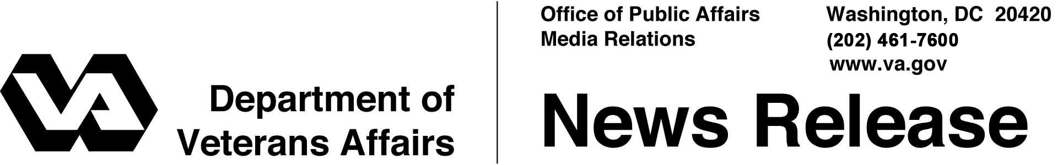

FOR IMMEDIATE RELEASE

August 1, 2012

VA Expanding Burial Options in Rural Areas
WASHINGTON – The Department of Veterans Affairs announced today that it is moving forward with a plan to provide burial services for Veterans in rural areas where there are no available VA national cemeteries, state Veterans cemeteries or tribal Veterans cemeteries.
“VA is committed to improving service to Veterans in rural areas,” said Secretary of Veterans Affairs Eric K. Shinseki. “Through an innovative partnership with existing cemeteries, we will be able to ensure burial for Veterans in more locations that meet the high standards of national shrines.”
Under the Rural Initiative plan, VA will build small National Veterans Burial Grounds within existing public or private cemeteries in rural areas where the unserved Veteran population is 25,000 or less within a 75-mile radius.
VA plans to open eight National Veterans Burial Grounds that will serve Veterans in the areas of Fargo, N.D.; Rhinelander, Wis.; Cheyenne, Wyo.; Laurel, Mont.; Idaho Falls, Idaho; Cedar City, Utah; Calais, Maine; and Elko, Nev.
VA officials will announce further details about the eight new burial grounds as information becomes available. This new initiative will make VA burial options available to more than 136,000 Veterans and their eligible dependents.
A National Veterans Burial Ground will be a small, VA-managed section of three to five acres within an existing public or private cemetery. VA will provide a full range of burial options and control the operation and maintenance of these lots. These sections will be held to the same “national shrine” standards as VA-run national cemeteries.
VA is still evaluating suitable sites for its Rural Initiative. In Laurel, Mont., VA is exploring with local officials the feasibility of acquiring a portion of the Yellowstone County Veterans Cemetery to establish as a National Veterans Burial Ground.

VA operates 131 national cemeteries in 39 states and Puerto Rico and 33 soldiers' lots and monument sites. Nearly four million Americans, including Veterans of every war and conflict -- from the Revolutionary War to the current conflicts in Iraq and Afghanistan -- are buried in VA’s national cemeteries on more than 19,000 acres.
Veterans with a discharge issued under conditions other than dishonorable, their spouses and eligible dependent children can be buried in a VA national cemetery. Other burial benefits available for all eligible Veterans, regardless of whether they are buried in a national cemetery or a private cemetery, include a burial flag, a Presidential Memorial Certificate and a government headstone, grave marker or medallion.
More information on VA burial benefits is available from national cemetery offices, from the Internet at www.cem.va.gov or by calling VA Regional Offices toll-free at 800-827-1000. To make burial arrangements at the time of need at any VA national cemetery, call the National Cemetery Scheduling Office at 800-535-1117.

# # #

