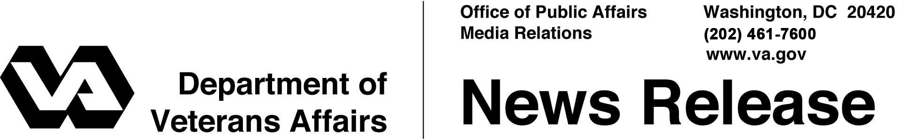

FOR IMMEDIATE RELEASE
August 16, 2011

VA Publishes Social Media Policy
Policy Establishes Responsible Use for Web-based Collaboration Tools

WASHINGTON – The Department of Veterans Affairs (VA) announced today the release of a policy directive regarding the secure use of Web-based collaboration and social media tools. The policy allows the Department and its employees to leverage emerging platforms that enhance communication, stakeholder outreach, and information exchange as the Department transforms itself into a 21st Century organization attuned to the needs of Veterans of all generations.
“Veterans should have consistent and convenient access to reliable VA information real time using social media —whether on a smartphone or a computer,” said Secretary of Veterans Affairs Eric K. Shinseki. “They also should be able to communicate directly with appropriate VA employees electronically.”
The policy, “VA Directive 6515: Use of Web-Based Collaboration Technologies,” encourages the adoption and use of social media by VA employees. It provides workplace boundaries and establishes the Department’s philosophy for communication: VA is open and transparent, and VA is willing and able to engage and collaborate with its many stakeholders online.
“This isn’t about using social media because it’s cool or because it’s a fad,” said VA Director of Online Communications Brandon Friedman. “It’s about getting the right information to the right Veteran at the right time. This policy sets us on a path toward changing how we talk—and listen—to Vets.”

- More -

Social Medial Policy 2/2/2/2

VA began launching social media sites in 2009 and the Department has over 100 Facebook pages, more than 50 Twitter feeds, two blogs, a YouTube channel, and a Flickr page. VA’s Facebook pages have a combined subscribership of over 293,000 fans—with the Department’s main page reaching over 138,000. On Twitter, VA has a combined followership of over 53,000—with the Department’s main feed reaching over 22,000. VA has posted over 300 videos on YouTube and over 9,000 photos on Flickr, which have been viewed over a combined 1.1 million times. In November 2010, VA launched its first blog, VAntage Point, which distinguishes itself from other government blogs by actively soliciting guest pieces from both employees and the public. By the end of the year, the Department expects to have an active Facebook page and Twitter feed for all 152 VA Medical Centers.

More information:
VA Directive 6515 (Social Media Policy)
- http://www.va.gov/vapubs/viewPublication.asp?Pub_ID=551&FType=2
Directory of VA Social Media Sites
- http://www.va.gov/opa/SocialMedia.asp

VA’s Main Social Media Sites
- http://blogs.va.gov
- http://www.facebook.com/VeteransAffairs
- http://twitter.com/DeptVetAffairs
- http://www.youtube.com/user/DeptVetAffairs
- http://www.flickr.com/photos/VeteransAffairs

# # #

