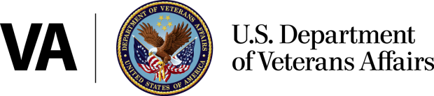
Office of Public Affairs
Media Relations
Washington, DC 20420
(202) 461-7600
www.va.gov
News Release

VA Grants Will Expand Transportation in Highly Rural Areas
Veterans to Have Easier Access to Health Care
WASHINGTON – The Department of Veterans Affairs (VA) and the White House Rural Council today announced the award of eight grants, totaling $815,051.50, which will improve access to health care for Veterans living in highly rural areas. The grants will assist over 11,000 Veterans in seven states and 56 counties by providing up to $50,000 per highly rural area to fund transportation services for Veterans to and from VA medical centers and other facilities that provide VA care. The grants are part of a program authorized by Congress to help state Veterans Service Agencies (SVSAs) and Veterans Service Organizations (VSOs) operate or contract for transportation services to transport Veterans to VA medical centers and other facilities that provide VA care.
In July 2013, VA began accepting applications for grants to help state Veterans Service Agencies and VSOs operate or contract for transportation services to transport Veterans to VA medical centers and other facilities that provide VA care. A new regulation establishes the program that will administer these grants. Transportation will be provided at no cost to Veterans.
“VA is committed to ensuring that all Veterans, including those who live in rural and remote areas, have access to the health care they have earned through service to our country,” said Acting Secretary of Veterans Affairs Sloan D. Gibson. “These grants will play a critical role in expanding access to VA healthcare for Veterans.”

Organizations awarded the grants include:
- Virginia Department of Veteran Services ($8,825.00 for one county in VA.) approximately benefiting over 89 Veterans;
- American Legion Post 20 ($49, 764.00 for one county in S.D.) approximately benefiting 1,507 Veterans;
- Veterans of Foreign Wars Post 8988 ($80,000.00 for two counties in CA.) approximately benefiting 849 Veterans;
- Nevada Department of Veteran Affairs ($46,850.00 for one county in Nevada) approximately benefiting 1,285 Veterans;
- Veterans of Foreign Wars Post 7202 ($150,000.00 for 13 counties in far west Texas) approximately benefiting 1,579Veterans;
- Washington State Department of Veterans Affairs ($100,000.00 for two counties) approximately benefiting 1,756 Veterans; and
- North Dakota Department of Veterans Affairs ($379, 612.50 for 36 counties in N.D.) approximately benefiting 5,477 Veterans.

###

