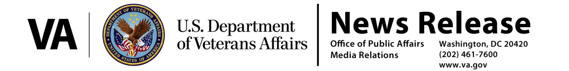

FOR IMMEDIATE RELEASE
June 23, 2014

Acting Secretary Gibson Statement on Whistleblower Protections

WASHINGTON – Acting Secretary of Veterans Affairs Sloan Gibson today released a statement following the Office of Special Counsel’s letter to the President regarding VA whistleblowers:

“At VA, we depend on the service of VA employees and leaders who place the interests of Veterans above and beyond self-interest, and who live by VA’s core values of Integrity, Commitment, Advocacy, Respect, and Excellence.

“I respect and welcome the letter and the insights from the Office of Special Counsel. I am deeply disappointed not only in the substantiation of allegations raised by whistleblowers, but also in the failures within VA to take whistleblower complaints seriously.

“VA accepts the OSC recommendations in today’s letter to the President. Accordingly, I have directed a comprehensive review of all aspects of the Office of Medical Inspector’s operation, to be completed within 14 days. This will include a review of process, structure, resourcing, and how recommendations are tracked and reviewed. Additionally, this review will include consideration of personnel actions and will designate an official to assess the conclusions and the proposed corrective actions in OSC reports.”

Acting Secretary Gibson sent a message to all VA employees on June 13, 2014 regarding the importance of whistleblower protection and has met with employees at VA Medical Centers across the country to reemphasize that message.

“I reminded all 341,000 of our employees that we must protect whistleblowers and create workplace environments that enable full participation of employees,” Gibson added. “As I told our workforce, intimidation or retaliation – not just against whistleblowers, but against any employee who raises a hand to identify a problem, make a suggestion, or report what may be a violation in law, policy, or our core values – is absolutely unacceptable. I will not tolerate it in our organization.”

# # #

