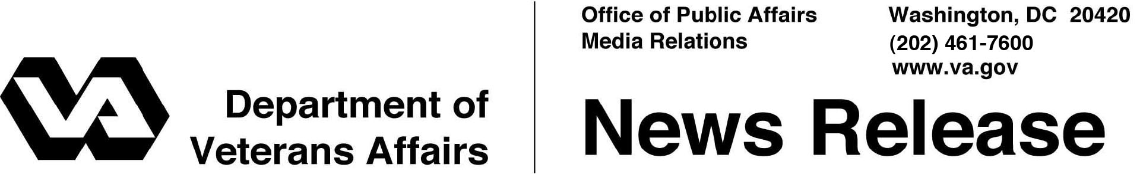

FOR IMMEDIATE RELEASE
September 20, 2012

VA Fills First Phase of Veterans Retraining Program to Enhance Job Skills
45,000 Veterans Approved for New VRAP Program

WASHINGTON – The Department of Veterans Affairs has approved applications for all 45,000 slots available in fiscal year (FY) 2012 under the successful Veterans Retraining Assistance Program (VRAP) and is in the process of approving applications for a total of 54,000 slots available in FY 2013.
“At VA, we know first-hand that Veterans make exceptional employees, which is why this Administration has deployed a full-court press to connect Veterans with good jobs,” said Secretary of Veterans Affairs Eric K. Shinseki. “The surge of Veterans applying for VRAP demonstrates this program’s importance to provide unemployed Veterans the opportunity to find employment in high-demand fields.”
VRAP is a new training and education program for unemployed Veterans who want to upgrade their skills for high-demand jobs. The goal of VRAP is to train a total of 99,000 Veterans over the next two years in more than 200 job skills that the Department of Labor (DOL) has determined are the most sought-after by employers.
The joint VA/DOL program is a provision of the Veterans Opportunity to Work (VOW) to Hire Heroes Act of 2011, which Congress passed and President Obama signed into law in November 2011. The program allows qualifying Veterans to receive up to 12 months of education assistance equal to the current full-time Montgomery GI Bill – Active Duty rate of $1,473 per month. Starting October 1, 2012 the rate will increase to $1546 per month.
To be eligible for VRAP, a Veteran must:
- Be 35-60 years old, unemployed on the day of application, and not dishonorably discharged;
- Not be eligible for any other VA education benefit program such as the Post-9/11 GI Bill, Montgomery GI Bill, or Vocational Rehabilitation and Employment;
- Not be enrolled in a federal or state job-training program within the last 180 days; and
- Not receive VA compensation at the 100 percent rate due to individual unemployability (IU).
“We’re gratified that 45,000 unemployed Veterans can begin the retraining they need to compete for in-demand jobs,” said VA Undersecretary for Benefits Allison A. Hickey. “We’re going to maintain the momentum of our outreach to make sure we get the maximum of 54,000 Veterans retrained in fiscal year 2013.”
Veterans approved for VRAP are encouraged to enroll as soon as possible and begin training full-time in a VA-approved program of study at their local community college or technical school. The program of study must lead to an associate degree, a non-college degree, or a certificate for a high-demand occupation as defined by DOL.
Some of the high-demand job training programs Veterans pursued in FY 2012 include- computer support specialist, general and operations manager, business operations specialist, and heating, air conditioning and refrigeration mechanic and installer.
VRAP applications were received from all 50 states, Puerto Rico, Guam, and the Virgin Islands. The Top 10 states for Veterans approved for training in the FY 2012 phase of VRAP are:
- California
- Florida
- Georgia
- Texas
- North Carolina
- New York
- Ohio
- Michigan
- Illinois
- Virginia
VRAP also attracted Veterans internationally, with applications coming from Veterans living in the Philippines, Canada, Japan, the Northern Mariana Islands, and areas of Europe and the Pacific where American military units are based.

Undersecretary Hickey explained that continued outreach on VRAP is particularly important because the program applies to a segment of the Veteran population that may not have regular interaction with VA or stay informed about the benefits and opportunities for which they may qualify.
VRAP is one of many efforts that VA and the Administration are undertaking to connect Veterans with employment. VA has held major live and virtual hiring fairs, as well as connected Veterans with career coaching and other career tools through the VA for Vets initiative. VA has also set a goal to increase Veteran employment within the Department and has partnered with Joining Forces and the U.S. Chamber of Commerce on Veteran hiring.
Potential applicants can learn more about VRAP and apply online at www.benefits.va.gov/VOW, or call VA toll-free at 1-800-827-1000. Information about the Department of Labor’s programs for Veterans is available at www.dol.gov/vets. Veterans can also visit the nearly 3,000 One-Stop Career Centers across the nation, listed at www.servicelocator.org, for in-person employment assistance.
# # #

