Pharmacy Benefits Management Dear Manufacturer Letter

Public Law 102-585 Section 603

(38 U.S.C. 8126)

The Veteran’s Healthcare Act of 1992 (“the Act”)

Pharmacy Benefits Management (PBM) Services 1st Ave – 1 Blk N of Cermak Rd
Bldg 37 Rm 139 (10P4P)
Hines, IL 60141 Annual Compliance

October 12, 2023

Additional copies available at: http://www.va.gov/oal/business/fss/publicLaw.asp.

TABLE OF CONTENTS

- Introduction …………………………………………………………………………. 3
- Background ……….………………………………………………………………… 3
  - Purpose ……….………………………………………………………………… 3
  - Expectations .…………………………………………………………………... 3
  - System requirements …………………………………………………………... 3
- Public Law Timetable (Overview)……………………………………………………. 3
- Detailed Timeline …..…………………………………………………………………. 4
- Excel Data Dictionary…………………………………………………………………. 5-6
- General Guidance ……………………………………………………………………. 7-8
- Attachments …………………………………………………………………………. 9-14
- Methodology Changes .………………………………………………………. 9
- Workbook Verification Disputes.…………………………………………….. 10-11
- Compliance reminders ………………………………………………………. 12
- FCP Disputes ……………………………………………………………….. 13
- Self-Disclosure ……………………………………………………………….. 14
- Appeal to the Nominal Increase Board……………………………………….. 15

INTRODUCTION

The Office of Pharmacy Benefits Management Services (PBM) is responsible for maintaining calculated federal ceiling prices (FCPs) for covered drugs through the Public Law annual reporting process. All companies of covered drugs are obligated to comply with the reporting requirements under Public Law 102-585, Section 603.

KGROUND

Public Law 102-585, also referred to as the Veterans Healthcare Act of 1992 (“the Act”), became law on November 4, 1992. Section 603 of the Act and the provisions of each company’s Master Agreement (MA) require companies to report annual non-Federal Average Manufacturer’s Price (non-FAMP) calculations for covered drugs.
Information about the Act is available on the Office of Acquisition and Logistics—Federal Supply Schedule Service (FSS) website at: http://www.va.gov/oal/business/fss/publicLaw.asp.

  - OSE

The purpose of this Dear Manufacturer Letter (DML) is to provide companies with guidance on complying with the 2023 annual non-FAMP reporting requirements (for 2024 FCPs) under Public Law 102-585, Section 603 NOTE: This is the first year of a Federal Supply Schedule (FSS) multiyear contract for statutory purposes. The annual Excel workbook structure and calculation methodologies differ for a first-year calculation from all other years. Several data fields and attachments have been eliminated from the workbook and the DML for the 2024 FCP calculations. Eliminated fields and attachments are identified throughout the guidance letter. Please retain a copy of this DML as it contains guidance in Parts VI and VII of this letter on various Public Law issues that frequently occur.

  - ECTATIONS

PBM will provide your company’s point of contact with an Excel workbook that is pre-populated with data. It is the company’s responsibility to verify the accuracy of the data in this workbook. Follow the guidance in this letter to report any disputes to the VA. If there are no disputes to the pre-populated data in the Excel workbook, you are advised to populate the workbook with data values as explained in this letter and return electronically to VA before the November 15, 2023, deadline. The excel data dictionary and Attachment C provide a list of compliance reminders to assist with your annual filing.

  - EM REQUIREMENTS
To comply with the annual reporting requirements, electronic mail (e-mail) and a computer loaded with Microsoft Excel (.xls) program is required.

- Year PUBLIC LAW TIMETABLE (OVERVIEW)

NLT OCT 1 | NAC Letter | Letter from National Acquisition Center (NAC) providing guidance on how Jan 1 FSS pricing updates will proceed
NLT OCT 17 | CPI-U Published & workbooks  distributed | PBM calculates the consumer price index-urban (CPI-U%) value and disseminates company’s  Excel workbook containing covered drugs subject to annual calculations
OCT 18 | Workbook Verification | Company reviews VA’s workbook for discrepancies, which may include omissions, 3Q disputes or any other discrepancies that may exist and notifies VA
Starting OCT 19 | FCP Calculations | PBM will start/continue to process the annual reports; NOTE: pending disputes will be resolved prior to FCP calculations.
OCT 29 | Deadline | Last day for companies to submit methodology change requests & related 3Q OLD restatements under (proposed) new methodology; This is also the last day companies may report any disputes identified in the company workbook (omissions and 3Q disputes  unrelated to methodology change)
NOV 15 | Deadline | Annual filing due.
NOV 21 | Deadline | Last day to submit request for modification (RFM) to NAC for guaranteed Jan 1 upload price

AILED TIMELINE

No Later Than (NLT) October 17, 2023
Companies’ designated non-FAMP representative will receive an e-mail from AMMHIN.PL102585@va.gov on behalf of the Public Law Manager. This e-mail will contain attachments of a current copy of PBM’s DML and an Excel workbook (.xls) of covered items subject to annual calculations. This Excel workbook (.xls), which is a locked version and contains select prepopulated cells, will be used by companies to complete the 2023 annual non-FAMP reporting requirements (for 2024 FCPs). Pages 5-6 of this DML provide the data dictionary of this Excel workbook.

By October 18, 2023
Workbook Verification: Companies must review the Excel workbook upon receipt for any disputes and discrepancies. Companies are advised to notify the VA of any disputes in the Excel workbook via e-mail as outlined in this guidance letter. Please note not all covered drugs are eligible for annual non-FAMP calculations; the workbook will only contain covered items that are subject to the annual non-FAMP calculation reporting. Companies must report all covered drug items that had/should have had a Permanent FCP in place on September 30, 2023, for the purpose of determining FCPs for Calendar Year 2024.

Starting October 19, 2023
The PBM Public Law Team will start to calculate the covered items’ changes in non-FAMP, additional discounts (if any), and the 2023 FCP (if not already in process). Companies are encouraged to submit their annual reports early, as FCP calculations are completed on a first-in first-out basis. Once the calculations are completed, the Excel workbook (.xls) will be sent by e-mail to the companies’ designated non-FAMP representative. Companies have two business days to review the 2024 FCPs and provide concurrence. Attachment D instructs how to submit FCP disputes by e-mail.

By October 29, 2023
- Deadline for companies to report and describe modifications in existing methodology used to calculate non-FAMP, and to request approval to restate 3Q 2022 (non-FAMP OLD) according to the new methodology (for purposes of an apples-to- apples additional discount calculation). This request must be submitted via e-mail to AMMHIN.PL102585@va.gov, as instructed in Attachment A. The VA will review the requests and communicate a resolution to the company. At this point, and to reduce e-mail traffic, a corrected workbook with revised data values will not be re-issued. The corrected values will be used in calculations and will reflect in the final FCP report to the company. To ensure accuracy in calculations, please provide a copy of the approved methodology communication when your company files the annual report. Companies that submit 3Q disputes due to methodology change requests after October 29 can expect increased delays in receiving their 2024 FCP calculations.
- Deadline for companies to report any Workbook Verification disputes via e-mail to AMMHIN.PL102585@va.gov, as instructed in Attachment B. Disputes can include any combinations of: any dispute(s) of the calculated non-FAMP for the 3Q non-FAMP Old value (07/01/2022 through 09/30/2022); the listing of drug items subject to the annual calculations, such as omitted items; or other disputes as to the accuracy of the contents of the Excel workbook (.xls) that was received. The VA will validate the disputes and communicate a resolution to the company. To reduce e-mail traffic, a corrected workbook with revised data values will not be re-issued. The corrected values will be used in calculations and will reflect in the final FCP report to the company.
- To ensure accuracy, please provide a copy of VA’s approved resolution when your company files the annual report.

By November 15, 2023
- Companies must report the annual non-FAMP (10/01/2022 through 09/30/2023) and 3Q non-FAMP New (07/01/2023 through 09/30/2023) calculations to the VA via e-mail to AMMHIN.PL102585@va.gov using the Excel workbook (.xls) provided by the PBM Public Law Manager. At this point in time, PBM will only re-issue corrected workbooks for extreme cases. IMPORTANT: Your Company must include a copy of VA’s approved resolution for identified disputes when filing the annual report to the VA. It is possible that your company has submitted disputes by the requested deadline to the VA, but the disputes are pending VA resolution. To remain compliant with the November 15 filing deadline, the company must submit their annual filing along with a copy of the original dispute verification e-mail along with current resolution status, if any. Calculations will not begin until all disputes have been resolved. Attachment C provides a list of compliance reminders.

By November 21, 2023
Companies’ authorized signatories must prepare and sign a new PPA addendum, listing each covered drug and its 2024 FCP. The VA National Acquisition Center (NAC) FSS Service will be issuing additional guidance no later than October 1, 2023, on how to submit a “Request For Modification” (RFM) via e-mail to AMMHIN.PL102585@va.gov to update contract pricing. The properly prepared RFM must be received by November 21, 2023, to guarantee an effective date of January 1, 2024.

CEL DATA DICTIONARY
Field Name | Definition | Edits Allowed
ID | Unique identifier assigned to item in Public Law database | No
YearID | Calendar year in which the Federal Ceiling Price applies | No
Prep_date | Date the report is prepared by company. Format = “mm/dd/yyyy” NOTE: Date entered restricted to 10/01/2023 and 01/15/2024 | Yes
ndc_1 | National Drug Code (NDC); ndc_1= Labeler code (5 digits) | No
ndc_2 | NDC; ndc_2 = Product code (4 digits) | No
ndc_3 | NDC; ndc_3 = Package code (2 digits) | No
Unt_pkg | Number of units per package | No
Date_enter | Date the NDC was reported as first commercially available for sale | No
Dose_form | Dosage form of the NDC | No
Strength | NDC strength | No
FDA_name | NDC name reported by company as listed on FDA registration form | No
Trade_name | NDC brand name reported by company | No
Generic_name | NDC generic name | No
Pct_cpiu | Percent Increase in Consumer Price Index (CPI-U). Calculated by multiplying the difference between the two index numbers by 100 and that product divided by the older of the two CPI-Us. Calculation is rounded to two decimal places; rounding up if 3rd decimal is >=5.  Examples: 2.1462 rounds to 2.15; 2.1449 rounds to 2.14 | No
fss | ATTENTION!! This field is not included in the 2023 annual Excel Workbook (for 2024 FCPs) since this year’s annual filing is considered the first year of a multi-year calculation for public law purposes. | No
fssmax | ATTENTION!! This field is not included in the 2023 annual Excel Workbook (for 2024 FCPs) since this year’s annual filing is  considered the first year of a multi-year calculation for public law purposes. | No
nfamp | 2023 Annual Non-Federal Average Manufacturer price (non-FAMP  =“nfamp” in Excel Table for ease of reference) is the weighted average manufacturers’ sales price for the NDC. Calculation is rounded to two decimal places; rounding up if 3rd decimal is >=5. For “false positive” non-FAMPs (negative sales divided by negative units), and no reportable sales, “0.00” should be  entered. Activity resulting in negative values should be reported as such. Do not return spreadsheet with blank values. | Yes
nfamp_old | Non-FAMP for 07/01/2022 thru 09/30/2022. See “nfamp” field above  for calculation and reporting requirements. | No
nfamp_new | Non-FAMP for 07/01/2023 thru 09/30/2023. See “nfamp” field above  for general calculation and reporting requirements. | Yes
nfamp_chg | Difference between “nfamp_new” and the “nfamp_old”. This number can be negative. NOTE: This field is not included in the initial workbook from PBM; included in the final workbook sent to companies with the calculations. | No

Field Name | Definition | Edits Allowed
add_disc | Difference between “nfamp_chg” and the legislative allowable increase. The allowable increase is the product of the “nfamp_old” and “Percent_cpiu”. This number must be >= $0.00. If “nfamp_chg” is negative, then $0.00 will be populated. NOTE: This field is not included in the initial workbook from PBM; included in the final workbook sent to companies with the calculations. | No
calcmax | 2023 Calculated Ceiling. Calculation based on 38 U.S.C.8126 (d)(2),(a)(2) and (c) is the product of the annual non-FAMP X 0.76,  less “add_disc” (additional discount). Calculation is rounded to two decimal places; rounding up if 3rd decimal is >=5. Examples: 2.1462 rounds to 2.15; 2.1449 rounds to 2.14 NOTE: This field is not  included in the initial workbook from PBM; included in the final workbook sent to companies with the calculations. | No
fcp | 2024 Federal Ceiling Price (FCP). Lower of 38 U.S.C. 8126(d)(1) or  38 U.S.C. 8126 (d)(2) , (a)(2) & (c). This field is determined by using the lower number of fssmax or calcmax. NOTE: This field is not included in the initial workbook from PBM; included in the final workbook sent to companies with the calculations. | No
disc_date | This field represents a covered item’s discontinuation date from the manufacturer’s FSS. NOTE: This field is not included in the initial workbook from PBM; it is included in the final workbook sent to companies with the calculations. | No
cnt_no | FSS contract number assigned by the National Acquisition Center  (NAC); current as of 9/30/2023 | No
company_of | Name of the company’s official authorizing and certifying that the data provided in this workbook is accurate | Yes
dispute_fss | ATTENTION!! This field is not included in the 2023 annual Excel Workbook (for 2024 FCPs) since this year’s annual filing is considered the first year of a multi-year calculation for public law  purposes. | Yes
dispute_nfamp_old | Enter a “Y” to dispute the 3Q old non-FAMP data if unrelated to  methodology change. Please follow the directions in Attachments A,  D or E, as applicable. If dispute_nfamp_old = Y, then Rev_nfamp_old field must be populated. | Yes
rev_fss | ATTENTION!! This field is not included in the 2023 annual Excel Workbook (for 2024 FCPs) since this year’s annual filing  is considered the first year of a multi-year calculation for public law purposes. | Yes
Rev_nfamp_old | Revised 3Q old value, if company populates the dispute_nfamp_old  field, then rev_nfamp_old should not be blank; Calculation is rounded to two decimal places; rounding up if 3rd decimal is >=5. | Yes
non_taa | This field indicates covered item(s) which have been identified as  items sourced from a non-U.S., non-designated country under the requirements of the Trade Agreements Act (TAA). They are considered covered drugs as defined by the Veteran’s Health Care Act of 1992, P.L. 102-585, Sect. 603, therefore, your company must continue to report non-FAMP to PBM for any covered drug  and maintain a FCP for the drug annually with PBM. | No

- ERAL GUIDANCE

Each covered drug’s mandated FCP for 2024 (the first year of FSS multiyear contracts for statutory purposes) will be determined by adopting calculation results described in 38 U.S.C 8126 (a)(2) & (c). The same percent change in Consumer Price Index-Urban (CPI-U) will be utilized in performing this calculation. This change in CPI-U is identified as the percent change from September 2022 to September 2023. The U.S. Bureau of Labor Statistics shows the derive percent change was calculated as 3.70%. There will be NO comparison to the 2023 FSS Price plus CPI-U (the 38 U.S.C. 8126 (d) (1) calculation) for purposes of calculating the 2024 Federal Ceiling Prices, since 2024 has been determined to be the first year of FSS multiyear contracts for statutory purposes only.

The Federal Excise Tax (FET) on vaccines and the one-half of one percent (0.5%) IFF being incorporated into FSS contracts will not be included in calculations of non-FAMP or reporting of FCPs but will be included in the FSS/Big 4 (Department of Veterans Affairs, Department of Defense (DoD), Public Health Service/Indian Health Service, &
U.S. Coast Guard) selling price. Please see additional instructions from your respective contracting officer(s).

The Section 8126 (a) (2) & (c) calculation (Calc Max) will begin by multiplying the 2023 annual non-FAMP by
0.76 and then subtracting any additional discount. The additional discount is the difference between the “old” non- FAMP increased by CPI-U and the “new” non-FAMPs. This will become the 2024 FCP. If there are “no sales” in a benchmark third quarter of a year that is used to derive the new non-FAMP or old non-FAMP, there can be no additional discount calculation for that particular item. In those cases, negative non-FAMPs should be reported, and no additional discount will be calculated; additional discount will be entered as zero (0.00). If a covered drug had no reportable sales in the 2023 annual non-FAMP period, its calculated 2024 FCP will be the 2023 FCP increased by the CPI-U.

If they meet the other VA criteria, nominal prices excludable from non-FAMP’s for 2023 calculations must be prices that are less than 10 percent of that particular items non-FAMP during the third quarter of 2022(07/01/2022 through 09/30/2022). Where sales to end-users are required for calculation of non-FAMP due to the absence of wholesale sales, you need not include purchases by PHS grantees or disproportionate share hospitals (“covered entities”) if the prices for those transactions were determined by PHS pursuant to Sect. 602 of the Veterans Health Care Act of 1992.

Also, in figuring wholesale sales, you need not include the chargebacks required to satisfy end-user purchases by the entities at prices determined by PHS under Sect. 602, or at prices set in negotiations with the PHS Section 602 pharmaceutical prime vendor (PPV) and any subcontractors. However, sales to these entities at prices not negotiated by the Sect. 602 PPV and lower than Sect. 602 statutorily calculated prices must be included in non- FAMP calculations. Finally, sales of specific inpatient covered drugs to disproportionate share hospitals at Sect. 602 prices may be excluded from non-FAMP if you have properly obtained a “hold harmless letter” from VA (see October 19, 2001, Dear Manufacturer Letter).

Any VA-approved changes in non-FAMP methodology (for example, the 90/10 Rule or smoothing of some of the elements in the non-FAMP calculation) require the 3Q non-FAMP Old to be restated using the new methodology to ensure an apples-to-apples comparison for the purposes of the additional discount. Any non-FAMP methodology change that is due to errors, requires a self-disclosure to the VA as instructed in Attachment E.

VA must require that all wholesale sales (or direct sales where those are the proper beginning point) used for 2023 annual and third quarter 2023 non-FAMP reports (to be filed this November) be reduced by the amounts reflecting certain TRICARE Retail Network usage data posted or transmitted by DoD during the FY 2023 12-month reporting period, because the TRICARE usage constitutes sales to the Federal Government.

Manufacturers will use DoD’s payment-due dates to decide which TRRx usage may be ascribed to the relevant reporting periods (See chart below). Covered drug scripts filled for TRICARE beneficiaries through the TRRx/T-Pharm Network should be treated by manufacturers as sales to the Federal Government, for non-FAMP reporting purpose, beginning on the payment-due date transmitted by DoD to the manufacturer in the File containing the manufacturer’s quarterly DoD usage data and refund invoice.

Quarter | Billing Period | Refund Payment Due Date
Q2 2022 | April - June 2022 | November 22,2022
Q3 2022 | July - September 2022 | February 21, 2023
Q4 2022 | October - December 2022 | May 20, 2023
Q1 2023 | January - March 2023 | August 22, 2023

After PBM receives a company’s non-FAMP data, PBM will calculate the [Change in non-FAMP], [Additional Discount], and [2024 Federal Ceiling Price] for each covered drug item subject to the 2023 annual reporting requirements for 2024 FCPs. PBM will send you an Excel workbook (.xls) via e-mail of your company’s calculated 2024 FCPs after the non-FAMP data has been calculated. If your company does not agree with any of VA’s calculations of the FCPs, you must formally notify VA within two workdays after VA sends the email. If you submit any corrected annual non-FAMP reports, they will be reviewed by VA who will determine if the restatements can be provisionally approved by the Public Law Policy Group (PLPG).

These provisionally approved non_FAMP restatements will be subject to an audit by the Office of Inspector General (OIG).

The quarterly non-FAMP report for the third quarter of 2023 consists of the same data as the “new non-FAMP” (07/01/2023 to 09/30/2023) reported on the 2023 annual calculation form, which is due by November 15, 2023. Consequently, it will not be necessary to submit the non-FAMP third quarter 2023 report separately. However, companies that do not meet the November 15, 2023, annual reporting deadline will be subject to penalties for late data reporting as described in the MA, paragraph (IV) (B). Please note that 38 U.S.C. 8126 (e) (2) and Sect. 1927

(b) (3) of the Social Security Act (reflected in the MA) impose a civil money penalty on late reporting manufacturers in the amount of $10,000.00 for each day in which required information has not been provided. VA asks that you submit the required annual data as soon as possible after the CPI-U change is posted in October and you receive this e-mail.

Section 8126 (e) of the Law states that quarterly non-FAMP reports are due 30 days after the end of the quarter. These figures should be as accurate as possible since they serve as an indicator of pricing trends and will be used during OIG audits. Nevertheless, to assist companies in providing the most accurate quarterly non-FAMP calculations possible, PBM will not seek imposition of late penalties for unreported data until 45 days after the end of each quarter. The same 45-day forbearance applies to filing Temporary and Permanent New Drug non-FAMPs. Again, please note that each year the non-FAMP third quarter data is submitted as part of the Annual Report (which is due 45 days after the end of the third quarter).

If you have any questions about any of the above information, please call Cheryl Kohutynski or Dustin Ehster, at (708) 786-7985 or (708) 786-4387, respectively.

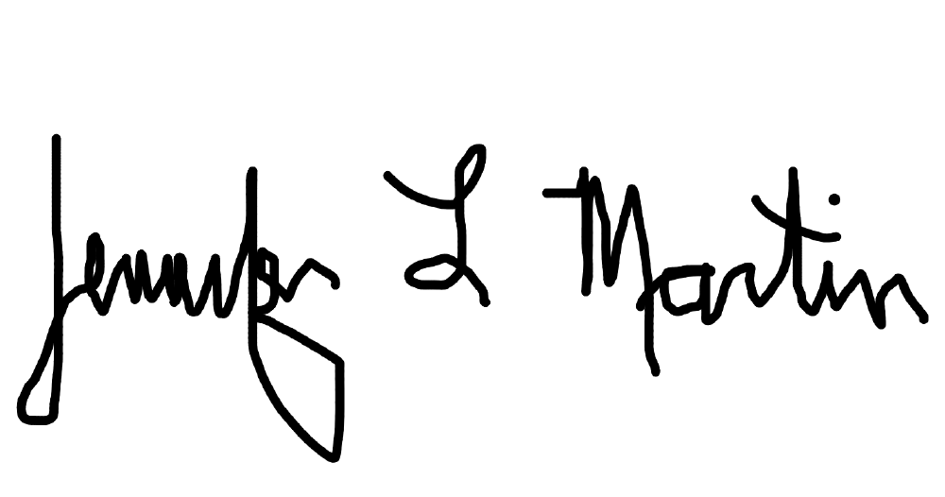
Sincerely,

Jennifer Martin, PharmD Deputy Chief Consultant
Pharmacy Benefits Management Services VACO Pharmacy Service

VI. ATTACHMENTS

- METHODOLOGY CHANGE REQUEST DUE DATE: 10/29/2023

Purpose: Allows the company to request review and approval from VA of a change in their methodology used to calculate non-FAMP data for the 2023 annual reporting year, and to request approval of restated 3Q2022 (non- FAMP OLD) recalculated under the new methodology (for purposes of an apples-to-apples additional discount calculation). The VA Public Law Policy Group (PLPG) will review these requests and approve/disapprove and send notification to the company. At this point, and to reduce e-mail traffic, a corrected workbook with revised data values will not be re-issued. The corrected values will be used in calculations and will reflect in the final FCP report to the company.

NOTE: This format is to request non-FAMP methodology changes in advance of the due date (Oct 29, 2023). Instructions: Requesting Modifications to Existing Methodology Used to Calculate non-FAMP

  - Prepare a letter requesting approval for a change in calculation methodology.
  - Specify the reasons for the change in methodology and provide all supporting documentation.
  - In the workbook, identify the 3Q2022 values impacted by the methodology change.
  - Send original workbook via e-mail to AMMHIN.PL102585@va.gov including option (a),(b) or (c)-(see example e-mail below):
    - For new requests, keep line number 1 in the body of the e-mail and populatethe dispute_nfamp_old with “Y” and provide the rev_nfamp_old values
    - For pending requests, keep line number 2 in the body of the e-mail and populate the dispute_nfamp_old with “Y” and provide the rev_nfamp_old values

If VA has already approved your company’s methodology change request but the values in the annual workbook do not reflect the change, please send an e-mail to AMMHIN.PL102585@va.gov; populate the dispute_nfamp_old field with “Y” and populate the restated 3Q 2022 values in “rev_nfamp_old” fields; include documented PLPG review and recommended approval and update the subject line with the FSS contract number and “Methodology Change Approved”
  - For options 4(a) & (b) above, subject line should include the full FSS contract number + manufacturer’s name, and the words: “METHODOLOGY CHANGE”
  - PLPG will review the request and any associated documentation prior submitting its recommendation to the VA. The 2022 3Q NFAMP Old must be restated with the new methodology to ensure an apples-to apples comparison for the purposes of the additional discount. If PLPG recommends accepting the proposed methodology, PLPG will communicate its recommendation to AMMHIN.PL102585@va.gov . The VA will then notify the contractor of its decision.
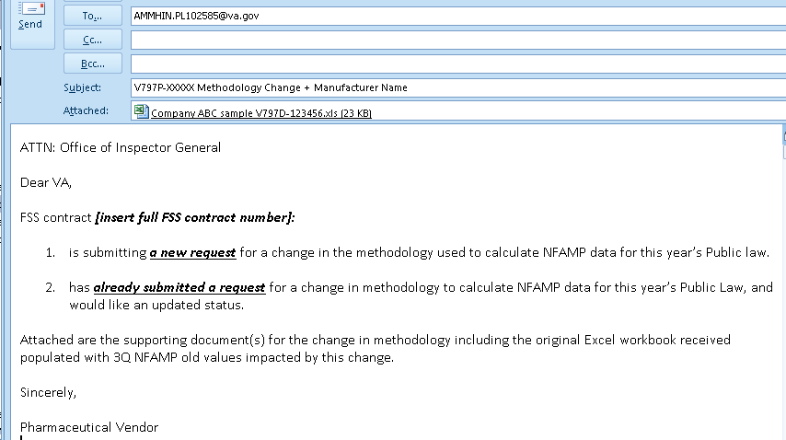
  - Upon approval, PBM will use the updated methodology (revised 3Q OLD values) to calculate 2024 FCPs Example:
9

WORKBOOK VERIFICATION DISPUTES RETURN DATE: 10/29/2023

Purpose: For the manufacturer to notify the VA of any disputes concerning the accuracy of the annual workbook contents provided for verification. Disputes can be a 3Q CY 2022 (non-FAMP OLD) dispute (unrelated to methodology change) and/or a potentially omitted covered item(s).

Instructions: How to submit 3Q CY 2022 (non-FAMP Old) disputes unrelated to methodology changes and/or a potentially omitted covered item(s). NOTE: Items introduced after 04/01/2023 may not be included in this year’s annual workbook for 2024 FCP calculations (exceptions are covered drug NDC changes of existing item(s) and divested/acquired items).

  - Upon receipt of your company’s Excel workbook, review the covered items where potential disputes exist. Multiple disputes may exist in the Excel workbook.

  - To dispute the 3Q CY 2022 price: populate column U with a “Y” and input the revised 3Q 2022 value in column V. Provide document(s) to support the disputed 3Q 2022 value(s).

  - Subject heading should include the full contract number and the words “Dispute Notification.”
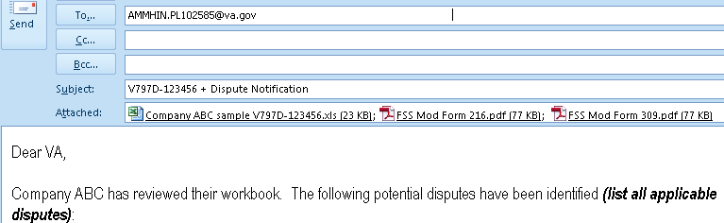

- 3Q 2022 (nfamp_old) Dispute
- Omitted Item
As instructed in the DML, the original workbook and supporting documents have been submitted for consideration.

  - To notify PBM of a potential omission: Identify potential covered item(s) omitted from workbook.

  - In the body of the e-mail, provide the data for the following fields (see example below):
- NDC_11, Date of Market Entry, Trade & Generic Name
- 2023 annual non-FAMP value (10/01/2022 to 9/30/2023)
- 3Q Calendar Year 2022 (non-FAMP OLD) value (07/01/2022 to 09/30/2022), if applicable
- 3Q Calendar Year 2023 (non-FAMP NEW) value (07/01/2023 to 09/30/2023), if applicable
- Indicate if omitted item is due to a change of NDC (Yes/No/)
  - If “Y”, please update Date Market Entry column with the date of the New NDC

B. WORKBOOK VERIFICATION DISPUTES (cont’d) RETURN DATE: 10/29/2023

Dear PBM:

FSS contract number [insert full or pending contract number here] believes the item(s) listed below should have been included in this year's workbook for the following reason(s):

NDC11 | Date of Market Entry | Trade Name | Generic | Annual non- FAMP  value | 3Q non- FAMP  OLD value | 3Q non- FAMP  New value | 42-2A NDC  Change (Y/N?) | Reason
00011222233 | 3/18/2022 | DRUG BRAND CREAM | GENERIC CREAM
11111222233 | 3/28/2022 | DRUG BRAND BOTTLE | GENERIC BOTTLE

  - Subject heading should include the full contract number and the words “Dispute Notification”

  - The original Excel workbook received should be returned via e-mail to AMMHIN.PL102585@va.gov.
  - PBM and FSS will work to resolve issues and to reduce e-mail traffic, a corrected workbook will not be re- issued. Omitted item(s) will be included in the final FCP report to the company.

  - PBM will only process the data after all disputes have been resolved. All corrected information will be included in the final 2024 FCP calculation workbook.

  - Unresolved item(s) will be tagged for follow-up in the 1Q 2024 CY, on a case-by-case basis.

COMPLIANCE REMINDERS
Rounding - Annual non-FAMP data includes sales from 10/01/2022 to 09/30/2023 (“nfamp” column “P” in Excel workbook) and 3Q non-FAMP NEW data includes sales from 07/01/2023 to 09/30/2023 (“nfamp_new” column “Q” in Excel workbook) and must contain data (i.e., NULL or BLANK is not valid). Calculation is rounded to two decimal places; rounding up if 3rd decimal is >=5. If there are no reportable sales for the covered item(s), enter “0.00”; negative values should be reported as such.

Rounding Examples: value of 2.1462 rounds to 2.15 value of 2.1449 rounds to 2.14

Discontinuations - Covered drug items that are contained in the annual workbook received from PBM but have a pending FSS discontinuation modification should still have a 2023 annual non-FAMP report filed to calculate a 2024 FCP; there is no need for a price-changing FSS Request for Modification (RFM) for 2024, IF the stock of the discontinued drug at wholesalers is exhausted by about Dec. 1, 2023. (In such a case, a proper deletion FSS RFM would be filed before Jan. 1, 2023.) However, if sales of wholesaler stock will continue into 2024, the company must follow all the usual steps to have statutory pricing in place for 2024.

Flu Vaccines - The VA has established specific guidelines for reporting the provisional and permanent FCP data for influenza vaccines that are excluded from the workbook. Companies are expected to comply with the reporting requirements of the October 19, 2001, DML for reporting provisional FCP data. For reporting permanent FCP data for influenza vaccines, companies are expected to comply with the reporting requirements outlined in the March 31, 2004, DML.

Eligibility - Annual non-FAMP data will not be required to be reported for a new covered drug that was introduced into the commercial market after April 1, 2023 and has not experienced at least one full calendar quarter of sales by September 30, 2023. In addition, the item will not appear in the annual workbook for FCP calculations. (NDC changes are the exception to this rule).

Permanent FCP establishment - All new covered drugs that reach Permanent FCP stage after September 30, 2023 (that is, any product with a date of market entry after April 1, 2023) must be reported under separate e- mail from the 2023 annual report. These permanent FCPs will remain in effect for the 2023 calendar year and through the 2024 calendar year until the next annual filing due in November of 2024.

Dear Manufacturer Letters (DML) - Library of all DMLs available at the following website: http://www.va.gov/oal/business/fss/publicLaw.asp.

NDC Changes - If a manufacturer of a covered drug changes their NDC, the new NDC number must be added to the contract at the time of launch at the same FCP and contract pricing as the original NDC. Further, both the old and new NDC must remain on contract until the old NDC is off the market and out of the supply chain. The non-FAMP sales data for both the “old” and “new” NDCs must be combined (or blended) when reporting. If new covered drug NDC(s) are not included in the initial workbook received from the Public Law Manager, or if there is a pending FSS NDC Change modification, please follow the directions under omitted items (page 11). The new NDC(s) will be included in the final 2024FCP workbook.

Excel workbook – Several of the cells in PBM’s Excel workbooks are locked and read-only. A copy of an unlocked Excel workbook will be supplied to companies upon request if needed for data processing.
However, the final Excel workbook submitted to the Public Law Manager by companies must be the original locked Excel workbook received from PBM.

TRICARE (TRRx) - VA has provided further guidance to manufacturers on how to treat sales which become the basis for TRICARE Retail Pharmacy Program (TRRx) rebates (page 8). Additional guidance can be found at: https://health.mil/About-MHS/Defense-Health-Agency/Operations/Pharmacy- Division/Information-for-Pharmaceutical-Manufacturers/Contact-the-TRICARE-Retail-Refund-Team.

FSS Contract Number Changes - FSS contracts are awarded with a five-year duration period. Your FSS contract may be awarded a new contract number during Public Law season after the locked spreadsheet has been submitted to your company. The newly awarded contract number will be used for the final 2024 FCP workbook.

2024 FCP DISPUTE PROCESS

Instructions: How to Submit a Dispute of the 2024 calculated FCPs for annual reporting year 2023

Purpose: Company is to use this format to dispute or resubmit data for 2024 FCP calculations that are the result of database and/or scrivener errors. If a company wishes to dispute an FCP because it believes the non-FAMP data it provided was in error, it should submit a self-disclosure under Attachment E rather than an FCP Dispute e-mail. If a company wishes to dispute an FCP that was calculated correctly, but it believes is unreasonably low, it should follow the guidance in the February 24, 1993 DML to submit an FCP increase appeal to the VA FCP Nominal Increase Board, via e-mail to AMMHIN.PL102585@va.gov.

  - In the report, identify all covered items where the 2024 FCP is being disputed due to a data base error.

  - In the body of the e-mail, provide the values for the following fields:
- NDC_11 and TRADE_NAM E
- Calculated FCP and Revised FCP
- Revised 2023 non-FAMP value (10/01/2022 to 09/30/2023)
- Revised 3Q Calendar Year 2023 non-FAMP value (07/01/2023 to 09/30/2023)
- Reason for dispute

  - Include all documentation that would support the dispute or resubmission, as necessary.

  - Subject heading should include the full contract number and title “Dispute FCP Report”.

NOTE: Resubmissions are limited to disputes resulting from database errors only and reports should be submitted via e-mail to nonfamp@va.gov.

Example:
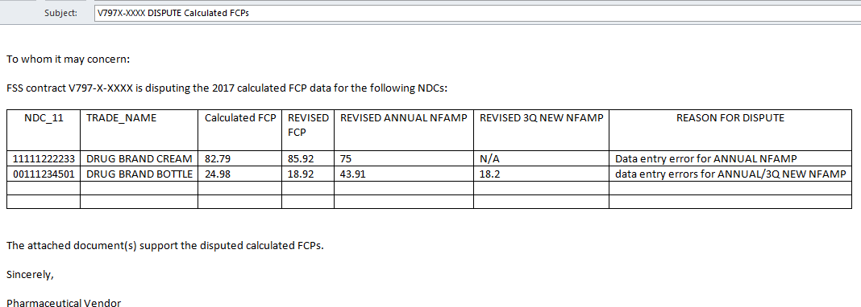

Examples of database errors/reasons in which PBM can immediately address:
- Revised 3Q 2022 value(s) approved, but not used for the 2024 FCP calculations.
- Revised 3Q 2022 value(s) restated due to an approved change in the non-FAMP calculation methodology.
- Omitted item(s) had incorrect 3Q 2022 value applied for the 2024 FCP calculations Scrivener’s errors during entry (e.g., 3Q values were entered into the annual fields)

NOTE: Due to the time constraints and review processes involved, 2024 calculated FCPs unrelated to database errors may be delayed.

SELF-DISCLOSURE

Instructions: How to Submit a Self-disclosure for Federal Supply Schedule (FSS) Public Law Non- Compliance or Pricing Errors

Purpose: Provides the manufacturer with a process for making a self-disclosure of any Public Law non-compliance or pricing errors that occurred during any period the manufacturer was subject to the Public Law (manufacturing and selling covered drug products). The AMMHIN.PL102585@va.gov mailbox will rout self-disclosures to the OIG and the VA Office of General Counsel (OGC) for an audit.

Examples of non-compliance or pricing errors requiring disclosure include (but are not limited to):

- Failure to obtain an FSS contract and sign a Master Agreement in a timely manner.
- Failure to submit non-FAMP data and add a new covered drug to an FSS contract in a timely manner.
- Errors in calculating non-FAMPs
- Misclassifying covered drugs as non-covered drugs
- Deleting covered drugs from an FSS contract prematurely
- Price Reductions Clause Violations that impacted the FCPs
- Incorrect treatment of:
  - NDC number changes
  - New Package Sizes
  - Transferred Drugs

To make a self-disclosure, a manufacturer should do the following:

Prepare a letter that states the non-compliance error, what caused the error, what covered drug item(s) (including NDC #s) were affected by the error, specific date ranges when the error(s) occurred, and what remedial action the manufacturer is proposing or has taken.

  - Provide the first commercial sale dates of all NDCs involved, for all self-disclosure issues.
  - Estimated overcharges owed to the Government, if known. If not known, please state this fact in the disclosure letter and explain why an estimated overcharges amount cannot be provided.
  - For transferred drug treatment errors, provide the date that the transferee obtained full legal rights and responsibilities for the products, the transferee’s first commercial sale dates, explanation of the treatment of the transferor’s remaining inventory, and details of any interim arrangements between the transferor and transferee regarding sales of the products and sales reporting responsibilities to the VA for IFF purposes.
  - For new package size errors, please provide the NDC number used as the closest package size and the pro- rated calculations.
  - Provide supporting documentation for the disclosure including the original and restated non-FAMPS and related FCPs and the detailed non-FAMP methodology used in the calculations.
  - Provide the point of contact(s) for OIG to contact if an audit is needed.
  - Send the disclosure letter via e-mail notification to AMMHIN.PL102585@va.gov .
  - The email Subject should include the full FSS contract number, manufacturer’s name, and the words: “Self- Disclosure”.
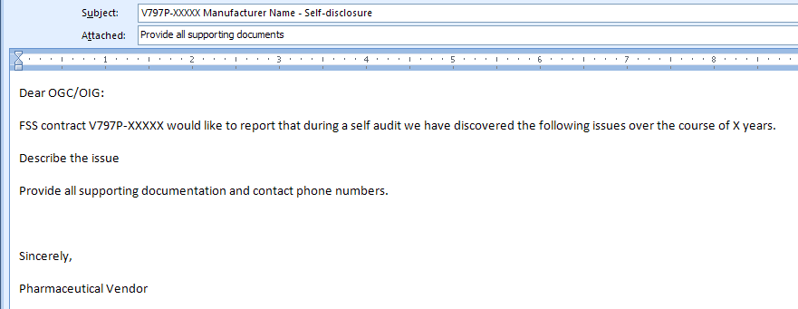
Example:

APPEAL TO THE NOMINAL INCREASE BOARD

Instructions: How to Submit a request to the Nominal Increase Board for FCP increases

Purpose: Provides the manufacturer with a process for making an appeal to the Nominal Increase Board to increase the FCP if it is determined that selling at that price would cause the manufacturer to lose money in its overall business. The AMMHIN.PL102585@va.gov mailbox will route appeal to the appropriate VA representative who will review the appeal and make its recommendation to the Nominal Increase Board.

Guidance: December 30, 1992, February 24, 1993, & July 15, 1993 Dear Manufacturer Letters

Before submitting an appeal to the Nominal Increase Board, the manufacturer should first consider if a change in non-FAMP methodology (for example, smoothing the 3Q NFAMPs) eliminates the financial problem.

To submit an appeal letter to the Nominal Increase Board, all of the following information must be sent to the AMMHIN.PL102585@va.gov mailbox:

  - The formal nominal increase materials that are outlined in the 1993 Dear Manufacturer Letter (DML). This includes:
    - The certification signed by the president of the company found on page 3 of the DML.
    - Justification for the increase for each NDC item
    - Financial problem that allegedly exists with the statutorily calculated FCP
    - Explanation of how it would be in the best interests of VA or another Federal agency to pay more for a covered drug product than the statutory formula specifies
  - The total overall volume of commercial sales for all products marketed.
  - The sales percentage of the NDCs that relief is being requested to overall sales of all products marketed.
  - The sales percentage of total Government sales to total sales volume.
  - The Cost of Goods Sold per unit for each NDC in the format shown below:
    - Direct Materials
    - Direct Labor
    - Fixed Overhead (specific overhead costs must be defined and itemized)
    - Variable Overhead (specific overhead costs must be defined and itemized)
    - Other Costs (each type of other cost must be defined and itemized)

NDC # NDC # NDC #
Product Name Product Name Product Name 2022 FCP Currently in Place
Less: Cost of Goods Sold - Per Unit
Direct Materials Direct Labor Fixed Overhead
Variable Overhead

Total Cost of Goods Sold | $0.00 | $0.00 | $0.00
Other Costs -- Please Detail and Define
Total Other Costs | $0.00 | $0.00 | $0.00
Net Profit/Loss Per Unit | $0.00 | $0.00 | $0.00

  - Provide the point of contact(s) for Nominal Increase Board for follow-up questions.
  - Email the appeal letter to the AMMHIN.PL102585@va.gov mailbox
  - The email Subject should include the full FSS contract number, manufacturer’s name, and the words: “Appeal to the Nominal Increase Board”.
  - Deadline for submissions each year is September 1st.

