

VA Optometric Service
The Veterans Health Administration (VHA), a division of the Department of Veterans Affairs (VA), is the largest integrated health care system in the world. VA Optometric Service was created by Public Law 94-581 on October 21, 1976 with the establishment of the Director of Optometric Service position. In that law, optometrists were also transferred with podiatrists into Chapter 73 of Title 38, United States Code that had previously included allopathic and osteopathic physicians and dentists.

For more than a quarter century, VA Optometric Service has evolved into a national leader for provision of quality patient care, clinical education, and research. Over 775 optometrists at more than 325 VA facility sites across the country provide the majority of primary eye care and low vision rehabilitation services for our Nation’s Veterans. The role of the VA Optometric Service, as well as expansion of optometric career opportunities, continues to develop into the 21st century.

Tradition of Clinical Excellence
VA optometrists work and interact with other health care providers as important members of an interdisciplinary health care team. As part of the medical staff, they enjoy a broad range of clinical privileges in a variety of work environments, including VA medical centers, ambulatory care centers, community living centers, blind rehabilitation centers as well as community-based outpatient clinics. Many challenging and rewarding VA opportunities allow optometrists to fully utilize their professional skills and knowledge, while also working with peers who are recognized as experts in the field.

VA optometrists provide comprehensive
low vision rehabilitation services at regional inpatient Blind Rehabilitation Centers. This specialty care is complemented by low vision rehabilitation care at outpatient low vision and blind rehabilitation clinics as well as Visual Impairment Center To Optimize Remaining Sight (VICTORS) programs.

Eye/Vision Research Opportunities
Through funded research grants that are provided by VA Research Service, National Eye Institute within NIH, and private sources, many VA optometrists actively participate in low vision rehabilitation and basic research as well as multi-center clinical trials. The results of these research projects have resulted in improved ocular disease prevention and low vision rehabilitation outcomes for the rapidly increasing number of visually impaired and legally blind Veterans.

Academic Affiliations/Scholarship
Approximately 61% of VA optometrists have faculty appointments at affiliated schools and colleges of optometry. Many VA optometrists also hold other academic appointments; about 8% are affiliated with schools and colleges of medicine and osteopathy. VA optometrists help train about 1200 to 1300 optometry students, over 215 optometry residents, and up to 6 optometric fellows annually at VA medical facilities across the country.

These academic affiliations, as well as continuing education offered by local facilities, provide lifelong learning opportunities. Most VA optometrists become Fellows and/or Diplomates of the American Academy of Optometry. As a group, they are widely published, having authored numerous peer-reviewed journal articles, book chapters and textbooks, and are sought after lecturers at local, regional, national, and international professional meetings.

Employment Applications
Hiring decisions are determined locally, so applications or questions should be directed to the point of contact at the VA facility where employment is desired. This may include the Human Resources Management Service, Chief of Optometry Service, or the service chief under which optometry is administratively organized. You may also contact the Director, Optometric Service, or visit our website at http://www.va.gov/optometry/ for current employment opportunities.

VA Federal Employment Benefits

Basic Benefit Plan
- Group health and life insurance plans, subsidized by the Federal Government
- Flexible Spending Accounts availability
- Liability protection under Federal Tort Claims Act, 28 U.S.C. (b)-(d)
- Federal Employees Retirement System (FERS) includes basic pension benefit, Social Security, and Thrift Savings Plan (TSP), similar to 401(k)
- Promotion opportunities for personal achievement and clinical excellence

Leave and Holidays
- 26 days annual vacation leave (accumulates up to 86 days)
- 13 days annual sick leave (unlimited accumulation)
- Up to 15 days military leave (reservists, National Guard)
- 10 paid Federal holidays
- Family and Medical Leave Act participation
- Additional time off may be given for continuing education

VA Optometrist Qualifications
Minimum requirements include:
- O.D. degree from an Accreditation Council on Optometric Education (ACOE) accredited institution
- Current, active, unrestricted license in any state or territory of the United States
- U.S. citizen (non-citizens may be appointed when qualified citizens are not available)
- English language proficiency
- Satisfactory physical examination

Salary Information
Entry level grade and salary is determined by the Optometry Professional Standards Board based on professional education, training, and experience, including such credentials as:
- ACOE accredited Residency training
- National Board of Examiners in Optometry certification
- Fellow, American Academy of Optometry
- Authorship and publication
- Qualification for affiliated academic appointment
- Evidence of previous clinical excellence



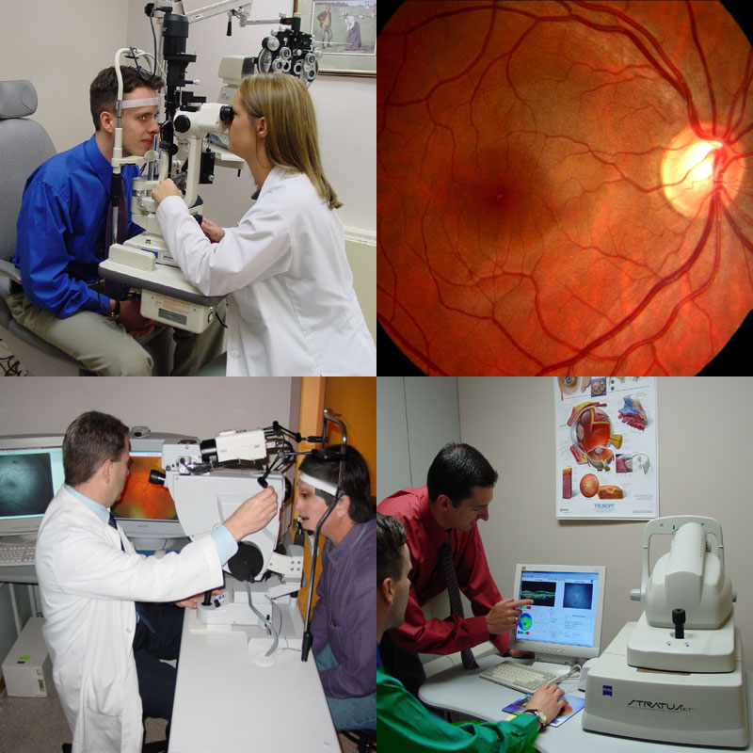

VA OPTOMETRIC SERVICE
CAREER OPPORTUNITIES

John C. Townsend, O.D., F.A.A.O.
Director, Optometric Service (10P4E)
Veterans Health Administration
George H. Fallon Federal Building
31 Hopkins Plaza, Room 1250
Baltimore, Maryland 21201-2896
Phone: (410) 637-4754
Fax: (410) 637-4751

Website: http://www.va.gov/optometry/

