Beneficiary Travel

Release Notes

DGBT*1.0*32

October 2018

Department of Veterans Affairs
Office of Information and Technology (OIT)
Product Development
Revision History
Change | Date | Tech Writer,  Project Manager
Original document. | March 2017 | redacted
Some technically significant updates. | February 2018 | redacted
Updated process based on IAM Requirements change | October 2018 | redacted

Table of Contents

Overview 4
Web Server/Regional Configuration 5
Install the CA SiteMinder WebAgent 5
Export the Web Server Certificate to .pfx File in IIS 7 5
Separate the Private Key and SSL Certificate 6
Cache/Site Configuration 7
Cache SSL/TLS Configuration 7
Import the XML file 8

Overview
The Beneficiary Travel (BT) Dashboard is a web-based application designed to be used along with the existing VistA Beneficiary Travel Claim option in concurrent sessions for a patient. BT Dashboard calculates the driving mileage from the patient’s address to a configured set of institutions. Using the Beneficiary Travel Claim menu, the application automatically synchronizes with travel claims as claims are created in VistA. BT Dashboard also displays patient appointments, claims, notes, orders, and consults. Patch DGBT*1.0*32 upgrades the existing BT Dashboard login methodology by allowing users to authenticate using their PIV card, rather than Access/Verify codes.
Before the BT Dashboard PIV authentication can be used on a workstation, the CA SiteMinder WebAgent must be installed and the Cache Instance must be configured. This involves:

- Installing the CA SiteMinder WebAgent
- Exporting the Web Server certificate (.pfx)
- Separating the Private Key and SSL Certificate
- Configuring SSL/TLS in Cache
- Importing the XML file

Web Server/Regional Configuration

Install the CA SiteMinder WebAgent

This part will need to be done at each Web Server (which means that this will probably be done once per Region).

As a part of the Identity Access Management (IAM) teams VistA Integrated Web Applications integration pattern, the CA SiteMinder WebAgent must be installed on the Beneficiary Travel Dashboard web server. Upon verifications that the required IP addresses and ports are open on the web server, the IAM team will provide a separate CA SiteMinder WebAgent Installation Guide as well as configuration instructions.

Export the Web Server Certificate

You will need to export the web server certificate and private key, used to encrypt your Beneficiary Travel Dashboard URLs, to a .pfx file.

Export the Web Server Certificate to .pfx File in IIS 7
Instructions from: https://www.digicert.com/ssl-support/pfx-import-export-iis-7.htm
- On the Web Sever in the Start menu click Run and then type mmc.
- Click File > Add/Remove Snap-in.
- Click Certificates > Add.
- Select Computer Account and then click Next. Select Local Computer and then click Finish. Then close the add standalone snap-in window and the add/remove snap-in window.
- Click the + to expand the certificates (local computer) console tree and look for the personal directory/folder. Expand the certificates folder.
- Right-click on the certificate you want to backup and select ALL TASKS > Export.
- Choose Yes, export the private key and include all certificates in certificate path if possible.
Warning: Do not select the delete private key option.
- Leave the default settings and then enter your password if required.
- Choose to save the file and then click Finish. You should receive an "export successful" message. The .pfx file is now saved to the location you selected.
Once you have the .pfx file, you will need to send it to the IAM team.

Separate the Private Key and SSL Certificate
You will need to separate your web server Private Key and SSL Server Certificate from the .pfx file created in the previous step. You can use the OpenSSL commands below to create the two files.
openssl pkcs12 -in certificate.pfx -nocerts -out private_key.pem -nodes
openssl pkcs12 -in certificate.pfx -nokeys -out certificate.cer
The newly generated .pem and .cer files will be used in the next step.
(Note: If you do not have access to OpenSSL, please open a CA ticket with the NTL.APP.VistA.Bene Travel 1_0 Dashboard group and ask for your ticket to be escalated to Tier 3.)

Cache/Site Configuration

This part will need to be done at each Cache System Management Portal (which means that this will probably be done once per Site).

Cache SSL/TLS Configuration
In the Cache System Management Portal click ‘SSL/TLS Configuration’:
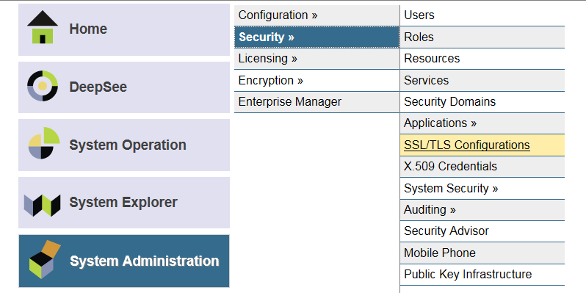

Click ‘Create New Configuration’:
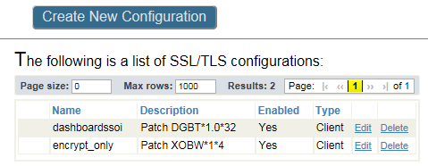

Enter the fields as shown below:
- Ensure that your configuration name is ‘dashboardssoi’.
- Under ‘This client’s credentials’
  - The ‘File containing this configuration’s X.509 certificate’ is the SSL certificate from the web server (.cer).
  - The ‘File containing associated private key’ is the private key file created earlier in this guide (.pem).
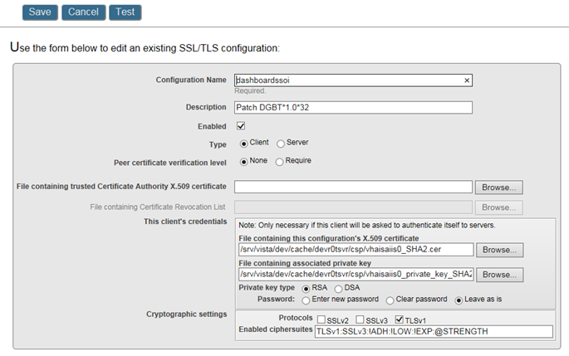
Click ‘Save’.

Import the XML file
Use Caché Studio to import the source code XML.
Note: Caché Studio should be connected to your VistA server in your station’s namespace.
- Click the Tools menu and select Import Local.
Caché>Studio>Tools>Import Local

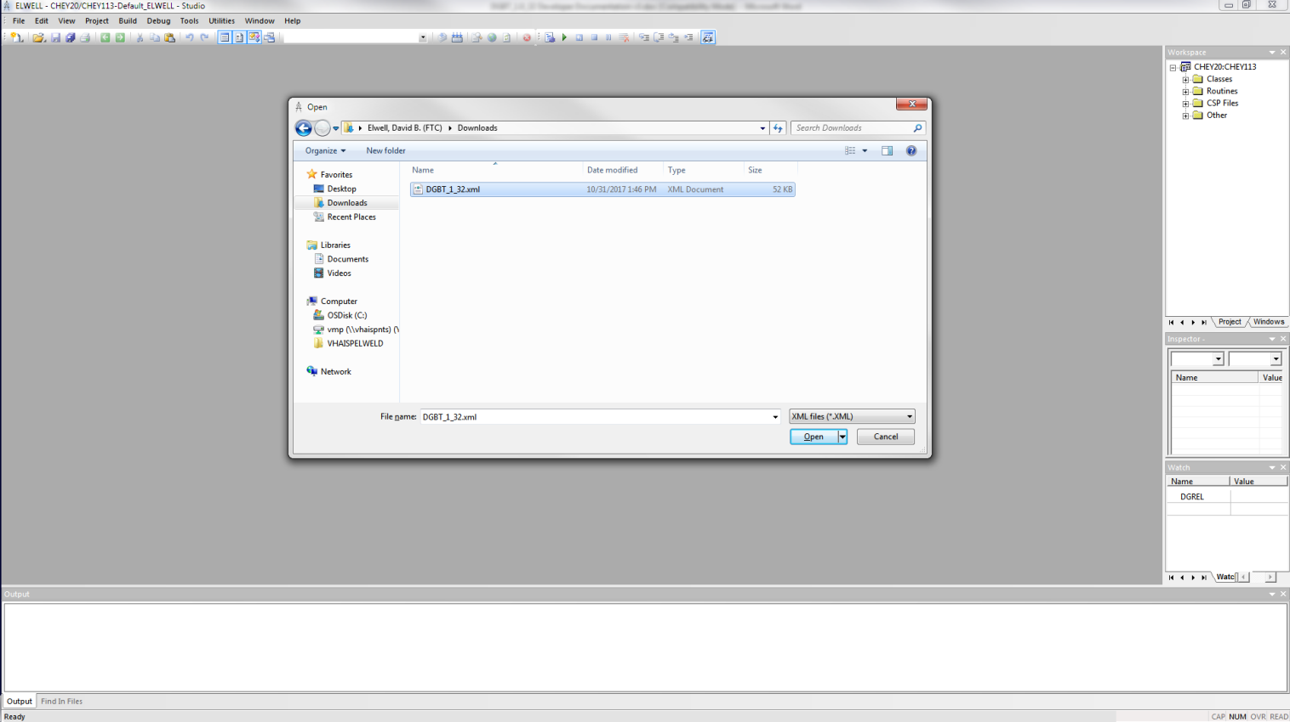
Beneficiary Travel – Studio Open window
- Browse to the DGBT_1_32.xml file retrieved from download.vista.med.va.gov.
- Click the Open button.
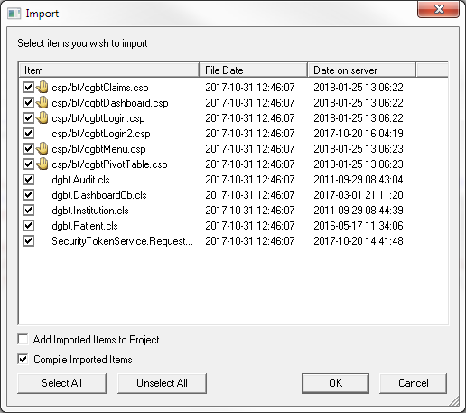
Beneficiary Travel – Studio Import window
- Ensure the Add Imported Items to Project checkbox is not selected and that Compile Imported Items is selected.
- Click the OK button to import the Beneficiary Travel Dashboard .csp and .cls project files.

The End.

