Department of Veterans Affairs

Office of Information & Technology (OIT) Product Development

VistA Mental Health Clinical Reminder Dialog Templates

User Guide
PXRM*2.0*32

November 2014
Version 1.3

Revision History

Date | Version | Description | Author
September 2014 | 1.3 | Updated for release | Information Innovators Inc.
February 2014 | 1.2 | Document specific to PXRM*2.0*32 (Increment 3) | Information Innovators Inc.
August 2013 | 1.1 | Document specific to PXRM*2.0*29 (Increments 1&2) | Information Innovators Inc.
January 2013 | 1.0 | Initial draft | K&R Consulting, Inc.

Contents
Introduction 1
Target audience 1
Other sources of information 1
Related documentation 1
Background 1
About the MHA application 2
MHCR dialog templates for PXRM*2.0*32 2
To access and complete an MHCR dialog template 3
About signing your progress note 9
To sign your progress note 9
APPENDIX A: Finding Items For Evidence Based Psychotherapy 10
APPENDIX B: Finding Items For Social Skills Training 10
APPENDIX C: Finding Items For Interpersonal Therapy 11
APPENDIX D: Finding Items For Integrated Behavioral Couples 13
APPENDIX E: Finding Items For Cognitive Behavioral Therapy For 15
APPENDIX F: Finding Items For Behavioral Family Therapy 17

Introduction
The purpose of this document is to provide clinicians with the information they need to use the Mental Health Clinical Reminder (MHCR) Dialog Templates (patch PXRM*2.0*32) in the VA’s Computerized Patient Record System (CPRS). It is not intended to provide basic information such as logging in to CPRS, or getting help. For information on those and other fundamentals, see Related Documentation.

Target audience
The intended users are the Mental Health clinicians who deliver these particular Evidenced- Based Psychotherapies (EBPs) at VHA facilities. The Clinical Reminder Dialog Templates (patch PXRM*2.0*32) will be made available to all clinicians engaged in the supported therapy protocols. Proficiency in CPRS is the only user requirement.

Other sources of information
Other relevant information is also available on the Clinical Reminders website: http://vista.med.va.gov/reminders/

Related documentation
The following manuals are available from the VistA Documentation Library (VDL) http://www.va.gov/vdl:

Documentation | Documentation file name
Computerized Patient Record System (CPRS) User Guide GUI version February 2012 | cprsguium.PDF
Mental Health Clinical Reminders Dialog Installation and Setup Guide | PXRM_2.0_32_IG.PDF
MHCR Release Notes | PXRM_2.0_32_UM.PDF
Clinical Reminders Manager’s Manual | PXRM_2.0_MM.PDF
Clinical Reminders Technical Manual | PXRM_2.0_TM.PDF

Background
The Improve Veterans’ Mental Health (IVMH) Initiative is part of the Department of Veterans Affairs (VA)’s set of 21st century transformational initiatives (T21). The Mental Health Clinical Reminders (MHCR) project was designed to help facilitate IVMH by providing a national distribution of MHCR dialog templates appropriate for Evidence Based Psychotherapy (EBP) protocols. The protocols will be used for the treatment of mental health conditions, including depression, post-traumatic stress disorder, and others. The national reminder dialog templates will facilitate uniform data collection. This will allow Mental Health Services (MHS) the ability to effectively monitor implementation of the therapy protocols as well as evaluate the effectiveness of the therapies. The templates will assist in providing uniformity across mental services within the VA.
Access to the MHCR templates is through the CPRS environment. All of the templates will use the existing Clinical Reminder dialog functionalities; no new functionalities have been created to support the protocols.

About the MHA application
The dialog templates may include Mental Health Assistant (MHA) instruments as part of the template dialog. If so, you will have the option to complete the instruments. Depending on how your site has configured the reminder dialogs, the assessment will appear in the progress note or not. (Both approaches are used in the EBP templates included in this project.)

MHCR dialog templates for PXRM*2.0*32
Mandated template drawer names are listed in the installation procedure steps in the Installation Guide - Patch PXRM*2.0*32. To facilitate clinician recognition of the correct templates, those drawer names are abbreviated versions of the titles listed in full here. The national EBP training programs have created clinician training materials based on the mandated (abbreviated) template drawer names, therefore the names, the order of those names, and the names of their enclosing folders should be followed – see note on page 14 (section 3.3.3 Installation Guide - Patch PXRM*2.0*32). The mandated drawer names are abbreviated versions of these:

BFT - Behavioral Family Therapy
- VA-MH BFT 1 ORIENTATION
- VA-MH BFT 2 EDUCATION SESSION
- VA-MH BFT 3 COMMUNICATION SESSION
- VA-MH BFT 4 PROBLEM-SOLVING SESSION
- VA-MH BFT 5 FINAL SESSION
- VA-MH BFT 6 EARLY TERMINATION

CBT-I - Cognitive Behavioral Therapy for Insomnia
- VA-MH CBT-I 1 EVALUATION SESSION
- VA-MH CBT-I 2 INITIAL TREATMENT PHASE
- VA-MH CBT-I 3 MIDDLE TREATMENT PHASE
- VA-MH CBT-I 4 FINAL SESSION
- VA-MH CBT-I EARLY TERMINATION

IBCT - Integrative Behavioral Couple Therapy
- VA-MH IBCT 1 INITIAL
- VA-MH IBCT 2 INDIVIDUAL
- VA-MH IBCT 3 NON VETERAN
- VA-MH IBCT 4 FEEDBACK
- VA-MH IBCT 5 THERAPY
- VA-MH IBCT 6 TERMINATION
- VA-MH IBCT EARLY TERMINATION

IPT - Interpersonal Psychotherapy for Depression
- VA-MH IPT 1 DEPRESSION
- VA-MH IPT 2 DEPRESSION
- VA-MH IPT 3 DEPRESSION

- VA-MH IPT 4 DEPRESSION MAINT
- VA-MH IPT EARLY TERMINATION

SST - Social Skills Training
- VA-MH SST 1 INITIAL
- VA-MH SST 2 GROUP VISIT
- VA-MH SST 3 FINAL VISIT
- VA-MH SST EARLY TERMINATION

To access and complete an MHCR dialog template
- Sign onto CPRS.
The Patient Selection window opens:
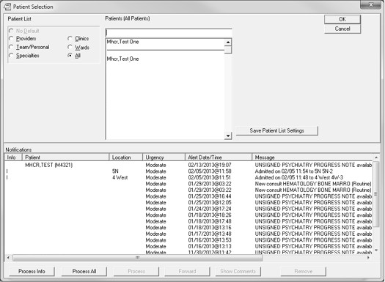

- Select the patient you want to work with, in your usual manner. The patient’s record opens in Cover Sheet view:

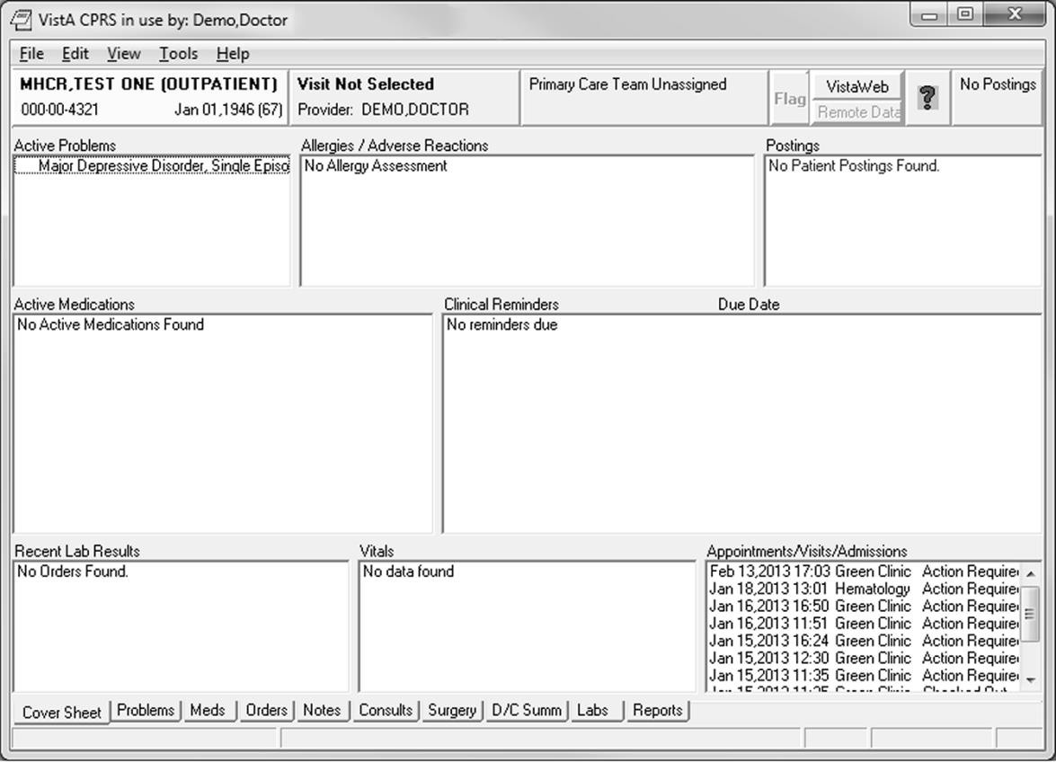

- Click the Notes tab.
The Notes view opens, showing a New Note button:

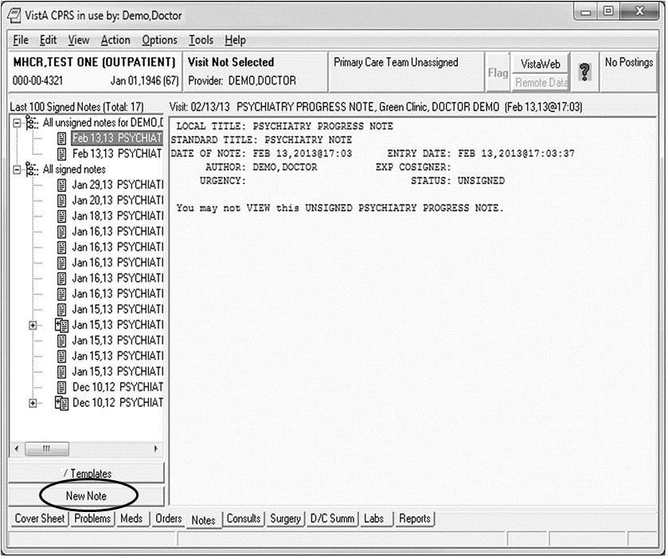
- Click New Note.
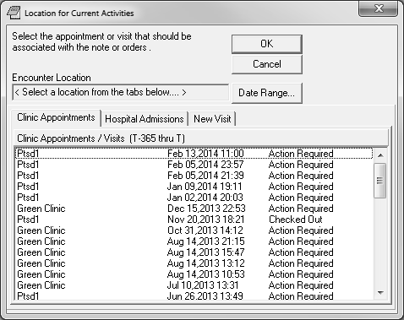
The Location for Current Activities window opens:

- Select a location.
The location displays in the Encounter Location read-only field.
--OR--
Click the tab for Hospital Admissions or New Visit. If New Visit, select a Visit Location and a Date and Time of Visit.
- Click OK.
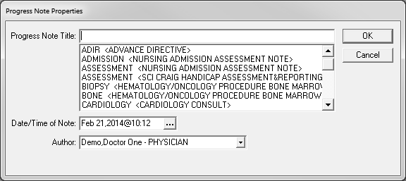
The Progress Note Properties window opens.
- Type the note title into the Progress Note Title field or select from the list, then click OK. You are returned to the Notes tab view.
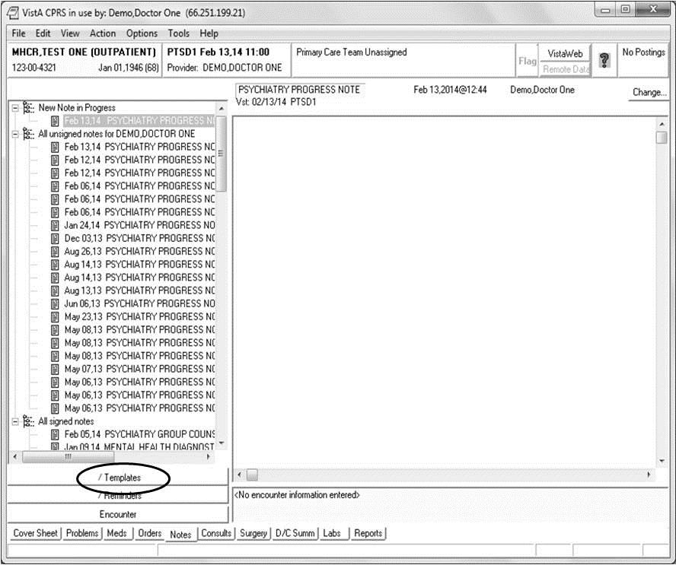

- Click Templates.
The Templates section opens:
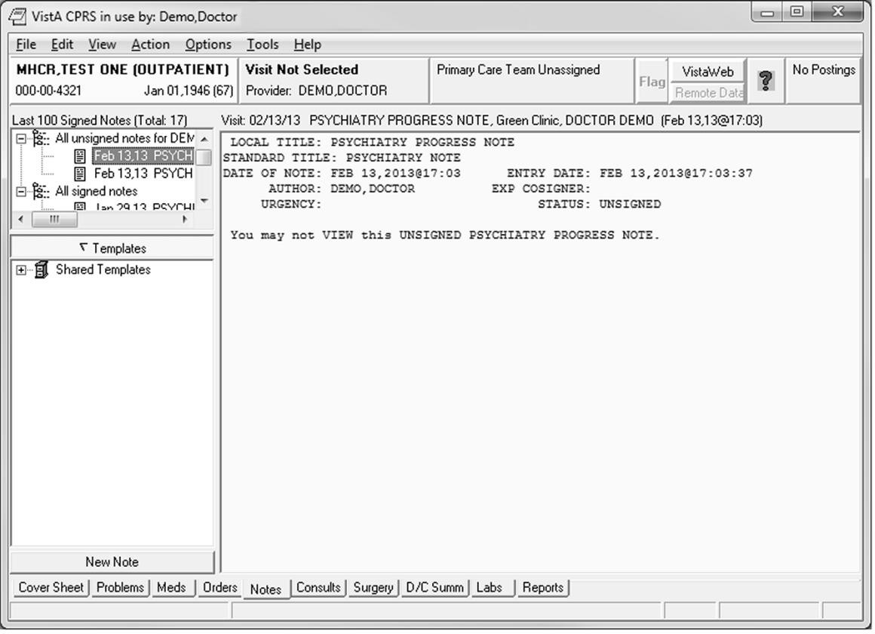
- Expand the list of Shared Templates by clicking +, then double-click the template you want, as shown in the section view:
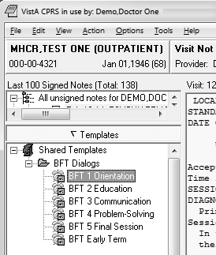

The template opens:

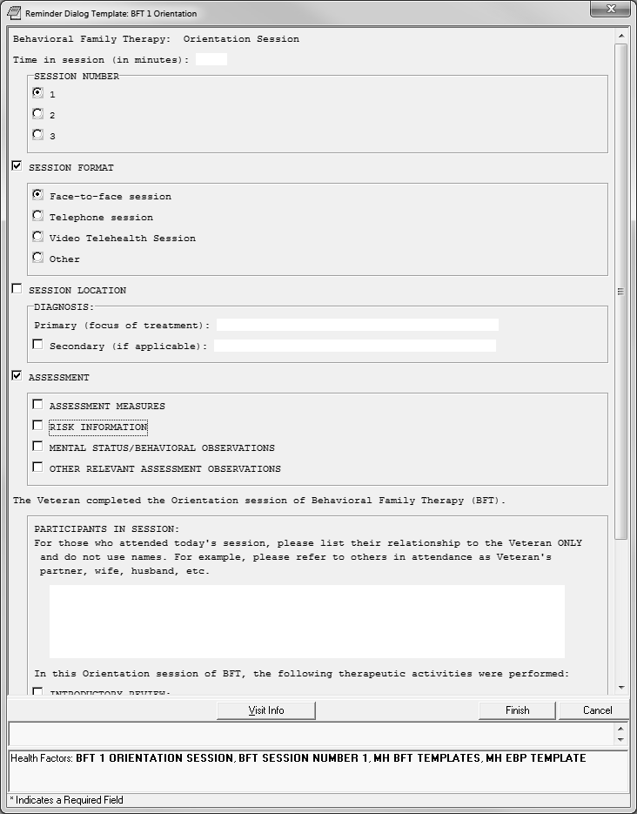

- Click to select the items you want; continue scrolling to review the entire template.
Note: Selecting some options opens a text field for data entry.

- Type data in the text fields as necessary.

- When you have completed the template, click Finish.
The template window closes, and you are returned to the CPRS Notes view, showing the information you entered in the form of a progress note.

About signing your progress note
You must sign the note with your electronic signature before it can become a note that other CPRS users can see, as well as a permanent entry in the patient’s record.

To sign your progress note
- Click the Action menu (top of CPRS Notes view window), and select Sign Note Now. The Sign Note dialog box opens.
- Type your electronic signature code into the Signature Code field, then click OK. Your note is signed, and you are returned to the CPRS Notes view.

APPENDIX A: Finding Items For Evidence Based Psychotherapy:

12 | MH | EVIDENCED BASED PSYCHOTHER TEMPLATES
13 | MH | EBP PLAN REFERRAL
14 | MH | EBP EARLY TERM AGREE
15 | MH | EBP EARLY TERM NO CONTACT
16 | MH | EBP EARLY TERM DISCONT TX
17 | MH | EBP EARLY TERM SYMPTOMS REMIT
18 | MH | EBP TEMPLATE
19 | MH | EBP PLAN PT AGREE
20 | MH | EBP PLAN BOOSTER SESSION
21 | MH | EBP PLAN TX COMPLETE

APPENDIX B: Finding Items For Social Skills Training

22 | MH | SST | TEMPLATES
23 | MH | SST | 3 REVIEW PROGRESS DISCONTINUE
24 | MH | SST | 3 REVIEW PROGRESS TERMINATE
25 | MH | SST | 3 REVIEW PROGRESS COMPLETED
26 | MH | SST | 3 REVIEW PROGRESS ATTENDING NO
27 | MH | SST | 3 FINAL
28 | MH | SST | THERAPY
29 | MH | SST | LEVEL ACTIVE NO
30 | MH | SST | LEVEL PROMPT
31 | MH | SST | LEVEL ACTIVE YES
32 | MH | SST | PARTICIPATION LEVEL
33 | MH | SST | PARTICIPATION NUMBER 4
34 | MH | SST | PARTICIPATION NUMBER 3
35 | MH | SST | PARTICIPATION NUMBER 2
36 | MH | SST | PARTICIPATION NUMBER 1
37 | MH | SST | PARTICIPATION NUMBER
38 | MH | SST | SUGGESTIONS IMPROVE
39 | MH | SST | POS FEEDBACK
40 | MH | SST | SKILL MODELED GROUP
41 | MH | SST | SKILL MODELED ROLE
42 | MH | SST | SKILL STEPS
43 | MH | SST | SKILL RATIONALE
44 | MH | SST | ASSIGNMENT
45 | MH | SST | ESTABLISHED AGENDA
46 | MH | SST | SOCIAL SKILLS TAUGHT COPING
47 | MH | SST | SOCIAL SKILLS TAUGHT VOCATIONAL
48 | MH | SST | SOCIAL SKILLS TAUGHT CONFLICT
49 | MH | SST | SOCIAL SKILLS TAUGHT ASSERTIVE
50 | MH | SST | SOCIAL SKILLS TAUGHT CONVERSATION
51 | MH | SST | SOCIAL SKILLS TAUGHT OTHER
52 | MH | SST | SOCIAL SKILLS TAUGHT HEALTH
53 | MH | SST | SOCIAL SKILLS TAUGHT FRIENDSHIP
54 | MH | SST | SOCIAL SKILLS TAUGHT COMMUNAL
55 | MH | SST | SOCIAL SKILLS TAUGHT FOUR
56 | MH | SST | SOCIAL SKILLS TAUGHT
57 | MH | SST | ASSESSMENT YES
58 | MH | SST | ASSESSMENT NO
59 | MH | EBP | COLLABORATION HIGH

60 | MH | EBP | COLLABORATION MEDIUM
61 | MH | EBP | COLLABORATION LOW
62 | MH | EBP | MOTIVATION ENHANCE BARRIERS
63 | MH | EBP | MOTIVATION ENHANCE ATTITUDES
64 | MH | EBP | MOTIVATION ENHANCE BENEFITS
65 | MH | EBP | MOTIVATION ENHANCE CONSEQUENCES
66 | MH | EBP | MOTIVATION ENHANCE GOALS
67 | MH | SST | 2 GROUP VISIT
68 | MH | SST | 1 INITIAL
69 | MH | SST | TREATMENT GOALS LONG
70 | MH | SST | TREATMENT GOALS SHORT
71 | MH | SST | TREATMENT GOALS
72 | MH | SST | TREATMENT GOALS NOT IDENTIFIED

APPENDIX C: Finding Items For Interpersonal Therapy
- MH IPT FOR DEPRESSION
- MH IPT SESSION NUMBER COMPLETED 17+
- MH IPT SESSION NUMBER COMPLETED 16
- MH IPT SESSION NUMBER COMPLETED 15
- MH IPT SESSION NUMBER COMPLETED 14
- MH IPT SESSION NUMBER COMPLETED 13
- MH IPT SESSION NUMBER COMPLETED 12
- MH IPT SESSION NUMBER COMPLETED 4
- MH IPT SESSION NUMBER COMPLETED 3
- MH IPT SESSION NUMBER COMPLETED 2
- MH IPT SESSION NUMBER COMPLETED 1
- MH IPT SESSION NUMBER COMPLETED 11
- MH IPT SESSION NUMBER COMPLETED 10
- MH IPT SESSION NUMBER COMPLETED 9
- MH IPT SESSION NUMBER COMPLETED 8
- MH IPT SESSION NUMBER COMPLETED 7
- MH IPT SESSION NUMBER COMPLETED 6
- MH IPT SESSION NUMBER COMPLETED 5
91 | MH | IPT | THERAPY
92 | MH | IPT | EARLY TERM OUTSIDE OF SSN
93 | MH | IPT | HOMEWORK NOT ASSIGNED NEXT SSN
94 | MH | IPT | HOMEWORK NOT ASSIGNED LAST SSN
95 | MH | IPT | HOMEWORK NOT COMPLETE
96 | MH | IPT | HOMEWORK COMPLETE
97 | MH | IPT | TECHNIQUE ROLE PLAY
98 | MH | IPT | TECHNIQUE DECISION ANALYSIS
99 | MH | IPT | TECHNIQUE DIRECTIVE
100 | MH | IPT | TECHNIQUE THERAPEUTIC RELATION
101 | MH | IPT | TECHNIQUE COMMUNICATION TECHNIQUE
102 | MH | IPT | TECHNIQUE COMMUNICATION ANALYSIS
103 | MH | IPT | TECHNIQUE CLARIFICATION
104 | MH | IPT | TECHNIQUE ENCOURAGE AFFECT
105 | MH | IPT | TECHNIQUE EXPLORATION
106 | MH | IPT | DEFICITS COMPARE THER
107 | MH | IPT | DEFICITS REPETITIVE
108 | MH | IPT | DEFICITS COMPARE
109 | MH | IPT | DEFICITS CONNECT

110 | MH | IPT | DEFICITS RELATION
111 | MH | IPT | DEFICITS REDUCE ISOL
112 | MH | IPT | ROLE TRANSITION SKILL ENCOURAGE
113 | MH | IPT | ROLE TRANSITION AFFECT
114 | MH | IPT | ROLE TRANSITION OPPORTUNITIES
115 | MH | IPT | ROLE TRANSITION FEELINGS
116 | MH | IPT | ROLE TRANSITION COMPARE
117 | MH | IPT | ROLE TRANSITION COPING
118 | MH | IPT | ROLE TRANSITION SKILL DEVELOP
119 | MH | IPT | ROLE TRANSITION POSITIVE
120 | MH | IPT | ROLE TRANSITION LET GO
121 | MH | IPT | ROLE DISPUTE STAGE
122 | MH | IPT | ROLE DISPUTE PARALLEL
123 | MH | IPT | ROLE DISPUTE EXPECTATIONS
124 | MH | IPT | ROLE DISPUTE CONNECT
125 | MH | IPT | ROLE DISPUTE PATTERNS
126 | MH | IPT | ROLE DISPUTE PLAN
127 | MH | IPT | GRIEF INVOLVE
128 | MH | IPT | GRIEF RECONSTRUCT
129 | MH | IPT | GRIEF DESCRIBE
130 | MH | IPT | GRIEF ELICIT
131 | MH | IPT | GRIEF LINK
132 | MH | IPT | GRIEF FRIEND
133 | MH | IPT | GRIEF MOURN
134 | MH | IPT | INTERPERSONAL DEFICIT SECONDARY
135 | MH | IPT | ROLE TRANSITION SECONDARY
136 | MH | IPT | ROLE DISPUTE SECONDARY
137 | MH | IPT | GRIEF SECONDARY
138 | MH | IPT | INTERPERSONAL DEFICIT PRIMARY
139 | MH | IPT | ROLE TRANSITION PRIMARY
140 | MH | IPT | ROLE DISPUTE PRIMARY
141 | MH | IPT | GRIEF PRIMARY
142 | MH | IPT | ENCOURAGE GOAL DESCRIBE
143 | MH | IPT | GOAL SET
144 | MH | IPT | PROBLEM REVIEW
145 | MH | IPT | SESSION NUMBER 1 MAINT
146 | MH | IPT | SESSION NUMBER 2 MAINT
147 | MH | IPT | SESSION NUMBER 3 MAINT
148 | MH | IPT | SESSION NUMBER 12+ MAINT
149 | MH | IPT | SESSION NUMBER 11 MAINT
150 | MH | IPT | SESSION NUMBER 10 MAINT
151 | MH | IPT | SESSION NUMBER 9 MAINT
152 | MH | IPT | SESSION NUMBER 8 MAINT
153 | MH | IPT | SESSION NUMBER 7 MAINT
154 | MH | IPT | SESSION NUMBER 6 MAINT
155 | MH | IPT | SESSION NUMBER 5 MAINT
156 | MH | IPT | SESSION NUMBER 4 MAINT
157 | MH | IPT | 4 MAINTENANCE SESSION
158 | MH | IPT | 3 SKILLS
159 | MH | IPT | 3 FOCUS
160 | MH | IPT | 3 PROBLEM
161 | MH | IPT | 3 MOOD
162 | MH | IPT | 3 CONTINUE
163 | MH | IPT | 3 RESPOND

164 | MH | IPT | 3 FUTURE
165 | MH | IPT | 3 TRIGGER
166 | MH | IPT | 3 FEELINGS
167 | MH | IPT | MORE DEPRESSED
168 | MH | IPT | LESS SOCIAL NETWORK
169 | MH | IPT | SAME SOCIAL NETWORK
170 | MH | IPT | SAME DEPRESSED
171 | MH | IPT | LESS DEPRESSED
172 | MH | IPT | SESSION NUMBER 17+
173 | MH | IPT | SESSION NUMBER 16
174 | MH | IPT | SESSION NUMBER 15
175 | MH | IPT | SESSION NUMBER 14
176 | MH | IPT | SESSION NUMBER 13
177 | MH | IPT | SESSION NUMBER 12
178 | MH | IPT | SESSION NUMBER 11
179 | MH | IPT | SESSION NUMBER 10
180 | MH | IPT | SESSION NUMBER 9
181 | MH | IPT | SESSION NUMBER 8
182 | MH | IPT | SESSION NUMBER 7
183 | MH | IPT | SESSION NUMBER 6
184 | MH | IPT | SESSION NUMBER 5
185 | MH | IPT | SESSION NUMBER 4
186 | MH | IPT | 3 TERMINATION SESSION
187 | MH | IPT | SESSION NUMBER 3
188 | MH | IPT | 2 INTERMEDIATE SESSION
189 | MH | IPT | 1 INITIAL SESSION
190 | MH | IPT | SESSION NUMBER 2
191 | MH | IPT | SESSION NUMBER 1
192 | MH | IPT | INTERPERSONAL FORMULATION
193 | MH | IPT | INTERPERSONAL INVENTORY
194 | MH | IPT | SICK ROLE EXPLAIN
195 | MH | IPT | DEP EDUC

APPENDIX D: Finding Items For Integrated Behavioral Couples Therapy

- MH IBCT TEMPLATES
- MH IBCT SESSION NUMBER COMPLETED 1
- MH IBCT SESSION NUMBER COMPLETED >24
- MH IBCT SESSION NUMBER COMPLETED 24
- MH IBCT SESSION NUMBER COMPLETED 20
- MH IBCT SESSION NUMBER COMPLETED 18
- MH IBCT SESSION NUMBER COMPLETED 17
- MH IBCT SESSION NUMBER COMPLETED 15
- MH IBCT SESSION NUMBER COMPLETED 14
- MH IBCT SESSION NUMBER COMPLETED 13
- MH IBCT SESSION NUMBER COMPLETED 11
- MH IBCT SESSION NUMBER COMPLETED 10
- MH IBCT SESSION NUMBER COMPLETED 9
- MH IBCT SESSION NUMBER COMPLETED 7
- MH IBCT SESSION NUMBER COMPLETED 6
- MH IBCT SESSION NUMBER COMPLETED 4

- MH IBCT SESSION NUMBER COMPLETED 3
- MH IBCT SESSION NUMBER COMPLETED 23
- MH IBCT SESSION NUMBER COMPLETED 22
- MH IBCT SESSION NUMBER COMPLETED 21
- MH IBCT SESSION NUMBER COMPLETED 19
- MH IBCT SESSION NUMBER COMPLETED 16
- MH IBCT SESSION NUMBER COMPLETED 12
- MH IBCT SESSION NUMBER COMPLETED 8
- MH IBCT SESSION NUMBER COMPLETED 5
- MH IBCT SESSION NUMBER COMPLETED 2
- MH IBCT THERAPY
- MH IBCT 7 EARLY TERMINATION
224 | MH | IBCT | DIRECT CHANGE STRATEGY
225 | MH | IBCT | TOLERANCE BUILD
226 | MH | IBCT | UNIFIED DETACHMENT
227 | MH | IBCT | EMPATHIC JOIN
228 | MH | IBCT | PRACTICE NOT ASSIGNED
229 | MH | IBCT | PRACTICE NOT COMPLETE
230 | MH | IBCT | PRACTICE COMPLETE
231 | MH | IBCT | SESSION NUMBER 5
232 | MH | IBCT | SESSION NUMBER 6
233 | MH | IBCT | SESSION NUMBER 7
234 | MH | IBCT | SESSION NUMBER >24
235 | MH | IBCT | SESSION NUMBER 24
236 | MH | IBCT | SESSION NUMBER 20
237 | MH | IBCT | SESSION NUMBER 18
238 | MH | IBCT | SESSION NUMBER 17
239 | MH | IBCT | SESSION NUMBER 15
240 | MH | IBCT | SESSION NUMBER 14
241 | MH | IBCT | SESSION NUMBER 13
242 | MH | IBCT | SESSION NUMBER 11
243 | MH | IBCT | SESSION NUMBER 10
244 | MH | IBCT | SESSION NUMBER 9
245 | MH | IBCT | SESSION NUMBER 23
246 | MH | IBCT | SESSION NUMBER 22
247 | MH | IBCT | SESSION NUMBER 21
248 | MH | IBCT | SESSION NUMBER 19
249 | MH | IBCT | SESSION NUMBER 16
250 | MH | IBCT | SESSION NUMBER 12
251 | MH | IBCT | SESSION NUMBER 8
252 | MH | IBCT | 6 TERMINATION
253 | MH | IBCT | 5 THERAPY
254 | MH | IBCT | WEEKLY QUESTIONNAIRE
255 | MH | IBCT | FOCUS OVERVIEW
256 | MH | IBCT | DEEP
257 | MH | IBCT | FEEDBACK OVERVIEW
258 | MH | IBCT | SESSION NUMBER 4
259 | MH | IBCT | SESSION NUMBER 3
260 | MH | IBCT | 4 FEEDBACK
261 | MH | IBCT | SESSION NUMBER 2
262 | MH | IBCT | 3 NON VETERAN
263 | MH | IBCT | 2 INDIVIDUAL
264 | MH | IBCT | SESSION NUMBER 1
265 | MH | IBCT | 1 INITIAL

APPENDIX E: Finding Items For Cognitive Behavioral Therapy For Insomnia

266 | MH | CBT-I TEMPLATES (INSOMNIA)
267 | MH | CBT-I SESSION NUMBER COMPLETED 4
268 | MH | CBT-I SESSION NUMBER COMPLETED 3
269 | MH | CPT TEMPLATES (COGNITIVE PROCESSING)
270 | MH | CPT SESSION NUMBER COMPLETED 2
271 | MH | CBT-I SESSION NUMBER COMPLETED 1
272 | MH | CBT-I SESSION NUMBER COMPLETED 11+
273 | MH | CBT-I SESSION NUMBER COMPLETED 10
274 | MH | CBT-I SESSION NUMBER COMPLETED 9
275 | MH | CBT-I SESSION NUMBER COMPLETED 8
276 | MH | CBT-I SESSION NUMBER COMPLETED 7
277 | MH | CBT-I SESSION NUMBER COMPLETED 6
278 | MH | CBT-I SESSION NUMBER COMPLETED 5
279 | MH | CBT-I THERAPY
280 | MH | CBT-I EARLY TERM OUTSIDE OF SSN
281 | MH | CBT-I FINAL SELF RPT FUNCT NO CHANGE
282 | MH | CBT-I FINAL SELF RPT FUNCT WORS
283 | MH | CBT-I FINAL SELF RPT FUNCT IMPROV
284 | MH | CBT-I FINAL SELF RPT SLEEP NO CHANGE
285 | MH | CBT-I FINAL SELF RPT SLEEP WORS
286 | MH | CBT-I FINAL SELF RPT SLEEP IMPROV
287 | MH | CBT-I FINAL SLEEP EFFIC DECREASE
288 | MH | CBT-I FINAL SLEEP EFFIC INCREASE
289 | MH | CBT-I FINAL TOTAL SLEEP TIME DECREASE
290 | MH | CBT-I FINAL TOTAL SLEEP TIME INCREASE
291 | MH | CBT-I FINAL AWAKEN NUMBER DECREASE
292 | MH | CBT-I FINAL AWAKEN NUMBER INCREASE
293 | MH | CBT-I FINAL WASO DECREASE
294 | MH | CBT-I FINAL WASO INCREASE
295 | MH | CBT-I FINAL SLEEP LATENCY DECREASE
296 | MH | CBT-I FINAL SLEEP LATENCY INCREASE
297 | MH | CBT-I GOAL NOT ACHIEVE
298 | MH | CBT-I GOAL PARTIAL ACHIEVE
299 | MH | CBT-I GOAL ACHIEVE
300 | MH | CBT-I CONTINUING SELF CARE PLAN
301 | MH | CBT-I HANDOUT ACTION
302 | MH | CBT-I DEVELOP PLAN
303 | MH | CBT-I FEELING TIRED
304 | MH | CBT-I ENJOYING YOUR MORNING
305 | MH | CBT-I THINGS TO DO
306 | MH | CBT-I STAYING AWAKE
307 | MH | CBT-I GET IN THE WAY
308 | MH | CBT-I Q&A RULES
309 | MH | CBT-I REVIEWED COGNITIVE
310 | MH | CBT-I RELAXATION PROG
311 | MH | CBT-I ADJUSTED BEDTIME
312 | MH | CBT-I PROBLEM SOLVED ISSUES
313 | MH | CBT-I ADHERENCE TO THERAPY
314 | MH | CBT-I BLANK DIARY PROVIDED

315 | MH | CBT-I | BEDTIME ADJUST OTHER
316 | MH | CBT-I | INPUT
317 | MH | CBT-I | SLEEP NEED
318 | MH | CBT-I | SLEEP DIARY REVIEWED
319 | MH | CBT-I | ADHERENCE HIGH
320 | MH | CBT-I | ADHERENCE MEDIUM
321 | MH | CBT-I | ADHERENCE LOW
322 | MH | CBT-I | SNQ SEVERE
323 | MH | CBT-I | SNQ MODERATE
324 | MH | CBT-I | SNQ MILD
325 | MH | CBT-I | PRESCRIBED BEDTIME ADHERENCE | NO
326 | MH | CBT-I | PRESCRIBED BEDTIME ADHERENCE
327 | MH | CBT-I | SLEEP DIARY COMPLETE
328 | MH | CBT-I | SLEEP DIARY NOT COMPLETE
329 | MH | CBT-I | ISI NO CHANGE
330 | MH | CBT-I | ISI INCREASE
331 | MH | CBT-I | ISI REDUCTION
332 | MH | CBT-I | ISI SEVERE
333 | MH | CBT-I | ISI MODERATE
334 | MH | CBT-I | ISI MILD
335 | MH | CBT-I | SESSION NUMBER >10
336 | MH | CBT-I | SESSION NUMBER 10
337 | MH | CBT-I | SESSION NUMBER 9
338 | MH | CBT-I | SESSION NUMBER 8
339 | MH | CBT-I | SESSION NUMBER 7
340 | MH | CBT-I | SESSION NUMBER 6
341 | MH | CBT-I | SESSION NUMBER 5
342 | MH | CBT-I | SESSION NUMBER 4
343 | MH | CBT-I | 4 FINAL SESSION
344 | MH | CBT-I | AVOID NAPPING
345 | MH | CBT-I | ADDRESSED BARRIERS
346 | MH | CBT-I | ASSESSED BARRIERS
347 | MH | CBT-I | CHANGING THINK
348 | MH | CBT-I | COG THERAPY
349 | MH | CBT-I | RELAXATION TRAINING
350 | MH | CBT-I | TIME IN BED
351 | MH | CBT-I | SESSION NUMBER 3
352 | MH | CBT-I | 3 MIDDLE TREATMENT
353 | MH | CBT-I | IMPLEMENT SLEEP RESTRICTION
354 | MH | CBT-I | IMPLEMENT STIMULUS CONTROL
355 | MH | CBT-I | AVOID HEAVY MEALS
356 | MH | CBT-I | BEDROOM DARK
357 | MH | CBT-I | EXERCISE REGULARLY
358 | MH | CBT-I | LIMIT TOBACCO USE
359 | MH | CBT-I | LIMIT ALCOHOL USE
360 | MH | CBT-I | LIMIT CAFFEINE
361 | MH | CBT-I | TURN CLOCK AROUND
362 | MH | CBT-I | BARRIERS NONE
363 | MH | CBT-I | SLEEP HYGIENE
364 | MH | CBT-I | CALMING THE MIND
365 | MH | CBT-I | PRESCRIBED BEDTIME
366 | MH | CBT-I | OVERCOMING INSOMNIA
367 | MH | CBT-I | SLEEP RESTRICTION THERAPY
368 | MH | CBT-I | STIMULUS CONTROL THERAPY

369 | MH | CBT-I | PSYCHOEDUCATION ON SLEEP
370 | MH | CBT-I | SESSION NUMBER 2
371 | MH | CBT-I | 2 INITIAL TREATMENT
372 | MH | CBT-I | SESSION NUMBER 1
373 | MH | CBT-I | 1 EVALUATION SESSION
374 | MH | CBT-I | BLANK SLEEP DIARY
375 | MH | CBT-I | UNDERSTAND HOMEWORK ASSIGN
376 | MH | CBT-I | INSTRUCT SLEEP DIARY
377 | MH | CBT-I | EXPLAIN HOMEWORK
378 | MH | CBT-I | LENGTH OF TREATMENT
379 | MH | CBT-I | TREATMENT GOALS INITIAL
380 | MH | CBT-I | EFFICACY
381 | MH | CBT-I | DESCRIPTION CBT-I
382 | MH | CBT-I | IS CANDIDATE RECEPTIVE NO
383 | MH | CBT-I | IS CANDIDATE RECEPTIVE YES
384 | MH | CBT-I | IS CANDIDATE
385 | MH | CBT-I | NOT A CANDIDATE
386 | MH | CBT-I | MEDS INTERFERE TAKING
387 | MH | CBT-I | MEDS INTERFERE NOT TAKING
388 | MH | CBT-I | WAKING NONE
389 | MH | CBT-I | WAKING OTHER
390 | MH | CBT-I | WAKING LATE
391 | MH | CBT-I | WAKING ASSIST
392 | MH | CBT-I | WAKING SNOOZE
393 | MH | CBT-I | PRE-SLEEP NONE
394 | MH | CBT-I | PRE-SLEEP OTHER
395 | MH | CBT-I | PRE-SLEEP FEARS
396 | MH | CBT-I | PRE-SLEEP PHYSICAL TENSION
397 | MH | CBT-I | PRE-SLEEP WORRY
398 | MH | CBT-I | PRE-SLEEP RUMINATION
399 | MH | CBT-I | COMORBIDITIES PSYCHIATRIC YES
400 | MH | CBT-I | COMORBIDITIES PSYCHIATRIC NO
401 | MH | CBT-I | COMORBIDITIES MEDICAL YES
402 | MH | CBT-I | COMORBIDITIES MEDICAL NO
403 | MH | CBT-I | DBAS SIGNIFICANT
404 | MH | CBT-I | DBAS SOME
405 | MH | CBT-I | DBAS NONE

APPENDIX F: Finding Items For Behavioral Family Therapy

406 MH BFT TEMPLATES (BEHAVIORAL FAMILY)
- MH BFT SESSION NUMBER COMPLETED 20+
- MH BFT SESSION NUMBER COMPLETED 20
- MH BFT SESSION NUMBER COMPLETED 19
- MH BFT SESSION NUMBER COMPLETED 18
- MH BFT SESSION NUMBER COMPLETED 17
- MH BFT SESSION NUMBER COMPLETED 16
- MH BFT SESSION NUMBER COMPLETED 15
- MH BFT SESSION NUMBER COMPLETED 14
- MH BFT SESSION NUMBER COMPLETED 13
- MH BFT SESSION NUMBER COMPLETED 12

- MH BFT SESSION NUMBER COMPLETED 11
- MH BFT SESSION NUMBER COMPLETED 10
- MH BFT SESSION NUMBER COMPLETED 9
- MH BFT SESSION NUMBER COMPLETED 8
- MH BFT SESSION NUMBER COMPLETED 7
- MH BFT SESSION NUMBER COMPLETED 6
- MH BFT SESSION NUMBER COMPLETED 5
- MH BFT SESSION NUMBER COMPLETED 4
- MH BFT SESSION NUMBER COMPLETED 3
- MH BFT SESSION NUMBER COMPLETED 2
- MH BFT SESSION NUMBER COMPLETED 1
428 | MH | BFT | TEMPLATES
429 | MH | BFT | EARLY TERM OUTSIDE OF SSN
430 | MH | BFT | FAMILY MTG NA
431 | MH | BFT | FAMILY MTG NOT HELD
432 | MH | BFT | FAMILY MTG HELD
433 | MH | BFT | HMWRK NOT ASSIGNED
434 | MH | BFT | HMWRK NOT COMPLETE
435 | MH | BFT | HMWRK PARTIAL COMPLETE
436 | MH | BFT | HMWRK COMPLETE
437 | MH | BFT | SESSION NUMBER 25
438 | MH | BFT | SESSION NUMBER 24
439 | MH | BFT | SESSION NUMBER 23
440 | MH | BFT | SESSION NUMBER 22
441 | MH | BFT | SESSION NUMBER 21
442 | MH | BFT | SESSION NUMBER 20
443 | MH | BFT | SESSION NUMBER 19
444 | MH | BFT | SESSION NUMBER 18
445 | MH | BFT | SESSION NUMBER 17
446 | MH | BFT | SESSION NUMBER 16
447 | MH | BFT | SESSION NUMBER 15
448 | MH | BFT | 5 FINAL SESSION
449 | MH | BFT | PROBLEM SOLVING ASSIST
450 | MH | BFT | PROBLEM SOLVING STEPS
451 | MH | BFT | PROBLEM SOLVING RATIONALE
452 | MH | BFT | PROBLEM SOLVING INTRO
453 | MH | BFT | PROBLEM SOLVING IMPLEMENT
454 | MH | BFT | PROBLEM SOLVING SOLUTION
455 | MH | BFT | PROBLEM SOLVING EVALUATE
456 | MH | BFT | PROBLEM SOLVING BRAINSTORM
457 | MH | BFT | PROBLEM SOLVING DEFINE
458 | MH | BFT | SESSION NUMBER 14
459 | MH | BFT | SESSION NUMBER 13
460 | MH | BFT | SESSION NUMBER 12
461 | MH | BFT | SESSION NUMBER 11
462 | MH | BFT | SESSION NUMBER 10
463 | MH | BFT | 4 PROBLEM SOLVING SESSION
464 | MH | BFT | ROLE PLAY 3
465 | MH | BFT | ROLE PLAY 2
466 | MH | BFT | ROLE PLAY 1
467 | MH | BFT | SESSION NUMBER 9
468 | MH | BFT | SESSION NUMBER 8
469 | MH | BFT | SESSION NUMBER 7
470 | MH | BFT | SESSION NUMBER 6

471 | MH | BFT | 3 COMMUNICATION SESSION
472 | MH | BFT | HMWRK MATERIALS PROVIDED
473 | MH | BFT | HMWRK OTHER
474 | MH | BFT | HMWRK GOAL
475 | MH | BFT | HMWRK FAMILY MTG
476 | MH | BFT | HMWRK HANDOUT
477 | MH | BFT | SESSION NUMBER 5
478 | MH | BFT | SESSION NUMBER 4
479 | MH | BFT | SESSION NUMBER 3
480 | MH | BFT | 2 EDUCATION SESSION
481 | MH | BFT | SESSION NUMBER 2
482 | MH | BFT | SESSION NUMBER 1
483 | MH | BFT | COUPLES RELATIONSHIP
484 | MH | BFT | IND LIFE HX
485 | MH | BFT | IND FAMILY INTERVIEW
486 | MH | BFT | 1 ORIENTATION SESSION

