VA-Oncology Lung Template User Guide

- Background Information
The National Oncology Program Office seeks to provide tools to enable providers to format essential clinical data within text progress notes so that it is readily available for clinical care and to measure the quality of cancer care in VA in a prospective, continuous, timely, and cost- efficient manner. Using Reminder Dialog Templates in CPRS is one mechanism to achieve these goals.

Oncology reminder dialog templates will include the necessary clinical information to measure standard quality indicators. Quality indicators are selected from those endorsed by the National Quality Forum, used in ASCO's Quality Oncology Practice Initiative, and other sources.

General Information
The purpose of this guide is to provide the end-user with directions on how to perform medical documentation using the VA-Oncology Lung Template. The VA-Oncology Lung Template was developed and is supported by the National Oncology Program Office in Specialty Care Services (part of Patient Care Services). REDACTED.

Recommended Users
The primary users of the Lung Cancer Template are providers in services of medical oncology, radiation oncology, and surgical oncology. Secondary uses may include pulmonologists, oncology nurses, cancer care coordinators, palliative care specialists, and cancer registrars.

Installation
The facility Clinical Applications Coordinator (CAC)/Health Information Specialist (HIS) at each site has received instructions on how to load and implement the VA-Oncology Lung Template. These instructions are part of the PXRM_2_0_38_IG which accompanies this patch. Its primary intended use is as a template that is pulled into an open progress note rather than as a standalone note. The VA-Oncology Lung Template should be available in a shared folder in the template drawer in CPRS. The location and naming convention for the template and shared folder will vary by site. Users should contact their local help desk or local CAC/HIS if the VA- Oncology Lung Template cannot be located in CPRS.

Facilities might choose to link the template to a specific standalone note title rather than use it as a template that is inserted into an open progress note. However, doing so might limit the availability of the template to the range of providers who could make use of the template.
Users will need to contact their local CAC/HIS determine the local name of the note.

Usage
It is recommended that the VA-Oncology Lung Template be initiated and used for newly- diagnosed lung cancer cases and that information is updated periodically throughout the course of care (see documentation section E pages 2-3 for time points during the course of care where the use of the Lung Template is suggested to be used). The template is not intended to be a chart abstraction tool that is only filled in at the end of care, but rather to be used concurrently with delivery of care throughout the patient’s course. When the template is opened on subsequent visits, previously documented information is viewable (see documentation section

E3 for examples pages 5-7). This information can be updated by entering data in the corresponding areas. No section of the template is required. Thus, the provider can complete only those sections of the template that are relevant to a patient at a particular time. However, once a section is begun, all subsections must either be completed or the check removed from the top level of that section.

Documentation:
The VA-Oncology Lung Template is separated into three sections: diagnosis, treatment and post- treatment.

Definitions for Each Section Diagnosis Section
- Date of first abnormal radiology:
Date of first abnormal radiology prior to the initial diagnosis of lung cancer that documented suspicion of lung cancer. For example, date of first abnormal radiology could be 3 years prior to diagnosis when observation with serial CTs began or when lesion enlarged enough to warrant further workup.

Date of diagnosis
Date first procedure performed that confirmed the initial pathologic diagnosis of lung
cancer (e.g. date of biopsy). If no biopsy was done, provide date that provider made decision to treat as lung cancer.

Clinical stage
Stage based on physical examination, imaging tests, and/or biopsies done in the absence of pathological staging procedures. For NSCLC, select a Summary Stage 0-IV, OR a TNM Stage. For SCLC, select Summary Stage then indicate limited or extensive, or TNM Stage. Include the date the stage was determined.

Pathological stage
Staging done after lung resection surgery or invasive mediastinal staging. For NSCLC, select a Summary Stage 0-IV, OR a TNM Stage. For SCLC, select Summary Stage then indicate limited or extensive, or TNM Stage. Include the date the stage was determined.

Histology
Indicate histology of tumor.

Molecular Testing:
EGFR Mutational Analysis and ALK translocation test. Indicate if test was done and result.

ECOG Performance Status
ECOG Scale definitions:
0 = Fully active, able to carry on all pre-disease performance without restriction
1 = Restricted in physically strenuous activity but ambulatory and able to carry out work of a light or sedentary nature, e.g., light house work, office work
2 = Ambulatory and capable of all self-care but unable to carry out any work activities. Up and about more than 50% of waking hours
3 = Capable of only limited self-care, confined to bed or chair more than 50% of waking hours 4 = Completely disabled. Cannot carry on any self-care. Totally confined to bed or chair

5 = Dead

Treatment Section
- If tumor board available has case been presented?
If tumor board available, indicate whether or not case has been discussed. If discussed, include the date of the first tumor board discussion. If no tumor board available, select N/A.

Surgery performed? (Stages I, II, III)
If surgery was performed, indicate type and outcome of surgery, along with the date of surgery. If surgery was not performed, select reason.

Lymph node sampling (Stages I, II, III)
If LN sampling done, indicate procedure and date. If not, specify reason.

Radiation therapy administered
Indicate if radiation therapy was administered. If yes, indicate intent, if the intent was discussed with the patient, site of radiation, date therapy started, and if stereotactic body radiation was administered. If radiation therapy was not administered indicate reason. This section is used later to indicate when radiation has stopped and the reason it was stopped.

Chemotherapy administered
Indicate if chemotherapy was administered. If yes, indicate intent, if the intent was discussed with the patient, name of chemotherapy drug(s) administered, and the dates each chemotherapy drug was begun. If platinum-based doublet chemo was not administered, provide the reason why not. If the patient has a non-squamous cell NSCLC histology and bevacizumab was not administered, indicate a reason why bevacizumab was not administered. If no chemotherapy was administered indicate reason why.

Post-Treatment Section
- Result of most recent follow-up
Indicate the result(s) of most recent follow-up including the patient’s status and the date of this assessment

Did the patient receive referral for hospice or palliative care (Stage III or IV)
Indicate if patient received a referral for hospice/palliative care, and the date of that referral.

Initial Entries:
Users should document only in sections that are pertinent to their patient. There are no required fields at this point. However, once a section is opened, users are required to answer all questions within that section, or uncheck the box for that section (in which case no information from that section will be included).

(continued on next page)

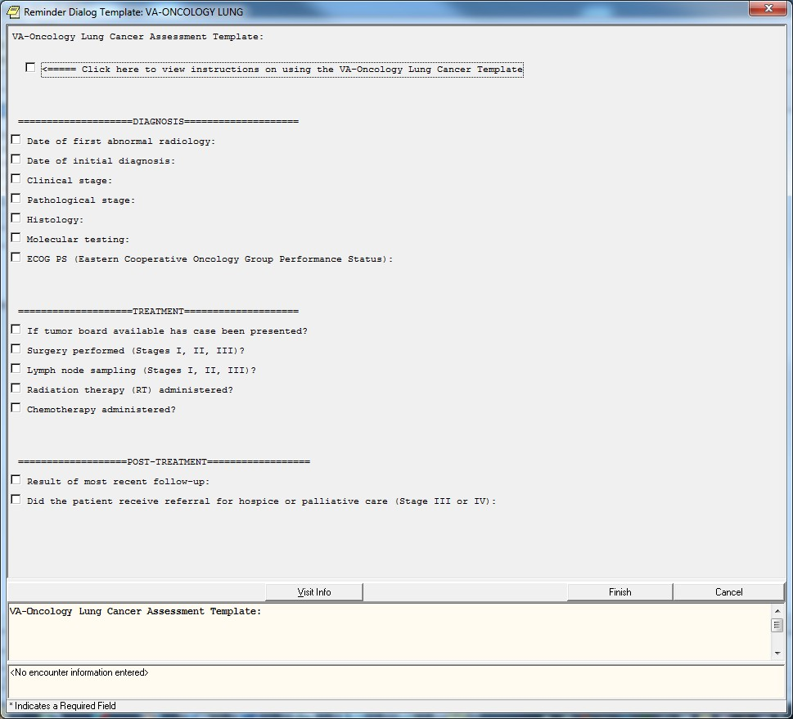

a. Missing Required Fields:
Whenever a section is opened the user is required to answer all questions in that section. If the user clicks on finish without answering all questions in a section a pop-up box will appear directing the user back to the specific unanswered question. For example, the ECOG PS section is not a required entry unless the user clicks on the checkbox for that section. Once that section is opened the user is required to select a score from the list. If the user clicks on finish without selecting an ECOG score the user will get the following error message:
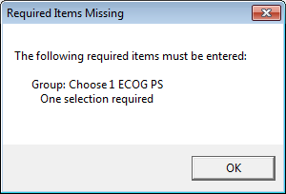

Subsequent Entries:

NOTE: After the initial use of VA-Oncology Lung Template the template text changes to Re- Assessment.
Initial Entry
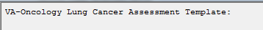

Subsequent Entry

Header
Previously entered information in the VA-Oncology Lung Template will display in a header. The Header information will be included in the progress note text and is similar to information that is often included manually at the top of oncology provider notes.
The Header is broken into three sections mimicking the template: diagnosis, treatment, and post-treatment. Each Header item will display up to 10 entries in descending order.

NOTE: The following elements are not included in the header: Performance status documentation (ECOG), tumor board presentations, and hospice and palliative referral. However, users are able to visualize previously entered information in these areas, provided data has been previously entered, when they click open these sections in the template (e.g. check to update text displays—see section below for more information).

Example A: The header below represents data that was entered in the fields: date of first abnormal radiology, date of initial diagnosis, pathological summary stage, histology, surgery performed, radiation therapy administered, and chemotherapy administered.
NOTE: No lung cancer POST-TREATMENT data available indicates that the user did not enter any information the Post-Treatment section.
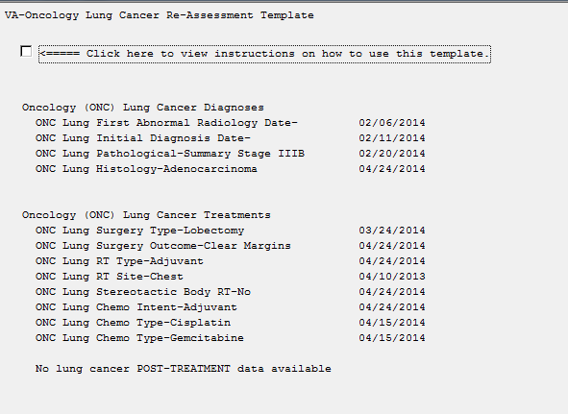

Check to Update
Once a section has been documented, the message “check to update” will display
upon subsequent use of the template. When a user clicks open a section that has “check to update” previously entered information will display. A user can then decide to enter

new data if applicable. Note: Radiation Therapy and Chemotherapy sections do not follow this rule. See section 4 page 7 for detailed instructions on the radiation and chemotherapy sections.
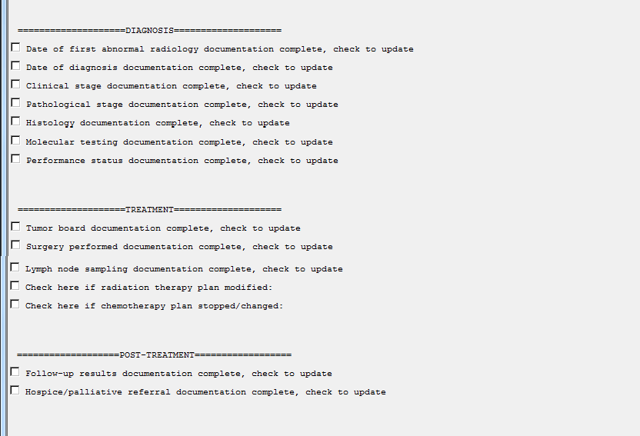

Example C (expanded check to update section):
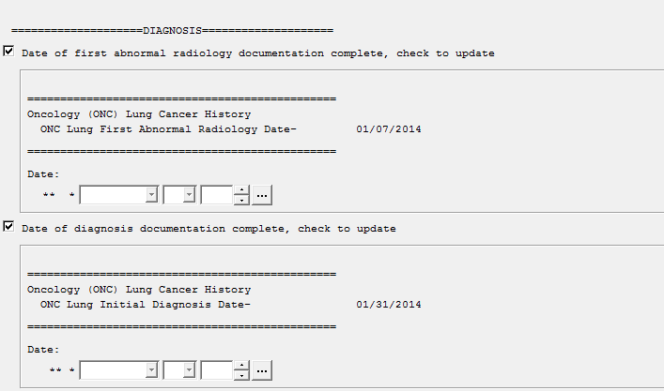
Previously entered information displays in sections that have “check to update.” This information does not pull into the progress note, but may be included in the header (see above).

  - Radiation Therapy/Chemotherapy Subsequent Entries:
User should enter reason for stopping/changing these therapies, and the date stopped. Users should document any new radiation therapy sites or new chemotherapy drugs that were started. Documentation of stopping and subsequent chemotherapy or radiotherapy may be done at the same time or at separate times, depending on the documentation appropriate to the patient’s care.

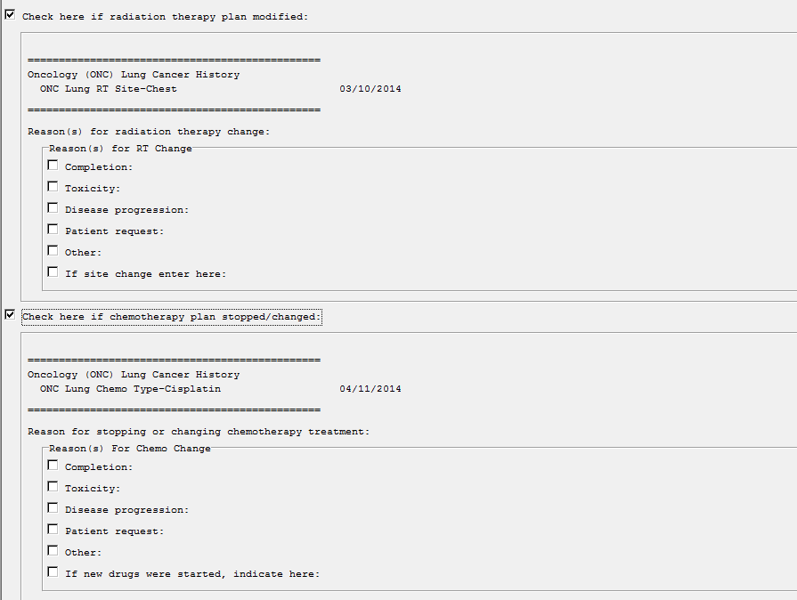
Previously entered chemotherapy information
Previously entered RT information

Date Fields
All date fields are required and are blank to decrease chances of entering erroneous dates. To enter a date click on the … symbol. This will open up the calendar in CPRS.
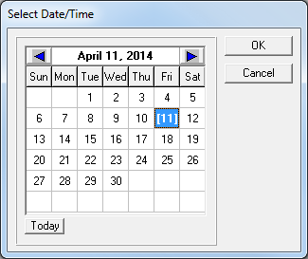

Instruction box for using the VA-Oncology Lung Cancer Template is included in template
