Clinical Reminders

Patches PXRM*2*15 and TIU*1*246

National TBI/Polytrauma Rehabilitation Dialog

INSTALLATION & SETUP GUIDE

March 2009

Office of Information and Technology Department of Veterans Affairs

Contents

INTRODUCTION 1
Web Sites 2
PRE-INSTALLATION 3
Required Software 3
Estimated Installation Time 3
INSTALLATION 4
- Retrieve the PXRM*2.0*15 build 4
- Install the build first in a training or test account. 4
- Load the distribution. 4
  - Backup a Transport Global 4
  - Compare Transport Global to Current System 4
  - Verify Checksums in Transport Global 5
  - Print Transport Global (optional) 5
- Install the build. 5
- Install File Print 6
- Build File Print 6
- Post-installation routines 6
- Deletion of init routines 6
SETUP 7
APPENDIX A: INSTALLATION EXAMPLE 16
APPENDIX B: REMINDER DIALOG 18
APPENDIX C: FAQ 22

ii Clinical Reminder Setup Guide March 2009

Introduction

The National Defense and Authorization Act (NDAA) calls for VA Medical Centers to use standardized documentation that outlines the plan of rehabilitation care and community reintegration for patients who have experienced a Traumatic Brain Injury (TBI). To meet the needs of the NDAA, Patient Care Services (PCS) supports the development of a standardized progress note title and associated documentation method for TBI Rehabilitation Care and Community Reintegration for use in the Computerized Patient Record System or in Veterans Health Information Systems & Technology Architecture (VistA) Order Entry/Results Reporting (OE/RR).

Ultimately, the addition of a standardized note title and documentation will ensure all patients receive the same level of care. It will also allow for national monitoring of the program as standardized data can be rolled up and extracted to those individuals who monitor the program directly.

This project consists of patch numbers PXRM*2.0*15 and TIU*1*246.

PXRM*2.0*15 Patch Description
The Reminder patch installs the Reminder Dialog VA-TBI/POLYTRAUMA REHAB/ REINTEGRATION PLAN OF CARE on your local system. The dialog will be used by Rehab clinicians to document the interdisciplinary treatment plan of care. The clinician will document the Type of Plan: an Initial plan, Interim Plan, or Discharge plan. The Type of Plan will be stored as a PCE Health Factor. In a future patch, the type of plan will be used to trigger a reminder for a follow-up review of the plan.

The remainder of the reminder dialog contains required topics that one clinician will use to collect word processing responses to meet requirements specified by the Office of Rehabilitation Services at VACO and the Secretary’s office.

TIU*1*246 description

This patch deploys the TBI/POLYTRAUMA DOCUMENTS / TBI/POLYTRAUMA REHABILITATION/REINTEGRATION PLAN OF CARE Document Class/Title Pair in support of NSR #20080818. It maps the newly introduced TBI/POLYTRAUMA REHABILITATION/REINTEGRATION PLAN OF CARE National Title to the TBI
TREATMENT PLAN NOTE Enterprise Standard Title, and if possible, activates the new title. It will optionally allow the site to attach the new TBI/POLYTRAUMA REHABILITATION/ REINTEGRATION PLAN OF CARE National Title to a local document class at the Clinical Application Coordinator's discretion.

Environment Check ROUTINE: TIUE246
Prior to installation, the routine checks to see whether the user is a member of the Clinical Application Coordinator (CAC) User Class. If not, it will prompt the user to affirm that they either have a CAC present with them, or have consulted a CAC, in order to offer an informed

decision as to which Document Class the new Title should be assigned to (with the new National TBI/POLYTRAUMA DOCUMENTS as default). It will also detect the case where the installation is complete, and if necessary, allow the site to move the Title to a different Document Class, cleaning up any residue in the process.

Pre- and post-install routine: TIUP246
Before the installation, it cleans out any prior instances of the REMINDERS EXCHANGE FILE ENTRY that deploys the TBI/POLYTRAUMA DOCUMENTS / TBI/POLYTRAUMA
REHABILITATION/REINTEGRATION PLAN OF CARE Document Class / Title Pair. Following installation, the routine installs the new TIU DOCUMENT DEFINITION entries into file 8925.1, maps the new TBI/POLYTRAUMA REHABILITATION/REINTEGRATION
PLAN OF CARE Title to the TREATMENT PLAN NOTE Enterprise Standard Title, activates the new title, and attaches the new Document Class to the PROGRESS NOTES class.

Web Sites
Site | URL | Description
National Clinical Reminders site | http://vista.med.va.gov/reminders | Contains manuals, PowerPoint presentations, and other information about  Clinical Reminders
VistA Document Library | http://www.va.gov/vdl/ | Contains manuals for Clinical Reminders  and
NOTE: In this document you will see references to both PXRM*2*15 and PXRM*2.0*15. The difference is that PXRM*2*15 is the name of the patch and PXRM*2.0*15 is the name of the build.
This patch can be loaded with users on the system. Installation will take less than 2 minutes. Installation should be coordinated with the person who manages Clinical Reminders at your site and be scheduled during a time of lower system usage.

Pre-Installation

This manual describes how to install and set up Clinical Reminders patch PXRM*2*15 and Text Integration Utilities patch, TIU*1*246.

Before proceeding with installation of this patch, you need to either have a CAC present with you, or have consulted the CAC as to the Document Class under Progress Notes in which the new TBI/POLYTRAUMA REHABILITATION/REINTEGRATION PLAN OF CARE Title
should be placed..

Required Software

Package/Patch | Namespace | Version | Comments
Clinical Reminders | PXRM | 2.0 | Fully patched
Health Summary | GMTS | 2.7 | Fully patched
HL7 | HL | 1.6 | Fully patched
Kernel | XU | 8.0 | Fully patched
MailMan | XM | 7.1 | Fully patched
Mental Health YS*5.01*85 | YS | 5.01
Text Integration Utilities (TIU)
VA FileMan | DI | 22 | Fully patched

Estimated Installation Time

Installation | About 2 minutes
Setup after installation by the Reminder  Manager or CAC to address local implementation | Approximately 20 minutes (depending partly  on the experience level of the manager or CAC)

Installation

This build can be installed with users on the system, but it should be done during non-peak hours.

NOTE: Before proceeding with installation of this patch, make sure a CAC is present or has been consulted about the Document Class under Progress Notes in which the new TBI/POLYTRAUMA REHABILITATION/REINTEGRATION
PLAN OF CARE Title should be placed.

The installation needs to be done by a person with DUZ(0) set to "@."

Retrieve the PXRM*2.0*15 build
Use ftp to access the build, the name of the host file is PXRM_2_0_15.KID, from one of the following locations:

Albany | REDACTED | REDACTED
Hines | REDACTED | REDACTED
Salt Lake City | REDACTED | REDACTED

Install the build first in a training or test account.
Installing in a non-production environment will give you time to get familiar with new functionality and complete the setup for reminders and dialogs prior to installing the software in production.

Load the distribution.
In programmer mode type, D ^XUP, select the Kernel Installation & Distribution System menu (XPD MAIN), then the Installation option, and then the option LOAD a Distribution. Enter your directory name and PXRM_2_0_15.KID at the Host File prompt.

Example
Select Installation Option: LOAD a Distribution

Enter a Host File:<your directory name> PXRM_2_0_15.KID

KIDS Distribution saved on Dec 14, 2007@11:53:53 Comment: PXRM*2.0*15

From the Installation menu, you may elect to use the following options:

Backup a Transport Global
This option will create a backup message of any routines exported with the patch. It will NOT back up any other changes such as DDs or templates.

Compare Transport Global to Current System
This option will allow you to view all changes that will be made when the patch is installed. It compares all components of the patch (routines, DDs, templates, etc.).

Verify Checksums in Transport Global
This option will allow you to ensure the integrity of the routines that are in the transport global. If there are any discrepancies, do not run the Install Package(s) option. Instead, run the Unload a Distribution option to remove the Transport Global from your system.
Retrieve the file again from the anonymous directory (in case there was corruption in FTPing) and Load the Distribution again. If the problem still exists, log a Remedy ticket and/or call the national Help Desk (1-888-596-HELP) to report the problem.

Print Transport Global (optional)
This option will allow you to view the components of the KIDS build.

Install the build.
From the Installation menu on the Kernel Installation and Distribution System (KIDS) menu, run the option Install Package(s). Select the build PXRM*2.0*15 and proceed with the install. If you have problems with the installation, log a Remedy ticket and/or call the National Help Desk to report the problem.
Select Installation & Distribution System Option: Installation
Select Installation Option: INSTALL PACKAGE(S)
Select INSTALL NAME: PXRM*2.0*15

Answer "NO" to the following prompt:

Want KIDS to INHIBIT LOGONs during install? NO// NO

NOTE: DO NOT QUEUE THE INSTALLATION, because this installation may ask questions requiring responses and queuing will stop the installation. The most common are replacements for finding items or quick orders during the installation of Reminder Exchange file entries.

NOTE: If you need to reinstall the build, you should answer No to the prompt “Is this acceptable” when you see this message:
You are not known to the system to be a Clinical Application Coordinator (CAC).

Before proceeding with installation of this patch, you need to either have a CAC present with you, or have consulted the CAC as to the Document Class under Progress Notes in which the new TBI/POLYTRAUMA REHABILITATION/REINTEGRATION PLAN OF CARE Title should be placed.

Are You Prepared to Continue? NO// YES

The TBI/POLYTRAUMA REHABILITATION/REINTEGRATION PLAN OF CARE Title has
already been installed on your system...

It currently descends from the TBI/POLYTRAUMA DOCUMENTS Document Class. Is this Acceptable? YES// NO
TIU*1.0*246 Build will not be installed, Transport Global deleted!
Feb 11, 2009@09:41:03

Installation Example
See Appendix A.
Setting up programmer environment Terminal Type set to: C-VT220

Select OPTION NAME: XPD MAIN Kernel Installation & Distribution System menu Select Kernel Installation & Distribution System Option: Installation
Select Installation Option: Install Package(s) [XPD INSTALL BUILD] Select INSTALL NAME: PXRM*2.0*15

Install File Print
Use the KIDS Install File Print option to print out the results of the installation process.
Select Utilities Option: Install File Print Select INSTALL NAME: PXRM*2.0*15

Build File Print
Use the KIDS Build File Print option to print out the build components.
CLINICAL REMINDERS
PXRM*2.0*15
Select BUILD NAME: DEVICE: HOME//
Select Utilities Option: Build File Print

Post-installation routines
TIUP246
This is the pre- and post-install routine for patch TIU*1*246. Before the installation, it cleans out any prior instances of the REMINDERS EXCHANGE FILE ENTRY that deploys the TBI/POLYTRAUMA DOCUMENTS / TBI/POLYTRAUMA INDIVIDUALIZED REHABILITATION/REINTEGRATION PLAN OF CARE
Document Class /Title Pair. After installation, the routine installs the new TIU DOCUMENT DEFINITION entries into file 8925.1, maps the new TBI/POLYTRAUMA INDIVIDUALIZED REHABILITATION/REINTEGRATION PLAN OF CARE Title to
the TREATMENT PLAN NOTE Enterprise Standard Title, activates the new title, and attaches the new Document Class to the PROGRESS NOTES class.

PXRMP15I
This is the pre- and post-install routine for patch PXRM*2.0*15. Before the installation, it cleans out any prior instances of the REMINDERS EXCHANGE FILE ENTRY that deploy the VA-TBI/POLYTRAUMA REHAB/REINTEGRATION PLAN OF CARE
reminder dialog. Following installation, it invokes the Reminders Exchange Utility's Silent Installer to install the new VA-TBI/POLYTRAUMA REHAB/REINTEGRATION PLAN OF CARE reminder dialog.

Deletion of init routines
After everything has been successfully installed you may delete the init routines.

Setup

The VA-TBI/POLYTRAUMA REHAB/REINTEGRATION PLAN OF CARE reminder dialogs
needs to be attached to the National Note TBI/POLYTRAUMA REHABILITATION/ REINTEGRATION PLAN OF CARE. This is done by assigning the reminder to a TIU Template, then attaching the template to the note title.

Steps to assign a reminder dialog to a TIU Template.

- Set the dialog to be used in a TIU Template. This is done by using the TIU Template Reminder Dialog Parameter under the CPRS Reminder Configuration option. Example is below.

Select OPTION NAME: PXRM MANAGERS MENU Reminder Managers Menu

Select Reminder Managers Menu Option: CP CPRS Reminder Configuration

Select CPRS Reminder Configuration Option: TIU TIU Template Reminder Dialog Parameter

Reminder Dialogs allows as Templates may be set for the following:

1 | User | USR | [choose from NEW PERSON]
3 | Service | SRV | [choose from SERVICE/SECTION]
4 | Division | DIV | [choose from INSTITUTION]
5 | System | SYS | [CPRS27.FO-SLC.MED.VA.GOV]
Enter selection: 5 System CPRS27.FO-SLC.MED.VA.GOV Select Display Sequence: 2
Are you adding 2 as a new Display Sequence? Yes// YES

Display Sequence: 2// 2
Clinical Reminder Dialog: VA-TBI/POLYTRAUMA REHAB/REINTEGRATION PLAN OF CARE reminder dialog NATIONAL
...OK? Yes// <Enter> (Yes)
Select Display Sequence: <Enter>

CA Add/Edit Reminder Categories CL CPRS Lookup Categories
CS CPRS Cover Sheet Reminder List MH Mental Health Dialogs Active PN Progress Note Headers
RA Reminder GUI Resolution Active
TIU TIU Template Reminder Dialog Parameter DL Default Outside Location
PT Position Reminder Text at Cursor NP New Reminder Parameters
GEC GEC Status Check Active WH WH Print Now Active

- 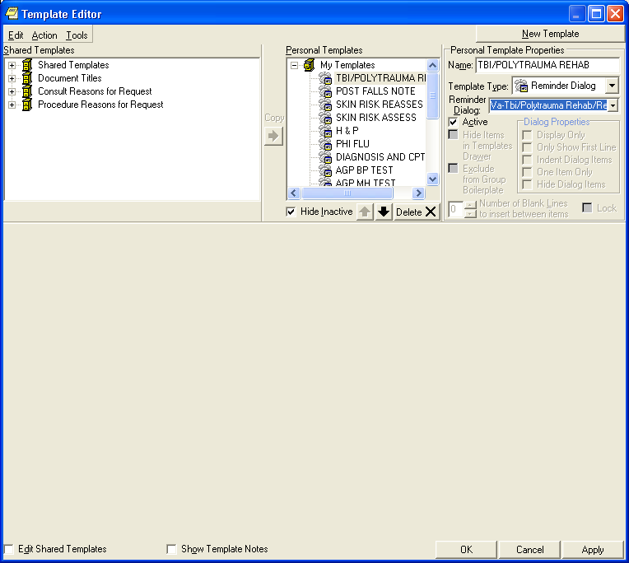In CPRS, create the new template and assign the reminder dialog to it. This is done by accessing the template editor from the Notes Tab in CPRS Options|Create New Template.
- In the Template Editor, enter a unique name in the Name field.
- Select Reminder Dialog in the Template Type field
- Select the VA-TBI/POLYTRAUMA REHAB/REINTEGRATION PLAN OF CARE entry in the Reminder Dialog field.

- 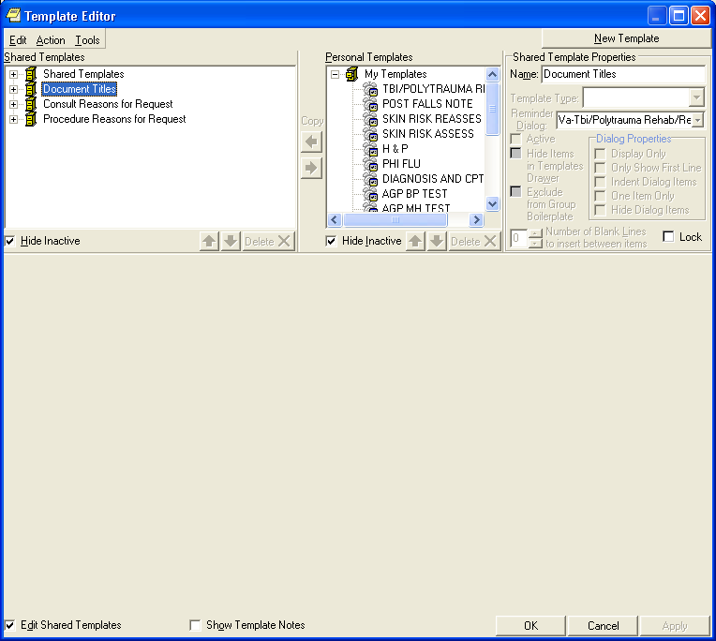In the template editor, click on the Document Titles category in the Shared Templates window pane.
- Make sure Edit Shared Templates checkbox is “checked.”

- 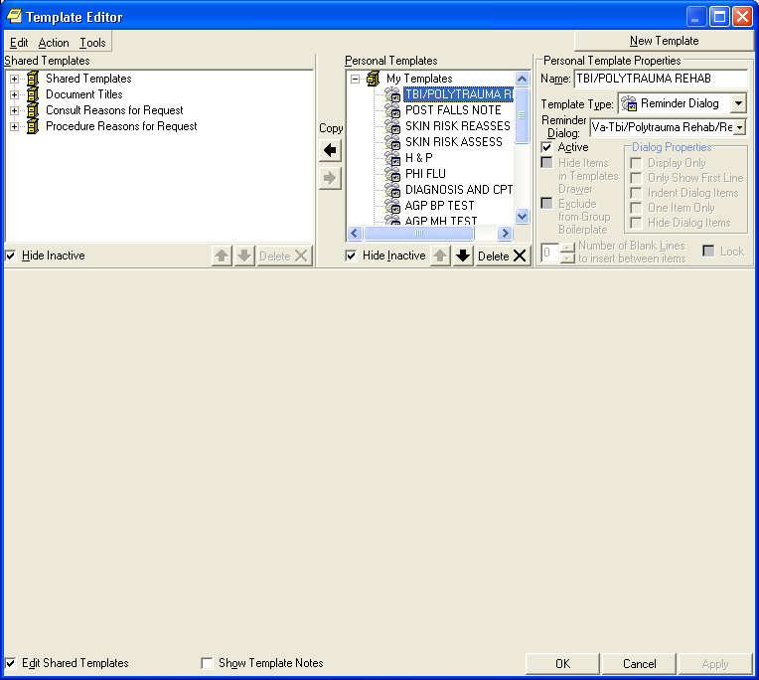Click on the template created in Step 3 in the Personal Templates window panes.

- Click on the arrow pointing to the left to move the new template under the Document Title category.

- Click OK.

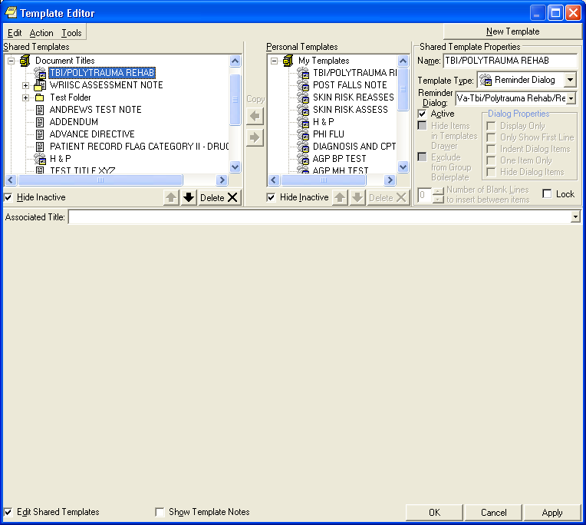
11. Verify that the new template is listed under the Document Titles category; then highlight it by clicking on the template.

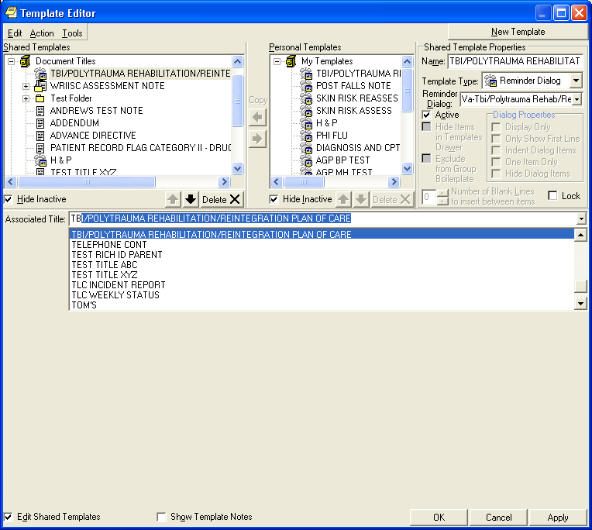
12. Pick the title TBI/POLYTRAUMA REHABILITATION/REINTEGRATION PLAN OF CARE in the Associated Title field, and click OK.

- Test the template by selecting the TBI/POLYTRAUMA REHABILITATION/ REINTEGRATION PLAN OF CARE when writing a new note.
  - In the CPRS GUI, open the NOTES tab.
  - Click on New Note.
  - When the Progress Note Properties box opens, type TBI in the Title box.
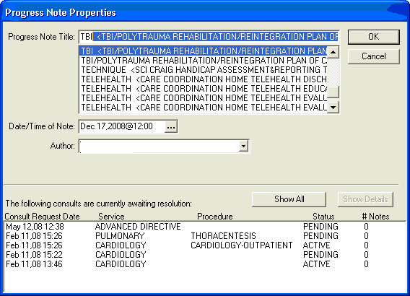
  - The TBI dialog template is displayed; click on it and click OK.

- The dialog opens up. Select the Plan of Care Type: Initial, Interim, or Discharge.

NOTE: It’s okay to answer “No” to the statement, “Plan Has Been Communicated to Military.”
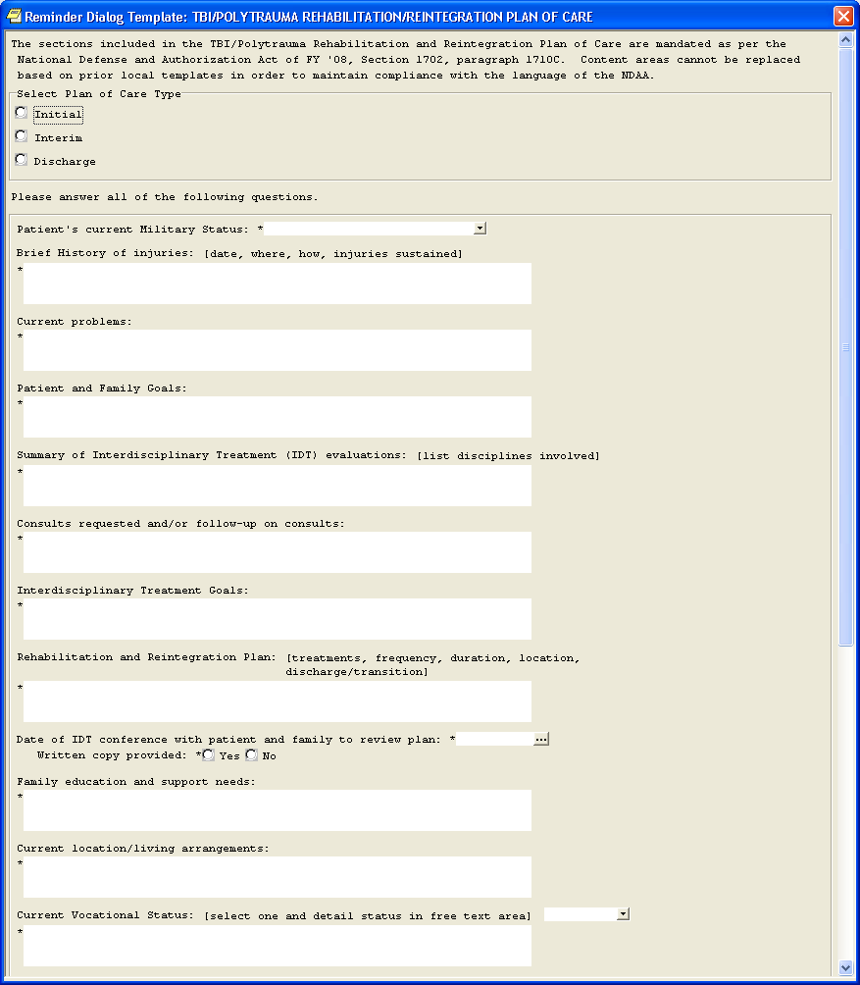

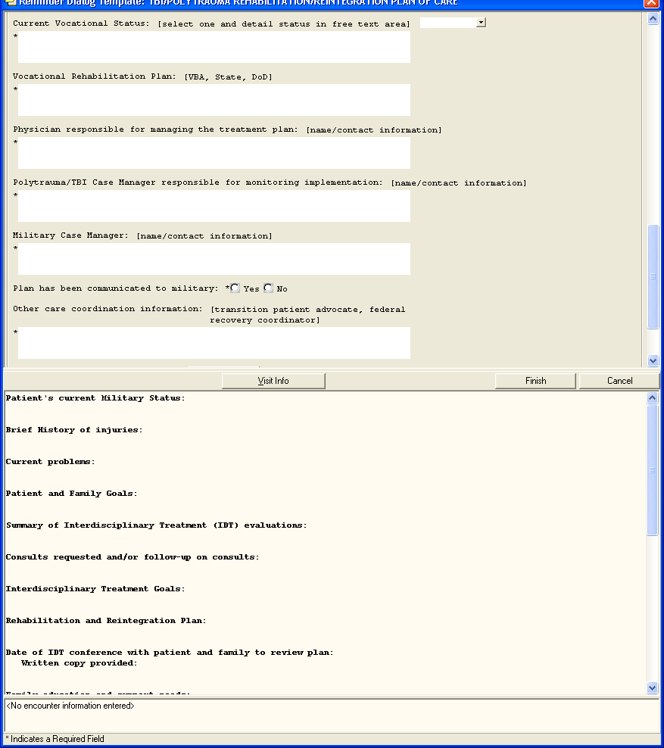

It’s okay to check “no”

- Ensure that selecting a Plan of Care Type creates one of the following Health Factors for the visit: TBI/POLYTRAUMA INITIAL PLAN OF CARE, TBI/POLYTRAUMA INTERIM PLAN OF CARE, TBI/POLYTRAUMA DISCHARGE PLAN OF CARE.
- Ensure the progress note text generated by the reminder dialog is appropriate.

Appendix A: Installation Example

Loaded from Distribution 2/3/09@16:18:16
=> PXRM*2.0*15 and TIU*1.0*246 ;Created on Feb 03, 2009@16:11:21

This Distribution was loaded on Feb 03, 2009@16:18:16 with header of PXRM*2.0*15 and TIU*1.0*246 ;Created on Feb 03, 2009@16:11:21
It consisted of the following Install(s): PXRM*2.0*15 TIU*1.0*246
Checking Install for Package PXRM*2.0*15 Install Questions for PXRM*2.0*15
Incoming Files:

811.8 REMINDER EXCHANGE (including data) Note: You already have the 'REMINDER EXCHANGE' File. I will OVERWRITE your data with mine.

Checking Install for Package TIU*1.0*246
Will first run the Environment Check Routine, TIUE246

You are not known to the system to be a Clinical Application Coordinator (CAC).

Before proceeding with installation of this patch, you need to either have a CAC present with you, or have consulted the CAC as to the Document Class under Progress Notes in which the new TBI/POLYTRAUMA REHABILITATION/REINTEGRATION PLAN OF CARE Title should be placed.

Are You Prepared to Continue? NO// YES

Install Questions for TIU*1.0*246

Incoming Files:

811.8 REMINDER EXCHANGE (including data) Note: You already have the 'REMINDER EXCHANGE' File. I will OVERWRITE your data with mine.

To be selectable, the new TBI/POLYTRAUMA REHABILITATION/REINTEGRATION PLAN OF CARE title must be added to an appropriate Document Class. If you don't specify a local Document Class, the title will be associated with a new National one called TBI/POLYTRAUMA DOCUMENTS.
...
Select Document Class for TBI/POLYTRAUMA: <== select local Document class or press Enter

Want KIDS to INHIBIT LOGONs during the install? NO//
Want to DISABLE Scheduled Options, Menu Options, and Protocols? NO//

Enter the Device you want to print the Install messages.
Don’t queue the install.
You can queue the install by enter a 'Q' at the device prompt. Enter a '^' to abort the install.

DEVICE: HOME// HOME

Install Started for PXRM*2.0*15 :

Feb 03, 2009@16:19:32

Build Distribution Date: Feb 03, 2009

Installing Routines:
Feb 03, 2009@16:19:32

Running Pre-Install Routine: PRE^PXRMP15I

Installing Data Dictionaries:
Feb 03, 2009@16:19:32

Installing Data:
Feb 03, 2009@16:19:32

Running Post-Install Routine: POST^PXRMP15I

Installing reminder VA-TBI/POLYTRAUMA REHAB/REINTEGRATION PLAN OF CARE

Updating Routine file... Updating KIDS files...
PXRM*2.0*15 Installed.
Feb 03, 2009@16:19:41

Not a production UCI

NO Install Message sent
TIU*1.0*246

Install Started for TIU*1.0*246 :
Feb 03, 2009@16:19:41

Build Distribution Date: Feb 03, 2009

Installing Routines:
Feb 03, 2009@16:19:41

Running Pre-Install Routine: PRE^TIUP246

Installing Data Dictionaries:
Feb 03, 2009@16:19:41

Installing Data:
Feb 03, 2009@16:19:41

Running Post-Install Routine: POST^TIUP246

Installing Reminder Exchange entry TIU*1*246 2009

Updating Routine file...

Updating KIDS files...

TIU*1.0*246 Installed.
Feb 03, 2009@16:19:41

Not a production UCI NO Install Message sent Install Completed

Appendix B: Reminder Dialog

REMINDER DIALOG INQUIRY Jan 15, 2009 3:27:58 pm Page 1

NUMBER: 1538

DIALOG NAME: VA-TBI/POLYTRAUMA REHAB/REINTEGRATION PLAN OF CARE

Type: reminder dialog

Associated reminder:
Class: NATIONAL
Sponsor: Office of Rehabilitation Services in VACO Review Date:

Edit History:

Edit Date: JAN 15,2009 14:45 Edit By: CRUSER, FIFTEEN
Edit Comments: Exchange Install

DIALOG COMPONENTS:

Seq. Dialog

1 Element: VA-TBI/POLY TEXT
Text: The sections included in the TBI/Polytrauma Rehabilitation and Reintegration Plan of Care are mandated as per the National Defense and Authorization Act of FY '08, Section 1702, paragraph 1710C. Content areas cannot be replaced based on prior local templates in order to maintain compliance with the language of the NDAA.

- Group: VA-TBI/POLY PLAN OF CARE TYPE Text: [BOX, SUPPRESS, SHOW, ONE ONLY] Resolution: DONE AT ENCOUNTER

  - Element: VA-TBI/POLY INITIAL PLAN Text: Initial Plan of Care
Finding: TBI/POLYTRAUMA INITIAL PLAN OF CARE [660172] (HEALTH FACTOR)
Resolution: DONE AT ENCOUNTER

3.5 Element: VA-TBI/POLY INTERIM PLAN Text: Interim Plan of Care
Finding: TBI/POLYTRAUMA INTERIM PLAN OF CARE [660177] (HEALTH FACTOR)
Resolution: DONE AT ENCOUNTER

3.10 Element: VA-TBI/POLY DISCHARGE PLAN Text: Discharge Plan of Care
Finding: TBI/POLYTRAUMA DISCHARGE PLAN OF CARE [660178] (HEALTH FACTOR)
Resolution: DONE AT ENCOUNTER

- Group: VA-TBI/POLY PLAN OF CARE QUESTIONS
Text: Please answer all of the following questions. [BOX, SUPPRESS, SHOW, NO SELECTION]

  - Element: VA-TBI/POLY MILITARY STATUS
Text: Patient's current Military Status: {FLD:TBI/POLY MILITARY STATUS}

5.3 Element: VA-TEXT BLANK LINE PN TEXT ONLY Text:

5.5 Element: VA-TBI/POLY HISTORY OF INJURIES
Text: Brief History of injuries: {FLD:TBI/POLY INJURIES INFO}
{FLD:TBI/POLY WORD PROCESSING}

5.8 Element: VA-TEXT BLANK LINE PN TEXT ONLY Text:

5.10 Element: VA-TBI/POLY PROBLEMS Text: Current problems:
{FLD:TBI/POLY WORD PROCESSING}

5.12 Element: VA-TEXT BLANK LINE PN TEXT ONLY Text:

5.15 Element: VA-TBI/POLY PATIENT GOALS Text: Patient and Family Goals:
{FLD:TBI/POLY WORD PROCESSING}

5.17 Element: VA-TEXT BLANK LINE PN TEXT ONLY Text:

5.20 Element: VA-TBI/POLY IDT EVALUATIONS
Text: Summary of Interdisciplinary Treatment (IDT) evaluations:
{FLD:TBI/POLY IDT INFO}
{FLD:TBI/POLY WORD PROCESSING}

5.22 Element: VA-TEXT BLANK LINE PN TEXT ONLY Text:

5.25 Element: VA-TBI/POLY CONSULTS
Text: Consults requested and/or follow-up on consults:
{FLD:TBI/POLY WORD PROCESSING}

5.28 Element: VA-TEXT BLANK LINE PN TEXT ONLY Text:

5.30 Element: VA-TBI/POLY IDT GOALS
Text: Interdisciplinary Treatment Goals:
{FLD:TBI/POLY WORD PROCESSING}

5.32 Element: VA-TEXT BLANK LINE PN TEXT ONLY Text:

INFO}
5.35 Element: VA-TBI/POLY REHAB AND REINTEGRATION PLAN
Text: Rehabilitation and Reintegration Plan: {FLD:TBI/POLY REHAB

{FLD:TBI/POLY WORD PROCESSING}

5.37 Element: VA-TEXT BLANK LINE PN TEXT ONLY Text:

5.40 Element: VA-TBI/POLY IDT CONF DATE
Text: Date of IDT conference with patient and family to review plan:
{FLD:TBI/POLY DATE}
Written copy provided: {FLD:TBI/POLY YESNO}

5.43 Element: VA-TEXT BLANK LINE PN TEXT ONLY Text:

5.45 Element: VA-TBI/POLY FAMILY ED AND SUPPORT NEEDS Text: Family education and support needs:
{FLD:TBI/POLY WORD PROCESSING}

5.50 Element: VA-TEXT BLANK LINE PN TEXT ONLY Text:

5.55 Element: VA-TBI/POLY CURRENT LIVING ARRANGEMENTS Text: Current location/living arrangements:
{FLD:TBI/POLY WORD PROCESSING}

5.60 Element: VA-TEXT BLANK LINE PN TEXT ONLY Text:

5.65 Element: VA-TBI/POLY VOCATIONAL STATUS
Text: Current Vocational Status: {FLD:TBI/POLY VOCATIONAL INFO}
{FLD:TBI/POLY VOCATIONAL STATUS}
{FLD:TBI/POLY WORD PROCESSING}

5.75 Element: VA-TEXT BLANK LINE PN TEXT ONLY Text:

5.80 Element: VA-TBI/POLY VOCATIONAL REHAB PLAN
Text: Vocational Rehabilitation Plan: {FLD:TBI/POLY VOCATIONAL REHAB INFO}
{FLD:TBI/POLY WORD PROCESSING}

5.85 Element: VA-TEXT BLANK LINE PN TEXT ONLY Text:

5.90 Element: VA-TBI/POLY PHYSICIAN MANAGING IDT PLAN
Text: Physician responsible for managing the treatment plan:
{FLD:TBI/POLY CONTACT INFO}
{FLD:TBI/POLY WORD PROCESSING}

5.95 Element: VA-TEXT BLANK LINE PN TEXT ONLY Text:

5.100 Element: VA-TBI/POLY CASE MANAGER
Text: Polytrauma/TBI Case Manager responsible for monitoring implementation: {FLD:TBI/POLY CONTACT INFO}
{FLD:TBI/POLY WORD PROCESSING}

5.105 | Element: VA-TEXT BLANK LINE PN TEXT ONLY  Text:
5.110 | Element: VA-TBI/POLY MILITARY CASE MANAGER  Text: Military Case Manager: {FLD:TBI/POLY CONTACT INFO}
{FLD:TBI/POLY WORD PROCESSING}
5.115 | Element: VA-TEXT BLANK LINE PN TEXT ONLY  Text:
5.120 | Element: VA-TBI/POLY PLAN COMM TO MILITARY  Text: Plan has been communicated to military: {FLD:TBI/POLY YESNO}
5.125 | Element: VA-TEXT BLANK LINE PN TEXT ONLY  Text:
5.130 | Element: VA-TBI/POLY OTHER CARE COORD INFO

Text: Other care coordination information: {FLD:TBI/POLY OTHER INFO}
{FLD:TBI/POLY WORD PROCESSING}
{FLD:TBI/POLY WORD PROCESSING}

5.135 | Element: VA-TEXT BLANK LINE PN TEXT ONLY  Text:
5.140 | Element: VA-TBI/POLY NEXT REVIEW DATE  Text: Date care plan will be reviewed {FLD:TBI/POLY DATE}
5.145 | Element: VA-TEXT BLANK LINE PN TEXT ONLY  Text:
5.150 | Element: VA-TBI/POLY ADDITIONAL INFO  Text: Additional Information: {FLD:TBI/POLY ADD INFO}

Appendix C: FAQ

Q: What is meant by Current Problems (physical, mental, spiritually, etc.…)

A: The purpose of the template is to document the Rehabilitation and Reintegration plan of care. Community reintegration refers to the resumption of age, gender, and culturally appropriate roles in the family, community and workplace. Community reintegration should emphasize a multidisciplinary approach, which also includes peers and family, in the attempt to close the gap between treatment activities and functional competence in the individual’s natural environment. The primary focus of community reintegration should be on what the individual with polytrauma and TBI needs to achieve for returning to home, community, work, or school. That being said, the current problems section of the template should be used to address any barriers the patient is facing, which are limiting their ability to successfully resume the roles mentioned above. There is intentional flexibility to allow the treatment team to document the primary problems for each individual patient, but this could refer to physical, mental, spiritual problems, or even be broken down further into memory, balance, strength, cognition, etc., problems.

Q: Who is supposed to be the managing physician if the patient is seen by multiple specialists, such as MH, TBI, primary care, and what if the patient is being discharged from the hospital.

A: The managing physician should be the physiatrist on the Polytrauma/TBI Interdisciplinary Team.

Q: Who is the Military Case Manager if the patient is discharged from the military? Does the document need to be sent to the military if the patient is a veteran? This raises the question: why are these fields required?

A: This would not be applicable if the patient has been discharged from the military. The law says VA is to assume case management roles if they are discharged.

Q: What is the date of review if the patient is being discharged from the hospital? This raises the question: why is this field required?

A: The template is to document the Rehabilitation and Reintegration plan of care for a patient as s/he transitions back into the community. It is not an inpatient-specific tool, but rather a tool for the IDT to document their plan as patients resume their roles or ‘reintegrates’ back into the community.

Q: Is the Discharge Plan of Care for being discharged from the hospital or from the program?

A: This can be either, depending upon the overall plan for the patient. If the IDT feels an inpatient does not have future issues to be addressed related to their rehabilitation and

reintegration back into the community, it may take place at the time of DC from the hospital. In many cases, these individuals may continue to require services as they resume their roles in the community, and the Discharge plan of care would then be utilized when they are ultimately DC’d from the IDT program while an outpatient.

