Delivery Operations Claims Management Platform (DOCMP) – Pega

Software Version 1.0

User Guide
January 2024
Department of Veterans Affairs
Office of Information and Technology (OIT)

Revision History
NOTE: The revision history cycle begins once changes or enhancements are requested after the document has been baselined.
Date | Revision | Description | Author
01/18/2024 | 1.0 | Initial Release. | VetsEZ

Artifact Rationale
Per the Veteran-focused Integrated Process (VIP) Guide, the User’s Guide is required to be completed prior to Critical Decision Point #2 (CD2), with the expectation that it will be updated as needed. A User Guide is a technical communication document intended to give assistance to people using a particular system, such as VistA end users. It is usually written by a technical writer, although it can also be written by programmers, product or project managers, or other technical staff. Most user guides contain both a written guide and the associated images. In the case of computer applications, it is usual to include screenshots of the human-machine interfaces, and hardware manuals often include clear, simplified diagrams. The language used is matched to the intended audience, with jargon kept to a minimum or explained thoroughly. The User Guide is a mandatory, build-level document, and should be updated to reflect the contents of the most recently deployed build. The sections documented herein are required if applicable to your product.
Table of Contents
1. Introduction 1
1.1. Purpose 1
1.2. Document Orientation 1
1.2.1. Organization of the User Guide 1
1.2.2. Assumptions 2
1.2.3. Disclaimers 2
1.2.3.1. Software Disclaimer 2
1.2.3.2. Documentation Disclaimer 2
1.2.4. Documentation Conventions 2
1.3. Enterprise Service Desk and Organizational Contacts 3
2. System Summary 4
2.1. Configuration 4
2.2. Data Flows 4
2.3. User Access Levels 5
2.4. Continuity of Operation 5
3. Getting Started 5
3.1. Logging On 5
3.2. System Menu 6
3.2.1. Home Page Overview 6
3.2.2. User Role Functionality 8
3.2.2.1. Read-Only User 8
3.2.2.2. EEV Contact Representatives 9
3.2.2.3. EEV Supervisor 10
3.2.2.4. EEV Supervisor Dashboard Overview 11
3.2.2.5. OHI Supervisor 14
3.2.2.6. OHI Supervisor Dashboard Overview 15
3.2.2.7. OHI Voucher Examiner 17
3.3. Logging Off 18
4. Using the Software 19
4.1. Conducting a Search 19
4.2. Viewing Documents 21
4.2.1. Document Details Functions 22
4.2.1.1. Viewing Related Documents 22
4.2.1.2. Auditing Documents 23
4.2.1.3. Escalating Documents 23
4.3. Assigning Cases 24
4.3.1. Assigning Cases in the Work Queue 24
4.3.2. Assigning Cases in the Work List 25
4.4. Pulling Reports 26
4.4.1. Exporting Reports 27
4.5. Editing Cases 28
4.5.1. Bulk Editing Cases 30
4.6. Working with OHI Certificates 31
4.6.1. Self-Assign a Document 31
4.6.2. View and Update OHI Certificates 32
5. Appendix A: Acronyms and Abbreviations 34

Table of Figures
Figure 1: DOCMP – Pega Data Flow Diagram 4
Figure 2: DOCMP – Pega Login Page 6
Figure 3: DOCMP - Pega Home Page 6
Figure 4: DOCMP - Pega Dashboard 7
Figure 5: DOCMP - Pega Application Header 7
Figure 6: DOCMP - Pega Tabs 7
Figure 7: DOCMP - Pega Sidebar Navigation 8
Figure 8: Default Read-Only User Screen 8
Figure 9: EEV Contact Representative Dashboard Example 9
Figure 10: EEV Supervisor Dashboard 10
Figure 11: EEV Supervisor Dashboard - Daily Workload Report 11
Figure 12: EEV Supervisor Dashboard – Work Queue 12
Figure 13: EEV Supervisor Dashboard – Work List 13
Figure 14: Default OHI Supervisor User Screen 14
Figure 15: OHI Supervisor Dashboard – Work Queue 15
Figure 16: OHI Supervisor Dashboard – Work List 16
Figure 17: Default OHI Voucher Examiner Screen 17
Figure 18: User Profile drop-down menu 18
Figure 19: DOCMP - Pega Search Options Tab 19
Figure 20: DOCMP - Pega Search Option Entry 20
Figure 21: DOCMP - Pega Search Results 21
Figure 22: EEV Contact Representative Dashboard 21
Figure 23: Document Details Tab 22
Figure 24: Document Details - Related Function 23
Figure 25: Document Details - Audit Function 23
Figure 26: Document Details – Escalate Confirmation Dialog Box 24
Figure 27: Unassigned Work Queue 24
Figure 28: Assigned Document Confirmation Message 25
Figure 29: Assigned Work List 25
Figure 30: Work List – Assign To Selection 26
Figure 31: Report Browser Tab 26
Figure 32: Report Details Tab 27
Figure 33: EEV Contact Representative User Dashboard 28
Figure 34: EEV Contact Representative Document Details Tab (1 of 2) 28
Figure 35: EEV Contact Rep Document Details Tab (2 of 2) - Additional Details View 29
Figure 36: Save Confirmation 29
Figure 37: User Work List Selected Cases 30
Figure 38: Bulk Edits Dialog Box 30
Figure 39: OHI Voucher Examiner Dashboard 31
Figure 40: Self-assign Confirmation 32
Figure 41: OHI Document Details Tab (1 of 2) 32
Figure 42: OHI Document Details Tab (2 of 2) - Additional Details View 33
Figure 43: OHI Document Save Confirmation 33

Introduction
The Delivery Operations Claims Management Platform (DOCMP) – Pega is a tool designed to provide the Department of Veterans Affairs (VA) with a way to receive, track, and archive incoming documents. It enables Veteran Family Medical Programs (VFMP) to process intakes of new beneficiary applications, process, and review reimbursement claims, and logs the documents’ history once it is scanned into the VA system. These all enable VFMP to file and reimburse Veterans and their beneficiaries in a timely manner.

Purpose
The purpose of this document is to provide simple and comprehensive instructions for using the DOCMP – Pega user interface (UI) screens.

Document Orientation
The Delivery Operations Claims Management Platform (DOCMP) - Pega v1.0 User Guide will provide explanations of each screen and of all user interface options within the context of an easy-to-understand demonstration data scenario.
This document is also designed to provide the user with screen-by-screen “how to” information on the usage of DOCMP - Pega.

Organization of the User Guide
- Section 1: Introduction
This section provides the purpose of this manual, an overview of the DOCMP – Pega software, disclaimers, conventions, and contact information for the user to seek additional information.
- Section 2: System Summary
This section provides a graphical representation of the DOCMP – Pega data flow and an explanation of the application’s user access levels.
- Section 3: Getting Started
This section provides initial steps to register a user with DOCMP – Pega, as well as a general walkthrough of the system from initiation through exit, enabling the user to understand the sequence and flow of the system.
- Section 4: Using the Software
This section provides users with step-by-step instructions on how to complete operations in DOCMP – Pega.
- Appendix A: Acronyms and Abbreviations
This section provides a list of acronyms and abbreviations found in this document.

Assumptions
This guide was written with the following assumed experience/skills of the audience:
- Users have been provided with the appropriate active roles and access to the DOCMP – Pega web application.
- Users have completed any prerequisite training on the DOCMP – Pega web application.

Disclaimers

Software Disclaimer
This software was developed at the Department of Veterans Affairs (VA) by employees of the Federal Government in the course of their official duties. Pursuant to title 17 Section 105 of the United States Code this software is not subject to copyright protection and is in the public domain. VA assumes no responsibility whatsoever for its use by other parties, and makes no guarantees, expressed or implied, about its quality, reliability, or any other characteristic. We would appreciate acknowledgement if the software is used. This software can be redistributed and/or modified freely if any derivative works bear some notice that they are derived from it, and any modified versions bear some notice that they have been modified.

Documentation Disclaimer
The appearance of external hyperlink references in this manual does not constitute endorsement by the Department of Veterans Affairs (VA) of this Web site or the information, products, or services contained therein. The VA does not exercise any editorial control over the information you may find at these locations. Such links are provided and are consistent with the stated purpose of the VA.

Documentation Conventions
This guide uses the following methods to highlight different aspects of the material.
Table 1: Documentation Symbols and Descriptions
Symbol | Description
 | Informs the reader of generally useful information related to the topic.
 | Contains useful information for accomplishing specific tasks.

Enterprise Service Desk and Organizational Contacts
For issues related to DOCMP – Pega that cannot be resolved by this guide or the site administrator, please contact the Enterprise Service Desk (ESD).

System Summary

Configuration
DOCMP – Pega is accessed using a secure web browser and a secure Virtual Private Network (VPN).

Data Flows
Figure 1: DOCMP – Pega Data Flow Diagram
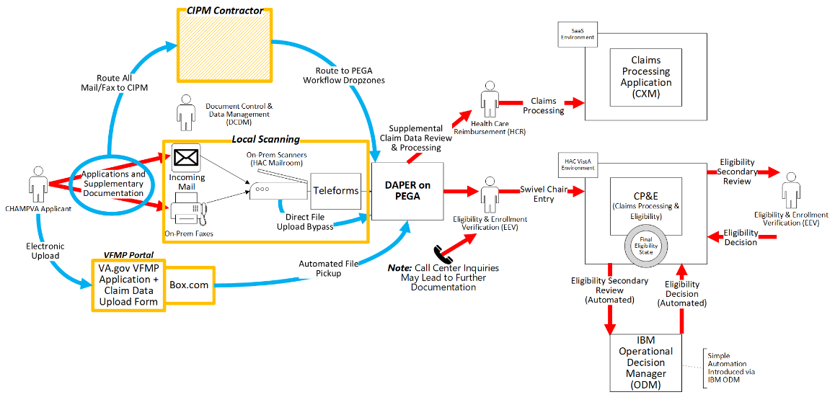

User Access Levels
The access to each feature in DOCMP – Pega is aligned to user roles and responsibilities. Some features included in this User Guide will not be visible or available to all users. There are five DOCMP – Pega user access levels:
- VFMP Read-Only: This user type can only search and view documents and is unable to make any updates or submissions.
- Eligibility, Enrollment, and Verification (EEV) Contact Representatives: EEV Contact Representatives can use DOCMP – Pega to edit their assigned cases, view attachments to enter the beneficiary's demographics into Veterans Health Information Systems and Technology Architecture (VistA) and notate determination information.
- EEV Supervisor: EEV Supervisors can use DOCMP – Pega to assign eligibility cases to their team members as well as generate reports on a variety of case-related information.
- Office of Health Information (OHI) Supervisor: OHI Supervisors can use DOCMP – Pega to assign cases to their team members.
- OHI Voucher Examiner: OHI Voucher Examiners from the Review and Resolution Department (R&R) can use DOCMP – Pega to see the incoming OHI Certificates for applicants that are already entered into VistA and finalize their insurance eligibility.

Continuity of Operation
The VA Enterprise Cloud (VAEC) handles the Continuity of Operations.

Getting Started
This section describes the process of gaining access to the DOCMP – Pega application and walks through the application from initiation to exit.

Logging On
To log on to the DOCMP – Pega application, users first must authenticate their Personal Identity Verification (PIV) card and sign on to the VA network. After users have completed the authentication process, they can access the DOCMP – Pega site.
- Navigate to the DOCMP - Pega URL. The DOCMP – Pega Login Page displays.
Figure 2: DOCMP – Pega Login Page
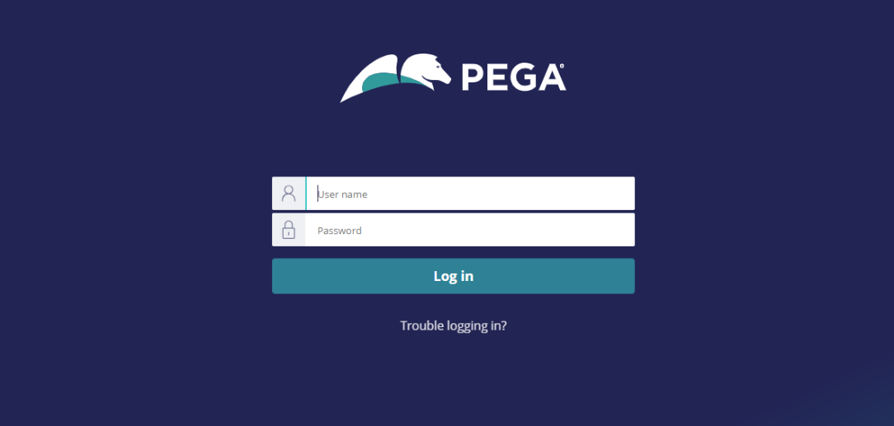
- Enter your User name and Password.
- Select Log in.

System Menu
The DOCMP – Pega application offers different menu options for the functions specific to each user role: VFMP Read-only User, EEV Contact Representatives, EEV Supervisor, OHI Supervisor, and OHI Voucher Examiner. Once you have been assigned your role, you will be able to access its functions.

Home Page Overview
Figure 3: DOCMP - Pega Home Page
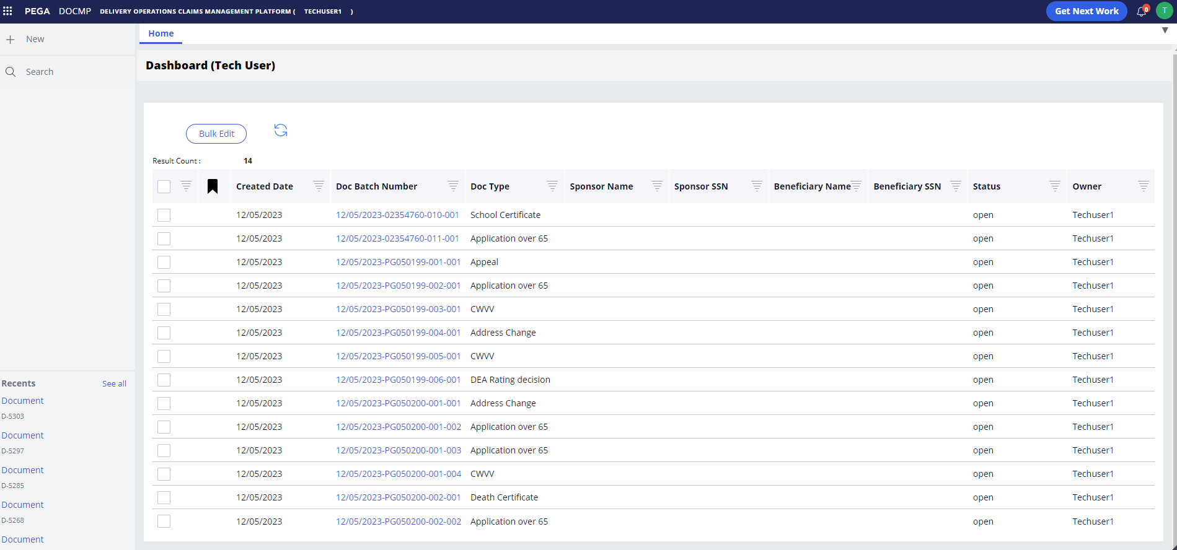
The DOCMP - Pega home page contains some general elements that are common to all user views:
- Dashboard - is the main content area of the application and displays content in individual tabs based on what the user has selected.
Figure 4: DOCMP - Pega Dashboard
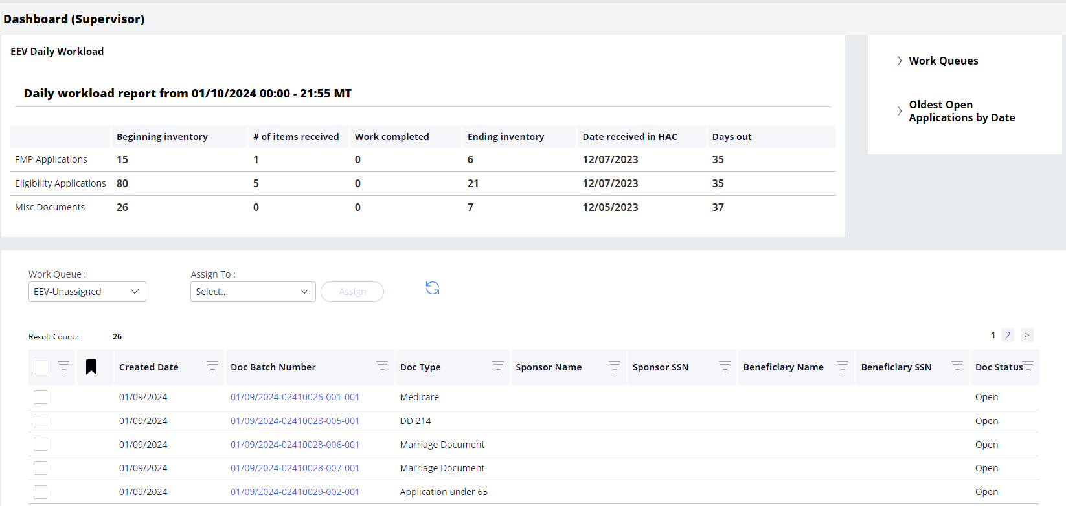
- Application Header - at the top of the page. Displays the application name and the role type of the active user. The header also includes the Get Next Work button, the notifications icon, and the user profile icon.
Notifications are not currently enabled at this time, but this feature will be available with a future release.
Figure 5: DOCMP - Pega Application Header
- Tabs – below the Application Header. Displays the active content on the dashboard. When a new action is taken (e.g., selecting a document selection or conducting a search) a new tab will open.
Figure 6: DOCMP - Pega Tabs
- Sidebar Navigation – located on the left side of the page. Lists the operations available for each role type.
Figure 7: DOCMP - Pega Sidebar Navigation
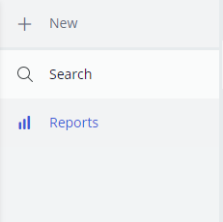

User Role Functionality

Read-Only User
Read-only users may only run searches and view documents within the application and cannot make any changes or updates.
Figure 8: Default Read-Only User Screen
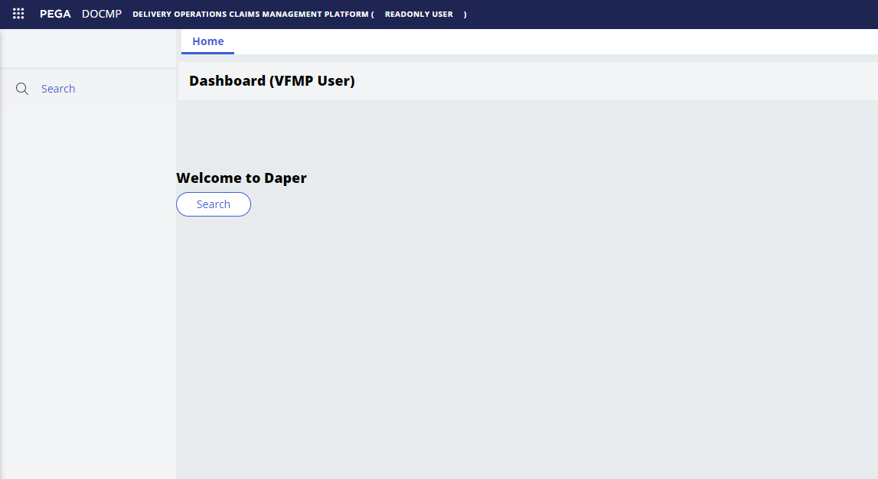

EEV Contact Representatives
Users with the EEV Contact Representative role can view and edit the documents that have been assigned to them in DOCMP - Pega. After logging into the application, the EEV Contact Representative Dashboard displays. Their dashboard displays a table of work items that have been assigned to them.
Figure 9: EEV Contact Representative Dashboard Example
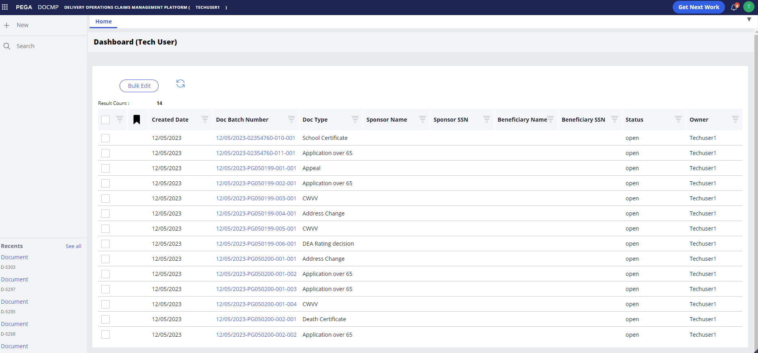
Contact Representative users have access to the following functions:
- Search: This button is located within the sidebar navigation and when selected, will open a new tab allowing the user to choose from a variety of options to refine their search of available documents.
- Recents: Also accessed from the sidebar navigation and lists the user’s most recently accessed documents.
- Get Next Work: This button is in the header at the top of the page. When selected, it opens the user’s next work item in a new tab.
- Bulk Edit: Located above the work list, this button allows the user to select multiple cases and update them all with the same information or action.
- Refresh button: This button allows the user to refresh the list to view the most recent items.
The Work Queue lists all items that have been assigned to the user and contains the following fields:
- Result Count: A read-only field that displays the total number of items that have been assigned to the user.
- Created Date: The date on which the document was uploaded into the system.
- Doc Batch Number: A system-generated number used to identify the batch associated with a document upload; especially useful when there are multiple documents associated with a case.
- Doc Type: Specifies the type of document (e.g., school certificate, Medicare, etc.)
- Sponsor Name: First and last name of the sponsor.
- Sponsor SSN: The sponsor’s Social Security Number (SSN).
- Beneficiary Name: First and last name of the person named as beneficiary.
- Beneficiary SSN: The beneficiary’s SSN.
- Doc Status: Displays the working status of the item (e.g., Open, Complete, etc.)
- Owner: Displays the user that is currently assigned to work on the item.

EEV Supervisor
Users with the EEV Supervisor role can assign cases to their team members, pull reports, and review escalated cases.
Figure 10: EEV Supervisor Dashboard
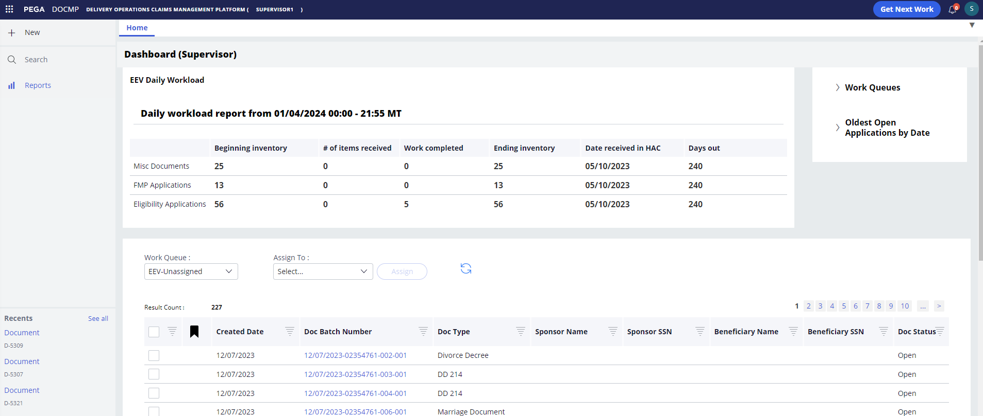
EEV Supervisors have access to the following main functions:
- Search: This button is located within the sidebar navigation and when selected, will open a new tab allowing the user to choose from a variety of options to refine their search of available documents.
- Reports: Located within the sidebar navigation; opens a new tab which displays all reports that are available to view.
- Recents: Accessed from the sidebar navigation and lists the user’s most recently accessed documents.
- Get Next Work: This button is in the header at the top of the page. When selected, it opens the user’s next work item in a new tab.
- Assign: This button allows supervisors to assign or re-assign work items to their team members.
- Bulk Edit: Located above the work list, this button allows the user to select multiple cases and update them all with the same information or action.

EEV Supervisor Dashboard Overview
The EEV Supervisor dashboard contains three main sections that the user can work from:
- Daily Workload
- Work Queue
- Work List
The Daily Workload section displays a report of the total workload inventory from the previous day, organized by type. The data shown in this report is updated daily. It contains the following fields:
Figure 11: EEV Supervisor Dashboard - Daily Workload Report
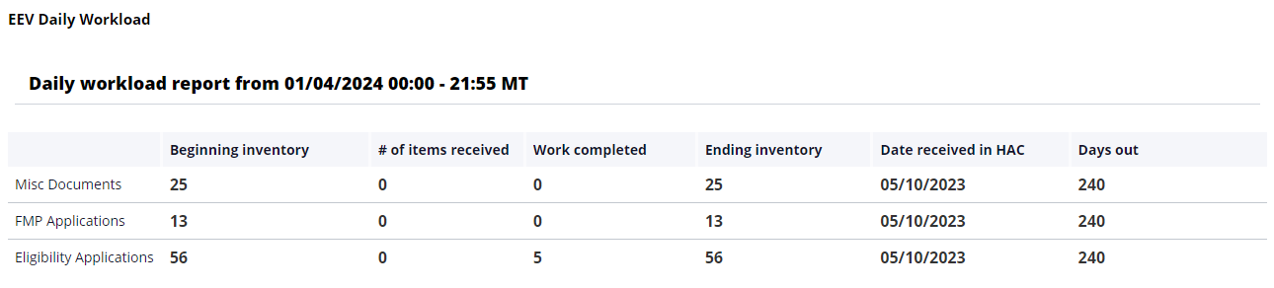
- Beginning inventory: The total count of work items that were in the system at the end of the previous day.
- # of items received: The number of new items received the previous day.
- Work completed: The number of work items marked as completed.
- Ending inventory: The total count of open work items in the system the last time the report was refreshed.
- Date received in HAC: Date when VFMP received the file; included in the Doc Batch Number.
- Days out: The number of days from date received to previous/current day.

The Work Queue lists all items that need to be assigned or worked on.
Figure 12: EEV Supervisor Dashboard – Work Queue
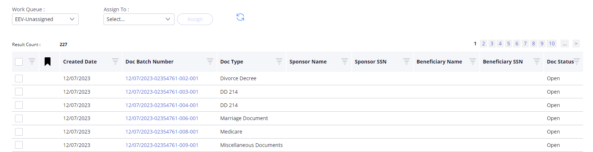
- Work Queue: Drop-down menu that allows a supervisor to select the status of the work items listed. Options include:
  - Unassigned – All items that have not yet been assigned to a team member or queue.
  - Supervisor Action – Items that require action on behalf of the supervisor.
  - Rescan Request – Items that have been flagged as needing to be rescanned due to visual quality or other reason.
- Assign To: Drop-down menu that lists team members or groups that can have cases assigned to them.
- Assign: This button allows supervisors to assign or re-assign work items to their team members.
- Refresh button: This button allows the user to refresh the list to view the most recent items.
- Result Count: A read-only field that displays the total number of items still listed in the queue.
- Created Date: The date on which the document was uploaded into the system.
- Doc Batch Number: A system-generated number used to identify the batch associated with a document upload; especially useful when there are multiple documents associated with a case.
- Doc Type: Specifies the type of document (e.g., school certificate, Medicare, etc.)
- Sponsor Name: First and last name of the sponsor.
- Sponsor SSN: The sponsor’s SSN.
- Beneficiary Name: First and last name of the person named as beneficiary.
- Beneficiary SSN: The beneficiary’s SSN.
- Doc Status: Displays the working status of the item (e.g., Open, Complete, etc.)

The Work List contains work items that have already been assigned to a particular user.
Figure 13: EEV Supervisor Dashboard – Work List
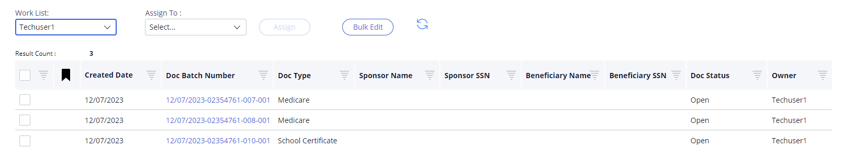
- Work List: Drop-down menu that allows a supervisor to select a team member from the drop-down menu to see what has already been assigned to that individual.
- Assign To: Drop-down menu that lists of team members or groups that can have cases assigned to them. A supervisor can use this to re-assign an item to another team member, if desired.
- Assign: This button allows supervisors to assign or re-assign work items to their team members.
- Bulk Edit: Located above the work list, this button allows the user to select multiple cases and update them all with the same information or action.
- Refresh button: Displayed as an image, this button allows the user to refresh the list to view the most recent items.
- Result Count: A read-only field that displays the total number of items contained in the list.
- Created Date: The date on which the document was uploaded into the system.
- Doc Batch Number: A system-generated number used to identify the batch associated with a document upload; especially useful when there are multiple documents associated with a case.
- Doc Type: Specifies the type of document (e.g., school certificate, Medicare, etc.)
- Sponsor Name: First and last name of the sponsor.
- Sponsor SSN: The sponsor’s SSN.
- Beneficiary Name: First and last name of the person named as beneficiary.
- Beneficiary SSN: The beneficiary’s SSN.
- Doc Status: Displays the working status of the item (e.g., Open, Complete, etc.)
- Owner: Displays the user that is currently assigned to work on the item.

OHI Supervisor
Users with the OHI Supervisor role can assign cases to their team members and review escalated cases.
Figure 14: Default OHI Supervisor User Screen
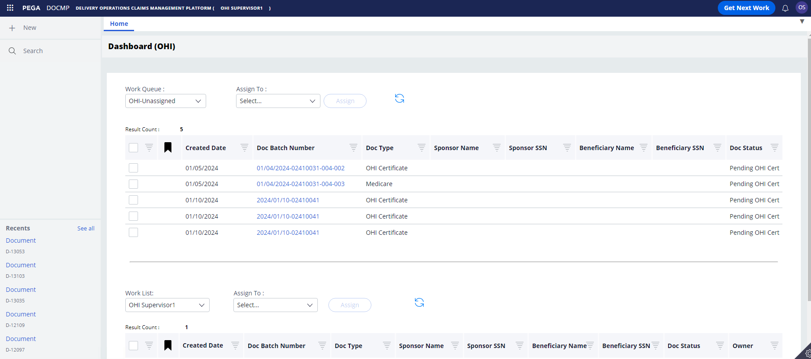
OHI Supervisors have access to the following main functions:
- Search: This button is located within the sidebar navigation and when selected, will open a new tab allowing the user to choose from a variety of options to refine their search of available documents.
- Recents: Accessed from the sidebar navigation and lists the user’s most recently accessed documents.
- Get Next Work: This button is in the header at the top of the page. When selected, it opens the user’s next work item in a new tab.
- Assign: This button allows supervisors to assign or re-assign work items to their team members.

OHI Supervisor Dashboard Overview
The OHI Supervisor dashboard contains two main sections that the user can work from:
- Work Queue
- Work List
The Work Queue lists all items that need to be assigned or worked on.
Figure 15: OHI Supervisor Dashboard – Work Queue
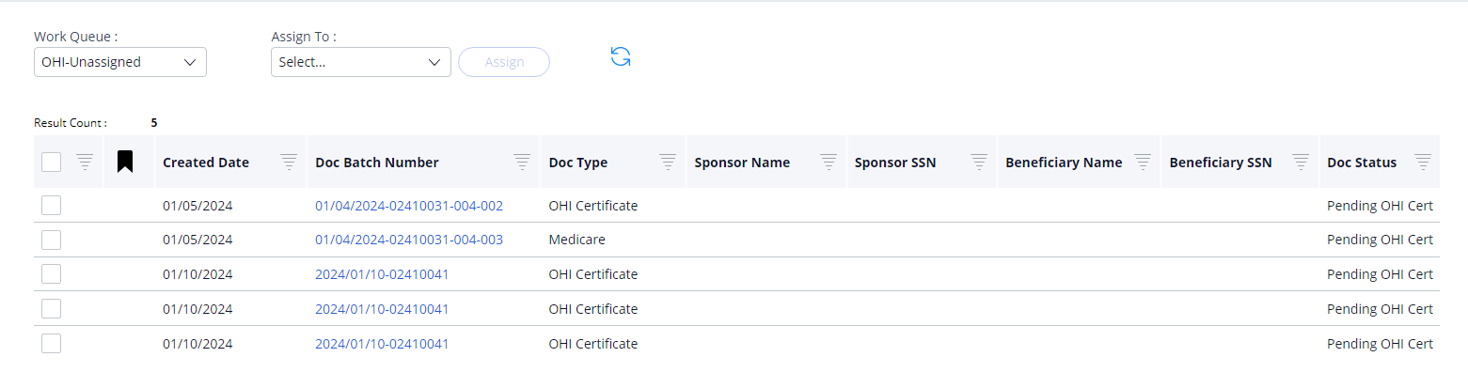
- Work Queue: Drop-down menu that allows a supervisor to select the status of the work items listed. Options include:
  - Unassigned – All items that have not yet been assigned to a team member or queue.
  - Supervisor Action – Items that require action on behalf of the supervisor.
  - Rescan Request – Items that have been flagged as needing to be rescanned due to visual quality or other reason.
- Assign To: Drop-down menu that lists team members or groups that can have cases assigned to them.
- Assign: This button allows supervisors to assign or re-assign work items to their team members.
- Refresh button: This button allows the user to refresh the list to view the most recent items.
- Result Count: A read-only field that displays the total number of items still listed in the queue.
- Created Date: The date on which the document was uploaded into DOCMP - Pega.
- Doc Batch Number: A system-generated number used to identify the batch associated with a document upload; especially useful when there are multiple documents associated with a case.
- Doc Type: Specifies the type of document (e.g., school certificate, Medicare, etc.)
- Sponsor Name: First and last name of the sponsor.
- Sponsor SSN: The sponsor’s SSN.
- Beneficiary Name: First and last name of the person named as beneficiary.
- Beneficiary SSN: The beneficiary’s SSN.
- Doc Status: Displays the working status of the item (e.g., Open, Complete, etc.)
The Work List section contains work items that have already been assigned to a particular user.
Figure 16: OHI Supervisor Dashboard – Work List
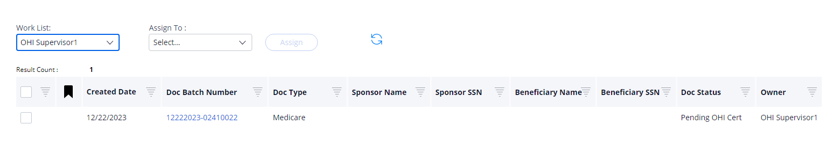
- Work List: Drop-down menu that allows a supervisor to select a team member from the drop-down menu to see what has already been assigned to that individual.
- Assign To: Drop-down menu that lists of team members or groups that can have cases assigned to them. A supervisor can use this to re-assign an item to another team member, if desired.
- Assign: This button allows supervisors to assign or re-assign work items to their team members.
- Refresh button: Displayed as an image, this button allows the user to refresh the list to view the most recent items.
- Result Count: A read-only field that displays the total number of items contained in the list.
- Created Date: The date on which the document was uploaded into the system.
- Doc Batch Number: A system-generated number used to identify the batch associated with a document upload; especially useful when there are multiple documents associated with a case.
- Doc Type: Specifies the type of document (e.g., school certificate, Medicare, etc.)
- Sponsor Name: First and last name of the sponsor.
- Sponsor SSN: The sponsor’s SSN.
- Beneficiary Name: First and last name of the person named as beneficiary.
- Beneficiary SSN: The beneficiary’s SSN.
- Doc Status: Displays the working status of the item (e.g., Open, Complete, etc.)
- Owner: Displays the user that is currently assigned to work on the item.

OHI Voucher Examiner
Users with the OHI Voucher Examiner role can self-assign, view, and update OHI certificates in DOCMP - Pega. After logging into the application, the OHI Voucher Examiner user’s default view will be their Work Queue, which displays any work items that have already been assigned.
Figure 17: Default OHI Voucher Examiner Screen
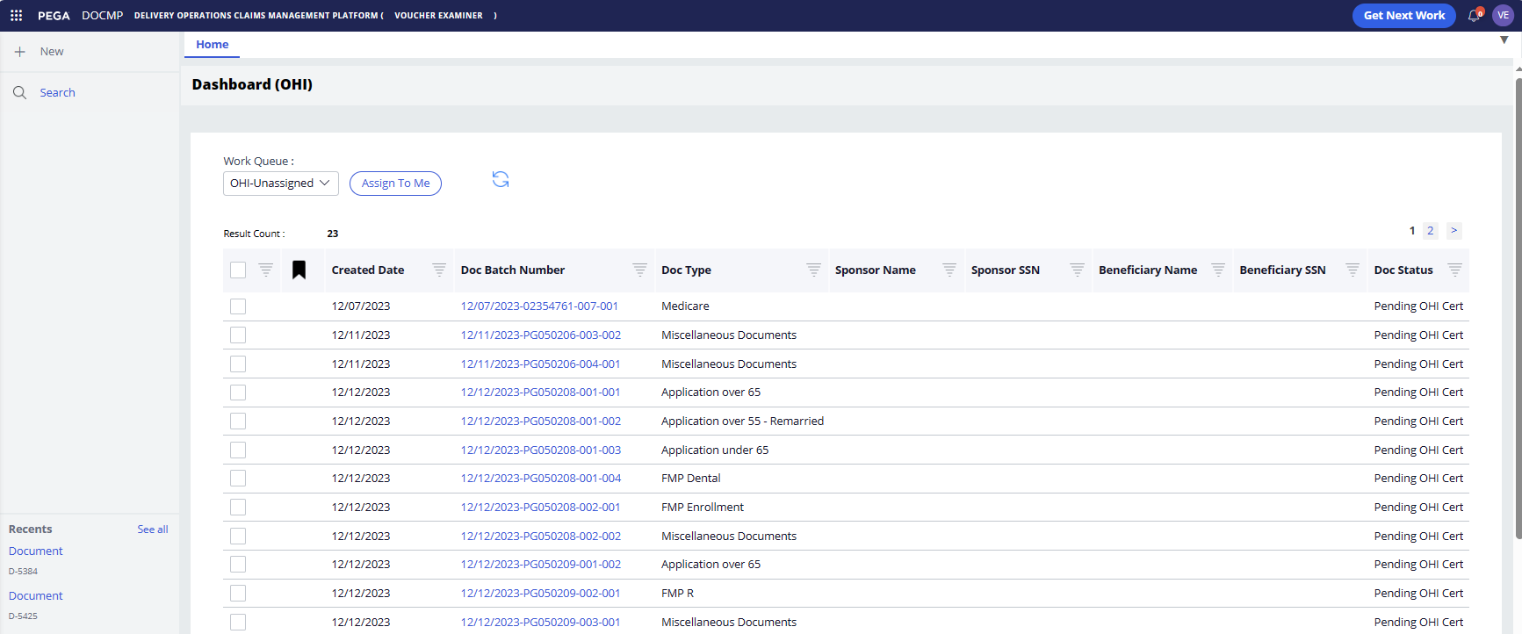
OHI Voucher Examiners have access to the following functions:
- Search: This button is located within the sidebar navigation and when selected, will open a new tab allowing the user to choose from a variety of options to refine their search of available documents.
- Recents: Also accessed from the sidebar navigation and lists the user’s most recently accessed documents.
- Get Next Work: This button is located in the header at the top of the page. When selected, it opens the user’s next work item in a new tab.
- Assign to Me: This button allows examiners to assign work items to themselves.
- Refresh button: This button allows the user to refresh the list to view the most recent items.
The Work Queue lists all items that have already been assigned to the user and contains the following fields:
- Result Count: A read-only field that displays the total number of items that have been assigned to the user.
- Created Date: The date on which the document was uploaded into the system.
- Doc Batch Number: A system-generated number used to identify the batch associated with a document upload; especially useful when there are multiple documents associated with a case.
- Doc Type: Specifies the type of document (e.g., school certificate, Medicare, etc.)
- Sponsor Name: First and last name of the sponsor.
- Sponsor SSN: The sponsor’s SSN.
- Beneficiary Name: First and last name of the person named as beneficiary.
- Beneficiary SSN: The beneficiary’s SSN.
- Doc Status: Displays the working status of the item (e.g., Open, Complete, etc.)

Logging Off
Properly exiting the application helps to prevent personal patient information from being visible to others. To reenter the application, reload the DOCMP - Pega URL.
- To exit the DOCMP - Pega application, select the user profile icon in the top-right corner of the screen to open the drop-down menu.
Figure 18: User Profile drop-down menu
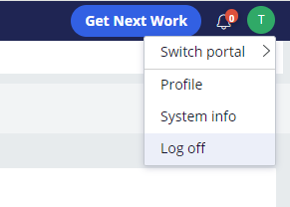
- Select Log off.

Using the Software
DOCMP - Pega provides user functionality for the following operations:
- Conducting a Search
- Viewing Documents
  - Document Details Functions
- Assigning Cases
  - Assigning Cases in the Work Queue
  - Assigning Cases in the Work List
- Pulling Reports
  - Exporting Reports
- Editing Cases
  - Bulk Editing Cases
- Working with OHI Certificates
  - Self-Assign a Document
  - View and Update OHI Certificates

Conducting a Search
Any user role may run searches and view files in the DOCMP - Pega application. To conduct a search, follow the steps listed below:
- From the sidebar navigation menu, select Search. The DOCMP - Pega Search Options tab displays.
Figure 19: DOCMP - Pega Search Options Tab
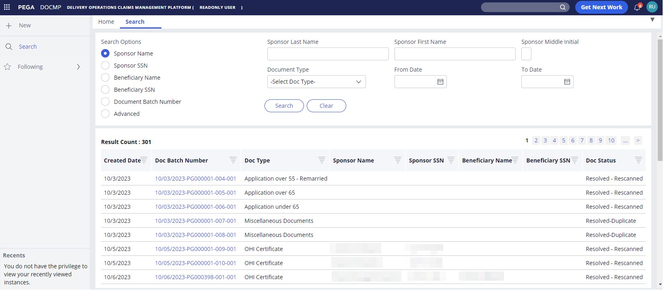
- The Search tab allows you to select the radio buttons for the type of search you want to conduct. The available data fields will change based on your selection. The options are as follows:
  - Sponsor Name
  - Sponsor SSN
  - Beneficiary Name
  - Beneficiary SSN
  - Document Batch Number
  - Advanced
- Enter the search criteria into the applicable field(s) to locate the item you want to view.
For the purposes of this instruction, the Sponsor Last Name has been entered as the search criteria.
Figure 20: DOCMP - Pega Search Option Entry
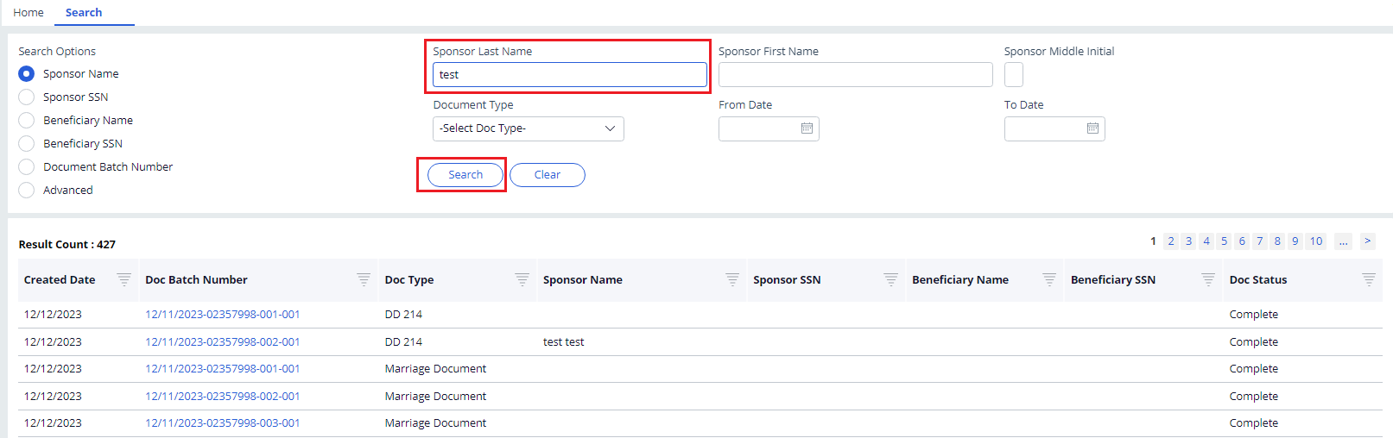
- Select Search. The search results display in the Result Count section of the page.
Figure 21: DOCMP - Pega Search Results
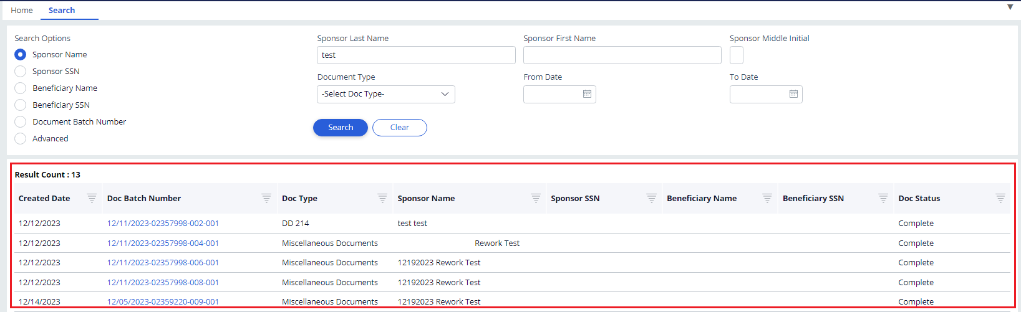
Select the Clear button if you want to start over with new search criteria.

Viewing Documents
Any user role may view files in the DOCMP - Pega application. To view the details of a document, follow the steps listed below:
Figure 22: EEV Contact Representative Dashboard
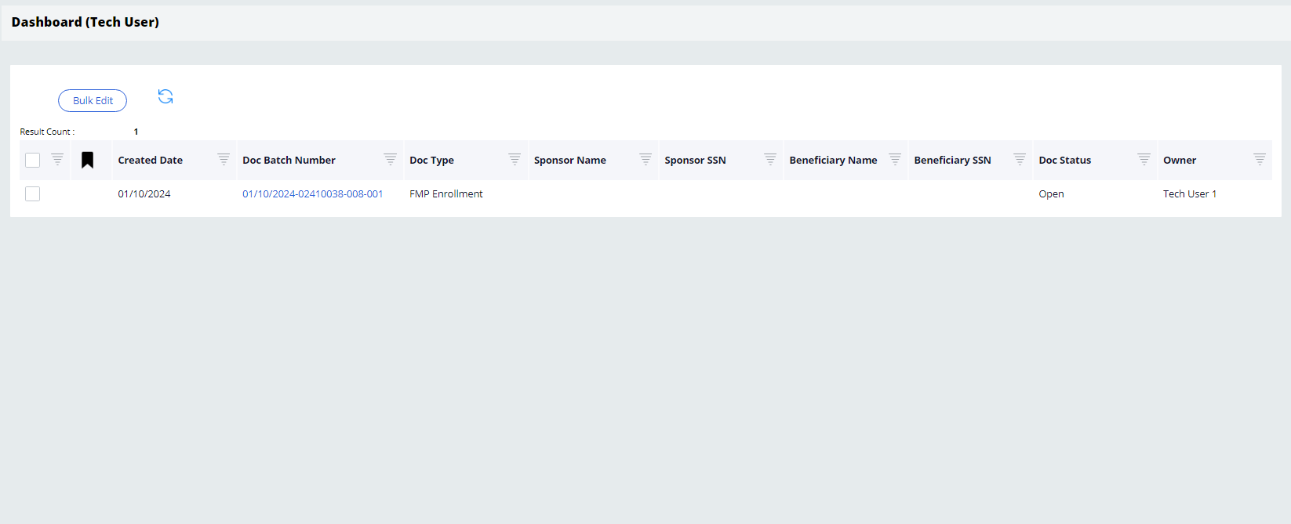
- From the Dashboard, select the link under the Doc Batch Number column for the file you would like to view. The details of the selected document will open in a new tab.
Figure 23: Document Details Tab
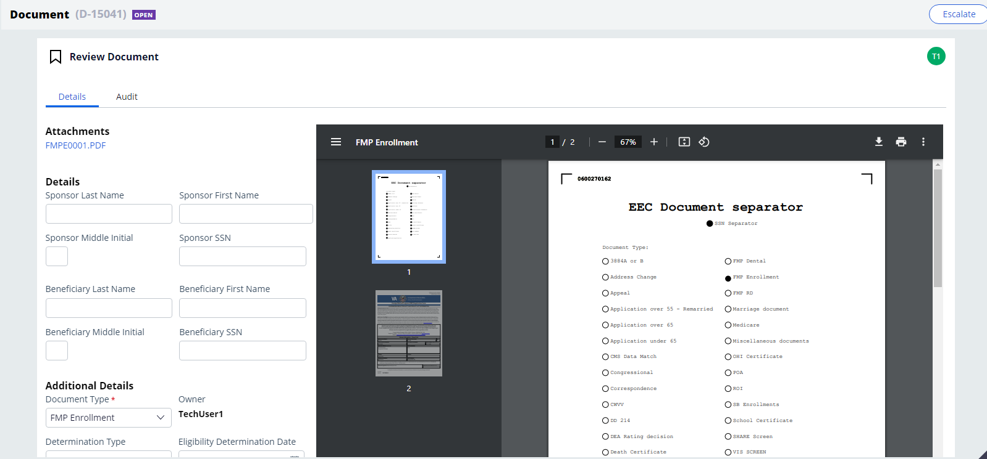
- To view an electronic copy of the document, selecting the link under Attachments will allow you to download a copy of the full document for viewing.
To close the tab, select the X next to the assignment name/number.

Document Details Functions
There are three additional functions available to use within the Document Details tab: Related, Audit, and Escalate.

Viewing Related Documents
If there are multiple documents associated with the same sponsor/beneficiary, the Related option will be available. Selecting this option will display a list of any related documents.
Figure 24: Document Details - Related Function
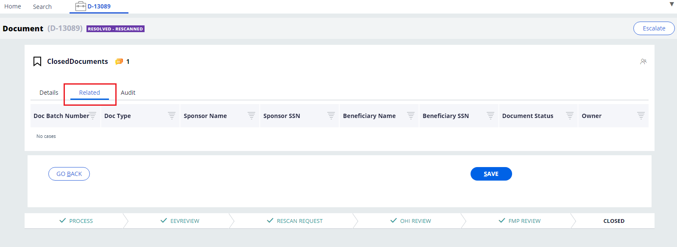

Auditing Documents
The Audit function tracks all user and system activity for the document. Selecting this option will display the document History details which include:
- Time
- Description
- Performed by
Figure 25: Document Details - Audit Function
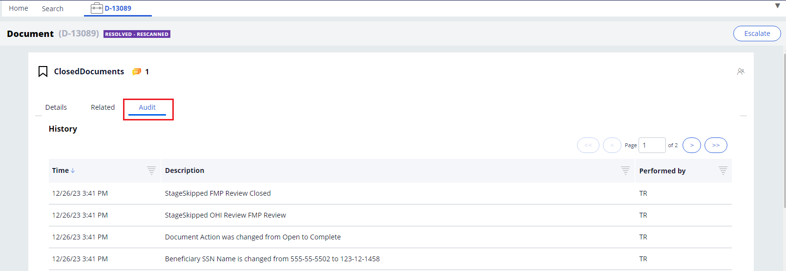

Escalating Documents
The Escalate function allows you to assign a document to a supervisor for further review or to request a rescan. To escalate a case, follow the steps listed below:
- Select the Escalate button and a confirmation dialog box will display.
Figure 26: Document Details – Escalate Confirmation Dialog Box
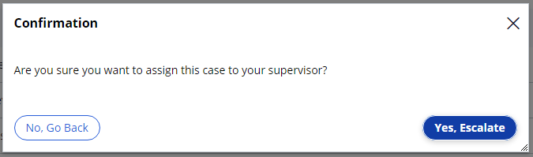
- Select No, Go Back if you want to continue working on the document. Select Yes, Escalate to confirm the escalation to your supervisor. When the escalation is complete, the system will return you to the Search page.

Assigning Cases

Assigning Cases in the Work Queue
Only users with a Supervisor role can assign cases in the application. To assign cases from the Work Queue, follow the steps listed below:
- From the Work Queue drop-down menu select Unassigned. All unassigned cases will be displayed on the dashboard.
Figure 27: Unassigned Work Queue
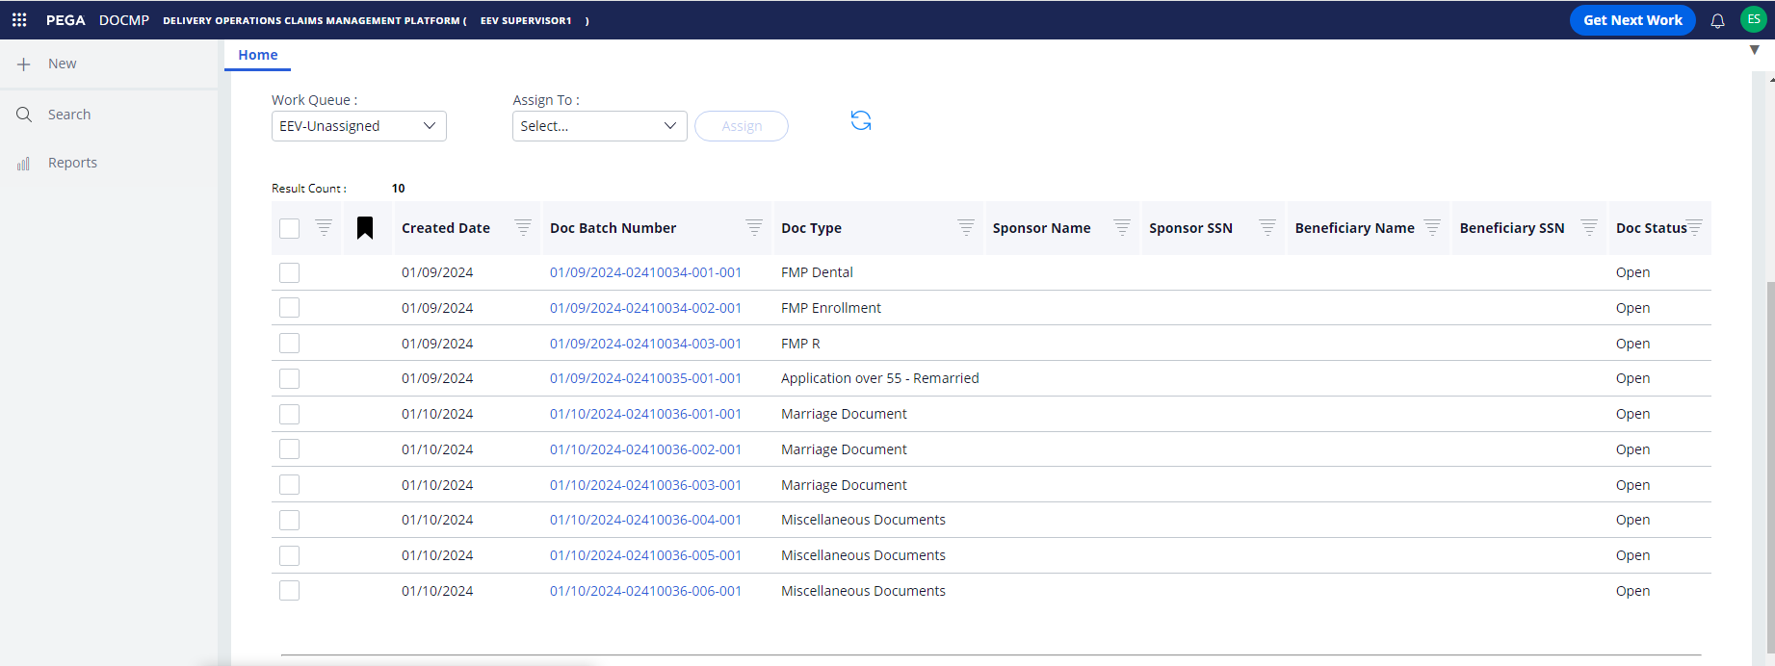
- Select the checkbox next to the case/document you want to assign.
- From the Assign To drop-down menu, select the name of the individual you want to assign the file to.
- Select Assign. The screen will update with a confirmation that an item has been assigned to the user.
Figure 28: Assigned Document Confirmation Message
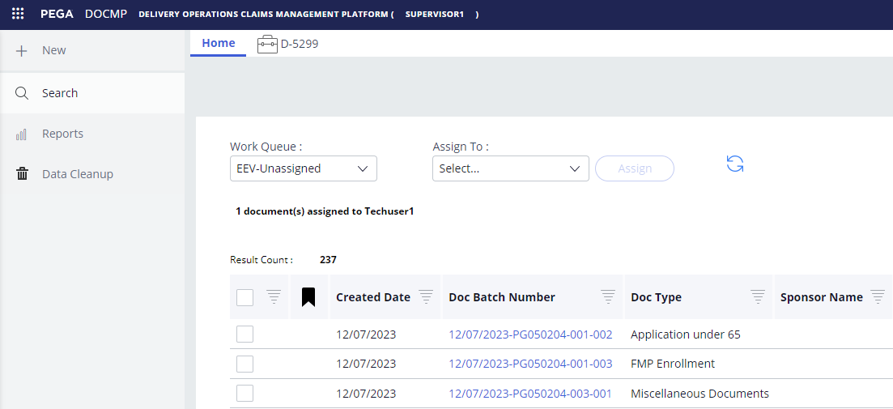
You can also verify that the assignment was successful by selecting the worker’s name from the Work List drop-down menu. All cases assigned to that worker will be displayed.

Assigning Cases in the Work List
To assign cases in the work list, follow the steps listed below:
- From the Work List drop-down menu, select Assigned or the name of the user whose work list you are editing. The cases will be displayed on the dashboard.
Figure 29: Assigned Work List
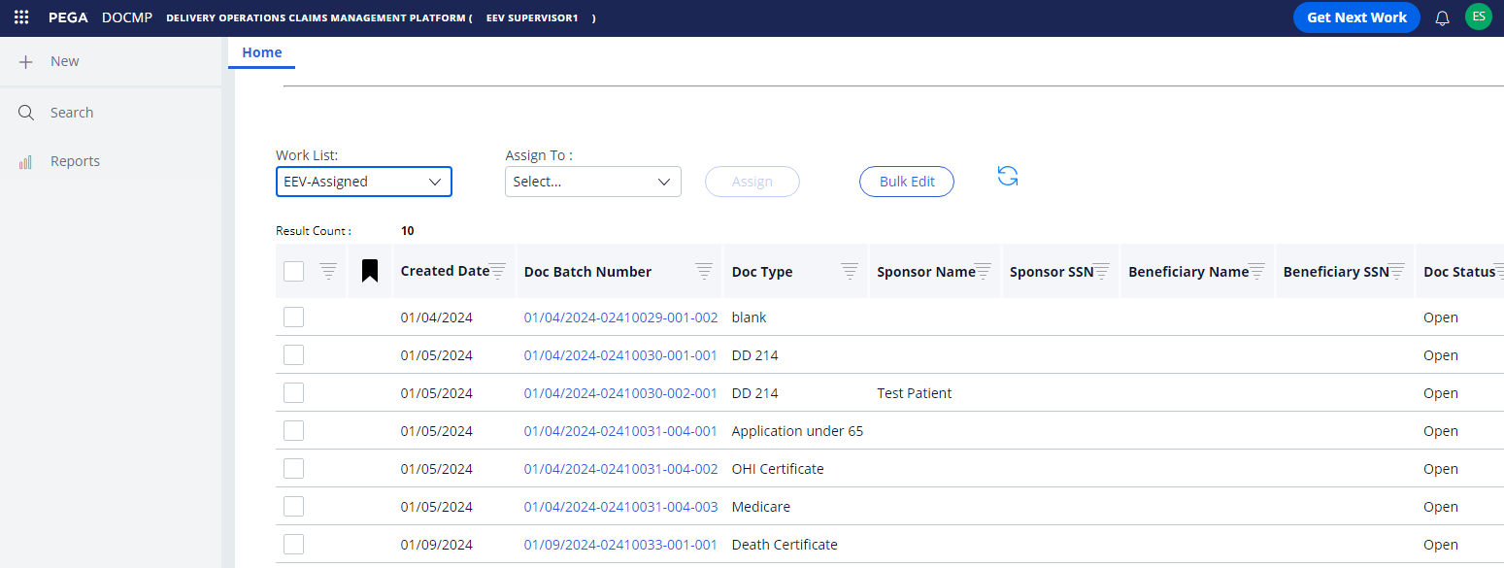
- Select the checkbox next to the case/document you want to assign/re-assign.
- From the Assign To drop-down menu, select the name of the individual you want to assign the file to.
Figure 30: Work List – Assign To Selection
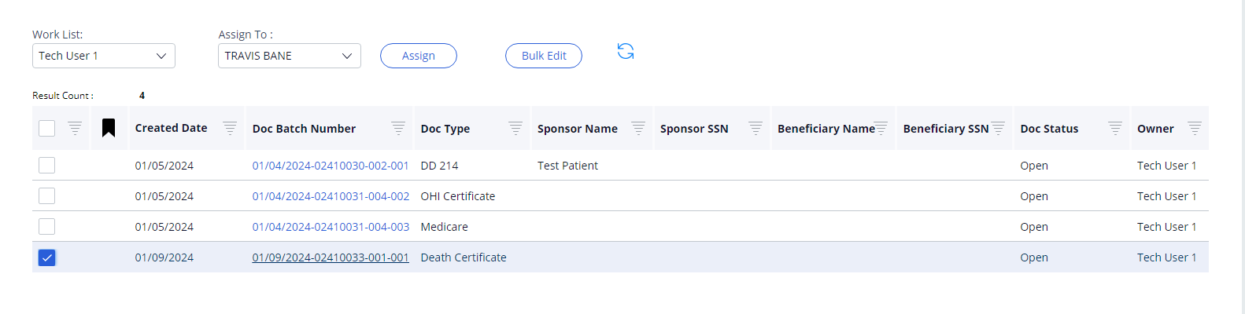
- Select Assign. The item will be removed from the work list.

Pulling Reports
Only users with an EEV Supervisor role can pull reports in the application. To pull a report, follow the steps listed below:
- From the sidebar navigation menu, select the Reports option. The Reports tab displays.
Figure 31: Report Browser Tab
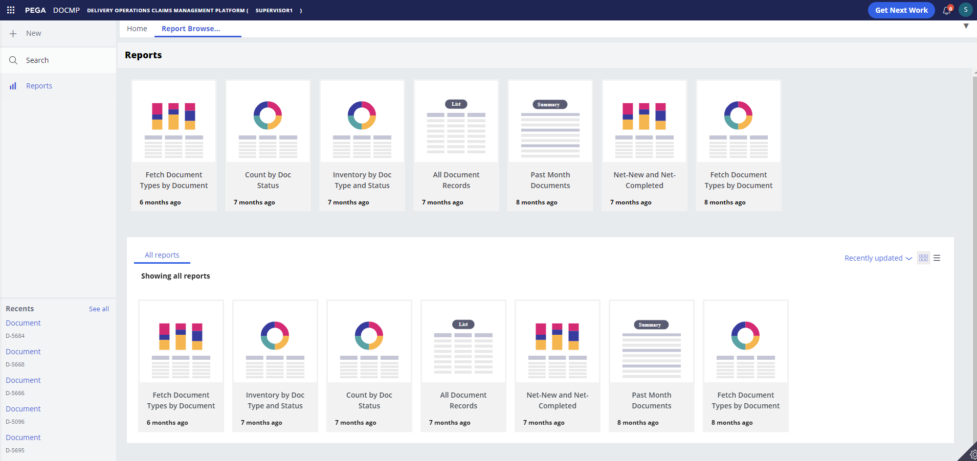
- Select the report type you want to view. The details of the report will display in a new tab.
Figure 32: Report Details Tab
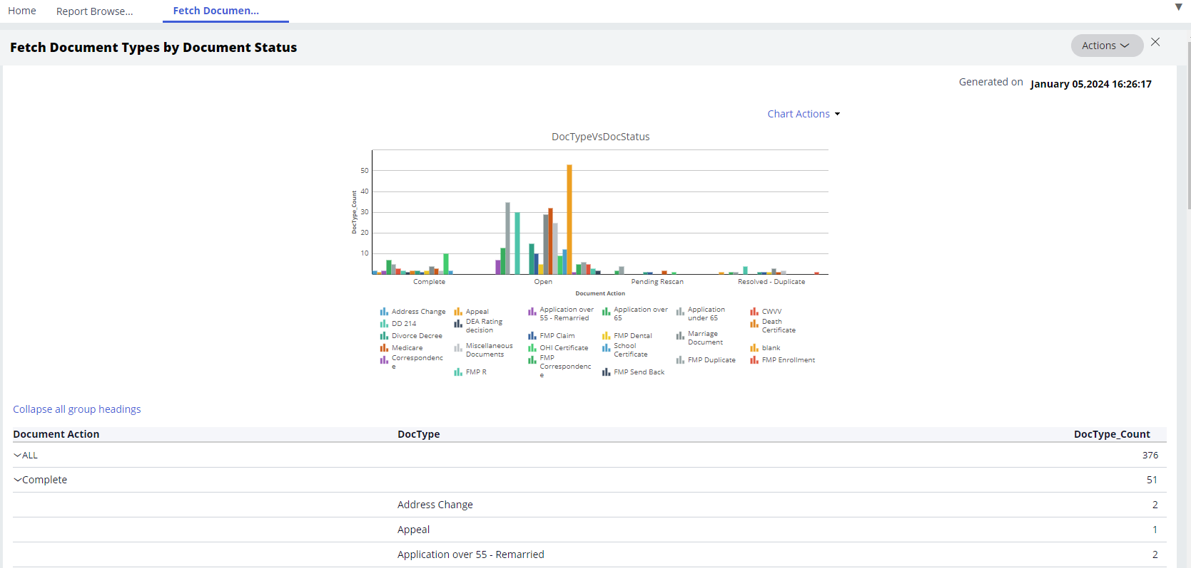

Exporting Reports
DOCMP – Pega allows Supervisor users to export report data to a PDF or Excel file. To export a report, follow the steps listed below:
- From the sidebar navigation menu, select the Reports option. The Reports tab displays.
- Select the report type you want to view. The details of the report will display in a new tab.
- From the Actions drop-down menu, select Refresh, Export to PDF, or Export to Excel. The system will automatically download the file in the chosen format (.pdf or .xlsx).

Editing Cases
Users with a Supervisor or Contact Representative role may edit cases in the DOCMP - Pega application. The fields that can be edited include the beneficiary's name and SSN, dates, document type, and case status. To edit a case, follow the steps listed below:
Figure 33: EEV Contact Representative User Dashboard
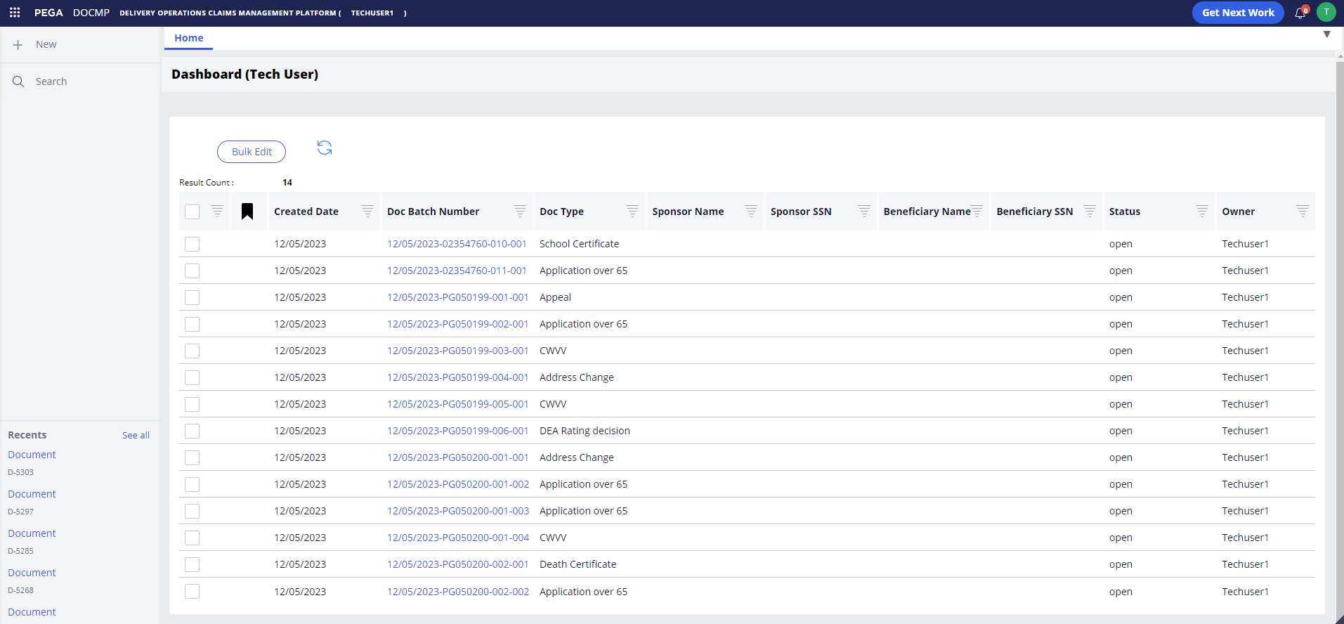
- From the Dashboard, select the Doc Batch Number of the work item and it will open in a new tab.
Figure 34: EEV Contact Representative Document Details Tab (1 of 2)
Figure 35: EEV Contact Rep Document Details Tab (2 of 2) - Additional Details View
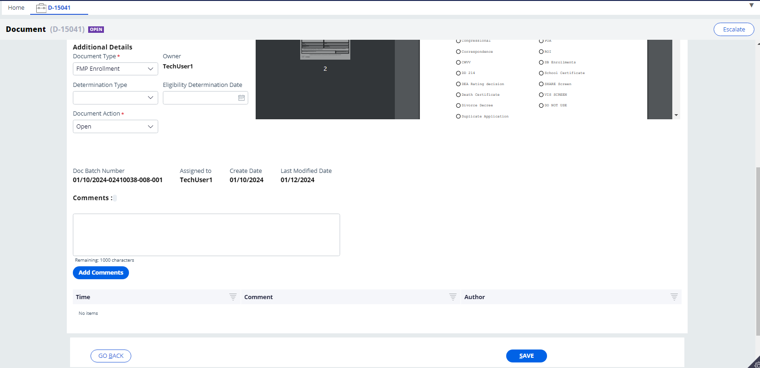
- Enter or edit the information in the fields.
- Under Additional Details, confirm that the system has populated the Document Type drop-down menu correctly. Select the desired option (Complete, Open, Request Rescan, or Resolved as Duplicate) from the Document Action drop-down menu and add any Comments that may be needed.
- Select Save.
Figure 36: Save Confirmation
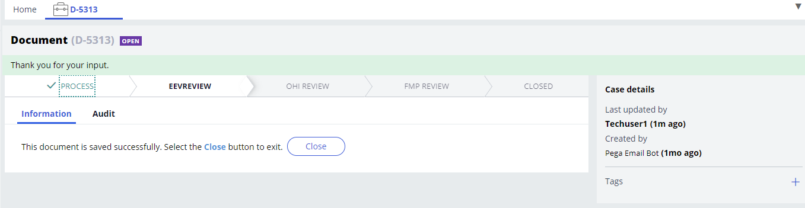
Select the Go Back button if you want to return to your work list without saving your changes.

Bulk Editing Cases
DOCMP - Pega allows users with an EEV Supervisor or EEV Contact Representative role to select multiple cases and update them all with the same information or action. To bulk edit a case, follow the steps listed below:
- From the Dashboard (or EEV Supervisor Work List), select the checkboxes next to the cases you want to edit.
Figure 37: User Work List Selected Cases
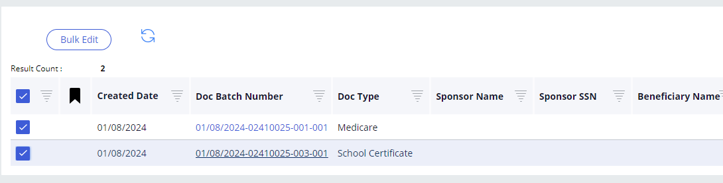
- Select the Bulk Edit button. The Bulk Edits dialog box displays.
Figure 38: Bulk Edits Dialog Box
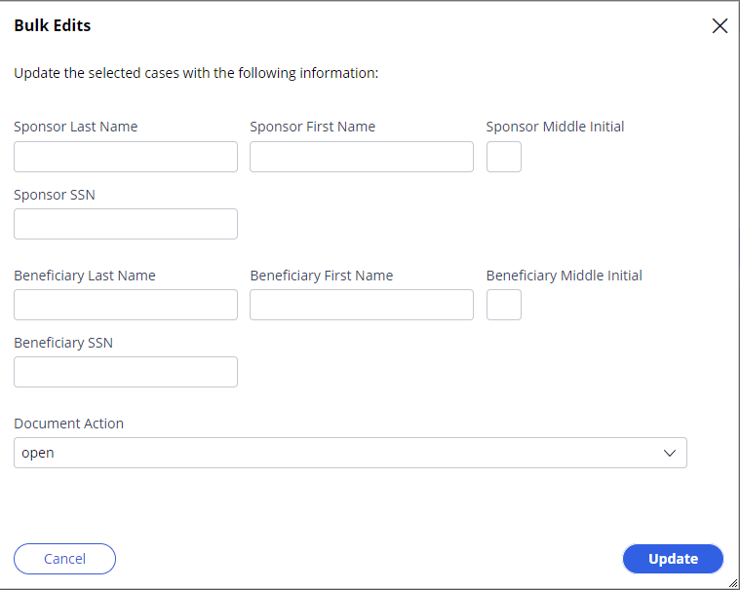
- Enter the information or select the action you want to complete for the selected items.
- Select Update. The dialog box will close, and your update(s) will be visible in the work list.
Select the Cancel button if you want to return to your work list without saving your changes.

Working with OHI Certificates
Any user with an OHI Voucher Examiner role may self-assign, view, and update OHI certificates in the DOCMP - Pega application.

Self-Assign a Document
To self-assign a document, follow the steps listed below.
Figure 39: OHI Voucher Examiner Dashboard
- From the Dashboard (OHI Voucher Examiner), select the checkbox next to the item in your Work Queue.
- Select the Assign to Me button. The screen will update with confirmation that an item has been assigned to you.
Figure 40: Self-assign Confirmation
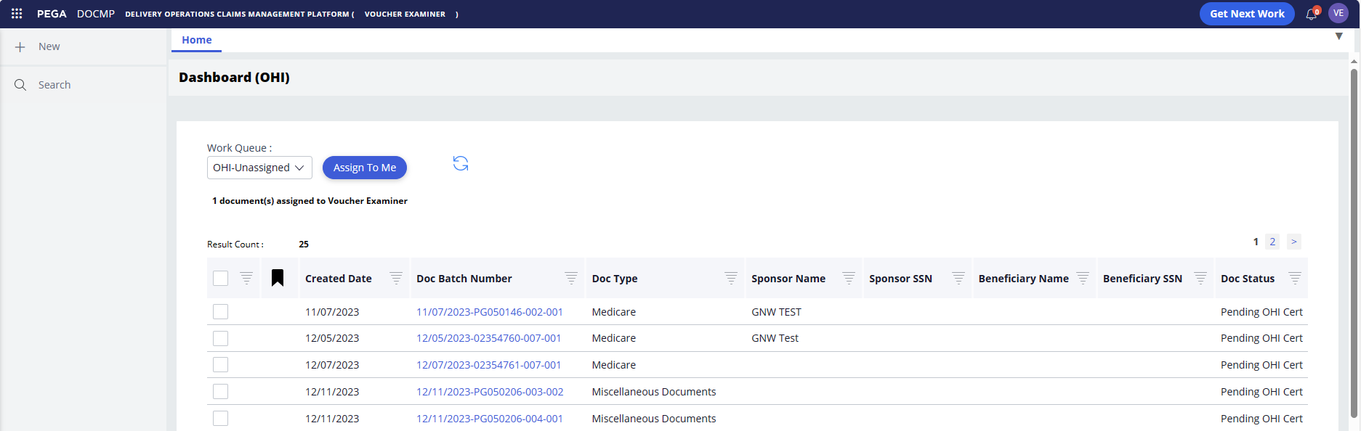
Alternatively, you can select the Get Next Work button which will assign to you the oldest document from the OHI Unassigned Work Queue.

View and Update OHI Certificates
To view and update OHI Certificates, follow the steps listed below:
- From the Dashboard (OHI Voucher Examiner) select the Doc Batch Number of the item from the Work List. The details of the selected document will open in a new tab.
Figure 41: OHI Document Details Tab (1 of 2)
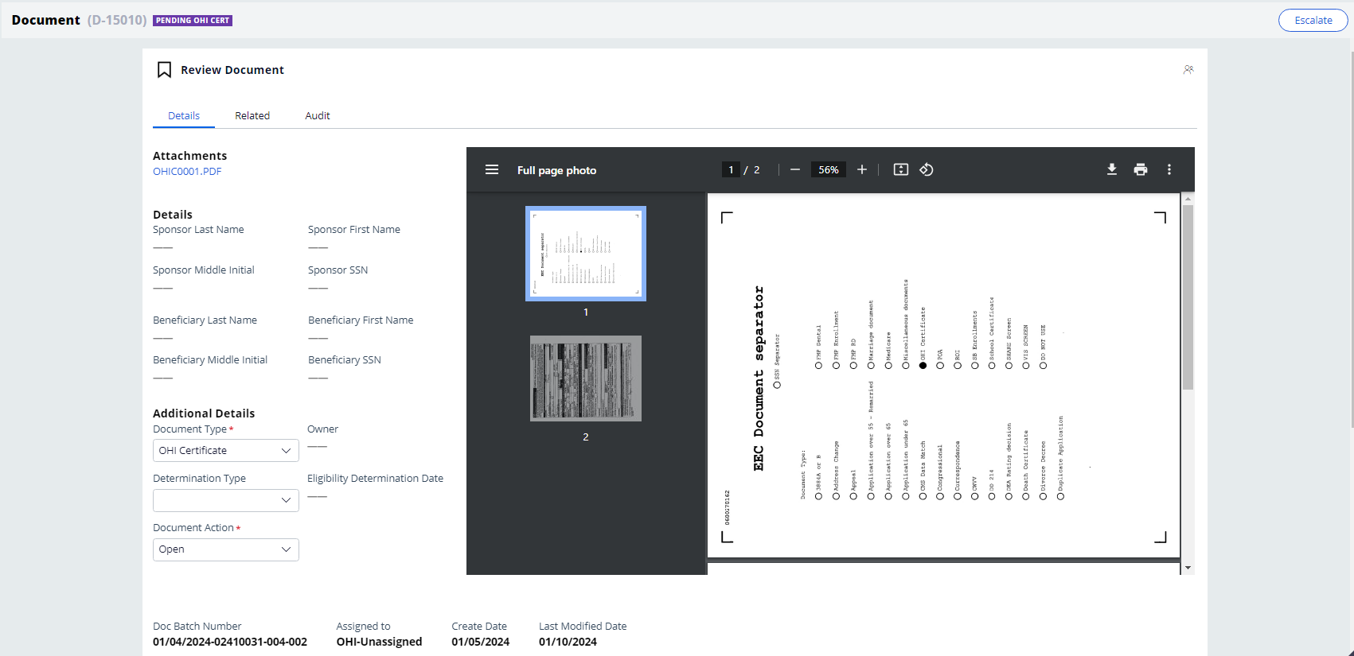
Figure 42: OHI Document Details Tab (2 of 2) - Additional Details View
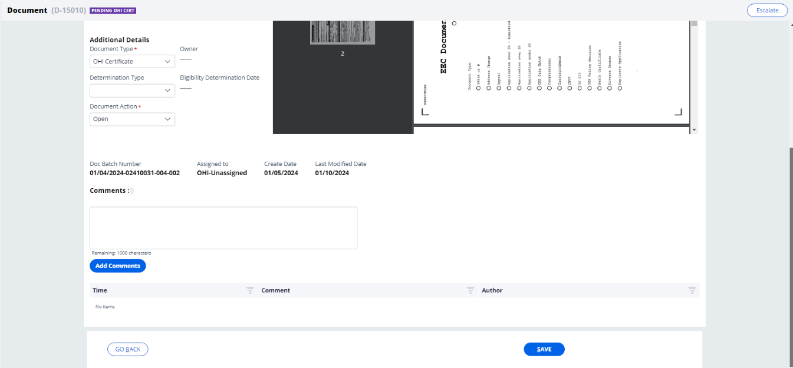
- Confirm the beneficiary information listed.
- Under Additional Details, confirm that the system has populated the Document Type drop-down menu correctly. Select the desired option (Complete, Open, or Resolved as Duplicate) from the Document Action drop-down menu and add any Comments that may be needed.
- Select Save. You will receive confirmation that the document was saved successfully.
Figure 43: OHI Document Save Confirmation
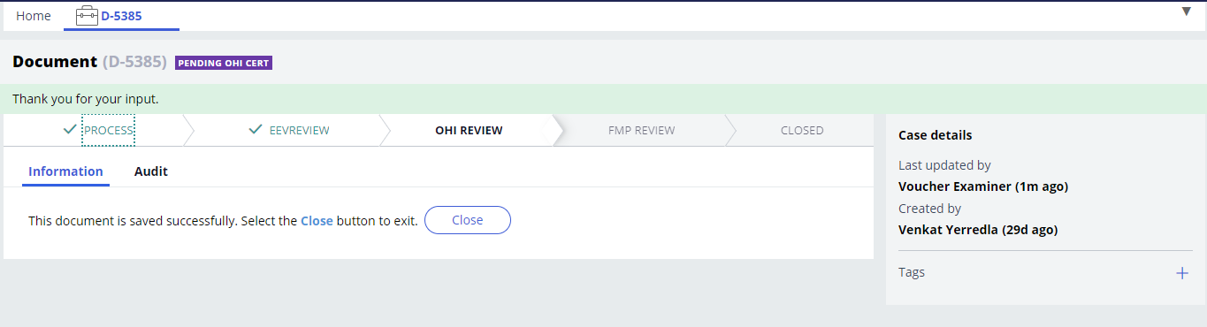

Appendix A: Acronyms and Abbreviations
Acronym | Definition
DOCMP | Delivery Operations Claims Management Platform
EEV | Eligibility, Enrollment, and Verification
ESD | Enterprise Service Desk
HAC | Health Administration Center
OHI | Office of Health Information
OIT | Office of Information and Technology
PDF | Portable Document Format
Pega | Low-Code Platform for Workflow Automation
PIV | Personal Identity Verification
R&R | Review and Resolution Department
SSN | Social Security Number
URL | Uniform Resource Locator
VA | Department of Veterans Affairs
VAEC | VA Enterprise Cloud
VFMP | Veteran Family Medical Programs
VIP | Veteran-focused Integrated Process
VistA | Veterans Health Information Systems and Technology Architecture
VPN | Virtual Private Network

