One Consult - Order to Consult – Admin Key

Software Version 1.0.03

Training Guide
December 2018
Department of Veterans Affairs
Office of Information and Technology (OI&T)

Revision History
NOTE: The revision history cycle begins once changes or enhancements are requested after the document has been baselined.
Date | Revision | Description | Author
12/07/2018 | 1.0 | Initial Document Release | AbleVets
Table of Contents
1. Introduction 1
1.1. OR ADMIN RBP TO CC Only Consult Ordering 1
1.2. Discontinuing a COMMUNITY CARE -ADMIN or -DS Consult Immediately After Creation 6
1.2.1. Discontinue from the Consults Tab 6
1.3. Admin Key and OREMAS Key Ordering 8
List of Figures
Figure 1: User Logged Into CPRS 1
Figure 2: Template: COMMUNITY CARE-ADMIN- Window 2
Figure 3: Order a Consult 3
Figure 4: Consult: Pending Status 4
Figure 5: Order Displayed in Bold Font 4
Figure 6: Review/Sign Changes 5
Figure 7: Pending Status 5
Figure 9: Selecting a consult 6
Figure 10: Selecting Discontinue from the Action menu 6
Figure 11: Discontinue Consult: Comments Field 7
Figure 12: Discontinued Consult 7
Figure 14: User Logged Into CPRS 8
Figure 15: COMMUNITY CARE-ADMIN- Window 8
Figure 16: Order a Consult 9
Figure 17: Consult 10
Figure 18: Order Displayed in Bold Font 10
Figure 19: Review/Sign Changes 11
Figure 20: Unable to Release Orders 11
Figure 21: Hold until Signed Selected 12
Figure 22: Pending Status 12

Introduction
This guide provides instructions on how to use the new OR ADMIN RBP TO CC security key ordering capabilities for CPRS users that currently hold the OREMAS key. The OREMAS key currently enables the CPRS user to place orders on behalf of a clinician with and order action of Signature on Chart. With the new OR ADMIN RBP TO CC security key release, the CPRS users will now have both OR ADMIN RBP TO CC and OREMAS key rights, which will enable them to enter orders with Signature on Chart and Administratively Released by Policy release options. Users with both keys will see a different behavior in CPRS workflow that is documented below. This workflow is not optimal, but without some underlying changes in CPRS, it cannot currently be avoided so this guide will provide instructions on how to work within this current workflow to place the COMMUNITY CARE -ADMIN or -DS consult orders that will be automatically release to the office of Community Care.

OR ADMIN RBP TO CC Only Consult Ordering
To place orders using the Admin Key, the user should hold the OR ADMIN RBP TO CC security key (the Admin Key).
The CPRS user will follow the steps listed below to place orders with the OR ADMIN RBP TO CC only:
- Log in to CPRS.
Figure 1: User Logged Into CPRS
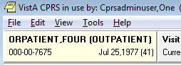
- From the Orders or Consults tab, create a consult. The consult must have a Service/Specialty name that starts with COMMUNITY CARE and contains -ADMIN or -DS. The consult Reason for Request template will display.
Figure 2: Template: COMMUNITY CARE-ADMIN- Window
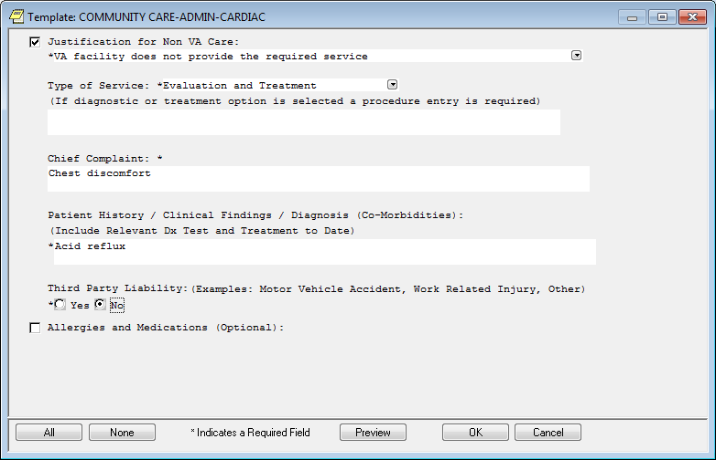
- Complete the template and click OK. The Order a Consult window displays with Reason for Request template data from the template.
Figure 3: Order a Consult
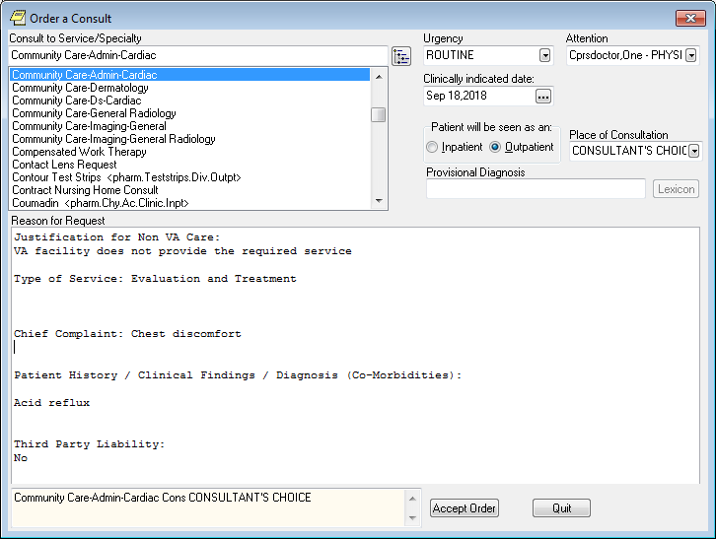
- Complete order dialog fields and then click Accept Order. The Consult displays in the window in a pending status.
Figure 4: Consult: Pending Status
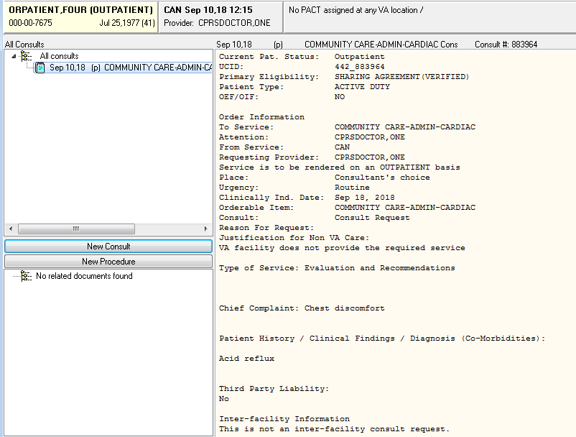
- On the Orders tab the consult order is in pending status and is displayed in bold font.
The bold font is not normal CPRS workflow behavior and needs to be updated.
Figure 5: Order Displayed in Bold Font
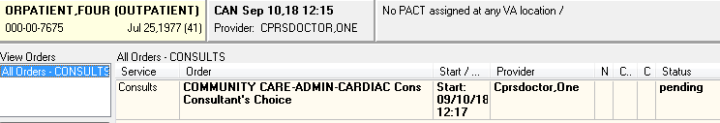
- Refresh the Orders tab.
- Select File>Refresh Patient. The Review/Sign Changes dialog box displays.
Figure 6: Review/Sign Changes
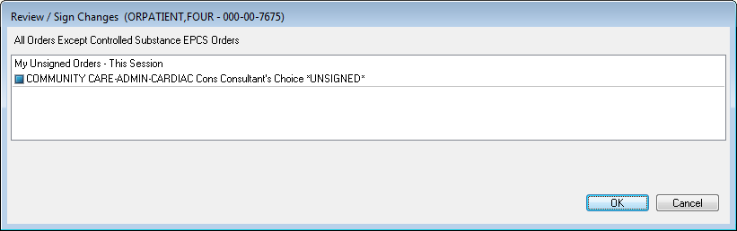
Select New Patient and Review/Sign Changes will also cause this popup to appear, as would exiting CPRS.
- Click OK. The Status column now displays as pending and is no longer bold font.
Figure 7: Pending Status
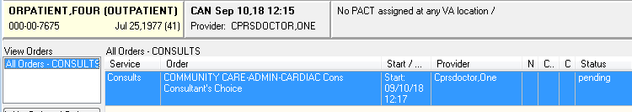

Discontinuing a COMMUNITY CARE -ADMIN or -DS Consult Immediately After Creation

Discontinue from the Consults Tab
Discontinuing a Consult should always be done on the Consults tab. NEVER ATTEMPT TO DO THIS ON THE ORDERS TAB.
It is possible that a user may realize that they have made a mistake in creating a consult and will need to discontinue the consult. To discontinue from the Consults tab, follow the steps listed below:
- From the Consults tab in CPRS, click on the consult in the left-hand panel to select it.
Figure 8: Selecting a consult
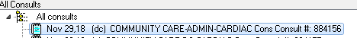

- From the Action menu, select Consult Tracking, and then select Discontinue. The Discontinue Consult: Comments dialog box displays.
Figure 9: Selecting Discontinue from the Action menu
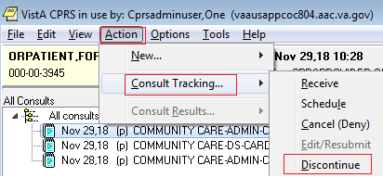
- In the Discontinue Consult dialog box, enter comments in the Comments field.
Figure 10: Discontinue Consult: Comments Field
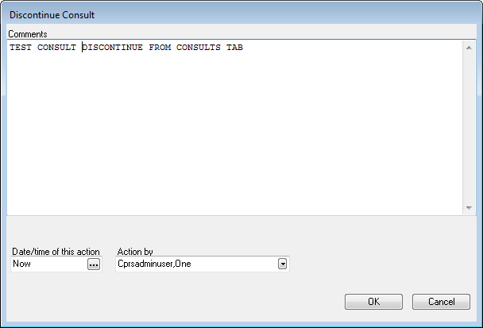
- Click OK. The consult detail now shows that the consult has been discontinued.
Figure 11: Discontinued Consult
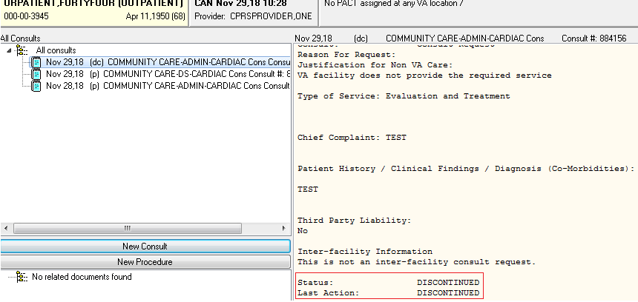

Admin Key and OREMAS Key Ordering
The CPRS user will follow the steps listed below to place orders with the OR ADMIN RBP TO CC Key and OREMAS Key:
- Log in to CPRS.
Figure 12: User Logged Into CPRS
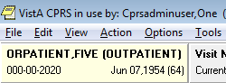
- From the Orders or Consults tab, create a consult. The consult must have a Service/Specialty name that starts with COMMUNITY CARE and contains -ADMIN or -DS. The consult Reason for Request template will appear:
Figure 13: COMMUNITY CARE-ADMIN- Window
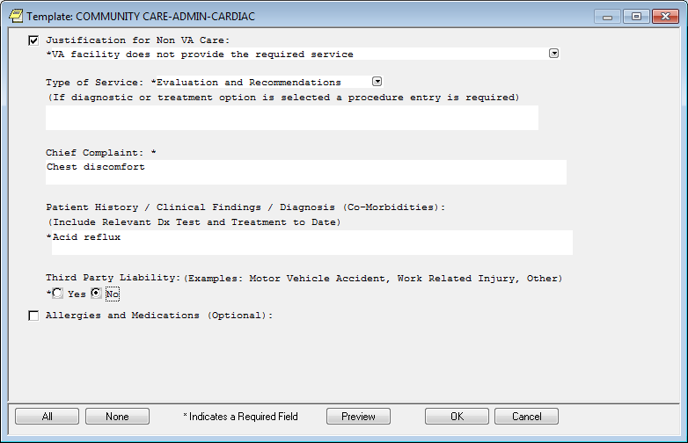
- Complete the template and click OK. The Order a Consult dialog window displays with Reason for Request template data from the template.
Figure 14: Order a Consult
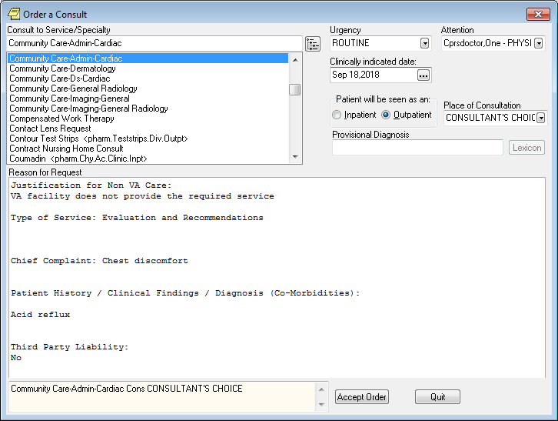
- Complete order dialog fields and then click Accept Order. The Consult displays in the window in a pending status.
Figure 15: Consult
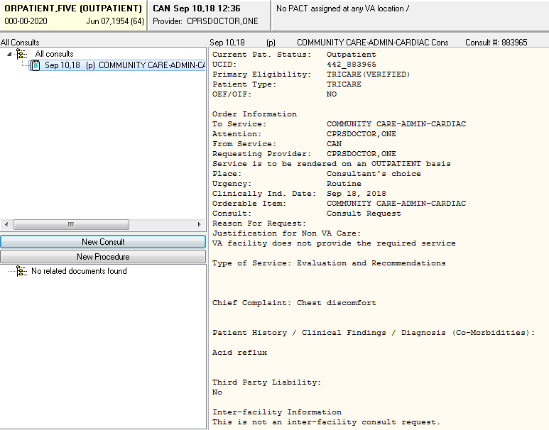
- On the Orders tab the consult order is in pending status and is displayed in bold font.
The bold font is not normal CPRS workflow behavior and needs to be updated.
Figure 16: Order Displayed in Bold Font
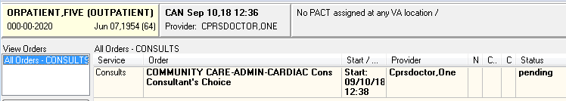
- Refresh the Orders tab.
- Select File>Refresh Patient. The Review/Sign Changes dialog box displays.
Figure 17: Review/Sign Changes
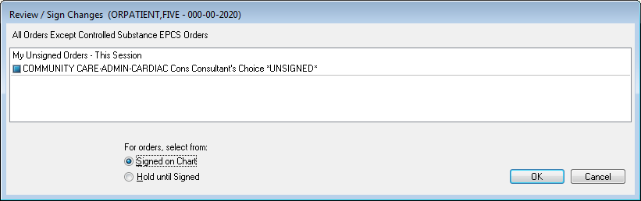
Select New Patient and Review/Sign Changes will also cause this popup to appear, as would exiting CPRS.
Since the Administrative User holds the OREMAS key, CPRS offers the option to sign the order or hold until it is signed.
- Select the Signed on Chart radio button.
- Click OK.
Figure 18: Unable to Release Orders
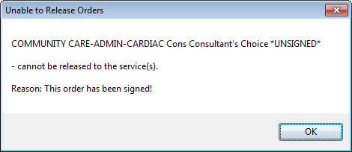
- The user selects Hold until Signed.
Figure 19: Hold until Signed Selected
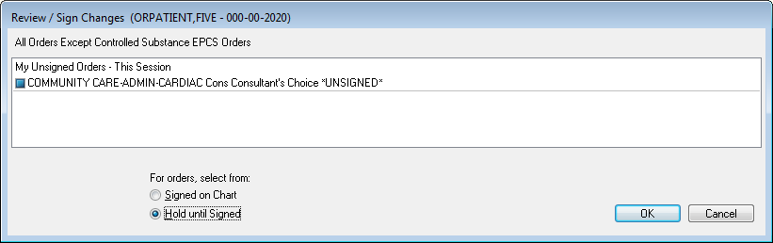
- The user clicks OK. The order now shows Pending with no bold.
Figure 20: Pending Status
