Consult Toolbox

Software Version 1.9.0076

User Guide
September 2020
Department of Veterans Affairs
Office of Information and Technology (OIT)

Revision History
NOTE: The revision history cycle begins once changes or enhancements are requested after the document has been baselined.
Date | Revision | Description | Author
09/22/2020 | 15.0 | Release of version 1.9.0076. Updates include:  - Updated screen captures to reflect version number 1.9.0076.  - Added Unable to Schedule functionality to Receive Consult and Adding Comment to Consult section.  - Updated Receive Consult Menu Options screen.  - Updated Add Comment Menu Options screen.  - Added Community Cares Functions to Receiving Consult Activities section. | AbleVets
07/10/2020 | 14.0 | Release of version 1.9.0072. Updates include:  - Updated screen captures to reflect version number 1.9.0072.  - Added the Consult Previously Sent to HSRM message.  - Added Re-send to HSRM Referral check box.  - Updated the COVID-19 Consult Factor Types and Definitions table in Appendix B.  - Updated COVID-19 priority definitions.  - Updated screens to reflect COVID-19 priority definition updates. | AbleVets
05/01/2020 | 13.0 | Release of version 1.9.0065. Updates include:  - Coronavirus Disease of 2019 (COVID-19) updates.  - Updated screens to reflect new software version number.  - Added Appendix A1.3: Receive Community Care Functions: COVID-19 Priority.  - Added Appendix A2.3: Add Comment Community Care Functions: COVID-19 Priority.  - Updated COVID-19 Priority 1 and Priority 2 descriptions.  - Updated the Consult Factor Types and Definitions table in Appendix B. | AbleVets
04/17/2020 | 12.0 | Release of version 1.9.0063. Updates include:  - Coronavirus Disease of 2019 (COVID-19) updates.  - Added Enable COVID-19 workflow for Receive Consult and Clinical Review options check box under the Other User Settings tab.  - Added Appendix A: Management of Consults when COVID-19 Workflow is Enabled.  - Updated screen captures to reflect version number 1.9.0063.  - Updated the Consult Factor Types and Definitions table in Appendix B. | AbleVets
12/04/2019 | 11.0 | Release of version 1.9.0054. Updates include:  - Updated screen captures to reflect version number 1.9.0054.  - Updated Specific Eligibility Verified menu options under MSA Elig. Verification tab.  - Updated Forward to Community Care options.  - HSRM Forwarding Consults | AbleVets
6/04/2019 | 10.1 | Update of version 1.9.0004. CAN Score API updates include:  - Updated CAN Score description.  - Updated name from National Service Desk to Enterprise Service Desk. | AbleVets
5/07/2019 | 10.0 | Release of version 1.9.0004. Updates include:  - Updated screen captures to reflect version number 1.9.0004.  - Added CAN Score note.  - Updated SEOC from optional to mandatory.  - Removed Care Coordination from Community Care Functions  - Updated SAR tab to Secondary Authorization Request (SAR)/Request for Service (RFS).  - Added Launch DST section.  - Added additional SEOC warning message. | AbleVets
11/06/2018 | 9.2 | Updated the Other User Settings screen capture. Added the Preferred Client Cert: content to the document.  Software released to field as 1.9.002B. | AbleVets
8/28/2018 | 9.1 | Added Appendix A: Consult Factor Types and Definitions. | AbleVets
06/15/18 | 9.0 | Community Care SEOC functionality modified to utilize the SEOC DB, CAN Score functionality modified to utilize the CAN Score API when available, other functionality refined.  v1.9.02 | AbleVets
6/4/2018 | 8.0 | Community Care SEOC interim functionality expanded to include additional SEOCs, other functionality refined.  V1.8.01 | AbleVets
01/19/18 | 7.0 | Community Care SEOC interim functionality added, other functionality refined  v1.7.01 | AbleVets
06/15/17 | 6.0 | Community Care Functions section, Enable/Disable functionality refined  v1.0.6051 | REDACTED
05/04/17 | 5.1 | Enable and Disable functionality added  v1.0.0505 | REDACTED
10/05/16 | 5.0 | Rework of community care  Refinements of other modules  v1.0.5 | REDACTED
04/05/16 | 4.0 | Deployment Version  v1.0.4 | REDACTED
01/21/15 | 3.0 | Revisions to Discontinue consult  v1.0.3 | REDACTED
01/05/15 | 2.0 | Conversion to dialog boxes  v1.0.2 | REDACTED
11/27/15 | 1.0 | Initial Version  v1.0 | REDACTED

Artifact Rationale
Per the Veteran-focused Integrated Process (VIP) Guide, the User’s Guide is required to be completed prior to Critical Decision Point #2 (CD2), with the expectation that it will be updated as needed. A User Guide is a technical communication document intended to give assistance to people using a particular system, such as VistA end users. It is usually written by a technical writer, although it can also be written by programmers, product or project managers, or other technical staff. Most user guides contain both a written guide and the associated images. In the case of computer applications, it is usual to include screenshots of the human-machine interfaces, and hardware manuals often include clear, simplified diagrams. The language used is matched to the intended audience, with jargon kept to a minimum or explained thoroughly. The User Guide is a mandatory, build-level document, and should be updated to reflect the contents of the most recently deployed build. The sections documented herein are required if applicable to your product.

Table of Contents
1. Introduction 1
1.1. Purpose 1
1.2. Document Orientation 1
1.2.1. Organization of the Manual 1
1.2.2. Assumptions 2
1.2.3. Coordination 2
1.2.4. Disclaimers 2
1.2.4.1. Software Disclaimer 2
1.2.4.2. Documentation Disclaimer 2
1.2.5. Documentation Conventions 3
1.2.6. References and Resources 3
1.3. Enterprise Service Desk and Organizational Contacts 3
2. System Summary 3
2.1. System Configuration 3
2.2. Data Flows 4
2.3. User Access Levels 4
2.4. Continuity of Operation 4
3. Getting Started 4
3.1. Accessing Consult Toolbox 4
3.1.1. Enabling Consult Toolbox 4
3.1.2. Setting Consult Toolbox Preferences 6
3.2. System Menu 12
3.2.1. Receive 12
3.2.2. Discontinue 13
3.2.3. Forward 13
3.2.4. Add Comment 13
3.2.5. Significant Findings 14
3.2.6. Administrative Complete 14
4. Using the Software 14
4.1. Receiving Consult Activities 15
4.1.1. Receiving Functions 15
4.1.1.1. Receiving Consult Steps 18
4.1.2. Unable to Schedule Functions 20
4.1.2.1. Unable to Schedule Steps 21
4.1.3. Community Care Functions 23
4.1.3.1. MSA Eligibility Verification 23
4.1.3.2. Community Care MSA Eligibility Verification Steps 25
4.1.3.2.1. Community Care (CC) Document Administrative Screening 26
4.1.3.2.1.1. Community Care (CC) Document Administrative Screening Steps 29
4.1.3.3. Consult Review 32
4.1.3.3.1. Consult Review Steps 34
4.1.3.3.2. Clinical Triage 36
4.1.3.3.2.1. Clinical Triage Steps 38
4.1.3.4. Authorization 41
4.1.3.4.1. Authorization Steps 44
4.1.3.5. DoD 46
4.1.3.5.1. DoD Steps 47
4.1.3.6. MSA Pt Contacts 49
4.1.3.6.1. MSA Pt Contacts Steps 53
4.1.3.7. Appt Tracking 55
4.1.3.7.1. Appt Tracking Steps 59
4.1.3.8. Secondary Authorization Request (SAR)/Request for Service (RFS) 61
4.1.3.8.1. SAR/RFS Steps 62
4.1.3.9. Consult Completion 64
4.1.3.9.1. Consult Completion Steps 66
4.2. Discontinuing Consult 67
4.2.1. Discontinuing In-house Consult Steps 70
4.2.2. Discontinuing Community Care Consult Steps 72
4.3. Forwarding Consult 74
4.3.1. Forwarding Consult Steps 75
4.4. Adding Comment to Consult 76
4.4.1. Scheduler Functions 76
4.4.1.1. Scheduling Calls and Letters 77
4.4.1.1.1. Scheduling Calls and Letters Steps 79
4.4.1.2. Scheduling and Rescheduling Efforts 81
4.4.1.2.1. Scheduling and Rescheduling Efforts Steps 83
4.4.1.3. Community Care Eligibility 86
4.4.1.3.1. Community Care Eligibility Steps 89
4.4.2. Unable to Schedule Functions 91
4.4.2.1. Unable to Schedule Steps 92
4.4.3. Community Care Functions 94
4.4.3.1. MSA Eligibility Verification 95
4.4.3.2. Community Care MSA Eligibility Verification Steps 96
4.4.3.2.1. Community Care (CC) Document Administrative Screening 98
4.4.3.2.1.1. Community Care (CC) Document Administrative Screening Steps 101
4.4.3.3. Consult Review 104
4.4.3.3.1. Consult Review Steps 106
4.4.3.3.2. Clinical Triage 108
4.4.3.3.2.1. Clinical Triage Steps 110
4.4.3.4. Authorization 114
4.4.3.4.1. Authorization Steps 116
4.4.3.5. DoD 119
4.4.3.5.1. DoD Steps 120
4.4.3.6. MSA Pt Contacts 122
4.4.3.6.1. MSA Pt Contacts Steps 126
4.4.3.7. Appt Tracking 128
4.4.3.7.1. Appt Tracking Steps 132
4.4.3.8. Secondary Authorization Request (SAR)/Request for Service (RFS) 134
4.4.3.8.1. SAR/RFS Steps 135
4.4.3.9. Consult Completion 137
4.4.3.9.1. Consult Completion Steps 139
4.4.4. Clinical Review Options 141
4.4.4.1. Setting Clinical Review Options 143
4.4.5. Launch DST 145
4.5. Significant Findings – Community Care Action Needed Notation 146
4.5.1. Significant Findings Steps 148
4.6. Administratively Complete 150
4.6.1. Administratively Close Consult Steps 150
5. Troubleshooting 152
5.1. National Service Desk and Organizational Contacts 152
6. Acronyms and Abbreviations 153
Appendix A: Management of Consults when COVID-19 Workflow is Enabled 154
Appendix A1: Receiving Consult Activities when COVID-19 Workflow is Enabled 154
Appendix A1.1: VA Clinic Referrals 155
Appendix A1.3: Receive Community Care Functions: COVID-19 Priority 160
Appendix A2: Setting Clinical Review Options when COVID-19 Workflow is Enabled 164
Appendix A2.1: VA Clinical Referrals 164
Appendix A2.2: Community Care Referrals 169
Appendix A2.3: Add Comment Community Care Functions: COVID-19 Priority 172
Appendix B: Consult Factor Types and Definitions 176

Table of Figures
Figure 1: Consult Toolbox Data Flow 4
Figure 2: Enable Consult Toolbox Menu Option 5
Figure 3: SEOC Database Unreachable Message 5
Figure 4: About Consult Toolbox 6
Figure 5: Consult Toolbox Preferences Window 7
Figure 6: Add Comment to Consult Options 8
Figure 7: Discontinue Consult Options 8
Figure 8: Receive Consult Options 9
Figure 9: Other User Settings Tab 10
Figure 10: Consult Tracking… Menu Options 12
Figure 11: Receive Menu Options 12
Figure 12: Discontinuing Consult Menu Option 13
Figure 13: Forward Menu Options 13
Figure 14: Add Comment Menu Options 13
Figure 15: Significant Findings Menu Option 14
Figure 16: Administratively Complete Menu Option 14
Figure 17: Receive Routine Consult Options Window 15
Figure 18: Low Risk Clinics Options 17
Figure 19: Extra Scheduling Effort Options 17
Figure 20: Receive Consult Dialog Box 18
Figure 21: Receive Menu 18
Figure 22: Receive Routine Consult Options Window 19
Figure 23: Receive Unable to Schedule Window 21
Figure 24: Receive Consult Dialog Box 21
Figure 25: Receive Menu 22
Figure 26: Unable to Schedule Window 22
Figure 27: MSA Elig. Verification Tab 23
Figure 28: Specific Eligibility Verified Menu Options 24
Figure 29: Receive Consult Dialog Box 25
Figure 30: Receive Menu 25
Figure 31: MSA Elig. Verification Tab 26
Figure 32: Administrative Screening 27
Figure 33: CAN Score Fields Enabled 28
Figure 34: MSA Elig. Verification Tab: Document Administrative Screening Section 29
Figure 35: Administrative Screening (for use by community care staff only) Window 30
Figure 36: Scheduling staff member you will alert: Field 31
Figure 37: Document Administrative Screening Populated 31
Figure 38: Consult Review Tab 32
Figure 39: Request Approved Options 32
Figure 40: Request Disapproved Options 33
Figure 41: Clinical Review Method Menu Options 33
Figure 42: Receive Consult Dialog Box 34
Figure 43: Receive Menu 35
Figure 44: Consult Review Tab 35
Figure 45: Clinical Triage for Care Coordination 36
Figure 46: Receive Consult Dialog Box 38
Figure 47: Receive Menu 38
Figure 48: Consult Review Tab 39
Figure 49: Clinical Triage for Care Coordination 39
Figure 50: New Clinical Triage Coordination Level 40
Figure 51: Comment Added to Consult 41
Figure 52: Authorization Tab 42
Figure 53: Service Line Menu Options 42
Figure 54: List of Active SEOCs 43
Figure 55: Display SEOC 43
Figure 56: Receive Consult Dialog Box 44
Figure 57: Receive Menu 44
Figure 58: Authorization Tab 45
Figure 59: Consult Previously Sent to HSRM Warning Message 45
Figure 60: DoD Tab 46
Figure 61: DoD Urgency Menu Options 46
Figure 62: Receive Consult Dialog Box 47
Figure 63: Receive Menu 47
Figure 64: DoD Tab 48
Figure 65: MSA Pt Contacts 49
Figure 66: Search by Provider Tab 51
Figure 67: Search by Institution Tab 52
Figure 68: Receive Consult Dialog Box 53
Figure 69: Receive Menu 54
Figure 70: MSA Pt Contacts Tab 54
Figure 71: Appt Tracking Tab 55
Figure 72: Appointment Date Calendar View 56
Figure 73: Receive Consult Dialog Box 59
Figure 74: Receive Menu 59
Figure 75: Appt Tracking Tab 60
Figure 76: SAR/RFS Tab 61
Figure 77: Receive Consult Dialog Box 62
Figure 78: Receive Menu 62
Figure 79: SAR/RFS Tab 63
Figure 80: Consult Completion Tab 64
Figure 81: Records Received Menu Options 65
Figure 82: Receive Consult Dialog Box 66
Figure 83: Receive Menu 66
Figure 84: Consult Completion Tab 67
Figure 85: General Discontinuation Comments Tab 68
Figure 86: Other Reason Options 69
Figure 87: Comm Care Discontinuation Comments Tab 69
Figure 88: Discontinue Consult Dialog Box 70
Figure 89: Discontinuing Consult Menu 71
Figure 90: Discontinue Consult Options 71
Figure 91: Discontinue Consult Dialog Box 72
Figure 92: Discontinuing Consult Menu 72
Figure 93: Comm Care Discontinuation Comments Tab 73
Figure 94: Forward to Community Care Options Tab 74
Figure 95: Forward Consult Dialog Box 75
Figure 96: Forward Consult Menu 75
Figure 97: Forward to Community Care Options Window 76
Figure 98: Calls and Letters Tab 77
Figure 99: Add Comment to Consult Dialog Box 79
Figure 100: Community Care Menu 79
Figure 101: Calls and Letters Tab 80
Figure 102: Viewing Consult History 81
Figure 103: Sched/Rescheduling Efforts Tab 82
Figure 104: Add Comment to Consult Dialog Box 83
Figure 105: Community Care Menu 84
Figure 106: Calls and Letters Tab 84
Figure 107: Sched/Rescheduling Efforts Tab 85
Figure 108: Community Care Eligibility Tab 86
Figure 109: Search by Provider Tab 87
Figure 110: Search by Institution Tab 88
Figure 111: Add Comment to Consult Dialog Box 89
Figure 112: Community Care Menu 90
Figure 113: Calls and Letters Tab 90
Figure 114: Community Care Eligibility Tab 91
Figure 115: Receive Unable to Schedule Window 92
Figure 116: Add Comment to Consult Dialog Box 93
Figure 117: Community Care Menu 93
Figure 118: Unable to Schedule Window 94
Figure 119: MSA Elig. Verification Tab 95
Figure 120: Specific Eligibility Verified Menu Options 95
Figure 121: Add Comment to Consult Dialog Box 96
Figure 122: Community Care Menu 97
Figure 123: MSA Elig. Verification Tab 97
Figure 124: Administrative Screening 99
Figure 125: CAN Score Fields Enabled 100
Figure 126: MSA Elig. Verification Tab: Document Administrative Screening Section 101
Figure 127: Administrative Screening (for use by community care staff only) Window 102
Figure 128: Scheduling staff member you will alert: Field 103
Figure 129: Document Administrative Screening Populated 103
Figure 130: Consult Review Tab 104
Figure 131: Request Approved Options 104
Figure 132: Request Disapproved Options 105
Figure 133: Clinical Review Method Menu Options 105
Figure 134: Add Comment to Consult Dialog Box 106
Figure 135: Community Care Menu 107
Figure 136: Consult Review Tab 107
Figure 137: Clinical Triage for Care Coordination 108
Figure 138: Add Comment to Consult Dialog Box 110
Figure 139: Community Care Menu 110
Figure 140: Consult Review Tab 111
Figure 141: Clinical Triage for Care Coordination 112
Figure 142: New Clinical Triage Coordination Level 113
Figure 143: Comment Added to Consult 114
Figure 144: Authorization Tab 114
Figure 145: Service Line Menu Options 115
Figure 146: List of Active SEOCs 115
Figure 147: Display SEOC 116
Figure 148: Add Comment to Consult Dialog Box 117
Figure 149: Community Care Menu 117
Figure 150: Authorization Tab 118
Figure 151: Consult Previously Sent to HSRM Warning Message 118
Figure 152: DoD Tab 119
Figure 153: DoD Urgency Menu Options 119
Figure 154: Add Comment to Consult Dialog Box 120
Figure 155: Community Care Menu 120
Figure 156: DoD Tab 121
Figure 157: MSA Pt Contacts 122
Figure 158: Search by Provider Tab 124
Figure 159: Search by Institution Tab 125
Figure 160: Add Comment to Consult Dialog Box 126
Figure 161: Community Care Menu 127
Figure 162: MSA Pt Contacts Tab 127
Figure 163: Appt Tracking Tab 128
Figure 164: Appointment Date Calendar View 129
Figure 165: Add Comment to Consult Dialog Box 132
Figure 166: Community Care Menu 132
Figure 167: Appt Tracking Tab 133
Figure 168: SAR/RFS Tab 134
Figure 169: Add Comment to Consult Dialog Box 135
Figure 170: Community Care Menu 136
Figure 171: SAR/RFS Tab 136
Figure 172: Consult Completion Tab 137
Figure 173: Records Received Menu Options 138
Figure 174: Add Comment to Consult Dialog Box 139
Figure 175: Community Care Menu 139
Figure 176: Consult Completion Tab 140
Figure 177: Clinical Review Options 141
Figure 178: Add Comment to Consult Dialog Box 143
Figure 179: Community Care Menu 143
Figure 180: Clinical Review Options 144
Figure 181: Add Comment to Consult Dialog Box 145
Figure 182: Community Care Menu 145
Figure 183: Decision Support Tool Dashboard 146
Figure 184: Significant Findings Update 147
Figure 185: Update Significant Findings Dialog Box 148
Figure 186: Significant Findings Menu 149
Figure 187: Significant Findings Update 149
Figure 188: Administratively Close 150
Figure 189: Administratively Complete Dialog Box 151
Figure 190: Administratively Complete Menu 151
Figure 191: Administratively Close Dialog Box 152
Figure 192: Receiving and Rescheduling Consult Options Window 155
Figure 193: Extra Scheduling Effort Options 157
Figure 194: Receive Consult Dialog Box 157
Figure 195: Receive Menu 158
Figure 196: Receiving and Rescheduling Consult Options Window 158
Figure 197: Receive Community Care Functions: COVID-19 Priority Tab 160
Figure 198: Receive Consult Dialog Box 161
Figure 199: Receive Menu 162
Figure 200: COVID-19 Priority Tab 162
Figure 201: Receiving and Rescheduling Consult Options Window: VA Clinic Referrals Tab 164
Figure 202: Extra Scheduling Effort Options 166
Figure 203: Add Comment to Consult Dialog Box 166
Figure 204: Community Care Menu 167
Figure 205: VA Clinic Referrals Tab 167
Figure 206: Receiving and Rescheduling Consult Options: Community Care Referrals Tab 169
Figure 207: Add Comment to Consult Dialog Box 170
Figure 208: Community Care Menu 171
Figure 209: Community Care Referrals Tab 171
Figure 210: Add Comment Community Care Functions: COVID-19 Priority Tab 172
Figure 211: Add Comment to Consult Dialog Box 173
Figure 212: Community Care Menu 174
Figure 213: COVID-19 Priority Tab 174

Introduction
The Consult Toolbox (CTB) software was created by the Atlanta VA Medical Center (VAMC) in response to a need to manage the process of consult management. During the life of a consult, there are steps of actions to be taken, and there is a need to be able to track these steps at an individual patient level. Additionally, there is a need to be able to understand the overall status of consult management at a macro level, and identify specific services needing attention or resources. Without opening and reading a patient medical record, it is difficult to identify which Veterans have had which scheduling steps completed.
This software does several things. First, it makes it very easy for staff to document actions completed quickly and consistently. Second, it uses consistent verbiage to document these steps. Third, it eliminates the need to take a second action or make a separate entry to track scheduling steps. Fourth, this consistent verbiage allows software analysis of records without needing to have software changes to Veterans Health Information Systems and Technology Architecture (VistA) or Computerized Patient Record System (CPRS).
A separate process using Corporate Data Warehouse (CDW) queries and reports allows creation of views showing such things as Veterans who have not had first call, second call, scheduling letter sent or how much time has passed between these events.
Together, these allow tracking and managing consults without the need to keep a separate list or other workflow to know which consults need attention.

Purpose
The purpose of this document is to provide instruction for utilizing the Consult Toolbox to standardize and streamline consult management for Community Care.

Document Orientation
The Consult Toolbox User Guide will provide explanations of each screen and of all user interface options within the context of an easy to understand demonstration data scenario.
This document is also designed to provide the user with screen-by-screen “how to” information on the usage of Consult Toolbox.

Organization of the Manual
Section 1: Introduction
The Introduction section provides the purpose of this manual, an overview of the Consult Toolbox software, an overview of the software used, project references, contact information for the user to seek additional information, and an acronyms and abbreviations list for this manual.
Section 2: System Summary
The System Summary section provides a graphical representation of the equipment, communication, and networks used by the system, user access levels, how the software will be accessed, and contingencies and alternative modes of operation.

Section 3: Getting Started
Information for the Getting Started section provides a general walk-through of the system from initiation through exit, enabling the user to understand the sequence and flow of the system.
Section 4: Using the Software
This section gives the user the “how to” information to use Consult Toolbox, including many step-by-step procedures.
Section 5: Troubleshooting
This section provides troubleshooting for the Consult Toolbox user.
Section 6: Acronyms and Abbreviations
This section provides a list of acronyms and abbreviations found in this document.

Assumptions
The user must have login credentials for CPRS.

Coordination
N/A

Disclaimers

Software Disclaimer
This software was developed at the Department of Veterans Affairs (VA) by employees of the Federal Government in the course of their official duties. Pursuant to title 17 Section 105 of the United States Code this software is not subject to copyright protection and is in the public domain. VA assumes no responsibility whatsoever for its use by other parties, and makes no guarantees, expressed or implied, about its quality, reliability, or any other characteristic. We would appreciate acknowledgement if the software is used. This software can be redistributed and/or modified freely provided that any derivative works bear some notice that they are derived from it, and any modified versions bear some notice that they have been modified.

Documentation Disclaimer
The appearance of external hyperlink references in this manual does not constitute endorsement by the Department of Veterans Affairs (VA) of this Web site or the information, products, or services contained therein. The VA does not exercise any editorial control over the information you may find at these locations. Such links are provided and are consistent with the stated purpose of the VA.

Documentation Conventions
This manual uses several methods to highlight different aspects of the material.
Table 1. Documentation Symbols and Descriptions
Symbol | Description
 | CAUTION: Used to caution the reader to take special notice of critical information.
Notes are used to inform the reader of general information including references to additional reading material.

References and Resources
Readers who wish to learn more about CPRS and Consult Toolbox should consult the following:
- CPRS: Consult/Request Tracking in the VDL: https://www.va.gov/vdl/application.asp?appid=62
- http://www.vehu.va.gov/vehu/Resources.cfm

Enterprise Service Desk and Organizational Contacts
For issues related to the Consult Toolbox that cannot be resolved by this manual or the site administrator, please contact the Enterprise Service Desk at 855-NSD-HELP (673-4357).

System Summary

System Configuration
The Consult Toolbox software installs at the Windows level and resides in the system tray. It watches keyboard and mouse activity and comes to life when certain conditions occur. The first is it only activates when the currently active windows title Add Comment to Consult, Forward Consult, Discontinue Consult, Administratively Complete, Receive Consult, Update Significant Findings, or WIN+V. Otherwise it does nothing.
The second is when the user initiates a trigger event when either of these windows have the focus, then depending on the open window a menu appears for the user to select the appropriate action, then the software inserts the appropriate text into the comment box.
The defined trigger is a right mouse click in the supported CPRS consult actions.

Data Flows
The figure below displays the Consult Toolbox data flow between CPRS and SEOC.
Figure 1: Consult Toolbox Data Flow
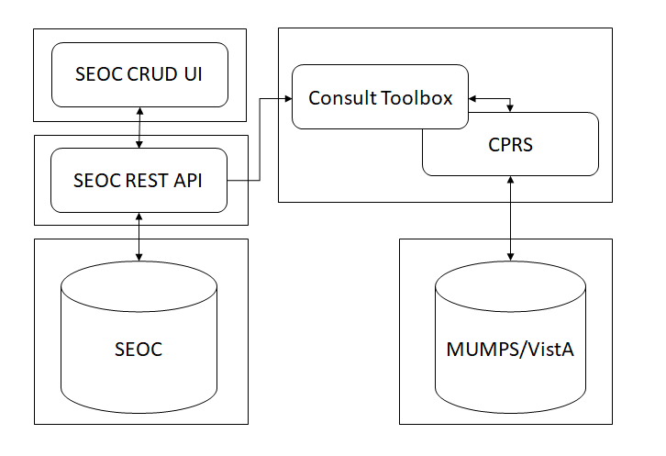

User Access Levels
The User must have access to CPRS to access Consult Toolbox.

Continuity of Operation
Consult Toolbox falls under the VistA Continuity of Operations Plan.

Getting Started
This section provides a general walkthrough of Consult Toolbox from initiation through exit.

Accessing Consult Toolbox
If you are unable to access/use Consult Toolbox, see the Troubleshooting section in this document or contact the National Service Desk at 855-NSD-HELP (673-4357).

Enabling Consult Toolbox
Before enabling Consult Toolbox in CPRS, you will need to run the ConsultToolbox.exe file. The file can be found in the following location: <C:\Program Files\ConsultToolBox\ConsultToolbox.exe>.
Consult Toolbox is part of the CPRS system which requires both a user name and password. On the first use, Consult Toolbox will be disabled until you enable through the CPRS Tools menu. Once enabled, you’ll want to set your preferences.
The Consult Toolbox should be enabled on the applicable computer (this only needs to be done once on a given computer for each person).
When installed on the PC, it will be installed on the workstation as an installed program, but it will need to be enabled. This should be set up on the CPRS Tools menu. Below is an example of how it might, look, but depending on how the station Clinical Application Coordinators (CAC) set-up the tool, the enable link may be in some other location on the tool bar, so each station may look different.
Figure 2: Enable Consult Toolbox Menu Option
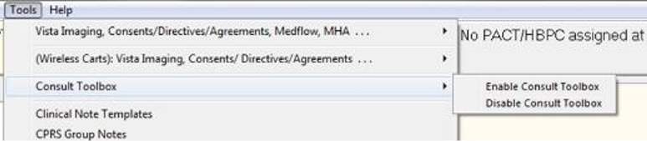
Selecting Enable Consult Toolbox will activate the Toolbox so it will open automatically each time Windows is opened. It only needs to be done once for a given PC and enabled; the Consult Toolbox will be active each time you log into this computer.
When changing computers, the user will need to enable it on the new computer. It will remain enabled from then on, until it is disabled. In the event the Consult Toolbox seems to not be working correctly, enable it again and it will reset.
If SEOC database is unavailable the following warning displays. SEOCs previously downloaded will still be available on the Authorization tab. Contact the NSD if no SEOCs are available.
Figure 3: SEOC Database Unreachable Message
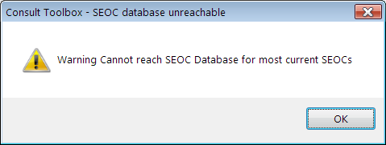

Setting Consult Toolbox Preferences
The Settings functionality within the Consult Toolbox provides any user the ability to select their default features upon opening the Toolbox based on their roles and responsibilities.
To update your Consult Toolbox settings, follow the steps listed below:
- Press the Windows + V key. Once these keys are pressed, the About Consult Toolbox dialog box opens.
Figure 4: About Consult Toolbox
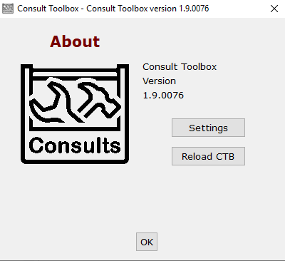
- Click Settings to set the preferences. The Consult Toolbox Preferences and Settings window opens.
Clicking OK will close the dialog box and otherwise do nothing. The Reload CTB resets the Consult Toolbox and can also be used to recover from a technical glitch.
Figure 5: Consult Toolbox Preferences Window
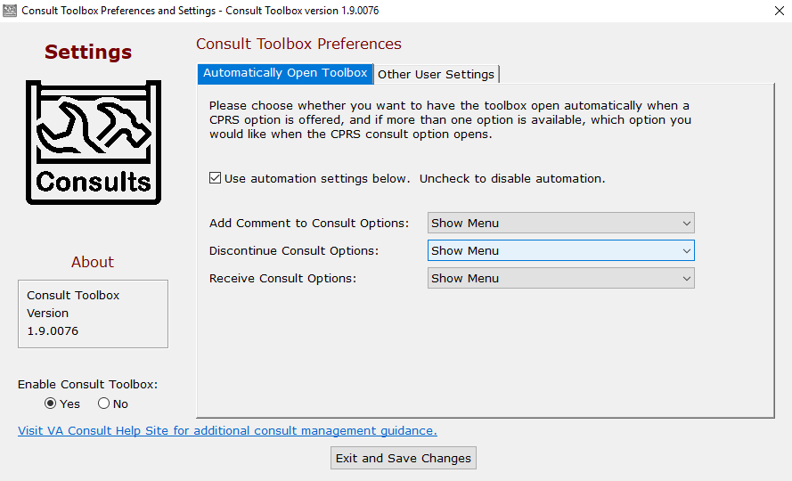
The Consult Toolbox Preferences and Settings window also displays the Consult Toolbox Version number.
- Select the Automatically Open Toolbox tab.
- From the Enable Consult Toolbox section, select Yes or No.
- Yes – this makes the Consult Toolbox function. By enabling it, a link to the Consult Toolbox is placed in the Windows Start Up folder, so the consult toolbox is active each time you log into this PC.
- No – this removes any link from the Startup Menu and turns off the Consult Toolbox. After selecting this option, the Consult Toolbox will no longer function. It will need to be enabled once again from the CPRS Tools menu.
- Select the Use automation settings below. check box to automate settings, otherwise the automation functionality will be disabled.
- From the Add Comment to Consult Options: drop-down menu, select the preferred add comment to consult option.
Figure 6: Add Comment to Consult Options
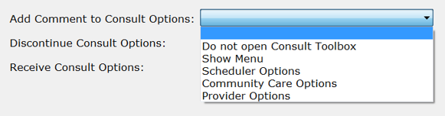
- Do not open Consult Toolbox: Nothing will happen when the CPRS add comment box opens.
- Show menu: As soon as the Add Comment to Consult box opens, the shortcut menu will show itself for the user to select. The user may select an option, or doing something else, including clicking in the white space of the box, will cause the shortcut menu to disappear.
- Scheduler Options: As soon as the Add Comment to Consult pop-up box appears, the Consult Toolbox screen for in-house VA schedulers will also appear.
- Community Care Options: As soon as the Add Comment to Consult pop-up box appears, the Community Care screen for the Consult Toolbox will also appear. This is the same screen that appears under Community Care Options on the Receive Consult CPRS box.
- Provider Options: As soon as the Add Comment to Consult dialog box opens, the provider review screen will appear.
For VA in-house consult schedulers, the recommended setting is Scheduler Options. For Community Care staff (clinical and administrative), the recommended setting is Community Care Options and for in-house clinicians, the recommended setting is Provider Options.
- From the Discontinue Consult Options: drop-down menu, select the preferred discontinue consult option.
Figure 7: Discontinue Consult Options
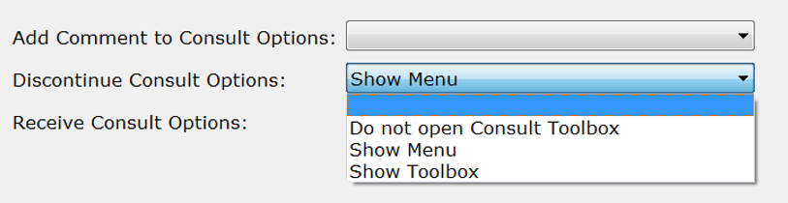
- Do not open Consult Toolbox: Nothing will happen when the CPRS discontinue box opens.
- Show menu: As soon as the Discontinue Consult window opens, the shortcut menu will show itself for the user to select. The user may select an option, or doing something else, including clicking in the white space of the box, will cause the shortcut menu to disappear.
- Show Toolbox: As soon Discontinue Consult window opens, the Consult Toolbox discontinue consult screen also appears.
- From the Receive Consult Options: drop-down menu, select the preferred receive consult option.
Figure 8: Receive Consult Options
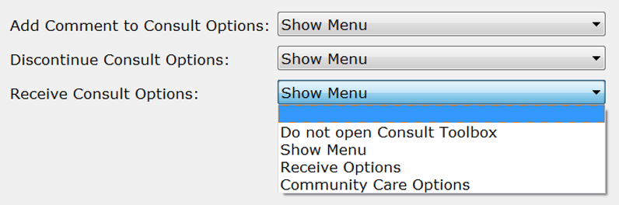
- Do not open Consult Toolbox: Nothing will happen when the receive consult box opens.
- Show menu: As soon as the Receive Consult box opens, the shortcut menu will show itself for the user to select. The user may select Receive Consult or select something else. Clicking in the white space of the box, will cause the shortcut menu to disappear.
- Receive Consult: As soon as the Receive Consult box appears, the Receive Consult screen for the Consult Toolbox will also appear.
- Community Care Options: As soon as the Receive Consult box appears, the Community Care screen for the Consult Toolbox will also appear. Note, this is the same screen appears under Community Care Options on the Add Comment to Consult CPRS box.
- Select the Other User Settings tab.
Figure 9: Other User Settings Tab
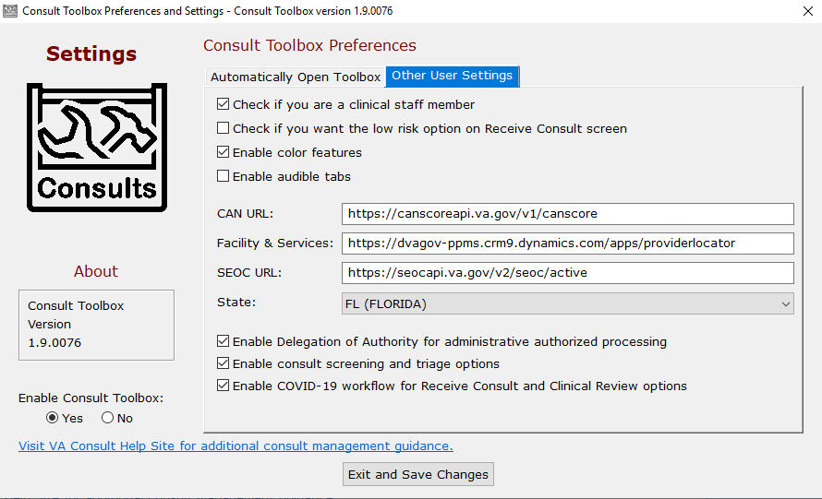
- Select the check boxes for the preferred settings.
- Check if you are a clinical staff member – This is pertinent only under the Community Care screen. If the user can make clinical assessments or decisions in the management of community care, select yes for this option. Staff selecting yes are typically nurses and licensed practitioners.
This check box must be selected to see the COVID-19 Priority tab in the Community Care Functions screen.
- Check if you want the low risk option on Receive Consult screen – Veterans Health Administration (VHA) has defined low risk clinics nationally to include: physical therapy, occupational therapy, kinesiotherapy, acupuncture, smoking clinic, MOVE clinic, massage therapy, chiropractic care and erectile dysfunction clinic. A full list of low risk clinics can be found in the VHA Consult SOP. As soon as the Receive Consult box appears, the Receive Consult screen for the Consult Toolbox for low risk clinics will also appear. Note that to use this option, a clinic must be approved as a low risk clinic by the facility consult management (Committee or Chief of Staff (COS) designee).
- Enable color features – If checked, certain screens will have some headings and selected tabs with color highlights instead of being in black, white and grey. The screen image above shows how the tabs look with color highlight off.
- Enable audible tabs – Reads aloud the community care comments panel tab name.
- CAN URL: - The Preferred Care Assessment Need (CAN) Universal Record Location (URL) should only be changed if directed by support personnel. The URL and certificate name can be changed by support to suit the execution environment.
- Client Cert: The name of the internet browser certificate that will be used to contact the CAN score server online.
- Facility & Services: - The URL used to access VA Community Care Provider Locator.
- SEOC URL: - The Preferred SEOC URL should only be changed if directed by support personnel. The URL and certificate name can be changed by support to suit the execution environment.
- State: Enter the state you typically use for community care providers. This will be the default setting any time you look up a provider for community care. You can always change it.
- Enable Delegation of Authority for administrative authorized processing – The Delegation of Authority is an action taken by the Chief of Staff to delegate clinical review authority for services that are requested through a community care consult. If this process was implemented in your facility, check this box.
- Enable consult screening and triage options – At the time of this version, local community care staff will have the ability to assign care coordination levels based on a Veterans complexity of needs. Check this box to begin using this functionality.
- Enable COVID-19 workflow for Receive Consult and Clinical Review options – Check this box to access the screens required for use during the Coronavirus Disease of 2019 (COVID-19) Pandemic.
For instructions on how to access the new screens during the COVID-19 Pandemic, please refer to Appendix A: Management of Consults when COVID-19 Workflow is Enabled.
- Click Exit and Save Changes to save the selected settings for future work sessions.

System Menu
The Action>Consult Tracking… menu in CPRS offers several Consult Toolbox functions: Receive, Discontinue, Forward, Add Comment, Significant Findings, and Administrative Complete.
Figure 10: Consult Tracking… Menu Options
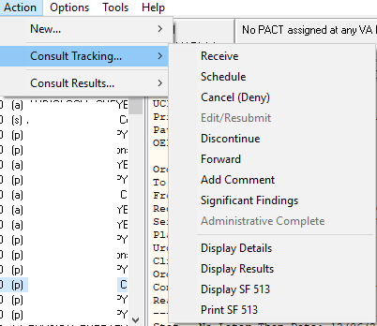

Receive
Figure 11: Receive Menu Options
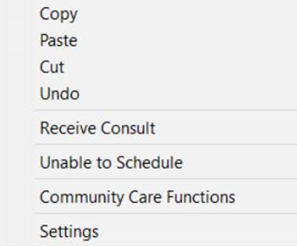

Discontinue
Figure 12: Discontinuing Consult Menu Option
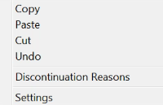

Forward
Figure 13: Forward Menu Options
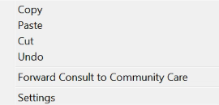

Add Comment
Figure 14: Add Comment Menu Options
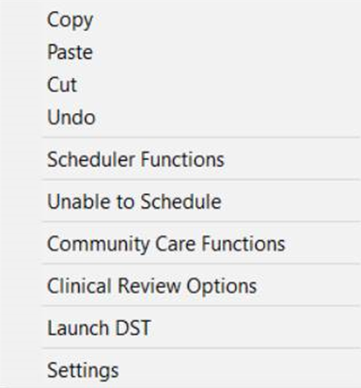

Significant Findings
Figure 15: Significant Findings Menu Option
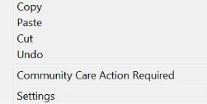

Administrative Complete
Figure 16: Administratively Complete Menu Option
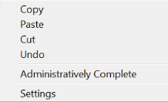

Using the Software
The Consult Toolbox provides user functionality in the following consult windows:
- Receiving Consult Activities — this can be configured to open automatically.
- Discontinuing Consult — this can be configured to open automatically.
- Forwarding Consult to Community Care – right-click in comment required, only for forwarding to community care.
- Adding Comment to Consult — this can be configured to open automatically.
- Significant Findings – right-click required, may be used when needing to convey a message to the ordering provider, though a progress note should also be present with more detail.
- Administratively Close Consult — right-click in comment required, only for instances where community care was completed, but records are unavailable.
For a list of Health Factors that are used in Consult Toolbox, please refer to Appendix B: Consult Factor Types and Definitions.

Receiving Consult Activities

Receiving Functions
For instructions on how to receive consults during the COVID-19 Pandemic please refer to Appendix A1: Receiving Consult Activities when COVID-19 Workflow is Enabled.
Clinicians and/or delegated administrative staff receive View Alert in CPRS/ of VA order/consult notification. When a provider receives a pending consult, review should include determination of whether the consult is appropriate to be scheduled, and optionally, additional direction can be given to the scheduler.
The Receiving Consult Activities is used by any clinic in the VA facility that receives a consult. This clinic may be an internal VA clinic or a community care clinic.
Figure 17: Receive Routine Consult Options Window
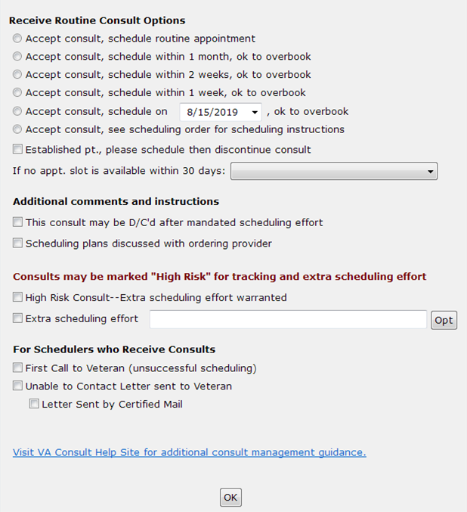
- Receive Routine Consult Options section
- Accept consult, schedule routine appointment – Accept consult, schedule within one month, ok to overbook—the reviewing provider has determined that the Veteran’s medical condition warrants them being seen within one month and should be overbooked if needed to accomplish that effect.
- Accept consult, schedule within 1 month (OK to overbook) – Accept consult schedule within two weeks, ok to overbook—the reviewing provider has determined that the Veteran’s medical condition warrants them being seen within two weeks and should be overbooked if needed to accomplish that effect.
- Accept consult, schedule within 2 weeks, (OK to overbook) – Accept consult schedule within one week ok to overbook—the reviewing provider has determined that the Veteran’s medical condition warrants them being seen within one week and should be overbooked if needed to accomplish that effect. If less than one week or immediate, the provider may add additional instructions, or speak directly with the scheduler if truly urgent.
- Accept consult, schedule within 1 week, (OK to overbook) – Accept consult schedule on a specific date—this allows the provider to specify the date to see the Veteran.
- Accept consult, schedule on MM/DD/YYYY, (OK to overbook) – Accept consult see scheduling order for scheduling instructions—this selection applies if the clinic or service provider prefers to convey scheduling instructions via a CPRS order.
- Accept consult; see scheduling order for scheduling instructions – this selection applies if the clinic or service provider prefers to convey scheduling instructions via CPRS order.
- Established pt., please schedule then discontinue consult – this selection applies if a consult is received for an established patient. Once the consult is received, it is sent to the scheduler to make the appointment. Once the appointment is made, the consult can be discontinued.
- If no appt. slot is available within 30 days:
    - Forward to Community Care Office
    - Discuss with clinical staff
- Additional comments and instructions section
- This consult may be D/C’d after mandated scheduling effort—this option allows the reviewing provider to determine at the time of acceptance that if the staff is unable to get the appointment scheduled, or if the Veteran cancels or no-shows twice, then the consult can be discontinued by the scheduler without having another clinical review. The consult is returned to the ordering provider to take whatever action deemed appropriate.
The This consult may be discontinued d/c’d after 1 missed appointment (approved low risk clinic) check box described below is only visable when enabled in the Consult Toolbox Settings.
- This consult may be discontinued d/c’d after 1 missed appointment (approved low risk clinic) – An additional option for low risk clinics exists for discontinuation after one missed appointment. This screen auto populates from settings described above.
Figure 18: Low Risk Clinics Options
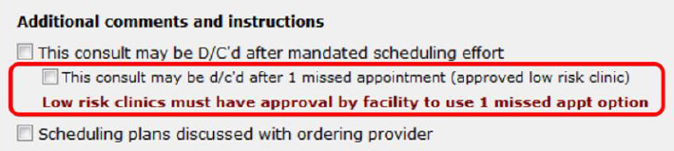
- Scheduling plans discussed with ordering provider—this selection is simply for the convenience of the reviewing provider to document the instance where they have discussed the case with the ordering provider. This allows them to easily document that conversation took place. It doesn’t have any significant ramifications with respect to consult processing.
- Consults should be marked “High Risk” for track and extra scheduling effort section
- High Risk Consult-Extra scheduling effort warranted – this will flag this consult as having a medically high-risk condition that warrants additional calls to the Veteran beyond the mandated minimum necessary effort. It also allows the receiving service to flag certain consults for closer follow up when the Veteran fails to keep appointments. Each service may define what high risk means to them. This is simply a way of segregating higher risk consults from the rest and notifying the staff to expend additional effort.
- Extra scheduling effort – allows the reviewer to specify what additional effort they would like. In addition to the selection of options, the user may type in other instructions.
Figure 19: Extra Scheduling Effort Options
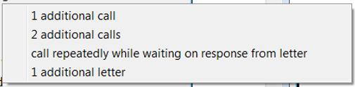
- For Schedulers Who Receives Consults section,
- First call to Veteran (unsuccessful scheduling) – This option supports recording calls to Veteran that were successful.
- Unable to Contact letter sent to Veteran – use this selection when a letter is sent to the Veteran indicating that the clinic has tried to reach the Veteran to schedule an appointment. This comment may be used each time a letter is sent, if sent more than once.
- Letter Sent by Certified Mail – in the case of high risk consults, business rules for the clinic or upon suggestion of the provider, it may be appropriate to send the Veteran a certified letter indicating that they have a potentially serious condition, and that the VA has been unsuccessful reaching them to provide care.

Receiving Consult Steps
To receive consult, follow the steps listed below:
- From the Action menu, select Consult Tracking…, and then select Receive. The Receive Consult dialog box opens.
Figure 20: Receive Consult Dialog Box
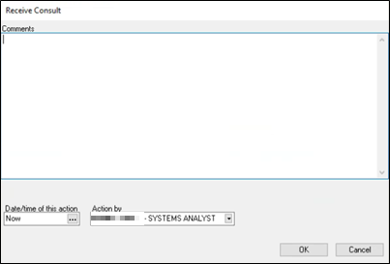
- In the Comments field, right-click to display the Receive menu.
Figure 21: Receive Menu
- From the Receive menu, select Receive Consult. The Receive Routine Consult Options window opens.
Figure 22: Receive Routine Consult Options Window
- From the Receive Routine Consult Options section, select the consult option. Accept consult, schedule routine appointment is the default process. The appointment will be scheduled according to routine scheduling instructions. Routine scheduling means that the Veteran will be given the next open appointment. If that appointment exceeds the wait time standard, the Veterans Community Care Program (VCCP) will be an option available to the Veteran.
Subsequent radio buttons under the receive consult options provide guidance to keep the Veteran in-house and overbook.
- If the Veteran is an established patient, then select the Established pt., please schedule then discontinue consult check box.
- If an appointment is not available for the Veteran within 30 days, select Forward to Community Care Office or Discuss with clinical staff from the If no appt. slot is available within 30 days: drop-down menu.
- From the Additional comments and instructions section, select the options that best apply to this consult.
- If the consult is high risk and needs to be tracked and extra scheduling efforts, select the High Risk Consult-Extra scheduling effort warranted check box from the Consults should be marked “High Risk” for track and extra scheduling effort section.
- If the consult is high risk, from the Extra scheduling effort select the option that to specify what additional effort you would like. In addition to the selection of options, you may type in other instructions.
- From the For Schedulers Who Receives Consults: section, select if a call was made to the Veteran or if a letter was sent was sent to the Veteran.
- Select the Letter Sent by Certified Mail check box if a certified letter was sent to the Veteran.
- Click OK.

Unable to Schedule Functions
The Unable to Schedule function is the replacement for Veterans awaiting care via the EWL in VistA. The use of the Unable to Schedule function should not be used for administrative transfer requests. The use of the Light Electronic Action Framework (LEAF) should be used for administrative transfer requests.
Staff who receive and schedule internal VA consults are required to activate and utilize the Consult Toolbox when available to document reasons that consults cannot be scheduled and to monitor these requests for care. Unable to Schedule consults should remain in an Active status until the patient is scheduled or care is delivered.
Providers and schedulers will only use this option when receiving an internal VA consult that cannot be scheduled 390 days in the future and the Veteran has already declined Community Care or there is no comparable service in the community.
Right clicking the text area while receiving a consult or when adding a comment will bring up the list of approved reasons. Selecting one or more of these reasons will provide standard text that may be inserted in the consult comments to document why the consult cannot be appropriately scheduled.
Figure 23: Receive Unable to Schedule Window
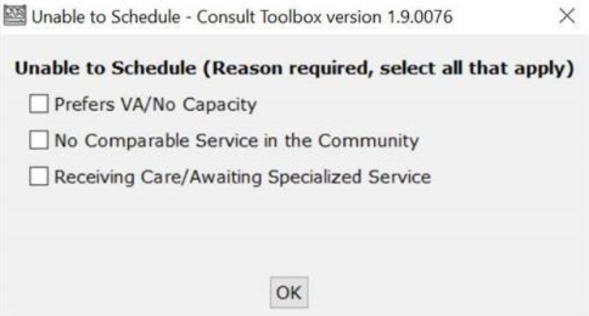
- Prefers VA/No Capacity – Wants VA care (opts out of Community Care) and is waiting for availability. Care need is not met.
- No Comparable Service in the Community – Service is unique to VA this is specific to GEC, Home Base Primary Care (HBPC), and Mental Health services, where the care is not offered in the community (e.g., Spinal Cord Injury, Purchased GEC Care, HBPC with no VA Primary Care).
- Receiving Care/Awaiting Specialized Service – Care needs being met in VA while waiting for specialized VA service (e.g., HBPC Patients receiving VA Primary Care).

Unable to Schedule Steps
If the consult is unable to schedule , follow the steps listed below:
- From the Action menu, select Consult Tracking…, and then select Receive. The Receive Consult dialog box opens.
Figure 24: Receive Consult Dialog Box
- In the Comments field, right-click to display the Receive menu.
Figure 25: Receive Menu
- From the Receive menu, select Unable to Schedule. The Unable to Schedule window opens.
Figure 26: Unable to Schedule Window
- From the Unable to Schedule section, select one or more reasons you were unable to schedule the consult.
- Click OK.
If you click OK before selecting an option, you will receive an error message stating that you must make a selection to continue.

Community Care Functions
For instructions on how to assign priority during the COVID-19 Pandemic please refer to Appendix A1.3: Receive Community Care Functions: COVID-19 Priority and Appendix A2.3: Add Comment Community Care Functions: COVID-19 Priority.
Community Care functions document activities that have taken place within the Community Care programs that are provided by the VA.
When compiling pertinent medical documentation for upload to the TPA Portal, it is highly recommended that the Referral Documentation Tool (REFDOC) be used. REFDOC is an innovative solution that extracts from the Veteran’s electronic medical record and records into PDF format for exchange with community care providers. REFDOC improves the timeliness of medical record transfers by allowing VA staff to quickly extract Veterans’ health information from Veterans Health Information Systems and Technology Architecture (VistA), Computerized Patient Record System (CPRS), and Corporate Data Warehouse (CDW) and compile it into a PDF package that can be easily shared with community providers.

MSA Eligibility Verification
Figure 27: MSA Elig. Verification Tab
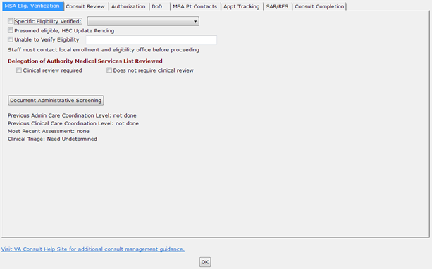
- Specific Eligibility Verified—allows staff to further signify that the Veteran is eligible under one of the administrative eligibilities. This option allows the user to identify Community Care eligibility. The drop-down offers the following options:
Figure 28: Specific Eligibility Verified Menu Options
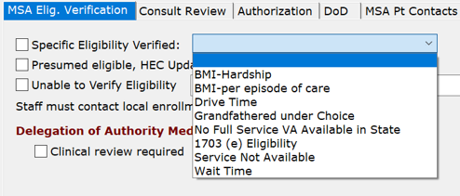
- BMI-Hardship
- BMI-per episode of care
- Drive Time
- Grandfathered under Choice
- No Full Service VA Available in State
- 1703 (e) Eligibility
- Service Not Available
- Wait Time – VA appointment is not available within the wait time standard.
*Grandfathered eligibility from Veterans Choice Program.
- Presumed eligible, HEC Update Pending —This is typically appropriate when a new Veteran is being registered and all evidence indicates (e.g. a DD 214 form) that the person is indeed a Veteran, but the eligibility cannot be verified by the Health Eligibility Center’s (HEC) systems. This is an indication that the record requires action by the HEC before the consult can move forward.
- Unable to Verify Eligibility —Staff member should take steps to verify eligibility. Staff is unable to verify the person’s eligibility for VA care or Community Care. This allows documentation of that fact and alerts the staff to refer the case to the appropriate person for resolution. A comment is available for further clarification but is not mandatory.
- Delegation of Authority Medical Services List Reviewed section. — This allows staff to select if clinical review is required, by checking a box.
- Clinical review required
- Does not require clinical review
- Document Administrative Screening

Community Care MSA Eligibility Verification Steps
To set the Community Care MSA Eligibility Verification options, follow the steps listed below:
- From the Action menu, select Consult Tracking…, and then select Receive. The Receive Consult dialog box opens.
Figure 29: Receive Consult Dialog Box
- In the Comments field, right-click to display the Receive menu.
Figure 30: Receive Menu
- From the Receive menu, select Community Care Functions. The Community Care Functions window opens with the MSA Elig. Verification tab displayed.
Figure 31: MSA Elig. Verification Tab
- Select the Specific Eligibility Verified, Presumed eligible, HEC Update Pending, or Unable to Verify Eligibility check box that best describes the Community Care MSA eligibility verification.
CAUTION: Staff must contact local enrollment and eligibility office before proceeding.
- Once you have contacted local enrollment and eligibility, select the best option from the Delegation of Authority Medical Services List Reviewed section.
Information under Document Administrative Screening is populated and provides care coordination information about this Veteran. Additional details are in Community Care Document Administrative Screening and Clinical Triage tool section.
- Click OK.

Community Care (CC) Document Administrative Screening
The Screening/Triage tool enables staff to assess the Veteran’s care coordination needs in the community. The tool consists of an administrative screening and clinical triage sections. While the administrative section may be completed by any integrated team staff member (MSA/PSA, Social Worker, RN), the clinical section may be only completed by clinical staff. The administrative section consists of questions about the urgency of the Veteran’s care request, the requested services in the consult, and the corresponding Veteran CAN (Care Assessment Need) score, accessible through VSSC. Based on the answers in this section, the tool will determine whether a clinical assessment will be necessary. If so, the tool will prompt the user to input the name of the RN responsible for completing the clinical section and send an alert.
Figure 32: Administrative Screening
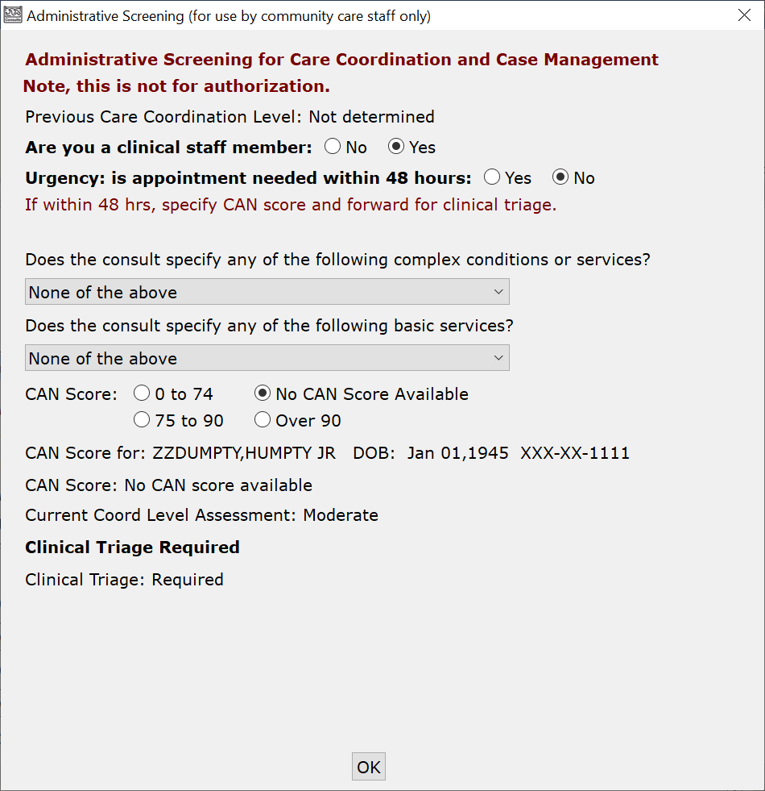
Administrative Screening for Care Coordination and Case Management section:
- Are you a clinical staff member: Yes or No—the first question asks if you are a clinical staff member. This box will screen to see if clinical staff needs to review an alert, which wouldn’t be needed if the user is a clinical staff person.
- Urgency: is appointment needed within 48 hours—if urgent care coordination is required, this should be forwarded immediately for clinical triage. (If within 48 hours, skip remaining questions and forward for clinical triage.)
- Does the consult specify any of the following complex conditions or services? — if the consult specifies any complex conditions or services, select one of the following options from the drop-down menu.
- New Cancer Diagnosis
- Outpatient Surgery
- Coronary Artery Bypass (CABG)
- Chronic Heart Failure
- Chronic Obstructive Pulmonary Disease/Pneumonia
- Inpatient Hospitalization (any cause)
- None of the above
- Does the consult specify any of the following basic services — if the consult specifies basic services, select the applicable service from the drop-down menu.
- Routine therapeutic services (Dialysis, OT, PT, RT)
- Routine Mammography
- Cervical Ca Screening (PAP Test)
- Complimentary and integrated medicine
- Direct Scheduling
- Routine Screening Colonoscopy
- Low Dose CT Scans
- None of the above
- CAN Score — CAN Scores serve as an important component to the Screening/Triage process providing a standardized evidence-based measure of Veteran risk. CAN Scores measure the probability of inpatient admission or death within a specified period of time (1 year) in percentage form. Toolbox automatically retrieves the CAN Score for a patient from the CDW via the CAN Score service.
If the CAN Score service is unavailable or a CAN Score does not exist for a patient, manual entry of the CAN Score is enabled.
Figure 33: CAN Score Fields Enabled
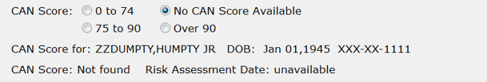
To access a Veteran’s CAN Score manually, the staff will be required to access VHA Support Service Center (VSSC). If CAN (Care Assessment Needs) Score is known, make the appropriate selection, or if not available, select No CAN Score Available from the following choices:
- 0 to 74
- 75 to 90
- Over 90
- No CAN Score Available
- CAN Score for: - Name of Veteran.
- DOB: - Veteran’s date of birth.
- SSN: - Veteran’s social security number.
- CAN Score: - Veteran’s CAN Score.
- Current Coord Level Assessment: - If this is not Basic, a box will open to input the name of the clinical staff member responsible for completing the clinical triage portion of the tool. This is not shown for clinical staff.
This does not send the actual alert, the user is responsible for sending the alert using the Send additional alerts button on the comment screen:
- Clinical Triage: - If the level of care coordination determined in the administrative screening section is not basic, the administrative staff member will alert a clinical care coordinator to complete the clinical triage section below. The clinical section consists of questions regarding the Veteran’s comorbidities, social factors, and need for assistance with Activities of Daily Living (ADLs). There is also a drop-down menu which the clinical care coordinator may fill out to override the results of the tool using clinical evidence-based judgment.
If clinical triage has already been performed, it will show. Also, if care coordination has already been assigned by Administrative screening (as in the example below) that will also show.
- Scheduling staff member you will alert: - Name of the scheduling staff member.
- Remember staff person for next referral: - option that tells the Consult Toolbox to remember the selected scheduling staff person for the next referral.

Community Care (CC) Document Administrative Screening Steps
To set the Document Administrative Screening options, follow the steps listed below:
Figure 34: MSA Elig. Verification Tab: Document Administrative Screening Section
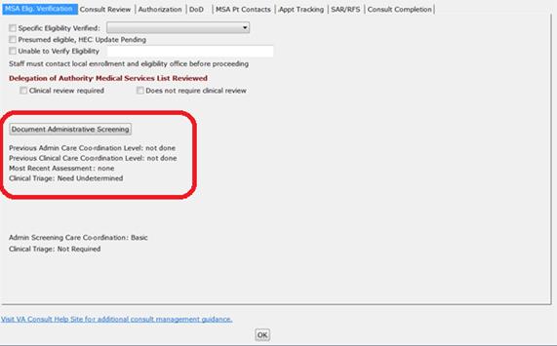
- From the MSA Elig. Verification tab, click Document Administrative Screening. The Administrative Screening (for use by community care staff only) window opens.
Figure 35: Administrative Screening (for use by community care staff only) Window
If clinical review has already been performed, it will show. If administrative screening has been performed on this consult previously, it will be indicated as such in the administrative screening section.
- Select the Yes or No radio button for the From the Are you a clinical staff member question.
- Select the Yes or No radio button if there is an urgency to have an appointment in the next 48 hours.
- From the Does the consult specify any of the following complex conditions or services? drop-down menu, select if the consult specifies any complex conditions or services.
Either a complex or basic service may be selected from the drop-down menus but not both, if both are selected the first selection will be reset to “None of the above”.
- From the Does the consult specify any of the following basic services? drop-down menu, select the applicable service.
- From the CAN Score section, select appropriate selection with regards to the CAN Score.
- If the Current Coord Level Assessment is not Basic, input the name of the clinical staff member responsible for completing the clinical triage portion of the tool in the Name of scheduling staff member you will alert: field. This is not shown for clinical staff.
Figure 36: Scheduling staff member you will alert: Field
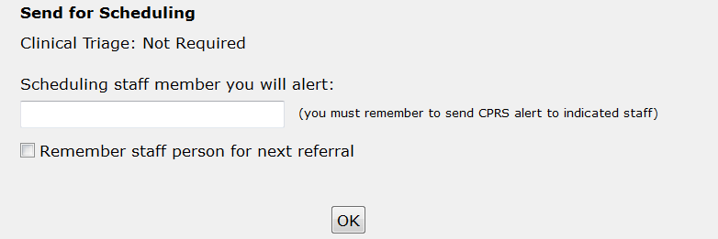
- Select the Remember staff person for next referral check box if you would like Consult Toolbox to remember your selection for the next referral.
This does not send the actual alert, the user is responsible for sending the alert using the Send additional alerts button on the comment screen:
- Click OK. The Document Administrative Screening information will populate on the MSA Elig. Verification tab.
Figure 37: Document Administrative Screening Populated
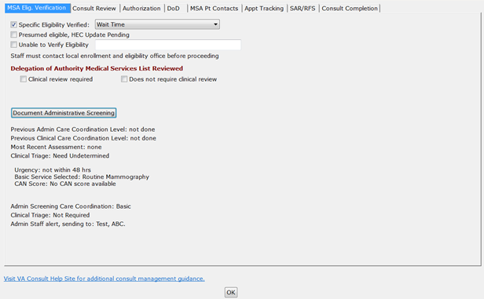

Consult Review
Figure 38: Consult Review Tab
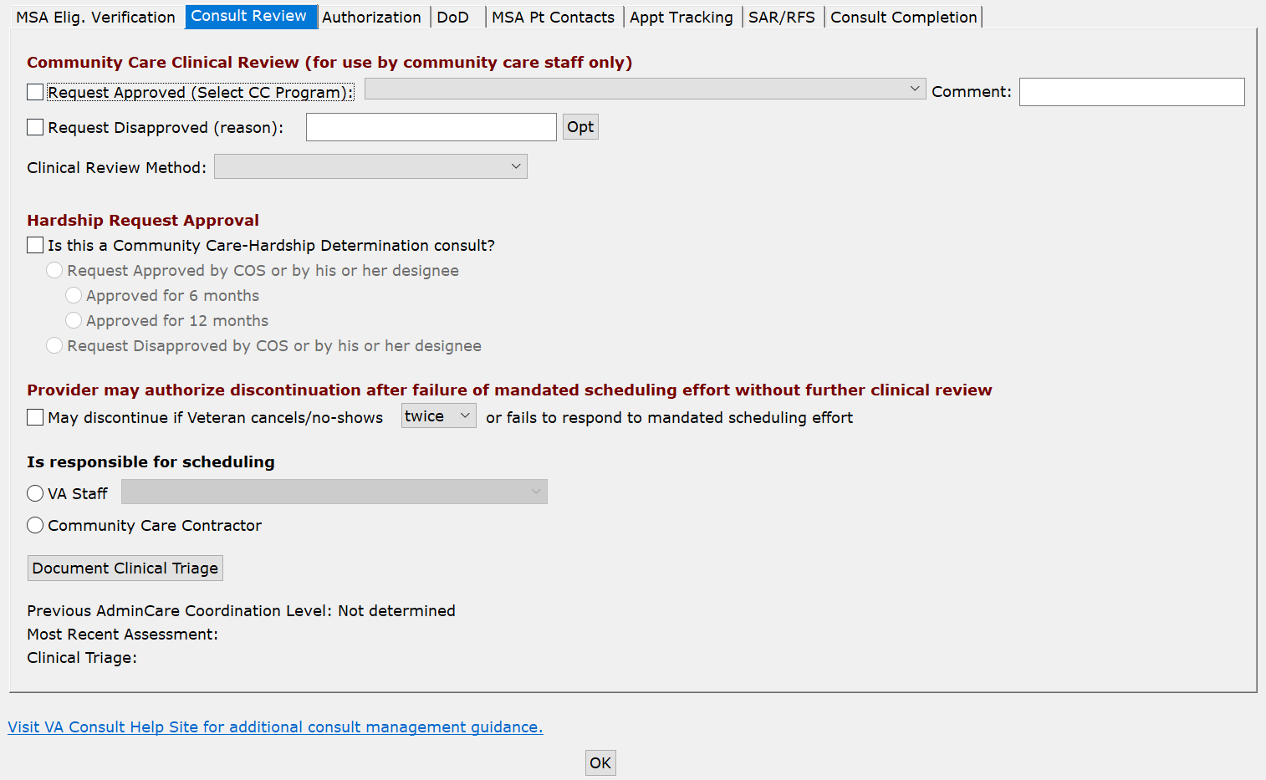
- Community Care Clinical Review (for use by community care staff only)
- Request Approved (Select CC Program)— Optional field. Various Community Care programs can be selected but must be one of the listed in the drop-down menu.
Figure 39: Request Approved Options
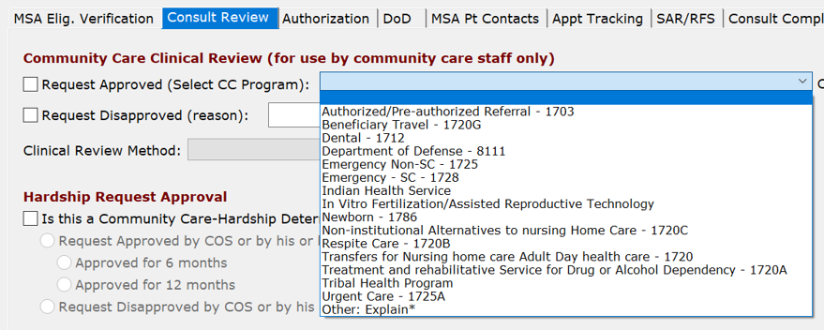
If you are located in Alaska , Tribal will be an additional option in the Request Approved (Select CC Program) drop-down menu.
The Request Approved (Select CC Program) list is intended to display the approved program authorities used to purchase care in the community.
- Comment:
- Request disapproved (reason) —reason request disapproved, enter other reason in the field or select an option from the Opt menu.
Figure 40: Request Disapproved Options
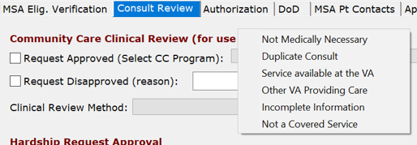
- Not Medically Necessary
- Duplicate Consult
- Service available at the VA
- Other VA Providing Care
- Incomplete Information
- Not a Covered Service
- Clinical Review Method:
Figure 41: Clinical Review Method Menu Options
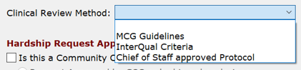
- MCG Guidelines
- InterQual Criteria
- Chief of Staff approved Protocol
- Hardship Request Approval:
- Is this a Community Care-Hardship Determination consult?
- Request Approved by COS or by his or her designee
- Approved for 6 months
- Approved for 12 months
- Request Disapproved by COS or by his or her designee
- Provider may authorize discontinuation after failure of mandated scheduling effort without further clinical review
- May discontinue if Veteran cancels/no-shows or fails to respond to mandated scheduling effort — If the Provider authorizes discontinuation after failure of mandated scheduling effort without further clinical review.
- twice
- once
- Is responsible for scheduling
- VA Staff
- VA schedules based on Veteran’s preference
- Veteran self-schedules
- Community provider schedules directly with Veteran
- Community Care Contractor
- Document Clinical Triage

Consult Review Steps
To set the CC Consult Review options, follow the steps listed below:
- From the Action menu, select Consult Tracking…, and then select Receive. The Receive Consult dialog box opens.
Figure 42: Receive Consult Dialog Box
- In the Comments field, right-click to display the Receive menu.
Figure 43: Receive Menu
- From the Receive menu,, select Community Care Functions. The Community Care Functions window opens with the MSA Elig. Verification tab displayed.
- Select the Consult Review tab.
Figure 44: Consult Review Tab
- From the Community Care Clinical Review section, select if the request was approved or disapproved. If the request was approved, you will need to select the CC Program from the drop-down. If the request was not approved, you will need to select the reason from the Opt menu.
- From the Hardship Request Approval section, select the best options.
- If the Provider authorizes discontinuation after failure of mandated scheduling effort without further clinical review, select May discontinue if Veteran cancels/no-shows or fails to respond to mandated scheduling effort check box and select the number of times from the drop-down menu.
- From the Is responsible for scheduling section, select if the scheduling will be done by either VA Staff or Community Care Contractor.
- Click OK.

Clinical Triage
If the level of care coordination determined in the administrative screening section is not basic, the administrative staff member will alert a clinical care coordinator to complete the clinical triage section below. The clinical section consists of questions regarding the Veteran’s comorbidities, social factors, and need for assistance with Activities of Daily Living (ADLs). There is also a drop-down menu which the clinical care coordinator may fill out to override the results of the tool using clinical evidence-based judgment.
If clinical triage has already been performed, it will show. Also, if care coordination has already been assigned by Administrative screening that will also show.
Figure 45: Clinical Triage for Care Coordination
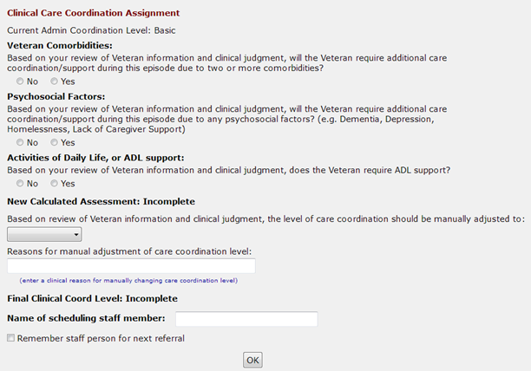

Clinical Care Coordination Assignment
The Screening/Triage tool will recommend a care coordination level once the following items are populated:
- Veteran Comorbidities:—select yes or no if based on your review of Veteran information and clinical judgement if the Veteran will require additional care coordination/support during this episode of care due to two or more comorbidities.
- Psychosocial Factors:—select yes or no if based on your review of the Veteran information and clinical judgement, if the Veteran will require additional care coordination/support during this episode of care due to any psychosocial factors (e.g. Dementia, Depression, Homelessness, Lack of Caregiver Support).
- Activities of Daily Life, or ADL support: –select yes or no if based on your review of Veteran information and clinical judgement, if the Veteran will require ADL support.
- New Calculated Assessment: — the tool will calculate a level of care coordination based on the answers in the administrative screening and clinical triage sections as displayed below:
- Based on review of Veteran information and clinical judgement, the level of care coordination should be manually adjusted to: - Based on clinical judgment, the clinical care coordinator may override the automated result. If manual adjustment is required for the level of care coordination, select the revised level in the drop-down menu along with the reason for adjustment in the textbox below.
- Basic
- Moderate
- Complex
- Urgent
- Reasons for manual adjustment of care coordination level — enter a clinical reason for manually changing care coordination level.
- Final Clinical Triage Coordination Level: - auto-populates based on the completion of clinical triage questions or manual override.
- Name of scheduling staff member: - Name of the scheduling staff member.
- Remember staff person for next referral – option that tells the Consult Toolbox to remember the selected staff person for the next referral.

Clinical Triage Steps
To complete the clinical triage, follow the steps listed below:
- From the Action menu, select Consult Tracking…, and then select Receive. The Receive Consult dialog box opens.
Figure 46: Receive Consult Dialog Box
- In the Comments field, right-click to display the Receive menu.
Figure 47: Receive Menu
- From the Receive menu,, select Community Care Functions. The Community Care Functions window opens with the MSA Elig. Verification tab displayed.
- Select the CC Consult Review tab.
Figure 48: Consult Review Tab
- Click the Document Clinical Triage button. The Clinical Triage for Care Coordination window opens.
Figure 49: Clinical Triage for Care Coordination
The Clinical Triage tool will recommend a care coordination level once the following items are populated.
- From the Veteran Comorbidities: section, select No or Yes if the Veteran will require additional care coordination/support during this episode of care due to two or more comorbidities.
- From the Psychosocial Factors: section, select No or Yes if the if the Veteran will require additional care coordination/support during this episode of care due to any psychosocial factors (e.g. Dementia, Depression, Homelessness, Lack of Caregiver Support).
- From the Activities of Daily Life, or ADL support: section, select No or Yes if the Veteran will require ADL support.
- The tool will automatically calculate a level of care coordination based on the answers in is the steps above. The coordination level displays in the New Clinical Triage Coordination Level section.
Figure 50: New Clinical Triage Coordination Level
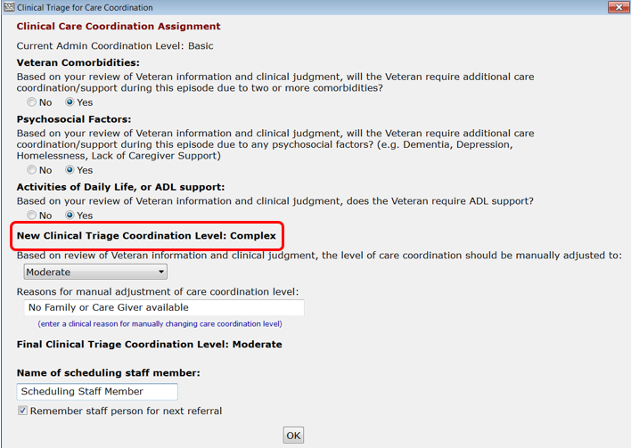
Based on clinical judgment, the clinical care coordinator may override the automated result. If manual adjustment is required for the level of care coordination, select the revised level in the drop-down menu along with the reason for adjustment in the text box.
- In the Reasons for manual adjustment of care coordination level: field, enter a clinical reason for manually changing care coordination level.
- The Final Clinical Triage Coordination Level: auto-populates based on the completion of clinical triage questions or manual override.
- In the Name of scheduling staff member: field, enter the name of the staff member.
- Select the Remember staff person for next referral check box if you want Consult Toolbox to remember the staff person.
- Click OK. The screening/triage tool will populate a comment in the body of the consult detailing the level of care coordination, directions for proceeding with care coordination, and a list of potential care coordination services required by the Veteran. The comment will also provide guidance on the frequency of contact and need for warm handoff.
Figure 51: Comment Added to Consult
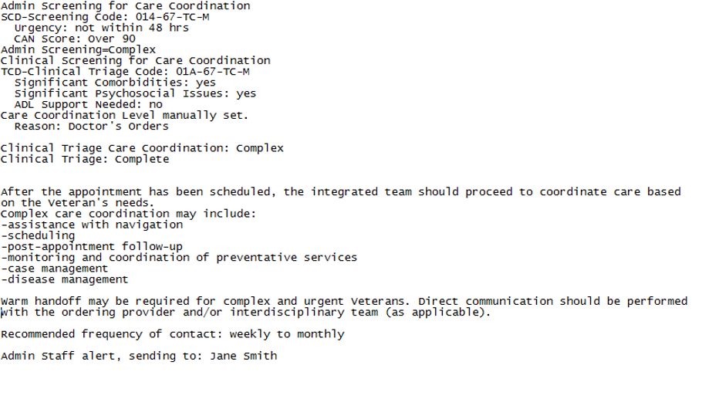

Authorization
This information documented within the Authorization tab populates from data contained in the consult if present, but will not be added to the consult again unless changes and the checkbox is checked shown and described below.
Figure 52: Authorization Tab
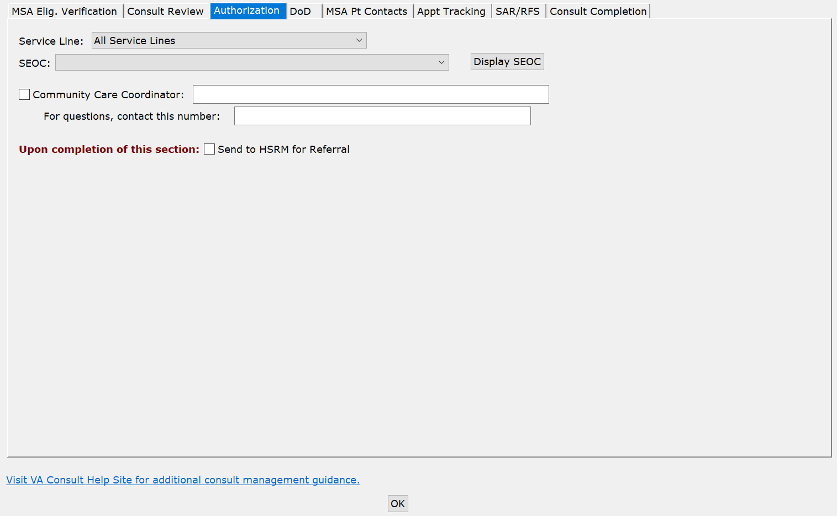
- Service Line – A broad category for the services and procedures included which is intended to be used as a way to group and filter SEOCs for easier accessibility. A standardized 3-letter abbreviation of the service line is included at the beginning of the SEOC ID.
Figure 53: Service Line Menu Options
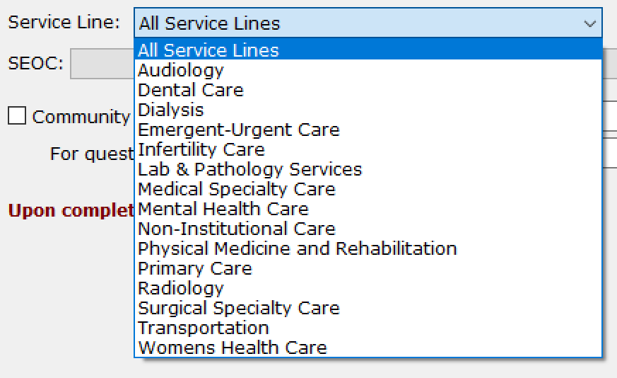
- SEOC – A SEOC selection is mandatory on every Community Care consult. If a SEOC has not been previously placed to the Consult, users should use Consult Toolbox to write a SEOC to the consult.
If SEOC database is unavailable the SEOC Database Unreachable Message displays. Contact the NSD if no SEOCs are available in th drop-down menu.
Figure 54: List of Active SEOCs
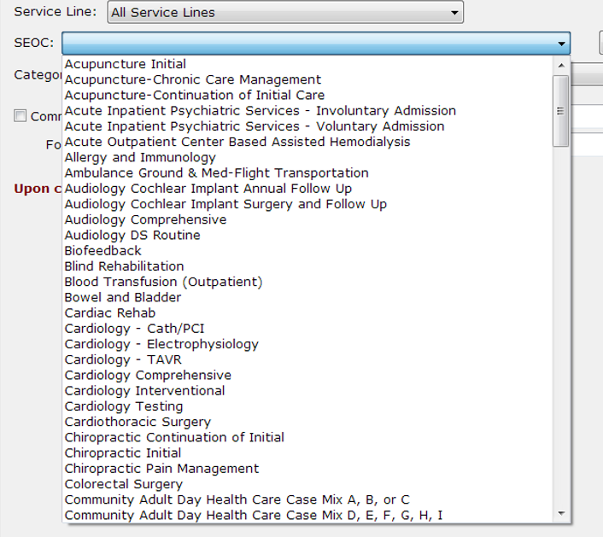
- Display SEOC – Option that allows you to view the details of the selected SEOC.
Figure 55: Display SEOC
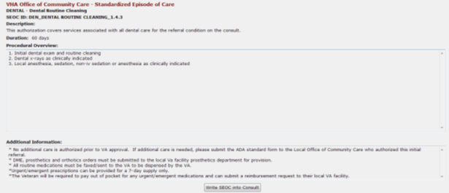
- Community Care Coordinator — typically referrals need to include the name of the Community Care Coordinator and a contact number. These can be inserted here. You must check the checkbox for this to be included.
- For questions, contact this number: - Community Care manager contact phone number.
- Upon completion of this section — send to HSRM for referral. If this check box is selected, a consult will transfer to HSRM in approved status even if the status in CPRS is cancelled, pending, discontinued, etc.

Authorization Steps
To view or edit the options within the Authorization tab, follow the steps below:
- From the Action menu, select Consult Tracking…, and then select Receive. The Receive Consult dialog box opens.
Figure 56: Receive Consult Dialog Box
- In the Comments field, right-click to display the Receive menu.
Figure 57: Receive Menu
- From the Receive menu,, select Community Care Functions. The Community Care Functions window opens with the MSA Elig. Verification tab displayed.
- Select the Authorization tab.
Figure 58: Authorization Tab
- From the Service Line drop-down menu, select the best option.
- From the SEOC drop-down menu, select one of the authorized service listed.
- Select the Community Care Manager check box to include the name of the Community Care manager and add a contact number.
- Once the referral is ready for Authorization Form, select the Send to HSRM for Referral check box from the Upon completion of this section:.
If the consult has already been sent to HSRM, the following message will display.
Figure 59: Consult Previously Sent to HSRM Warning Message
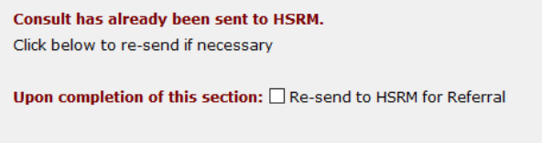
Select the check box if you need to re-send the consult to HSRM for Referral.
- Click OK.

DoD
This information documented within the DoD tab is used for coordinating care between the VA and the DoD Benefits Office.
Figure 60: DoD Tab
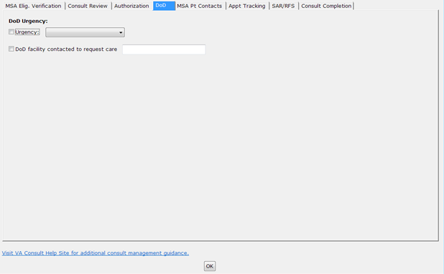
- DoD Urgency – Department of Defense Urgency
- Urgency
Figure 61: DoD Urgency Menu Options
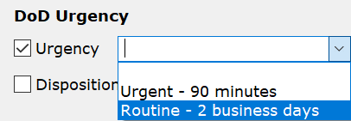
- Urgent – 90 minutes
- Routine – 2 business days
- DoD facility contacted to request care – Name of DoD facility contacted to request care.

DoD Steps
To view or edit the options within the DoD tab, follow the steps below:
- From the Action menu, select Consult Tracking…, and then select Receive. The Receive Consult dialog box opens.
Figure 62: Receive Consult Dialog Box
- In the Comments field, right-click to display the Receive menu.
Figure 63: Receive Menu
- From the Receive menu,, select Community Care Functions. The Community Care Functions window opens with the MSA Elig. Verification tab displayed.
- Select the DoD tab. The DoD tab displays.
Figure 64: DoD Tab
- If there is a DoD urgency, select the Urgency check box and then select the type of urgency from the drop-down menu.
- If a DoD facility was contacted to request care, select the check box and enter the name of the facility in the field.
- Click OK.

MSA Pt Contacts
Figure 65: MSA Pt Contacts
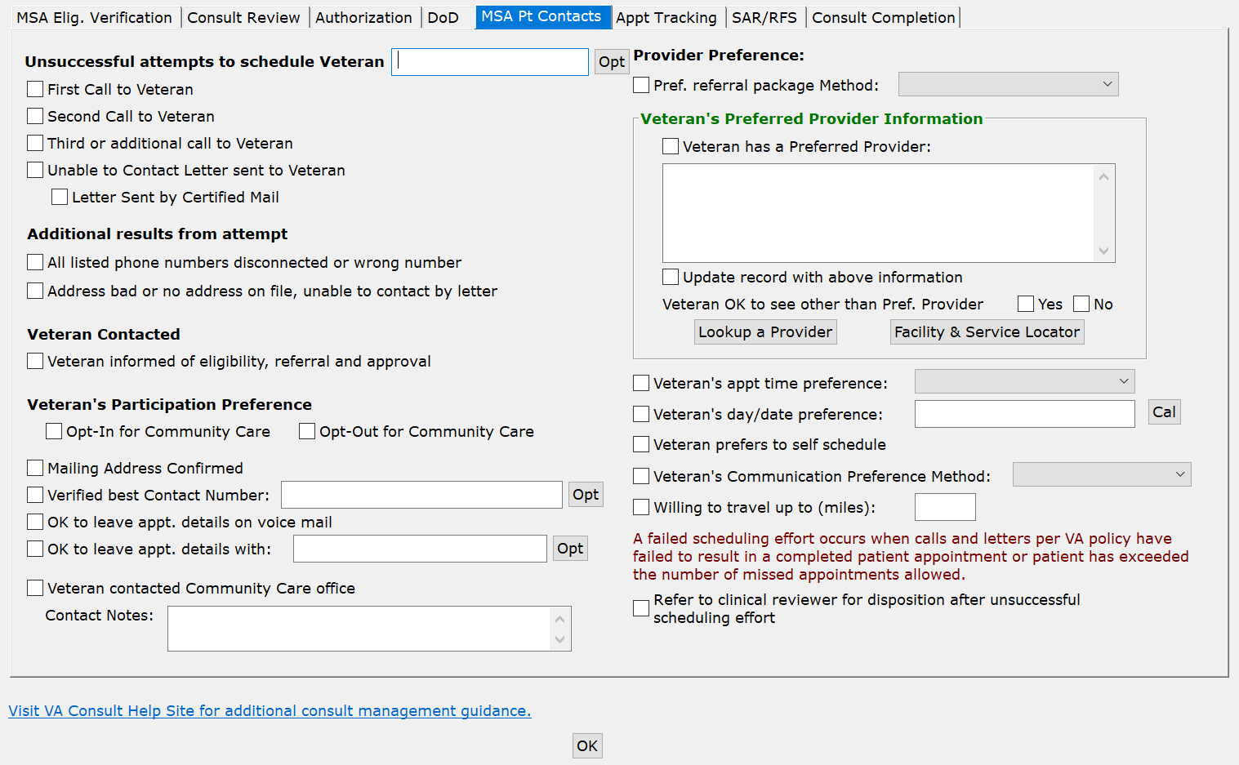
- Unsuccessful attempts to schedule Veteran — this allows recording first, second, and additional calls made to the Veteran to arrange care. Optionally, an annotation like “No Answer” can be added. Enter information regarding the attempt in the field or select an option from the Opt menu: Mail, Left Voice Mail, or Left Message with Family.
- First call to Veteran
- Second call to Veteran
- Third or additional call to Veteran
- Unable to Contact letter sent to Veteran — use this selection when a letter is sent to the Veteran indicating that the clinic has been trying to reach him/her to schedule an appointment. This comment may be used each time a letter is sent, if sent more than once.
- Letter Sent by Certified Mail—this is an additional indication that the letter above was sent by certified mail. Note that the certified mail indicator should be used in conjunction with the unable to contact letter.
- Additional Results from Attempt
- All listed phone numbers disconnected or wrong number—used when all the numbers listed for the Veteran are wrong (disconnected or you reach someone who doesn’t know the Veteran). This should not be used unless you have confirmed that all numbers in the record are bad.
- Address bad or No address on file, unable to contact by letter—this would apply in the instance where a letter sent has been returned by the post office or in the case of homeless Veterans. The latter case may require extra effort with the Homeless Veterans’ Program to try to reach the Veteran.
- Veteran Contacted
- Veteran Informed of eligibility, referral and approval—this simply documents that the Veteran has been informed of Community Care eligibility.
- Veteran’s Participation Preference
- Opt-In for Community Care—documents Veteran has opted-in.
- Opt-Out for Community Care—documents Veteran has opted-out for Community Care.
- Mailing Address Confirmed—indicates that the mailing address on file is correct. If not correct, MSA should correct the address, and then confirm that it is correct.
- Verified Best Contact Number—documents best number to contact this Veteran. In addition to the actual number, user may also note whether cell, home, or other number. Also, options to confirm existing numbers on file as the best number are provided. Enter the best contact number in the field or select an option from the Opt menu: home number on file, cell number on file, or work number on file.
- OK to leave appt. details on voice mail—documents that Veteran gives permission to leave appointment details on his/her voice mail.
- OK to leave appt. details with: —documents that Veteran gives permission to leave details of the appointment with another individual. Anything may be entered, or several options are provided if a specific family member is preferred. Enter the name of individual that the Veteran gives permission to leave details of the appointment with in the field or select an option from the Opt menu: Spouse, Daughter, Son, Caregiver, or Family.
- Veteran contacted Community Care office
- Contact Notes
- Provider Preference:
- Pref. referral package Method:
- Fax
- HSRM Portal
- Mail
- Secure Email
- Veteran’s Preferred Provider Information — if the Veteran has a provider they would like to see, that can be recorded here. Use the lookup tool so the correct provider information (including NPI number) can be part of the record. This pulls data from the Department of Health and Human Services database, which is updated daily
- Veteran has a Preferred Provider: Finding the preferred provider can be conducted using the Lookup a Provider option.
- Update record with above information
- Veteran OK to see other than Pref. Provider — if the Veteran has indicated a preferred provider, this documents whether they are willing so see someone else if there is no opportunity to see their preferred provider (provider not available or not willing to take Veteran).
- Yes
- No
- Lookup a Provider - Finding the preferred provider can be conducted using the Lookup a Provider option.
Figure 66: Search by Provider Tab
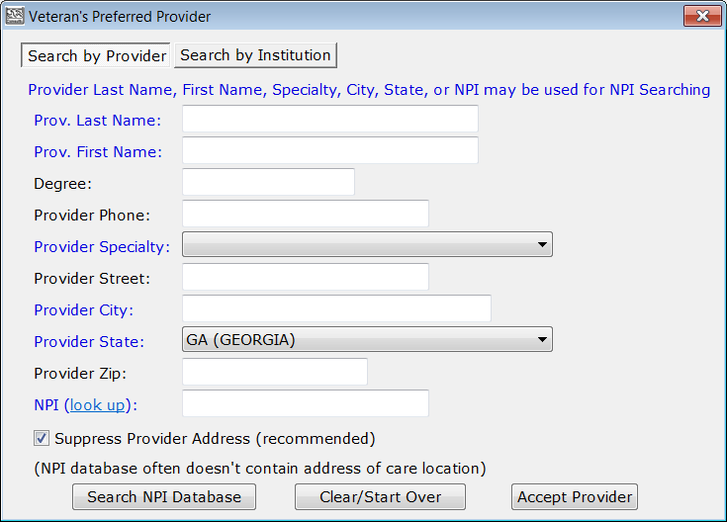
- Prov. Last Name: - This field may be used for NPI searching.
- Prov. First Name: - This field may be used for NPI searching.
- Degree:
- Provider Phone:
- Provider Specialty: - This field may be used for NPI searching.
- Provider Street:
- Provider City: - This field may be used for NPI searching.
- Provider State: - This field may be used for NPI searching.
- Provider Zip:
- NPI (look up): - This field may be used for NPI searching.
- Suppress Provider Address (recommended)
Figure 67: Search by Institution Tab
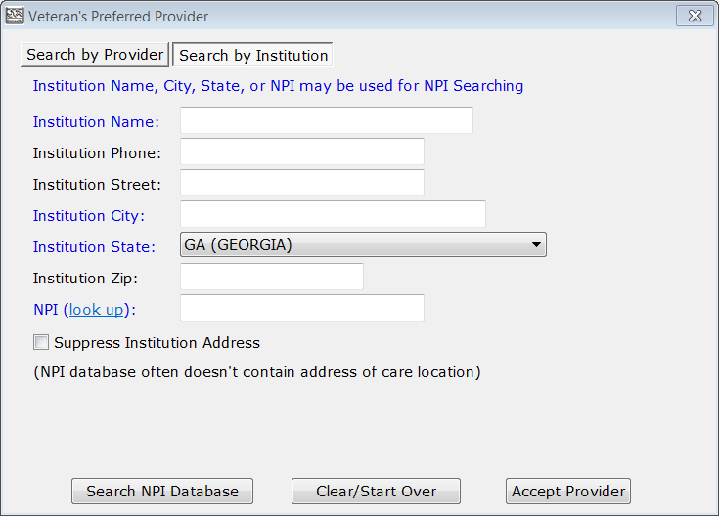
- Institution Name: - This field may be used for NPI searching.
- Institution Phone:
- Institution Street:
- Institution City: - This field may be used for NPI searching.
- Institution State: - This field may be used for NPI searching.
- Institution Zip:
- NPI (look up): - This field may be used for NPI searching.
- Suppress Institution Address
- Veteran’s appt time preference: this is an optional field that allows documentation of time of day preference. It can be Any, Morning, Afternoon, or anything else you’d like to enter.
- Veteran’s day/date preference: documents day of week or date Veteran would prefer the appointment. This is a free text field, though a CAL button is available to pick a specific date.
- Veteran prefers to self schedule
- Veteran’s Communication Preference Method: documents how the Veteran would like to be notified of appointment when scheduled. Options are:
- Home Phone
- Cell Phone
- Mail
- MHV Secure Message
- Text
- Willing to travel up to (miles): documents Veteran’s willingness to travel said number of miles to see a provider.
- Refer to clinical reviewer for disposition after unsuccessful scheduling effort — after failing to schedule an appointment by making two calls, sending a letter, and waiting two weeks, this option refers the consult to a clinician to review and disposition. Business rules for certain low-risk consults may allow the scheduler to discontinue without clinician review, or in the case the provider previously reviewed the consult and determined that it may be discontinued after a failure to schedule after mandated effort, or multiple missed appointments.

MSA Pt Contacts Steps
To view or edit the options within the MSA Pt Contacts tab, follow the steps below:
- From the Action menu, select Consult Tracking…, and then select Receive. The Receive Consult dialog box opens.
Figure 68: Receive Consult Dialog Box
- In the Comments field, right-click to display the Receive menu.
Figure 69: Receive Menu
- From the Receive menu,, select Community Care Functions. The Community Care Functions window opens with the MSA Elig. Verification tab displayed.
- Select the MSA Pt Contacts tab.
Figure 70: MSA Pt Contacts Tab
- From the Unsuccessful Attempts to Schedule Veteran section, select the best option.
- From the Additional Results from Attempt section, select the best options.
- From the Veteran Contacted section, select the best options.
- From the Veteran’s Participation Preference section, select the best options.
- From the Provider Information section, select the best options.
- From the Provider Preference section, select the best options.
- Select the Refer to clinical reviewer for disposition after unsuccessful scheduling effort check box if after failing to schedule an appointment by making two calls, sending a letter, and waiting two weeks, this option refers the consult to a clinician to review and disposition.
- Click OK.

Appt Tracking
Figure 71: Appt Tracking Tab
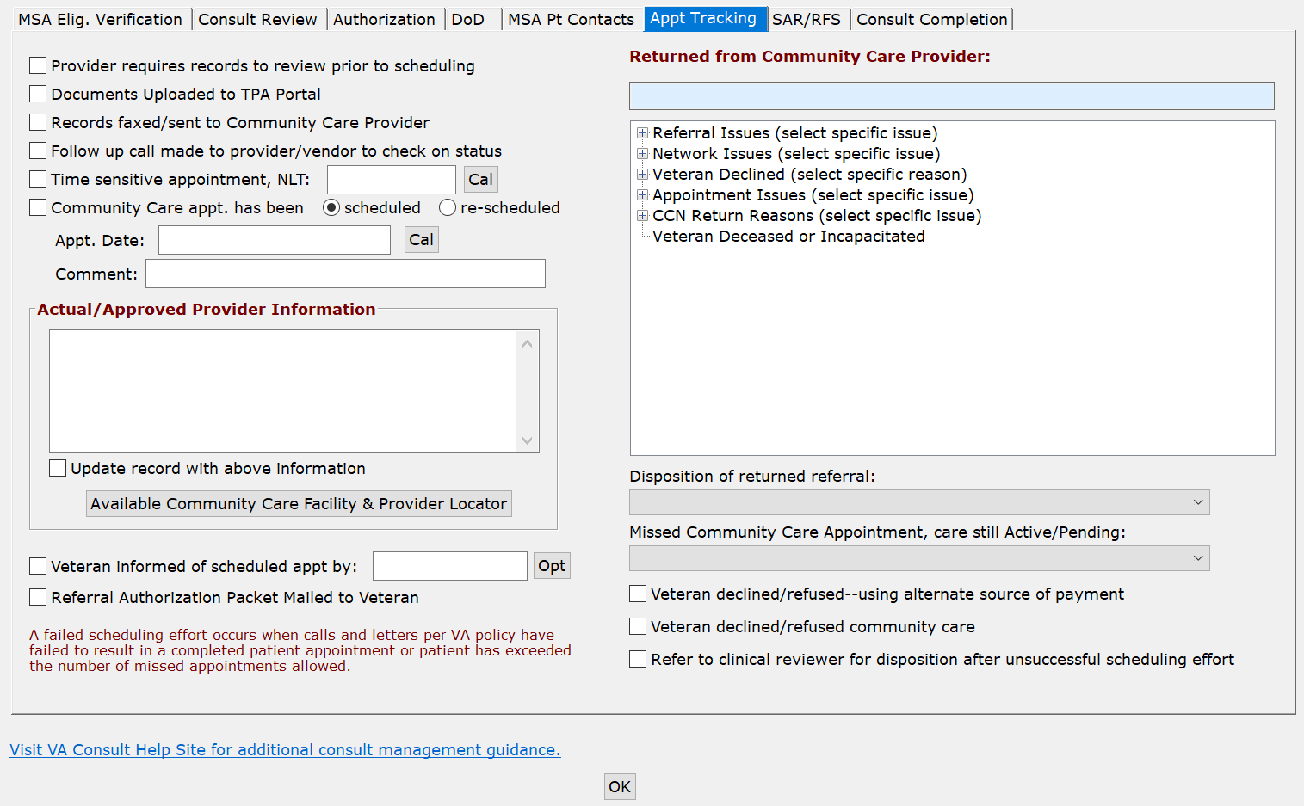
- Provider requires records to review prior to scheduling — records a situation where the potential Community Care provider requires records to be reviewed prior to accepting the referral.
- Document Uploaded to TPA Portal — allows Community Care staff to record when documentation for a Community Care referral has been uploaded to the TPA’s portal. Note, during the document upload process, the unique ID will also be included.
- Records faxed/sent to Community Care Provider —
- Follow up call made to provider/vendor to check on status—documents a follow up call to vendor to check on referral status, such as in the case where records review was required.
- Time sensitive appointment, NLT—documents a no later than date for the appointment to be scheduled.
- Community Care apt has been—scheduled or unscheduled. This allows Community Care staff to flag the consult as having an appointment under Community Care.
- Appointment Date: Records the appointment date. This is not required if a shadow appointment has been scheduled in VistA Scheduling. This is a free text entry field; however, a calendar widget is provided for easy date and time entry.
Figure 72: Appointment Date Calendar View
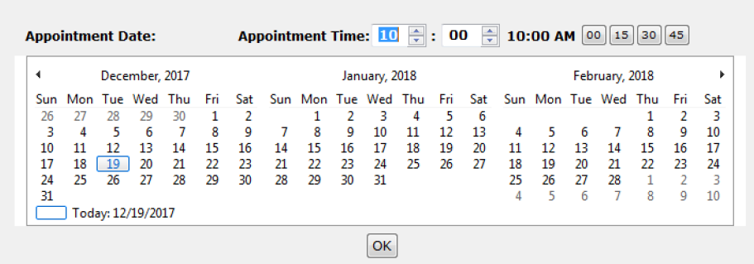
- Comment –
- Actual/Approved Provider Information — The name of the actual provider with whom the Veteran has an appointment should be selected using the Lookup a Provider button, which works the exact same as the one on the MSA Pt Contacts tab. It may be different from the one the Veteran preferred if, for instance, the provider was unable to see Veteran, or was not participating as a VA community provider.
- Update record with above information
- Available Community Care Facility & Provider Locator
- Veteran informed of scheduled appt. by—Enter the method of notification for the scheduled appointment in the field or select an option from the Opt menu: mail, phone, phone and mail, or MyHealtheVet.
- Referral Authorization Packet Mailed to Veteran—referral authorization packet mailed to Veteran
- Returned from Community Care Provider: — These data fields are used to indicate when a referral has been returned from Community Care Provider with the corresponding rationale.
- Referral Issues (select specific issue)
- Duplicate
- Non Covered Service — Veteran referred to community provider for services that are not part of benefits package.
- Missing VA Data/Forms — Missing or incomplete documentation required to appoint.
- VA requested return of referral — VA contacts contractor and requests return of referral.
- Unable to review within contract standards — Contractor was not able to review within the contract standard.
- Non-Disclosure of OHI by Veteran — Veteran acknowledges having OHI and fails to provide.
- Unable to contact Veteran during Out Bound Call Process — Could not appoint due to no contact from Veteran via call or letter.
- Network Issues (select specific issue)
- No Network Provider Available — No network provider available for requested service(s). This does not include a Veteran requesting a specific provider.
- VA Requested Providers Outside of Network — Non‐contracted provider.
- Veteran Requested Specific Provider — Veteran requested a specific provider for care that is not available on the PC3 network or by Community Care provider agreement.
- Appointed with Incorrect Provider/Type of Care — Appointed with incorrect provider or incorrect type of care.
- Already Appointed — Care has been previously scheduled by the Veteran, VA or the Contractor.
- Veteran Declined (select specific reason)
- Veteran Declined Distance — Inside Commute Standard — Network provider is in contractors’ network and within the commute standards.
- Veteran Declined Distance — Outside Commute Standard — Network provider is in contractors’ network but provider is NOT within the commute standards.
- Veteran Declined Appt Time — Veteran declined time for scheduled appointment.
- Veteran Declined Does Not Want Care — Veteran declined request for care.
- Veteran Declined Use of PC3/Community Care — Veteran no longer wants to participate in the program.
- Appointment Issues (select specific issue)
- Veteran No-Show — Veteran did not show up for scheduled appointment.
- Contractor Return – Unable to schedule within contract terms — Care not scheduled within the contractual time and VA is requesting back due to time lapse.
- VA Request Return – Care Already Scheduled by Contractor — VA requested the authorization after Contractor scheduled care.
- Unable to contact Veteran Out Bound Call Process — Could not appoint due to no contact from Veteran via call or letter.
- CCN Return Reasons (select specific issue)
- No CCN Provider Available to Schedule Within Timeliness Standard
- No CCN Providers Available to Schedule Within Drive Time Standard
- Veteran Prefers CCN Provider Outside of Drive Time Standard
- Veteran Willing to Accept CCN Provider Outside of Drive-Time Standard
- Veteran Willing to Accept CCN Provider Outside of Timeliness Standard
- Veteran Prefers Non-CCN Provider
- Veteran Self-Schedules
- Service Not Provided in CCN
- Veteran Deceased or Incapacitated — Authorization returned due Veteran deceased or incapacitated.
- Disposition of returned referral: - document the status of the referral
- Scheduled using Provider Agreement.
- In-house VA Appointment arranged.
- Forwarded to in-house service.
- Resubmitted new referral authorization to vendor.
- Scheduled using Community Care.
- Missed Community Care Appointment, care still Active/Pending: - document the reason for the missed appointment.
- Veteran was No-Show for community care appointment
- Veteran Canceled community care appointment (Cancel by Veteran)
- Community Care Provider canceled appointment (Cancel by clinic)
- Veteran declined/refused – using alternate source of payment
- Veteran declined/refused community care
- Refer to clinical reviewer for disposition after unsuccessful scheduling effort — after failing to schedule an appointment by making two calls, sending a letter, and waiting two weeks, this option refers the consult to a clinician to review and disposition. Business rules for certain low-risk consults may allow the scheduler to discontinue without clinician review, or in the case the provider previously reviewed the consult and determined that it may be discontinued after a failure to schedule after mandated effort, or multiple missed appointments.

Appt Tracking Steps
To view or edit the options within the Appt Tracking tab, follow the steps below:
- From the Action menu, select Consult Tracking…, and then select Receive. The Receive Consult dialog box opens.
Figure 73: Receive Consult Dialog Box
- In the Comments field, right-click to display the Receive menu.
Figure 74: Receive Menu
- From the Receive menu,, select Community Care Functions. The Community Care Functions window opens with the MSA Elig. Verification tab displayed.
- Select the Appt Tracking tab.
Figure 75: Appt Tracking Tab
- Select the best option for appointment tracking.
- From the Actual/Approved Provider Information section, enter the name of the actual provider with whom the Veteran has an appointment.
- In the Veteran informed of scheduled appt by: field, enter the method used to inform the Veteran of the schedule appointment or select an option from the Opt menu.
- Select the Referral Authorization Packet Mailed to Veteran if a packet was mailed to the Veteran.
- From the Returned from Community Care Provider: section, select the reason why the referral was returned from the Community Care Provider with the corresponding rationale.
- From the Disposition of returned referral drop-down menu, select the status of the referral.
- From the Missed Community Care Appointment care still Active/Pending drop-down menu, select the reason for the missed appointment.
- If the records were received, select the Records Received check box and select the option from the drop-down menu.
- If the Veteran is using an alternate source of payment, select the Veteran declined/refused – using alternate source of payment check box.
- If the Veteran does not want to use Community Care, select the Veteran declined/refused community care check box.
- Click OK.

Secondary Authorization Request (SAR)/Request for Service (RFS)
Figure 76: SAR/RFS Tab
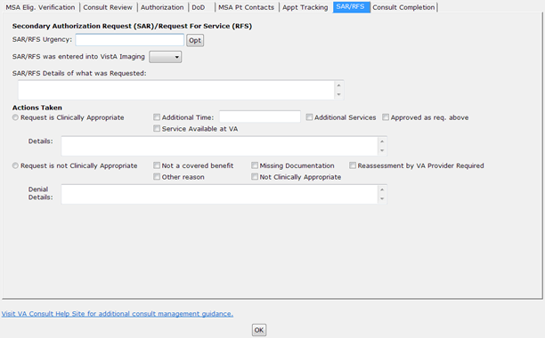
- Secondary Authorization Request (SAR)/Request for Service (RFS) section
- SAR/RFS Urgency — Insert the urgency for the secondary authorization request/request for service field or select an option from the Opt menu: Routine, w/in 48 hours, w/in 1 week, or w/in 1 month.
- SAR/RFS was entered into VistA Imaging
- Yes
- No
- SAR/RFS Details of what was Requested: - comment related to the SAR.
- Actions Taken
- Request is Clinically Appropriate – note reasons by check boxes, or with detailed description.
- Additional Time:
- Additional Services
- Approved as req. above
- Details
- Request is not Clinically Appropriate — note reasons by check boxes, or with detailed description.
- Not a covered benefit
- Missing Documentation
- Reassessment by VA Provider Required
- Other reason
- Not Clinically Appropriate
- Denial Details:

SAR/RFS Steps
To view or edit the options within the SAR/RFS tab, follow the steps below:
- From the Action menu, select Consult Tracking…, and then select Receive. The Receive Consult dialog box opens.
Figure 77: Receive Consult Dialog Box
- In the Comments field, right-click to display the Receive menu.
Figure 78: Receive Menu
- From the Receive menu,, select Community Care Functions. The Community Care Functions window opens with the MSA Elig. Verification tab displayed.
- Select the SAR/RFS tab.
Figure 79: SAR/RFS Tab
- From the Secondary Authorization Request (SAR) / Request for Service (RFS) section, enter the SAR/RFS urgency in the field or select an option from the Opt menu.
- From the SAR/RFS was entered into VistA Imaging drop-down menu, select Yes or No.
- In the SAR/RFS Details of what was Requested field, enter the details.
- From the Actions Taken section, select if the SAR/RFS was clinically appropriate or not.
- Click OK.

Consult Completion
Figure 80: Consult Completion Tab
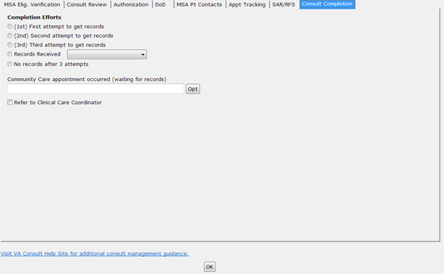
- Completion Efforts
- (1st) First attempt to get records — documents first request for records for Community Care.
- (2nd) Second attempt to get records — documents second request for records for Community Care.
- (3rd) Third attempt to get records — documents third request for records for Community Care.
- Records Received — documents receipt of records pertinent to this consult. This is particularly useful in the case that those records cannot be uploaded to VistA Imaging immediately.
Figure 81: Records Received Menu Options
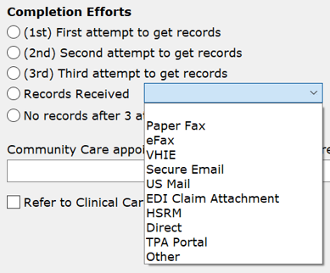
- Paper Fax
- eFax
- VHIE
- Secure Email
- US Mail
- EDI Claim Attachment
- HSRM
- Direct – Directly from Veteran.
- TPA Portal
- Other
- No records after 3 attempts. — documents that three attempts have been made to receive records. This makes the consult a candidate for administrative closure.
- Community Care appointment occurred (waiting for records) – Enter information in the field or select an option from the Opt menu: Per Veteran, awaiting records/confirmation, Per TPA Portal, awaiting records, or Per Provider, awaiting records.
- Refer to Clinical Care Coordinator — clinical review determines next steps after care when there are no records.

Consult Completion Steps
To view or edit the options within the Consult Completion tab, follow the steps below:
- From the Action menu, select Consult Tracking…, and then select Receive. The Receive Consult dialog box opens.
Figure 82: Receive Consult Dialog Box
- In the Comments field, right-click to display the Receive menu.
Figure 83: Receive Menu
- From the Receive menu,, select Community Care Functions. The Community Care Functions window opens with the MSA Elig. Verification tab displayed.
- Select the Consult Completion tab.
Figure 84: Consult Completion Tab
- From the Completion Efforts section, select the options for completion.
- In the Community Care appointment occurred (waiting for records) field, enter the information or select an option from the Opt menu.
- Click OK.

Discontinuing Consult
When discontinuing a consult, a reason that meets central office criteria must be entered to document the reason for discontinuation. Right clicking the text area will bring up the list of approved reasons. Additional comments may be made as well. There are two tabs, one relates to in-house consults, and one for Community Care consults.
Figure 85: General Discontinuation Comments Tab
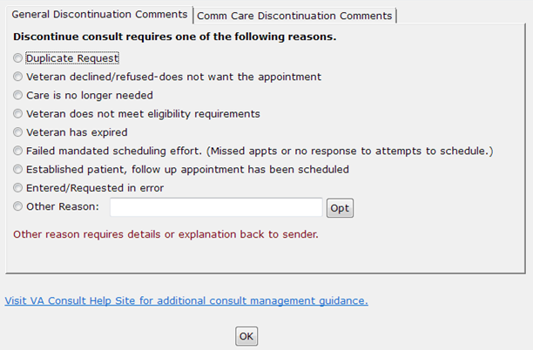
- Discontinue consult requires one of the following reasons section
- Duplicate Request
- Veteran declined/refused-does not want the appointment
- Care is no longer needed
- Veteran does not meet eligibility requirements – This is to be used where VA benefits or the Veteran’s clinical situation do not allow them to receive this service from the VA. An example would be routine dental care for a Veteran not eligible for dental care.
- Veteran has expired – Use if Veteran is deceased.
- Failed mandated scheduling effort (Missed appointments or no response to attempts to schedule.) – use when Veteran has missed two or more appointments or fails to respond to mandated minimum number of calls, letter(s), and adequate time to respond.
- Established patient, follow up appointment has been scheduled – this indicates that the established Veteran has been scheduled with a follow up appointment, and the consult is no longer needed.
- Entered/Requested in error –
- Other Reason: - Other reason requires details or explanation back to sender. Enter a reason in the field or select an option from the Opt menu. In addition, selection of this option will prompt for an explanation. This option is used primarily when there is some defect in the request, so feedback to the ordering clinician is appropriate.
Figure 86: Other Reason Options
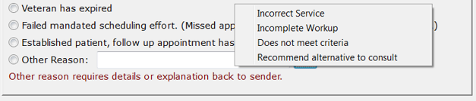
- Incorrect Service
- Incomplete Workup
- Does not meet criteria
- Recommend alternative to consult
Figure 87: Comm Care Discontinuation Comments Tab
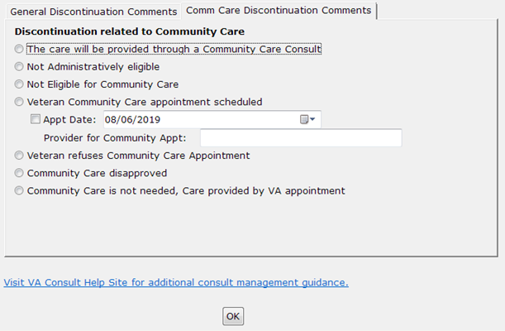
- Discontinuation related to Community Care section
- The care will be provided through a Community Care Consult – Care will be provided by Community Care. USE WITH CAUTION. This is saying that this consult is being discontinued and a Community Care consult will be issued for this service. Typically, a consult should only be discontinued when a Community Care appointment has been scheduled (See next option).
This option would be selected when, for example, an Interfacility Consult is sent from Site A to Site B, enabling Community Care. The consult would then be discontinued by staff at Site B with instructions to order a Community Care consult at site A.
- Not Administratively eligible – Veteran is not eligible.
- Not Eligible for Community Care – Veteran is not eligible for Community Care.
- Veteran Community Care appointment scheduled – This is used when the TPA has confirmed that an appointment has been scheduled for the Veteran.
- Appt Date: - Additionally, the date of the appointment can be recorded. Note that the calendar widget contains a default date, so you must check the box to indicate that the date in the box is the appointment date for it to be recorded.
- Provider for Community Appt: - If the name of the provider is known, that should be added as well. If the provider name field is filled in, that is also added to the consult comment.
- Veteran refuses Community Care Appointment – used when the Veteran refuses non-VA appointment.
- Community Care disapproved – used when the request for non-VA care is disapproved or does not meet requirements.
- Community Care not needed, care provided by another VA appointment – use when, apart from this consult, the Veteran’s needs were met by care already received at another appointment. Consider using a duplicate request if more appropriate.

Discontinuing In-house Consult Steps
To discontinue an in-house consult, follow the steps listed below:
- From the Action menu, select Consult Tracking…, and then select Discontinue. The Discontinue Consult dialog box opens.
Figure 88: Discontinue Consult Dialog Box
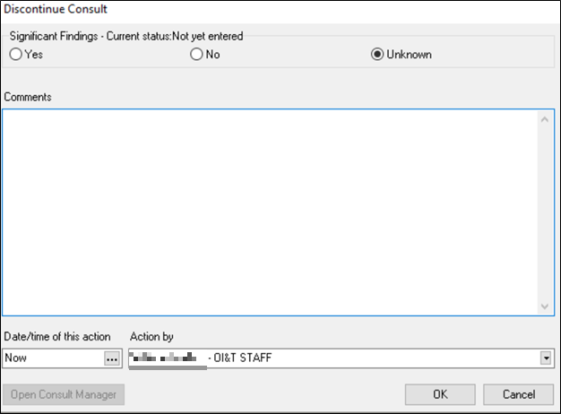
- In the Comments field, right-click to display the Discontinuing Consult menu.
Figure 89: Discontinuing Consult Menu
- From the Discontinuing Consult menu, select Discontinuation Reasons. The Discontinue Consult Options window opens.
Figure 90: Discontinue Consult Options
- Select the General Discontinuation Comments tab.
- From the Discontinue consult requires one of the following reasons section, select the reason why the consult is being discontinued.
- Click OK.

Discontinuing Community Care Consult Steps
To discontinue a Community Care consult, follow the steps listed below:
- From the Action menu, select Consult Tracking…, and then select Discontinue. The Discontinue Consult dialog box opens.
Figure 91: Discontinue Consult Dialog Box
- In the Comments field, right-click to display the Discontinuing Consult menu.
Figure 92: Discontinuing Consult Menu
- From the Discontinuing Consult menu, select Discontinuation Reasons. The Discontinue Consult Options window opens.
- Select the Comm Care Discontinuation Comments tab.
Figure 93: Comm Care Discontinuation Comments Tab
- From the Discontinuation related to Community Care section, select the Community Care discontinuation reason.
CAUTION: The care will be provided through a Community Care Consult option should be used with CAUTION. This is saying that this consult is being discontinued and a Community Care consult will be issued for this service. Typically, a consult should only be discontinued when a Community Care appointment has been scheduled (See next option).
This The care will be provided through a Community Care Consult option would be selected when an Interfacility Consult is sent from Site A to Site B. The consult would then be discontinued by staff at Site B with instructions to order a Community Care consult at site A.

The calendar widget contains a default date, so you must check the box to indicate that the date in the box is the appointment date for it to be recorded.
- Click OK.

Forwarding Consult
At present forwarding only supports forwarding to Community Care.
This tab will be used by staff in internal VA clinics if the Veteran has opted in to receive care in the community.
Figure 94: Forward to Community Care Options Tab
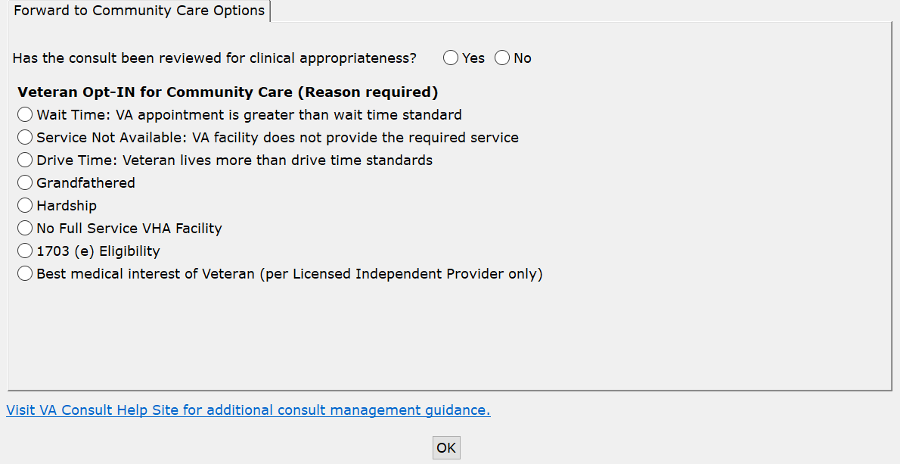
Forward to Community Care Options section
- Has the consult been review for clinical appropriateness?
- Yes
- No
- Veteran Opt-IN for Community Care (Reason required)
- Wait Time: VA appointment is greater than wait time standard
- Service Not Available: VA facility does not provide the required service
- Drive Time: Veteran lives more than drive time standards
- Grandfathered
- Hardship
- No Full Service VHA Facility
- 1703 (e) Eligibility
- Best medical interest of Veteran (per Licensed Independent Provider only)
- Nature or Simplicity of Service
- Frequency of service
- Need for an attendant
- Potential for improved continuity of care
- Difficulty in traveling

Forwarding Consult Steps
To forward consult, follow the steps listed below:
- From the Action menu, select Consult Tracking…, and then select Forward. The Forward Consult dialog box opens.
Figure 95: Forward Consult Dialog Box
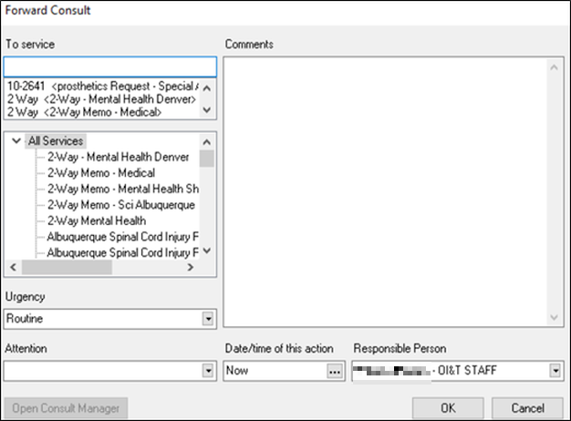
- In the Comments field, right-click to display the Forward Consult menu.
Figure 96: Forward Consult Menu
- From the Forward Consult menu, select Forward Consult to Community Care. The Forward to Community Care Options window opens.
Figure 97: Forward to Community Care Options Window
- From the Forward to Community Care Options section, select if the consult has been reviewed for clinical appropriateness.
- From the Veteran Opt-IN for Community Care section, select the appropriate Community Care reason.
- Click OK.

Adding Comment to Consult
There are many activities that can take place that should be documented in the medical record, as this is the official Veteran record, and needs to be tracked. The Consult Toolbox makes this quick and easy. The activities are divided into four user groups, and then from the group, specific activities can be documented. The four groups are:
- Scheduler Functions
- Community Care Functions
- Clinical Review Options
- Launch DST

Scheduler Functions
The Scheduler Options window documents Consult Management for In-House Schedulers. The In-House Schedulers can document activity in three tabs:
- Calls and Letters
- Sched/Rescheduling Efforts
- Community Care Eligibility

Scheduling Calls and Letters
It is important to note that if a call results in a successfully scheduled appointment, these comments are not required. When an appointment is scheduled, it should be linked to the consult which will, in turn, annotate the consult and change the status to “Scheduled.”
The comments are intended for documentation of scheduling effort when there has not been an appointment scheduled, so that unsuccessful calls to the Veteran may be documented. In those cases, it should be recorded that the Veteran was called, and the attempt was unsuccessful. This includes the case where the Veteran is contacted, but they didn’t want to schedule the appointment at that time.
Figure 98: Calls and Letters Tab
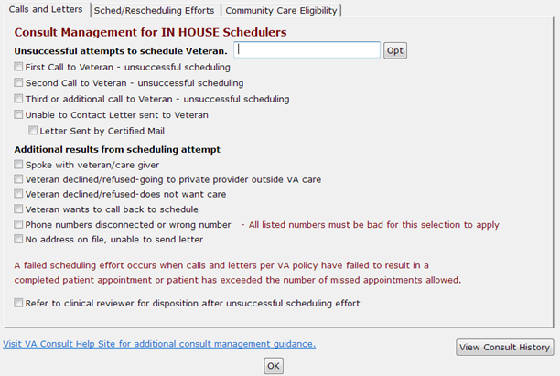
- Unsuccessful attempts to schedule Veteran Opt menu, select the best option.
- No Answer—used when you attempt to call the Veteran but there is no voice mail to leave a message.
- Left message on voicemail—used when you leave a message on the Veteran’s voice mail to call back. You should not provide any details that might violate PHI restrictions, but your number to return the call would be appropriate.
- Left message with family member—used when you speak to a family member, but they are unable to commit to an appointment on behalf of the Veteran.
- Unable to leave message—used when you speak to a family member, but they are not able to take a message. You should not provide any details that might violate PHI restrictions, but your number to return the call would be appropriate.
- Unsuccessful attempts to schedule Veteran
- Select first, second, or third call to Veteran as appropriate. If the Veteran has no-showed or cancelled, then you need to start over with a new scheduling effort and first, second, and possibly third or additional calls. If you make more than three calls, use the 3rd call for all subsequent calls.
- Unable to Contact letter sent to Veteran—use this selection when a letter is sent to the Veteran indicating that the clinic has been trying to reach the Veteran to schedule an appointment. This comment may be used each time a letter is sent, if sent more than once.
- Letter Sent by Certified Mail—in the case of high risk consults, business rules for the clinic or upon suggestion of the provider, it may be appropriate to send the Veteran a certified letter indicating that they have a potentially serious condition, and that the VA has been unsuccessful reaching them to provide care.
- Additional results from scheduling attempt
- Spoke with veteran/care giver—this documents that you did in fact talk to the Veteran or their care giver.
- Veteran declined/refused – going to private provider outside VA Care – the Veteran has indicated that they would rather use their private insurance and arrange care outside the VA at his/her own expense.
- Veteran declined/refused – does not want care – this selection is used if the Veteran tells the scheduler they do not want to schedule the appointment. Depending on the business rules for the clinic, they may very well require review by a licensed practitioner before discontinuation.
- Veteran wants to call back to schedule—this is when you do speak to the Veteran/care giver, but they don’t want to make the appointment at that time, but indicate they’ll call back to schedule. This is an example of a case where the Veteran was reached, but this would count as an unsuccessful attempt to schedule.
- Phone numbers disconnected or wrong number—used when all the numbers listed for the Veteran are wrong (disconnected or you reach someone who doesn’t know the Veteran). This should not be used unless you’ve confirmed that all numbers in the record are bad.
- No address on file, unable to send letter—this would apply in the instance where a letter sent is returned by the post office, or in the case of homeless Veterans. The latter case may require extra effort with the Homeless Veterans Program to try to reach the Veteran.

Scheduling Calls and Letters Steps
To schedule calls and letters, follow the steps listed below:
- From the Action menu, select Consult Tracking…, and then select Add Comment. The Add Comment to Consult dialog box displays.
Figure 99: Add Comment to Consult Dialog Box
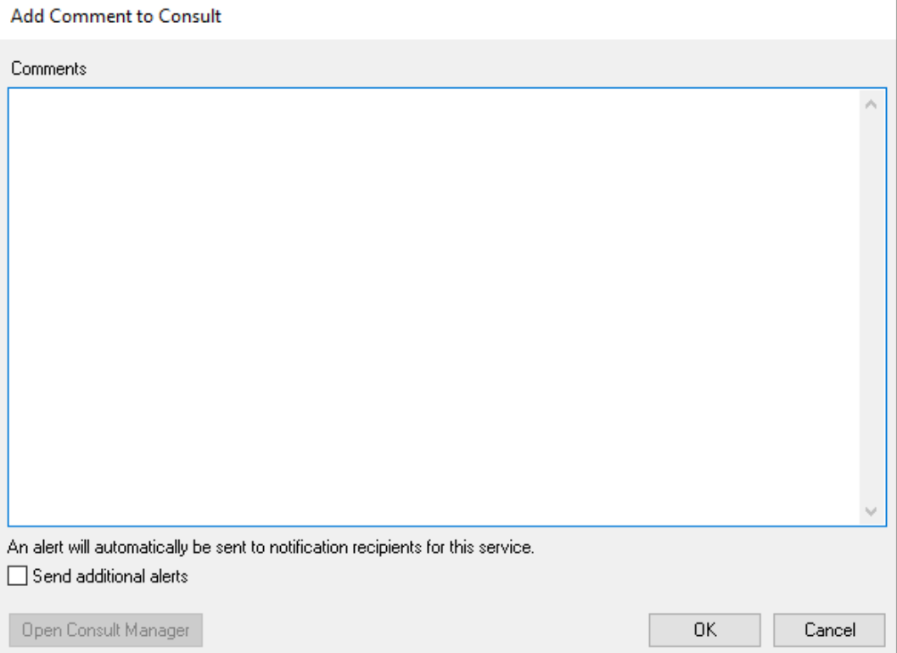
- In the Comments field, right-click to display the Community Care menu.
Figure 100: Community Care Menu
- From the Community Care menu, select Scheduler Functions. The Scheduler Options window opens with the Calls and Letters tab displayed.
Figure 101: Calls and Letters Tab
- In the Unsuccessful attempts to schedule Veteran field enter the information or select the best option from the Opt menu.
- From the Unsuccessful attempts to schedule Veteran section, select if a first, second, or subsequent call to Veteran check box.
- Select the Unable to Contact Letter sent to Veteran check box if you were unable to reach the Veteran and sent a letter.
- Select the Letter Sent by Certified Mail check box if you sent a certified letter.
- From the Additional results from scheduling attempt, select the options you may wish to record to better document efforts. Not all clinics will have a need for all options.
- If a scheduling effort fails after attempting to schedule an appointment by making two calls, sending a letter, and waiting two weeks, select the Refer to clinical reviewer for disposition after unsuccessful scheduling effort check box.
Business rules for certain low-risk consults may allow the scheduler to discontinue without clinician review, or in the case the provider previously reviewed the consult and determined that it may be discontinued after a failure to schedule after mandated effort or multiple missed appointments.
- Click View Consult History. The Viewing Consult History dialog box displays.
Figure 102: Viewing Consult History
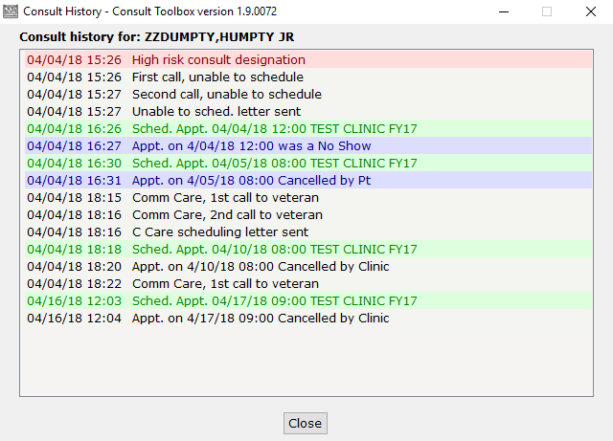
- Click Close Consult History.
- Click OK.

Scheduling and Rescheduling Efforts
Within this tab, these data fields track the number of missed appointments and/or the reason Veteran did not want appointment to be scheduled. It is important for in-house Schedulers to document these data fields to eliminate wait lists and decrease wait times for Veterans in need of care. Additionally, by documenting Veteran’s usage of private insurance and preference to seek care outside of the VA at their own expense, VA staff can track the utilization of VA benefits. IMPORTANT: appointments scheduled in VistA Scheduling and properly linked to an appointment will automatically update the consult, with both scheduling appointments and also when appointments are cancelled or the Veteran no-shows. In those cases, there is no need to document missed appointments with the Toolbox. First cancel-by-Veteran or no-show counts as a first missed appointment. Subsequent cancel-by Veteran or no-show counts as the second (or third+) missed appointment.
Figure 103: Sched/Rescheduling Efforts Tab
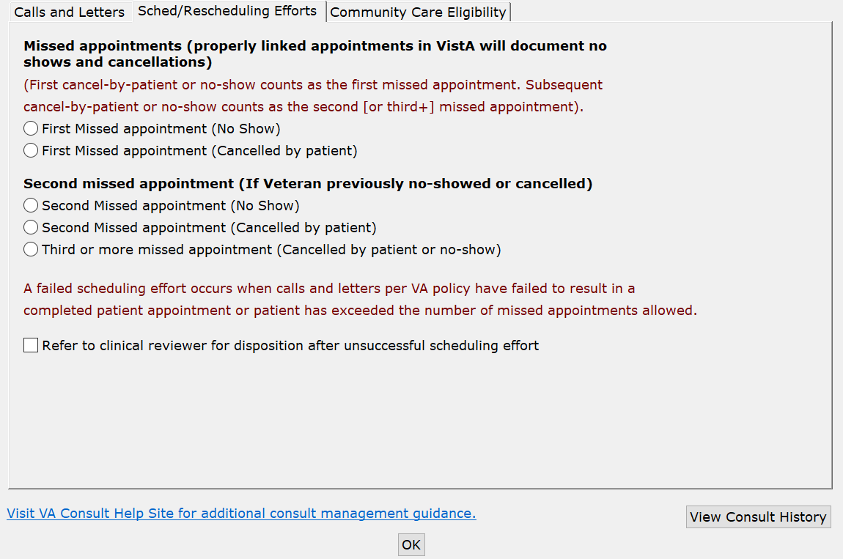
- Missed appointments
- First Missed appointment (No Show) — missed appointment. It is important to track the missed appointment, as a Veteran who fails to keep appointments may be depriving other Veterans an opportunity to receive care.
- First Missed appointment (Cancelled by patient)—this is cancelled-by-Veteran. It is important to track this missed appointment, as a Veteran who fails to keep appointments may be depriving other Veterans an opportunity to receive care.
- Second missed appointment
- Second Missed appointment (No Show)—missed appointment. This should be recorded, and in addition, if the appointment has been pre-reviewed for discontinuation after two missed appointments, the consult should be discontinued in an additional step. If not pre-reviewed, then it should be referred to the provider for disposition.
- Second Missed appointment (Cancelled by patient)—missed appointment. This should be recorded, and in addition, if the appointment has been pre-reviewed for discontinuation after two missed appointments, the consult should be discontinued in an additional step. If not pre-reviewed, then it should be referred to the provider for disposition.
- Third or more missed appointment (Cancelled by patient or no-show)—appointments that are missed either by cancel by Veteran or no-show are tracked here, without distinction.
- Refer to clinical reviewer for disposition after unsuccessful scheduling effort

Scheduling and Rescheduling Efforts Steps
To schedule and rescheduling efforts, follow the steps listed below:
- From the Action menu, select Consult Tracking…, and then select Add Comment. The Add Comment to Consult dialog box displays.
Figure 104: Add Comment to Consult Dialog Box
- In the Comments field, right-click to display the Community Care menu.
Figure 105: Community Care Menu
- From the Community Care menu, select Scheduler Functions. The Scheduler Options window opens with the Calls and Letters tab displayed.
Figure 106: Calls and Letters Tab
- Select the Sched/Rescheduling Efforts tab.
Figure 107: Sched/Rescheduling Efforts Tab
- From the Missed appointments (properly linked appointments in VistA will document no shows and cancellations) section, select the best option.
- From the Second missed appointment (If Veteran previously no-showed or cancelled) section, select the best option.
- If a scheduling effort fails after attempting to schedule an appointment by making two calls, sending a letter, and waiting two weeks, select the Refer to clinical reviewer for disposition after unsuccessful scheduling effort checkbox.
Business rules for certain low-risk consults may allow the scheduler to discontinue without clinician review, or in the case the provider previously reviewed the consult and determined that it may be discontinued after a failure to schedule after mandated effort or multiple missed appointments.
- Click OK.

Community Care Eligibility
This data field documents a Veteran’s decision to opt-in or out of the Veterans Community Care Program (VCCP) if there is insufficient access within a VA clinic.
Figure 108: Community Care Eligibility Tab
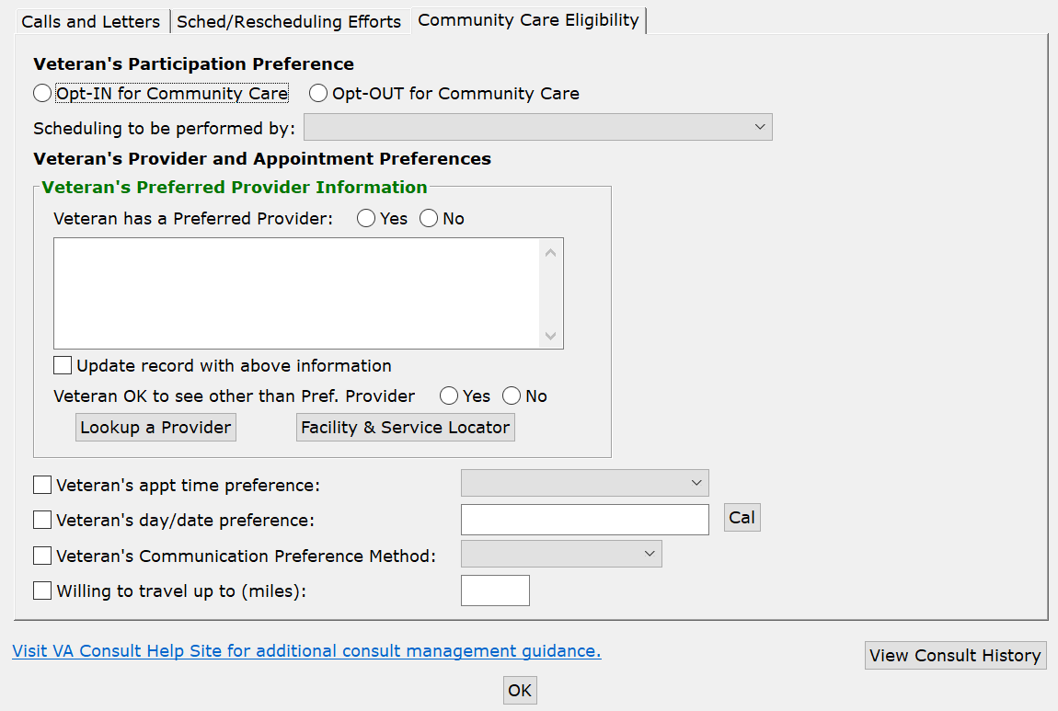
Veteran’s Participation Preference section
- Opt-IN for Community Care (Reason required)—this documents that the Veteran opts in for Community Care.
- Opt-OUT for Community Care—this documents that the Veteran opts out for Community Care.
- Scheduling to be performed by
- VA schedules based on Veteran’s preferences
- Veteran self-schedules
- Community provider schedules directly with Veterans
Veteran’s Provider and Appointment Preferences section
- Veteran has a Preferred Provider - Finding the preferred provider can be conducted using the Lookup a Provider option.
- Yes
- No
- Update record with above information
- Veteran OK to see other than Pref. Provider - if the Veteran has indicated a preferred provider, this documents whether they are willing so see someone else if there is no opportunity to see their preferred provider (provider not available or not willing to take Veteran).
- Yes
- No
- Lookup a Provider - Finding the preferred provider can be conducted using the Lookup a Provider option.
Figure 109: Search by Provider Tab
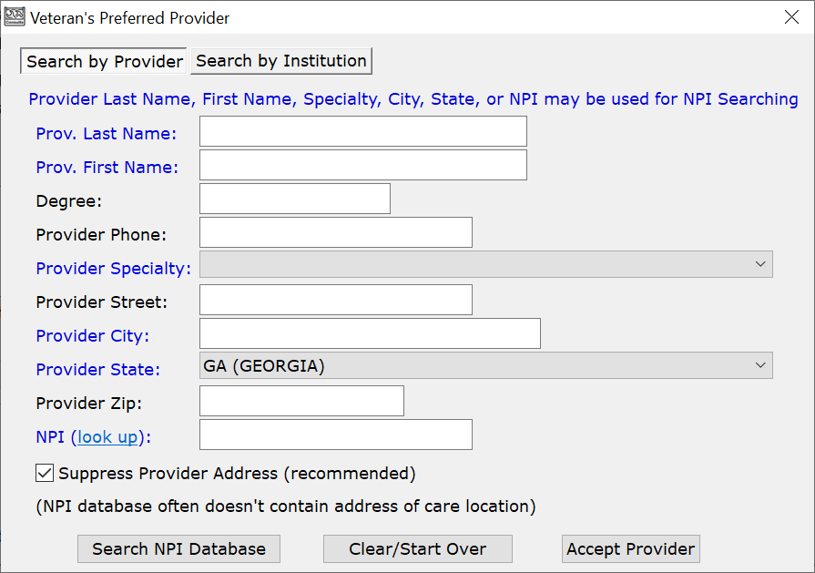
- Prov. Last Name: - This field may be used for NPI searching.
- Prov. First Name: - This field may be used for NPI searching.
- Degree:
- Provider Phone:
- Provider Specialty: - This field may be used for NPI searching.
- Provider Street:
- Provider City: - This field may be used for NPI searching.
- Provider State: - This field may be used for NPI searching.
- Provider Zip:
- NPI (look up): - This field may be used for NPI searching.
- Suppress Provider Address (recommended)
Figure 110: Search by Institution Tab
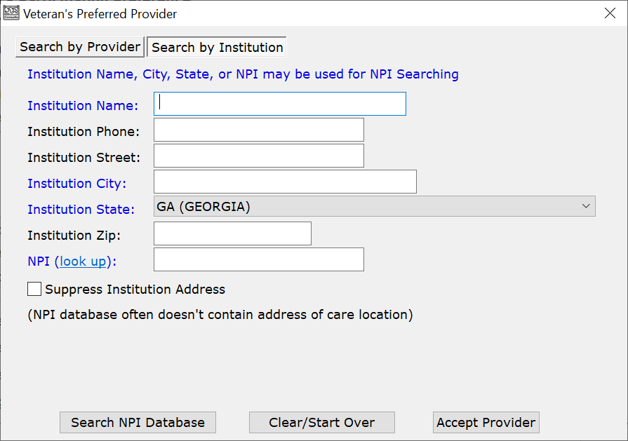
- Institution Name: - This field may be used for NPI searching.
- Institution Phone:
- Institution Street:
- Institution City: - This field may be used for NPI searching.
- Institution State: - This field may be used for NPI searching.
- Institution Zip:
- NPI (look up): - This field may be used for NPI searching.
- Suppress Institution Address
- Facility & Service Locator- Finding the preferred facility and service can be conducted using the Facility & Service Locator option. This option will take you to the VA Community Provider Locator.
- Veteran’s appt time preference:
- Any
- Morning
- Afternoon
- Veteran’s day/date preference:
- Veteran’s Communication Preference Method:
- Home Phone
- Cell Phone
- Mail
- MHV Secure Message
- Text
- Willing to travel up to (miles):

Community Care Eligibility Steps
To set the Community Care eligibility, follow the steps listed below:
- From the Action menu, select Consult Tracking…, and then select Add Comment. The Add Comment to Consult dialog box displays.
Figure 111: Add Comment to Consult Dialog Box
- In the Comments field, right-click to display the Community Care menu.
Figure 112: Community Care Menu
- From the Community Care menu, select Scheduler Functions. The Scheduler Options window opens with the Calls and Letters tab displayed.
Figure 113: Calls and Letters Tab
- Select the Community Care Eligibility tab.
Figure 114: Community Care Eligibility Tab
- From the Veteran’s Participation Preference section, select if the Veteran is opting in or opting out of Community Care.
- From the Scheduling to be performed by: drop-down menu, select an option.
- From the Veteran’s Provider and Appointment Preferences section, select the options to document the Veteran’s preferences.
- Click OK.

Unable to Schedule Functions
The Unable to Schedule function is the replacement for Veterans awaiting care via the EWL in VistA. The use of the Unable to Schedule function should not be used for administrative transfer requests. The use of the Light Electronic Action Framework (LEAF) should be used for administrative transfer requests.
Staff who receive and schedule internal VA consults are required to activate and utilize the Consult Toolbox when available to document reasons that consults cannot be scheduled and to monitor these requests for care. Unable to Schedule consults should remain in an Active status until the patient is scheduled or care is delivered.
Providers and schedulers will only use this option when receiving an internal VA consult that cannot be scheduled 390 days in the future and the Veteran has already declined Community Care or there is no comparable service in the community.
Right clicking the text area while receiving a consult or when adding a comment will bring up the list of approved reasons. Selecting one or more of these reasons will provide standard text that may be inserted in the consult comments to document why the consult cannot be appropriately scheduled.
Figure 115: Receive Unable to Schedule Window
- Prefers VA/No Capacity – Wants VA care (opts out of Community Care) and is waiting for availability. Care need is not met.
- No Comparable Service in the Community – Service is unique to VA this is specific to GEC, Home Base Primary Care (HBPC), and Mental Health services, where the care is not offered in the community (e.g., Spinal Cord Injury, Purchased GEC Care, HBPC with no VA Primary Care).
- Receiving Care/Awaiting Specialized Service – Care needs being met in VA while waiting for specialized VA service (e.g., HBPC Patients receiving VA Primary Care).

Unable to Schedule Steps
To receive consult, follow the steps listed below:
- From the Action menu, select Consult Tracking…, and then select Add Comment. The Add Comment to Consult dialog box displays.
Figure 116: Add Comment to Consult Dialog Box
- In the Comments field, right-click to display the Community Care menu.
Figure 117: Community Care Menu
- From the Community Care menu, select Unable to Schedule. The Unable to Schedule window opens.
Figure 118: Unable to Schedule Window
- From the Unable to Schedule section, select one or more reasons you were unable to schedule the consult.
- Click OK.
If you click OK before selecting an option, you will receive an error message stating that you must make a selection to continue.

Community Care Functions
For instructions on how to assign priority during the COVID-19 Pandemic please refer to Appendix A1.3: Receive Community Care Functions: COVID-19 Priority and Appendix A2.3: Add Comment Community Care Functions: COVID-19 Priority.
Community Care functions document activities that have taken place within the Community Care programs that are provided by the VA.
When compiling pertinent medical documentation for upload to the TPA Portal, it is highly recommended that the Referral Documentation Tool (REFDOC) be used. REFDOC is an innovative solution that extracts from the Veteran’s electronic medical record and records into PDF format for exchange with community care providers. REFDOC improves the timeliness of medical record transfers by allowing VA staff to quickly extract Veterans’ health information from Veterans Health Information Systems and Technology Architecture (VistA), Computerized Patient Record System (CPRS), and Corporate Data Warehouse (CDW) and compile it into a PDF package that can be easily shared with community providers.

MSA Eligibility Verification
Figure 119: MSA Elig. Verification Tab
- Specific Eligibility Verified—allows staff to further signify that the Veteran is eligible under one of the administrative eligibilities. This option allows the user to identify Community Care eligibility. The drop-down offers the following options:
Figure 120: Specific Eligibility Verified Menu Options
- BMI-Hardship
- BMI-per episode of care
- Drive Time
- Grandfathered under Choice
- No Full Service VA Available in State
- 1703 (e) Eligibility
- Service Not Available
- Wait Time – VA appointment is not available within the wait time standard.
*Grandfathered eligibility from Veterans Choice Program.
- Presumed eligible, HEC Update Pending —This is typically appropriate when a new Veteran is being registered and all evidence indicates (e.g. a DD 214 form) that the person is indeed a Veteran, but the eligibility cannot be verified by the Health Eligibility Center’s (HEC) systems. This is an indication that the record requires action by the HEC before the consult can move forward.
- Unable to Verify Eligibility —Staff member should take steps to verify eligibility. Staff is unable to verify the person’s eligibility for VA care or Community Care. This allows documentation of that fact and alerts the staff to refer the case to the appropriate person for resolution. A comment is available for further clarification but is not mandatory.
- Delegation of Authority Medical Services List Reviewed section. — This allows staff to select if clinical review is required, by checking a box.
- Clinical review required
- Does not require clinical review
- Document Administrative Screening

Community Care MSA Eligibility Verification Steps
To set the Community Care MSA Eligibility Verification options, follow the steps listed below:
- From the Action menu, select Consult Tracking…, and then select Add Comment. The Add Comment to Consult dialog box displays.
Figure 121: Add Comment to Consult Dialog Box
- In the Comments field, right-click to display the Community Care menu.
Figure 122: Community Care Menu
- From the Community Care menu, select Community Care Functions. The Community Care Functions window opens with the MSA Elig. Verification tab displayed.
Figure 123: MSA Elig. Verification Tab
- Select the Specific Eligibility Verified, Presumed eligible, HEC Update Pending, or Unable to Verify Eligibility check box that best describes the Community Care MSA eligibility verification.
CAUTION: Staff must contact local enrollment and eligibility office before proceeding.
- Once you have contacted local enrollment and eligibility, select the best option from the Delegation of Authority Medical Services List Reviewed section.
Information under Document Administrative Screening is populated and provides care coordination information about this Veteran. Additional details are in Community Care Document Administrative Screening and Clinical Triage tool section.
- Click OK.

Community Care (CC) Document Administrative Screening
The Screening/Triage tool enables staff to assess the Veteran’s care coordination needs in the community. The tool consists of an administrative screening and clinical triage sections. While the administrative section may be completed by any integrated team staff member (MSA/PSA, Social Worker, RN), the clinical section may be only completed by clinical staff. The administrative section consists of questions about the urgency of the Veteran’s care request, the requested services in the consult, and the corresponding Veteran CAN (Care Assessment Need) score, accessible through VSSC. Based on the answers in this section, the tool will determine whether a clinical assessment will be necessary. If so, the tool will prompt the user to input the name of the RN responsible for completing the clinical section and send an alert.
Figure 124: Administrative Screening
Administrative Screening for Care Coordination and Case Management section:
- Are you a clinical staff member: Yes or No—the first question asks if you are a clinical staff member. This box will screen to see if clinical staff needs to review an alert, which wouldn’t be needed if the user is a clinical staff person.
- Urgency: is appointment needed within 48 hours—if urgent care coordination is required, this should be forwarded immediately for clinical triage. (If within 48 hours, skip remaining questions and forward for clinical triage.)
- Does the consult specify any of the following complex conditions or services? — if the consult specifies any complex conditions or services, select one of the following options from the drop-down menu.
- New Cancer Diagnosis
- Outpatient Surgery
- Coronary Artery Bypass (CABG)
- Chronic Heart Failure
- Chronic Obstructive Pulmonary Disease/Pneumonia
- Inpatient Hospitalization (any cause)
- None of the above
- Does the consult specify any of the following basic services — if the consult specifies basic services, select the applicable service from the drop-down menu.
- Routine therapeutic services (Dialysis, OT, PT, RT)
- Routine Mammography
- Cervical Ca Screening (PAP Test)
- Complimentary and integrated medicine
- Direct Scheduling
- Routine Screening Colonoscopy
- Low Dose CT Scans
- None of the above
- CAN Score — CAN Scores serve as an important component to the Screening/Triage process providing a standardized evidence-based measure of Veteran risk. CAN Scores measure the probability of inpatient admission or death within a specified period of time (1 year) in percentage form. Toolbox automatically retrieves the CAN Score for a patient from the CDW via the CAN Score service.
If the CAN Score service is unavailable or a CAN Score does not exist for a patient, manual entry of the CAN Score is enabled.
Figure 125: CAN Score Fields Enabled
To access a Veteran’s CAN Score manually, the staff will be required to access VHA Support Service Center (VSSC). If CAN (Care Assessment Needs) Score is known, make the appropriate selection, or if not available, select No CAN Score Available from the following choices:
- 0 to 74
- 75 to 90
- Over 90
- No CAN Score Available
- CAN Score for: - Name of Veteran.
- DOB: - Veteran’s date of birth.
- SSN: - Veteran’s social security number.
- CAN Score: - Veteran’s CAN Score.
- Current Coord Level Assessment: - If this is not Basic, a box will open to input the name of the clinical staff member responsible for completing the clinical triage portion of the tool. This is not shown for clinical staff.
This does not send the actual alert, the user is responsible for sending the alert using the Send additional alerts button on the comment screen:
- Clinical Triage: - If the level of care coordination determined in the administrative screening section is not basic, the administrative staff member will alert a clinical care coordinator to complete the clinical triage section below. The clinical section consists of questions regarding the Veteran’s comorbidities, social factors, and need for assistance with Activities of Daily Living (ADLs). There is also a drop-down menu which the clinical care coordinator may fill out to override the results of the tool using clinical evidence-based judgment.
If clinical triage has already been performed, it will show. Also, if care coordination has already been assigned by Administrative screening (as in the example below) that will also show.
- Scheduling staff member you will alert: - Name of the scheduling staff member.
- Remember staff person for next referral: - option that tells the Consult Toolbox to remember the selected scheduling staff person for the next referral.

Community Care (CC) Document Administrative Screening Steps
Figure 126: MSA Elig. Verification Tab: Document Administrative Screening Section
- From the MSA Elig. Verification tab, click Document Administrative Screening. The Administrative Screening (for use by community care staff only) window opens.
Figure 127: Administrative Screening (for use by community care staff only) Window
If clinical review has already been performed, it will show. If administrative screening has been performed on this consult previously, it will be indicated as such in the administrative screening section.
- Select the Yes or No radio button for the From the Are you a clinical staff member question.
- Select the Yes or No radio button if there is an urgency to have an appointment in the next 48 hours.
- From the Does the consult specify any of the following complex conditions or services? drop-down menu, select if the consult specifies any complex conditions or services.
Either a complex or basic service may be selected from the drop-down menus but not both, if both are selected the first selection will be reset to “None of the above”.
- From the Does the consult specify any of the following basic services? drop-down menu, select the applicable service.
- From the CAN Score section, select appropriate selection with regards to the CAN Score.
- If the Current Coord Level Assessment is not Basic, input the name of the clinical staff member responsible for completing the clinical triage portion of the tool in the Name of scheduling staff member you will alert: field. This is not shown for clinical staff.
Figure 128: Scheduling staff member you will alert: Field
- Select the Remember staff person for next referral check box if you would like Consult Toolbox to remember your selection for the next referral.
This does not send the actual alert, the user is responsible for sending the alert using the Send additional alerts button on the comment screen:
- Click OK. The Document Administrative Screening information will populate on the MSA Elig. Verification tab.
Figure 129: Document Administrative Screening Populated

Consult Review
Figure 130: Consult Review Tab
- Community Care Clinical Review (for use by community care staff only)
- Request Approved (Select CC Program)— Optional field. Various Community Care programs can be selected but must be one of the listed in the drop-down menu.
Figure 131: Request Approved Options
If you are located in Alaska , Tribal will be an additional option in the Request Approved (Select CC Program) drop-down menu.
The Request Approved (Select CC Program) list is intended to display the approved program authorities used to purchase care in the community.
- Comment:
- Request disapproved (reason) —reason request disapproved, enter other reason in the field or select an option from the Opt menu.
Figure 132: Request Disapproved Options
- Not Medically Necessary
- Duplicate Consult
- Service available at the VA
- Other VA Providing Care
- Incomplete Information
- Not a Covered Service
- Clinical Review Method:
Figure 133: Clinical Review Method Menu Options
- MCG Guidelines
- InterQual Criteria
- Chief of Staff approved Protocol
- Hardship Request Approval:
- Is this a Community Care-Hardship Determination consult?
- Request Approved by COS or by his or her designee
- Approved for 6 months
- Approved for 12 months
- Request Disapproved by COS or by his or her designee
- Provider may authorize discontinuation after failure of mandated scheduling effort without further clinical review
- May discontinue if Veteran cancels/no-shows or fails to respond to mandated scheduling effort — If the Provider authorizes discontinuation after failure of mandated scheduling effort without further clinical review.
- twice
- once
- Is responsible for scheduling
- VA Staff
- VA schedules based on Veteran’s preference
- Veteran self-schedules
- Community provider schedules directly with Veteran
- Community Care Contractor
- Document Clinical Triage

Consult Review Steps
To set the CC Consult Review options, follow the steps listed below:
- From the Action menu, select Consult Tracking…, and then select Add Comment. The Add Comment to Consult dialog box displays.
Figure 134: Add Comment to Consult Dialog Box
- In the Comments field, right-click to display the Community Care menu.
Figure 135: Community Care Menu
- From the Community Care menu, select Community Care Functions. The Community Care Functions window opens with the MSA Elig. Verification tab displayed.
- Select the Consult Review tab.
Figure 136: Consult Review Tab
- From the Community Care Clinical Review section, select if the request was approved or disapproved. If the request was approved, you will need to select the CC Program from the drop-down. If the request was not approved, you will need to select the reason from the Opt menu.
- From the Hardship Request Approval section, select the best options.
- If the Provider authorizes discontinuation after failure of mandated scheduling effort without further clinical review, select May discontinue if Veteran cancels/no-shows or fails to respond to mandated scheduling effort check box and select the number of times from the drop-down menu.
- From the Is responsible for scheduling section, select if the scheduling will be done by either VA Staff or Community Care Contractor.
- Click OK.

Clinical Triage
If the level of care coordination determined in the administrative screening section is not basic, the administrative staff member will alert a clinical care coordinator to complete the clinical triage section below. The clinical section consists of questions regarding the Veteran’s comorbidities, social factors, and need for assistance with Activities of Daily Living (ADLs). There is also a drop-down menu which the clinical care coordinator may fill out to override the results of the tool using clinical evidence-based judgment.
If clinical triage has already been performed, it will show. Also, if care coordination has already been assigned by Administrative screening that will also show.
Figure 137: Clinical Triage for Care Coordination
Clinical Care Coordination Assignment
The Screening/Triage tool will recommend a care coordination level once the following items are populated:
- Veteran Comorbidities:—select yes or no if based on your review of Veteran information and clinical judgement if the Veteran will require additional care coordination/support during this episode of care due to two or more comorbidities.
- Psychosocial Factors:—select yes or no if based on your review of the Veteran information and clinical judgement, if the Veteran will require additional care coordination/support during this episode of care due to any psychosocial factors (e.g. Dementia, Depression, Homelessness, Lack of Caregiver Support).
- Activities of Daily Life, or ADL support: –select yes or no if based on your review of Veteran information and clinical judgement, if the Veteran will require ADL support.
- New Calculated Assessment: — the tool will calculate a level of care coordination based on the answers in the administrative screening and clinical triage sections as displayed below:
- Based on review of Veteran information and clinical judgement, the level of care coordination should be manually adjusted to: - Based on clinical judgment, the clinical care coordinator may override the automated result. If manual adjustment is required for the level of care coordination, select the revised level in the drop-down menu along with the reason for adjustment in the textbox below.
- Basic
- Moderate
- Complex
- Urgent
- Reasons for manual adjustment of care coordination level — enter a clinical reason for manually changing care coordination level.
- Final Clinical Triage Coordination Level: - auto-populates based on the completion of clinical triage questions or manual override.
- Name of scheduling staff member: - Name of the scheduling staff member.
- Remember staff person for next referral – option that tells the Consult Toolbox to remember the selected staff person for the next referral.

Clinical Triage Steps
To complete the clinical triage, follow the steps listed below:
- From the Action menu, select Consult Tracking…, and then select Add Comment. The Add Comment to Consult dialog box displays.
Figure 138: Add Comment to Consult Dialog Box
- In the Comments field, right-click to display the Community Care menu.
Figure 139: Community Care Menu
- From the Community Care menu, select Community Care Functions. The Community Care Functions window opens with the MSA Elig. Verification tab displayed.
- Select the CC Consult Review tab.
Figure 140: Consult Review Tab
- Click the Document Clinical Triage button. The Clinical Triage for Care Coordination window opens.
Figure 141: Clinical Triage for Care Coordination
The Clinical Triage tool will recommend a care coordination level once the following items are populated.
- From the Veteran Comorbidities: section, select No or Yes if the Veteran will require additional care coordination/support during this episode of care due to two or more comorbidities.
- From the Psychosocial Factors: section, select No or Yes if the if the Veteran will require additional care coordination/support during this episode of care due to any psychosocial factors (e.g. Dementia, Depression, Homelessness, Lack of Caregiver Support).
- From the Activities of Daily Life, or ADL support: section, select No or Yes if the Veteran will require ADL support.
- The tool will automatically calculate a level of care coordination based on the answers in is the steps above. The coordination level displays in the New Clinical Triage Coordination Level section.
Figure 142: New Clinical Triage Coordination Level
Based on clinical judgment, the clinical care coordinator may override the automated result. If manual adjustment is required for the level of care coordination, select the revised level in the drop-down menu along with the reason for adjustment in the text box.
- In the Reasons for manual adjustment of care coordination level: field, enter a clinical reason for manually changing care coordination level.
- The Final Clinical Triage Coordination Level: auto-populates based on the completion of clinical triage questions or manual override.
- In the Name of scheduling staff member: field, enter the name of the staff member.
- Select the Remember staff person for next referral check box if you want Consult Toolbox to remember the staff person.
- Click OK. The screening/triage tool will populate a comment in the body of the consult detailing the level of care coordination, directions for proceeding with care coordination, and a list of potential care coordination services required by the Veteran. The comment will also provide guidance on the frequency of contact and need for warm handoff.
Figure 143: Comment Added to Consult

Authorization
This information documented within the Authorization tab populates from data contained in the consult if present, but will not be added to the consult again unless changes and the checkbox is checked shown and described below.
Figure 144: Authorization Tab
- Service Line – A broad category for the services and procedures included which is intended to be used as a way to group and filter SEOCs for easier accessibility. A standardized 3-letter abbreviation of the service line is included at the beginning of the SEOC ID.
Figure 145: Service Line Menu Options
- SEOC – A SEOC selection is mandatory on every Community Care consult. If a SEOC has not been previously placed to the Consult, users should use Consult Toolbox to write a SEOC to the consult.
If SEOC database is unavailable the SEOC Database Unreachable Message displays. Contact the NSD if no SEOCs are available in th drop-down menu.
Figure 146: List of Active SEOCs
- Display SEOC – Option that allows you to view the details of the selected SEOC.
Figure 147: Display SEOC
- Community Care Coordinator — typically referrals need to include the name of the Community Care Coordinator and a contact number. These can be inserted here. You must check the checkbox for this to be included.
- For questions, contact this number: - Community Care manager contact phone number.
- Upon completion of this section — send to HSRM for referral. If this check box is selected, a consult will transfer to HSRM in approved status even if the status in CPRS is cancelled, pending, discontinued, etc.

Authorization Steps
To view or edit the options within the Authorization tab, follow the steps below:
- From the Action menu, select Consult Tracking…, and then select Add Comment. The Add Comment to Consult dialog box displays.
Figure 148: Add Comment to Consult Dialog Box
- In the Comments field, right-click to display the Community Care menu.
Figure 149: Community Care Menu
- From the Community Care menu, select Community Care Functions. The Community Care Functions window opens with the MSA Elig. Verification tab displayed.
- Select the Authorization tab.
Figure 150: Authorization Tab
- From the Service Line drop-down menu, select the best option.
- From the SEOC drop-down menu, select one of the authorized service listed.
- Select the Community Care Manager check box to include the name of the Community Care manager and add a contact number.
- Once the referral is ready for Authorization Form, select the Send to HSRM for Referral check box from the Upon completion of this section:.
If the consult has already been sent to HSRM, the following message will display.
Figure 151: Consult Previously Sent to HSRM Warning Message
Select the check box if you need to re-send the consult to HSRM for Referral.
- Click OK.

DoD
This information documented within the DoD tab is used for coordinating care between the VA and the DoD Benefits Office.
Figure 152: DoD Tab
- DoD Urgency – Department of Defense Urgency
- Urgency
Figure 153: DoD Urgency Menu Options
- Urgent – 90 minutes
- Routine – 2 business days
- DoD facility contacted to request care – Name of DoD facility contacted to request care.

DoD Steps
To view or edit the options within the DoD tab, follow the steps below:
- From the Action menu, select Consult Tracking…, and then select Add Comment. The Add Comment to Consult dialog box displays.
Figure 154: Add Comment to Consult Dialog Box
- In the Comments field, right-click to display the Community Care menu.
Figure 155: Community Care Menu
- From the Community Care menu, select Community Care Functions. The Community Care Functions window opens with the MSA Elig. Verification tab displayed.
- Select the DoD tab. The DoD tab displays.
Figure 156: DoD Tab
- If there is a DoD urgency, select the Urgency check box and then select the type of urgency from the drop-down menu.
- If a DoD facility was contacted to request care, select the check box and enter the name of the facility in the field.
- Click OK.

MSA Pt Contacts
Figure 157: MSA Pt Contacts
- Unsuccessful attempts to schedule Veteran — this allows recording first, second, and additional calls made to the Veteran to arrange care. Optionally, an annotation like “No Answer” can be added. Enter information regarding the attempt in the field or select an option from the Opt menu: Mail, Left Voice Mail, or Left Message with Family.
- First call to Veteran
- Second call to Veteran
- Third or additional call to Veteran
- Unable to Contact letter sent to Veteran — use this selection when a letter is sent to the Veteran indicating that the clinic has been trying to reach him/her to schedule an appointment. This comment may be used each time a letter is sent, if sent more than once.
- Letter Sent by Certified Mail—this is an additional indication that the letter above was sent by certified mail. Note that the certified mail indicator should be used in conjunction with the unable to contact letter.
- Additional Results from Attempt
- All listed phone numbers disconnected or wrong number—used when all the numbers listed for the Veteran are wrong (disconnected or you reach someone who doesn’t know the Veteran). This should not be used unless you have confirmed that all numbers in the record are bad.
- Address bad or No address on file, unable to contact by letter—this would apply in the instance where a letter sent has been returned by the post office or in the case of homeless Veterans. The latter case may require extra effort with the Homeless Veterans’ Program to try to reach the Veteran.
- Veteran Contacted
- Veteran Informed of eligibility, referral and approval—this simply documents that the Veteran has been informed of Community Care eligibility.
- Veteran’s Participation Preference
- Opt-In for Community Care—documents Veteran has opted-in.
- Opt-Out for Community Care—documents Veteran has opted-out for Community Care.
- Mailing Address Confirmed—indicates that the mailing address on file is correct. If not correct, MSA should correct the address, and then confirm that it is correct.
- Verified Best Contact Number—documents best number to contact this Veteran. In addition to the actual number, user may also note whether cell, home, or other number. Also, options to confirm existing numbers on file as the best number are provided. Enter the best contact number in the field or select an option from the Opt menu: home number on file, cell number on file, or work number on file.
- OK to leave appt. details on voice mail—documents that Veteran gives permission to leave appointment details on his/her voice mail.
- OK to leave appt. details with: —documents that Veteran gives permission to leave details of the appointment with another individual. Anything may be entered, or several options are provided if a specific family member is preferred. Enter the name of individual that the Veteran gives permission to leave details of the appointment with in the field or select an option from the Opt menu: Spouse, Daughter, Son, Caregiver, or Family.
- Veteran contacted Community Care office
- Contact Notes
- Provider Preference:
- Pref. referral package Method:
- Fax
- HSRM Portal
- Mail
- Secure Email
- Veteran’s Preferred Provider Information — if the Veteran has a provider they would like to see, that can be recorded here. Use the lookup tool so the correct provider information (including NPI number) can be part of the record. This pulls data from the Department of Health and Human Services database, which is updated daily
- Veteran has a Preferred Provider: Finding the preferred provider can be conducted using the Lookup a Provider option.
- Update record with above information
- Veteran OK to see other than Pref. Provider — if the Veteran has indicated a preferred provider, this documents whether they are willing so see someone else if there is no opportunity to see their preferred provider (provider not available or not willing to take Veteran).
- Yes
- No
- Lookup a Provider - Finding the preferred provider can be conducted using the Lookup a Provider option.
Figure 158: Search by Provider Tab
- Prov. Last Name: - This field may be used for NPI searching.
- Prov. First Name: - This field may be used for NPI searching.
- Degree:
- Provider Phone:
- Provider Specialty: - This field may be used for NPI searching.
- Provider Street:
- Provider City: - This field may be used for NPI searching.
- Provider State: - This field may be used for NPI searching.
- Provider Zip:
- NPI (look up): - This field may be used for NPI searching.
- Suppress Provider Address (recommended)
Figure 159: Search by Institution Tab
- Institution Name: - This field may be used for NPI searching.
- Institution Phone:
- Institution Street:
- Institution City: - This field may be used for NPI searching.
- Institution State: - This field may be used for NPI searching.
- Institution Zip:
- NPI (look up): - This field may be used for NPI searching.
- Suppress Institution Address
- Veteran’s appt time preference: this is an optional field that allows documentation of time of day preference. It can be Any, Morning, Afternoon, or anything else you’d like to enter.
- Veteran’s day/date preference: documents day of week or date Veteran would prefer the appointment. This is a free text field, though a CAL button is available to pick a specific date.
- Veteran prefers to self schedule
- Veteran’s Communication Preference Method: documents how the Veteran would like to be notified of appointment when scheduled. Options are:
- Home Phone
- Cell Phone
- Mail
- MHV Secure Message
- Text
- Willing to travel up to (miles): documents Veteran’s willingness to travel said number of miles to see a provider.
- Refer to clinical reviewer for disposition after unsuccessful scheduling effort — after failing to schedule an appointment by making two calls, sending a letter, and waiting two weeks, this option refers the consult to a clinician to review and disposition. Business rules for certain low-risk consults may allow the scheduler to discontinue without clinician review, or in the case the provider previously reviewed the consult and determined that it may be discontinued after a failure to schedule after mandated effort, or multiple missed appointments.

MSA Pt Contacts Steps
To view or edit the options within the MSA Pt Contacts tab, follow the steps below:
- From the Action menu, select Add Comment. The Add Comment to Consult dialog box displays.
Figure 160: Add Comment to Consult Dialog Box
- In the Comments field, right-click to display the Community Care menu.
Figure 161: Community Care Menu
- From the Community Care menu, select Community Care Functions. The Community Care Functions window opens with the MSA Elig. Verification tab displayed.
- Select the MSA Pt Contacts tab.
Figure 162: MSA Pt Contacts Tab
- From the Unsuccessful Attempts to Schedule Veteran section, select the best option.
- From the Additional Results from Attempt section, select the best options.
- From the Veteran Contacted section, select the best options.
- From the Veteran’s Participation Preference section, select the best options.
- From the Provider Information section, select the best options.
- From the Provider Preference section, select the best options.
- Select the Refer to clinical reviewer for disposition after unsuccessful scheduling effort check box if after failing to schedule an appointment by making two calls, sending a letter, and waiting two weeks, this option refers the consult to a clinician to review and disposition.
- Click OK.

Appt Tracking
Figure 163: Appt Tracking Tab
- Provider requires records to review prior to scheduling — records a situation where the potential Community Care provider requires records to be reviewed prior to accepting the referral.
- Document Uploaded to TPA Portal — allows Community Care staff to record when documentation for a Community Care referral has been uploaded to the TPA’s portal. Note, during the document upload process, the unique ID will also be included.
- Records faxed/sent to Community Care Provider —
- Follow up call made to provider/vendor to check on status—documents a follow up call to vendor to check on referral status, such as in the case where records review was required.
- Time sensitive appointment, NLT—documents a no later than date for the appointment to be scheduled.
- Community Care apt has been—scheduled or unscheduled. This allows Community Care staff to flag the consult as having an appointment under Community Care.
- Appointment Date: Records the appointment date. This is not required if a shadow appointment has been scheduled in VistA Scheduling. This is a free text entry field; however, a calendar widget is provided for easy date and time entry.
Figure 164: Appointment Date Calendar View
- Comment –
- Actual/Approved Provider Information — The name of the actual provider with whom the Veteran has an appointment should be selected using the Lookup a Provider button, which works the exact same as the one on the MSA Pt Contacts tab. It may be different from the one the Veteran preferred if, for instance, the provider was unable to see Veteran, or was not participating as a VA community provider.
- Update record with above information
- Available Community Care Facility & Provider Locator
- Veteran informed of scheduled appt. by—Enter the method of notification for the scheduled appointment in the field or select an option from the Opt menu: mail, phone, phone and mail, or MyHealtheVet.
- Referral Authorization Packet Mailed to Veteran—referral authorization packet mailed to Veteran
- Returned from Community Care Provider: — These data fields are used to indicate when a referral has been returned from Community Care Provider with the corresponding rationale.
- Referral Issues (select specific issue)
- Duplicate
- Non Covered Service — Veteran referred to community provider for services that are not part of benefits package.
- Missing VA Data/Forms — Missing or incomplete documentation required to appoint.
- VA requested return of referral — VA contacts contractor and requests return of referral.
- Unable to review within contract standards — Contractor was not able to review within the contract standard.
- Non-Disclosure of OHI by Veteran — Veteran acknowledges having OHI and fails to provide.
- Unable to contact Veteran during Out Bound Call Process — Could not appoint due to no contact from Veteran via call or letter.
- Network Issues (select specific issue)
- No Network Provider Available — No network provider available for requested service(s). This does not include a Veteran requesting a specific provider.
- VA Requested Providers Outside of Network — Non‐contracted provider.
- Veteran Requested Specific Provider — Veteran requested a specific provider for care that is not available on the PC3 network or by Community Care provider agreement.
- Appointed with Incorrect Provider/Type of Care — Appointed with incorrect provider or incorrect type of care.
- Already Appointed — Care has been previously scheduled by the Veteran, VA or the Contractor.
- Veteran Declined (select specific reason)
- Veteran Declined Distance — Inside Commute Standard — Network provider is in contractors’ network and within the commute standards.
- Veteran Declined Distance — Outside Commute Standard — Network provider is in contractors’ network but provider is NOT within the commute standards.
- Veteran Declined Appt Time — Veteran declined time for scheduled appointment.
- Veteran Declined Does Not Want Care — Veteran declined request for care.
- Veteran Declined Use of PC3/Community Care — Veteran no longer wants to participate in the program.
- Appointment Issues (select specific issue)
- Veteran No-Show — Veteran did not show up for scheduled appointment.
- Contractor Return – Unable to schedule within contract terms — Care not scheduled within the contractual time and VA is requesting back due to time lapse.
- VA Request Return – Care Already Scheduled by Contractor — VA requested the authorization after Contractor scheduled care.
- Unable to contact Veteran Out Bound Call Process — Could not appoint due to no contact from Veteran via call or letter.
- CCN Return Reasons (select specific issue)
- No CCN Provider Available to Schedule Within Timeliness Standard
- No CCN Providers Available to Schedule Within Drive Time Standard
- Veteran Prefers CCN Provider Outside of Drive Time Standard
- Veteran Willing to Accept CCN Provider Outside of Drive-Time Standard
- Veteran Willing to Accept CCN Provider Outside of Timeliness Standard
- Veteran Prefers Non-CCN Provider
- Veteran Self-Schedules
- Service Not Provided in CCN
- Veteran Deceased or Incapacitated — Authorization returned due Veteran deceased or incapacitated.
- Disposition of returned referral: - document the status of the referral
- Scheduled using Provider Agreement.
- In-house VA Appointment arranged.
- Forwarded to in-house service.
- Resubmitted new referral authorization to vendor.
- Scheduled using Community Care.
- Missed Community Care Appointment, care still Active/Pending: - document the reason for the missed appointment.
- Veteran was No-Show for community care appointment
- Veteran Canceled community care appointment (Cancel by Veteran)
- Community Care Provider canceled appointment (Cancel by clinic)
- Veteran declined/refused – using alternate source of payment
- Veteran declined/refused community care
- Refer to clinical reviewer for disposition after unsuccessful scheduling effort — after failing to schedule an appointment by making two calls, sending a letter, and waiting two weeks, this option refers the consult to a clinician to review and disposition. Business rules for certain low-risk consults may allow the scheduler to discontinue without clinician review, or in the case the provider previously reviewed the consult and determined that it may be discontinued after a failure to schedule after mandated effort, or multiple missed appointments.

Appt Tracking Steps
To view or edit the options within the Appt Tracking tab, follow the steps below:
- From the Action menu, select Consult Tracking…, and then select Add Comment. The Add Comment to Consult dialog box displays.
Figure 165: Add Comment to Consult Dialog Box
- In the Comments field, right-click to display the Community Care menu.
Figure 166: Community Care Menu
- From the Community Care menu, select Community Care Functions. The Community Care Functions window opens with the MSA Elig. Verification tab displayed.
- Select the Appt Tracking tab.
Figure 167: Appt Tracking Tab
- Select the best option for appointment tracking.
- From the Actual/Approved Provider Information section, enter the name of the actual provider with whom the Veteran has an appointment.
- In the Veteran informed of scheduled appt by: field, enter the method used to inform the Veteran of the schedule appointment or select an option from the Opt menu.
- Select the Referral Authorization Packet Mailed to Veteran if a packet was mailed to the Veteran.
- From the Returned from Community Care Provider: section, select the reason why the referral was returned from the Community Care Provider with the corresponding rationale.
- From the Disposition of returned referral drop-down menu, select the status of the referral.
- From the Missed Community Care Appointment care still Active/Pending drop-down menu, select the reason for the missed appointment.
- If the records were received, select the Records Received check box and select the option from the drop-down menu.
- If the Veteran is using an alternate source of payment, select the Veteran declined/refused – using alternate source of payment check box.
- If the Veteran does not want to use Community Care, select the Veteran declined/refused community care check box.
- Click OK.

Secondary Authorization Request (SAR)/Request for Service (RFS)
Figure 168: SAR/RFS Tab
- Secondary Authorization Request (SAR)/Request for Service (RFS) section
- SAR/RFS Urgency — Insert the urgency for the secondary authorization request/request for service field or select an option from the Opt menu: Routine, w/in 48 hours, w/in 1 week, or w/in 1 month.
- SAR/RFS was entered into VistA Imaging
- Yes
- No
- SAR/RFS Details of what was Requested: - comment related to the SAR.
- Actions Taken
- Request is Clinically Appropriate – note reasons by check boxes, or with detailed description.
- Additional Time:
- Additional Services
- Approved as req. above
- Details
- Request is not Clinically Appropriate — note reasons by check boxes, or with detailed description.
- Not a covered benefit
- Missing Documentation
- Reassessment by VA Provider Required
- Other reason
- Not Clinically Appropriate
- Denial Details:

SAR/RFS Steps
To view or edit the options within the SAR/RFS tab, follow the steps below:
- From the Action menu, select Consult Tracking…, and then select Add Comment. The Add Comment to Consult dialog box displays.
Figure 169: Add Comment to Consult Dialog Box
- In the Comments field, right-click to display the Community Care menu.
Figure 170: Community Care Menu
- From the Community Care menu, select Community Care Functions. The Community Care Functions window opens with the MSA Elig. Verification tab displayed.
- Select the SAR/RFS tab.
Figure 171: SAR/RFS Tab
- From the Secondary Authorization Request (SAR) / Request for Service (RFS) section, enter the SAR/RFS urgency in the field or select an option from the Opt menu.
- From the SAR/RFS was entered into VistA Imaging drop-down menu, select Yes or No.
- In the SAR/RFS Details of what was Requested field, enter the details.
- From the Actions Taken section, select if the SAR/RFS was clinically appropriate or not.
- Click OK.

Consult Completion
Figure 172: Consult Completion Tab
- Completion Efforts
- (1st) First attempt to get records — documents first request for records for Community Care.
- (2nd) Second attempt to get records — documents second request for records for Community Care.
- (3rd) Third attempt to get records — documents third request for records for Community Care.
- Records Received — documents receipt of records pertinent to this consult. This is particularly useful in the case that those records cannot be uploaded to VistA Imaging immediately.
Figure 173: Records Received Menu Options
- Paper Fax
- eFax
- VHIE
- Secure Email
- US Mail
- EDI Claim Attachment
- HSRM
- Direct – Directly from Veteran.
- TPA Portal
- Other
- No records after 3 attempts. — documents that three attempts have been made to receive records. This makes the consult a candidate for administrative closure.
- Community Care appointment occurred (waiting for records) – Enter information in the field or select an option from the Opt menu: Per Veteran, awaiting records/confirmation, Per TPA Portal, awaiting records, or Per Provider, awaiting records.
- Refer to Clinical Care Coordinator — clinical review determines next steps after care when there are no records.

Consult Completion Steps
To view or edit the options within the Consult Completion tab, follow the steps below:
- From the Action menu, select Consult Tracking…, and then select Add Comment. The Add Comment to Consult dialog box displays.
Figure 174: Add Comment to Consult Dialog Box
- In the Comments field, right-click to display the Community Care menu.
Figure 175: Community Care Menu
- From the Community Care menu, select Community Care Functions. The Community Care Functions window opens with the MSA Elig. Verification tab displayed.
- Select the Consult Completion tab.
Figure 176: Consult Completion Tab
- From the Completion Efforts section, select the options for completion.
- In the Community Care appointment occurred (waiting for records) field, enter the information or select an option from the Opt menu.
- Click OK.

Clinical Review Options
Provider functions allow providers reviewing records to document the results of their review or other actions that need to be documented.
Figure 177: Clinical Review Options
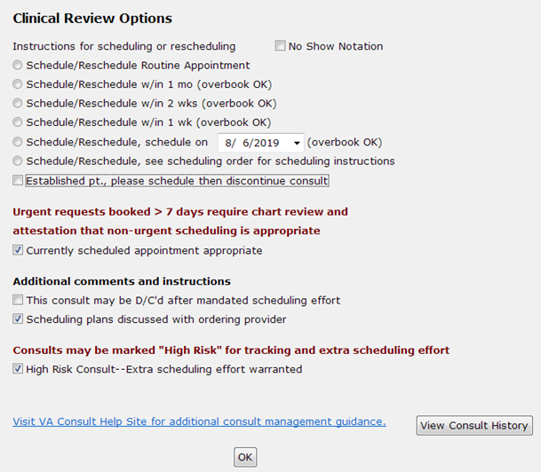
- Instructions for scheduling or rescheduling — Providers reviewing consults need to comment when they review incomplete consults (this is different from when they review a consult to accept or receive it). This can occur after a no show, or if a consult has languished, or as the result of failed scheduling efforts. An urgent consult that isn’t seen urgently must be reviewed to assure that either it wasn’t urgent medically, or the delay is the fault of the Veteran. The workflow here is that a routine appointment follows the normal scheduling protocols. If the provider indicates the appointment should be scheduled within a certain time frame, then an overbook may be required. For the scheduler, he or she should first look for an open appointment within the designated time frame, using an available appointment if one is available. Only overbook if no appointment is available. For example, if the provider says within two weeks, and there is an open appointment in 10 days, it would be inappropriate to overbook in six days when there is an open appointment available.
- No Show Notation
- Schedule/Reschedule Routine Appointment—this option is available here, but more likely would be used in the “Receive Consult” box described in more detail below.
- Schedule/Reschedule w/in 1 mo (overbook OK) —
- Schedule/Reschedule w/in 2 wks (overbook OK) —
- Schedule/Reschedule w/in 1 wk (overbook OK) —
- Schedule/Reschedule, schedule on date (overbook OK) —
- Schedule/Reschedule, see scheduling order for scheduling instructions —
- Established pt., please schedule then discontinue consult — the work flow here is important. It could be that something new has happened with the Veteran and the referring provider felt that an appointment was needed, or it could be that the referring provider didn’t realize the Veteran was already active with the clinic. If there is indeed something new going on with the Veteran, it would not be inappropriate to complete the consult as an e-consult, but in either case, the consult should result in a follow-up appointment. Typically, you’d select scheduling instructions above, and then instruct the scheduler to discontinue the consult once the follow up appointment has been scheduled.
- Urgent requests booked > 7 days require chart review and attestation that non-urgent scheduling is appropriate.
- Currently scheduled appointment appropriate—this option is for STAT consults that are scheduled more than 7 days from the create date, but after clinical review, are felt to be appropriately timed. This step is extremely important for both STAT consults and those consults stop codes identified as Level 1 (“Important and Acute”) such as cardiology, radiology, oncology, etc. The VA is wanting to make sure that Veterans with high risk conditions receive timely care. Many consults in those high-risk specialties are for low risk problems, and this is how that is documented.
- Additional comments and instructions
- This consult may be D/C’d after mandated scheduling effort—this option would NOT typically be used, as this is a comment, asking someone else to discontinue the consult in a separate step. It could be useful in the instance where a reviewer doesn’t have access to discontinue a consult.
- Scheduling plans discussed with ordering provider – this selection is simply for the convenience of the reviewing provider to document the instance where they have discussed the case with the ordering provider. This allows them to easily document that conversation took place. It doesn’t have any significant ramifications with respect to consult processing.
- Consults may be marked “High Risk” for tracking and extra scheduling effort
- High Risk Consult –Extra scheduling effort warranted — Consults may be flagged as high risk by the service line. Each service line should define what this means. There will be reportable separately, so they may be tracked with a higher level of scrutiny. Also, after a letter has been sent to Veteran, staff may continue to attempt to reach the Veteran by phone during the 14 days after the letter was sent. Document of additional attempts is required.

Setting Clinical Review Options
To document the results of your review or other actions that need to be documented, follow the steps listed below:
- From the Action menu, select Consult Tracking…, and then select Add Comment. The Add Comment to Consult dialog box displays.
Figure 178: Add Comment to Consult Dialog Box
- In the Comments field, right-click to display the Community Care menu.
Figure 179: Community Care Menu
- From the Community Care menu, select Clinical Review Options. The Clinical Review Options window opens.
Figure 180: Clinical Review Options
- From the Instructions for scheduling or rescheduling section, select the instruction for consult.
- From the Urgent requests booked > 7 days require chart review and attestation that non-urgent scheduling is appropriate section, select the Currently scheduled appointment clinically appropriate check box for STAT consults that are scheduled more than seven days from the create date, but after clinical review, are felt to be appropriately timed.
- From the Additional comments and instructions section, select the appropriate option(s).
- From the Consults may be marked “High Risk” for tracking and extra scheduling effort section, select the High Risk Consult—Extra scheduling effort warranted check box if the consult needs extra scheduling.
- Click OK.

Launch DST
To launch Decision Support Tool (DST) from CTB, follow the steps listed below:
- From the Action menu, select Consult Tracking…, and then select Add Comment. The Add Comment to Consult dialog box displays.
Figure 181: Add Comment to Consult Dialog Box
- In the Comments field, right-click to display the Community Care menu.
Figure 182: Community Care Menu
- From the Community Care menu, select Launch DST. The Decision Support Tool Dashboard opens.
Figure 183: Decision Support Tool Dashboard
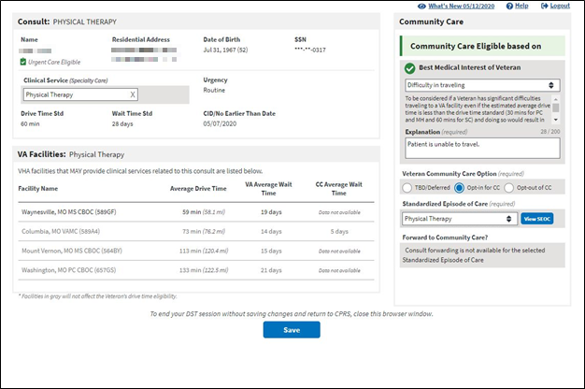
For additional information regarding Decision Support Tool, please refer to the Care Coordination Decision Support Tool (DST) User Guide.

Significant Findings – Community Care Action Needed Notation
Use this feature to flag significant findings for the ordering provider (e.g., test results are available). This box is used with the significant findings CPRS comment to alert the ordering provider of results received especially in the case where a follow up action is needed on the part of the VA provider.
Figure 184: Significant Findings Update
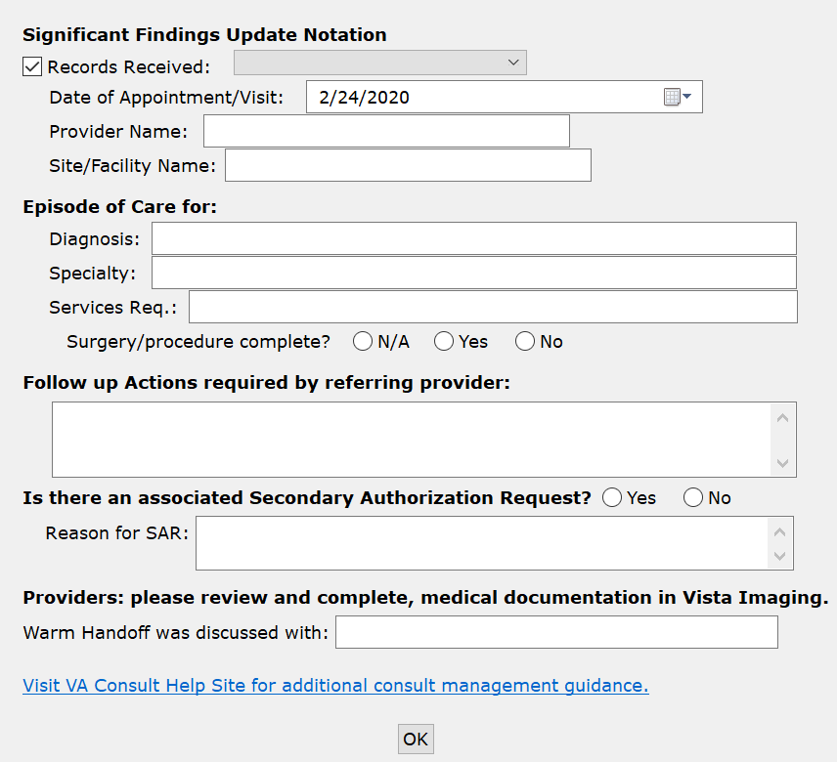
- Significant Findings Update Notation
- Records Received
- Paper Fax
- eFax
- VHIE
- Secure Email
- US Mail
- EDI Claim Attachment
- HSRM
- Direct – Directly from Veteran.
- TPA Portal
- Other
- Date of Appointment/Visit
- Provider Name
- Site/Facility Name
- Episode of Care for:
- Diagnosis
- Specialty:
- Services Req.
- Surgery/procedure complete?
- N/A
- Yes
- No
- Follow up Actions required by referring provider: (Required Field)
- Is there an associated Secondary Authorization Request (SAR)?
- Yes
- No
- Reason for SAR
- Providers: please review and complete, medical documentation in VistA Imaging.
- Warm Handoff was discussed with:

Significant Findings Steps
To update significant findings for the ordering provider, follow the steps listed below:
- From the Action menu, select Consult Tracking…, and then select Significant Findings. The Update Significant Findings dialog box displays.
Figure 185: Update Significant Findings Dialog Box
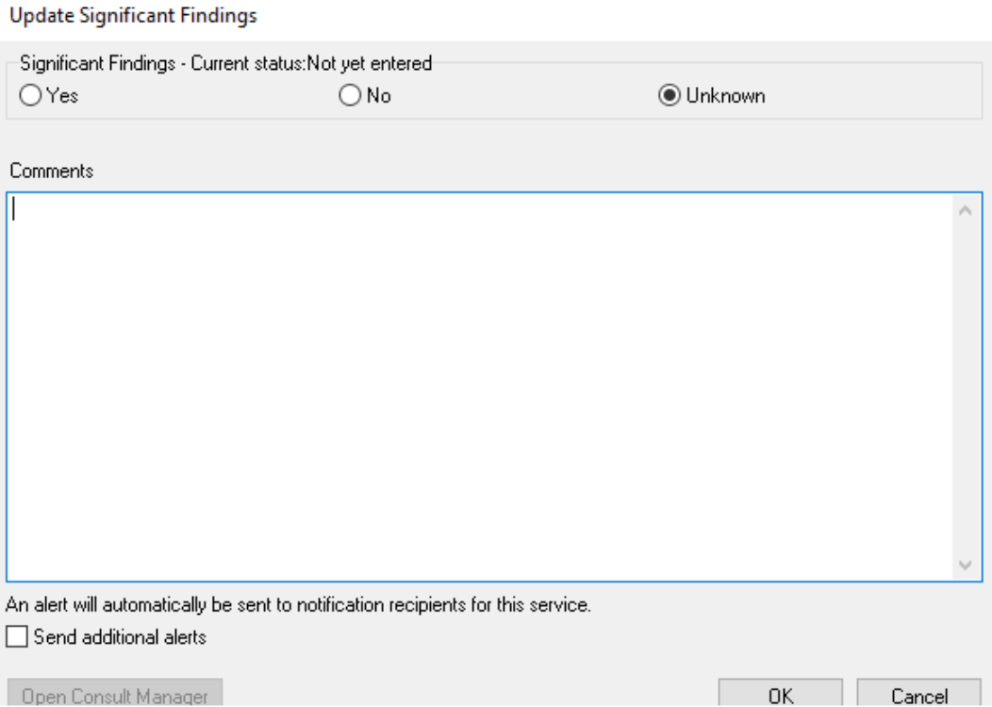
- In the Comments field, right-click to display the Significant Findings menu.
Figure 186: Significant Findings Menu
- From the Significant Findings menu, select Community Care Action Required. The Significant Findings Update window displays.
Figure 187: Significant Findings Update
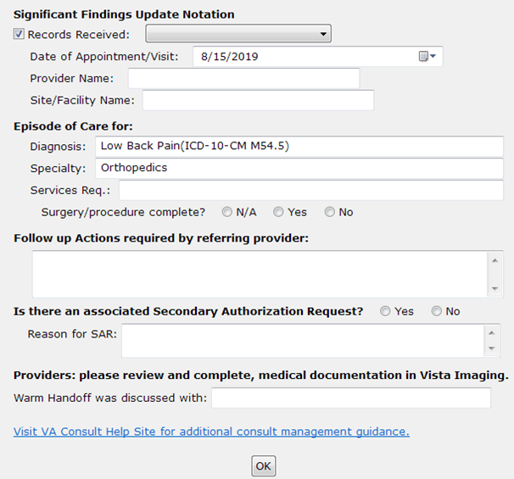
- If the records were received, select the Records Received check box and select an option from the drop-down menu.
- In the Episode of Care for: section, enter the diagnosis, specialty, services required, and if the surgery/procedure is complete.
- In the Follow up Actions required by referring provider: section, enter the required actions.
- Select if a Secondary Authorization Request is needed. If a Secondary Authorization Request is needed, enter the reason in the Reason for SAR field.
- Enter the name of the individual that the warm handoff was discussed with in the Warm Handoff discussed with: field.
- Click OK.

Administratively Complete
After one attempt to obtain records, a consult may be administratively closed. This will record that the consult was closed without records, which may be tracked.
Figure 188: Administratively Close
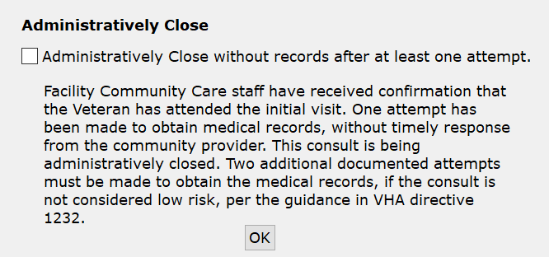
Administratively Close without records after at least one attempt. — Facility Community Care staff have received confirmation that the Veteran had attended the initial visit. One attempt has been made to obtain medical records, without timely response from the community provider. This consult is being administratively closed. Two additional documented attempts must be made to obtain the medical records, if the consult is not considered low risk, per the guidance in VHA directive 1232.

Administratively Close Consult Steps
To administratively close a consult, follow the steps listed below:
- From the Action menu, select Consult Tracking…, and then select Significant Findings. The Administratively Complete dialog box displays.
Figure 189: Administratively Complete Dialog Box
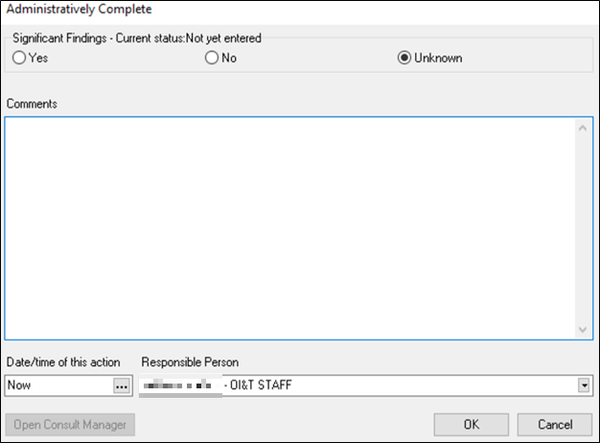
- In the Comments field, right-click to display the Administratively Complete menu.
Figure 190: Administratively Complete Menu
- From the Administratively Complete menu, select Administratively Complete. The Administratively Close dialog box displays.
Figure 191: Administratively Close Dialog Box
- Select the Administratively Close without records after at least one attempt. check box to administratively close the consult. Selecting this check box confirms that that the Veteran received care for initial visit. One attempt has been made to obtain medical records without a timely response from the community provider.
- Click OK.

Troubleshooting
- If Consult Toolbox is not running in CPRS, the user will need to verify that Consult Toolbox in running in the system tray.
- If SEOC database is unavailable, a warning message will display notifying you that the SEOC Database cannot be reached for the most current SEOCs. SEOCs previously downloaded will still be available on the Authorization tab. Contact the NSD if no SEOCs are available.

National Service Desk and Organizational Contacts
For issues related to the Consult Toolbox that cannot be resolved by this manual or the site administrator, please contact the National Service Desk at 855-NSD-HELP (673-4357).

Acronyms and Abbreviations
Acronym | Definition
CAC | Clinical Application Coordinators
CAN | Care Assessment Need
CCAD | Community Care Agile Development
CDW | Corporate Data Warehouse
CID | Clinically Indicated Date
COS | Chief of Staff
CPRS | Computerized Patient Record System
CTB | Consult Toolbox
DOA | Delegation of Authority
DoD | Department of Defense
DST | Decision Support Tool
HEC | Health Eligibility Center
NSD | National Service Desk
OI&T | Office of Information and Technology
Opt | Option
PCP | Primary Care Physician
RFS | Request for Service
SAR | Secondary Authorization Request
SEOC | Standardized Episode of Care
SOP | Standard Operating Procedure
URL | Universal Record Location
VA | Department of Veterans Affairs
VAMC | VA Medical Center
VDL | VA Software Document Library
VHA | Veterans Health Administration
VistA | Veterans Health Information Systems and Technology Architecture
VVC | VA Video Connect

Appendix A: Management of Consults when COVID-19 Workflow is Enabled
In March 2020, a national crisis was declared with nearly nationwide requests for all non-essential services to be suspended and people shelter in their homes to avoid the spread of the COVID-19 virus. Impact on the VA included cancellation of most elective procedures and outpatient clinics. This included cancellation of many appointments associated with consults.
The Office of Veterans Access to Care (OVAC) and the Office of Community Care (OCC), have partnered to develop the COVID-19 workflows within the CTB version 1.9.0063 to aid in prioritizing scheduling and rescheduling Veterans in VA and the community during the COVID-19 Pandemic. The functionality described below replaces the standard Receive Consult and Clinical Review workflows when the COVID-19 workflow is enabled.

Appendix A1: Receiving Consult Activities when COVID-19 Workflow is Enabled
Clinicians and/or delegated administrative staff receive View Alert in CPRS/ of VA order/consult notification. When a provider receives a pending consult, review should include determination of whether the consult is appropriate to be scheduled, and optionally, additional direction can be given to the scheduler.
The Receiving Consult Activities is used by any clinic in the VA facility that receives a consult. This clinic may be an internal VA clinic or a community care clinic.
When the COVID-19 workflow is enabled, the Receiving and Rescheduling Consult Options window is accessible from the Receive option and the COVID-19 Priority tab is accessible from the Community Care functions. These windows provide the ability to prioritize consults due to the COVID-19 Pandemic.

Appendix A1.1: VA Clinic Referrals
This section replaces section 4.1 Receiving Consult Activities when the Enable COVID-19 workflow for Receive Consult and Clinical Review options check box is selected under the Other User Settings Tab.
Figure 192: Receiving and Rescheduling Consult Options Window
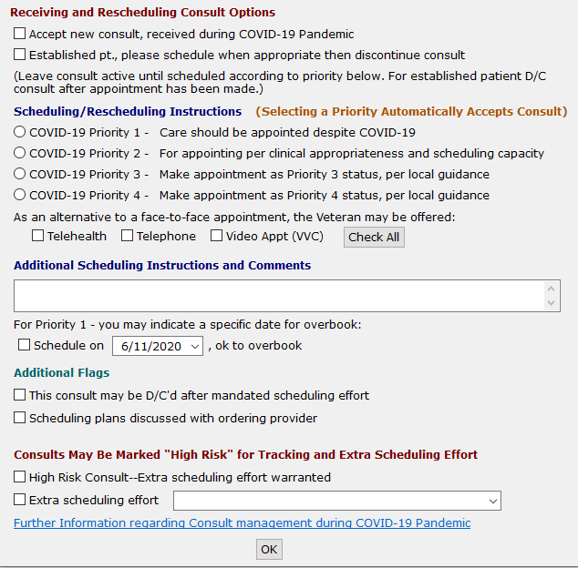
- Accept new consult, received during COVID-19 Pandemic –this selection applies if the reviewing provider has determined that the Veteran’s medical condition warrants them being seen during the COVID-19 Pandemic.
- Established pt., please schedule when appropriate then discontinue consult - this selection applies if a consult is received for an established patient. Once the consult is received, it is sent to the scheduler to make the appointment. Once the appointment is made, the consult can be discontinued.
- Scheduling / Rescheduling Instructions (Selecting a Priority Automatically Accepts Consult) – when receiving or reviewing a consult, a scheduling priority can be indicated.
- COVID-19 Priority 1 – Care should be appointed despite COVID-19 - do not wait until normal operations, schedule appointment now.
- COVID-19 Priority 2 – For appointing per clinical appropriateness and scheduling capacity - first group to schedule when normal operations begin. Community Care consults should also be scheduled based on local market availability.
- COVID-19 Priority 3 - Make appointment as Priority 3 status, per local guidance - optional, but a way to separate less urgent consults from the Priority 2. Your department can define criteria how to separate 2 from 3.
- COVID-19 Priority 4 - Make appointment as Priority 4 status, per local guidance - optional, a way to separate non-urgent consults from the Priority 3. Again, you can define which ones belong to this category or if you use it at all.
- As an alternative to a face-to-face appointment, the Veteran may be offered:
- Telehealth - Telehealth Appointment may be offered to the Veteran.
- Telephone - Telephone Appointment may be offered to the Veteran.
- Video Appt (VVC)- VA Video Connect (VVC) appointment may be offered to the Veteran.
- Check All – Selects all three options.
- Additional Scheduling Instruction and Comments
- For Priority 1 – you may indicate a specific date for overbook:
- Schedule on MM/DD/YYYY, ok to overbook - Accept consult see scheduling order for scheduling instructions—this selection applies if the clinic or service provider prefers to convey scheduling instructions via a CPRS order.
- Additional Flags
- This consult may be D/C’d after mandated scheduling effort—this option allows the reviewing provider to determine at the time of acceptance that if the staff is unable to get the appointment scheduled, or if the Veteran cancels or no-shows twice, then the consult can be discontinued by the scheduler without having another clinical review. The consult is returned to the ordering provider to take whatever action deemed appropriate.
The This consult may be discontinued d/c’d after 1 missed appointment (approved low risk clinic) check box described below is only visable when enabled in the Consult Toolbox Settings.
- This consult may be D/C’d after 1 missed appointment (approved low risk clinic)- – An additional option for low risk clinics exists for discontinuation after one missed appointment. This screen auto populates from settings described above.
- Scheduling plans discussed with ordering provider
- Consults May Be Marked “High Risk” for Tracking and Extra Scheduling Effort
- High Risk Consult—Extra scheduling effort warranted – this will flag this consult as having a medically high-risk condition that warrants additional calls to the Veteran beyond the mandated minimum necessary effort. It also allows the receiving service to flag certain consults for closer follow up when the Veteran fails to keep appointments. Each service may define what high risk means to them. This is simply a way of segregating higher risk consults from the rest and notifying the staff to expend additional effort.
- Extra scheduling effort – allows the reviewer to specify what additional effort they would like. In addition to the selection of options, the user may type in other instructions.
Figure 193: Extra Scheduling Effort Options
To receive or schedule a consult during the COVID-19 Pandemic, follow the steps listed below:
- From the Action menu, select Consult Tracking…, and then select Receive. The Receive Consult dialog box opens.
Figure 194: Receive Consult Dialog Box
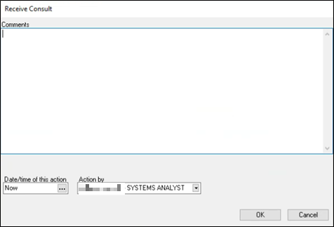
- In the Comments field, right-click to display the Receive menu.
Figure 195: Receive Menu
- From the Receive menu, select Receive Consult. The Receiving and Rescheduling Consult Options window opens.
Figure 196: Receiving and Rescheduling Consult Options Window
- Select the Accept new consult, received during COVID-19 Pandemic check box to accept consults.
- If the Veteran is an established patient, then select the Established pt., please schedule when appropriate then discontinue consult check box.
- From the Scheduling / Rescheduling Instructions section, select the appropriate COVID-19 priority.
- From the As an alternative to a face-to-face appointment, the Veteran may be offered: section, select if the Veteran may attend the appointment via Telehealth, Telephone, Video Appt, or select Check All for all three options.
- In the Additional Scheduling Instruction and Comments text box, enter additional information if needed.
- From the For Priority 1 – you may indicate a specific date for overbook: section, select the Schedule check box and enter/select a specific date.
- From the Additional Flags section, select the check box if the consult may be discontinued after mandated scheduling effort. If the consult can be discontinued, select the check box if the consult may be discontinued after one missed appointment.
Low risk clinics must have approval from the facility to use the one missed appointment option.
- If the scheduling plans has been discussed with the ordering provider, select the Scheduling plans discussed with ordering provider check box.
- If the consult is high risk and needs to be tracked and extra scheduling efforts, select the High Risk Consult—Extra scheduling effort warranted check box from the Consults May Be Marked “High Risk” for Tracking and Extra Scheduling Effort section.
- If the consult is high risk, from the Extra scheduling effort drop-down menu select the option to specify what additional effort you would like.
- Click OK.

Appendix A1.3: Receive Community Care Functions: COVID-19 Priority
This section replaces section 4.1 Receiving Consult Activities when the Enable COVID-19 workflow for Receive Consult and Clinical Review options check box is selected under the Other User Settings Tab.
Figure 197: Receive Community Care Functions: COVID-19 Priority Tab
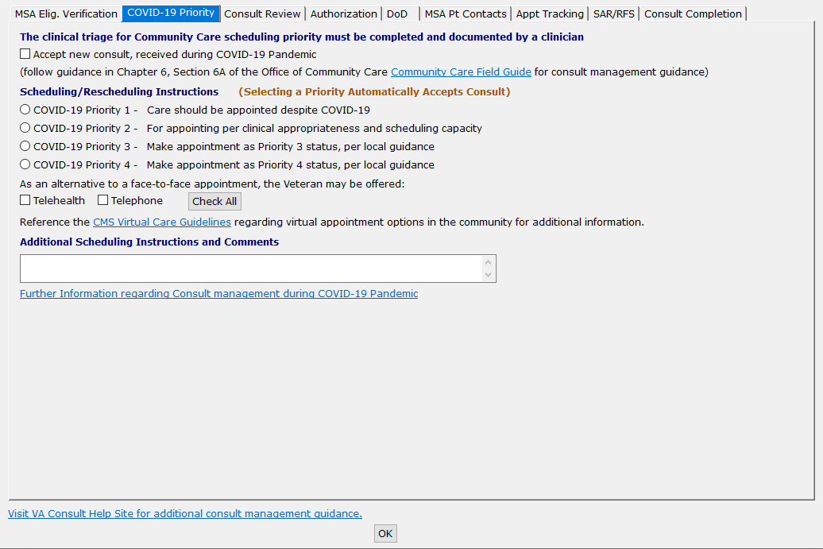
- The clinical triage for Community Care scheduling priority must be completed and documented by a clinician
- Accept new consult, received during COVID-19 Pandemic - this selection applies if the reviewing provider has determined that the Veteran’s medical condition warrants them being seen during the COVID-19 Pandemic.
- Scheduling / Rescheduling Instructions (Selecting a Priority Automatically Accepts Consult)
- COVID-19 Priority 1 – Care should be appointed despite COVID-19 - do not wait until normal operations, schedule appointment now.
- COVID-19 Priority 2 – For appointing per clinical appropriateness and scheduling capacity - first group to schedule when normal operations begin. Community Care consults should also be scheduled based on local market availability.
- COVID-19 Priority 3 - Make appointment as Priority 3 status, per local guidance - optional, but a way to separate less urgent consults from the Priority 2. Your department can define criteria how to separate 2 from 3.
- COVID-19 Priority 4 - Make appointment as Priority 4 status, per local guidance - optional, a way to separate non-urgent consults from the Priority 3. Again, you can define which ones belong to this category or if you use it at all.
- As an alternative to a face-to-face appointment, the Veteran may be offered:
- Telehealth - Telehealth Appointment may be offered to the Veteran.
- Telephone - Telephone Appointment may be offered to the Veteran.
- Check All – Selects both options.
- Additional Scheduling Instruction and Comments
To set the Community Care COVID-19 Priority options, follow the steps listed below:
The clinical triage for Community Care scheduling priority must be completed and documented by a clinician/Delegation of Authority (DOA).
- From the Action menu, select Consult Tracking…, and then select Receive. The Receive Consult dialog box opens.
Figure 198: Receive Consult Dialog Box
- In the Comments field, right-click to display the Receive menu.
Figure 199: Receive Menu
- From the Receive menu, select Community Care Functions. The Community Care Functions window opens with the MSA Elig. Verification tab displayed.
- Select the COVID-19 Priority tab.
Figure 200: COVID-19 Priority Tab
- Select the Accept new consult, received during COVID-19 Pandemic check box to accept consults.
- From the Scheduling / Rescheduling Instructions section, select the appropriate COVID-19 priority.
- From the As an alternative to a face-to-face appointment, the Veteran may be offered: section, select if the Veteran may attend the appointment via Telehealth, Telephone, or Check All for both options.
- In the Additional Scheduling Instruction and Comments text box, enter additional information if needed.
- Click OK.

Appendix A2: Setting Clinical Review Options when COVID-19 Workflow is Enabled
Provider functions allow providers reviewing records to document the results of their review or other actions that need to be documented.
When the COVID-19 workflow is enabled, the Receiving and Rescheduling Consult Options window is accessible from the Clinical Review Options and the COVID-19 Priority tab is accessible from the Community Care functions. These windows provide the ability to prioritize consults due to the COVID-19 Pandemic.

Appendix A2.1: VA Clinical Referrals
This section replaces section 4.1 Receiving Consult Activities when the Enable COVID-19 workflow for Receive Consult and Clinical Review options check box is selected under the Other User Settings Tab.
Figure 201: Receiving and Rescheduling Consult Options Window: VA Clinic Referrals Tab
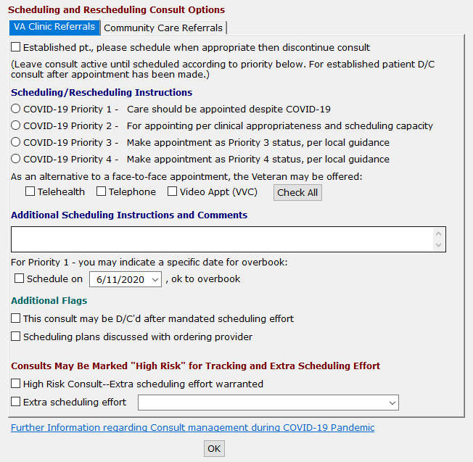
- Established pt., please schedule when appropriate then discontinue consult - this selection applies if a consult is received for an established patient. Once the consult is received, it is sent to the scheduler to make the appointment. Once the appointment is made, the consult can be discontinued.
- Scheduling / Rescheduling Instructions (Selecting a Priority Automatically Accepts Consult) – when receiving or reviewing a consult, a scheduling priority can be indicated.
- COVID-19 Priority 1 – Care should be appointed despite COVID-19 - do not wait until normal operations, schedule appointment now.
- COVID-19 Priority 2 – For appointing per clinical appropriateness and scheduling capacity - first group to schedule when normal operations begin. Community Care consults should also be scheduled based on local market availability.
- COVID-19 Priority 3 - Make appointment as Priority 3 status, per local guidance - optional, but a way to separate less urgent consults from the Priority 2. Your department can define criteria how to separate 2 from 3.
- COVID-19 Priority 4 - Make appointment as Priority 4 status, per local guidance - optional, a way to separate non-urgent consults from the Priority 3. Again, you can define which ones belong to this category or if you use it at all.
- As an alternative to a face-to-face appointment, the Veteran may be offered:
- Telehealth - Telehealth Appointment may be offered to the Veteran.
- Telephone - Telephone Appointment may be offered to the Veteran.
- Video Appt (VVC)- VA Video Connect appointment may be offered to the Veteran.
- Check All – Selects all three options.
- Additional Scheduling Instruction and Comments
- For Priority 1 – you may indicate a specific date for overbook:
- Schedule on MM/DD/YYYY, ok to overbook - Accept consult see scheduling order for scheduling instructions—this selection applies if the clinic or service provider prefers to convey scheduling instructions via a CPRS order.
- Additional Flags
- This consult may be D/C’d after mandated scheduling effort—this option allows the reviewing provider to determine at the time of acceptance that if the staff is unable to get the appointment scheduled, or if the Veteran cancels or no-shows twice, then the consult can be discontinued by the scheduler without having another clinical review. The consult is returned to the ordering provider to take whatever action deemed appropriate.
- Scheduling plans discussed with ordering provider
- Consults May Be Marked “High Risk” for Tracking and Extra Scheduling Effort
- High Risk Consult—Extra scheduling effort warranted – this will flag this consult as having a medically high-risk condition that warrants additional calls to the Veteran beyond the mandated minimum necessary effort. It also allows the receiving service to flag certain consults for closer follow up when the Veteran fails to keep appointments. Each service may define what high risk means to them. This is simply a way of segregating higher risk consults from the rest and notifying the staff to expend additional effort.
- Extra scheduling effort – allows the reviewer to specify what additional effort they would like. In addition to the selection of options, the user may type in other instructions.
Figure 202: Extra Scheduling Effort Options
To add a comment to a consult to provide scheduling guidance during the COVID-19 Pandemic, follow the steps listed below:
- From the Action menu, select Consult Tracking…, and then select Add Comment. The Add Comment to Consult dialog box displays.
Figure 203: Add Comment to Consult Dialog Box
- In the Comments field, right-click to display the Community Care menu.
Figure 204: Community Care Menu
- From the Community Care menu, select Clinical Review Options. The Receiving and Rescheduling Consult Options window opens.
- Select the VA Clinic Referrals tab.
Figure 205: VA Clinic Referrals Tab
- If the Veteran is an established patient, then select the Established pt., please schedule when appropriate then discontinue consult check box.
- From the Scheduling / Rescheduling Instructions section, select the appropriate COVID-19 priority.
- From the As an alternative to a face-to-face appointment, the Veteran may be offered: section, select if the Veteran may attend the appointment via Telehealth, Telephone, Video Appt (VVC), or Check All for all three options.
- In the Additional Scheduling Instruction and Comments text box, enter additional information if needed.
- From the For Priority 1 – you may indicate a specific date for overbook: section, select the Schedule check box and enter/select a specific date.
- From the Additional Flags section, select the check box if the consult may be discontinued after mandated scheduling effort. If the consult can be discontinued, select the checkbox if the consult may be discontinued after one missed appointment.
Low risk clinics must have approval from the facility to use the one missed appointment option.
- If the scheduling plans has been discussed with the ordering provider, select the Scheduling plans discussed with ordering provider check box.
- If the consult is high risk and needs to be tracked and extra scheduling efforts, select the High Risk Consult—Extra scheduling effort warranted check box from the Consults May Be Marked “High Risk” for Tracking and Extra Scheduling Effort section.
- If the consult is high risk, from the Extra scheduling effort drop-down menu select the option to specify what additional effort you would like.
- Click OK.

Appendix A2.2: Community Care Referrals
This section replaces section 4.1 Receiving Consult Activities when the Enable COVID-19 workflow for Receive Consult and Clinical Review options check box is selected under the Other User Settings Tab.
Figure 206: Receiving and Rescheduling Consult Options: Community Care Referrals Tab
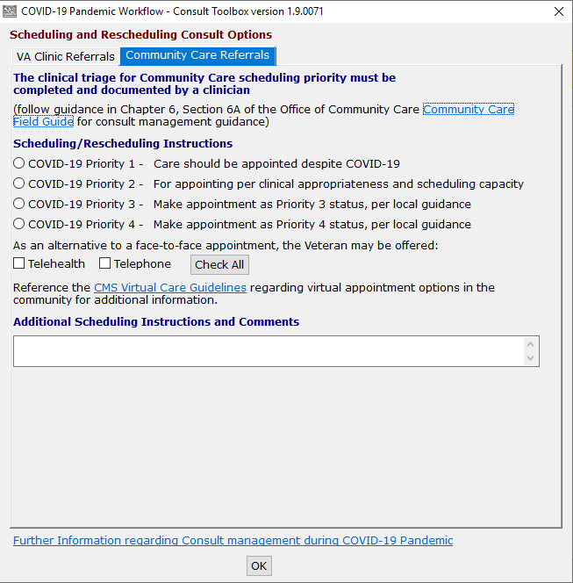
- The clinical triage for Community Care scheduling priority must be completed and documented by a clinician/DOA
- Scheduling / Rescheduling Instructions (Selecting a Priority Automatically Accepts Consult)
- COVID-19 Priority 1 – Care should be appointed despite COVID-19 - do not wait until normal operations, schedule appointment now.
- COVID-19 Priority 2 – For appointing per clinical appropriateness and scheduling capacity - first group to schedule when normal operations begin. Community Care consults should also be scheduled based on local market availability.
- COVID-19 Priority 3 - Make appointment as Priority 3 status, per local guidance - optional, but a way to separate less urgent consults from the Priority 2. Your department can define criteria how to separate 2 from 3.
- COVID-19 Priority 4 - Make appointment as Priority 4 status, per local guidance - optional, a way to separate non-urgent consults from the Priority 3. Again, you can define which ones belong to this category or if you use it at all.
- As an alternative to a face-to-face appointment, the Veteran may be offered:
- Telehealth - Telehealth Appointment may be offered to the Veteran.
- Telephone - Telephone Appointment may be offered to the Veteran.
- Check All – Selects both options.
- Additional Scheduling Instruction and Comments
To add a comment to a consult to provide scheduling guidance during the COVID-19 Pandemic, follow the steps listed below:
The clinical triage for Community Care scheduling priority must be completed and documented by a clinician/DOA.
- From the Action menu, select Consult Tracking…, and then select Add Comment. The Add Comment to Consult dialog box displays.
Figure 207: Add Comment to Consult Dialog Box
- In the Comments field, right-click to display the Community Care menu.
Figure 208: Community Care Menu
- From the Community Care menu, select Clinical Review Options. The Receiving and Rescheduling Consult Options window opens.
- Select the Community Care Referrals tab.
Figure 209: Community Care Referrals Tab
- From the Scheduling / Rescheduling Instructions section, select the appropriate COVID-19 priority.
- From the As an alternative to a face-to-face appointment, the Veteran may be offered: section, select if the Veteran may attend the appointment via Telehealth, Telephone, or Check All for both options.
- In the Additional Scheduling Instruction and Comments text box, enter additional information if needed.
- Click OK.

Appendix A2.3: Add Comment Community Care Functions: COVID-19 Priority
This section replaces section 4.1 Receiving Consult Activities when the Enable COVID-19 workflow for Receive Consult and Clinical Review options check box is selected under the Other User Settings Tab.
Figure 210: Add Comment Community Care Functions: COVID-19 Priority Tab
- The clinical triage for Community Care scheduling priority must be completed and documented by a clinician/DOA
- Scheduling / Rescheduling Instructions (Selecting a Priority Automatically Accepts Consult)
- COVID-19 Priority 1 – Care should be appointed despite COVID-19 - do not wait until normal operations, schedule appointment now.
- COVID-19 Priority 2 – For appointing per clinical appropriateness and scheduling capacity - first group to schedule when normal operations begin. Community Care consults should also be scheduled based on local market availability.
- COVID-19 Priority 3 - Make appointment as Priority 3 status, per local guidance - optional, but a way to separate less urgent consults from the Priority 2. Your department can define criteria how to separate 2 from 3.
- COVID-19 Priority 4 - Make appointment as Priority 4 status, per local guidance - optional, a way to separate non-urgent consults from the Priority 3. Again, you can define which ones belong to this category or if you use it at all.
- As an alternative to a face-to-face appointment, the Veteran may be offered:
- Telehealth - Telehealth Appointment may be offered to the Veteran.
- Telephone - Telephone Appointment may be offered to the Veteran.
- Check All – Selects both options.
- Additional Scheduling Instruction and Comments
To set the Community Care COVID-19 Priority options during the COVID-19 Pandemic, follow the steps listed below:
The clinical triage for Community Care scheduling priority must be completed and documented by a clinician/Delegation of Authority (DOA).
- From the Action menu, select Consult Tracking…, and then select Add Comment. The Add Comment to Consult dialog box displays.
Figure 211: Add Comment to Consult Dialog Box
- In the Comments field, right-click to display the Community Care menu.
Figure 212: Community Care Menu
- From the Community Care menu, select Community Care Functions. The Community Care Functions window opens with the MSA Elig. Verification tab displayed.
- Select the COVID-19 Priority tab.
Figure 213: COVID-19 Priority Tab
- From the Scheduling / Rescheduling Instructions section, select the appropriate COVID-19 priority.
- From the As an alternative to a face-to-face appointment, the Veteran may be offered: section, select if the Veteran may attend the appointment via Telehealth, Telephone, or Check All for both options.
- In the Additional Scheduling Instruction and Comments text box, enter additional information if needed.
- Click OK.

Appendix B: Consult Factor Types and Definitions
Consult Factor Type | Consult Factor Text
A1- | Accept consult, schedule within 1 week, (OK to overbook).
A1M | Accept consult, schedule within 1 month (OK to overbook).
A2- | Accept consult, schedule within 2 weeks, (OK to overbook).
AAR | Approved as Requested (SAR)
AB- | Address bad or no address on file, unable to send letter.
AC- | Accept consult, schedule routine appointment.
ACC | Admin Screening Care Coordination
ACF | Community care approved under Choice First.
ACN | Administratively closed without records
ADT | Accept Consult, schedule on specific date, ok to overbook
AEV | Administrative Eligibility verified.
AFD | AFD-DST Forward To: servicename
AFU | AFU-Total Authorized Units/Visits:
ALR | Alert Sent to: nameofperson
ANV | Community care approved under NVCC.
AOK | Mailing Address Confirmed
APP | DoD Consult Approved
AS- | Accept consult, see scheduling order for scheduling instructions.
C1- | First call to veteran, unable to schedule.
C1C | Comm Care First Call to Veteran
C2- | Second call to veteran, unable to schedule.
C2C | Comm Care Second Call to Veteran
C3- | Third or subsequent call to Veteran(unsuccessful scheduling)
C3- | Third or additional call to veteran, unable to schedule.
C3C | Comm Care Third or subseq. Call to Veteran
CA- | Clinically Appropriate to wait for the scheduled appointment.
CAD | Vista cancellation for Administrative reason
CAN | Administratively closed without records
CAP | Community care approved for specified program.
CAP | Community care approved for specified program.
CAT | CAT-SEOC CoC:
CB- | Patient contacted but pt will call back to schedule later.
CBD | CBD-Care authorization expires on
CCA | A community care appt has been scheduled.
CCC | Community Care Cancelled by Patient
CCD | Community Care Appointment Date:
CCE | CC Eligibility Status:
CCH | Community Care Appt Scheduling to be handled by:
CCL | Vista Cancelled by Clinic
CCM | Care Coordination was manually Set
CCO | Care Coordination Time Spent:
CCP | Community Care Cancelled by Clinic
CCR | Community Care Provider:
CCR | Community Care Provider:
CCS | Community Care Appointment has been Scheduled
CEV | Choice Eligibility Verified.
CEV | Choice Eligibility Verified.
CHD | Contractor Not Used: Community Provider declines Choice Network participation.
CHD | CHD-Community Provider declines Choice Network participation
CHN | Network Provider not accepting Choice patients
CHN | Contractor Not Used: Network Provider not accepting Choice, patients.
CHU | Contractor Not Used: Choice Provider unable to schedule within CID (Urgency)
CHU | Choice Provider unable to schedule within CID (Urgency)
CHV | Veteran declined appointment due to date/time/distance
CHV | Contractor Not Used: Veteran declined appointment due to date/time/distance.
CID | Prior CID=FactorData after Edit/Resubmit
CLA | Admin Screening Care Coordination:
CLC | Clinical Triage Care Coordination:
CLV | Care Coordination Level
CMP | Completed Consult
CNC | Consult Cancelled
CNS | Community Care Veteran No Show for Appt
COC | Community care appointment occurred, per patient (awaiting confirmation).
COI | Veteran OPT-IN for choice.
COO | Veteran OPT-OUT for choice.
COR | Community care appointment occurred, records received.
COT | Community care appointment occurred, per TPA portal, awaiting records.
CP1 | Cancelled by patient, first missed appointment.
CP2 | Cancelled by patient, second missed appointment.
CPP | Consult ready for CPP Referral
CPT | Vista Cancelled by Patient
CSC | CSC-Consult stop code
CSN | CSN-Clinical Service:
CST | CST-Consult service type:
CTC | Clinical Triage: Complete
CTN | Clinical Triage: Not Required
CTR | Clinical Triage: Required
CU- | Patient states that they have an appointment scheduled through the Veterans Choice program, however there is no documentation to this effect in the consult.
CVA | Accept new consult, received during COVID-19 Pandemic
CV1 | COVID-19 Priority 1. Schedule appointment despite COVID-19 restrictions.
CV2 | COVID-19 Priority 2. For appointing per clinical appropriateness and scheduling capacity.
CV3 | COVID-19 Priority 3. Make appointment as Priority 3 status, per local guidance
CV4 | COVID-19 Priority 4. Make appointment as Priority 4 status, per local guidance
DAF | DAF-DST Forwarding: Yes/No
DCA | DCA-DST CC Best Interest of Vet:
DCB | DST CC Best Interest of Vet:
DCC | DST CC eligibility: No clinic appts available
DCD | DST CC eligibility: DRIVE TIME
DCF | DST CC Best Interest of Vet:
DCG | DCG-DST CC eligibility: GRANDFATHERED
DCH | DST CC eligibility: HARDSHIP
DCI | DST CC Best Interest of Vet:
DCO | DCO-DST CC Best Interest of Vet:
DCP | DoD Consult Present
DCQ | DST CC Best Interest of Vet:
DCS | If no apt within 30 days Discuss with clinical staff
DCT | DST CC Best Interest of Vet:
DCV | DST CC eligibility: NO FULL-SVC VHA FACILITY
DCX | DST Service not offered within search radius
DCY | DST IFC agreement not available
DDO | DoD Date of Svc Outside of Approved EOC
DEC | Patient declines/refuses-does not want appointment. Please submit new consult if patient agrees to care.
DIS | Disapprove Reason
DLA | Delegation of Auth.: Administrative
DLC | Delegation of Auth.: Clinical
DNC | Non DoD consult present
DNF | DST No VHA facilities within search radius
DNP | DoD Consult Not Present
DNY | Request for community care is disapproved.
DOK | OK to leave appt. details with
DP | Scheduling plans discussed with ordering provider.
DSC | Discontinued Consult
DSF | Documents sent via fax to community care provider.
DSO | Disassociate Report
DSP | DSP-DST data saved prior to signing consult
DST | DST-DST ID:
DTE | DTE-Veteran's Day/Date Preference:
DU- | Document Uploaded to TPA Portal.
DUP | Duplicate Request.
DVE | DVE-DST Vista Error
E90 | No appointment within 90 days
EDC | Established patient, follow-up appointment has been scheduled.
EEF | Extra Scheduling Effort requested
ENV | Environmental factors:
ERS | Edit/Resubmit
EST | Established patient, please schedule appt. then DC consult.
EWL | On EWL or awaiting CHOICE. Pt added to Electronic Wait List, no available appt w/in 90 days.
EXP | Patient has expired.
FDX | FDX-Veteran has an active Third Party Release on file.
FSE | Failed mandated scheduling effort (multiple missed/cancelled appts. or patient did not respond to mandated scheduling effort). Consult discontinued, per VA consult management policy. Please submit a new request if care is still desired and patient agrees to receiving care.
FUV | Follow up call made to provider/vendor to check on status.
FWD | FORWARDED FROM
FWR | FWD TO REMOTE SERVICE
G30 | Appointment is greater than 30 days from PID
GEO | Geographical challenges:
GVM | Guideline Method used for approval
HEC | Presumed eligible, HEC Update Pending.
HR- | High risk consult, please continue to attempt scheduling even after mandatory scheduling effort.
HSR | Consult ready for HSRM Referral
ICR | ICR-Initiate Community Care Referral
INC | INCOMPLETE RPT
INF | Veteran informed of eligibility, referral and approval.
L1- | L1-Unable to schedule letter sent by mail to Veteran.
L1- | Letter sent to patient.
L1C | Community Care unable to contact letter sent by Mail.
LC- | Certified letter sent to patient regarding scheduling.
LCC | Community Care unable to contact letter sent by Certified Mail.
LDT | Shortest average drive time (min):
LM- | Left message on voice mail.
LMF | Left message with family member.
MA3 | Third or more missed appointments.
MAT | Approval for maternity care
ME | May discontinue if Veteran cancels/no-shows once or fails to respond to mandated scheduling effort.
MED | Medical condition:
MFU | Follow up call made to veteran while on wait list to confirm wait list status.
MIE | Explanation of BMI - OTHER:
MLS | Willing to travel up to (miles):
MOK | MOK-OK to leave appt. details on voice mail.
MSC | Scheduled but not from VistA
NAA | Next avail clinic appt:
NAE | Not administratively eligible.
NAP | DoD Consult Not Approved
NEL | Patient does not meet eligibility requirements.
NET | No earlier than date:
NLT | No later than date:
NN- | Care is no longer needed.
NNA | NEW NOTE ADDED
NOS | VA facility does not provide the required service
NR- | No records received after three attempts.
NS1 | No Show, first missed appointment.
NS2 | No Show, second missed appointment.
NSH | Vista Patient was a No-Show
NVA | The care will be provided through a Community Care Consult.
NVD | Non-VA Care disapproved.
NVD | Community Care disapproved.
NVN | Community Care not needed, care provided by VA appointment.
NVN | Non-VA care not needed, care provided by VA appointment.
NXC | Not eligible for Choice.
OCC | Ok to send to Community Care if no apt within 30 days
ODC | Other discontinuation reason:
OTH | Vista cancellation for other reason
OTP | OTP-Veteran OK to see other than Preferred Provider
P30 | Procedure scheduled greater than 30 days from PID
PAC | Provider was contacted for Alternate Plan of Care
PB- | Phone contact number bad/incorrect or disconnected.
PFP | PFP-Veteran's Preferred Provider
PKT | Referral Packet mailed to veteran.
PRA | Community Care Provider has accepted referral
PRC | Procedure(s) Approved for Community Care
PRD | Procedure Requested
PRF | Preferred notification method:
PRQ | Provider requires records to review prior to scheduling.
PSP | Patient's actual Scheduled Provider
PVT | Patient declines/refuses-going to private provider outside VA care.
R1- | First attempt to get records from community care.
R1- | First attempt to get records from community care.
R2- | Second attempt to get records from community care.
R3- | 3rd attempt to get records from community care.
R3- | Third attempt to get records from community care.
R3- | 3rd attempt to get records from community care
RAC | Refer to clinical reviewer for administrative completion.
RCF | RCF-Received 7332 signed ROI Form, ready to schedule.
REC | Receive Consult
REF | Veteran declined/refused-does not want appointment.
REF | Veteran refuses Community Care appointment.
REF | Patient refuses non-VA appointment.
REL | REL-Veteran has a signed ROI for 7332 conditions on file.
RFC | Patient declined/refused community care.
RFV | Referral returned from community care vendor.
ROI | Mailed 7332 ROI Form to enable this referral to proceed.
RP- | Referred to provider for disposition after unsuccessful scheduling effort.
RP- | Referred to provider for disposition after unsuccessful scheduling effort.
RP- | Referred to provider for disposition after unsuccessful scheduling effort.
RR- | Records from community care provider received.
RRH | Records Received via:
S1M | Schedule/reschedule within 1 month, ok to overbook.
S1W | Schedule/reschedule within 1 week, ok to overbook.
S2W | Schedule/reschedule within 2 weeks, ok to overbook.
SAR | Secondary Authorization Request
SCC | This Referral is for a Service Connected Condition.
SCD | Administrative Care Coordination Screening
SCR | Service/Care Approved for Community Care
SDC | Patient still desires care.
SDT | Accept Consult, schedule on specific date, ok to overbook
SDX | SDX-Veteran has dx requiring 7332 ROI.
SEO | Standard Episode of Care
SEV | Specific Eligibility:
SIG | SIG FINDING UPDATE
SIM | Nature or simplicity of service (UEXB):
SOR | Schedule/reschedule-see Scheduling Order for instructions.
SPA | This referral is for Special Authority.
SPC | Specialty Approved for Community Care
SR- | Schedule/reschedule routine appointment.
SRA | SAR Approval Status
SSC | SSC-Veteran prefers to self schedule appointment.
SSC | Veteran prefers to self-schedule appointment.
SSP | Subspecialty Approved for Community Care
SUR | SAR Urgency:
SV- | Spoke with veteran/care giver.
SVC | Services requested.
TCC | Clinical Triage Care Coordination
TCD | Clinical Care Coordination Triage
TEL | Telephone Appointment may be offered to the Veteran
TFR | Timeframe for Episode of Care Approved
THL | Telehealth Appointment may be offered to the Veteran
TIM | TIM-Veteran's Time Preference: Any
TOS | Type of service
UCH | Prior Urgency after Edit/Resubmit
UNV | Unable to Verify Eligibility
URG | Urgency:
US1 | Unable to Schedule: Wants VA care (opts out CC) and is waiting for availability. Care need is not met.
US2 | Unable to Schedule: Service is unique to VA
US3 | Unable to Schedule: Care needs being met in VA while waiting for unique specialized VA service
UXB | Unusual or Excessive travel burden
VCA | Vista cancellation for other reason
VCC | Veteran CC Option:
VCL | On EWL or awaiting CHOICE. Pt added to VCL.
VCL | Veteran placed on VCL
VDS | Returned Referral Disposition
VPP | VPP-Receipt Package Preference:
VSC | Vista Scheduled Appointment
VST | %Sar Request Sent to VISTA Imaging%
VTC | VTC-Veteran contacted Community Care.
VVC | VVC Appointment may be offered to the Veteran
WHO | This consult was discussed with and handed off to
XXC | Some other status change reason

