Care Management
Care Management within the HealtheVet Desktop Clinician Dashboard
Nurse Dashboard Sign List Query Tool

User Manual
Version 1.8

July 2016

Department of Veterans Affairs Office of Information and Technology (OIT) Enterprise Program Management Office (EPMO)

Revision History

Date | Patch | Page | Change | Project Manager | Technical Writer
6/16 | ORRC*1*8 | 1,4,5,35 | Added errors encountered during installation and instructions how to change shortcut icon. Applied recommended changes on CM/JRE installation process. Updated Java Baseline version to 1.8. Also applied recommended changes on CM VistA installation procedures. Also revised installation procedures and updated software versions. | REDACTED | REDACTED
5/07 | ORRC*1*7 | 1, 80 | Added information about known issue with disappearing links | REDACTED | REDACTED
5/07 | ORRC*1*7 | 3 | Added information about Dashboard Coexistence option  without Query Tool | REDACTED | REDACTED
4/07 | ORRC*1*7 | 2 | Added information about Dashboard Coexistence | REDACTED | REDACTED
5/07 | ORRC*1*7 | 3, 6 | Added information about Alternate Themes for displaying | REDACTED | REDACTED
3/07 | ORRC*1*7 | 22 | Added Display the Clinician Dashboard | REDACTED | REDACTED
2/07 | ORRC*1*7 | 4, 5 | In the Workstation System Requirements, changed references to JRE1.4.1_12. In the Logging On section, explained JRE error  message. | REDACTED | REDACTED
2/07 | ORRC*1*5 | 19 | Edited description of order acknowledgment options and  menu, per changes in the | REDACTED | REDACTED
5/06 | ORRC*1*3 | 42 | Changed Error! Reference source not found. section to clarify what  causes an icon to appear and how to clear the icon | REDACTED | REDACTED
5/06 | ORRC*1*3 | 43 | Changed Text Orders Column (TxOrd) section to clarify what  causes an icon to appear | REDACTED | REDACTED
5/06 | ORRC*1*3 | 55 | Added sections about Locally Defined Display Groups and How to Add a Local Display Group as a  Member of the Nursing Display | REDACTED | REDACTED
4/05 | ORRC*1*2 | 11 | Added info about new notifications features | REDACTED | REDACTED

Date | Patch | Page | Change | Project Manager | Technical Writer
4/05 | ORRC*1*2 | 28, 45,  69 | Added info about new Go-to- Chart link | REDACTED | REDACTED
4/05 | ORRC*1*2 | 4 | Added info about new user- context support, which provides  simplified sign-on functionality | REDACTED | REDACTED
4/05 | ORRC*1*2 | 29, 44,  69 | Added info about changes to patient record flags | REDACTED | REDACTED
4/05 | ORRC*1*2 | 24 | Added info about changes to  headlights in the Clinician Dashboard Sign column | REDACTED | REDACTED
4/05 | ORRC*1*2 | 21, 37 | Added info about changes to hover hints | REDACTED | REDACTED

Table of Contents

- Care Management Overview 1
Workstation System Requirements 4
Logging On 4
Selecting a Default Perspective 5
Select a Theme 6
- Alert Notifications 7
Alert Notifications in CPRS and Care Management 7
Alert Notifications in CPRS and the Care Management Clinician Dashboard 7
Alert Notifications in CPRS and the Care Management Nurse Dashboard 11
- Order Acknowledgement Inquiry 17
Clinician Dashboard 19
Display the Clinician Dashboard 20
Viewing Details of an Item on the Clinician Dashboard 20
Criteria Used to Determine if a Patient is Listed on Your Clinician Dashboard 21
Dynamic Patient List 21
CPRS Default Patient List 22
Creating a Custom Patient List 22
Viewing Patient Demographic Information 26
Viewing Patient Record Flags 27
Result Column 27
Acknowledging a Result 28
Task Column 29
Criteria for Displaying Tasks on the Clinician Dashboard 30
Event Column 31
Sign Column 31
Adding an Item to Your Signature List 36
Signing Items on your Signature List 36
Working with Tasks 36
Opening the CPRS Patient Chart from the Clinician Dashboard 36
Refreshing the Clinician Dashboard 36
- Nurse Dashboard 37
Displaying the Nurse Dashboard 38
Criteria Used to Determine if an Icon Appears for a Patient Listed on Your Nurse Dashboard 38
Setting the Nurse Dashboard Date Ranges 38
The CPRS Default List 40
Creating a Custom Patient List 40
Viewing Details of an Item on the Nurse Dashboard 43
Viewing Patient Demographic Information 43
Viewing Patient Record Flags 44
Result Column 45
Acknowledging a Result 45
Task Column 46
Viewing Future Tasks on the Nurse Dashboard 46
Event Column 48
Unverified Orders (UnVer) Column 49
Text Orders Column (TxOrd) 49
- Sign List 53
Signing Items on Your Signature List 53
- Task Editor 55
Creating a New Task 55
Completing a Task 56
Editing a Task 57
- Query Tool 59
Types of Reports 59
Selecting a Report 60
Defining the Patient Lists to Search 61
Locally Defined Display Groups 61
How to Add a Local Display Group as a Member of the Nursing Display Group 61
Defining the Patient Lists to Search 62
Editing the Criteria in a Predefined Report 64
Additional Steps for Custom Reports 66
Selecting the Items to Include in the Report 66
Selecting the Date Range for the Selected Items 66
Filtering the Selected Patient Lists 67
Including Patients Who Had an Inpatient, Outpatient, or Pharmacy Visit to any Clinic During a Specific Date Range 68
Including Patients who had an Inpatient, Outpatient, or Pharmacy Visit to a Specific Clinic 69
Including Patients with a Specific Primary Outpatient Provider 70
Moving to the Next Pane 70
Choosing the Fields that Appear on the Report 71
Naming the Report 72
Displaying the Report 73
Viewing Patient Record Flags 74
Opening the CPRS Patient Chart from a Query Tool Report 75
Printing the Report 75
Exporting the Report 76
Editing a Report 76
Saving a Report with a Different Name 76
Deleting a Custom Report 77
Renaming a Custom Report 77
Stopping a Query or Report in Progress 77
- Keyboard Shortcuts 79
Appendix A: Known Issue – Disappearing links 81

1 Care Management Overview
The Care Management project was initiated because VA healthcare professionals needed an application that could display order and result information for a relevant panel of patients. The four applications (known as “perspectives”) that comprise Care Management—Clinician Dashboard, Nurse Dashboard, Sign List, and Query Tool—provide a complement to, rather than a replacement for, the single-patient view offered by the Computerized Patient Record System (CPRS).

Key features:
  - An intuitive graphical user interface (GUI)
  - Pre-defined and custom patient lists to provide an at-a-glance view of multiple patients who have items that require attention
  - Editable, linkable tasks to help track important follow-up items
  - A multi-patient, multi-item sign list to reduce administrative time
  - Color-coded icons to indicate the status of items that require attention
  - Flexible, pre-defined and custom reports to extract the most current data available for a variety of criteria

Patch ORRC*1*8
  - This patch enhances the functionality of the Care Management application by supporting the co- existence of the Clinician and the Nursing Dashboard, which allows users to work in both Dashboards at the same time
  - The patch also makes sure that the Care Management application launches with JRE 8 (32 bit) or greater.
  - In support of Section 508 Standards, Subpart B, 1194.21, paragraph (i), a theme choice for users with limited color perception is included in this patch, along with several other fixes to enhance the 508 compliance of the Care Management application.

KNOWN ISSUE: After you click a link, sometimes the link text disappears (becomes “whited-out”), and a dotted box is displayed. You can still click on the box to invoke the link. Also you may click in the pane that contains the link to restore the text.
See the Appendix for further information.

Care Management Perspectives

Clinician Dashboard
The Clinician Dashboard provides clinicians with an easy-to-read table that lists patients who have items that need attention. The table allows clinicians to quickly and easily view healthcare information. For example, you can use the Clinician Dashboard to quickly determine which patients have order results that should be reviewed or acknowledged, or documents that need to be signed.

Nurse Dashboard
The Nurse Dashboard provides nurses with an easy-to-read table that lists patients who have items that require a nurse’s attention. For example, you can use the Nurse Dashboard to quickly determine which patients have orders that need to be verified. The Nurse dashboard also displays patients’ vitals.

Query Tool
The Query Tool allows you to create reports based on patient data. You can use the five predefined reports (Abnormal Results, Consult Status, Incomplete Orders, Recent Activity, and Scheduled/Due Activity) or you can create a custom report.

Sign List
The Sign List allows you to sign multiple items for multiple patients. For example, using the Sign List you could sign a discharge summary for John Smith and notes for Jane Smith simultaneously. The types of items that appear on your Sign List depend on which dashboard you are using. Items that appear on the Sign List for the Clinician Dashboard include unsigned and uncosigned clinical documents. Items that appear on the Sign List for the Nurse Dashboard include unverified orders and completed text orders.
Note: The Clinical Application Coordinator (CAC) at your site assigns access to HealtheVet Desktop perspectives. You may not have access to all of the perspectives listed above.

Dashboard Coexistence

Dashboard coexistence, which is introduced in Patch 7, allows certain users to switch between the Nurse Dashboard and Clinician Dashboard without shutting down the application. This new feature enables dual use for hybrid users such as Nurse Practitioners, Nurses who work inpatient and outpatient settings, Advance Practice Nurses, Case Managers, or Clinical Educators/Trainers, etc., without requiring the use of two accounts or having to switch the perspective assignment in VistA.

The coexistence users must have the appropriate settings in VistA in order to view both Dashboards. Also, the users are still limited by the keys they hold as to what actions they can take.
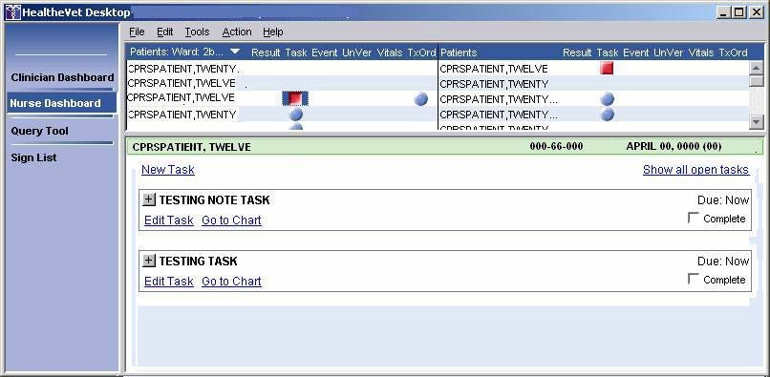

2 Care Management (CM) 1.8
User Manual
July 2016

Dashboard Coexistence without the Query Tool
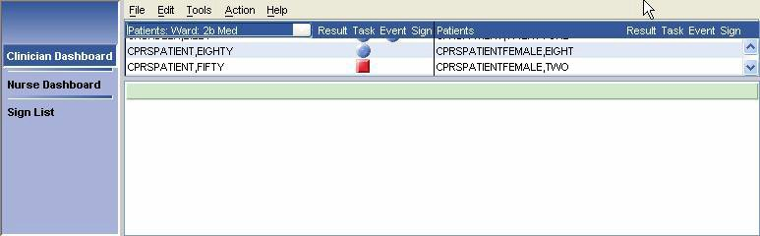
For users who need both nurse and clinician dashboards, but shouldn’t have the Query tool, another option is available.

Task Editor
Care Management also includes a Task Editor, which allows you to create patient-related tasks. The tasks you can create are based on items listed in the Clinician and Nurse Dashboards. For example, using the Task Editor, you could create a task to call a patient based on a lab result indicating an abnormal white blood cell count. Any user can view and act on tasks created in the Task Editor.
Links to different perspectives are located in the perspective selector on the left side of the HealtheVet Desktop. To display a new perspective, simply click the appropriate link. For example, to display the Sign List perspective, click Sign List on the HealtheVet Desktop perspective selector.
The output from the current perspective is displayed in the output (right) pane. The output pane is further divided into an upper pane and a lower pane. The upper pane contains general information, while the lower pane contains detailed information about the items you select in the upper pane.

Alternate Theme
A theme alternative “Current Windows Theme” has been provided for those with limited color perception. The new theme uses high contrast symbols on the dashboard in place of color-coded icons.

The original theme shipped with the application “HealtheVet Desk Top Theme” used color-coded dashboard icons. The user now can choose “Current Windows Theme” which displays data as symbols. This support has been specifically added for those with limited color perception.

The new symbols and meanings
* Critical
X Normal
√ Normal Acknowledged

Applying Alternate Theme

Use Tools->Options->Desktop to select theme

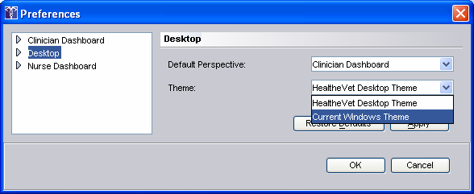

Workstation System Requirements
- Windows 7 or Windows 8 Workstation with Terminal Services
- Workstation hardware should comply with VA Desktop Minimum Acceptable Configurations http://vaww.vairm.vaco.va.gov/VADesktop
- Java SE Runtime Environment version 8 (JRE 8) or greater.

To download JRE version 8 go to link: http://www.oracle.com/technetwork/java/javase/downloads/java-archive-javase8-2177648.html#jre- 8u65-oth-JPR then choose the Java SE Runtime Environment 8 hyperlink (Java SE Runtime Environment 8u65) or greater. Download the product/file description with Windows x86 which is the 32 bit version. You can either choose between the online or offline. (Offline is preferred if you plan to also install on other workstations.)

Note: You must install JRE 8 (32 bit) in the default directory.

Logging On
Care Management is simplified sign-on/user context-enabled (SSO/UC-enabled). If another SSO/UC- enabled VISTA GUI application—such as CPRS GUI version 26—is already running on your workstation, you do not need to log in to Care Management. Simply double-click the launches HealtheVetDesktopLauncher.bat shortcut icon to launch Care Management.
If, on the other hand, another SSO/UC-enabled application is not running on your workstation, you must log in to Care Management.
To log on to Care Management, follow these steps:
- Double-click the HealtheVetDesktopLauncher.bat shortcut icon.
- The HealtheVet splash screen appears. If necessary, HealtheVet Desktop automatically downloads new plug-ins and modules from the HealtheVet server.
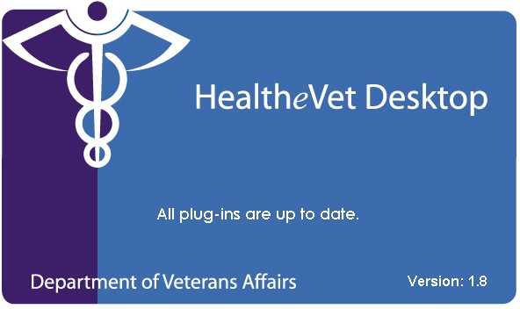

If necessary, HealtheVet Desktop automatically downloads new plug-ins and modules.
Note: Click Cancel to stop downloading new plug-ins and modules.
- When the VistA Sign On dialog box appears, type your access code.
- Type your verify code.
- Click OK. The HealtheVet Desktop appears.

Selecting a Default Perspective
The default perspective is displayed every time you start HealtheVet Desktop.
Your site’s CAC may have already assigned a default perspective for you. If not, you should select a default perspective after you log in for the first time. You may also want to change your current default perspective. For example, you may want to change your default perspective from the Clinician or Nurse Dashboard to the Sign List. You can change your default perspective at any time.
To select (or change) a default perspective, follow these steps:
- On the main menu, select Tools, and then click
Options. The Preferences dialog box appears.
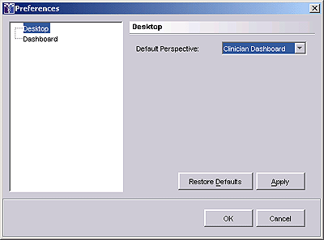
The Preferences dialog box.
- Select Desktop from the pane on the left side of the screen.
- Select a default perspective from the Default Perspective pull-down list.
Note: If you are not authorized to access a particular perspective, you will not be able to set this perspective as your default perspective
- Click OK. The selected perspective is now the default perspective.
Note: If a default perspective is not set, the first perspective in the perspective list will be the default perspective.

July 2016 Care Management (CM) 1.8 5
User Manual

Select a Theme
Users with limited color perception may choose an alternate theme that uses symbols to convey information about headlights instead of color.

Headlight symbols
Symbol | Meaning
* | Critical
X | Normal
Check mark | Normal Acknowledged

To select a theme, follow these steps:

- . On the main menu, select Tools, then click Options. The Preferences dialog box appears.
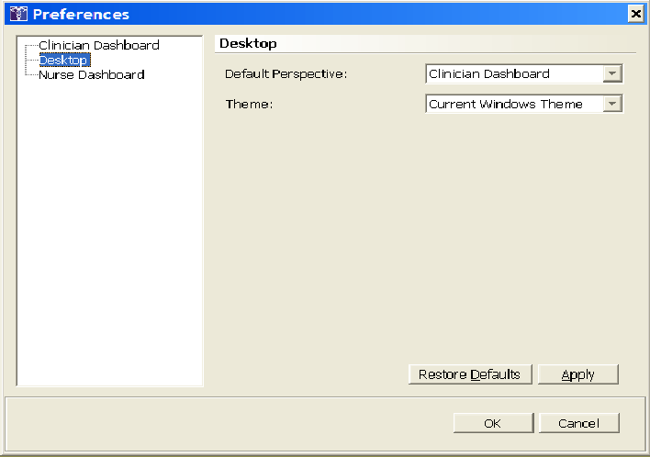

- Click Desktop
- In the Theme box, select the theme

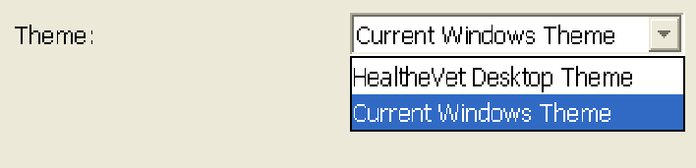

  - To use colored headlights, select HealtheVet Desktop Theme.
  - To use symbol headlights, select Current Windows Theme
.
- Click OK.

Alert Notifications

Alert Notifications in CPRS and Care Management
Care Management uses alert notifications to display headlights in some—but not all—dashboard columns. For example, it does not use alert notifications to display headlights in the Clinician Dashboard Result column, but it does use them to display headlights in the Clinician Dashboard Event column.
However, although Care Management does not use alert notifications to display headlights in the Clinician Dashboard’s Result column, if users acknowledge results in Care Management and the users have alert notifications for these results in CPRS, their actions clear the alert notifications in CPRS.
Actions that users take in Care Management cause CPRS to process alert notifications according to existing CPRS parameter settings. For example, suppose you have set alert notification parameters in CPRS to notify specific users if a patient makes an unscheduled clinic visit. Further, suppose that you have set the ORB DELETE MECHANISM parameter to A (all recipients), which clears the alert notification for everyone after any one of these specified recipients has viewed it. If one of the specified recipients views an alert notification for an unscheduled clinic visit in Care Management, the user’s action causes CPRS to clear this alert notification for all of the specified recipients.
The following tables explain the conditions that cause headlights to appear in the Clinician and Nurse Dashboards, actions that remove the headlights (usually after users refresh or close and then open their dashboard), and the effect these actions have on alert notifications in CPRS.

Alert Notifications in CPRS and the Care Management Clinician Dashboard

CM  Column | What Turns on the CM Headlight? | What Action Turns off the CM Headlight? | For Whom is the CM Headlight Removed? | What Is the Associated CPRS  Alert? | Does The CPRS  Alert Cause the Headlight  to Appear in CM? | What Happens to the CPRS Alert?
Result | The user is the ordering provider  and  the item ordered (lab, radiology, procedure, consult) has a result available for review  and  the order occurred after the date specified in  the ORRC | Acknowledge | Removed for ordering provider | Imaging Results  Abnormal Imaging Results  Imaging Patient Examined  Imaging Results Amended  Lab Results  Abnormal Lab Result (Info)  Abnormal Lab Results (Action) | No No  No No  No No  No | Removed for ordering provider, and adheres to local alert-deletion settings for individual or all recipients (ORB DELETE MECHANISM)  Note: Additional information regarding CPRS notifications is located  at http://vista.med.va.gov/cprs/html/itc_notification_and_alert_ref.html

CM  Column | What Turns on the CM Headlight? | What Action Turns off the CM Headlight? | For Whom is the CM Headlight Removed? | What Is the Associated CPRS  Alert? | Does The CPRS  Alert Cause the Headlight to Appear  in CM? | What Happens to the CPRS Alert?
 | ACTIVATIO N DATE  parameter |  |  | Consult/Request Resolution | No
 |  |  |  | Critical Lab Result (Info) | No
 |  |  |  | Critical Lab Results (Action) | No
 |  |  |  | Flagged OI Results-Inpt | No
 |  |  |  | Flagged OI Results-Outpt | No
 |  |  |  | Orderer-Flagged Results | No
 |  |  |  | Stat Results | No
Task | The | Complete | Removed for | N/A | N/A | N/A
 | uncompleted | or | all users when:
 | task is due | delete | the task is
 | and |  | completed by
 | the user |  | any user
 | created the |  | or
 | task |  | the creator of
 | or |  | the task
 | the user is the |  | deletes it
 | patient’s
 | primary or
 | attending
 | provider or is
 | associated
 | with the
 | patient via a
 | patient list
 | (Team/Persona
 | l/ Auto
 | Linked)
Event  (For Events) | The event notification is activated in CPRS  and  the user is the patient’s | View | Removed for the user only | Admission Discharge  Unscheduled Visit | Yes Yes Yes | Removed for the user, and adheres to local alert- deletion settings for individual or all recipients  (ORB DELETE

CM  Column | What Turns on the CM Headlight? | What Action Turns off the CM Headlight? | For Whom is the CM Headlight Removed? | What Is the Associated CPRS  Alert? | Does The CPRS  Alert Cause the Headlight  to Appear in CM? | What Happens to the CPRS Alert?
Event (For Other  Notifications) | primary or attending provider or is associated with the patient via a patient list (Team/Persona l/ Auto Linked)  When the alerts are enabled and applicable to the patient in CPRS, and the user has selected the CPRS Default or a custom patient list, alerts for items in the Other Notifications box trigger a headlight to display  or  when alerts are enabled and applicable to the patient in CPRS and the user has selected the Dynamic patient list, alerts for items  in the Other Notifications | N/A  Note: Users cannot act on these alerts from Care Management; they are view only  Note: Users must act on alerts for items listed in the Other Notifications display box via CPRS. | No Users  Care Management removes a patient from the Dynamic patient list when a user resolves all other headlights associated with the patient  Users must clear CPRS alerts listed within the Other Notifications display box in CPRS | Transfer from Psychiatry  Deceased Patient  All other non- event CPRS alerts (i.e., alerts for unsigned orders, expiring medications, etc.), excluding alerts for items that trigger headlights in the Result column  The following result alerts are not displayed for the ordering provider in the Event column because they are represented by headlights in the Result column: Lab Results Abnormal Lab Result (Info) Abnormal Lab Results (Action) Critical Lab Result (Info) Critical Lab Results (Action) Consult/Request Resolution Imaging Results  Abnormal Imaging Results | Yes Yes  Yes | MECHANISM)  N/A  Note: Users must act on alerts for items listed in the Other Notifications display box via CPRS  Note: Additional information regarding CPRS notifications is located  At http://vista.med.va.gov/cprs/html/itc_notification_and_alert_ref.html

CM  Column | What Turns on the CM Headlight? | What Action Turns off the CM Headlight? | For Whom is the CM Headlight Removed? | What Is the Associated CPRS  Alert? | Does The CPRS  Alert Cause the Headlight to Appear  in CM? | What Happens to the CPRS Alert?
 | box trigger a headlight to appear in the Event column |  |  | Imaging Patient Examined  Imaging Results Amended Flagged OI Results-Inpt Flagged OI Results-Outpt Orderer-Flagged Results  Stat Results
Sign | The user is the expected signer | Sign | Removed for the user | Unsigned Document | No | Removed for the user after signature
 | or  the user is the expected cosigner |  |  | Uncosigned Document | No
 | or
the user is the expected
additional signer

Alert Notifications in CPRS and the Care Management Nurse Dashboard

CM  Column | What Turns on the CM Headlight? | What Action Turns off the CM  Headlight? | For Whom is the CM Headlight Removed? | What Are the Associated CPRS  Alert(s)? | Does the CPRS  Alert Cause the Headlight to Appear  in CM? | What Happens to the CPRS Alert?
Result | The ordered item (lab, radiology, procedure, consult) is expecting a result  and  the result was posted within the date range specified for results in the user’s Nurse Dashboard Preferences (associated parameters: ORRC NURSE RESULT DATE  MAX and ORRC NURSE RESULT DATE MIN)  and  the patient appears on the user’s Nurse Dashboard | Acknowledge and  date-range settings | The user who acknowledges the result  Note: The headlight is removed only from the dashboard of the user who acknowledges the result | Imaging Results  Abnormal Imaging Results  Imaging Results Amended  Imaging Patient Examined  Lab Results  Abnormal Lab Result (Info)  Abnormal Lab Results (Action)  Consult/Request Resolution  Critical Lab Result (Info)  Critical Lab Results (Action)  Flagged OI Results-Outpt  Flagged OI Results-Inpt  Orderer-Flagged | No No  No No  No No  No No No No No  No No  No | Removed for the user, and adheres to local alert-deletion settings for individual or all recipients (ORB DELETE MECHANISM)  Note: Additional information regarding CPRS notifications is located  at http://vista.med.va.gov/cprs/html/itc_notification_and_alert_ref.html

CM  Column | What Turns on the CM Headlight? | What Action Turns off the CM  Headlight? | For Whom is the CM Headlight Removed? | What Are the Associated CPRS  Alert(s)? | Does the CPRS  Alert Cause the Headlight to Appear  in CM? | What Happens to the CPRS Alert?
Results

Stat Results
Task | The uncompleted task is due  and  the patient appears on the user’s Nurse Dashboard | Complete or  delete | Removed for all users when: the task is completed by any user  or  the creator of the task deletes it | N/A | N/A | N/A
Event | The appointment is scheduled within the date range specified for events in the user’s Nurse Dashboard Preferences (associated parameters: ORRC NURSE EVENT DATE MAX  and ORRC NURSE EVENT DATE MIN) | None  Note: Controlled by date-range settings | For each user when the appointment date falls outside of the date range specified for events in his or her Nurse Dashboard Preferences | N/A | N/A | N/A
 | and
 | the patient appears on the user’s Nurse Dashboard

CM  Column | What Turns on the CM Headlight? | What Action Turns off the CM  Headlight? | For Whom is the CM Headlight Removed? | What Are the Associated CPRS  Alert(s)? | Does the CPRS  Alert Cause the Headlight  to Appear in CM? | What Happens to the CPRS Alert?
UnVer  (Unverified Orders) | The unverified order(s) fall(s) within the date range specified on the Orders tab in the user’s Nurse Dashboard Preferences (associated parameters: (ORRC NURSE UNVERIFIED DATE MAX  and ORRC NURSE UNVERIFIED DATE MIN)  and  the patient appears on the user’s Nurse Dashboard | Verify/Sign | The unverified order(s) fall(s) within the date range specified on the Orders tab in the user’s Nurse Dashboard Preferences (associated parameters: (ORRC NURSE UNVERIFIE D DATE  MAX and ORRC NURSE UNVERIFIE D DATE MIN)  and  the patient appears on the user’s Nurse Dashboard | Unverified Order  Unverified Medication Order | No  No | Removed for the user, and adheres to local alert- deletion settings for individual or all recipients (ORB DELETE MECHANISM)

CM  Column | What Turns on the CM Headlight? | What Action Turns off the CM  Headlight? | For Whom is the CM Headlight Removed? | What Are the Associated CPRS  Alert(s)? | Does the CPRS  Alert Cause the Headlight  to Appear in CM? | What Happens to the CPRS Alert?
TxOrd  (Text Orders) | The patient has uncompleted text orders that fall within the date range specified on the Orders tab in the user’s Nurse Dashboard Preferences (associated parameters: ORRC NURSE TEXT ORDER DATE MAX  and ORRC NURSE TEXT ORDER DATE MIN)  or  the patient has orders that have been completed, but have been completed for fewer hours than specified in the ORPF ACTIVE ORDERS CONTEXT HRS  parameter  and  the patient appears on the user’s Nurse Dashboard | Complete/ Sign  Note: Controlled by date-range settings and parameters | Completed/ Signed text orders are removed for all users based on the value specified in the ORPF ACTIVE ORDERS CONTEXT HRS  parameter  and  active text orders are removed for individual users based on the date range specified in the user’s Nurse Dashboard Preferences | N/A | N/A | N/A

CM  Column | What Turns on the CM Headlight? | What Action Turns off the CM  Headlight? | For Whom is the CM Headlight Removed? | What Are the Associated CPRS  Alert(s)? | Does the CPRS  Alert Cause the Headlight  to Appear in CM? | What Happens to the CPRS Alert?
Vitals | The vitals measurements were entered within the date range specified for vitals in the user’s Nurse Dashboard Preferences (associated parameters: ORRC NURSE VITALS DATE MAX  and ORRC NURSE VITALS DATE MIN)  and  the patient appears on the user’s Nurse Dashboard | None  Note: Controlled by date-range settings | For individual users based on the date range specified in the user’s Nurse Dashboard Preferences | N/A | N/A | N/A

Order Acknowledgement Inquiry
New options have been created to provide timely order acknowledgement lists. These options are under a new Care Management Menu [ORRC CM MENU] located on the CPRS Configuration (Clin Coord) Menu [OR PARAM COORDINATOR MENU].
The options are:
  - OR ORDER ACKNOWLEDGEMENT INQUIRY BY ORDER
  - PR ORDER ACKNOWLEDGEMENT INQUIRY BY PROVIDER Example:
Select OPTION NAME: OR PARAM COORDINATOR MENU CPRS Configuration (Clin Coord) menu AL Allocate OE/RR Security Keys
KK Check for Multiple Keys DC Edit DC Reasons
GP GUI Parameters ...
GA GUI Access - Tabs, RPL MI Miscellaneous Parameters
NO Notification Mgmt Menu ... OC Order Checking Mgmt Menu ... MM Order Menu Management ...
LI Patient List Mgmt Menu ... FP Print Formats
PR Print/Report Parameters ... RE Release/Cancel Delayed Orders US Unsigned orders search
EX Set Unsigned Orders View on Exit NA Search orders by Nature or Status
CM Care Management Menu ... << Care Management Menu
DO Event Delayed Orders Menu ... PM Performance Monitor Report

ORDER ACKNOWLEDGEMENT INQUIRY BY PROVIDER

Select CPRS Configuration (Clin Coord) Option: CM Care Management Menu OR ORDER ACKNOWLEDGEMENT INQUIRY BY ORDER
PR ORDER ACKNOWLEDGEMENT INQUIRY BY PROVIDER

Select Care Management Menu Option: PR ORDER ACKNOWLEDGEMENT INQUIRY BY PROVIDER This option searches the ORDER ACKNOWLEDGMENT file for un-acknowledged orders
only by provider. This can be used to help a provider identify those orders that s/he still needs to take care of.
Orders that have already been acknowledged will NOT show up here.
Select NEW PERSON NAME: ORRCPROVIDER,ONE DEVICE: HOME// HOME
Listing of ORDER ACKNOWLEDGMENTES by Provider
=============================================
ORDER: | 20941 | PROVIDER: ORRCPROVIDER,ONE
ORDER: | 20985 | PROVIDER: ORRCPROVIDER,ONE
ORDER:  End of | 21041  report. | PROVIDER: ORRCPROVIDER,ONE

ORDER ACKNOWLEDGEMENT INQUIRY BY ORDER
Orders that have been acknowledged will show the date/time of acknowledgement.

Select CPRS Configuration (Clin Coord) Option: CM Care Management Menu OR ORDER ACKNOWLEDGEMENT INQUIRY BY ORDER
PR ORDER ACKNOWLEDGEMENT INQUIRY BY PROVIDER
Select Care Management Menu Option: OR ORDER ACKNOWLEDGEMENT INQUIRY BY ORDER This option searches the ORDER ACKNOWLEDGMENT file for entries related to a
specific order. This can be used to help determine if a provider has already acknowledged an order or not.
Enter an Order Number: : 21041 Enter an Order Number: : 10004174
Enter an Order Number: : <Enter> DEVICE: HOME// HOME
Listing of ORDER ACKNOWLEDGEMENTS by order number  =================================================  ORDER: 21041 PROVIDER: ORRCPROVIDER,ONE ACKNOWLEDGEMENT DATE/TIME: Sep 15, 2004@06:44 |  |  | This one has been acknowledged.  This one hasn’t.
ORDER: 10004174 PROVIDER: ORRCPROVIDER,TWO

End of report.

Clinician Dashboard
The Clinician Dashboard provides clinicians with an easy-to-read table that lists patients who have items that need attention. The table is displayed in the upper pane and includes the following columns:
- Result column
- Task column
- Event column
- Sign column
If a patient has items that need attention, one of the following icons appears in a column:
- The icon indicates new, due or outstanding items that contain normal results or low- or medium- priority tasks.
- The icon indicates high-priority tasks, items that contain abnormal results, or items that contain significant findings.
- The icon indicates that you have acted on all of the items with which it is associated. In most cases, refreshing or exiting Care Management removes this icon.
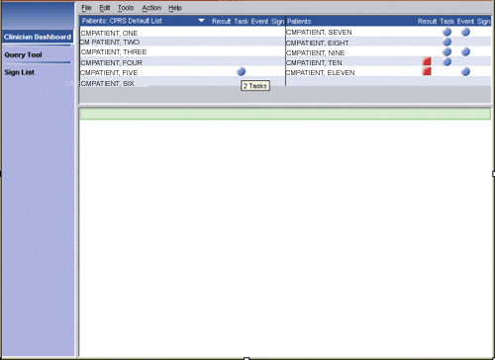
If you hold your mouse pointer over an icon, a hover hint appears indicating the number of items that are associated with the icon. For example, in the graphic below, the hover hint indicates that CMpatient, Five has two tasks.

The hover hint shows that CMpatient, Five has two tasks.

Display the Clinician Dashboard
To display the Clinician Dashboard, follow these steps:

- On the HealtheVet Desktop perspective selector, click Clinician Dashboard. The Clinician Dashboard appears.
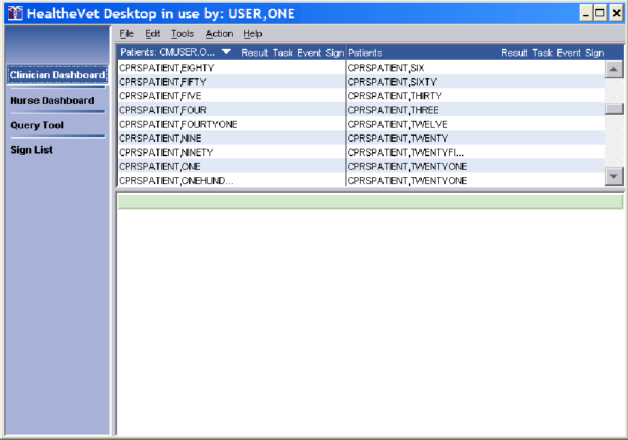
If this is your first time using the Clinician Dashboard, see Creating a Patient List .

- The patients from your patient list appear in the upper pane.

Viewing Details of an Item on the Clinician Dashboard
To view details of an item on the Clinician Dashboard, follow these steps:
- Click an icon in the Result, Task, Event, or Sign column. Items that have not been acknowledged, completed, viewed, or signed appear in individual boxes in the lower pane.
Note: You can also click on a patient’s name to display the patient’s demographic information in the lower pane.
- Click the plus () or minus () icon to expand or collapse a box.

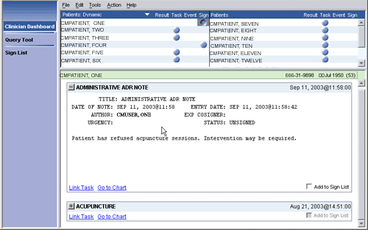
The details of an item displayed on the Clinician Dashboard

Criteria Used to Determine if a Patient is Listed on Your Clinician Dashboard
Care Management includes three types of patient lists:
- The Dynamic patient list
- The CPRS Default List
- Custom patient lists

Dynamic Patient List
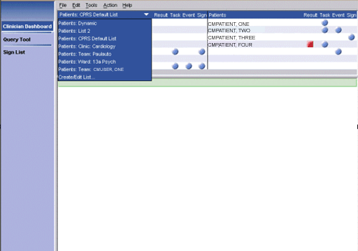
The Clinician Dashboard includes a drop-down menu from which you can select a patient list.
The Clinician Dashboard includes a drop-down menu from which you can select a patient list.

Included in this selection is a dynamically generated patient list—called the dynamic patient list—that incorporates patients from all of the individual patient lists in CPRS. Patients who appear in this list meet one or more of the following criteria:

- The patient has order results that have not been acknowledged (see Acknowledging a Result) and you are the ordering provider.
- The patient has documents that need to be signed and you are the designated signer, cosigner, or additional signer.
- You have one or more outstanding notifications for the patient.
- The patient has incomplete tasks that are due and you meet one or more of the following three criteria:
  - You created the task
  - You are the patient’s attending or primary provider
  - You are linked to the patient through a team or personal patient list
All patients who appear on the dashboard as a result of selecting Patients: Dynamic from the patient list have associated icons.

CPRS Default Patient List
The Clinician Dashboard also includes the CPRS Default List, which, as its name suggests, is based on—and synchronized with—your default patient list in CPRS. When you select this list, Care Management displays all of the patients who are included in your default patient list in CPRS.
If you select this list but have not selected a default patient list in CPRS, no patients appear on your Clinician Dashboard.
Note: To avoid potential confusion, you should select a default patient list in CPRS before selecting Patients: CPRS Default List in Care Management. For more information, see “Setting a Default Patient List” in the CPRS user guide or access this topic from the CPRS GUI Help menu.

Creating a Custom Patient List
You can specify which patients appear on your Clinician Dashboard by creating a custom patient list. To create a custom patient list, follow these steps:
- Click Clinician Dashboard on the HealtheVet Desktop perspective selector.
- Select Create/Edit List from the Patients drop-down menu.

- To create a patient list for the Clinician Dashboard, select Create/Edit List from the Patients drop- down menu.
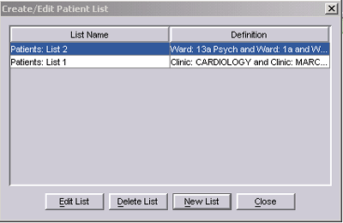
The Create/Edit Patient List dialog box appears.
The Create/Edit Patient List dialog box.

- Click New List from the Create/Edit Patient List dialog box. The Patients dialog box appears. The tabs across the top of the dialog box (Clinic Appointments, Ward, Personal/Team, Specialty, Provider, and Registry) correspond to different patient lists.
Note: Depending on your access rights, you may not see all of these tabs on the Patients dialog box.
Specifically, if you don’t have the ROR VA HEPC User key, Care Management does not display the Registry tab.

- Select the tab for the patient list or lists you want to add.

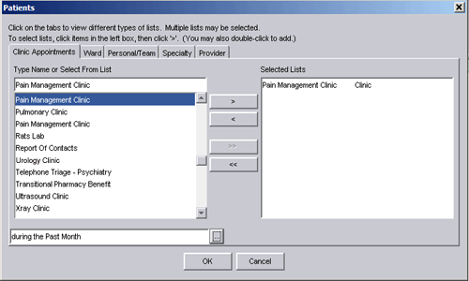
Note: You can use any or all of these patient lists. However, your results are likely to be more coherent if you carefully consider your list selections.
The Patients dialog box

- Select a clinic, ward, personal/team, specialty, provider, or registry list from the Type Name or Select From List pane.
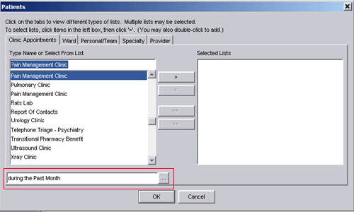
Note: If you select a clinic from the Clinic Appointments tab, you must also specify a date range. To do this, click the ellipse button (at the bottom of the dialog box) and select a date range. The date range you specify tells the Clinician Dashboard to display patients who have, or have had, appointments in the clinic within the specified date range. In the example below, Care Management will display patients who had appointments in the Pain Management clinic in the past month.

In this example, Care Management will display patients who had appointments in the Pain Management Clinic in the past month.
- Click the Add arrow (). The item moves to the Selected Lists pane.
Note: Alternately, you can double-click an item to move it to the Selected Lists pane. If it is available, you can also click the Add All arrow ( ) to move all of the items in the Type Name or Select From List pane to the Selected List pane. (The Add All arrow is available for the Ward, Personal/Team, and Specialty tabs.)
The Pain Management Clinic is displayed on the Selected Lists pane.

- Repeat Steps 4-6 if you want to add additional patient lists.
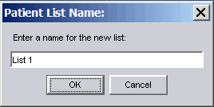
- Click OK. Care Management displays the Patient List Name dialog box.
The Patient List Name dialog box.

- Use the default name or type a name for the patient list.

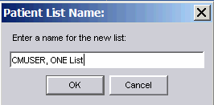
This list will be called CMUSER, ONE List.

- Click OK to accept the custom list. The patients from the new list appear in the Clinician Dashboard’s upper pane. Dashboard lights (or icons) appear for patients who have items that need attention. The name of the new list also appears in the Patients menu.
- Click Cancel to exit the Patient List Name dialog box without accepting the custom list.

Viewing Patient Demographic Information
Click a patient’s name to view his or her demographic information. The demographic information appears in the lower pane and may include the patient’s:
- Address
- Eligibility
- Health insurance information
- Ward status
- Provider
- Attending physician
- Admission status
- Future appointments
- Religion
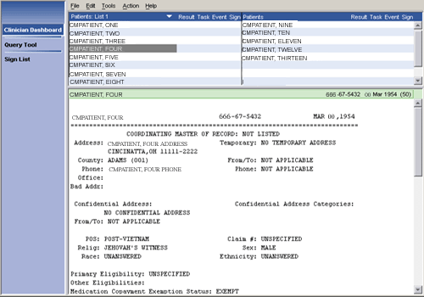
- Sex
Demographic information for CMpatient, Four displayed on the Clinician Dashboard.

Viewing Patient Record Flags
Patient record flags alert you to important information about patients—such as behavioral problems. Because this information can be vital to the safety of VHA patients and clinical staff, Care Management displays patient record flags (if they exist) for patients you select via the Clinician Dashboard, Nurse Dashboard, and Query Tool. On the Clinician Dashboard, Care Management displays patient record flags when you:
- Click a headlight to display associated details
- Click a patient’s name to display demographic information
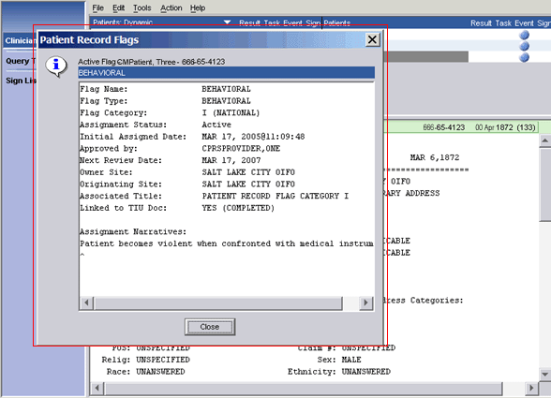
Each session, Care Management displays patients’ patient record flags once per perspective. For example, if Care Management displayed patient record flags for CMPatient, Five when you clicked his name, it wouldn’t display his patient record flags again when you subsequently clicked on one of his headlights (provided you hadn’t closed and reopened Care Management in the interim). However, if for the first time in the same session you selected CMPatient, Five in a Query Tool report, Care Management would again display his patient record flags.
Care Management displays patient record flags (if they exist) when you select patients’ names to view their demographic information.

Result Column
An icon in the Result column indicates that a patient has lab, consult, procedure, or radiology results that the user has not acknowledged. Icons appear in the Result column of the Clinician Dashboard only if the user is the ordering provider. The user can view/acknowledge results from the Clinician Dashboard.

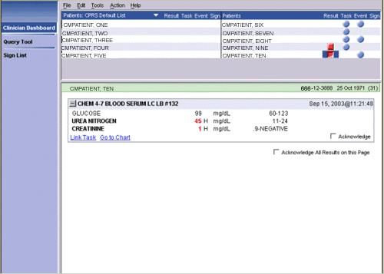
An icon in the Result column indicates that a patient has results that have not been acknowledged.

Acknowledging a Result
Acknowledging a result removes the result from the Clinician Dashboard. (Ordering providers are required to acknowledge results in Care Management regardless of the notification or deletion parameters set up in CPRS.)
To acknowledge a result, follow these steps:
- Click an icon in the Result column.
- Results that have not been acknowledged appear in individual results boxes in the lower pane.
- Click the plus ( ) or minus () icon to expand or collapse a results box.
- Select the appropriate Acknowledge check box.
- The result is now acknowledged. On the main menu, click Action, then click Refresh Dashboard to refresh the screen.

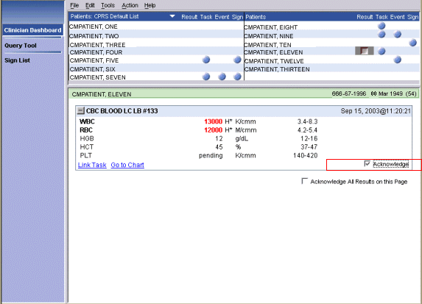
You can acknowledge a result to remove it from the Clinician Dashboard.

Task Column
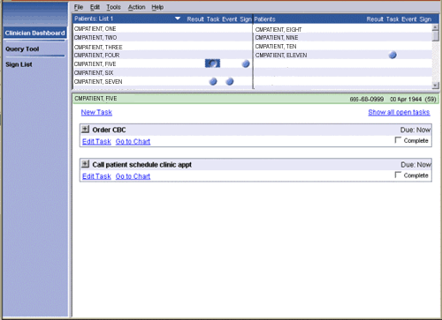
An icon in the Task column indicates that a patient has uncompleted tasks in the Task Editor module. For more information, see the Task Editor.
Tasks for patient CMPatient, Five are displayed on the Clinician Dashboard.

Criteria for Displaying Tasks on the Clinician Dashboard
Tasks appear on your Clinician Dashboard only if they are uncompleted, due, and meet one or more of the following criteria:
- You created the task
- You are associated with the patient in one or more of the following ways:
  - You are an inpatient’s primary or attending provider (as defined in the DG BED CONTROL menu)
  - You are assigned to an auto-link list on which the patient is included
  - The patient is associated with you through a personal or team list (OE/RR list file #100.21)
Note: All providers attached to a team list see tasks for all patients included on this list.

Viewing Future Tasks on the Clinician Dashboard

Although icons appear in the Task column only for tasks that are uncompleted and due, you can view a patient’s future tasks by following these steps:
- Click to select an icon in the Task column or, if no icon is present, click the area under the Task
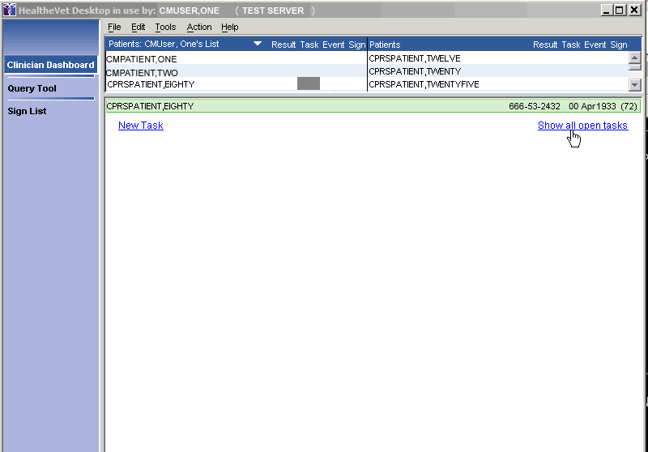
column heading where an icon associated with tasks would appear.
If CPRSPatient, Eighty has future tasks, you can display them by first clicking in the space under the Task column heading, then selecting the Show all open tasks link, which appears on the right side of the bottom pane.
- Click the Show all open tasks link, which appears on the right side of the bottom pane. The Show all open tasks link then disappears and Care Management displays all uncompleted tasks for the selected patient.

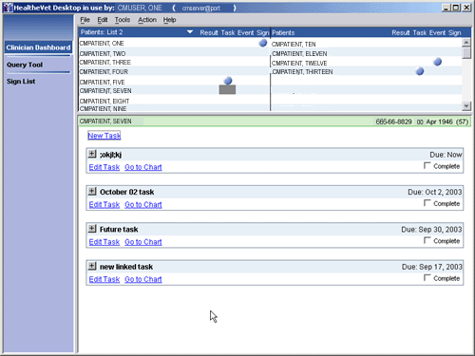
Care Management displays all uncompleted tasks for the selected patient (CMPatient, Seven).
Note: The Show all open tasks link displays tasks for all patients who appear on your Clinician Dashboard, including patients who do not meet the criteria described in the “Criteria for Displaying Tasks on the Clinician Dashboard” section above.

KNOWN ISSUE: Some links such as Show All Open Tasks become “whited out” after clicking once. However, the links are still usable. See the Appendix for further information.

Event Column
An icon in the Event column indicates that an admission, discharge (including death), transfer, or unscheduled clinic visit has occurred. After you have fully expanded and viewed an item in the Event column, the icon turns gray and remains gray for the remainder of the session or until you refresh the dashboard. When you refresh the dashboard or end the session and begin a new session, Care Management removes the icon from the Clinician Dashboard.
Note: The notification for a particular event must be turned on in CPRS for an icon to appear in the Event column. (To turn on notifications, click Tools on the main menu in CPRS GUI. Click Options, then click Notifications).

Sign Column
Icons in the Sign column indicate that patients have documents that require your signature or co- signature. Care Management also displays icons in this column if someone has identified you as an additional signer.

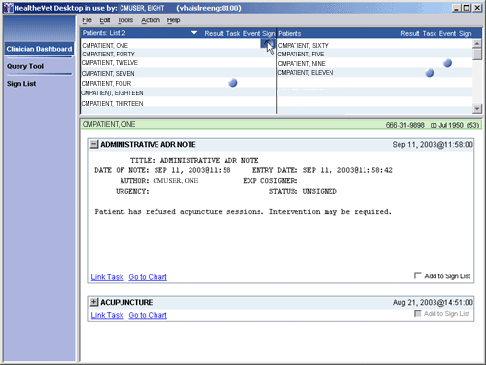
The icon in the Sign column indicates that CMPatient, One has documents that need to be signed
Note: Remember, you cannot sign a document until you have entered all required encounter data. If a document requires encounter data, Care Management does not display the Sign checkbox.
Instead, it notifies you that encounter data may be required. In this case, click the Go to Chart to Sign Document link, which takes you to the patient’s chart in CPRS. If CPRS requires encounter data, you can then enter it in CPRS. For information about how CPRS determines the need for encounter data, see the “Encounter Parameters” section of the Computerized Patient Record System (CPRS) Technical Manual.
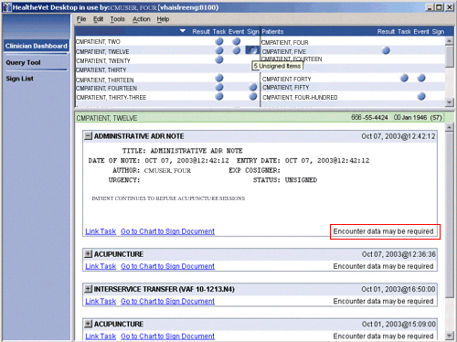
If CPRS requires encounter data, Care Management does not display the Sign check box.

Adding an Item to Your Signature List
To add an item to your signature list, follow these steps:
- Click an icon in the Sign column. Items that require your signature appear in individual boxes.
- Click the plus ( ) or minus () icon to expand or collapse a signature box. You must expand the note once to activate the electronic signature functionality.
- Select the Add to Sign List checkbox for items you want to add to your signature list. Care Management then adds the items to your signature list.

Signing Items on your Signature List
See Sign List .

Working with Tasks
Tasks are created in the Task Editor. For further information, see the Task Editor .

Opening the CPRS Patient Chart from the Clinician Dashboard
You can open the CPRS patient chart from the Clinician Dashboard, Nurse Dashboard, and Query Tool perspective by clicking the Go to Chart hyperlink. On the Clinician Dashboard, this hyperlink appears in boxes that display items associated with the Result, Task, Event, and Sign columns. The Go to Chart hyperlink also appears at the bottom of the patient-demographics display. As you might expect, when you click this hyperlink, CPRS opens to your default tab using the patient that you have selected on your Clinician Dashboard.

Note: This feature requires that:
  - OR*3.0*173 (CPRS version 29) or a later version of CPRS is installed at your site
  - A Sentillion Vault is installed at your site
  - Sentillion Desktop Components are installed on your workstation

Refreshing the Clinician Dashboard
After you have performed an action (such as acknowledging or verifying an order), you can refresh the Clinician Dashboard display by clicking Action on the main menu, then clicking Refresh Dashboard. You can also refresh the Clinician Dashboard by pressing the <F5> key.

Nurse Dashboard
The Nurse Dashboard provides nurses with an easy-to-read table that lists the names of patients from a selected patient list. Dashboard lights (icons) appear for patients who have items that need attention.
The table is displayed in the upper pane and includes the following columns:
- Results column
- Task column
- Event column
- Unverified Orders (UnVer) column
- Text Orders (TxOrd) column
- Vitals column
The following icons indicate patients who have items that need attention:
- The icon indicates new, due, or outstanding items that contain normal results or a low- or medium- priority tasks.
- The icon indicates items that contain abnormal results, significant findings, critical vitals, or high priority tasks.
- The icon indicates that you have acted on all of the items with which this icon is associated. In most cases, refreshing or exiting Care Management removes this icon. However, for text orders, the gray icon remains on the dashboard for the period specified in the CPRS ORPF ACTIVE CONTEXT HRS parameter, which determines the number of hours that completed text orders remain on the active list.
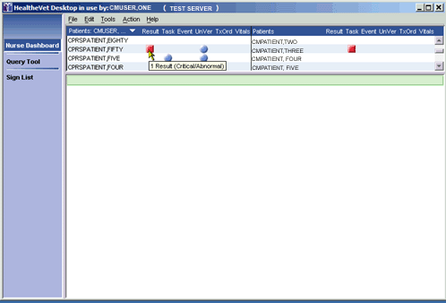
If you hold your mouse pointer over an icon, Care Management displays a hover hint indicating the number of items associated with the icon.

Hover hints indicate the number of items that are associated with each icon.

Displaying the Nurse Dashboard
To display the Nurse Dashboard, follow these steps:

- Click Nurse Dashboard on the HealtheVet Desktop perspective selector. The Nurse Dashboard appears. If this is your first time using the Nurse Dashboard, see Creating a Patient List.
- The patients from your patient list appear in the upper pane.

Criteria Used to Determine if an Icon Appears for a Patient Listed on Your Nurse Dashboard
Icons appear on the Nurse Dashboard for patients who meet the following criteria:
- The patient is on your patient list
-and-
- The patient has any of the following items that fall within the specified date range (see Setting the Nurse Dashboard Date Ranges):
  - Unacknowledged results (regardless of who wrote the order)
  - Uncompleted tasks that are due (regardless of who authored the tasks)
  - Appointments
  - Unverified orders
  - Uncompleted text orders
  - Vitals/Measurements

Setting the Nurse Dashboard Date Ranges
The Nurse Dashboard displays items based on default or user-specified date ranges. If you want to change the dashboard’s default date ranges, you can easily do so through the Preferences dialog box. However, keep in mind that the date ranges you specify can affect system response times. If you experience long response times, decrease the start date for dashboard items. On the other hand, if the Nurse Dashboard is not displaying all of the items you want to see, increase the start date for these items.
Note: The following table lists the maximum and minimum values users can assign through the Preferences dialog box. These limitations do not exist when you specify date ranges by accessing the parameters directly.

Desktop Minimum and Maximum Date Ranges
 | Minimum | Maximum
Events Stop | T-30 | T+30
Events Start | T-180 | T
Results Stop | T-30 | T+30
Results Start | T-180 | T
Text Order Stop | T-30 | T+180
Text Order Start | T-365 | T
Unverified Order Stop | T-30 | T+30
Unverified Order Start | T-180 | T
Vitals Stop | T-30 | T
Vitals Start | T-180 | T
To change the default date ranges for items that appear on the Nurse Dashboard, follow these steps:

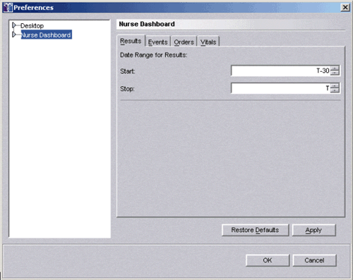
- On the main menu, click Tools, then click Options. The Preferences dialog box appears.
The Preferences dialog box.
- Select Nurse Dashboard in the left-hand pane.
- Select the Results, Events, Orders, or Vitals tab to set a date range for these individual items.
- Type the appropriate dates in the Start and Stop fields. These fields accept only relative dates (T+1, for example).
- Click OK.

Restoring Default Date Ranges

To restore default date ranges, click Restore Defaults in the Preferences dialog box. The following table lists the default date ranges that ship with Care Management:

 | Start | Stop
Events | T | T+7
Results | T-2 | T
Text Orders | T-365 | T
Unverified  Orders | T-2 | T
Vitals | T-7 | T
Note: Your site’s clinical application coordinator (CAC) can specify site-specific date ranges.
Consequently, the values in this table may not reflect the default date ranges that apply to your site.

The CPRS Default List
The Nurse Dashboard includes a CPRS Default patient list, which, as its names suggests, is your default patient list in CPRS. When you select the CPRS Default list, the Nurse Dashboard uses the criteria delineated in the “Criteria Used to Determine if an Icon Appears for a Patient Listed on Your Nurse Dashboard” section above. Icons appear for patients who meet one or more of these criteria.
The CPRS Default patient list is synchronized with the default patient list in CPRS. For example, suppose you change your default patient list selection in CPRS. When you subsequently select—or refresh—the CPRS Default patient list on the Nurse Dashboard, the dashboard displays a CPRS Default patient list that is based on the new default patient list in CPRS.
Note: To avoid potential confusion, you should select a default patient list in CPRS before selecting the CPRS Default list in Care Management. For more information, see “Setting a Default Patient List” in the CPRS user guide or access this topic from the CPRS GUI Help menu.

Creating a Custom Patient List
To create a custom patient list, follow these steps:
- Click Nurse Dashboard on the HealtheVet Desktop perspective selector.
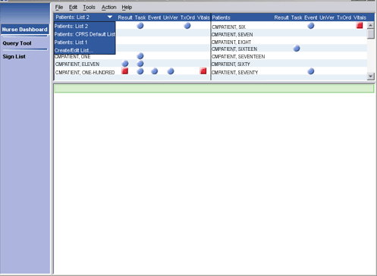
- Select Create/Edit List from the Patients list.
- To create a patient list for the Nurse Dashboard, select Create/Edit List from the Patients list. The
Create/Edit Patient List dialog box appears.

- Click New List.
The Patients dialog box appears. The tabs across the top of the dialog box (Clinic Appointments, Ward, Personal/Team, Specialty, Provider, and Registry) correspond to different patient lists.
Note: Depending on your access rights, you may not see all of these tabs on the Patients dialog box.
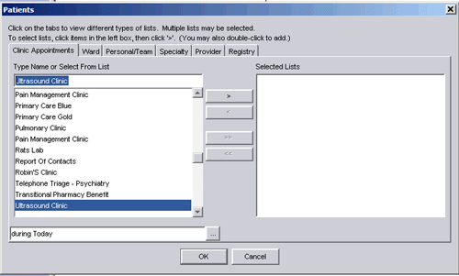
Specifically, if you don’t have the ROR VA HEPC USER key, Care Management does not display the Registry tab.
The Patients dialog box
- Select the tab for the patient list you want to add.
- Select a clinic, ward, personal/team, specialty, or provider list from the Type Name or Select From List pane.
Note: If you select a clinic from the Clinic Appointments tab, you must also specify a date range. To do this, click the button (at the bottom of the dialog box) and select a date range. The date range you specify tells the Nurse Dashboard to display patients who have, or have had,

appointments in the clinic within the specified date range. In the example below, patients who had, appointments in the Pain Management Clinic in the past month will be displayed on the Nurse Dashboard.
In this example, patients who had appointments in the Pain Management Clinic in the past month will be added to the patient list.
- Click the Add arrow (). The item moves to the Selected Lists pane.
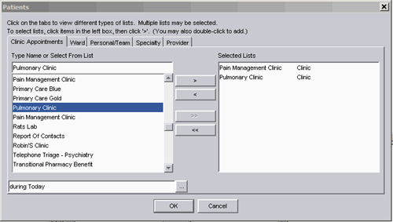
Note: Alternately, you may double-click an item to move it to the Selected Lists pane. If it is available, you can also click the Add All arrow ( ) to move all of the items in the Type name or select from list pane to the Selected Lists pane. (The Add All arrow is available for the Ward, Personal/Team, and Specialty tabs.)
Clicking the Add arrow adds the Pain Management Clinic and the Pulmonary Clinic list to the
Selected Lists pane.

- Repeat Steps 4-6 if you want to add additional patient lists.
- Click OK. The Patient List Name dialog box appears.
The Patient List Name dialog box.
- Type a name for the patient list or accept the default name.
This list will be called CMUSER, ONE List.
- Click OK. Patients from the new list appear in the upper pane. Dashboard lights (icons) appear for patients who have items that need attention. The name of the new list also appears in the Patients list.

Viewing Details of an Item on the Nurse Dashboard
To view details of an item on the Nurse Dashboard, follow these steps:
- Click an icon in the Result, Task, Event, Unverified Orders (UnVer), Text Orders (TxOrd), or Vitals column. Items that have not been acknowledged, signed, or verified appear in individual boxes in the lower pane.
Note: You can also click on a patient’s name. When you do so, Care Management displays the patient’s demographic information in the lower pane.
- Click the plus () or minus () icon to expand or collapse a box.

Viewing Patient Demographic Information
Click a patient’s name to view his or her demographic information. The demographic information appears in the lower pane and may include the patient’s:
- Address
- Eligibility
- Health insurance information
- Ward status
- Provider
- Attending physician
- Admission status
- Future appointments

- Religion
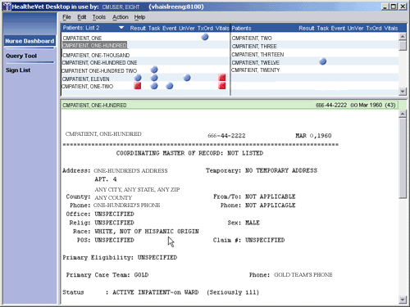
- Sex
Patient demographic information appears in the lower pane.

Viewing Patient Record Flags
Patient record flags alert you to important information about patients—such as behavioral problems. Because this information can be vital to the safety of VHA patients and clinical staff, Care Management displays patient record flags (if they exist) for patients you select via the Nurse Dashboard, Clinician Dashboard, and Query Tool. On the Nurse Dashboard, Care Management displays patient record flags when you:
- Click a headlight to display associated details
- Click a patient’s name to display demographic information
Each session, Care Management displays patients’ patient record flags once per perspective. For example, if Care Management displayed patient record flags for CMPatient, Five when you clicked his name, it wouldn’t display his patient record flags again when you subsequently clicked on one of his headlights (provided you hadn’t closed and reopened Care Management in the interim). However, if for the first time in the same session you selected CMPatient, Five in a Query Tool report, Care Management would again display his patient record flags.

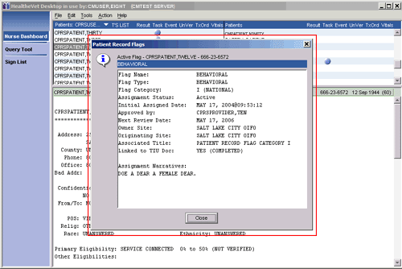
Care Management displays patient record flags (if they exist) when you select patients’ names to view their demographic information.

Result Column
An icon in the Result column indicates that a patient has unacknowledged (by you, specifically) lab, consult, procedure, or radiology results within the date range specified for results. (See Setting the Nurse Dashboard Date Ranges)

Acknowledging a Result
After you acknowledge all of a patient’s results, Care Management deactivates the icon in the Result column of the Nurse Dashboard. When you subsequently refresh the dashboard or exit Care Management, it removes the icon from the dashboard. When you acknowledge a result, Care Management removes it from your dashboard. The dashboards of other users are not affected by your acknowledgement.
To acknowledge a result, follow these steps:
- Click the icon in the Result column. Results that have not been acknowledged appear chronologically in individual results boxes in the lower pane.
- Click the plus ( ) or minus () icon to expand or collapse a results box.
- Select the appropriate Acknowledge check box. The result is now acknowledged. To refresh the dashboard, click Action on the main menu, then click Refresh Dashboard.
Note: You can also acknowledge all results on a page by selecting the Acknowledge All Results on this Page check box.

Task Column
An icon in the Task column indicates that a patient has tasks in the Task Editor that have not been completed. All uncompleted patient tasks that are due now appear in the Nurse Dashboard. For more information, see the “Task Editor” section of this manual.

Viewing Future Tasks on the Nurse Dashboard
Although icons appear in the Task column only for uncompleted tasks that are due, you can view a patient’s future tasks by following these steps:
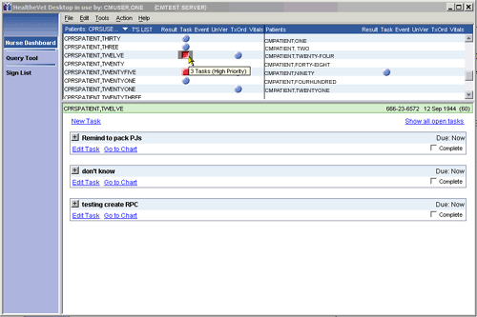
- Click an icon in the Task column or, if no icon is present, click the area under the Task heading where an icon associated with tasks would appear.
If CMPatient, Twelve has future tasks, you can display them by first clicking in the space under the Task column heading, then selecting the Show all open tasks link, which appears on the right side of the bottom pane.
- Click the Show all open tasks link, which appears on the right side of the bottom pane. The Show all open tasks link then disappears and Care Management displays all uncompleted tasks for the selected patient.

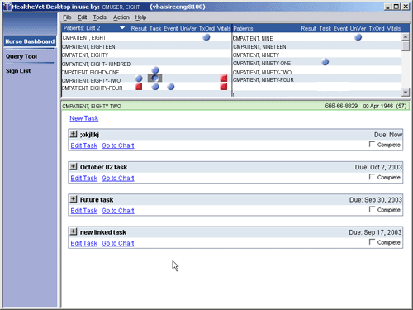
Care Management displays all uncompleted tasks for the selected patient (CMPatient, Eighty-Two).

Event Column
An icon in the Event column indicates that a patient has an appointment within the date range specified for events (see Setting the Nurse Dashboard Date Ranges) This icon is not removed from the dashboard after you view the event. Instead, it remains on the dashboard until the stop date specified in the Events date range occurs.
Progress notes that are attached to past appointments appear in the boxes that display these appointments
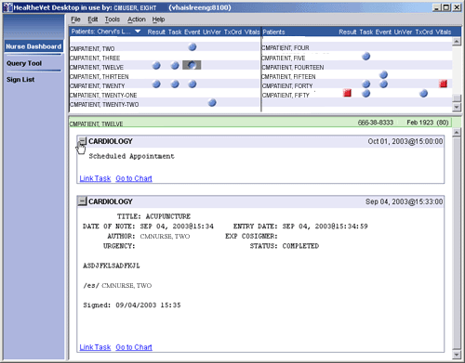
Progress notes that are attached to past appointments appear in the boxes that display these appointments.

Unverified Orders (UnVer) Column
Icons that appear in the unverified orders (UnVer) column are based on the date range you specify for unverified orders. These icons indicate that an inpatient has orders within this date range that have not been verified by nursing. (See Setting the Nurse Dashboard Date Ranges)
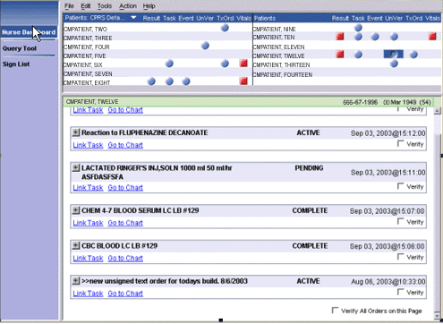
An icon in the UnVer (unverified orders) column indicates that an inpatient has unverified orders within the date range specified in the Nurse Dashboard Preferences dialog box.
To verify orders, follow these steps:
  - Click an icon in the unverified orders (UnVer) column. Orders that have not been verified appear chronologically in individual boxes in the lower pane.
  - Click the plus ( ) or minus () icon to expand or collapse a box.
  - Select the appropriate Verify check boxes. You can also verify all of the orders on a page by selecting the Verify All Orders on this Page check box. The checked orders now appear on your Sign List. After you sign the orders, they are verified. See Sign List for more information.
Note: The Verify checkbox is active only for ORELSE key holders.

Text Orders Column (TxOrd)
Icons that appear in the text orders (TxOrd) column indicate that:
- A patient has uncompleted text orders that fall within the date range specified in the Nurse Dashboard Preferences dialog box
-or-
- A patient has orders that have been completed, but have been completed for fewer hours than specified in the ORPF ACTIVE ORDERS CONTEXT HRS parameter

Completing Text Orders
To complete orders in the text-orders column, follow these steps:
- Click an icon in the text orders (TxOrd) column.
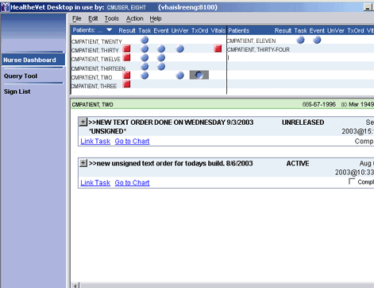
When you select an icon in the TxOrd column, text orders appear in the lower pane. The Complete
check box is active for uncompleted orders.
- Click the plus ( ) or minus () icon to expand or collapse a box.
- Select the appropriate Complete check boxes. The selected items are now added to your signature list. After you sign the orders, they will be complete. See Sign List for more information.

Vitals Column
An icon in the Vitals column indicates that the patient has vital signs (from the vital signs package) that fall within the date range specified in the Nurse Dashboard Preferences dialog box. The Nurse Dashboard can display the following vitals:
- Blood Pressure
- Temperature
- Respiration
- Pulse
- Height
- Weight
- Central Venous Pressure
- Circumference/Girth
- Pulse Oximetry
- Pain

Note: The Nurse Dashboard can display up to 100 vitals within a given date range.

Opening the CPRS Patient Chart from the Nurse Dashboard
You can open the CPRS patient chart from the Nurse Dashboard, Clinician Dashboard, and Query Tool by clicking the Go to Chart hyperlink. On the Nurse Dashboard, this hyperlink appears in boxes that display items associated with the Result, Task, Event, UnVer, TxOrd and Vitals columns. The Go-to- Chart hyperlink also appears at the bottom of the patient-demographics display. When you click this hyperlink, CPRS opens to your default tab using the patient that you have selected on your Nurse Dashboard.
Note: This feature requires that:
  - OR*3.0*173 (CPRS version 29) is installed at your site
  - A Sentillion Vault is installed at your site
  - The Sentillion Desktop Components are installed on your workstation

Refreshing the Nurse Dashboard
After you have performed an action (such as acknowledging or verifying an order), you can refresh the Nurse Dashboard display by clicking Action on the main menu, then clicking Refresh Dashboard (or by pressing the <F5> key.

Sign List
The Sign List allows you to sign multiple items for multiple patients at the same time.

Signing Items on Your Signature List
To sign the items on your signature list, follow these steps:
- Click the Sign List link in the HealtheVet Desktop perspective selector.
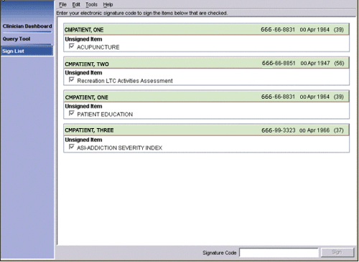
The items on your signature list appear in patient signature boxes. A check appears next to the items that will be signed. You can clear an item by clicking on the checkbox. Unselected item(s) remain unsigned after you apply your electronic signature code.
The Care Management sign list
- Type your signature code in the Signature Code field at the bottom of the dialog box.
- Click Sign. The selected items are then signed and removed from your signature list.

Task Editor
The Task Editor allows you to create a list of tasks to perform for a patient. These tasks must be linked to a patient on the Clinician or Nurse Dashboard. You may also link tasks to one or more items that appear on the same dashboard as does the patient.
For example, using the Task Editor, you could create a task to call a patient based on a lab result that indicates an abnormal white blood cell count.

Creating a New Task
- Click the Clinician Dashboard perspective or the Nurse Dashboard perspective on the HealtheVet Desktop perspective selector.
- Click the name of the patient for whom you want to create a task.
- On the main menu, click Action, then click Create Task.
-or-
Click an icon adjacent to the patient’s name on the Clinician or Nurse Dashboard and then click the
Link Task link at the bottom of the screen.
-or-
Click an icon adjacent to the patient’s name in the Task column (or the blank area under the Task
heading where a task icon would appear) and click the New Task link. The Create Task dialog box appears.
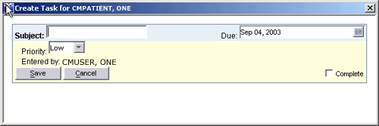
The Create Task dialog box
Note: If the Link [item] to Task dialog box appears, select the task to which you want to link the item or select Link to new task.

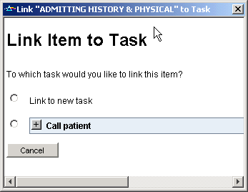
The Link [item] to Task dialog box allows you to choose whether to link the item to an existing task or create a new task.
- In the Subject field, type the subject of the new task. .
- In the Due field, type or select a due date for the task. (The default is today.)
Note: This field does not support relative date notation (T-20, for example).
- Select a priority for the task (the default is low).
- Click Save. The task is created.
Note: Icons do not appear on the dashboard until the task is due.

Completing a Task
When you have completed a task, follow these steps to remove the task from the Clinician or Nurse Dashboard:
- Click the icon in the Task column. The associated tasks appear in the lower pane.
- Select the Complete check box for the task you want to complete. The task is now marked complete.
- On the main menu, click Action, then click Refresh Dashboard to refresh the Clinician or Nurse Dashboard.
If all of the tasks for a patient have been completed, Care Management removes the icon in the Task
column. (Care Management also removes the icon if you exit the program.)

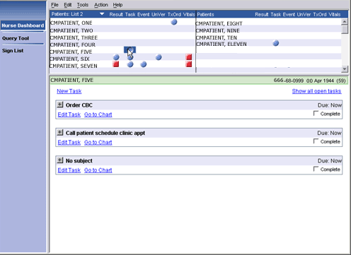
- When you have completed a task, select the Complete check box to remove the task from the dashboard.

Editing a Task
To edit a task from the Clinician or Nurse Dashboard, follow these steps:
- Click an icon in the Task column. Tasks that are currently due appear in individual task boxes in the lower pane. To show tasks with a due date in the future, click the Show All Tasks link.
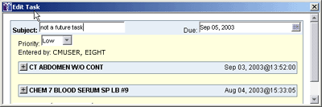
- Click the Edit Task link. The Edit Task dialog box appears. The titles of items associated with the task appear in the middle of the dialog box. Click the plus/minus () icon to expand or collapse an item.
The Edit Task dialog box
- Make the appropriate changes.
- Click Save.
Note: You can also delete a task that you have created by clicking Edit Task and then clicking Delete.

Query Tool
The Query Tool perspective allows you to create reports for a group of patients based on criteria you specify. Specifically, this perspective offers five predefined reports, which are available in the upper pane. It also offers a Create Custom Search option that allows you to create custom reports.
Criteria for the selected report are displayed in the lower pane. Criteria displayed in blue font must be defined before the Query Tool can display the report. To define these criteria, click the blue hyperlink. Criteria in maroon font have already been defined (but can be changed).
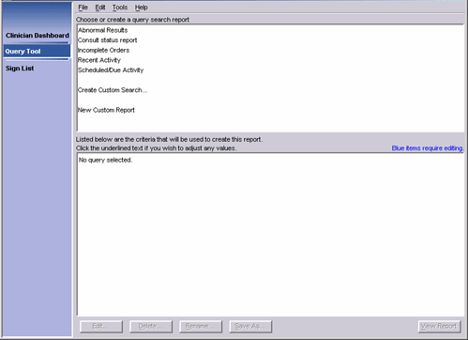
Note: Large reports may cause a significant strain on network resources.
The CPRS Query Tool

Types of Reports
The Query Tool’s six types of reports are described below:
  - Abnormal Results Report - The Abnormal Results report lists patients with abnormal results that fall into the specified date range.
Note: The Abnormal Results report returns only results that were entered after your site installed the Hepatitis C patches (OR*3*153). These patches should have been installed on or about April 9, 2003.
  - Consult Status Report - The Consult Status report lists patients for whom consults were ordered from specified services within a specified date range.
  - Incomplete Orders Report - The Incomplete Orders report lists patients with orders in a specified date range that have a partial or pending status. (You can also select other types of statuses—such as active or cancelled—for the Incomplete Orders report.)

July 2016
Care Management (CM) 1.8 59
User Manual

- Recent Activity Report - By default, the Recent Activity report returns orders and documents created within the past 24 hours. However, you can select specific document classes and other time ranges for this report.
- Scheduled/Due Activity Report - The Scheduled/Due Activity report lists patients with orders or consults that are pending or scheduled. (You can also select a date range, patient list, and order/consult status for this report.)
- Custom Report - The custom report feature allows you to create reports that are more detailed and more complex than are any of the predefined reports. With a custom report, you can specify exactly which information is displayed.
For example, you could create a custom report that returns all of the orders placed on March 13, 2003 for patients who had appointments in the Cardiology clinic in the past month and for whom the primary outpatient provider was CMProvider, Thirteen.

Selecting a Report
To select a report, follow these steps:
- Click Query Tool on the HealtheVet Desktop perspective selector. HealtheVet Desktop displays the Query Tool perspective.
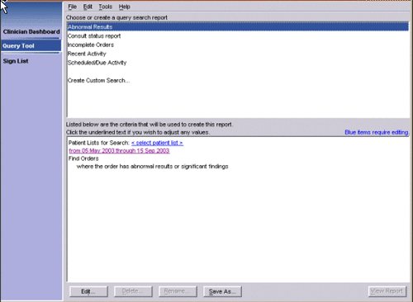
- In the upper pane, select either Abnormal Results, Consult status report, Incomplete Orders, Recent Activity, Scheduled/Due Activity or Create Custom Search.
Criteria for the Abnormal Results report displayed on the lower pane.
Note: If you select Create Custom Search, the screen shown below appears. If the lower pane is not visible, click the Expand arrow ( ) that appears at the bottom of the Create Custom Report – Search Items pane.

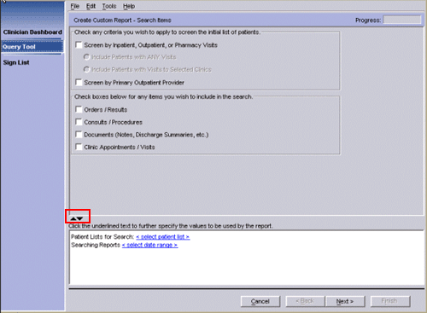
If you select Create Custom Search screen: if the lower pane is not visible, click the Expand arrow ( ).

Defining the Patient Lists to Search
Note: When searching for generic text orders in the Nursing Display group using the Query Tool, it is important to realize that this will not return text orders that were ordered during an IMO clinic ordering session.

Locally Defined Display Groups
If your site decides to create locally defined display groups, consider the effects this can have elsewhere in VistA. The Care Management application searches the Nursing and Clinic Orders display group for orders to include under the TxOrd column on the Nursing Dashboard. Therefore, if a new display group contains nursing orders that require the icon to display under the TxOrd column on the Nursing Dashboard,
they will need to be added as a member of the nursing display group in the display group file.

How to Add a Local Display Group as a Member of the Nursing Display Group
Follow these steps.
- From the FileMan main menu, select OPTION: ENTER OR EDIT FILE ENTRIES.
- At the INPUT TO WHAT FILE prompt, select DISPLAY GROUP.
- At the EDIT WHICH FIELD prompt, select MEMBER. Then choose to edit all MEMBER sub-fields.
- At the Select DISPLAY GROUP prompt, select NURSING.
- At the MEMBER prompt, enter your locally created display group.
- If asked “Are you adding this display group as a new MEMBER?”, enter yes.
- At the MEMBER SEQUENCE prompt, select default answer.

Defining the Patient Lists to Search
After you select a report, you must select patient lists for the Query Tool to search. To define the list of patients that will be searched, follow these steps:
- Click <select patient list> in the lower pane. The Patients dialog box appears. The tabs across the top of the dialog box (Clinic Appointments, Ward, Personal/Team, Specialty, Provider, and Registry) correspond to different patient lists.
The Patients dialog box.
- Click the tab for the patient list you want to add.
Note: Depending on your access rights, you may not see all of the tabs on the Patients dialog box. Specifically, if you don’t have the ROR VA HEPC USER key, Care Management does not display the Registry tab.
- Select a clinic, ward, personal/team, specialty, provider, or registry list from the Type Name or Select From List pane.
Note: If you select a clinic from the Clinic Appointments tab, you must also specify a date range. To do this, click the button (at the bottom of the dialog box) and select a date range. The date range you specify tells the Query Tool to search for patients who have/had appointments in the clinic within the specified date range. In the example below, the Query Tool will search for patients who had appointments in the Pain Management clinic in the past month.

In this example, patients who had appointments in the Pain Management clinic in the past month will be added to the patient list.
- Click the Add arrow (). The item moves to the Selected Lists pane.
Note: You may also double-click an item to move it to the Selected Lists pane. For patient lists in the
Personal/Team, Specialty, and Registry tabs, you can also click the Add All arrow (
) to move all of the items in the Type Name or Select From List pane to the
Selected List pane.
Click the Add arrow to add the Pain Management clinic list to the Selected Lists pane.
- Repeat Steps 2-4 if you want to add additional patients.
- Click OK. The selected lists appear in the lower pane.

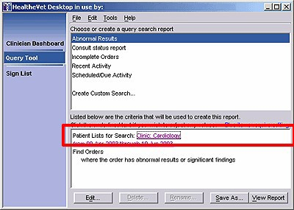
The selected clinic appears on the lower pane.
If you selected a predefined report and do not want to alter its default criteria, skip to Displaying the Report . If you selected the Create Custom Search option, you need to follow Additional Steps for Custom Reports .

Editing the Criteria in a Predefined Report
You can change the default criteria (displayed in maroon font) for any predefined report. To change a criterion, simply click on the appropriate link. After you change a criterion, the new criterion is displayed in the lower pane.
For example, to change the date range on the Abnormal Results report, click the From [date] Through [date] hyperlink. To change the order status on the Incomplete Orders Report, click the hyperlink displayed after the following words: where the order status is.

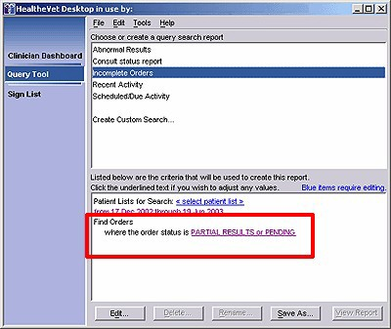
Click the Partial Results or Pending hyperlink to change the order status.
Note: When you follow these steps to edit a predefined or custom report, Care Management does not save your edits. That is, when you close this application, edited criteria return to their original state. If you want to save your edits, select a report and then click the Edit bar in the lower pane. After you have edited the criteria for this report, you can save your edits by clicking the Save As bar. This creates a new report that uses your edited criteria as its default criteria.
The following table lists the default criteria you can change for each predefined report:

Report | Predefined Criteria | To change, click…(in the lower pane)
Abnormal Results Report | Date Range | The from [date] through [date] hyperlink
Consult Status Report | Date Range | The from [date] through [date] hyperlink
 | Consulting Service | The hyperlink displayed after these words: where the  consulting service is
Incomplete Orders | Date Range | The from [date] through [date] hyperlink
 | Order Status | The hyperlink displayed after these words: where the order  status is
Recent Activity | Date Range | The hyperlink displayed after these words: Searching Reports
 | Document Class | The hyperlink displayed after these words: where the  document class is
Scheduled/Due Activity | Date Range | The hyperlink displayed after these words: Searching  Reports
 | Service Category  (display group) | The hyperlink displayed after these words: where the  service category (display Searching Reports group) is
 | Order Status | The hyperlink displayed after these words: where the order  status is
 | Consult Status | The hyperlink displayed after these words: where the  consult status is

Additional Steps for Custom Reports
If you select a custom report, you must also select the items to include in the report . In addition, you select a date range for the specified items and (optionally) filter the selected patient lists .

Selecting the Items to Include in the Report
You can select the following items for your custom report:
- Orders / Results
- Consults / Procedures
- Documents
- Clinic Appointments / Visits
To include one of these items in the report, select the appropriate check box in the lower half of the upper pane. For example, if you want to include orders and results in the report, select the Orders / Results check box.
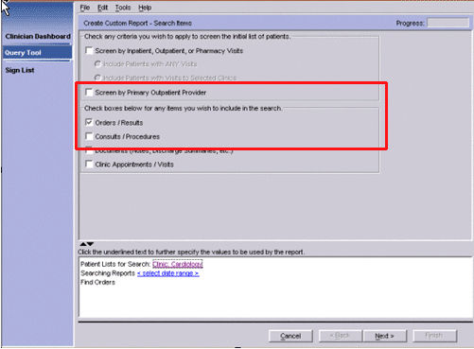
You can specify the items you want to include in the report by selecting the appropriate check boxes.

Selecting the Date Range for the Selected Items
You must specify a date range for the item(s) you selected in Selecting the Items to Include in the Report. To specify a date range, follow these steps:
- Click the <select date range> hyperlink in the lower pane. The Date Range dialog box appears.

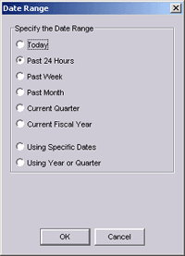
The Date Range dialog box

- Select the appropriate date range.
- Click OK. The date range appears in the criteria pane.
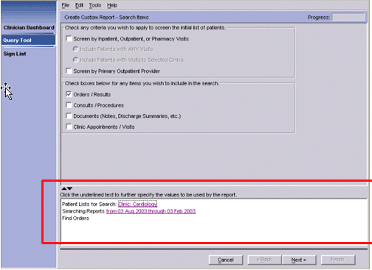
This report will return patients who had an appointment in the Cardiology clinic and who have orders that were entered between August 3, 2002 and February 3, 2003.

Filtering the Selected Patient Lists
After you have followed the steps in Selecting the Items to Include in the Report , you can (optionally) filter the patient list(s) you selected in Defining the Patient Lists to Search . For example, suppose you selected patients in Ward 2B, but want a report that includes only Ward 2B patients for whom you are

the provider. You can filter the Ward 2B patient list to include only these patients. You can apply one or more of the following filters to refine the patient lists you select:
- Patients with inpatient, outpatient, or pharmacy visits during a specific date range
- Patients with inpatient, outpatient, or pharmacy visits to a specific clinic
- Patients with a specific primary outpatient provider

Including Patients Who Had an Inpatient, Outpatient, or Pharmacy Visit to any Clinic During a Specific Date Range
- Select the Screen by Inpatient, Outpatient, or Pharmacy Visits check box.
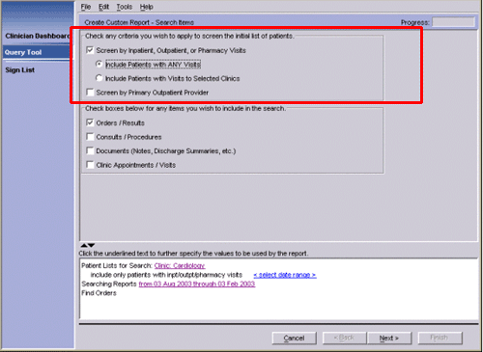
- Select Include Patients with ANY visits.
To only include patients who had an inpatient, outpatient, or pharmacy visit during a specific date range, select the Screen by Inpatient, Outpatient, or Pharmacy Visits check box and then select Include Patients with ANY visits.
- Set the date range for the visits by clicking the <select date range> hyperlink, which is displayed after the following: include only patients with inpt/outpt/pharmacy visits.

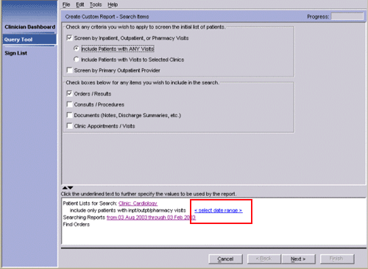
Set the date range for visits by clicking the <select date range> hyperlink, which is displayed after the following words: include only patients with inpt/outpt/pharmacy visits.

Including Patients who had an Inpatient, Outpatient, or Pharmacy Visit to a Specific Clinic
- Select the Screen by Inpatient, Outpatient, or Pharmacy Visits check box.
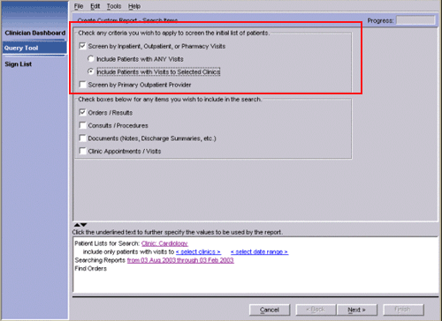
- Select Include Patients with Visits to Selected Clinics.

To include patients who had an inpatient, outpatient, or pharmacy visit to a specific clinic, select the corresponding check boxes.
- Click the <select clinics> hyperlink (in the lower pane) to select the clinics.
- If you want to select a date range for the visits, click the <select date range> hyperlink (on the same line on as the <select clinics> hyperlink).

Including Patients with a Specific Primary Outpatient Provider
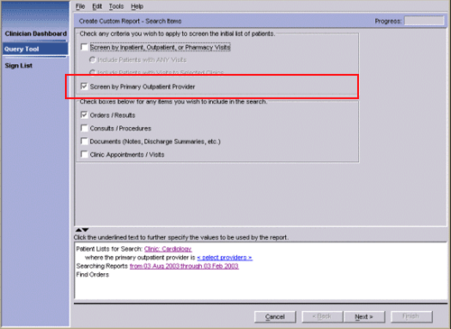
- Select the Screen by Primary Outpatient Provider check box.
The Query Tool allows you to screen the patient list by primary outpatient provider.
- Select a primary provider by clicking the <select providers> hyperlink in the lower pane.

Moving to the Next Pane
After you have defined all of the necessary criteria on a pane (all of the blue text is now maroon), click Next. Additional panes appear, allowing you to further refine your search. Complete each pane until the Available Fields pane appears.

Choosing the Fields that Appear on the Report
The available fields are now displayed in the Available Fields pane.
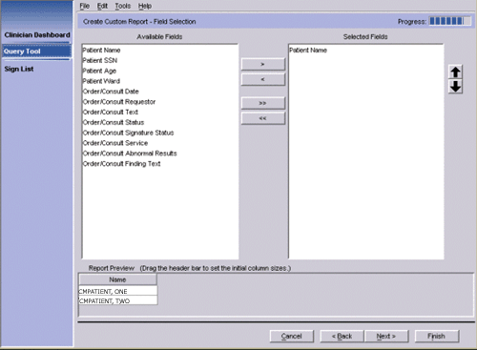
The fields that can be included in this report are displayed in the Available Fields pane. Note: This list varies depending on which options you selected earlier.
- Select the fields you want to include in the report. Press and hold Ctrl to select multiple fields or
Shift to select a range of fields.

- Click the Add arrow ( ) to move the selected fields to the Selected Fields pane. Click the
Add All arrow ( ) to move all of the fields to the Selected Fields pane.
Note: You can also double-click an item to move it to the Selected Fields pane.
A preview of the report appears in the lower pane. You can reposition a header by dragging the header to a new position or by using the up and down buttons on the right side of the screen. You can also expand or contract a column by dragging the edge of the column.

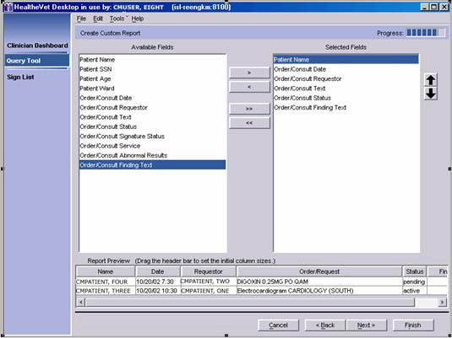
A preview of the custom report appears in the lower pane.
- Click Next. The Report Name dialog appears.

Naming the Report
- Type a name for the report in the Report Name field.
Note: If you want to save this report for future use, be sure the Save the report for later reuse check box is selected. If you do not select this check box, the report will be available only until you close the HealtheVet Desktop.

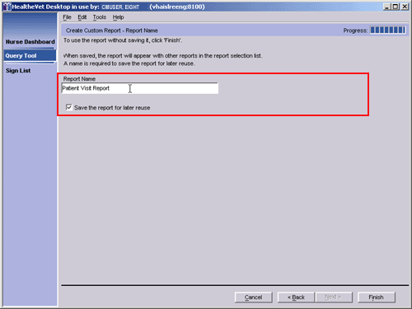
This report will be named Patient Visit Report.
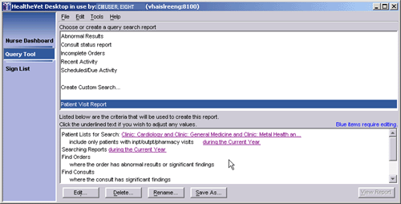
- Click Finish. The name of the report you created appears under Create Custom Search in the upper pane.
The Patient Visit Report is displayed in the upper pane.

Displaying the Report
To display the report, follow these steps:
- Click View Report. The Query Tool polls the database. After a few moments, the report appears in a table in the upper pane.

Note: If sensitive patients are included in the patient lists you select, a dialog displaying the names of these sensitive patients appears. This dialog enables you to select or cancel the selection of

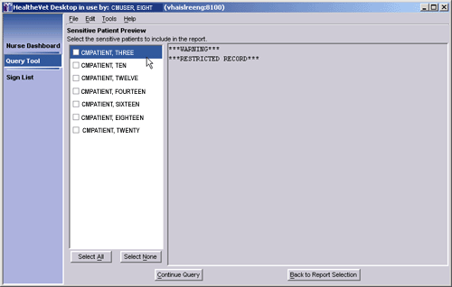
sensitive patients you wish to include or exclude from the report, respectively. If a sensitive patient is included in a report, an entry is made into the DG SECURITY LOG file.
From the Sensitive Patient Preview dialog, you can select or cancel the selection of sensitive patients whom you want to include in or exclude from your report, respectively.

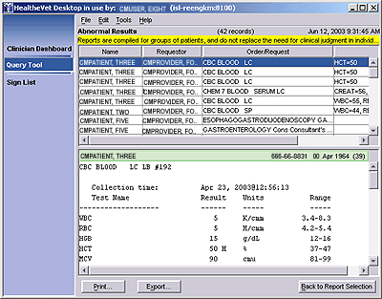
- Click an item in the table to see details about the item. The details appear in the lower pane.
The results of the Abnormal Results report are displayed on the lower pane for CMPatient, Three.

Viewing Patient Record Flags
Patient record flags alert you to important information about patients—such as behavioral problems. Because this information can be vital to the safety of VHA patients and clinical staff, Care Management

displays patient record flags (if they exist) for patients you select via the Nurse Dashboard, Clinician Dashboard, and Query Tool. On the Query Tool perspective, Care Management displays patient record flags when you:
- Click to display details associated with Query Tool results
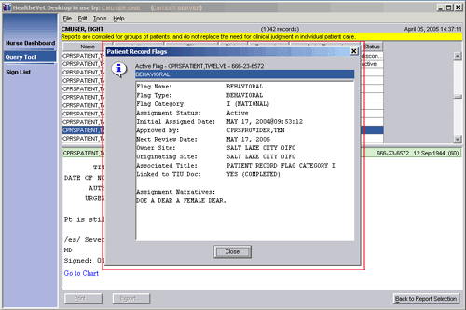
Each session, Care Management displays patients’ patient record flags once per perspective. For example, if Care Management displayed patient record flags for CMPatient, Five when you clicked his name in a Query Tool report, it wouldn’t display his patient record flags again when you clicked his name a second time (provided you hadn’t closed and reopened Care Management in the interim). However, if for the first time in the same session you clicked CMPatient, Five’s name on the Clinician Dashboard, Care Management would again display his patient record flags.
Care Management displays patient record flags, if they exist, for patients you select in Query Tool reports.

Opening the CPRS Patient Chart from a Query Tool Report
You can open the CPRS patient chart from the Query Tool, Clinician Dashboard, and Nurse Dashboard by clicking the Go to Chart hyperlink. In the Query Tool perspective, this hyperlink appears at the bottom of the detail display, which Care Management presents when you click a patient’s name in a Query Tool report. When you click this hyperlink, CPRS opens to your default tab using the patient whose name you selected in the Query Tool report.

Printing the Report
Note: You must have the ORRC QUERY RESULT EXPORT key to print a report.

After you have displayed the report, you can print the report by clicking Print. However, only the information in the upper pane will print.
Note: You can also select Page Setup and Print Preview options from the File menu.

Exporting the Report
Note: You must have the ORRC QUERY RESULT EXPORT key to export a report. To export a report, follow these steps:
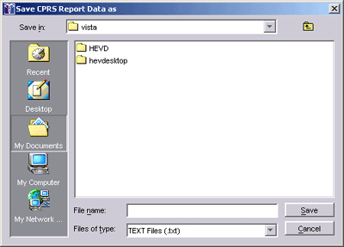
- Click Export. The Save CPRS Report Data as dialog box appears.
The Save CPRS Report Data as dialog box
- Type a name for the exported report.
- Browse to the location where you want to save the exported report.
- Click Save. The report is saved as a text file.

Editing a Report
Note: You can edit both custom and predefined reports. If you choose to edit a predefined report, Care Management creates a copy of the predefined report and saves it as a custom report.
To edit a report, follow these steps:
- In the Query Tool’s upper pane, click the report you want to edit.
- Click Edit. The Create Custom Report – Search Items dialog appears.
- Edit the report as necessary.

Saving a Report with a Different Name
- In the Query Tool’s upper pane, click the report you want to copy and rename.
- Click Save As. The Enter New Query Name dialog box appears.
- Type a name for the new report.
Note: Report names are limited to 80 characters and cannot include the caret (^) character.
- Click OK. The report appears in the upper pane under the words Create Custom Search.

Deleting a Custom Report
Note: You cannot delete a predefined report.
- From the Query Tool’s upper pane, select the custom report you want to delete.
- Click Delete. The Delete Report dialog box appears.
- Click OK to delete the report.

Renaming a Custom Report
- In the Query Tool’s upper pane, click the custom report you want to copy and rename.
- Click Rename
- Type a new name for the report in the Report Name field.
- Click Finish. The renamed report appears in the upper pane.

Stopping a Query or Report in Progress
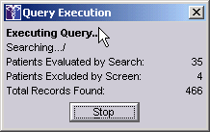
Because large queries can affect system performance, you may need to stop a query or report in progress. You can do this by clicking the Stop button while the query is running. Partial results appear in the upper pane.
You can stop a query or report by clicking Stop while the query is running.

Keyboard Shortcuts

Menu | Command | Keystroke
HealtheVet Desktop
(All Modules)
N/A | Move focus to the next pane or to the perspective selector | F6
 | Move focus to the next field or control | Tab or Arrow Keys
 | Expand or compact a box, place a check in a check box, click a  button, or follow a hyperlink. | Spacebar
 | Place a check in a check box | Spacebar
File | Page Setup | Alt+F-U
 | Print | Alt+F-P
 | Print Preview | Alt+F-V
 | Exit | Alt+F-X
Edit | Redo | Ctrl+Shift+Z
 | Cut | Ctrl+X
 | Copy | Ctrl+C
 | Paste | Ctrl+V
 | Delete | Delete
Tools | Options | Alt+T-O
Help | Help Contents | Alt+H-H
 | What’s This | Alt+H-T
 | About HealtheVet Desktop | Alt+H-A
Clinician Dashboard
Action | Refresh Clinician Dashboard | Alt+A-R, F5
 | Create Task | Alt+A-C
 | Open the patient selection list | Alt+P
Nurse Dashboard
Action
 | Refresh Dashboard | Alt+A-R, F5
 | Create Task | Alt+A-C
 | Open the patient selection list | Alt+P
Query Tool
 | Follow a Hyperlink/Click a Button | Return
 | View Report | Alt+V
 | Save As… | Alt+S
 | Stopping a Report in Progress | Alt+S
 | Export a Report | Alt+X
 | Back to Report Selection | Alt+B

Appendix A: Known Issue – Disappearing links

Problem
The text of many links becomes “whited out” after clicking once. A dotted box is displayed to show the location of the link and links are still usable.
This issue is related to the version of Java Runtime Environment (JRE); it occurs in all versions of JRE1.4.2 that are higher than JRE1.4.2_01. JRE 1.4.2_01 with which the application was originally tested didn’t have a links problem, but had several other problems. After careful analysis, it was found that each JRE had its pros and cons, but JRE1.4.2_12 was the most compatible version. The links issue was classified as a low priority issue compared to the other issues.
Remediation
After you click a link, sometimes the link text disappears, and a dotted box is displayed. You can still click on the box to invoke the link. Also you may click in the pane that contains the link to restore the text.
The following example demonstrates that the links actually work, despite the missing text. Example
- Click Show all open tasks link.
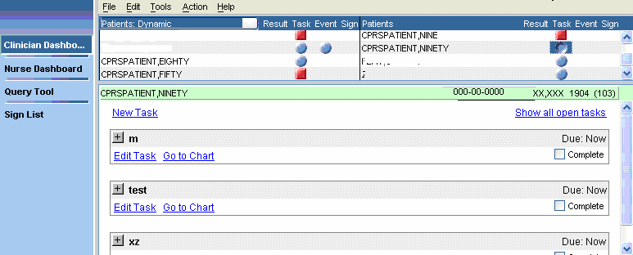

- The New Task link text disappears, and a dotted box is displayed.

Note: Clicking on the box will still work and invoke the New Task dialog.

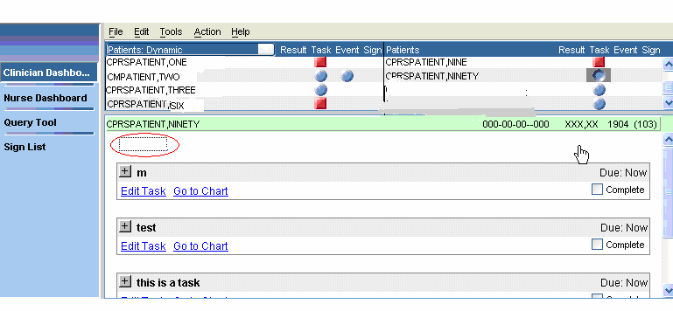

- If you click the task button again, the New Task text re-appears.

