March 2008

This distribution contains change pages for patch MD*1.0*14 of the Clinical Procedures 1.0 Implementation Guide.
The following documentation change pages should be inserted before these replacement pages: File Name: Patch:
MD_1_P4_IMPG.PDF MD*1.0*4

Patch MD*1.0*14 pages:

Replace Pages: With Pages:
Title page Title page
Revision History Revision History
Table of Contents Table of Contents
1-9 to 1-12 1-9 to 1-12
Chapter 4 Chapter 4
Chapter 6 to 17 Chapter 6 to 18

Note: A new chapter “Scheduled Options” was added before the former Chapter 7. All subsequent chapters were renumbered accordingly.

CLINICAL PROCEDURES IMPLEMENTATION GUIDE

Version 1.0
April 2004

Revised March 2008

Department of Veterans Affairs Health Systems Design and Development
Provider Systems

Revision History

Description | Date | Technical Writer
Originally released. | April 2004
1Patch MD*1.0*4 released. | September 2006 | REDACTED
2Patch MD*1.0*9 released November 2007. Updated Setting up HL7 Parameter for port 5000 with CACHE. | March 2008 | REDACTED
3Patch MD*1.0*14 released. Updated Setting Up Consults for Clinical Procedures, Exported XPAR Kernel Parameters, add new section called Scheduled Options. Added information about launching CP Gateway under the section Working with CP Gateway. | March 2008 | REDACTED

1 Patch MD*1.0*4 September 2006 Patch 4 release added.
2 Patch MD*1.0*9 November 2007 Patch 9 release added.
3 Patch MD*1.0*14 March 2008 Patch 14 release added.

Table of Contents

- Introduction 1-1
About Clinical Procedures 1-1
About CP User 1-8
About CP Manager 1-8
About CP Gateway 1-8
Intended Audience 1-8
Related Manuals 1-9
General CP Package Information 1-10
Resource Requirements 1-11
Hospital Location File Requirement (Implementing Workload Reporting) 1-12
VistA Imaging 1-12
- Using CP Manager 2-1
CP Manager Toolbar 2-1
Finding a Parameter 2-2
Deleting an Automated Instrument or Procedure 2-3
Printing Reports 2-4
- About Test Accounts and Imaging 3-1
Changing All Test Accounts 3-2
Changing the Current Namespace 3-2
Configuring the Imaging Display Station 3-5
Changing Test Accounts that Use a Background Processor 3-6
Connecting the Background Processor PC to VistA Servers 3-9
Refreshing Existing Test Accounts 3-10
- Setting Up TIU for Clinical Procedures 4-1
Step 1 - Verify Clinical Procedures Class Upload Header 4-2
Step 2 - Create CP Class Document Definitions 4-3
Example of New TIU Prompts 4-9
Step 3 - Define Clinical Procedures Class Document Parameters 4-10
- About ASU Business Rules and the Role of the Interpreter 5-1
How Business Rules Work 5-1
Role of the Interpreter 5-3
- Setting Up Clinical Procedures 6-1
Step 1 - Populate the CP Definition (#702.01) file 6-1
Step 2 – Setting Up Instruments 6-2
Editing an Automated Instrument 6-3
Adding an Automated Instrument 6-8
Using the Instrument Analyzer 6-11
Step 3 – Setting Up Procedures 6-12
Editing a Procedure 6-12
Adding a Procedure 6-16
Step 4 – Setting Up System Parameters 6-18
Allow non-instrument attachments 6-19
Bypass CRC Checking 6-21
Clinical Procedures Home Page 6-21
Clinical Procedures On-Line 6-21
CP/BGP Transfer Directory 6-21
CRC Values 6-22
Calculating a File’s CRC Value 6-23
Days to keep instrument data 6-23
Imaging File Types 6-24
Offline Message 6-25
Version Compatibility 6-25
VistA Scratch HFS Directory 6-27
Step 5 – Exported Kernel XPAR Parameters 6-28
- Scheduled Options 7-1
- Setting Up Consults for Clinical Procedures 8-1
Step 1 – Setting Up Consult Services 8-1
Step 2 - Creating Consult Procedures 8-5
- Setting Up CPRS for Clinical Procedures 9-1
Step 1 – Setting Up the Notification 9-1
Step 2 – Editing Parameters 9-3
Ask Encounter Update (ORWPCE ASK ENCOUNTER UPDATE) 9-4
Broadcast Messages to Other Apps (ORWOR BROADCAST MESSAGES) 9-5
Force PCE Entry (ORWPCE FORCE PCE ENTRY) 9-6
Add CP User to the CPRS Tools Menu (ORWT TOOLS MENU) 9-7
- Working with CP Gateway 10-1
Log File Options 10-4
- Setting Up HL7 Parameters 11-1
Configuration Instructions Information 11-1
IP Addresses and Ports 11-1
Setting Up a New HL7 Single Listener for High-Volume Devices 11-2
Creating a Logical Link 11-3
Creating a Device Protocol Client 11-4
Activating the Logical Links 11-6
Adding a Device Client as a Server Subscriber 11-6
Using Port 5000 11-8
Benefits of Using a Single Port Listener 11-8
Setting Up Port 5000 11-8
File Settings 11-8
Technical Issues 11-10
- Configuring the Automated Instrument Share Folder 12-1
- Troubleshooting 13-1
- Glossary 14-1
- Appendix A – CP Application Startup Options and Command Line Switches 15-1
Introduction 15-1
What is a Command Line Switch? 15-1
Shared Broker Environment 15-1
CPRS Tools Menu 15-2
All Command Line Switches 15-3
- Appendix B – Exported Procedures List 16-1
- Appendix C - Instrument Processing Routines 17-1
- Index 18-1

April 2004 Clinical Procedures V. 1.0 iii

Related Manuals
Here is a list of related manuals that you may find helpful: Clinical Procedures Installation Guide
Clinical Procedures Technical Manual and Package Security Guide
Clinical Procedures User Manual Clinical Procedures Release Notes CPRS User Guide: GUI Version CPRS Setup Guide
Consult/Request Tracking User Manual Consult/Request Tracking Technical Manual
Text Integration Utilities (TIU) Implementation Guide Text Integration Utilities (TIU) User Manual
VistA Imaging System (Clinical) User Manual

These manuals can be found in the VistA Documentation Library (VDL), http://www.va.gov./vdl. Select Clinical from the VDL web page, select the package you want, and then select the manuals. For example, you can select CPRS on the left side of the page. The list of CPRS manuals is displayed.

1You may also want to read the CP Implementation Process (Webpage), which is available on the CP website. Go to http://vista.med.va.gov/ClinicalSpecialties/clinproc/.
Point to Clinical Procedures Project, then click Documentation. When the Documentation page displays, click Clinical Procedures Documents, then click The CP Implementation Process (Webpage). This list includes a high-level step-by-step guide to the installation and the implementation process.

1 MD*1.0*14 March 2008 Changed document name from “Site Installation Checklist” to “The CP Implementation Process (Webpage).” Revised directions to access the document.

General CP Package Information
- Name spacing and file listing.
Clinical Procedures is found in the MD namespace. All routines, templates and options begin with MD. File numbers range from 702 to 704 and are stored in the ^MDD and ^MDS globals. The range of 704.201 to 704.209 is stored in the ^MDK global. Here is a list of the Clinical Procedures files:

#702 CP Transaction
#702.01 CP Definition
#702.09 CP Instrument #703.1 CP Result Report

- Queuing TaskMan jobs.

Queued TaskMan jobs are not associated with this application.

- Accessing modules.

  - Assign the option [MD GUI USER] to the clinical staff, who need access to CP User.

  - Assign the option [MD GUI MANAGER] to the Clinical Application Coordinator, CP package coordinator, and Information Resource Management Service (IRMS) staff for access to CP Manager.

  - Assign the MD MANAGER key to the Clinical Application Coordinator or the CP Package Coordinator. This key controls access to the Update Study Status menu option that allows clinicians to fix study errors. This key also controls access to the Delete Study option.

  - Assign the MAGCAP CP user security key to technicians, who will be using VistA Imaging to capture a consent form and link it to a CP study or TIU document.

- Printer issues.

All reports are printed to Client (Windows) printers.

- Online Help.

Online help is available when questions arise. Click Help or choose Help from the menu bar. You can also press F1 for help on a specific window.

- Automatic Version Updates.

CP applications (client and server) do not contain automatic update capabilities. You must remove the previous version before you can install the new version.

- Command line switches.

For alternate methods of running Clinical Procedures, refer to Appendix A - CP Application Startup Options and Command Line Switches, p. 15-1.

Resource Requirements
  - Clinical Procedures can only run at sites that are running VistA Imaging V. 3.0.

  - Workstations must run Windows 2000 or later. 12 MB of available disc space is required.

VistA Server resources:

Globals Type of Data Size

^MDS Static global 25 k

^MDD Patient data for the 25-75 k/patient Clinical Procedures

^MDK Hemodialysis Studies 25-75 k/patient

NOTE: These globals must all be journaled.

Hospital Location File Requirement (Implementing Workload Reporting)
Be sure that the hospital location entry (Hospital Location #44 file) for each CP procedure contains the correct Institution field entry. The Hospital Location is used for workload reporting. (The Institution field tells VistA Imaging where to store the images on the server. If there is no Institution field, CP defaults to the institution of the user who logged on to CP Gateway.)

VistA Imaging
Providers at a site must use the VistA Imaging Display client to view CP results and reports. Be sure that VistA Imaging V.3.0 or greater and Patch 7 of Imaging V.3.0 (MAG*3.0*7) are installed.

Setting Up TIU for Clinical Procedures
This chapter describes the steps to follow to set up TIU for CP. The purpose of setting up TIU is to design the CP document hierarchy that creates the TIU document title, which is displayed to an authorized “Interpreter.” The procedures in this section describe how to configure the new Clinical Procedures Class in TIU. Be sure to follow these steps in sequential order.

Topics discussed in this chapter are:

  - Step 1 – Verify Clinical Procedures Class Upload Header
  - Step 2 – Create CP Class Document Definitions
  - Step 3 – Define Clinical Procedures Class Document Parameters

Note: Be sure the TIU Enhancement for Clinical Procedures patch (TIU*1*109) is installed before you set up TIU.

Step 1 - Verify Clinical Procedures Class Upload Header
The Upload Utility option displays information about how headers are formatted for dictated documents, which are transcribed offline and uploaded into VistA. This option also displays "blank" character, major delimiter and end of message signal as defined by your site. If the Clinical Procedure CLASS output does not match Figure 4-1, check to see if the TIU*1.0*109 patch was installed. The upload header for the Clinical Procedures Class is automatically set up when the TIU*1.0*109 patch is installed.

1 To verify that the upload header is appropriately defined for the Clinical Procedures Class, use the option [TIU UPLOAD HELP]. The output will look something like this:

Upload Utility: Access the following option:
Help for Upload Utility [TIU UPLOAD HELP]
Select DOCUMENT DEFINITION: CLINICAL PROCEDURES CLASS
$HDR: CLINICAL PROCEDURES
TITLE: GENERAL PROCEDURE
SSN: 666-12-1234
VISIT/EVENT DATE: 5/15/2001@08:15
AUTHOR: CPRSPROVIDER,ONE DATE/TIME OF DICTATION: 5/16/2001@09:25 LOCATION: MEDICAL-CONSULT 6200 EXPECTED COSIGNER: CPRSPROVIDER,TWO CONSULT REQUEST NUMBER: 1455
TIU DOCUMENT NUMBER: 543
PROCEDURE SUMMARY CODE: Normal DATE/TIME PERFORMED: 5/15/2001@08:00
$TXT
CLINICAL PROCEDURES Text

*** File should be ASCII with width no greater than 80 columns.
*** Use "@@@" for "BLANKS" (word or phrase in dictation that isn't understood).
Fig. 4-1

1 Patch MD*1.0*14 March 2008 Output display changed.

Step 2 - Create CP Class Document Definitions
You need to create CP document classes and titles. A Document Definition provides the building blocks for the TIU package. A Document Definition organizes a document into a hierarchical structure. This structure allows documents to inherit characteristics such as signature requirements and print characteristics from the higher levels, including Class and Document Class. A Document Definition also lets you create and use boilerplate text, embedded objects, and CPRS templates.

Types of Class Document Definitions:
CL Class – Main class of documents, such as Clinical Procedures.
DC Document Class – Categories of documents with related characteristics, such as CP Cardiology, CP GI.
TL Title – TIU note title, such as CP EKG.

To implement Clinical Procedures, your facility must set up new document definitions for the Clinical Procedures Class within TIU.

The CLINICAL PROCEDURES CLASS is installed with patch TIU*1.0*109 and is automatically set to Active.

It is strongly recommended that you create Clinical Procedures Titles and Document Classes with the “CP” prefix. This will avoid confusion with previously created Titles and Document Classes. Only documents under the CP class have the CP functionality.

To construct a new document definition sub-tree for Clinical Procedures, do the following:

- Go into the TIU IRM Maintenance menu.

Select Document Definitions Manager > Create Document Definitions.

A screen similar to the following is displayed. (An example of the hierarchy is shown here. On your screen, the levels under Clinical Procedures will not show):

Create Document Definitions May 07, 2003@09:03:57 Page: 1 of 1
BASICS
Name Type

1 CLINICAL DOCUMENTS |  | CL
2 DISCHARGE SUMMARY |  | CL
3 PROGRESS NOTES |  | CL
4 ADDENDUM |  | DC
5 CLINICAL PROCEDURES |  | CL
6 CP CARDIOLOGY |  | DC
7 CP PULMONARY FUNCTION | TEST | TL
8 CP EKG |  | TL
9 CP GI TESTS |  | DC
10 CP ENDOSCOPY |  | TL
11 CP COLONOSCOPY |  | TL
12 CP HEMATOLOGY |  | DC
13 CP BONE MARROW |  | TL
14 CP RHEUMATOLOGY |  | DC

?Help >Scroll Right PS/PL Print Scrn/List +/- >>> (Title) Restart Status...
(Component) Boilerplate Text Delete Select Action: Next Level//

The above example suggests a Service oriented set of Document Classes with one or more Titles under each. You need to work with your Clinical Application Coordinator (CAC), IRMS, and the Consulting Services to develop a complete set of Document Definitions for Clinical Procedures.

To view a list of already existing titles, use the Next Level option to expand the class you want to view.

You may have to navigate down the hierarchy to add Document Classes or Titles. The following are examples of going to other levels, creating a document class, and creating a title.

Example of going to the next level:

Create Document Definitions May 07, 2003@09:03:57 Page: 1 of 1
BASICS
Name Type
- CLINICAL DOCUMENTS CL
- DISCHARGE SUMMARY CL
- PROGRESS NOTES CL
- ADDENDUM DC
5 | CLINICAL | PROCEDURES |  | CL
 | ?Help | >Scroll Right | PS/PL Print | Scrn/List | +/- >>>
(Title) Restart Status...
(Component) Boilerplate Text Delete Select Action: Next Level// <RET> Next Level
Select CLINICAL DOCUMENTS Item (Line 2-5): 5 (Clinical Procedures
level)
Create Document Definitions May 07, 2003@09:03:57 Page: 1 of 1
BASICS
Name Type
- CLINICAL DOCUMENTS CL
- DISCHARGE SUMMARY CL
- PROGRESS NOTES CL
- ADDENDUM DC
- CLINICAL PROCEDURES CL
- CP CARDIOLOGY DC
- CP GI TESTS DC
- CP HEMATOLOGY DC
- CP RHEUMATOLOGY DC

?Help >Scroll Right PS/PL Print Scrn/List +/- >>>

(Title) | Restart | Status...
(Component) | Boilerplate Text | Delete

Example of creating a Document Class:

Select ACTION: CLASS Class/DocumentClass
Enter the Name of a new CLINICAL PROCEDURES: CP NEUROLOGY
TYPE: (CL/DC): DC DOCUMENT CLASS
CLASS OWNER: CLINICAL COORDINATOR Replace <RET>
STATUS: (A/I): INACTIVE// A ACTIVE SEQUENCE: <RET>
MNEMONIC: <RET>
MENU TEXT: CP Neurology// <RET>

Entry Created

Create Document Definitions May 07, 2003@09:03:57 Page: 1 of 1
BASICS
Name Type
- CLINICAL DOCUMENTS CL
- DISCHARGE SUMMARY CL
- PROGRESS NOTES CL
- ADDENDUM DC
- CLINICAL PROCEDURES CL
- CP CARDIOLOGY DC
- CP GI TESTS DC
- CP HEMATOLOGY DC
- CP RHEUMATOLOGY DC
- CP NEUROLOGY DC

?Help >Scroll Right PS/PL Print Scrn/List +/- >>>

(Title) | Restart | Status...
(Component) | Boilerplate Text | Delete

Example of creating a Title:

You must go to the appropriate level before a Title can be added.

Select Action: Next Level// <RET> Next Level
Select CLINICAL DOCUMENTS Item (Line 6-10): 10 (CP NEUROLOGY
level)
Create Document Definitions May 07, 2003@09:03:57 Page: 1 of 1
BASICS
+ Name Type
- CLINICAL PROCEDURES CL
- CP NEUROLOGY DC

?Help >Scroll Right PS/PL Print Scrn/List +/- >>>

(Class/DocumentClass) Next Level Detailed Display/Edit
Title Restart Status...
(Component) Boilerplate Text Delete

At this point a Title may be added.

Select Action: Title// Title
Enter the Name of a new NEUROLOGY: CP PSEUDOFOLLICULAR SCAN
CLASS OWNER: CLINICAL COORDINATOR Replace <RET>
1EVERY Local Title must be mapped to a VHA Enterprise Standard Title.
(See example in the following section: “Example of New TIU Prompts”)
STATUS: (A/I/T): INACTIVE// A ACTIVE SEQUENCE: <RET>
MENU TEXT: CP Pseudofollicular Scan Replace <RET>

Entry Created

If you wish, you may enter another CP NEUROLOGY

Create Document Definitions May 07, 2003@09:03:57 Page: 1 of 1
BASICS
+ Name Type
- CLINICAL PROCEDURES CL
- CP NEUROLOGY DC
- CP PSEUDOFOLLICULAR SCAN TL

?Help >Scroll Right PS/PL Print Scrn/List +/- >>>

(Title) Restart Status...
(Component) Boilerplate Text Delete

1 Patch MD*1.0*14 March 2008 New prompts added.

Select Action: Next Level//

1Example of New TIU Prompts
Several new TIU prompts display as each word of the new TIU note title is run through a series of checks against the national list.

In the following example, the name of the new TIU note title is “CP HEMOTEST.”

EVERY Local Title must be mapped to a VHA Enterprise Standard Title.

Remember, your LOCAL title is: CP HEMOTEST Attempting to map CP HEMOTEST
to a VHA Enterprise Standard Title...

Is "CP" a Subject Matter Domain? No.
Is "CP" a SYNONYM for a Subject Matter Domain? No.

Is "HEMOTEST" a Subject Matter Domain? No.
Is "HEMOTEST" a SYNONYM for a Subject Matter Domain? No.

Is "CP" a LOINC Role? No.
Is "CP" a SYNONYM for a LOINC Role? No.

Is "HEMOTEST" a LOINC Role? No.
Is "HEMOTEST" a SYNONYM for a LOINC Role? No.

Is "CP" a Setting? No.
Is "CP" a SYNONYM for a Setting? No.

Is "HEMOTEST" a Setting? No.
Is "HEMOTEST" a SYNONYM for a Setting? No.

Remember, your LOCAL title is: CP HEMOTEST Is "CP" a Service? No.
Is "CP" a SYNONYM for a Service? No.

Is "HEMOTEST" a Service? No.
Is "HEMOTEST" a SYNONYM for a Service? No.

Is "CP" a Document Type? No.
Is "CP" a SYNONYM for a Document Type? No.

Is "HEMOTEST" a Document Type? No.
Is "HEMOTEST" a SYNONYM for a Document Type? No.

AUGH! Let's try a manual look-up... Again, your LOCAL Title is: CP HEMOTEST

NOTE: Only ACTIVE Titles may be selected...

Select VHA ENTERPRISE STANDARD TITLE: DIALYSIS NOTE
I found a match of: DIALYSIS NOTE
... OK? Yes// YES

Ready to map LOCAL Title: CP HEMOTEST to VHA Enterprise Standard Title: DIALYSIS NOTE.
... OK? Yes// YES

1 Patch MD*1.0*14 March 2008 Update with new TIU prompts example to reflect TIU field change.

Done.
In the example above, “DIALYSIS NOTE” was selected as the VHA Enterprise Standard Title. You may use DIALYSIS NOTE as your title, but you are not required to do so. If another title from the VHA Enterprise Standard Title list is more appropriate for your site, you may select it from the list.

Step 3 - Define Clinical Procedures Class Document Parameters

You need to define a set of document parameters for the new CP Class.

  - Go into the TIU Maintenance Menu.

Select TIU Parameters Menu > Document Parameter Edit.

Note: (Entries in parentheses are recommended values.)

Parameters: Access the following menu:
TIU IRM Maintenance Menu [TIU IRM MAINTENANCE MENU]
TIU Parameters Menu [TIU SET-UP MENU]
Document Parameter Edit [TIU DOCUMENT PARAMETER EDIT]
Select DOCUMENT DEFINITION: CLINICAL PROCEDURES CLASS
DOCUMENT DEFINITION: CLINICAL PROCEDURES// <RET>
REQUIRE RELEASE: (NO)
REQUIRE MAS VERIFICATION: (NO)
*REQUIRE AUTHOR TO SIGN: (YES)
ROUTINE PRINT EVENT(S):
STAT PRINT EVENT(S):
MANUAL PRINT AFTER ENTRY: (NO)
ALLOW CHART PRINT OUTSIDE MAS: (YES)
*ALLOW >1 RECORDS PER VISIT: (YES)
ENABLE IRT INTERFACE:
*SUPPRESS DX/CPT ON ENTRY: (NO)
FORCE RESPONSE TO EXPOSURES:
*ASK DX/CPT ON ALL OPT VISITS: (YES)
SEND ALERTS ON ADDENDA:
ORDER ID ENTRIES BY TITLE:
SEND ALERTS ON NEW ID ENTRY:
SEND COSIGNATURE ALERT:
EDITOR SET-UP CODE:
If document is to be uploaded, specify Filing Alert Recipients: Select FILING ERROR ALERT RECIPIENTS: <identify local recipients as
appropriate>
Now enter the USER CLASSES for which cosignature will be required: Select USERS REQUIRING COSIGNATURE: <identify local recipients as
appropriate>
Now enter the DIVISIONAL parameters: Select DIVISION:
CHART COPY PRINTER:
STAT CHART COPY PRINTER:

Note: You must set parameters marked with an asterisk ‘*’. If a response is not entered for a particular parameter, the default value is ‘No’.

Setting Up Clinical Procedures
This chapter describes how to set up CP procedures, instruments, and system parameters. It is recommended that you follow these steps in sequential order. Topics discussed in this chapter include:

  - Step 1 – Populate the CP Definition file
  - Step 2 – Setting Up Instruments
  - Step 3 – Setting Up Procedures
  - Step 4 – Setting Up System Parameters

Step 1 - Populate the CP Definition (#702.01) file
You can populate the CP Definition (#702.01) file with names of clinical procedures automatically by running the INIT^MDPOST routine, and manually by using the procedure edit screen. Editing the procedures is described in detail later in this chapter.

Before you decide which method to use, review Appendix B – Exported Procedures List, p. 16-1, for the list of procedures. If the Clinical Application Coordinator (CAC) and the CP package coordinator decide to use these procedures for the medical center, IRM can run INIT^MDPOST to automatically populate the CP Definition file with a list of known procedures. These procedure definitions are not complete and must be edited using CP Manager to make them work properly. Additional procedures can also be added using CP Manager.

The application coordinators may initially populate the file manually and then run the INIT^MDPOST routine at a later time. This routine does not overwrite the existing data in the CP Definition file; it adds procedures that are not in the current CP Definition file.

All procedures are stored in a subfolder called Unassigned within the Procedures folder. All procedures are initially tagged inactive. Use CP Manager to activate specific procedures and associate the procedures with treating specialties.

Step 2 – Setting Up Instruments
Information on instruments is not complete after instrument information is added during installation. You must go into CP Manager and enter the necessary fields before the package will work successfully.

To access CP Manager:

- Double-click CP Manager on the desktop.
- Enter your access and verify codes.
- Click OK. The following main screen is displayed:
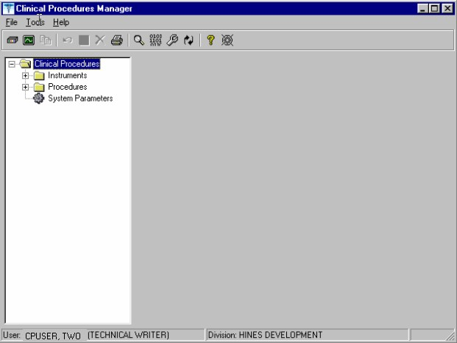
Figure 6-1

In most cases, you edit an existing automated instrument. The Mallinckrodt Clinivision, Olympus Endoworks, GE Medical Systems Muse and Viasys/Sensormedics Vmax automated device interfaces are exported with Clinical Procedures. You must edit all the automated instruments that you want to implement with necessary information.

Editing an Automated Instrument

The following list of fields applies to automated instruments:

* indicates fields that must be filled in for an active instrument to work properly.

BOLD indicates fields that are already populated when an automated instrument is exported.

Instrument Name

Printable Name Description

M Routine

Pkg. Code

Valid Attachment Types

If Bi-Directional Instrument is checked:

∗HL7 Inst ID

∗HL7 Link

- Notification Mailgroup
- Active
Serial Number (Optional)
Delete When Submitted (Optional) Default Extension (Optional)
IP Address (Optional) Port (Optional)
HL7 Unv Svc ID (Optional) Server Name (Optional) Share Name (Optional) Path Name (Optional)
Executable Name (Optional)

To edit an automated instrument:

- View the list of automated instruments. See Figure 6-2.

- Click on an automated instrument. The edit screen is displayed on the right side of the Clinical Procedures Manager window.

- Enter the fields that apply to the instrument you selected.

- Click Save when you are done.

- Click Print if you want to print an Automated Instrument report. See Printing Reports, p. 2-4.
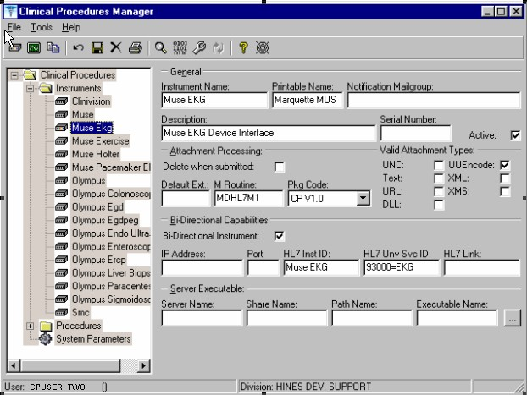
Figure 6-2

Here is a list of fields for automated instruments.

General: This section contains general information about the instrument.

Instrument Name: If you are editing an instrument, the name is filled in.

Note: This field must be filled in for an active instrument to work properly.

If you are adding a new instrument that is already supported by CP, do one of the following:
  - If the device is bi-directional, you can enter a name of your own choice (3-30 characters), such as Muse EKG (Tampa). The name does not have to be the vendor’s name.
  - If the device is uni-directional, you need to enter a CP defined name. In this case, you can contact TSO or NVS for the correct instrument name.

If you are adding a new instrument (bi-directional or uni-directional) that is not supported by CP, then you must enter a NOIS/Remedy help ticket. Keep in mind that adding unsupported instruments is a complex task and may cause some image quality problems.

Printable Name: Enter a name for the instrument report (3 to 30 characters). You can use the same name as the instrument name. This name is used as the printable name on reports. Must be filled in for an active instrument to work properly.

Notification Mailgroup: Enter the name of a local VistA mailgroup that contains a list of people, who will be notified if a problem arises with this automated instrument.

CP also exports a mailgroup called “MD DEVICE ERRORS” that can be used to populate this field. Enter MD and the field fills in with “MD DEVICE ERRORS’. The coordinator of this group is assigned during package installation. Must be filled in for an active instrument to work properly.

Description: Enter a description of the automated instrument (1-50 characters). Optional.

Serial Number: Enter the serial number of the automated instrument (1-50 characters). The serial number is used for documentation purposes. Optional.

Active: Select this option if you want to make the instrument active and able to transmit results. Do not select if the package coordinator wants to prevent data from a specific automated instrument from being processed. A package coordinator may want to enter the basic information for an automated instrument and not make it active. Must be selected to make this instrument active.

Attachment Processing: This section contains information about attachments.

Delete when Submitted: Select this option if the medical center does not want to store a duplicate report outside of Imaging, or if the vendor wants to delete files because of storage issues. The vendor determines whether or not the report files can be deleted.
This information is found in the vendor’s setup instructions. Optional.

Default Ext.: Enter a default file extension that is exported by the vendor, such as .html,
.jpg, and .pdf. This information should be obtained from the vendor or will be exported with future patches. Optional.

M Routine: Indicates the M routine used to process the HL7 message from the automated instrument (1-8 characters). Enter an M routine if the site is entering a new device. The routine must have a namespace of MDHL7* for any nationally released interfaces. This field also is automatically populated when an instrument interface patch is installed. If a local M routine is developed, use the local namespace. Refer to Appendix C – Instrument Processing Routines, p. 17-1, for a list of appropriate M routines for each instrument. Must be filled in for an active instrument to work properly.

Pkg. Code: Indicates which package is to process the instrument results. Must be filled in for an active instrument to work properly.

Medicine: Select if your study data is stored in the Medicine package. If a site is currently running Medicine and has an instrument used for Medicine, you can send the result to Medicine by selecting this field.
CP V1.0 Select if your study data is stored as a final report (in the format of an Imaging document) in Clinical Procedures.

Valid Attachment Types: Data types let CP know what kind of data output to expect from the automated instrument so that the data can be processed by the interface routines. The vendor setup instructions provide this information, or Clinical Procedures automatically exports this information. Must be filled in for an active instrument to work properly.

Here is a list of valid attachment types:

UNC (Universal Naming Convention or Uniform Naming Convention) - A PC format for specifying the location of resources on a local-area network (LAN).

UUENCODE (Unix-to-Unix ENCODE) - A set of algorithms for converting files into a set of ASCII characters that can be transmitted over a network.

Text - Text stored as ASCII codes.

XML (eXtensible Markup Language) - A specification developed by the World Wide Web Consortium (W3C), the organization that sets standards for the web. XML is a pared-down version of SGML. Designed especially for Web documents.

URL (Uniform Resource Locator) - The global address of documents and other resources on the World Wide Web.

XMS - An XML Style Sheet.

DLL (Dynamic Link Library) - A library of executable functions or data that can be used by a Windows application.

Bi-Directional Capabilities: This section contains specifics on the bi-directional capabilities of the instrument.

Bi-Directional Instrument: Select this option if this instrument supports a bi-directional interface.

IP Address: Enter the IP address for the instrument (7-15 characters). This field is for documentation purposes only. Refer to Chapter 11 – Setting Up HL7 Parameters, p. 11-1, for more information. Optional.

Port: Enter the port number for the instrument (a number between 1000 and 99999). This field is for documentation purposes only. Refer to Chapter 11 – Setting Up HL7 Parameters,
p. 11-1, for more information. Optional.

HL7 Inst ID: Enter the name of the actual device as provided by the vendor. This field is used to ID the device (3-30 characters). You can contact TSO or NVS for the correct ID. Must be filled in for an active instrument to work properly.

HL7 Unv Svc ID: This field defines what type of procedure the device can perform if the device can perform more than one procedure (1-48 characters). Optional.

HL7 Link: There is one unique link for each instrument. Select the appropriate link to the instrument from the dropdown list. Must be filled in for an active instrument to work properly.

Server Executable: The following fields make up the path for the automated instrument server (http://servername/servershare/serverpath/server.exe). Some devices do not produce reports that can be saved. Enter these fields if you want to capture a report from that type of device.

Server Name: The network name of the automated instrument (1-30 characters). Server Share: The name of the share drive on the automated instrument server (1-30 characters).
Server Path: The full directory path on the automated instrument share (1-150 characters). Server Executable: The name of the executable that produces the report on the automated instrument (1-30 characters). Browse to find the path where the server.exe program resides.

Adding an Automated Instrument

If a site has an instrument that needs to interface with CP, and that instrument is not exported with the Clinical Procedures package, you need to add the instrument. Make sure that CP supports the instrument interface. (The Mallinckrodt Clinivision, Olympus Endoworks, GE Medical Systems Muse and Viasys/Sensormedics Vmax automated device interfaces are exported with Clinical Procedures.) You can also find an updated list of supported devices on the CP website at http://vista.med.va.gov/ClinicalSpecialties/clinproc/.

Click Medical Device Interfaces on the left navigation bar, then click About Medical Interfaces.

1A warning screen displays when you attempt to add a new instrument (Fig. 6-3). This warning screen informs you that you should make sure CP supports the instrument interface you are attempting to add.
Figure 6-3

If you are adding a new instrument (bi-directional or uni-directional) that is not supported by CP, then you can use the New Instrument Request form, which is also located on the CP website at http://vista.med.va.gov/ClinicalSpecialties/clinproc/. You can also check p. 17-1 for a list of instruments. Keep in mind that adding unsupported instruments is a complex task and may cause some image quality problems.

In most cases, you can edit an existing automated instrument instead of adding a new one because several automated instruments are installed with Clinical Procedures. To view the names of devices, click the Instruments folder. A list of automated instruments is displayed on the left side of the Clinical Procedures Manager window (Figure 6-4).

1 Patch MD*1.0*4 September 2006 Add instrument warning added.

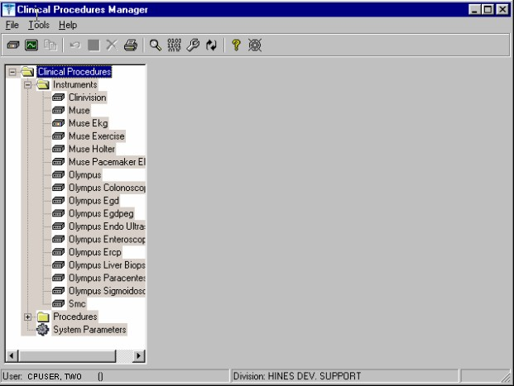
Figure 6-4

Indicates active instruments: Indicates non-active instruments:

- Select File > New > Instrument. The New Instrument screen is displayed.

- Enter a name that can be used to identify the automated instrument. If you are adding a new instrument that is already supported by CP, do one of the following:

  - If the device is bi-directional, you can enter a name of your own choice (3-30 characters), such as Muse EKG (Tampa). The name does not have to be the vendor’s name.
  - If the device is uni-directional, enter a CP defined name. In this case, you can contact TSO or NVS for the correct instrument name.

If you are adding a new instrument (bi-directional or uni-directional) that is not supported by CP, then you must you must enter a NOIS/Remedy help ticket. Keep in mind that adding unsupported instruments is a complex task and may cause some image quality problems.

This field must be filled in for an active instrument to work properly.

- Click OK. The Edit screen is displayed. Figure 6-5 is the edit screen for automated instruments. The Automated Instrument Name that you just entered is displayed.

- Enter data for each field as applicable. Refer to Editing an Automated Instrument, p. 6-3, for detailed field descriptions.

- Click Save when you are done.

- Click Print if you want to print an Automated Instrument report. See Printing Reports, p. 2-4.
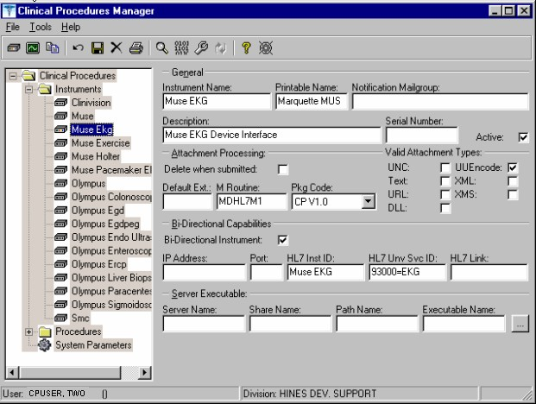
Figure 6-5

Using the Instrument Analyzer

Use the Instrument Analyzer to see if an automated instrument is ready to use with CP.

- Select Tools > Instrument Analyzer.
- Select the instrument that you want to analyze. Click Analyze. A window similar to Figure 6-6 is displayed. This window indicates the ready status of the instrument and lists other information as well.
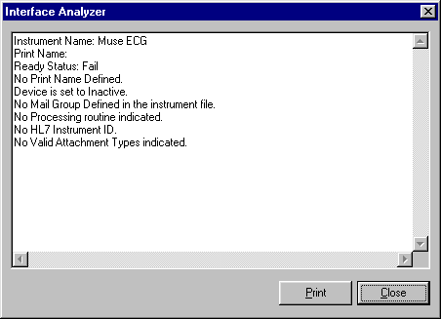
Figure 6-6

  - Ready Status - Pass or Fail. If the Ready Status is Fail, a list of missing fields for that automated instrument is displayed.
  - If an Imaging share directory has not been configured, the following message is displayed “No Imaging Share indicated in the System Parameters.”
  - If the M Routine (processing routine) is not in the MD or MC namespace, a warning is displayed indicating that the M Routine is not in the package namespace.

- Click Print or Close.

Step 3 – Setting Up Procedures
Information on procedures is not complete after populating the CP Definition file. You must go into CP Manager and enter the necessary fields before the package will work successfully.

If the INIT^MDPOST routine was run, a limited number of exported procedures are stored in a subfolder called Unassigned within the Procedures folder. If the INIT^MDPOST routine was not run, then you need to add new procedures. Since all procedures are initially inactive, you need to activate existing procedures and associate them with treating specialties.

Editing a Procedure

If the procedures have been exported, then you can edit them as needed. Using CP Manager, you must move each procedure that you want to activate from the Unassigned folder to a treating specialty folder.

  - Double-click the procedure. Now you can edit the procedure, complete the necessary fields, and make the procedure active.

  - To activate the procedure, be sure to select the Active field, and then fill in the following fields to ensure that the procedure works properly

Treating Specialty TIU Note Title Hospital Location

To edit a procedure:

- View the list of procedures. See Fig. 6-7.

- Click a procedure name. The edit screen is displayed on the right side of the Clinical Procedures Manager window.

- Enter the fields as applicable.

- Click Save when you are done.

- If you selected a different treating specialty folder, a confirmation message is displayed. Click OK to confirm that the procedure is in the correct treating specialty folder.

- Click Print if you want to print a Procedure report. See Printing Reports, p. 2-4.

Note: A procedure can only be deleted through the main menu bar. Refer to the section Deleting an Automated Instrument or Procedure, p. 2-3, for more information. If a procedure has been assigned through Consults, it cannot be deleted.
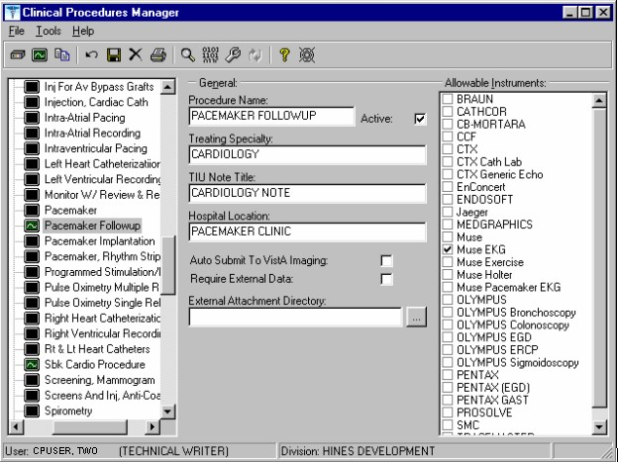
Figure 6-7

Here is a list of fields for Procedures.

General: This section contains general information about the procedure.

Procedure Name: Enter a name used to uniquely identify the procedure (3-30 characters). It is recommended that you enter the name in uppercase, such as PACEMAKER FOLLOWUP.

After you complete the edits, if you entered the name in upper case, the procedure name that you just entered is displayed in title case, Pacemaker Follow-up, (the first letter of every word is capitalized), in the left side of the CP Manager window. See Figure 6-6.

Active: Select if you want the procedure to be mapped to Consults. Only active procedures can be selected and linked to the Consults package. Be sure to fill in the Treating Specialty, TIU Note Title, and Hospital Locations fields. Do not select if you do not want procedures to display. Must be selected to make this procedure active.

Treating Specialty: Enter at least two letters of a treating specialty, such as CA for CARDIOLOGY, and then click the down arrow to select an appropriate match from the list. This list comes from the Treating Specialty (#45.7) file. Must be filled in for an active procedure to work properly.

TIU Note Title: Enter at least two letters of a TIU Note Title, such as CP CARD for CP CARDIOLOGY NOTE or CARD for CARDIOLOGY, and then click the down arrow to select an appropriate match from the list, which comes from the 8925.1 file. This title must be in the CLINICAL PROCEDURES CLASS. Must be filled in for an active procedure to work properly.

1Hospital Location: Enter at least two letters of a hospital location, such as CA for Cardiac Clinic, and then click the down arrow to select an appropriate match from the list, which comes from the #44 file. The Hospital Location file is the location where the workload credit for the procedure is tracked and is needed so CPRS can display the appropriate encounter form when prompted. Must be filled in for an active procedure to work properly.

You can enter a COUNT or NON-COUNT clinic for the hospital location.

  - A COUNT clinic captures workload. Patients must be checked in and checked out and an encounter form must be completed in order to collect workload.

  - A NON-COUNT clinic is used only for scheduling purposes and not for workload reporting.

There are three options available for setting up your clinics. The appropriate option for your site depends on how you currently do business and should be discussed with your project implementation manager.

  - COUNT clinic for scheduling purposes / NON-COUNT clinic for CP User. Patient must be checked in/out and encounter form completed on the scheduled appointment. CP User appointment will not collect workload.

  - NON-COUNT clinic for scheduling purposes / COUNT clinic for CP User. Appointment in scheduling package does not need to be checked in/out, nor does an encounter form need to be completed for the appointment. The check in/out and encounter form must be completed for the appointment created through CP User.

  - COUNT clinic for scheduling purposes that passes over to CP User. Patient must be checked in/out and encounter form must be completed. Note, however, that if you use Appointment Manager to check in the patient, you may have to wait up to thirty minutes before you can check-in the patient to CP. During the thirty-minute timeframe, the Patient Care Encounter (PCE) application establishes the visit date. (If you use the Scheduling application to capture workload, make sure that the clinic location is the same as the default location in the Hospital Location field.)

Auto Submit to VistA Imaging: Select if a procedure is processed by a bi-directional instrument and additional data does not need to be matched. The study is automatically

1 Patch MD*1.0*4 September 2006 Wording for Count/Non-count clinic modified.

submitted to VISTA Imaging. If this field is not selected, the study will be in the Ready to Complete status. Optional.

Require External Data: Select if you want this procedure to allow external attachments. For example, you might want to attach an independent report from a VA or non-VA health care facility. If you want to manually select external attachments, you must select this field.

Be sure the Allow Non-Instrument Attachments checkbox is selected in CP Manager > System Parameters. There is no default for this field.

External Attachment Directory: If you select Require External Data, enter the path where the data is located, or browse to locate a directory (3-150 characters). There is no default on this field. You can locate any directory on the LAN. This is the directory that CP User accesses to find attachments. This directory must be a network share directory that the VistA Imaging Background Processor can access.

Allowable Instruments: Select each automated instrument that provides results for this procedure. You can select more than one instrument for a procedure. If you only want to use external attachments, do not select any instruments.

You can select both Allowable Instruments and Require External Data. For example, you can have a pathology report from an endoscopy and you can attach the report to the procedure.

Adding a Procedure

Before you add a procedure, you can check to see if an appropriated titled procedure already exists that meets your needs. To view the names of procedures, select Procedures and then the appropriate treating specialty folder. A list of procedures is displayed. See Figure 6-8.
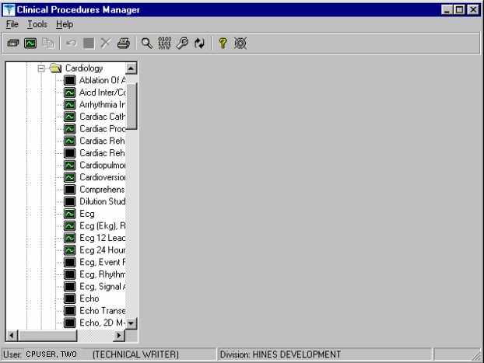
Figure 6-8

- Identifies an active procedure - Identifies an inactive procedure

If you decide that you do need to add a procedure, follow these instructions:

- Select File > New > Procedure.

- Enter the name of the procedure that you want to add. It is recommended that you enter the name in uppercase with a minimum of 3 characters and a maximum of 30 characters.

- Click OK. The Edit screen is displayed. Figure 6-9 is the edit screen for procedures. The Procedure Name that you just entered is displayed in the left side of the CP Manager window in the Unassigned folder.

- Enter data for each field as applicable. Refer to Editing a Procedure, p. 6-12, for detailed field descriptions.

- Click Save when you are done. After you complete the edits, if you entered the name in upper case, the procedure name that you just entered is displayed in title case.

- Click OK. The new procedure appears in the list on the left side of the CP Manager window. Check that the procedure is placed in the correct treating specialty folder.

- Click Print if you want to print a Procedure report. See Printing Reports, p. 2-4.
Figure 6-9

Step 4 – Setting Up System Parameters
System parameters are system-wide and affect all procedures and instruments. You must select Clinical Procedure On-Line, and fill in the Imaging Network Share and the VistA Scratch HFS Directory fields for CP to work properly. You can edit the other parameters as required for your site.

Here is a list of the system parameters:
* Indicates fields that must be filled in for CP to work properly. Allow non-instrument attachments
Bypass CRC Checking
Clinical Procedures Home Page
*Clinical Procedures On-Line 1* CP/BGP Transfer Directory CRC Values
Days to keep instrument data Imaging File Types
Offline Message Version Compatibility
- VistA Scratch HFS Directory

1 Patch MD*1.0*4 September 2006 Imaging Network Share directory name changed to CP/BGP Transfer Directory.

  - Click System Parameters, which is displayed under the Clinical Procedures folder. The System Parameters Edit window is displayed. See Figure 6-10.

  - Enter information in the necessary fields and in the optional fields as needed by your site.
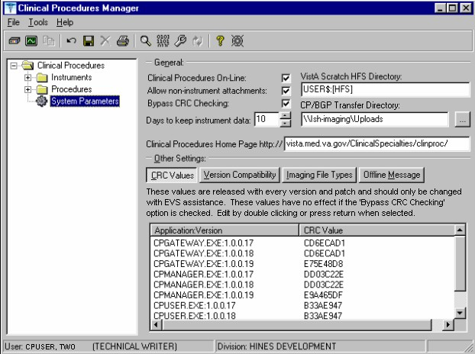
1Figure 6-10

Allow non-instrument attachments

Select if you want to let users attach files from the network to studies. If selected, the +Files icon displays in the Study window in CP User and lets the user select attachments. Indicates if external attachments (documents) are allowed including when an instrument has not created data.

1 Patch MD*1.0*4 September 2006 Imaging Network Share directory name changed to CP/BGP Transfer Directory.

Be sure to select Allow non-instrument attachments if you selected the Require External Data field in CP Manager for a specific procedure. If you do not select Allow non-instrument attachments, you will not be able to attach files to a procedure.

Bypass CRC Checking

Select if you want to bypass CRC (Cyclical Redundancy Check) during startup. When a CP application starts up, it can check with the server to be sure that the checksum of the application that is running is the same as the checksum of the application that was distributed. If the checksum values do not match, a message displays stating that the values do not match. Even if values don’t match, you can continue using CP.

The checksum value is associated with the version number of the software. You might want to bypass this check when your site is running CP in test mode. If you are running different versions of the application, then the checksum values will not match.

Clinical Procedures Home Page

Displays the Clinical Procedures home page and directs the browser to this page when accessed. This parameter is used by the client application in the Help menu when the user selects the option Clinical Procedures on the Web.

Note: The MDPOST routine in the KIDS build sets this field during installation. The data in the parameter is predefined. Do not modify this parameter unless the site is performing local modifications to the client software.

Clinical Procedures On-Line

Must select if you want to use CP User and CP Gateway. If this parameter is not selected, a warning message is displayed. (If a message has been entered into the Offline Message parameter, that message is displayed when the user tries to access CP User.)

This parameter is only effective when the VistA system is functioning and it is useful if you want to restrict access to Clinical Procedures. For example, you can set this field to offline if you are loading a newer version of CP.

CP/BGP Transfer Directory

Enter the shared directory that is accessed by the Imaging Background Processor (BGP) and CP Gateway. Reports generated from text need to be placed in a location that can be accessed by the BGP. The Network share must not reside physically on the Imaging RAID. You can also use Browse to select the directory. Must be filled in for CP to work properly.

CRC Values

A site can check that a specific build of the application is running on the client. This level of checking is not mandatory and you can use the Bypass CRC Checking parameter if the site does not want this level of security.

If a site is running more than one version of the application or is testing a new patch, this field can contain multiple entries, (Fig. 6-11). Each entry contains the name of the application with extension (no directory path) followed by a colon ‘:’ and the executable version number ‘#.#.#.#’. Each of these entries contains the CRC value for that particular version of the executable. You can also obtain CRC values for a version of an executable from the About menu or by selecting CP Manager > Tools > Calculate a File’s CRC Value.

Note: The MDPOST routine in the KIDS build sets this field during installation. The data in the parameter is predefined. Do not modify this parameter unless the site is performing local modifications to the client software
1Figure 6-11

Calculating a File’s CRC Value

You can calculate a file’s CRC (Cyclical Redundancy Check) value to determine if the file is the exact same file as the one that was distributed. CRC values are recalculated every time an application is compiled.

Select Tools > Calculate a file’s CRC Value.
- Select the file.
- You can copy the CRC value and paste it into a text file for reference purposes.

Days to keep instrument data

Enter the number of days (0-365) to save data from auto-instruments, after the data has been associated with a Clinical Procedures study. If the data has not been associated with a study, the data is not purged from the temporary storage area. Enter 0 or leave the field empty if you want the data to be retained forever.

Note: CP Gateway purges data daily. This purge only deletes the raw data that comes from the instrument. CP Gateway keeps data for a specified number of days based on the entry in “Days to keep Instrument Data”. Data older than this is purged. The data in Item Value field (#.1) and Item Text field (#.2) of the Upload Item multiple in the CP Results file (#703.1) are purged.

Imaging File Types

Verifies that a file type submitted by an instrument or user is acceptable and can be sent to the VistA Imaging RAID. The Open a Study option in CP User uses this system parameter to determine if a file is an acceptable file type, (Figure 6-12).

Note: The MDPOST routine in the KIDS build sets this field during installation. The data in the parameter is predefined. Do not modify this parameter unless the site is performing local modifications to the client software
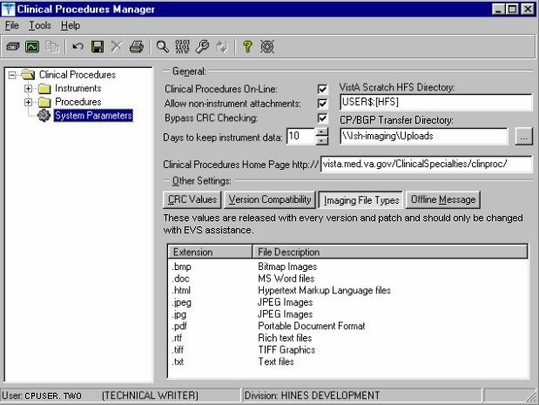
1Figure 6-12

Offline Message

Enter a message that users see when they try to activate CP User and Clinical Procedures is offline. This message only displays when the Clinical Procedures On-line parameter is not checked. See Figure 6-13.
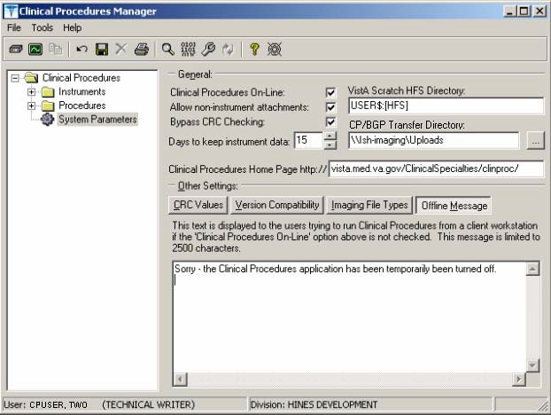
1Figure 6-13

Version Compatibility

Displays a list of client versions, identified by their executable name and windows file version, which are compatible with the currently running server version. More than one version of the software may be flagged as compatible for backward compatibility. See Figure 6-14.

To check the client version number:

1 Patch MD*1.0*4 September 2006 Imaging Network Share directory name changed to CP/BGP Transfer Directory.

- Open Windows Explorer and locate the Clinical Procedures folder.
- Right-click CPGateway.exe, or CPUser.exe., or CPManager.exe.
- Select Properties, and then click the Version tab. The version number, such as 1.0.0.17, is displayed.
- Go back to CP Manager. Double-click Clinical Procedures, and then click System Parameters.
- In the Version Compatibility tab, select each version that is compatible with the current server version, (Figure 6-14).

Note: The MDPOST routine in the KIDS build sets this field during installation. The data in the parameter is predefined. Do not modify this parameter unless the site is performing local modifications to the client software
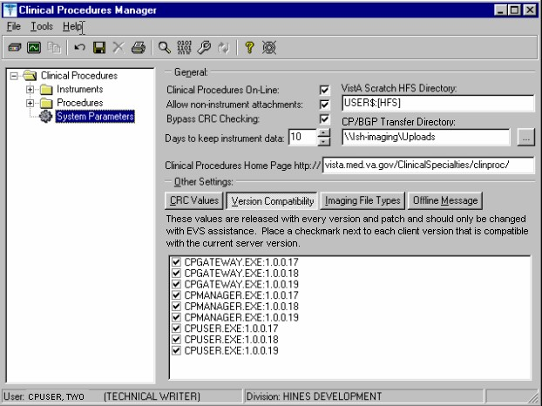
1Figure 6-14

If an executable version is not compatible, the following message is displayed when you try to use a Clinical Procedures application:

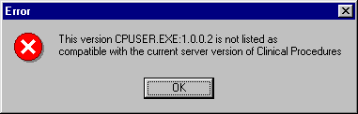
Figure 6-15

If the application is CP Manager, the user is allowed to continue. If the application is CP User, the user needs to contact IRM because the client needs to be upgraded to the current version.

VistA Scratch HFS Directory

Clinical Procedures uses the Host File Server (HFS) functionality in the VA Kernel to create reports. VistA broker processes require full read, write, and delete access to this directory. (Check with IRM about this directory.) If this directory is not filled in, CP tries to use the broker environment directory. Must be filled in for CP to work properly.

1Step 5 – Exported Kernel XPAR Parameters

There are four Kernel XAR Parameters exported with patch MD*1*14.
  - MD CHECK-IN PROCEDURE LIST
  - MD CLINIC QUICK LIST
  - MD CLINICS WITH MULT PROC
  - MD USE APPT WITH PROCEDURE

A new option called MD AUTO CHECK-IN SETUP was added to setup and implement procedures that will use auto study check-in. Once a procedure is set up to use the auto study check-in functionality in the MD CHECK-IN SETUP option, the software will check-in any existing order requests with the status of “PENDING,” “ACTIVE,” and “SCHEDULED” in the Consult Request Tracking package.

Note: If your site uses appointments, schedule them before you enter the procedures for auto check-in. If you do not, the patients associated with those appointments will need to be manually checked in.

This option collects the following information:

  - Use Appointment with procedure? (Yes/No) (Required) – The default is “NO”, if the site does not schedule procedures before the order is entered. Enter “YES” if the procedure appointment is scheduled before the order is entered and the ordering provider selects the appointment for the procedure during ordering in CPRS.
  - Procedure (Required)– Enter the CP Definition that will be using the auto study check-in functionality.
  - Schedule Appointment? (Required) - Enter 0 for None, 1 for Outpatient, 2 for Inpatient, or 3 for Both. This indicates that the site schedules appointments for inpatient, outpatients, both, or none.
  - Clinic (Optional) – Enter the hospital location(s) that will be used for scheduling the procedure.

Note: If no clinic is entered in the setup, CP will use the hospital location defined in the HOSPITAL LOCATION field of the CP Definition file (#702.01) as the location of the visit for the CP study check-in.

The following two pages contain a screen capture of the MD AUTO CHECK-IN SETUP option:

1 Patch MD*1.0*14 March 2008 Exported Kernel XPAR Parameters, option, and screen sample added.

Select OPTION NAME: MD AUTO CHECK-IN SETUP Auto Study Check-In Setup Auto Study Check-In Setup
Use Appointment with procedure? NO// ?
Default should be 'N' as most sites do not schedule procedures
before the order is entered. Select 'Y' if the procedure appointment is scheduled before the order is entered and the ordering provider selects the appointment for the procedure.
Enter either 'Y' or 'N'.
Use Appointment with procedure? NO// Procedure: ?
Enter a CP Definition for the procedure to have auto CP study check-in.
Answer with CP DEFINITION NAME
Do you want the entire CP DEFINITION List? N (No)

Procedure: COLONOSCOPY Schedule Appointment?: ?

REQUIRED field for the procedure to have auto CP study check-in. Enter a "^" will exit completely.

Enter 0 if you do not schedule appointments.
- if you only schedule appointments for outpatients.
- if you only schedule appointments for inpatients.
- if you schedule appointments for both 1 and 2. Select one of the following:
  - None
  - Outpatient
  - Inpatient
  - Both

Schedule Appointment?: Both Clinic: ?
Only required, if appointments are scheduled for the procedure. Enter the clinic used for scheduling the procedure.

Answer with HOSPITAL LOCATION NAME, or ABBREVIATION, or TEAM
Do you want the entire 112-Entry HOSPITAL LOCATION List? N (No) Clinic: GI LAB PIPER,ALPHA
Enter another clinic for the same procedure? NO// ?
Enter either 'Y' or 'N', if you want to assign more than one clinic. Enter another clinic for the same procedure? NO//YES
Clinic: TEST
- TEST/PROSTHETICS OBRIEN,FRANCES U
- TEST1
- TEST1234
- TEST3232
CHOOSE 1-4: 2 TEST1
Enter another clinic for the same procedure? NO// Procedure: ?
Enter a CP Definition for the procedure to have auto CP study check-in.

COLONOSCOPY
Answer with CP DEFINITION NAME
Do you want the entire CP DEFINITION List? N (No)
Procedure: EKG, ROUTINE (12 LEADS)
Schedule Appointment?: 0 None
Procedure:
>

Scheduled Options

1Two options are added by patch MD*1*14.

NAME: MD SCHEDULED STUDIES MENU TEXT: Scheduled Studies TYPE: run routine CREATOR: REDACTED
PACKAGE: CLINICAL PROCEDURES
DESCRIPTION: This option is tasked to run daily. It will process the HL7 messages that need to be sent to the device on a daily basis for CP studies.
ROUTINE: EN1^MDWORSR SCHEDULING RECOMMENDED: YES UPPERCASE MENU TEXT: SCHEDULED STUDIES

NAME: MD STUDY CHECK-IN MENU TEXT: Study Check-in TYPE: run routine CREATOR: REDACTED
PACKAGE: CLINICAL PROCEDURES
DESCRIPTION: This option is tasked to run daily. It checks-in CP studies for procedures that require multiple encounters such as Hemodialysis, Respiratory Therapy, and Sleep Studies.
ROUTINE: CLINICPT^MDWORSR SCHEDULING RECOMMENDED: YES UPPERCASE MENU TEXT: STUDY CHECK-IN

The two options needs to be scheduled to run daily.
Schedule the option MD SCHEDULED STUDIES to start the next day after patch installation at 4am. This task will process the studies that are associated with the appointments that are dated for that day. If the procedure request is associated with a future appointment, the study that is auto checked-in will have a status of “New”. The MD SCHEDULED STUDIES task will process the study and change the status to “Pending Instrument Data”.

Sample Screen capture of the scheduled option:

QUEUED TO RUN AT WHAT TIME: MAY 22,2007@04:00 DEVICE FOR QUEUED JOB OUTPUT:
QUEUED TO RUN ON VOLUME SET: site volume RESCHEDULING FREQUENCY: 1D
TASK PARAMETERS:
Edit Option Schedule Option Name: MD SCHEDULED STUDIES
Menu Text: Scheduled Studies TASK ID: 2619819
(R)
Select OPTION to schedule or reschedule: MD
- MD SCHEDULED STUDIES Scheduled Studies
- MD STUDY CHECK-IN Study Check-in
CHOOSE 1-2: 1 MD SCHEDULED STUDIES Scheduled Studies

1 Patch MD*1.0*14 March 2008 Add Scheduled Options.

Insert
Press <PF1>H for help
COMMAND:
SPECIAL QUEUEING:

Schedule the option MD STUDY CHECK-IN to start to run the next day after patch installation at 5am. If a procedure request requires multiple encounters, this task will auto check-in the study for the multiple encounters using the appointment scheduled. The RESCHEDULING FREQUENCY can be more than 1D (1 day), if your site schedule appointment for the day after 5am and the task will not be able to pick it up.
Insert
Press <PF1>H for help
COMMAND:
Option Name: MD STUDY CHECK-IN
Menu Text: Study Check-in TASK ID: 2620037

QUEUED TO RUN AT WHAT TIME: MAY 22,2007@05:00 DEVICE FOR QUEUED JOB OUTPUT:
QUEUED TO RUN ON VOLUME SET: site volume RESCHEDULING FREQUENCY: 1D
TASK PARAMETERS:
SPECIAL QUEUEING:
Study Check-in
Select OPTION to schedule or reschedule: MD STUDY CHECK-IN
...OK? Yes// (Yes)
(R)
Edit Option Schedule

Setting Up Consults for Clinical Procedures
This section explains how to set up services and procedures in the Consults package. Be sure the GMRC*3*17 patch is present before you implement Consults.

Topics discussed in this chapter are:

  - Step 1 – Setting Up Consult Services
  - Step 2 – Creating Consult Procedures

Step 1 – Setting Up Consult Services
Consult services must be set up so that users can receive alerts about procedure status and be able to process the procedure. You need to determine if a consult service exists that can be used only for CP procedures or if you need to create new consult services. A CP consult service is a subspecialty service that deals specifically with CP procedures. Be sure to use the CP prefix when you add a service.

Create a New Consult Service/Define an Interpreter:

You use the Consult Management menu to create a new consult service, to define an interpreter, and add that new consult service under the All Services specialty/subspecialty. A new consult service has to be added to the “All Services” specialty/subspecialty before the CP procedures will appear on the Consults tab in CPRS.

RPT Consult Tracking Reports ... SS Set up Consult Services
SU Service User Management CS Consult Service Tracking RX Pharmacy TPN Consults
GU Group update of consult/procedure requests UA Determine users' update authority
UN Determine if user is notification recipient
NR Determine notification recipients for a service TD Test Default Reason for Request
LH List Consult Service Hierarchy PR Setup procedures
CP Copy Prosthetics services DS Duplicate Sub-Service
IFC IFC Management Menu ... TP Print Test Page

****** Select Consult Management Option: SS Set up Consult Services Select Service/Specialty:CP CARDIOLOGY
Are you adding 'CP CARDIOLOGY' as a new REQUEST SERVICES (the 123RD)? No// Y
(Yes)

SERVICE NAME: CP CARDIOLOGY// <RET>

ABBREVIATED PRINT NAME (Optional): CARDIOL
INTERNAL NAME: <RET> Select SYNONYM: <RET> SERVICE USAGE: <RET> SERVICE PRINTER: <RET>
NOTIFY SERVICE ON DC: <RET>
REPRINT 513 ON DC: <RET>
PREREQUISITE:
No existing text Edit? NO// <RET>
PROVISIONAL DX PROMPT: <RET> PROVISIONAL DX INPUT: <RET> DEFAULT REASON FOR REQUEST: <RET>
No existing text Edit? NO// <RET>
RESTRICT DEFAULT REASON EDIT: <RET>

Inter-facility information IFC ROUTING SITE: <RET> IFC REMOTE NAME: <RET>
Select IFC SENDING FACILITY: <RET>

To define an interpreter, you can enter a user name in one of the following fields.

Note: Users entered into Update Users W/O Notifications or Update Teams W/O Notifications will not receive alerts.

- INDIVIDUAL TO NOTIFY
- SERVICE TEAM TO NOTIFY
- NOTIFICATION BY PT LOCATION
- UPDATE USERS W/O NOTIFICATIONS
- UPDATE TEAMS W/O NOTIFICATIONS

SERVICE INDIVIDUAL TO NOTIFY: CPPROVIDER, ONE Select SERVICE TEAM TO NOTIFY: CONSULT TEAM Select NOTIFICATION BY PT LOCATION: <RET> PROCESS PARENTS FOR NOTIFS: <RET>
Select UPDATE USERS W/O NOTIFICATIONS: CPUSER, THREE
Select UPDATE TEAMS W/O NOTIFICATIONS: <RET>
Select UPDATE USER CLASS W/O NOTIFS: <RET>
Select ADMINISTRATIVE UPDATE USER: <RET> Select ADMINISTRATIVE UPDATE TEAM: <RET> PROCESS PARENTS FOR UPDATES: <RET>

SPECIAL UPDATES INDIVIDUAL: <RET> RESULT MGMT USER CLASS: <RET> UNRESTRICTED ACCESS: <RET>
Select SUB-SERVICE/SPECIALTY: <RET>

Add/Edit Another Service? NO// <RET>

Now the service you just created must be added to the All Services service/specialty.

Select Consult Management Option: SS Set up Consult Services Select Service/Specialty:ALL SERVICES GROUPER ONLY SERVICE NAME: ALL SERVICES// <RET>
ABBREVIATED PRINT NAME (Optional): ALL// <RET>
Select SYNONYM: <RET>
SERVICE USAGE: GROUPER ONLY// <RET>
SERVICE PRINTER: <RET> NOTIFY SERVICE ON DC: <RET> REPRINT 513 ON DC: <RET> PREREQUISITE:
No existing text Edit? NO// <RET>
PROVISIONAL DX PROMPT: <RET> PROVISIONAL DX INPUT: <RET> DEFAULT REASON FOR REQUEST:
No existing text Edit? NO// <RET>
RESTRICT DEFAULT REASON EDIT: <RET>

SERVICE INDIVIDUAL TO NOTIFY: CPPROVIDER, ONE Select SERVICE TEAM TO NOTIFY: CONSULT TEAM Select NOTIFICATION BY PT LOCATION: <RET> PROCESS PARENTS FOR NOTIFS: <RET>
Select UPDATE USERS W/O NOTIFICATIONS: CPUSER, THREE
Select UPDATE TEAMS W/O NOTIFICATIONS: <RET> Select UPDATE USER CLASS W/O NOTIFS: <RET> Select ADMINISTRATIVE UPDATE USER: <RET> Select ADMINISTRATIVE UPDATE TEAM: <RET> PROCESS PARENTS FOR UPDATES: <RET>

SPECIAL UPDATES INDIVIDUAL: <RET> RESULT MGMT USER CLASS: <RET> UNRESTRICTED ACCESS: <RET>
Select SUB-SERVICE/SPECIALTY: CP CARDIOLOGY
Are you adding 'CP CARDIOLOGY' as a new SUB-SERVICE (the 13TH for this REQUEST SERVICES)? No// Y
(Yes) MNEMONIC:
Select SUB-SERVICE/SPECIALTY: <RET>

Add/Edit Another Service? NO//<RET>

Editing Users of an Existing Consult Service:

You can also use the Service User Management option to edit a Consult Service’s Update Users fields.

RPT Consult Tracking Reports ... SS Set up Consult Services
SU Service User Management CS Consult Service Tracking RX Pharmacy TPN Consults
GU Group update of consult/procedure requests UA Determine users' update authority
UN Determine if user is notification recipient
NR Determine notification recipients for a service TD Test Default Reason for Request
LH List Consult Service Hierarchy PR Setup procedures
CP Copy Prosthetics services DS Duplicate Sub-Service
IFC IFC Management Menu ... TP Print Test Page

Select Consult Management Option: SU Service User Management Select Service/Specialty: cp cardiology
Make sure data is entered for the applicable fields listed below: SERVICE INDIVIDUAL TO NOTIFY: CPPROVIDER, ONE Select SERVICE TEAM TO NOTIFY: CONSULT TEAM
Select NOTIFICATION BY PT LOCATION: <RET>
Select UPDATE USERS W/O NOTIFICATIONS: CPUSER, THREE
Select UPDATE TEAMS W/O NOTIFICATIONS: <RET> Select UPDATE USER CLASS W/O NOTIFS: <RET> Select ADMINISTRATIVE UPDATE USER: <RET> Select ADMINISTRATIVE UPDATE TEAM: <RET> SPECIAL UPDATES INDIVIDUAL: <RET>

Select Service/Specialty: <RET>

Step 2 - Creating Consult Procedures
Consult procedures in the GMRC file (#123.3) must be linked to clinical procedures. Be sure to use the “CP” prefix when you create new consult procedures to differentiate them from other consult procedures.

The following example shows how to create the consult procedure CP EKG 12 LEAD STAT and link it to the clinical procedure definition EKG, ROUTINE (12 LEADS).

1Note: Add the text “Visit Date: |VISIT DATE|“ to the first line of the DEAFULT REASON FOR REQUEST field. This will allow CP to pick up the appointment date/time from CPRS for the order request and use it for the auto CP study check-in. If you do not use appointments at all, you can skip the adding of the text. If your site schedules appointments, but the ordering provider does not select the appointment during ordering, you can still add the text. If there is already text in the DEFAULT REASON FOR REQUEST field, add the visit date text to the very first line.

Select Consult Management
Option:
PR Setup procedures

Select Procedure:CP EKG 12 LEAD STAT NAME: CP EKG 12 LEAD STAT// <RET> INACTIVE: NO// <RET>
Select SYNONYM: EKG// <RET>
INTERNAL NAME: <RET>
Select RELATED SERVICES: CP CARDIOLOGY// <RET>
TYPE OF PROCEDURE: ECG// <RET>
CLINICAL PROCEDURE: EKG, ROUTINE (12 LEADS)// <RET>

PREREQUISITE:
No existing text Edit? NO// <RET>
PROVISIONAL DX PROMPT: REQUIRED// <RET> PROVISIONAL DX INPUT: LEXICON// <RET> DEFAULT REASON FOR REQUEST:
1>Visit Date: |VISIT DATE|
2>Patient’s heart is beating abnormally. Needs analysis.
Edit? NO// <RET>
RESTRICT DEFAULT REASON EDIT: NO EDITING// <RET>

Orderable Item Updated

Field Descriptions:

NAME: The name of the procedure as it appears in the GMRC Procedure file (#123.3).

INACTIVE: Indicates if a procedure is no longer in use.

SYNONYM: Enter other names commonly used to refer to this procedure.

1 Patch MD*1.0*14 March 2008 Added visit date setup for auto study check in.

INTERNAL NAME: Enter a name for the procedure that is used internally by the facility.

RELATED SERVICES: Indicates which Consult services from the Request Services (#123.5) file are responsible for processing requests for this procedure.

TYPE OF PROCEDURE: Not applicable.

CLINICAL PROCEDURE: Provides a mapping between the CP Definitions (#702.01) file and the GMRC Procedures file. (CP definition entries must be active before you can map them.) Orders placed for a procedure having a valid entry in this field are processed and resulted using the Clinical Procedures package.

PREREQUISITE: Enter information on any consults or procedures that must be performed prior to ordering this consult. This field is presented to the ordering person upon selecting a Consult service and lets the ordering person abort the ordering if necessary. TIU objects may be embedded within this field, which are resolved for the current patient during ordering. Any TIU objects must be contained within vertical bars, such as |BLOOD PRESSURE|.

PROVISIONAL DX PROMPT: Used by CPRS to determine how to prompt for the provisional diagnosis when ordering this procedure. Set to OPTIONAL if you want the user to be prompted for the provisional diagnosis but also can let the user bypass answering the prompt. Set to SUPPRESS if you do not want the user to be presented with the provisional diagnosis prompt.
Set to REQUIRED if you want to enforce the user to answer the prompt before continuing to place the order.

PROVISIONAL DX INPUT: Determines the method that CPRS uses to prompt the user for input of the provisional diagnosis when ordering this procedure. Set to FREE TEXT and the user may type any text from 2-80 characters in length. Set to LEXICON and the user is required to select a coded diagnosis from the Clinical Lexicon.

DEFAULT REASON FOR REQUEST: Enter default text that can be used as the reason for request when ordering this procedure. This field allows boilerplate text to be imported into the reason for request. If the user places an order using a quick order having boilerplate text, that text supersedes any default text stored in this field. This field may contain any text including TIU objects. TIU Objects must be enclosed in vertical bars, such as |PATIENT NAME|.

RESTRICT DEFAULT REASON EDIT: Set to UNRESTRICTED, NO EDITING, or ASK
ON EDIT ONLY. If ASK ON EDIT ONLY is used, the user can only edit the default reason if the order is edited before releasing to the service. If a default reason for request exists, the option set in this field affects the ordering person’s ability to edit the default reason.

Setting Up CPRS for Clinical Procedures
This section explains how to set up notifications and parameters in the CPRS package. Topics discussed in this chapter are:

  - Step 1 – Setting Up the Notification - Recommended
  - Step 2 – Editing Parameters – Some parameters must be defined. See Step 2 – Editing Parameters, p. 9-3.

Step 1 – Setting Up the Notification
You must enable the CONSULT/PROC INTERPRETATION notification if you want to receive the “Ready for interpretation” alert in CPRS. You can enable the alert for one user, several users, or for the entire service. Use the Notification Mgmt Menu [ORB NOT COORD MENU].

- Enable/Disable Notifications
- Erase Notifications
- Set Urgency for Notifications (GUI)
- Set Deletion Parameters for Notifications
- Set Default Recipient(s) for Notifications
- Set Default Recipient Device(s) for Notifications
- Set Provider Recipients for Notifications
- Flag Orderable Item(s) to Send Notifications
- Archive(delete) after <x> Days
- Forward Notifications ...
- Set Delays for Unverified Orders ...
- Set Notification Display Sort Method (GUI)
- Send Flagged Orders Bulletin
- Determine Recipients for a Notification
- Display Patient Alerts and Alert Recipients
- Enable or Disable Notification System
- Display the Notifications a User Can Receive

Select Notification Mgmt Menu Option: 1 Enable/Disable Notifications

Set PROCESSING FLAG Parameters for Notifications Processing Flag may be set for the following:
1 | User | USR | [choose | from | NEW PERSON]
2 | Team (OE/RR) | OTL | [choose | from | OE/RR LIST]
3 | Service | SRV | [choose | from | SERVICE/SECTION]
4 | Location | LOC | [choose | from | HOSPITAL LOCATION]
5 | Division | DIV | [HINES DEV. EVALUATION]
6 | System | SYS | [EVL.DEV.ISC-CHICAGO.VA.GOV]
7 | Package | PKG | [ORDER ENTRY/RESULTS REPORTING]

Enter selection: Set this parameter according to the individual preference of your site.
Setting Processing Flag

Select Notification: ?

There are currently no entries for Notification.

Answer with OE/RR NOTIFICATIONS NUMBER, or NAME, or PACKAGE ID, or MESSAGE TEXT
Do you want the entire 49-Entry OE/RR NOTIFICATIONS List? N (No)

Select Notification: CONSULT/PROC INTERPRETATION
Are you adding CONSULT/PROC INTERPRETATION as a new Notification? Yes// <RET>
YES

Notification: CONSULT/PROC INTERPRETATION// <RET> CONSULT/PROC INTERPRETATION CONSULT/PROC INTERPRETATION
Value: ?

Code indicating processing flag for the entity and notification.
Select one of the following: M Mandatory
E Enabled
D Disabled Value: Enabled
  - Select Mandatory to specify that the notification cannot be turned off by the user.
  - Select Enabled to specify that the user can turn off the notifications.
  - Select Disabled to specify that notifications are not used.

After you set up the notification, you can set up quick orders and place them on appropriate order menus. Refer to the CPRS Setup Guide, which can be found in the VistA Documentation Library (VDL).

Step 2 – Editing Parameters
You can edit the following parameters in CPRS to indicate who should enter Patient Care Encounter information and how Windows messages are sent. You can also add CP User to the CPRS Tools menu.

Use the CPRS Manager menu to set these parameters:

  - Ask Encounter Update (ORWPCE ASK ENCOUNTER UPDATE) Required.
  - Broadcast Messages to Other Apps (ORWOR BROADCAST MESSAGES) Required.
  - Force PCE Entry (ORWPCE FORCE PCE ENTRY) Required.
  - Add CP User to the CPRS Tools Menu Optional.

Ask Encounter Update (ORWPCE ASK ENCOUNTER UPDATE)

The ORWPCE ASK ENCOUNTER UPDATE parameter determines if the user should be prompted to enter encounter information when signing a note. The Encounter Form in the AICS package is used to collect workload data. If a specific Encounter Form is not set up and linked to a hospital location, a generic Encounter Form is presented. Each service that has a study associated with it must set this parameter to Always.

Select OPTION NAME: CPRS MANAGER MENU ORMGR CPRS Manager Menu

CL Clinician Menu ...
NM Nurse Menu ...
WC Ward Clerk Menu ...
PE CPRS Configuration (Clin Coord) ... IR CPRS Configuration (IRM) ...
Select CPRS Manager Menu Option: IR CPRS Configuration (IRM) OC Order Check Expert System Main Menu ...
TI ORMTIME Main Menu ...
UT CPRS Clean-up Utilities ... XX General Parameter Tools ...
Select CPRS Configuration (IRM) Option: XX General Parameter Tools LV List Values for a Selected Parameter
LE List Values for a Selected Entity LP List Values for a Selected Package LT List Values for a Selected Template EP Edit Parameter Values
ET Edit Parameter Values with Template EK Edit Parameter Definition Keyword

Select General Parameter Tools Option: EP Edit Parameter Values
--- Edit Parameter Values ---

SELECT PARAMETER DEFINITION NAME: ORWPCE ASK ENCOUNTER UPDATE Ask
Encounter Update

ORWPCE ASK ENCOUNTER UPDATE may be set for the following:

  - User USR [choose from NEW PERSON]
  - Location LOC [choose from HOSPITAL LOCATION]
  - Service SRV [choose from SERVICE/SECTION]
  - Division DIV [HINES DEVELOPMENT]
  - System SYS [REDACTED—PUT YOUR SYSTEM HERE]
  - Package PKG [ORDER ENTRY/RESULTS REPORTING]

Enter selection: Set this parameter according to the individual preference of your site.
-------- Setting ORWPCE ASK ENCOUNTER UPDATE --------
ASK ENCOUNTER UDPATE: ALWAYS

If the site wants credit for workload for the inpatient and outpatient, select Always at this prompt.

Broadcast Messages to Other Apps (ORWOR BROADCAST MESSAGES)

The ORWOR BROADCAST MESSAGES parameter tells CPRS to send a message to all VistA applications stating that a new patient record is open or a new TIU note has been selected. This parameter setting allows all applications on the desktop, such as CP User, and VistA Imaging, to synchronize with CPRS. Always set this parameter to System.

Select PARAMETER DEFINITION NAME: ORWOR BROADCAST MESSAGES Broadcast
Window Messages to Other Apps

ORWOR BROADCAST MESSAGES may be set for the following:

1 User | USR | [choose from NEW PERSON]
5 System | SYS | [REDACTED – YOUR SYSTEM NAME WILL BE HERE]
10 Package | PKG | [ORDER ENTRY/RESULTS REPORTING]

Enter selection: 5 System REDACTED

- Setting ORWOR BROADCAST MESSAGES for System: REDACTED – YOUR SYSTEM NAME WILL BE HERE -
Enable Broadcasting Windows Messages: YES// <RET>

Force PCE Entry (ORWPCE FORCE PCE ENTRY)

If encounter data is missing, the user should be asked to enter the missing data. You must select Yes to the Force GUI PCE ENTRY prompt.

Select PARAMETER DEFINITION NAME: ORWPCE FORCE PCE ENTRY Force PCE Entry

ORWPCE FORCE PCE ENTRY may be set for the following:

1 | User | USR | [choose | from NEW PERSON]
2 | Location | LOC | [choose | from HOSPITAL LOCATION]
3 | Service | SRV | [choose | from SERVICE/SECTION]
4 | Division | DIV | [REDACTED]
5 | System | SYS | [REDACTED]
6 | Package | PKG | [ORDER ENTRY/RESULTS REPORTING]

Enter selection: Set this parameter according to the individual preference of your site.
---------- Setting ORWPCE FORCE PCE ENTRY ----------
FORCE GUI PCE ENTRY: ?

Do you wish to force entry of PCE data in the CPRS GUI?.

Select one of the following:

    - NO
    - YES

FORCE GUI PCE ENTRY: 1 YES

When data is needed and the user is the primary encounter provider, the ORWPCE FORCE PCE ENTRY parameter is checked to determine if the user needs to enter the missing encounter information before being allowed to sign the note. When this parameter is set to YES, users are asked to enter the missing data. When this parameter is set to NO, users are asked if they want to enter encounter information.

When data is needed and the user is the primary encounter provider, continued checks are made during the note-signing process to determine if there is still missing data. The user is continually prompted to enter the data, regardless of the ORWPCE FORCE PCE ENTRY setting.

If data is not needed or if the user is not the primary encounter provider, “Yes” and “No” prompts are displayed and the user determines what to enter.

Add CP User to the CPRS Tools Menu (ORWT TOOLS MENU)

You can use the ORWT TOOLS MENU to set up access to CP User from the CPRS Tools menu. You can set up the options for the site and then override them as appropriate at the division, service, and user levels. Here are some guidelines:

  - Enter each item in the format, NAME=COMMAND.

NAME is the name that displays on the menu, such as CP User. If you want to provide keyboard access, you can also enter & in front of a letter, such as CP &User.

COMMAND is the directory path followed by the executable name.

Notes:

  - You must surround a path that contains space characters, such as C:\Program Files\... with quotation marks. You can also include switches in the path. Here’s an example:

CP User=”C:\Program Files\Clinical Procedures\CP User.exe” /cprs
/dfn=%DFN /s=%SRV /p=%PORT

  - You can pass context-sensitive parameters, which are entered as placeholders, and then converted to the appropriate values at runtime. The placeholder parameter used with Clinical Procedures is:

%DFN Indicates the DFN of the currently selected patient in CPRS. This parameter passes the current patient to Clinical Procedures. You can also use %DFN as a placeholder in other CP applications.

%SRV Indicates the name of the server that CPRS is currently connected to. This parameter passes the current server name to Clinical Procedures. You can also use %SRV as a placeholder in other CP applications.

%PORT Indicates the listener port that CPRS is currently communicating through.
This parameter passes the current listener port to Clinical Procedures. You can also use %PORT as a placeholder in other CP applications.

  - Command line switches, such as nonsharedbroker, can be used. Refer to Appendix A - CP Application Startup Options and Command Line Switches, p. 15-1 for more information.

Example: Create a tools menu option that contains CP User.

From the system prompt, do the following:

- User USR [choose from NEW PERSON]
- Location LOC [choose from HOSPITAL LOCATION]
2.5 Service SRV [choose from SERVICE/SECTION]
- Division DIV [REGION 5]
- System SYS [OEC.ISC-SLC.VA.GOV] Enter selection: 1 User NEW PERSON
Select NEW PERSON NAME: CPUSER, FOUR CF
-------------- Setting ORWT TOOLS MENU for User: DELAWARE,JOHN --------------
Select Sequence: 1
Are you adding 1 as a new Sequence? Yes// YES
Sequence: 1// 1
Name=Command: CP User=”<directory name>\CP User.exe” /cprs /dfn=%DFN /s=%SRV /p=%PORT
Select Sequence:
CPRS GUI Tools Menu ORWT TOOLS MENU may
Select PARAMETER DEFINITION NAME: orwt TOOLS MENU
be set for the following:
Fig. 9-1

When you select “CP User” from the CPRS Tools menu, CP User is displayed and the actual server, port, and global reference are substituted for the command line switches.

Working with CP Gateway
CP provides bi-directional capabilities for the HL7 interface. With this feature, the VistA system can send information about a patient procedure directly to the instrument, which eliminates duplicate entries of patient data into an instrument. CP Gateway sends the results to the VistA M environment and converts the data into a usable format for the CP and VistA Imaging applications.

Every night after midnight, CP Gateway purges data based on the value in the Days to keep Instrument Data field (See CP Manager > System Parameters). This purge only deletes the raw data that comes from the instrument. The data to be purged has already been matched to a study.

The following flowchart describes what the CP Gateway does.

CP Gateway
Gateway Started

Gateway checks for new instrument data to convert

No
Is data waiting?
Yes
Was study reference in HL7 msg?
Yes
No
No
Is procedure marked auto submit?
Yes
No
Shutdown Gateway?
Yes
Gateway Halted.

Study status set to Submitted or error if submission fails

Study is submitted to VistA Imaging

Study status set to Ready to Complete

Attachments are automatically linked to the study.
Attachments are processed
Procedure is performed and Instrument transmits data via HL7 to VistA

Starting the CP Gateway application is the same as starting any VistA Broker application, which requires a VistA application and the appropriate command line switches. Refer to Appendix A - CP Application Startup Options and Command Line Switches for more information. ¹The CP Gateway application can be run on a server or on a workstation. The application must be launched by a person with VistA Access and Verify codes. This person must be assigned the MD GUI MANAGER menu option to be able to access the CP Gateway. DO NOT run the CP Gateway on a workstation that is running VistA Imaging.

Note: Remember to re-start the CP Gateway, if the workstation is re-started for some reason such as upgrade and patches. This will keep the connection up for the device interface and CP.

Note 2: It is not necessary but if you want to configure a stand-alone server or workstation for the CP Gateway, use the VA Naming Conventions. Your domain will be VHAxxx where xxx is the site's 3- character assigned name (e.g.,VHAISH is the domain name at Hines Field Office). You could use the following server name: VHA + 3-letter site name + CPG i.e., VHAISHCPG

After the application starts, three checks are performed to ensure that the proper environment exists.
- Verifies that the CP Gateway is a compatible version with the server installation.
- Verifies that the CP Gateway is the only one running in the selected environment (such as UCI and Volume set).
- Verifies that the CP Gateway has Read Write and Delete access to the directory stored in the MD IMAGING XFER DIRECTORY parameter.

If any of these checks fail, the processor shuts down. If the checks are acceptable, the application displays on the workstation as shown, Figure 10-1.
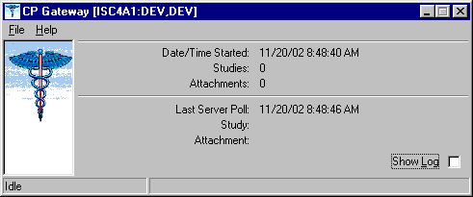
Figure 10-1

Click Show Log to view the application log. A session log is kept for the currently running session but is not saved to the workstation’s hard drive for patient security reasons.

1 Patch MD*1.0*14 March 2008 Added information about launching the CP Gateway.

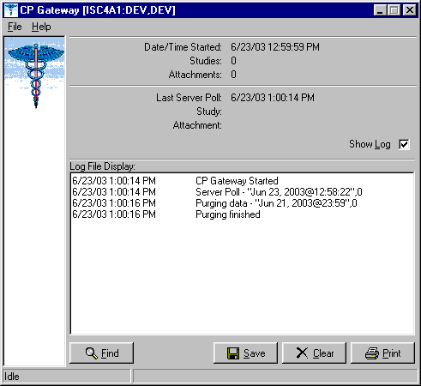
Figure 10-2

The log file tracks all the background operations and any problems that occur during the processing of attachments, Figure 10-2. In addition, the log file lists the date/time stamp of the background operation, a description of the background operation, and the number of studies to process at that time.

Log File Options
The following options are available while viewing the log file.

- Click Find to rapidly search the log file. A standard Windows find dialog is displayed and you can search the entire log file for a text value.

- Click Save if you want to save the entire contents of the log to an external file. The log file is saved in Rich Text Format (RTF) and can easily be opened in MS Word or other word processing applications.

- Click Clear to clear all entries in the current sessions log file. Be careful since you cannot recover past log entries if you have not previously saved them to a file.

- Click Print to select a printer and print the log. Be careful to check the size of the log file as it may be large if you have not cleared it recently.

You can display information about the server and you can also manage how the Gateway works.

- Choose File > Status. The server settings are displayed, Figure 10-3.
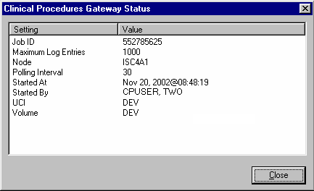
Figure 10-3

- Choose File > Shutdown. The server process is stopped and the application is terminated.

- Choose File > Set Poll Interval, Figure 10-4. The CP Gateway polls for new instrument data to transmit to VistA. You can adjust the number of seconds between polling operations. Enter a value from 10 to 300 seconds. The new value becomes effective after the next polling operation so it may take up to 5 minutes for the new value to be used.
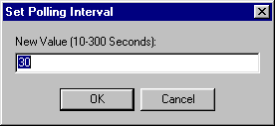
Figure 10-4

- Choose File > Set Maximum Log Entries. You can adjust the number of entries that are stored in the log file. Enter a value from 100 to 10000. After this value is reached, entries are deleted from the beginning of the log to keep the log file from growing too large. The new value becomes effective after the next polling operation so it may take up to 5 minutes for the new value to be used. When the CP Gateway is shut down, all entries are deleted from the log file.

Setting Up HL7 Parameters
1This section describes how to set up the HL7 parameters including configuration instructions, file settings, and technical issues. The tasks in this chapter require a working knowledge of the VistA HL7 application.

Topics discussed in this chapter are:

- Configuration Instructions Information
  - IP Addresses and Ports
- Setting Up a New HL7 Single Listener for High-Volume Devices
  - Creating a Logical Link
  - Creating a Device Protocol Client
  - Activating the Logical Links
  - Adding a Device Client as a Server Subscriber
- Using Port 5000
  - Benefits of Using a Single Port Listener
  - Setting Up Port 5000
- File Settings
- Technical Issues

Configuration Instructions Information
You can follow the steps described in this section to configure the HL7 application.

MCAR INST and MCAR OUT are automatically created during the KIDS installation. MCAR INST is used for all devices that send results information from the device to VistA and CP. Since all devices can use the same link, you only need one entry in the HL Logical Link (870) file.

However, you need to establish an MCAR OUT entry for each bi-directional device that receives information from VistA and CP. Each entry needs its own IP and port number, which agree with the device configuration. (Use the MCAR OUT sample provided in the HL Logical Link file. Set up the individual links for each bi-directional device. )

IP Addresses and Ports

You need to set up IP addresses and ports for the medical devices at your facility.

An IP address consists of a string of four numbers each ranging in value from 0 to 255. Here is an example of an IP address: 10.23.55.201. When a new device is installed, be careful when you assign IP addresses to the medical devices. It’s recommended that you set aside a block of IP addresses specifically for the medical devices. The range of numbers chosen is up to the facility, but make sure that there is a large enough range to allow for some growth. For example, IP

1 Patch MD*1.0*14 March 2008 Chapter revised to provide clarity.

addresses 10.23.55.201 through 10.23.55.225 could be blocked and used. In this way, the IRM staff can track down any possible problems that may be related to the medical device by looking at the IP address.

A port is the location on a medical device where you send and receive data. Some ports have predefined functions. For example, Port 80 is set up for the Web Server. Some vendors have predefined ports that they may want you to use. For example, Sensormedics recommends using Port 20000 for the VMAX. Others may only allow a limited range. Consult the device manual to determine which ports you can use.

A Startup Node defines the system on which you want the link to start.

Setting Up a New HL7 Single Listener for High-Volume Devices
Most medical devices send results to VistA using nonpersistent connections to the same port. Each device connects to the port just long enough to send results to VistA, then releases the port so that other devices may connect to it.

However, if you use a high-volume device (i.e., something that sends about 200 or more messages back and forth per day, such as MUSE or a hemodialysis device) that sends a lot of data all the time, we recommend that you give it its own port instead of sharing a port with other devices. This is because high-volume devices send so much data that they can tie up the port for a long time, preventing other devices (e.g., Olympus or Sensormedics) from using it.

Setting up a new HL7 listener involves four steps (which are described in more detail below):

- Creating a Logical Link
- Creating a Device Protocol Client
- Activating the Logical Links
- Adding a Device Client as a Server Subscriber

This document also contains information on Using Port 5000 what it is and when to use it).

Note: Although you can name your new logical links and device protocols anything you want, keep the names name spaced and descriptive since the names are similar and it can be easy to confuse them.

Creating a Logical Link
A logical link is an inbound or an outbound instrument data port from and to the medical device. It’s a listener waiting for data to come across. The first logical link (MCAR INST) is already created by default. To create a new HL7 single listener logical link for your device, you need to create a new logical link or edit an existing one.

- Decide which port to use. The facility, along with IRM, determines which port to use. This is the port used by the device to send data to the VistA listener. You can, for example, use port 1026 for Hemodialysis results and port 1027 for Sensormedics results. Do not use port 5000 for this type of setup. (See below for more information on port 5000.)
- From the Systems Manager Menu, choose HL Main Menu (HL) > Interface Developer Options (IN) > Link Edit (EL).
- At the Select HL Logical Link Note prompt, enter the name of the new logical link for your device. Name your new logical link something like MCAR2 INST. The next one (if you use more than one high-volume device) can be called MCAR3 INST, etc.
- Type yes when asked if you are adding ‘MCAR2 INST’ as a new HL LOGICAL LINK. The HL7 LOGICAL LINK screen displays.
HL7 LOGICAL LINK

NODE: MCAR2 INST INSTITUTION:
MAILMAN DOMAIN:

AUTOSTART: Enabled

QUEUE SIZE: 100

LLP TYPE: TCP <RET>

DNS DOMAIN:
Note: When this screen first displays for a new logical link, only the NODE and QUEUE SIZE fields will already contain values. The NODE field will display the logical link name you just created, and the QUEUE SIZE field will default to 10.

- Type Enabled in the Autostart field.
- Change the QUEUE SIZE value to 100. (Optional)
- Enter TCP in the LLP TYPE field, then press [Enter] to display the HL7 LOGICAL LINK screen (see following figure).

HL7 LOGICAL LINK
┌─────────────────────TCP LOWER LEVEL PARAMETERS──────────────────────────┐
│ MCAR3 INST | │
│ | │
│ TCP/IP SERVICE TYPE: SINGLE LISTENER | │
│ TCP/IP ADDRESS: | │
│ TCP/IP PORT: 1026 | │
│ TCP/IP PORT (OPTIMIZED): | │
│ | │
│ ACK TIMEOUT: 60 RE-TRANSMISION ATTEMPTS: 3 | │
│ READ TIMEOUT: EXCEED RE-TRANSMIT ACTION: ignore | │
│ BLOCK SIZE: SAY HELO: | │
│ | │
│STARTUP NODE: DEV:ISC4A2 PERSISTENT: NO | │
│ RETENTION: UNI-DIRECTIONAL WAIT: | │
└─────────────────────────────────────────────────────────────────────────┘

- Set TCP/IP SERVICE TYPE to SINGLE LISTENER.
- In the TCP/IP PORT field, enter the port number you decided to use (in step 1).
- Optionally set ACK TIMEOUT to 60.
- Press [Tab] to optionally set RE-TRANSMISION ATTEMPTS to 3.
- Optionally set EXCEED RE-TRANSMIT ACTION to ignore.
- Enter the appropriate STARTUP NODE.
- Set the PERSISTENT field to NO.
- [Tab] down to the COMMAND prompt, then select Close. You return to the HL7 LOGICAL LINK screen.
- [Tab] down to the COMMAND prompt, then select Save.
- At the COMMAND prompt, select Exit.
- The new link is useless until you assign protocols to it. Proceed to the next section to create a client protocol.

Creating a Device Protocol Client
You have to create a protocol for every inbound listener to VistA.

To create a protocol client from for your new logical link using a copy, follow these steps:

- Look at the protocol in 101 or use developer tools. Copy MCAR DEVICE CLIENT to make a new device client. Name it something like MCAR2 DEVICE CLIENT.
- Change the entry in the Logical Link field to match the new logical link. For example, if you just created a logical link named MCAR2 INST, change what’s in the Logical Link field from MCAR INST to MCAR2 INST. All other fields should match what was originally in MCAR DEVICE CLIENT.
- Proceed to the next section to make the new device protocol a subscriber to the device server.

To create a new protocol client for your new logical link, do the following:

- From the Systems Manager Menu, choose HL Main Menu (HL) > Interface Developer Options (IN) > Protocol Edit (EP).
- At the Select PROTOCOL NAME prompt, enter the name of the new device client for your device. Name your new device client something like MCAR2 Device Client or MCAR2 MUSE (depending on the device name).
- Type yes (or simply type y) when asked if you are adding ‘MCAR2 Device Client’ as a new PROTOCOL.
- Enter Instrument Device Client in the PROTOCOL ITEM TEXT field.
- Enter an appropriate identifier in the PROTOCOL IDENTIFIER field. The HL7 INTERFACE SETUP screen displays.
- [Tab] down to the TYPE field and enter subscriber, then press [Enter] to display PAGE 2 OF 2.

HL7 SUBSCRIBER PAGE 2 OF 2
MCAR2 Device Client

RECEIVING APPLICATION: MCAR INST

RESPONSE MESSAGE TYPE: ACK EVENT TYPE: R01 SENDING FACILITY REQUIRED?: NO RECEIVING FACILITY REQUIRED?: NO
SECURITY REQUIRED?:

LOGICAL LINK: MCAR2 INST PROCESSING RTN: D ^MDHL7A
ROUTING LOGIC:

- Type MCAR-INST in the RECEIVING APPLICATION field, then enter the following entries:
- RESPONSE MESSAGE TYPE = ACK
- EVENT TYPE = R01
- SENDING FACILITY REQUIRED = NO
- RECEIVING FACILITY REQUIRED = NO
- LOGICAL LINK = MCAR2 INST (use the appropriate name)
- PROCESSING RTN = D ^ MDHL7A (use the appropriate routine)

Note: The processing routine is the MUMPS routine that VistA uses to process the message received from the logical link.
- [Tab] down to the COMMAND prompt, then select Save.
- At the COMMAND prompt, select Exit.
- Proceed to the next section to make the new device protocol a subscriber to the device server.

Activating the Logical Links
Next, the links need to be activated. (The steps below assume that the original logical link has never been activated. If MCAR INST is already active, skip to step 4.)

- Choose HL Main Menu (HL) > Filer and Link Management Options (FI) >Start/Stop Links (SL).
- Activate the first logical link: Select HL LOGICAL LINK NODE: MCAR INST
- Select B for Background. (B is the default, so just press [Enter].
- Activate the next logical link: Select HL LOGICAL LINK NODE: (in this example it is

MCAR2 INST)
- Select B for Background. (B is the default, so just press [Enter].
- If you have more logical links to activate, repeat steps 4-5.
- If you haven’t done this already, use the CP Manager application to configure the device you are using. Refer to Editing an Automated Instrument, p. 6-3.
- Proceed to the next section to make the new device protocol a subscriber to the device server.

Adding a Device Client as a Server Subscriber
Next you have to make the newly-created protocols subscribers to MCAR DEVICE SERVER. Every client must be a subscriber to a server. That controls the outbound message to a medical device when you reply to it.
Go into MCAR DEVICE SERVER (under the protocol file or using the Interface Developer Option) and make sure that the new MCAR2 DEVICE CLIENT is a subscriber to it. Detailed steps follow:
- At the Select Systems Manager Menu, select HL for the HL7 Main Menu.
- At the Select HL7 Main Menu, select IN for Interface Developer Options.
- At Select Interface Developer Options, select EP for Protocol Edit.
- At the Select PROTOCOL NAME prompt, select MCAR Device Server. (If your site uses a different server name, select the appropriate name. You can display a list of available options, if necessary.)
- Press [Enter] at the TYPE prompt to go to PAGE 2 OF 2: the HL7 EVENT DRIVER screen. (Figure follows.)

HL7 EVENT DRIVER PAGE 2 OF 2
MCAR Device Server
SENDING APPLICATION: INST-MCAR
TRANSACTION MESSAGE TYPE: ORU EVENT TYPE: R01 MESSAGE STRUCTURE:
PROCESSING ID: P VERSION ID: 2.3 ACCEPT ACK CODE: APPLICATION ACK TYPE:

RESPONSE PROCESSING RTN:
SUBSCRIBERS
MCAR Device Client MCAR Device Client2

- To add the new protocol as a subscriber, [Down Arrow] or [Tab] down to the line below MCAR Device Client and enter the name of the new subscriber (e.g., MCAR2 Device Client). The HL7 screen displays.
- Verify that the entries are correct, then [Down Arrow] down to the COMMAND line and select Close. You return to the MCAR Device Server screen.
- Repeat steps 6-7 if you need to add more subscribers.
- [Down Arrow] down to the COMMAND line and select Save.
- In the COMMAND line, select Exit.

1Using Port 5000
Port 5000 is a Multi-Port Listener. The only reason to use the multiport listener is if your inbound port doesn’t work correctly because Cache is not handling ports correctly.
If Cache is handling ports correctly, then you should let Cache handle them. Use the individually shared ports for your devices rather than using the Multi-Port Listener.
If you’re at a facility that has listener problems under Cache, then use port 5000. Port 5000 is handled by VMS, not Cache.
Most sites allocate 25 ports to port 5000, but more can be allocated, if necessary.

Benefits of Using a Single Port Listener
A single port is easier to monitor and debug. It’s easy to determine if the problem is caused by the link or something else.
If you set up another Multi-Port Listener, you have to set it up in VMS. You’ll have to do that through UCX, which is a lot of work and beyond the scope of this document,

Setting Up Port 5000
- Edit MCAR DEVICE CLIENT so the logical link points to VAxxx (where xxx is an abbreviation for the hospital).
- Make sure all CP Medical devices send to port 5000.
- You don’t need to set up an additional MCAR INST (logical link) because you’re using an existing logical link which is VAxxx, where xxx is an abbreviation for the hospital (e.g., VAHIN for Hines).
- Make it an MCAR DEVICE server subscriber.

File Settings
The parameter settings for the HL7 Application Parameter file, HL Logical Link file, and the Protocol file are automatically set during the CP installation. They are listed here for reference. Fields that have bolded field names and bolded field entries must be set exactly as they appear in these examples.

HL7 Application Parameter (#771) file

This file contains a list of VistA applications that are capable of sending and receiving HL7 transmissions.

NAME: MCAR-INST ACTIVE/INACTIVE: ACTIVE FACILITY NAME: VISTA MAIL GROUP: POSTMASTER
COUNTRY CODE: US HL7 ENCODING CHARACTERS: ^~\& HL7 FIELD SEPARATOR: |

NAME: INST-MCAR ACTIVE/INACTIVE: ACTIVE

1 Patch MD*1.0*9 November 2007 Using Port 5000 with CACHE.

COUNTRY CODE: US HL7 ENCODING CHARACTERS: ^~\& HL7 FIELD SEPARATOR: |

HL Logical Link (#870) file

This file stores parameters that govern the behavior of the Logical Links and also stores information that drives the SYSTEMS LINK MONITOR display option.

NODE: MCAR INST LLP TYPE: TCP
QUEUE SIZE: 100 RE-TRANSMISSION ATTEMPTS: 3
ACK TIMEOUT: 60 EXCEED RE-TRANSMIT ACTION: ignore
TCP/IP PORT: 1026 TCP/IP SERVICE TYPE: SINGLE LISTENER PERSISTENT: NO

MCAR OUT provides an example of field entries for bi-directional instruments for outbound links to medical devices. The fields that have bolded field names and bolded field entries must be set exactly as they appear in this example. The other bolded fields must be edited to match your device specific requirements. For example, Device Type must be Non-Persistent Client. Non- bolded fields may not have a value depending on the state of the system.
NODE: MCAR OUT LLP TYPE: TCP
DEVICE TYPE: Non-Persistent Client STATE: Shutdown
AUTOSTART: Enabled TIME STOPPED: JAN 16, 2003@14:30:15
SHUTDOWN LLP ?: YES EXCEED RE-TRANSMIT ACTION: ignore
RE-TRANSMISSION ATTEMPTS: 3 TCP/IP PORT: 1028
ACK TIMEOUT: 60 PERSISTENT: NO
TCP/IP ADDRESS: 10.3.17.202 STARTUP NODE: DEV:ISC4A2
TCP/IP SERVICE TYPE: CLIENT (SENDER)

Note: When you need to create additional HL7 links for new devices, name the link in the following format:

- If you need to create more than one inbound link (MCAR INST), name the new links “MCAR”, followed by a number (1,2,3), a space, and then “INST”.

Example: MCAR2 INST

- Name outbound links “MCAR”, followed by a number (1,2,3), a space, and then a name for the device.

Example: MCAR2 SMC

See “Configuration Instructions Information” for information on setting the TCP/IP address and port and the Startup Mode.

Protocol (#101) file:

This file contains the protocols for processing HL7 messages.

NAME: MCAR Device Client ITEM TEXT: Instrument Device Client TYPE: subscriber CREATOR: CPUSER, FIVE
PACKAGE: MEDICINE
DESCRIPTION: Subscriber protocol for sending data to VISTA from clinical instruments.
TIMESTAMP: 57540,31165 RECEIVING APPLICATION: MCAR INST TRANSACTION MESSAGE TYPE: ORU EVENT TYPE: R01
PROCESSING ID: P LOGICAL LINK: MCAR INST
* VERSION ID: 2.3 RESPONSE MESSAGE TYPE: ACK PROCESSING ROUTINE: D ^MDHL7A SENDING FACILITY REQUIRED?: NO RECEIVING FACILITY REQUIRED?: NO

NAME: MCAR Device Server ITEM TEXT: Instrument HL7 Event Driver TYPE: event driver CREATOR: CPUSER, FIVE
PACKAGE: MEDICINE
DESCRIPTION: This protocol is used by the HL7 package to send results to VISTA from various clinical instrumentation.
TIMESTAMP: 57631,55707 SENDING APPLICATION: INST-MCAR TRANSACTION MESSAGE TYPE: ORU EVENT TYPE: R01
PROCESSING ID: P * VERSION ID: 2.3
SENDING FACILITY REQUIRED?: NO RECEIVING FACILITY REQUIRED?: NO
SUBSCRIBERS: MCAR Device Client

NAME: MCAR ORM CLIENT TYPE: subscriber
CREATOR: CPUSER, SIX RECEIVING APPLICATION: INST-MCAR
EVENT TYPE: O02 RESPONSE MESSAGE TYPE: ORR SENDING FACILITY REQUIRED?: NO RECEIVING FACILITY REQUIRED?: NO SECURITY REQUIRED?: NO ROUTING LOGIC: Q

NAME: MCAR ORM SERVER
ITEM TEXT: Clinical Procedures ORM Protocol Server
TYPE: event driver CREATOR: CPUSER, SIX
TIMESTAMP: 59276,54156 SENDING APPLICATION: MCAR-INST TRANSACTION MESSAGE TYPE: ORM EVENT TYPE: O01
VERSION ID: 2.3 SUBSCRIBERS: MCAR ORM CLIENT

*Note: Check vendor documentation for instructions on verifying the Version ID.

Technical Issues
For all sites:

To avoid error messages because of a missing or invalid 'Event Protocol', 'Invalid Processing Code', or 'Invalid Application Code', make sure that all settings (except TCP/IP PORT and TCP/IP ADDRESS, in the HL Logical Link (#870) file, which are site specific) are the same as the file settings listed previously in this chapter.

Be sure that the VERSION ID parameters in the Protocol (#101) file are set to the same HL7 Version that is being sent by the vendor instrument. The ITEM and SUBSCRIBERS fields in

the Device Server entry in the Protocol (#101) file MUST be the same as the Device Client name.

Configuring the Automated Instrument Share Folder
CP uses VistA Imaging as the main storage facility for the images and documents that come from a medical device. After one or more medical devices have been installed at the facility, you need to complete the setup. The vendor can provide you with the directory that is used to store the images and documents. You need to make that directory viewable to the VistA Imaging background processor, which will allow VistA Imaging to retrieve the document and store it on the VistA jukebox.

Here is a list of information you need to ensure that the share folder is set up correctly:

  - Directory name that holds the documents and images on the medical device. Be sure to get the directory name from the vendor when the device is installed.
  - VistA Imaging User (IU) and VistA Imaging Administrator (IA) accounts that are used when starting up the VistA Imaging background processor. You can get these names from the VistA Imaging coordinator at your facility.
  - The medical device and the Imaging background processor must be on the same Windows domain.
  - The medical device must have the same TCP/IP subnet mask as the Imaging background processor.
  - You need administration privileges to complete the setup.
  - You need to make the directory viewable on the medical device that has the documents and images.
  - The network path to the results folder cannot contain symbols, such as dollar signs ($).

Example: Setting up an automated instrument share folder:

This example describes how to share a Windows 2000 directory for the Widget EKG automated instrument where the medical device (Widget EKG) and the Imaging background processor are on the same domain VHAExample and subnet 255.255.240.0.

The directory that has the documents and images is C:\widget\doc. The VistA Imaging user is VHAISHIU and has an administrator logon to Windows.

- Using Windows Explorer, go to the parent directory of the folder that contains the folder to be shared (doc folder) (Figure 12-1).
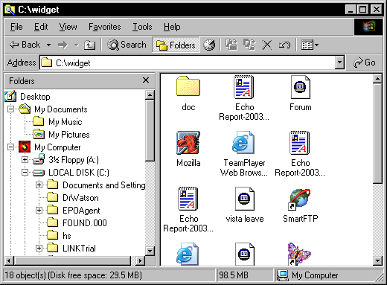
Figure 12-1

- Right-click the doc folder. Select Sharing from the drop-down menu. The Sharing tab on the doc properties dialog box is displayed, Figure 12-2.

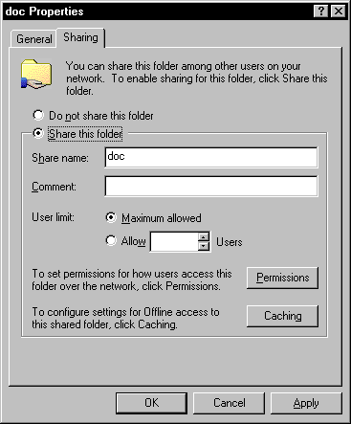
Figure 12-2

- Click Share this folder.
- Click Permissions.

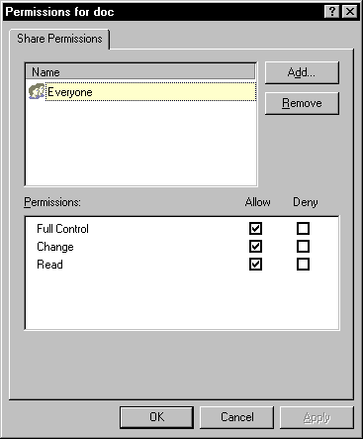
Figure 12-3

- Select Everyone, and then click Remove. (Figure 12-3).
- Click Add. The Select Users, Computers, or Groups window is displayed.

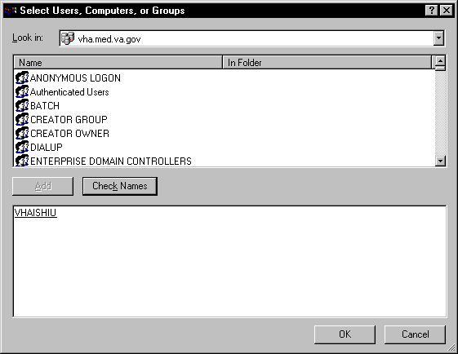
Figure 12-4

- Enter the name of the VistA Imaging (VHAISHIU) User (IU) into the bottom window and click Check Names. A line is displayed under the name if it is valid. Click OK to add the user (Figure 12-4). The Select Users, Computers, or Groups window closes and VHAISHIU is displayed in the Permissions dialog box.

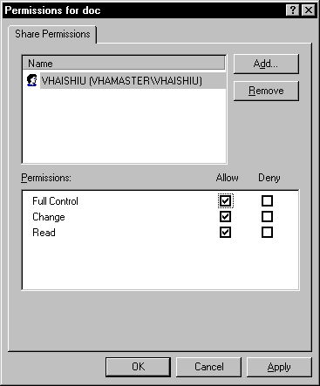
Figure 12-5

- Make sure the check boxes are selected in the “Allow” column for “Full Control”, “Change” and “Read” (Figure 12-5).
- Click Apply and then click OK. A hand displays under the file, which means that the file is now accessible to the VistA Imaging user.
- To test that the shared folder is set up correctly, have the VistA Imaging coordinator logon as VHAISHIU on a different PC. Check that the shared folder is viewable.

Troubleshooting
Here are frequently encountered errors and resolutions that can occur while running Clinical Procedures. To resolve most of these errors, you need access to CP Manager and CP User.

- You tried to launch a CP application and received the following error:
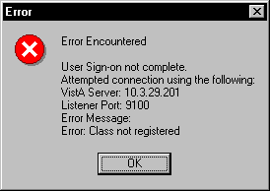
Figure 13-1

  - Highlight the CP application icon on your desktop. (When CP in installed, shortcuts for the applications are created on the desktop.)
  - Right-click, and then click Properties.
  - Enter the command line switch “/nonsharedbroker” in the Target field.
  - Press OK.

You can also add the “/nonsharedbroker” switch to the applications in Start > Programs >

Clinical Procedures.

- If you receive the following error:
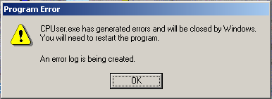
Figure 13-2

You need the MD GUI USER option to access CP User and the MD GUI MANAGER option to access CP Manager. Call IRM.

- During a CP Study Check-In, a procedure request was ordered but is not listed.

  - The GRMC procedure has not been linked to a CP procedure. You need to cancel the procedure request, and then use the following Procedure Setup option to link the GMRC procedure to the CP procedure.

Select OPTION NAME: GMRC MGR Consult Management

Select Consult Management Option: PR Setup procedures Select Procedure:CP EKG 12 LEAD STAT
NAME: CP EKG 12 LEAD STAT// <RET>
INACTIVE: NO// <RET>
Select SYNONYM: EKG// <RET>
INTERNAL NAME: <RET>
Select RELATED SERVICES: CP CARDIOLOGY// <RET>
TYPE OF PROCEDURE: ECG// <RET>
CLINICAL PROCEDURE: EKG, ROUTINE (12 LEADS)// <RET>

If you entered “?” in the Clinical Procedure field and you do not find a procedure that you want, use CP Manager to define and activate the CP procedures.

  - Open CP Manager.
  - Enter the name of the CP Procedure in the Procedure Name field. See Setting Up Clinical Procedures, p. 6-1.
  - Re-order the consult procedure.

- Allowable Instruments are associated with the CP procedure but you cannot see the instruments during Study Check-In.

  - Open CP Manager.
  - Expand the Procedures folder, and then select the procedure.
  - In the Allowable Instruments list, select the check box for the specific instrument.

- After a study is checked-in, you can’t find the study entry in CP User.

  - Open CP Manager.
d) Expand the Procedures folder, and then select the procedure.
b) Check that a treating specialty has been assigned.

Figure 13-3

- An error status is displayed for the study and the Update Study Status selection is unavailable. You must have the MD GUI MANAGER key, and then you can go to File > Update Study Status to review the problem.

The message in the following figure indicates that a Notification Mailgroup has not been assigned or the Medical Device is not Active.
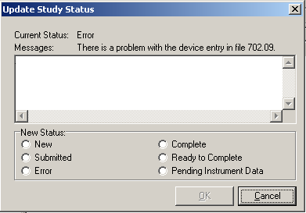
Figure 13-4

  - Open CP Manager.
  - Select the instrument.
  - Check that the Notification Mail Group has an entry and that the Active checkbox is selected.
  - Open CP User. Choose File > Update Study Status.
  - If the device is bi-directional, delete the study that was checked in and check-in a new study with the same procedure request to get the HL7 message transmitted to the medical device. If the device is uni-directional, check the Ready to Complete status, and click OK.

- If a study remains in Pending Instrument Data status and it is a bi-directional medical device, check to see if Auto Submit To VistA Imaging field is selected. .

  - Open CP Manager.
  - Expand the Procedures folder, and then select the procedure
  - Check that Auto Submit to VistA Imaging is selected.

For the current study, you still need to manually submit the result. For future studies, the result will be automatically submitted.

- The following two errors indicate that a TIU document Title has not been assigned to the CP procedure. The first error message is from CP during image submission if a TIU document has not been assigned to the CP Definition.

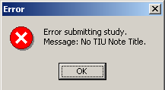
Figure 13-5

This second error screen is the Update Study Status screen from CP User. The first message is a CP warning. The second message is a warning from TIU that there is no TIU document.

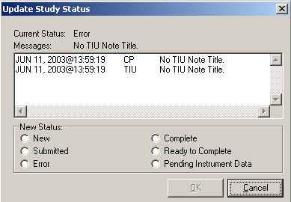
Figure 13-6

  - Open CP Manager
  - Select the procedure, and check that a TIU Note Title is assigned.
  - Open CP User and Update the Study Status to Ready to Complete.
  - Open the study and manually submit the results. By manually submitting the result, you prevent any re-occurrences of the error.

- These errors indicate that a Hospital Location has not been defined for the CP procedure.
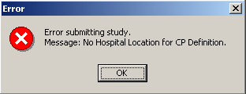
Figure 13-7

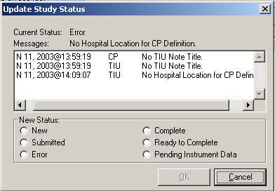
Figure 13-8

  - Open CP Manager and check that the Hospital Location has been defined.
  - Open CP User and Update the Study Status to Ready to Complete.
  - Open the study and submit it manually.

- If the Complete/Update Result option in CPRS > Action > Consults Results is unavailable, you need to be updated as the Interpreter. Use the Service User Management
> SERVICE INDIVIDUAL TO NOTIFY option to assign the Interpreter role.
Select Consult Management Option: SU Service User Management Select Service/Specialty: GASTROENTEROLOGY
Select UPDATE USERS W/O NOTIFICATIONS: CPUSER, SEVEN
//
Select UPDATE USERS W/O NOTIFICATIONS:
Select ADMINISTRATIVE UPDATE USER: CPUSER, EIGHT
//
Select ADMINISTRATIVE UPDATE USER:
SERVICE INDIVIDUAL TO NOTIFY: CPUSER, NINE CD 123 IRM FIELD OFFICE IRM FIELD OFFICE
PROGRAMMER
Select SERVICE TEAM TO NOTIFY: consultteam// Select NOTIFICATION BY PT LOCATION:

Select Service/Specialty:

- If you get the following error message:
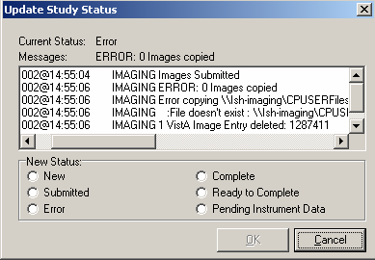
Figure 13-9

Make sure that the Imaging Background Processor can access the Network Share, where the result resides.

  - Open CP Manager.
  - Click Clinical Procedures.
  - Click System Parameters.
  - Check the path of the Imaging Network Share. (The Imaging Network Share must be a shared directory that can be accessed by the Imaging Background Processor and CP Gateway.)

- If a study remains in “Submitted” status, check the Imaging Background Processor log for errors and make sure that the “Import” checkbox is checked for the Import BP parameter.

From the Background Processor, choose Edit > BP Workstation Parameters. (You may need to find someone who is responsible for the Imaging Background Processor application.)

- If the Interpreter does not receive an alert that the procedure is ready for interpretation, check if the CONSULT/PROC INTERPRETATION notification is enabled and if the user has the Interpreter role.

  - You must enable the CONSULT/PROC INTERPRETATION notification if you want to receive the “Ready for interpretation” alert in CPRS. You can enable the alert for one user, several users, or for the entire service. Use the Notification Management Menu.

  - To assign the interpreter role, use the Consult Management menu. If user wants to receive alerts, do not enter them into the Update Users W/O Notifications field. This field is for users who want the role of interpreter but do not want to receive alerts. Refer to Setting Up Consult Services, p. 8-1.
Select Consult Management Option: SU Service User Management Select Service/Specialty: GASTROENTEROLOGY
Select UPDATE USERS W/O NOTIFICATIONS: CPUSER, SEVEN
//
Select UPDATE USERS W/O NOTIFICATIONS:
Select ADMINISTRATIVE UPDATE USER: CPUSER, EIGHT
//
Select ADMINISTRATIVE UPDATE USER:
SERVICE INDIVIDUAL TO NOTIFY: CPUSER, NINE CD 123 IRM FIELD OFFICE IRM FIELD OFFICE
PROGRAMMER
Select SERVICE TEAM TO NOTIFY: consultteam// Select NOTIFICATION BY PT LOCATION:

- If you receive the following error while trying to interpret a procedure:
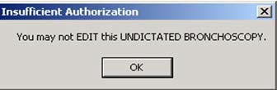
Figure 13-10

This message can occur if business rules have not been set up or if insufficient business rules have been set up for this document title.

To add a business rule:

  - Go into the User Class Management Menu.
  - Select Manage Business Rules.
  - Enter specific words at the appropriate prompts (Status, Action, User Class). These words are combined to make a business rule.

Glossary
Access Code A unique sequence of characters known by and assigned only to the user, the system manager and/or designated alternate(s). The access code (in conjunction with the verify code) is used by the computer to identify authorized users.

Action A functional process that a clinician uses in a computer program. For example, “Edit” and “Search” are actions. Protocol is another name for Action.

ADP Coordinator/ADPAC/Application Coordinator Automated Data Processing Application Coordinator. The person responsible for implementing a set of computer programs (application package) developed to support a specific functional area such as clinical procedures, PIMS, etc.

Application A system of computer programs and files that have been specifically developed to meet the requirements of a user or group of users.

Archive The process of moving data to some other storage medium, usually a magnetic tape, and deleting the information from active storage in order to free-up disk space on the system.

ASU Authorization/Subscription Utility, an application that allows sites to associate users with user classes, allowing them to specify the level of authorization needed to sign or order specific document types and orderables. ASU is distributed with TIU in this version.

Attachments Attachments are files or images stored on a network share that can be linked to the CP study. CP is able to accept data/final result report files from automated instruments. The file types that can be used as attachments are the following:

.txt Text files
.rtf Rich text files
.jpg JPEG Images
.jpeg JPEG Images
.bmp Bitmap Images
.tiff TIFF Graphics (group 3 and group 4 compressed and uncompressed types)
.pdf Portable Document Format
.html Hypertext Markup Language

.DOC (Microsoft Word files) are not supported. Be sure to convert .doc files to .rtf or to
.pdf format.

Automatic Version Updates Updating an account with new software versions without user intervention.

Background Processing Simultaneous running of a "job" on a computer while working on another job. Examples would be printing of a document while working on another, or the software might do automatic saves while you are working on something else.

Backup Procedures The provisions made for the recovery of data files and program libraries and for restart or replacement of ADP equipment after the occurrence of a system failure.

Boilerplate Text A pre-defined TIU template that can be filled in for titles to speed up the entry process. TIU exports several titles with boilerplate text, which can be modified to meet specific needs; sites can also create their own.

Browse Lookup the file folder for a file that you would like to select and attach to the study.
Such as clicking the “...” button to start a lookup.

Bulletin A canned message that is automatically sent by mail to a user when something happens to the database.

Business Rule Part of ASU, Business Rules authorize specific users or groups of users to perform specified actions on documents in particular statuses (e.g., an unsigned CP note may be edited by a provider who is also the expected signer of the note).

Class Part of Document Definitions, Classes group documents. For example, “CLINICAL PROCEDURES” is a class with many kinds of Clinical Procedures notes under it. Classes may be subdivided into other Classes or Document Classes. Besides grouping documents, Classes also store behavior which is then inherited by lower level entries.

Consult Referral of a patient by the primary care physician to another hospital service/ specialty, to obtain a medical opinion based on patient evaluation and completion of any procedures, modalities, or treatments the consulting specialist deems necessary to render a medical opinion.

Contingency Plan A plan that assigns responsibility and defines procedures for use of the backup/restart/recovery and emergency preparedness procedures selected for the computer system based on risk analysis for that system.

CP Clinical Procedures.

CP Study A CP study is a process created to link the procedure result from the medical device or/and to link the attachments browsed from a network share to the procedure order.

CPRS Computerized Patient Record System. A comprehensive VistA program, which allows clinicians and others to enter and view orders, Progress Notes and Discharge Summaries (through a link with TIU), Problem List, view results, and reports (including health summaries).

Device A hardware input/output component of a computer system, such as CRT, printer.

Document Class Document Classes are categories that group documents (Titles) with similar characteristics together. For example, Cardiology notes might be a Document Class, with Echo notes, ECG notes, etc. as Titles under it. Or maybe the Document Class would be Endoscopy Notes, with Colonoscopy notes, etc. under that Document Class.

Document Definition Document Definition is a subset of TIU that provides the building blocks for TIU, by organizing the elements of documents into a hierarchy structure. This structure allows documents (Titles) to inherit characteristics (such as signature requirements and print characteristics) of the higher levels, Class and Document Class. It also allows the creation and use of boilerplate text and embedded objects.

Edit Used to change/modify data typically stored in a file.

Field A data element in a file.

File The M construct in which data is stored for retrieval at a later time. A computer record of related information.

File Manager or FileMan Within this manual, FileManager or FileMan is a reference to VA FileMan. FileMan is a set of M routines used to enter, edit, print, and sort/search related data in a file, a database.

File Server A machine where shared software is stored.

Gateway The software that performs background processing for Clinical Procedures.
GUI Graphical User Interface – a Windows interface that uses pull-down menus, icons, pointer devices, and other metaphor-type elements that make a computer program, easier to use and that allows multi-processing (more than one window or process available at once).

Interpreter Interpreter is a user role exported with USR*1*19 to support the Clinical Procedures Class. The role of the Interpreter is to interpret the findings or results of a clinical procedure. Users who are authorized to interpret the results of a clinical procedure are sent a notification when an instrument report and/or images for a CP request are available for interpretation. Business rules are used to determine what actions an interpreter can perform on a document of a specified class, but the interpreter themselves are defined by the Consults application. These individuals are ‘clinical update users’ for a given consult service.

IRMS Information Resource Management Service.

Kernel A set of software utilities. These utilities provide data processing support for the application packages developed within the VA. They are also tools used in configuring the local computer site to meet the particular needs of the hospital. The components of this

operating system include: MenuMan, TaskMan, Device Handler, Log-on/Security, and other specialized routines.

M Formerly known as MUMPS or the Massachusetts (General Hospital) Utility Multi- Programming System. This is the programming language used to write all VistA applications.

Menu A set of options or functions available to users for editing, formatting, generating reports, etc.

Modality Another name for a medical instrument.

Module A component of a software application that covers a single topic or a small section of a broad topic.

Namespace A naming convention followed in the VA to identify various applications and to avoid duplication. It is used as a prefix for all routines and globals used by the application.

Network Server Share A machine that is located on the network where shared files are stored.

Notebook This term refers to a GUI screen containing several tabs or pages.

Option A functionality that is invoked by the user. The information defined in the option is used to drive the menu system. Options are created, associated with others on menus, or given entry/exit actions.

Package Otherwise known as an application.

Page This term refers to a tab on a GUI screen or notebook.

Password A protected word or string of characters that identifies or authenticates a user, a specific resource, or an access type (synonymous with Verify Code).

Pointer A special data type of VA FileMan that takes its value from another file. This is a method of joining files together and avoiding duplication of information.

Procedure Request Any procedure (EKG, Stress Test, etc.) which may be ordered from another service/specialty without first requiring formal consultation.

Queuing The scheduling of a process/task to occur at a later time. Queuing is normally done if a task uses up a lot of computer resources.

Result A consequence of an order. Refers to evaluation or status results. When you use the Complete Request (CT) action on a consult or request, you are transferred to TIU to enter the results.

Security Key A function which unlocks specific options and makes them accessible to an authorized user.

Sensitive Information Any information which requires a degree of protection and which should be made available only to authorized users.

Site Configurable A term used to refer to features in the system that can be modified to meet the needs of each site.

Software A generic term referring to a related set of computer programs.

Status Symbols Codes used in order entry and Consults displays to designate the status of the order.

Study See CP Study.

Task Manager or TaskMan A part of Kernel which allows programs or functions to begin at specified times or when devices become available. See Queuing.

Title Titles are definitions for documents. They store the behavior of the documents which use them.

TIU Text Integration Utilities.

User A person who enters and/or retrieves data in a system.

User Class User Classes are the basic components of the User Class hierarchy of ASU (Authorization/Subscription Utility) which allows sites to designate who is authorized to do what to documents or other clinical entities.

User Role User Role identifies the role of the user with respect to the document in question, such as Author/Dictator, Expected Signer, Expected Cosigner, Attending Physician, etc..

Verify Code A unique security code which serves as a second level of security access. Use of this code is site specific; sometimes used interchangeably with a password.

VistA Veterans Health Information Systems and Technology Architecture.

Appendix A – CP Application Startup Options and Command Line Switches
Topics discussed in this chapter are:

- Introduction
- What is a Command Line Switch?
- Shared Broker Environment
- CPRS Tools Menu
- All Command Line Switches

Introduction
Clinical Procedures was designed to operate as a standalone client or, when desired, launched from the tools menu of CPRS. CP uses the new Shared Broker environment and is also backwards compatible with previous releases of the RPC Broker. This functionality is achieved through the use of command line switches, which are applied to the Desktop Icons, Start Menu items, or the command assigned to an item on the CPRS tools menu.

What is a Command Line Switch?
A command line switch is a setting that is included in the call to the executable that controls the behavior of the executable. A common switch setting deployed in the VistA environment specifies the proper server on the proper listener port for the RPC Broker to connect to without user intervention. This is commonly seen when you create a desktop icon for CPRS with the
/s=BrokerServer /p=9200 switch. The connection to the VistA server is defined as BrokerServer on listener port 9200. (See the RPC Broker manuals for a complete description of defining a valid connection to pass to applications.)

Shared Broker Environment
CP was developed when the Shared Broker was being implemented. The Shared Broker provides a more responsive workstation environment by eliminating multiple sign-on requirements and preserving VistA server resources by combining several client applications into a single process/connection. CP provides this new functionality.

To assist sites in the migration to Shared Broker, CP is backwards compatible with the previous RPC Broker environment with a simple command line switch in the desktop icon, start menu item, and CPRS Tools Menu items. During the client GUI installation, desktop icons and start menu items are installed using the command line switch, /NonSharedBroker. By appending this command line switch, a call to launch a CP application causes the application to run with the old style broker and does not require that the workstation be upgraded with the latest broker client software.

Example:

\\MyAppServer\CP\CPuser.exe /server=BrokerServer /Port=9200 /NonSharedBroker

In this example, CPUser is executed from the server MyAppServer in share name CP and tries to connect to the VistA server defined as BrokerServer on listener port 9200. In addition, this command causes CPUser to connect to the previous version of the broker instead of the Shared Broker.

CPRS Tools Menu
If you want to use CP User from the CPRS tools menu, you need to launch CP User in a mode that causes it to listen to CPRS for patient changes and to exit when CPRS is closed. When appending the command line switch /cprs to the command in the CPRS Tools Menu command line, CP runs in a slave mode and does not allow patients to be selected within the CP environment. CPRS provides placeholders for the site to utilize when creating command lines for the tools menu. These are:

%srv Holds the name of the server that CPRS is currently connected to.
%port Holds the listener port that CPRS is currently communicating through.
%dfn Holds the DFN of the currently opened patient record in CPRS. Example command line for CPRS tools menu: CPUser=\\MyAppServer\CP\CPuser.exe /cprs /server=%s /port=%p /dfn=%d
In this example, the CPUser.exe on server MyAppServer in the Share CP runs as a slave under the CPRS application while connecting to the server that CPRS defined in %s on the listener port defined in %p. In addition, CP User opens the patient defined in %d upon starting.

For instructions on setting up the CPRS Tools menu, refer to, Adding Clinical Procedures to the CPRS Tools Menu, p. 9-7

Appendix A – CP Application Startup Options and Command Line Switches

All Command Line Switches
Clinical Procedures V. 1.0 command line parameters available from the command prompt or within Windows shortcut definitions and the CPRS Tools menu commands are defined by application.

CP User.exe [/server=servername] [/port=listenerport] [/cprs] [/dfn=patientdfn] [/helpdir=helpdirectory] [/debug={on|off}] [/brokertimeout=seconds] [/bypasscrc] [/NonSharedBroker]

CP Manager.exe [/server=servername] [/port=listenerport] [/helpdir=helpdirectory] [/debug={on|off}] [/brokertimeout=seconds] [/bypasscrc] [/NonSharedBroker]

CP Gateway.exe [/server=servername] [/port=listenerport] [/helpdir=helpdirectory] [/debug={on|off}] [/brokertimeout=seconds] [/bypasscrc] [/NonSharedBroker]

Switches:
Name | Description | Default
/server | Specifies a VistA server to which you are connected. | BROKERSERVER
/port | Specifies an alternate listener port on the  selected server. | 9200
/cprs | Specifies that the application is to run in slave mode under CPRS. This switch must be utilized when adding the CP User  application to the CPRS tools menu.
/dfn | Specifies the patient dfn (record identifier) to open upon application startup. This switch must be utilized when adding the CP  User application to the CPRS tools menu.
/helpdir | Location of the Clinical Procedures windows help files. | ../appdir/help of the application.
/debug | Sets the debug mode for both the RPC Broker and the Clinical Procedures  application. | Off
/brokertimeout | Overrides the timeout for the RPC Broker when executing a Remote Procedure. | 30

Name | Description | Default
/bypasscrc | Overrides the system parameters setting to check an applications crc32 value upon application startup. This switch should only be used during testing to avoid the messages if the site is implementing CRC verification.
/NonSharedBroker | This switch instructs the application to not  utilize the shared broker functionality. Used when the Shared Broker has not been implemented on the target workstation.

servername IP Address or Name of VistA server as it appears in the client Hosts. file.
Default Hosts. file locations:
NT 4.0 = c:\winnt\system32\drivers\etc\hosts. Win95/98 = c:\windows\hosts.
listenerport TCP Port that the Broker is running on the VistA server.

helpdirectory Directory path to a location containing the Clinical Procedures V. 1.0 Help Files.
seconds Integer value specifying the number of seconds the RPC Broker waits for a server response to an RPC.
patientdfn Value of the patient dfn to access when starting the CP User application.

Appendix B – Exported Procedures List
These exported procedures are contained in the MDPOST routine. When the INIT^MDPOST routine is run, these entries are added to your CP Definition (#702.01) file:

ABD PARACENTESIS: FOLLOWUP ABD PARACENTESIS: INITIAL ABLATION OF AV NODE FUNCTION AICD INTER/CONDITION
AIRWAY RESISTANCE ANO BIOPSY
ANO CONTROL BLEEDING
ANO DIAGNOSTIC (BRUSHINGS) ANO HOT BIOPSY(IES)
ANO SINGLE TUMOR (HOT/BICAP) ANOSCOPY
ARRHYTHMIA INDUCTION BY PACING ARTERIAL BLOOD GASES
ARTERIAL CANNULATION ARTERIAL PUNCTURE ARTHROC.ASPIR.INJ.INT.JT.BUR ARTHROC.ASPIR.INJ.MAJ.JT.BUR ARTHROCENT.ASPIR.INJ.SM.JT.BUR ASPIRATION
BIOPSY
BIOPSY LUNG, PERCUTANEOUS NDL BIOPSY, PLEURA
BONE MARROW
BONE MARROW INTERPRETATION BRONC DIAGNOSTIC W/BAL BRONC W/BRONC WASHING BRONC W/TRANSBRONC LUNG BX BRONCHIAL BRUSH
BRONCHOSCOPY W/BRONCH BIOPSY BRONCHOSCOPY W/WANG NEEDLE BRONCHOSCOPY, LASER BRONCHOSCOPY, STENT PLACEMENT BRONCHOSCOPY, THERAPEUTIC BRONCOSCOPY/FB REMOVAL
C&P EXAM
CARDIAC CATHETERIZATION CARDIAC REHAB W/O ECG MON CARDIAC REHAB/W ECG MON
CARDIOPULMONARY REHABILITATION

CARDIOVERSION, ELECTIVE CENTRAL VENOUS CANNULATION CHEMOTHERAPY
COL ABL (OTHR THAN SNARE/BI) COL BIOPSY
COL CONTROL HEM.
COL DIAGNOSTIC (BRUSHINGS) COL HOT BIOPSY(IES)
COL REMOVAL FB COL SNARE COLONOSCOPY
COMPREHENSIVE EP EVALUATION CPAP/BIPAP VENTILATION DIALYSIS PROCEDURES, HEMO DIALYSIS TRAINING/COMPLETE DIFFUSION
DILUTION STUDIES FOR CO MEAS ECG
ECG (EKG), RHYTHM STRIP ECG 12 LEAD
ECG 24 HOUR HOLTER MONITOR ECG MONITORING
ECG WITH INTERPRETATION ECG, EVENT RECORDER ECG, RHYTHM TRACING ECG, SIGNAL AVERAGE ECHO
ECHO TRANSESOPHOGEAL SINGLE PL ECHO, 2D M-MODE
ECHO, DOPPLER COLOR FLOW ECHO, DOPPLER, COMPLETE ECHO, TRANSESOPHOGEAL
ECHO, TRANSESOPHOGEAL BIPLANE ECHO, TRANSTHORACIC
EGD
EGD ABL (OTH THAN SNARE/BI) EGD BAND LIGATION
EGD BIOPSY
EGD DIAGNOSTIC (BRUSHINGS) EGD DILATION BALLOON
EGD DILATION WIRE EGD FOREIGN BODY
EGD HOT BIOPSY(IES) / BICAP EGD INJECTION / SCLEROSIS EGD SNARE/SINGLE
EGD TUBE/STENT

EKG, ROUTINE (12 LEADS)
ENDO OF BOWEL POUCH W/ BIOPSY ENDOMYOCARDIAL BIOPSY ENDOSCOPIC ULTRASOUND ENDOSCOPIC ULTRASOUND, BIOPSY ENDOSCOPY OF BOWEL POUCH ENDOTRACHEAL INTUBATION ENTEROSCOPY
EP EVAL OF CARDIO/DEFIB LEADS EP EVAL OF CARDIOVERTER/DEFIB EP EVAL W/ ARRHYTHMIA INDUCT EP EVAL W/ L ATRIAL RECORD
EP EVAL W/ L VENTRIC RECORD EP FOLLOWUP STUDY W/PACING EP STUDY
EPICARDIAL/ENDOCARDIAL MAPPING ERCP
ERCP ABL (OTHR THAN SN/BI) ERCP BALLOON DILATION ERCP BIOPSY
ERCP DEST STONES
ERCP DIAGNOSTIC (BRUSHINGS) ERCP DRAIN, TUBE
ERCP INSERTION OF TUBE/STENT ERCP PRESSURE OF ODDI
ERCP REM STONES
ERCP RMV FB OR CHG OF TUBE ERCP SPHINCTEROTOMY
ES ABLATION (OTHER) ES BAND LIGATION
ES BIOPSY
ES CONTROL BLEEDING
ES DIAGNOSTIC ENDO (BRUSHINGS) ES DILATION (BALLOON)
ES DILATION (WIRE) ES HOT BIOPSY(IES)
ES INJECTION / SCLEROSIS ES INSERTION TUBE/STENT ES REMOVAL FB
ES SNARE
ESOPHAGEAL DILATION ESOPHAGEAL MOTILITY STUDY ESOPHAGEAL RECORDING ESOPHAGUS
ETT
ETT W/ O2 CONSUMPTION

ETT W/ THALLIUM SCAN EXAM,SYNOVIAL FLUID CRYSTALS EXCERCISE CHALLENGE
FINE NEEDLE ASPIRATION FLEX SIG
FLOW VOLUME LOOP FLX ABLATION (OTHER) FLX BIOPSY
FLX CONTROL HEM.
FLX DECOMPRESS VOLVULUS FLX DIAGNOSTIC (BRUSHINGS) FLX HOT BIOPSY(IES)
FLX REMOVAL FB FLX SNARE
FRC
FT CHANGE OF G TUBE
FT EGD FOR PEG PLACEMENT
FT PERC PLACEMENT OF G TUBE FT REPOS TUBE THRU DUODENUM FT SM INT ENDO CONV G-J TUBE FT SM INT ENDO J TUBE PLACE HEART RATE VAR. ANALYSIS HEMODIALYSIS, ONE EVAL HEMODIALYSIS, REPEATED EVAL. HOLTER
I & D /DEBRIDEMENT ICD IMPLANTATION ICD INTERROGATION
ILEOSCOPY THROUGH STOMA ILEOSCOPY W/ BIOPSY INFUSION 1-8 HRS.
INFUSION TO 1 HR.
INJ FOR ANGIOGRAPHY
INJ FOR AV BYPASS GRAFTS INJ TENDON/LIGAMENT/CYST INJECTION, CARDIAC CATH INTRA-ATRIAL PACING INTRA-ATRIAL RECORDING INTRAVENTRICULAR PACING
INTRODUCTION OF NEEDLE/CATH IV FLUID THERAPY
IV INFUSION IV PUSH
IV THER. 1-8 HRS.
IV THER. UP TO 1 HR.
LASER SURGERY (NOT YAG)

LEFT HEART CATHETERIZATIION LEFT VENTRICULAR RECORDING LIVER BIOPSY
LUNG COMPLIANCE MECHANICAL VENTILATION METHACHOLINE CHALLENGE MONITOR W/ REVIEW & REPORT OVER GUIDE WIRE
PACEMAKE IMPLANTATION PACEMAKER
PACEMAKER FOLLOW UP PACEMAKER, RHYTHM STRIP PARACENTESIS
PERIPH BLOOD SMEAR INTERPRET PHLEBOTOMY
PLACE CATHETER IN VEIN, HEMO PLEURODESIS
PNEU BALLOON (30MM+) ACHALASIA PROC ABLATION (OTHER)
PROC BIOPSY
PROC CONTROL BLEEDING PROC DIAGNOSTIC (BRUSHINGS) PROC DILATION
PROC HOT BIOPSY(IES) PROC REMOVAL FB PROC SNARE
PROC TUMORS, MULT (HOT/SN/BI) PROCTOSCOPY
PROGRAMMED STIMULATION/PACING PSEUDOFOLLICULAR SCAN PULMONARY ARTERY CATHETER PULMONARY FUNCTION INTERPRET PULMONARY PROCEDURES
PULSE OXIMETRY MULTIPLE REHAB PULSE OXIMETRY SINGLE REHAB PULSE OXIMETRY, MULTIPLE RHEUMATOLOGY PROCEDURES RIGHT HEART CATHETERIZATION RIGHT VENTRICULAR RECORDING RT & LT HEART CATHETERS
SB ENDO W/ABLATION
SB ENDO W/BLEEDING CONTROL SB ENDO W/FB REMOVAL
SB ENDO W/HOT BIOPSIES SB ENDO W/INCL ILEUM
SB ENDO W/INCL ILEUM,BIOPSY

SB ENDO W/INCL ILEUM,BLD CONT SB ENDO W/TUMORS (SNARE) SCREENING, MAMMOGRAM SCREENS AND INJ, ANTI-COAG SLOW VITAL CAPACITY
SMALL BOWEL ENDOSCOPY
SMALL BOWEL ENDOSCOPY,BIOPSY SOUND/BOUGIE;SINGLE/MULT SPIROMETRY
SPIROMETRY, PRE & POST STO ABLATION
STO BIOPSY
STO CONTROL HEM. STO DIAG/BRUSHING STO FOREIGN BODY STO HOT BIOPSY(IES) STO SNARE
STOMA
STRESS TEST, ECHO IMAGING STRESS TEST, EXER (NON-IMAGE) STRESS TEST, NUCLEAR IMAGING SUBCUT./IM
SYMPTOM LIMITED EXERCISE TEST THORACENTESIS
THORACIC GAS VOLUME THORACOSTOMY THRESHOLD TEST (DUAL) THRESHOLD TEST (SGL)
TILT TABLE TEST FOR SYNCOPE TRANS. BLOOD
TRANS. INDWELL. VEN. ACC. CARE TRANS. THERAPEUTIC APHERESIS TRANSFUSION
VENIPUNCTURE (ROUTINE), HEMO

Appendix C - Instrument Processing Routines
The following is a listing of the processing routines associated with each instrument.

Instrument Name: | Processing Routine:
CLINIVISION | MDHL7R1
Muse | MDHL7M1
Muse EKG | MDHL7M1
Muse Exercise | MDHL7M1
Muse Holter | MDHL7M1
Muse Pacemaker EKG | MDHL7M1
OLYMPUS | MDHL7E
OLYMPUS Bronchoscopy | MDHL7E
OLYMPUS Colonoscopy | MDHL7E
OLYMPUS EGD | MDHL7E
OLYMPUS EGDPEG | MDHL7E
OLYMPUS ERCP | MDHL7E
OLYMPUS Endo Ultrasound | MDHL7E
OLYMPUS Enteroscopy | MDHL7E
OLYMPUS Liver Biopsy | MDHL7E
OLYMPUS Paracentesis | MDHL7E
OLYMPUS Sigmoidoscopy | MDHL7E
SMC | MDHL7P1

Index

A
alerts
setting up, 9-1
analyzer
for instruments, 6-11
Ask Encounter Update, 9-4

B
background processor
and test accounts, 3-6 configuring for test accounts, 3-7
Bi-Directional Interface Process Flow, 1-3 Broadcast Messages, 9-5
business rules
adding, 5-1
understanding, 5-1

C
classes
creating, 4-3
Clinical Procedures, 1-1
flowcharts, 1-1
general information, 1-11
introduction, 1-1
populating definition file, 6-1 setting up, 6-1
troubleshooting, 13-1
Command Line Switches, 15-1
Definition, 15-1
List of, 15-3
configuring
HL7 messages, 11-1
Consult procedures
creating, 8-5
Consult Services
setting up, 8-1
Consults
setting up, 8-1
CP Gateway, 1-9
working with, 10-1
CP Manager, 1-9
CP User, 1-9
CPRS, 9-8
editing parameters. setting up, 9-1
CPRS Tools Menu, 15-2

D
definition file
populating, 6-1
deleting an automated instrument or procedure, 2-3 document parameters
defining, 4-9

E
editing
instruments, 6-3
Exported Procedures List, 16-1

F
finding a parameter, 2-2 flowcharts
Clinical Procedures, 1-1
Force PCE Entry, 9-6

G
Glossary, 14-1

H
HL7
configuring, 11-1
fixing technical issues, 11-10
HL7 parameter
setting up, 11-1
hospital location file requirement, 1-13

I
images
and test accounts, 3-1
imaging, 3-1
Instrument Processing Routines, 17-1 instruments
adding, 6-8
deleting, 2-3
editing, 6-3
printing reports, 2-4
setting up, 6-2
using the instrument analyzer, 6-11
interpreter role
understanding, 5-1
introduction
Clinical Procedures, 1-1

M
manuals
related, 1-10

N
notifications
setting up, 9-1

P
parameters
finding, 2-2
populating
CP definition file, 6-1
printing
instrument reports, 2-4
procedure reports, 2-4 system parameter reports, 2-4
procedures
adding, 6-16
deleting, 2-3
editing, 6-12
printing reports, 2-4
setting up, 6-12

R
related manuals, 1-10 reports
printing, 2-4
resource requirements, 1-12

S
share folder
configuration for an automated instrument, 12-1
Shared Broker Environment, 15-1 system parameter reports
printing, 2-4
system parameters

allow non-instrument attachments, 6-19 bypass CRC checking, 6-21
calculating a file’s CRC value, 6-23 Clinical Procedures home page, 6-21 Clinical Procedures on-line, 6-21 CP/BGP Transfer Directory, 6-21 CRC values, 6-22
days to keep instrument data, 6-23 imaging file types, 6-24
offline message, 6-25
setting up, 6-18
version compatibility, 6-25
VISTA scratch HFS directory, 6-27

T
test accounts, 3-1
changing, 3-2
configuring background processor, 3-7 refreshing, 3-10
working with background processor, 3-6
titles
creating, 4-3
TIU
setting up, 4-1 toolbar, CP Manager, 2-1 troubleshooting, 13-1

U
Uni-Directional Interface Process Flow, 1-5

W
workload
implementing, 1-13
reporting, 1-13

