November 2010

This distribution contains change pages for patch MD*1.0*20 of the User Manual for the Clinical Procedures 1.0 Hemodialysis Module.
The change pages for CP Patch 19 should be inserted before the change pages for CP Patch 20: File Name: Patch:
MD_1_P20_UM.PDF MD*1.0*20

Patch MD*1.0*20 pages:

Replace Pages: With Pages:
Title page Title page
Revision History Revision History
Table of Contents Table of Contents
10-1 to 10-8 10-1 to 10-10

CLINICAL PROCEDURES V. 1.0 HEMODIALYSIS MODULE

USER MANUAL

Patch MD*1.0*6 May 2008

Revised November 2010 for MD*1.0*20

Department of Veterans Affairs Health Systems Design and Development
Provider Systems

Revision History

Description | Date | Author
Patch MD*1.0*6 released. | May 2008 | REDACTED
1Patch MD*1.0*19 released.  Added notes regarding Recent Postings & Infectious Diseases (Chapter 4).  Added list of lab tests that display on the Rx and Lab tab (Chapter 5). | March 2009 | REDACTED
2Patch MD*1.0*20 released.  Updated Figure 10-1, 10-9, and 10-12 with new screen captures to show Procedure description text. Add PCE Data content description in Confirming PCE Data Without Changing Anything section in Chapter 10. | November 2010 | REDACTED

1 MD*1.0*19 March 2009 Patch 19 release added.
2 MD*1.0*20 November 2010 Patch 20 release added.

Table of Contents

- Introduction 1-1
Intended Audience 1-1
Related Manuals. 1-1
Product Benefits 1-2
- Ordering a Hemodialysis Procedure 2-1
Requirements for CP Manager. 2-1
Ordering a Dialysis Procedure in CPRS 2-2
Checking in a New Study Using CP User 2-9
- Working with Hemodialysis 3-1
Requirements for the User 3-1
Opening Hemodialysis 3-1
Selecting a Patient 3-2
Enabling/Disabling a Patient Record 3-5
Study List Right-Click Menu 3-6
Study List Command Buttons 3-7
Review (Read-Only) Study Viewing 3-7
Hemodialysis Patient Data Screen Areas 3-9
Title Bar 3-9
Menu Bar 3-9
Patient Info Bar 3-14
Patient Data Screen Buttons. 3-15
Tabs/Options Screen 3-15
Status Line 3-16
Display Application Version. 3-16
Defining the Tabs of the Hemodialysis Patient Data Screen. 3-17
Cover Tab. 3-18
Rx and Lab Tab 3-19
Pre-Treatment Tab 3-20
Access Tab 3-21
Flowsheet Tab 3-22
Table of Contents
Post-Treatment Tab 3-23
Summary Tab 3-24
Submit Tab 3-25
- Editing/Viewing Information on the Cover Tab 4-1
Current Treatment Information 4-1
Recent Postings & Infectious Diseases 4-4
Alternate Display of Recent Postings & Infectious Diseases 4-5
Treatment History (Vascular Access Monitoring) 4-5
Past Treatment Data 4-6
- Entering Dialysis Prescription and Labs 5-1
Dialysis Rx 5-2
Lab Results 5-2
Displaying Lab Results 5-2
Comments 5-5
Comments Business Rules 5-6
- Entering Pre-Treatment Information 6-1
Pre-Treatment Assessment 6-2
Pain Assessment 6-3
Comments 6-6
- Entering Access Information 7-1
Access Sites 7-3
Adding a New Site 7-3
Assessing and Selecting a Site for Use 7-5
Removing a Site 7-6
Deleting a Site 7-8
Access Points Summary 7-8
Access Site Details 7-9
Current Site Status 7-9
Sites Detail 7-10
Comments 7-11
- Entering Flowsheet Information 8-1
Flowsheet 8-2
Flowsheet Buttons 8-3
ii Hemodialysis Patch MD*1.0*6 May 2008
Table of Contents
Flowsheet Right-Click Menu 8-4
Adding a TIU Note 8-5
Creating TIU Note Templates. 8-7
Performing the Falls Assessment 8-8
Reviewing TIU Note Text 8-9
Medication List. 8-10
Medication List Columns 8-11
Comments 8-12
- Entering Post-Treatment Information 9-1
Post-Treatment Assessment 9-2
Pain Assessment 9-2
Falls Risk Evaluation 9-2
Comments 9-2
- Viewing Summary Information 10-1
Treatment Summary 10-2
Clinic/Location 10-2
Healthcare Providers 10-3
Procedures and Diagnosis (CPT/ICD Codes) 10-5
Diagnosis. 10-5
Procedures 10-6
Service Connected Conditions 10-7
Confirming PCE Data Without Changing Anything 10-8
Comments 10-9
- Submitting the Study 11-1
Treatment Status Report 11-2
Alternate Treatment Status Report Display. 11-3
Viewing Additional Reports 11-4
Submitting the Study 11-5
Viewing Submitted Study Results 11-7
Viewing Study Results in CPRS 11-7
Viewing Study Results in CP User 11-9
- Attaching Results/External Attachments to a Study Using CP User 12-1
- Site Configurable Options 13-1
May 2008 Hemodialysis Patch MD*1.0*6 iii
Table of Contents
Displaying the Options Screen 13-1
Exiting the Options Screen 13-1
Customizing Drop-down List Items 13-2
Adding a TIU Note Title 13-3
Verifying the TIU Note Title Addition 13-4
Adding a List Item 13-5
Deleting List Items 13-7
Saving Custom Lists 13-8
Loading Custom Lists 13-9
Preferences. 13-9
Preferences (System vs. User) 13-10
Configuring System Preferences 13-10
Assigning System Preferences to Users 13-14
Editing User Preferences. 13-16
ADMIN ONLY Rights 13-17
Report Templates 13-18
Editing a Report Template 13-18
Creating a New Report Template 13-24
Note Templates 13-26
Editing Data Fields 13-27
- Data Tables 14-1
Administrators 14-1
Adding Administrators. 14-2
Application Events 14-3
Study Events 14-3
Defining Application Events Screen Buttons 14-4
- Troubleshooting 15-1
Preventing PCE “Data Loss” in the Hemodialysis Application 15-1
Reloading Flowsheet Data 15-3
Resolving “No Note Text” Error 15-5
Issue Description 15-5
Using More Than One Dialysis Device During a Treatment 15-6
- Glossary 16-1
iv Hemodialysis Patch MD*1.0*6 May 2008
Table of Contents
- Index 17-1

May 2008 Hemodialysis Patch MD*1.0*6 v

Table of Contents

vi Hemodialysis Patch MD*1.0*6 May 2008

Viewing Summary Information
The Summary tab displays a summary of the current treatment such as treatment start and end times, key lab results and vascular access monitoring information. Overall comments on the treatment can be noted on this tab. You can enter billing information and healthcare providers on this tab, as well.
The following information is displayed on the Summary tab:
  - Treatment Summary
  - Clinic/Location
  - Healthcare Providers
  - Procedures and Diagnosis (CPT/ICD Codes)
  - Service Connected Conditions
  - Confirming PCE Data Without Changing Anything
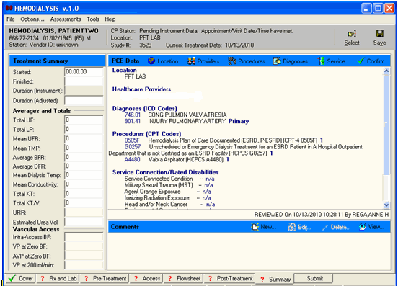
  - Comments
1Figure 10-1
Note: If the appointment/visit date/time is in the future, the date/time has not meet, the PCE data entry buttons will be grayed out until the appointment/visit date/time has been met.

1 Patch MD*1.0*20 November 2010 – Update Figure 10-1 with new screen capture to show Procedure text description.
May 2008 Hemodialysis Patch MD*1.0*6 10-1

Viewing Summary Information

Treatment Summary
You can view summary information for the treatment in the Treatment Summary section of the Summary tab. Located along the left-hand side of the screen, this data is organized into three sections:

Treatment Summary
- Averages and Totals
- Vascular Access
The fields in the Treatment Summary and Averages and Totals sections may populate automatically, depending on your site’s instruments and configuration. If this information is generated by an instrument, it cannot be edited. If your instruments do not send this data, then you may enter it manually by typing it into the fields.
Enter data into the Vascular Access section manually by typing it into the fields.

Clinic/Location
Click the Location button on the PCE Data toolbar to select the treatment location from a popup window.
Figure 10-2
Notes: Once a location has been selected, only a user with ADMIN rights can change the location.
If the location changes for a patient, PCE data will not carry over from a previous study. PCE data must then be re-entered manually. For more information on this subject, see the Troubleshooting section “Preventing PCE “Data Loss”.”
The PCE data (ICD, CPT) will carry over from a previous study if both studies share the same 1) hospital location and 2) procedure request(s).

  - Hemodialysis Patch MD*1.0*6 May 2008

Viewing Summary Information

Healthcare Providers
Use the Providers tab to associate providers to a treatment and specify one provider as primary. To associate healthcare providers to a treatment, do the following:
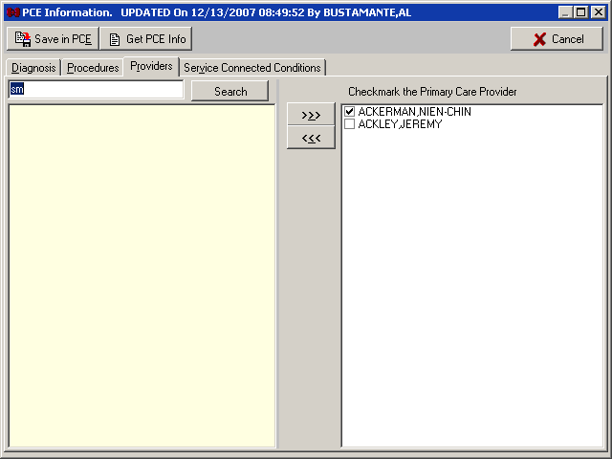
    - On the Summary tab, click the Providers button. The PCE Information window displays and the Providers tab is active (Figure 10-3).
Figure 10-3
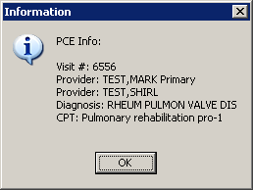
    - To view current PCE information, click Get PCE Info. A window displays the Visit #, Provider(s), Diagnosis, and CPT (procedure code). Click OK to close the window.
Figure 10-4

May 2008 Hemodialysis Patch MD*1.0*6 10-3

Viewing Summary Information

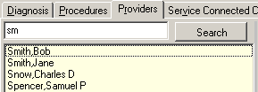
    - Type one or more letters of the provider’s last name into the edit field in the top-left corner of the window, then press <Enter> or click Search. The listview below the edit field displays the names of providers that match the letters you entered (Figure 10-5).
Figure 10-5
    - Highlight a name from the list of available providers, and then click the Move Right
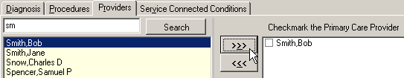
button. The selected name displays in the list of selected providers (Figure 10-6).
Figure 10-6
    - If more than one provider is associated with a treatment, checkmark the Primary Care Provider by clicking the provider’s name.
    - To remove a name from the list of selected providers, highlight the name, then click the
Move Left button.
    - Click Save Data in PCE to close the Billing Information window and return to the Summary tab, or click Cancel to return to the Summary tab without saving changes.

Note: To add diagnoses, procedures, or environmental conditions, you may simply click the appropriate tab on the Billing Information window (Figure 10-6). You don’t have to return to the Summary tab in between procedures.

  - Hemodialysis Patch MD*1.0*6 May 2008

Viewing Summary Information

Procedures and Diagnosis (CPT/ICD Codes)

Diagnosis
Use the Diagnosis tab to list diagnoses performed during a treatment and to specify one as the primary diagnosis. To list diagnoses performed during a treatment, do the following:
    - On the Summary tab, click the Diagnoses button. The PCE Information window displays and the Diagnosis tab is active
    - Type a few characters (alphanumeric) of the diagnosis into the Search field in the top- left corner of the window, then press <Enter> or click Search. The treeview below the Search field displays matching diagnoses.

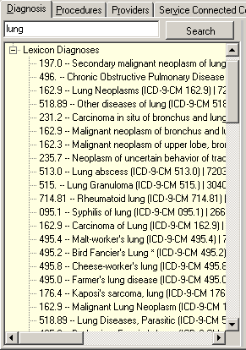
Figure 10-7 shows the results of searching for the word lung. Note that wildcard characters are not needed to locate the word in the middle of a line. In fact, this search returned results which are related to lungs even when the word is not part of the diagnosis, such as Pulmonary Aspergillosis and Adult Respiratory Distress Syndrome.
Figure 10-7
- Expand treeview nodes, if necessary. Highlight a diagnosis, and then click the Move Right button. The selected diagnosis displays in the list of selected diagnoses. Repeat as needed.

May 2008 Hemodialysis Patch MD*1.0*6 10-5

Viewing Summary Information

Shortcut: Double click a diagnosis to move it from one list to the other.
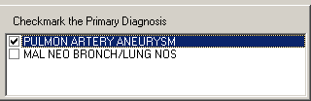
- If more than one diagnosis is associated with a treatment, select the check box of the primary diagnosis.
Figure 10-8
- Click Save Data in PCE to apply changes, close the Billing Information window, and return to the Summary tab, or click Cancel to return to the Summary tab without saving changes.

Procedures
Use the Procedures tab to list procedures performed during a treatment and specify one as the primary. ¹Users can search for Current Procedures Terminologies (CPT) and Healthcare Common Procedure Coding System (HCPCS) codes. To associate procedures to a treatment, do the following:
- On the Summary tab, click the Procedures button. The PCE Information window displays and the Procedures tab is active
- Type a few characters (alphanumeric) of the procedure into the Search field in the top- left corner of the window, then press <Enter> or click Search. The treeview below the Search field displays matching procedures.
- Expand treeview nodes, if necessary. Highlight a procedure, and then click the Move Right button. The selected procedure displays in the list of selected procedures. Repeat as needed.

Shortcut: Double click a procedure to move it from one list to the other.
- If a procedure was performed more than once, click the procedure’s Quantity cell, and then type the number.

- Repeat steps 2-4, as needed.
Figure 10-9

1 Patch MD*1.0*20 November 2010 – Reference CPT and HCPCS codes and update Figure10-9 with new screen capture.
  - Hemodialysis Patch MD*1.0*6 May 2008

Viewing Summary Information

- Click Save Data in PCE to apply changes, close the Billing Information window, and return to the Summary tab, or click Cancel to return to the Summary tab without saving changes.

Service Connected Conditions
Use the Service tab to indicate when the following conditions are associated with a patient:
    - Service Connected Condition
    - Combat Veteran
    - Agent Orange Exposure
    - Ionizing Radiation Exposure
    - Environmental Contaminants
    - Military Sexual Trauma (MST)
    - Head and/or Neck Cancer
To set environmental condition indicators, do the following:
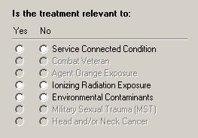
- On the Summary tab, click the Service button. The PCE Information window displays and the Service Connected Conditions tab is active. Some, or possibly none, of the radio buttons on this tab are available (Figure 10-10). Availability of options is based on the current patient’s profile.
Figure 10-10
- For each available service condition, click the Yes radio button if the condition is applicable to the current patient, or click No if it is not.
- Click Save in PCE to store the changes and return to the Summary tab, or click Cancel
to discard changes and return to the Summary tab.
The title bar of the PCE Information window displays the words UPDATED On followed by the following information (Figure 10-11):
  - The date

May 2008 Hemodialysis Patch MD*1.0*6 10-7

Viewing Summary Information

  - The time
  - The user name
Figure 10-11

Confirming PCE Data Without Changing Anything
For each treatment, if you do not add or change PCE information, you are still required to confirm that the existing PCE data is correct. ¹Current PCE data displays on the summary tab under the label “PCE Data,” as shown in the following:
- Location – workload location
- Healthcare Providers – Primary Care Provider and provider(s) associated with the treatment
- Diagnoses (ICD Codes) – International Classification of Diseases (ICD) Diagnosis Code, code description, and if it is a primary code
- Procedures (CPT Codes) – Current Procedure Terminology (CPT) or Healthcare Common Procedure Coding System (HCPCS Code), code description, and quantity
- Service Connection/Rated Disabilities – environment condition indicators associated with the patient

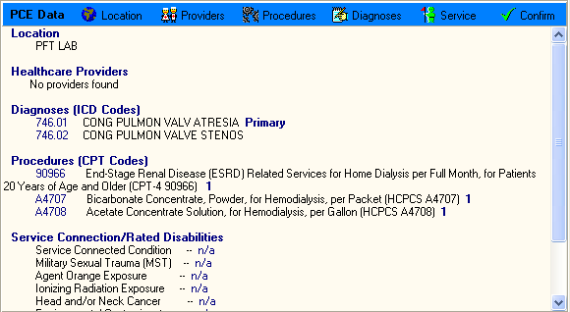
Figure 10-12

1 Patch MD*1.0*20 November 2010 – Add description for the PCE Data screen and update Figure10-12 to show example text description for CPT and HCPCS codes.
10-8 Hemodialysis Patch MD*1.0*6 May 2008

Viewing Summary Information

Once you have reviewed the existing information, click Confirm.
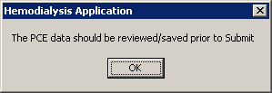
Note 1: If you try to submit a study without clicking the Confirm button, a popup message reminds you to review or save PCE data. Click OK, then return to the Summary tab and click Confirm.
Figure 10-13
Note 2: In rare cases, you may see the following popup message after you click Confirm: “Sorry, the PCE data was not updated even though the data was accepted.”
This message means that the PCE data for this study was already sent to the Austin Data Center, and it can no longer be updated.

Comments
Summary notes can be added and viewed in the Comments area at the bottom of the screen. For detailed instructions, see the “Comments” section in Chapter 5.

May 2008 Hemodialysis Patch MD*1.0*6 10-9

Viewing Summary Information

10-10 Hemodialysis Patch MD*1.0*6 May 2008

