June 2010

This distribution contains change pages for patch MD*1.0*21 of the Clinical Procedures 1.0 User Manual.
The change pages for CP Patch 21, should be inserted after the change pages for CP Patch 11: File Name: Patch:
MD_1_P21_UM.PDF MD*1.0*21

Patch MD*1.0*21 pages:

Replace Pages: With Pages:
Title page Title page
Revision History Revision History
Table of Contents Table of Contents
4-1 to 4-20 4-1 to 4-26
5-25 to 5-26 5-25 to 5-28
6-1 to 6-6 6-1 to 6-6
7-1 to 7-2 7-1 to 7-6

Add Pages 8-1 to 8-2

CLINICAL PROCEDURES USER MANUAL

Version 1.0
April 2004

Revised June 2010

Department of Veterans Affairs Office of Information & Technology Office of Enterprise Development

Revision History

Description | Date | Technical Writer
Originally released. | April 2004
1Patch MD*1.0*2 released. | July 2004
2Patch MD*1.0*10 released. | March 2005
3Patch MD*1.0*4 released. | September 2006 | REDACTED
4Patch MD*1.0*14 released. Added new sections for Auto Study Check-In to Ch. 3. | March 2008 | REDACTED
5Patch MD*1.0*11 released. Added new section in Ch. 3 for handling appointment no shows and cancellation with the auto study check-in. Replaced provider name in Ch. 4 with generic name. | June 2009 | REDACTED
6Patch MD*1.0*21 released. Added new section in Ch. 4 for resulting the high volume procedures.  Added Ad Hoc Health Summary Components for CP reports to Ch. 5. Added Ch. 6 Report Options.  Updated Ch 8 Index. | June 2010 | REDACTED

1 Patch MD*1.0*2 July 2004 Patch 2 release added.
2 Patch MD*1.0*10 March 2005 Patch 10 release added.
3 Patch MD*1.0*4 September 2006 Patch 4 release added.
4 Patch MD*1.0*14 March 2008 Patch release added.
5 Patch MD*1.0*11 June 2009 Patch release added.
6 Patch MD*1.0*21 June 2010 Patch release added.

Table of Contents
- Introduction 1-1
Intended Audience 1-6
Related Manuals. 1-6
Product Benefits 1-6
- Working with CP User 2-1
Opening CP User. 2-1
Defining CP User Icons 2-1
Selecting a Patient 2-2
Defining the Parts of the Main CP User Window 2-3
- Clinical Procedures Process, Part 1 3-1
Ordering a Consult Procedure in CPRS 3-1
Auto Study Check-In 3-9
Auto Check-In Without Appointment 3-10
Setting Up the Procedure 3-10
Procedure Request in CPRS. 3-15
Confirm the Auto Study Check-In 3-17
Auto Study Check-In With Appointment 3-17
Check-In a New Study 3-26
Updating Study Status to Correct Errors 3-32
Appointment No Shows and Cancellation 3-33
- Clinical Procedures Process, Part 2 4-1
Completing the Procedure 4-1
Entering the interpretation into the TIU Note 4-1
Entering Encounter Information 4-7
Signing Off. 4-12
Resulting High Volume Procedures 4-14
Viewing Clinical Procedures Results 4-22
Linking Consent Forms and Images to CP Documents 4-26
- Viewing the Reports 5-1
Abnormal 5-3
Brief Report 5-7
Full Captioned 5-8
Full Report 5-13
Procedures (local only) 5-18
Procedures 5-21
Configuring the Medicine Report to Display in CPRS. 5-23
Ad Hoc Health Summary Components for CP Reports 5-26
- Report Options 6-1
- Glossary 7-1
- Index 8-1

Table of Contents

Clinical Procedures Process, Part 2
This chapter describes the process to follow for completing clinical procedures. (This chapter uses the example of completing a colonoscopy to describe the Clinical Procedures process.) Be sure to follow the required steps in sequential order. You can do the optional steps as needed.

  - Complete the Procedure. Required
    - Enter an Interpretation into the TIU note. Required
    - Enter Encounter information. Required for workload counts
    - Sign off. Required
  - View Clinical Procedures results. Optional
  - Link consent forms and images to Clinical Procedures documents. Optional

Completing the Procedure
To complete the procedure, you need to enter the interpretation into the TIU note, enter encounter information, and sign off. In this example, the colonoscopy study is being completed.

Entering the interpretation into the TIU Note

- Logon to CPRS. The Patient Selection screen is displayed, Figure 4-1.

Clinical Procedures Process, Part 2

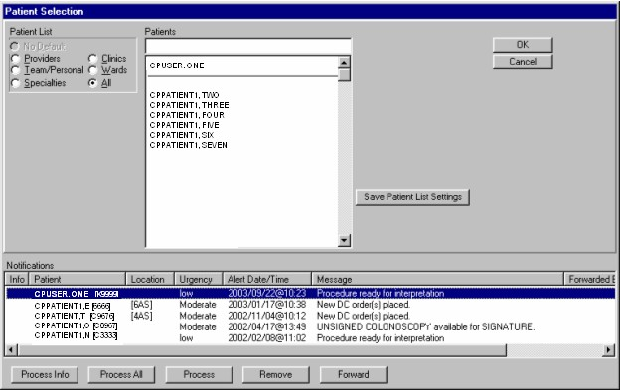
Figure 4-1

- In the Notifications box at the bottom of the screen, patients are listed with “Procedure ready for interpretation”.
  - Click Process Info if you want to process an informational alert (see left column under Notifications, Figure 4-1).
  - Click Process All if you want to process all of the items listed.
  - Click Process if you want to process an item through the Consults tab.
  - Click Remove if you want to remove an item from the list.
  - Click Forward if you want to forward the item to another person.

As part of this example, the patient, CPPATIENT, ONE, is selected. To view results through Consults, click Process. The Consults tab is displayed.

Clinical Procedures Process, Part 2

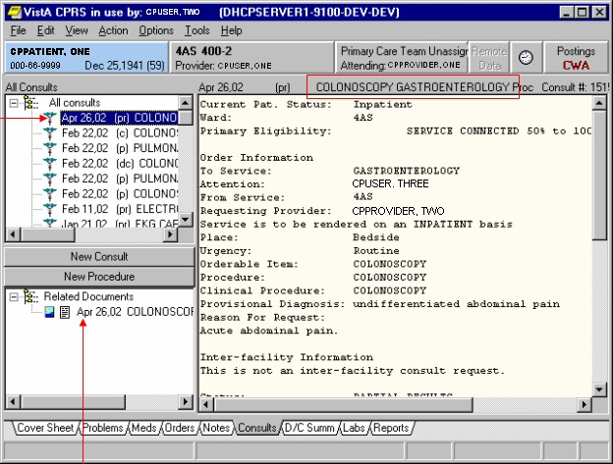
Figure 4-2

Note the image and note document within the Related Documents window (Figure 4-2).

The consult procedure now has a status of partial results (pr). The CP document has the TIU note title.

- Click the CP title in the Related Documents window. The CP document is displayed in the right window, Figure 4-3.

Clinical Procedures Process, Part 2

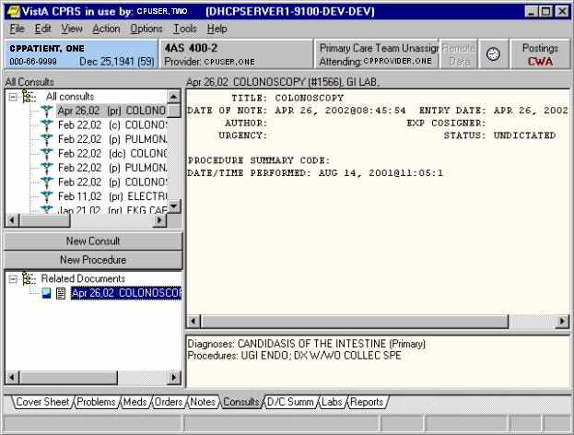
Figure 4-3

The Author is not defined, Figure 4-3. This note is automatically created when the instrument result is sent and submitted and an author does not exist. The Interpreter who is interpreting the result is the default Author. The status of the document is always UNDICTATED when the results are ready for interpretation.

- To select the results that you want to interpret, choose Action > Consult Results >
Complete/Update Results, Figure 4-4.

Clinical Procedures Process, Part 2

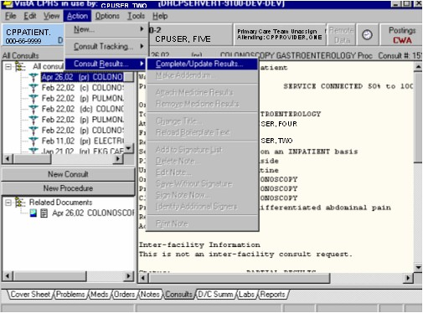
Figure 4-4

Note: To interpret the result, select the Complete/Update Results option. The Enter Required Fields dialog box is displayed, Figure 4-5. The interpreter’s name displays by default in the Author field.

Clinical Procedures Process, Part 2

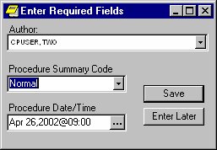
Figure 4-5

- Select the appropriate Procedure Summary Code from the list (Figure 4-5). The Procedure Summary Codes include Abnormal, Normal, Borderline, and Incomplete.

- Enter a Procedure Date/Time. Depending on the instrument, the Procedure Date/Time is passed in the HL7 message from the instrument. As the interpreter, you can accept the default. If the instrument does not pass the Procedure Date/Time, the interpreter has to enter a Procedure Date/Time.

The Procedure Summary Code and Procedure Date/Time are required fields for the initial note that you are editing.

If you close the Enter Required Fields dialog box without entering the requested information, CPRS prompts the interpreter again.

Any subsequent note created on the same procedure after this initial note does not require the Procedure Summary Code and Procedure Date/Time fields. The fields are optional on subsequent notes.

Clinical Procedures Process, Part 2

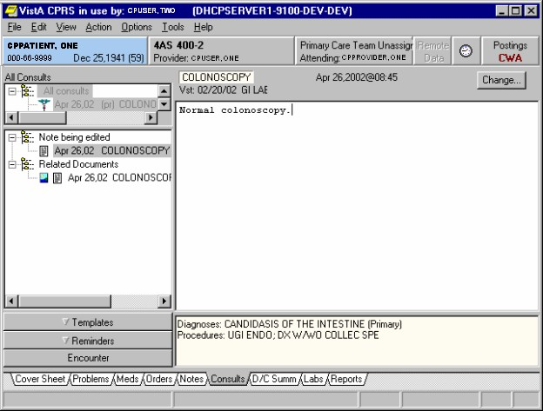
Figure 4-6

- Enter an interpretation in the space on the right side of the screen for the highlighted (current) consult procedure (Figure 4-6).

Entering Encounter Information

You can now enter encounter form information.

- To enter the encounter information and complete the consult procedure, you must select

Action > Consult Results > Sign Note Now.

You can also select the Encounter drawer (Figure 4-6) to enter encounter information.

Clinical Procedures Process, Part 2

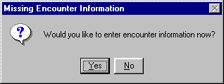
Figure 4-7

This window (Figure 4-7) asks if you want to enter encounter information now. Figure 4-7 is displayed depending on how CPRS parameters are set. See the Implementation Guide for information on defining CPRS parameters.

- Click Yes to enter encounter information, or click No to skip this step. If you choose No, you can enter the information at a later time. In this example, the Yes button is clicked and encounter information is entered.
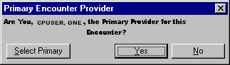
Figure 4-8

Figure 4-8 allows you to verify the primary provider for this encounter form.

- Click Yes.

CPRS brings up the Encounter Form that was set up for the Hospital Location, where the procedure was performed. The Visit Type tab is displayed.

- Enter appropriate information for visit type. For example, in Figure 4-9, the following information was entered:

Type of Visit. Established Patient

Section Name. Intermediate Exam 11-19 Min.

Visit Related to Service Connected Condition. Yes

Current providers for this encounter. 1CPUSER, ONE

1 Patch MD*1.0*11 June 2009 Replaced provider name with generic name.

Clinical Procedures Process, Part 2

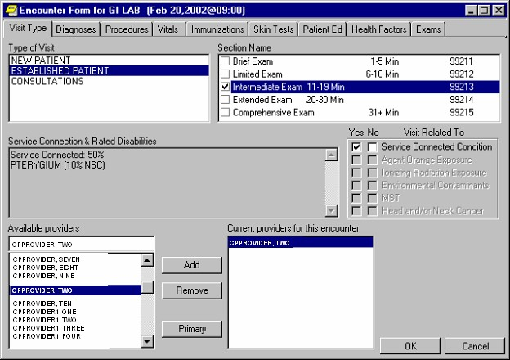
Figure 4-9

- Click the Diagnoses tab.

Clinical Procedures Process, Part 2

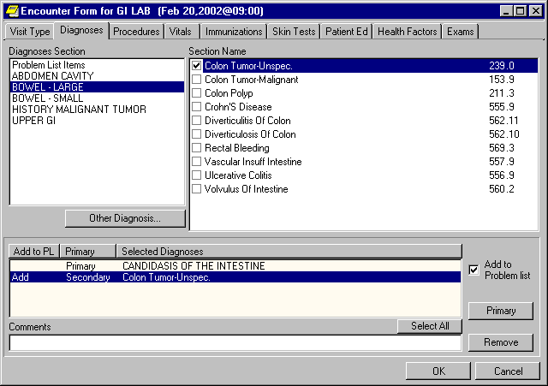
Figure 4-10

- Enter appropriate information for diagnoses. See Figure 4-10.

- Click the Procedures tab.

Clinical Procedures Process, Part 2

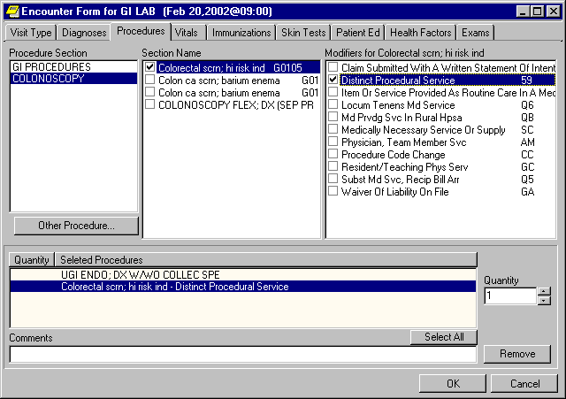
Figure 4-11

- Enter appropriate procedure information. See Figure 4-11.

- Click the Exams tab.

Clinical Procedures Process, Part 2

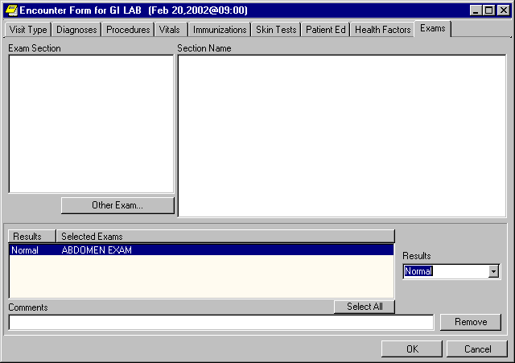
Figure 4-12

- Enter appropriate exam information. (See Figure 4-12.) Click OK to return to the Consults tab.

Signing Off

- To complete the consult procedure, select Action > Consult Results > Sign Note Now.
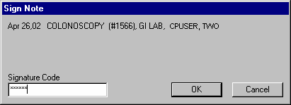
Figure 4-13

- Enter your electronic signature to sign the TIU note and complete the consult procedure.

Clinical Procedures Process, Part 2

- Click OK.
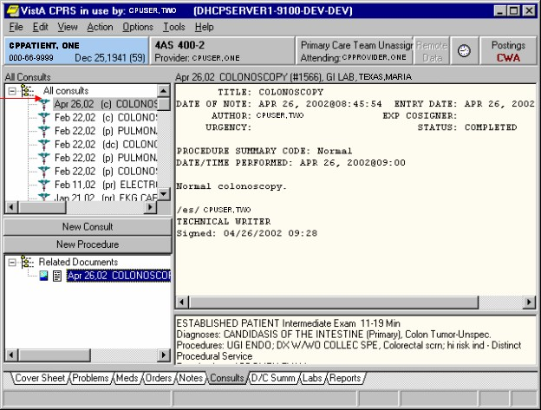
Figure 4-14

- The consult procedure now has a status of complete (Figure 4-14).

- The procedure location (GI LAB in Figure 4-14) is used for workload reporting.

- The workload for the procedure goes through the standard TIU interface with PCE (Patient Care Encounter).

Even though the consult is complete, you can still attach additional files and studies to the same order.

Clinical Procedures Process, Part 2

1Resulting High Volume Procedures
Patch MD*1.0*21 streamlines the process for high volume procedures such as the electrocardiograms. It reduces the steps for entering the interpretations and completing the procedure request for results that have been verified on the medical device.

Make sure the Clinical Application Coordinator and IRM Programmer Support follow the High Volume Procedure Checklist in Appendix E – High Volume Procedure Checklist of the Clinical Procedures Implementation Guide to implement a high volume procedure. Once you set up a procedure, you can use this functionality.

Do not setup a procedure for high volume, if you do not want to use the auto closure functionality and there is no text impression from the device. You should use the regular CP process.

There are multiple ways that the high volume procedure can be processed. The table below shows the different ways:

 | Procedure | Text | Setup
 | Any | No | Auto Closure with Proxy User
 | EKG(Muse) | Yes | Auto Closure with Proxy User,
 |  |  | Auto Closure with Muse interpreter, or
 |  |  | Significant Findings
 | Any | Yes | Auto Closure with Proxy User or
 |  |  | Significant Findings

Once the procedure is performed and transmitted to VistA, Clinical Procedures will create the note with four lines of text and administratively close the note. This first example shows a procedure with no text and it is auto closed by the proxy user with administrative closure.
LOCAL TITLE: CP TEST TITLE
STANDARD TITLE: CARDIOLOGY ATTENDING NOTE
DATE OF NOTE: MAR 17, 2009@09:42:05 ENTRY DATE: MAR 17, 2009@09:42:05 AUTHOR: CLINICAL,DEVICE PRO EXP COSIGNER:
URGENCY: STATUS: COMPLETED

** DOCUMENT IN VISTA IMAGING ** SEE FULL REPORT IN VISTA IMAGING

SIGNATURE NOT REQUIRED
SEE SIGNATURE IN VISTA IMAGING

Administrative Closure: 03/17/2009
by:
Clinical,Device Proxy Service

1 Patch MD*1.0*21 June 2010 Add Resulting High Volume Procedures section to Chapter 4.

Clinical Procedures Process, Part 2

If a procedure is set to get the text impression, Clinical Procedures will add the text into the note and administratively close the note. This functionality will only work if the medical device is capable of sending the text impression and the result is the final result and was verified on the device. Otherwise, the text will not be included in the note.

The next example shows the administratively closed note by the proxy user with the text impression added in the note for an EKG.
Administrative Closure: 03/17/2009
by:
Clinical,Device Proxy Service
BPM
93000.2 Ventricular Rate: 67
LOCAL TITLE: CP MUSE EKG STANDARD TITLE: CARDIOLOGY NOTE
DATE OF NOTE: MAR 17, 2009@08:41:49 ENTRY DATE: MAR 17, 2009@08:41:49 AUTHOR: CLINICAL,DEVICE PRO EXP COSIGNER:
URGENCY: STATUS: COMPLETED

PROCEDURE SUMMARY CODE: Machine Resulted DATE/TIME PERFORMED: MAR 17, 2009@08:40:5

** DOCUMENT IN VISTA IMAGING ** SEE FULL REPORT IN VISTA IMAGING

SIGNATURE NOT REQUIRED
SEE SIGNATURE IN VISTA IMAGING

** (Muse EKG(Bi-Directional)) AUTO-INSTRUMENT DIAGNOSIS ** Procedure: 93000 12 Lead ECG
Date Verified: Oct 15, 1998@15:04:18

The following example shows an EKG note with the text added, but the note was auto closed by the interpreter on the Muse:

LOCAL TITLE: CP MUSE EKG STANDARD TITLE: CARDIOLOGY NOTE
DATE OF NOTE: JUL 01, 2009@12:00:29 ENTRY DATE: JUL 01, 2009@12:00:29 AUTHOR: MUSE,INTERPRETER EXP COSIGNER:
URGENCY: STATUS: COMPLETED

PROCEDURE SUMMARY CODE: Machine Resulted DATE/TIME PERFORMED: AUG 04, 2008@09:00:4

** DOCUMENT IN VISTA IMAGING ** SEE FULL REPORT IN VISTA IMAGING

SIGNATURE NOT REQUIRED
SEE SIGNATURE IN VISTA IMAGING

** (Muse EKG(Bi-Directional)) AUTO-INSTRUMENT DIAGNOSIS **

Procedure: 93040 12 Lead ECG

Release Status: Released Off-Line Verified Date Verified: Aug 04, 2008@09:43:06 Interpreter: MUSE,INTERPRETER

93000.2 Ventricular Rate: 69 BPM

Clinical Procedures Process, Part 2
93000.3 Atrial Rate: | 69 | BPM
93000.4 P-R Interval: | 140 | ms
93000.5 QRS Duration: | 100 | ms
93000.6 Q-T Interval: | 386 | ms
93000 QTC Calculation(Bezet):413 ms 93000.12 Calculated P Axis: 75 degrees
93000.13 Calculated R Axis: 72 degrees
93000.14 Calculated T Axis: 72 degrees Normal sinus rhythm
Normal ECG

Administrative Closure: 07/01/2009
by: INTERPRETER MUSE INTERPRETER

The fourth example shows a procedure with the text of the result added to the significant findings of the consult and the note remains in the “Undictated” status. This example is the Detailed Consult that has the significant findings and the note displayed:
Protocol: Baseline
EVENT:
Event Log
3081204124528
DMS_11716 1
STUDYUID: STUDYNUM: CVIS-MODE:
Procedure: 99999
Cm Kg m2

Years
183.00
86.60
2.09
M 57.07
Case Demographics
PT-HT-CM:
PT-WT-KG:
PT-BSA:
PT-SEX:
PT-AGE:
Procedure: 99999
(entered) 06/25/09 16:46
** DOCUMENT IN VISTA IMAGING ** SEE FULL REPORT IN VISTA IMAGING

** (DMS (EP)) AUTO-INSTRUMENT DIAGNOSIS **

Procedure: 99999 Patient Demographics
CLINICAL,DEVICE P
CLINICAL,DEVICE P
TEST,TEST TEST,TEST
06/25/09 16:44
06/25/09 17:00
CPRS RELEASED ORDER SIG FINDING UPDATE
Responsible Person Entered By
Date/Time/Zone
Facility Activity
Current Pat. Status: Outpatient
Primary Eligibility: SC LESS THAN 50%

Order Information
To Service: CARDIOLOGY
From Service: CARDIOLOGY Requesting Provider: ACKERMAN,TEST
Service is to be rendered on an OUTPATIENT basis Place: Consultant's choice
Urgency: Routine
Orderable Item: CP EP
Procedure: CP EP Clinical Procedure: EP Reason For Request:
Colon exam.

Inter-facility Information
This is not an inter-facility consult request.

Status: COMPLETE
Last Action: COMPLETE/UPDATE Significant Findings: YES

  - Clinical Procedures V. 1.0 April 2004 User Manual

Clinical Procedures Process, Part 2

EVENT: Pre-Case Documentation
EVENT: Patient Arrives
EVENT: Patient on Table
EVENT: Pre-Procedure Teaching Performed
EVENT: Patient Verbalized Understanding of Procedure
EVENT: Consent Signed \T\ On Chart
EVENT: History \T\ Physical On Chart
EVENT: Armband Checked \T\ On Patient
EVENT:
EVENT: No Known Drug Allergies
EVENT: Patient Allergies:
EVENT: IV's Infusing:
EVENT: IV Site:
EVENT: Pre-Case Conscious Sedation Assessment
EVENT: Pre-Procedure Pulses Checked
EVENT:
EVENT: Lab Results Checked
EVENT: Physician Called
EVENT: Patient Prepped \T\ Draped In Usual Manner
EVENT: 12-Lead Print
EVENT: EP Procedure
EVENT: Physician Arrived
EVENT: SpO2 99%; HR 88 bpm; 121/88/109 NBP; RR 19/min
EVENT: Case Event - Diagnostic EP EVENT:
Case Event Type:Diagnostic EP,Physician:smith,john

EVENT: HR 87 bpm; ***/***/*** NBP; RR 19/min
EVENT: Case Start
EVENT: Fentanyl IV 5 mcg
EVENT: Midazolam IV 6 mg
EVENT: Procedure: EP Study with Induction
EVENT: Lidocaine Administered to:
EVENT: Percutaneous Puncture to:
EVENT: Sheath Inserted
EVENT: 8F SR3 8F sheath
EVENT: Catheter Inserted
EVENT: Quadrapolar EP catheter
EVENT: Conduction Intervals EVENT:
Case Event Type:Interventional EP,Physician:smith,john

EVENT: Arrhy : Tachy
EVENT: Arrhy : Terminated
EVENT: SpO2 94%; HR 187 bpm; 166/110/133 NBP; RR 20/min
EVENT: Arrhy : Tachy
EVENT: Arrhy : Terminated
EVENT: Arrhy : Tachy
EVENT: Arrhy : Terminated
EVENT: Procedure: Mapping
EVENT: Procedure: Electrophysiologic Ablation
EVENT: 5031TM Ablation catheter
EVENT: Post Case Documentation
EVENT: Case End
EVENT: Sheaths Pulled \T\ Manual Pressure Applied
EVENT: Sheaths Sutured In Place
EVENT: Post Case Conscious Sedation Assessment
EVENT: Post Procedure Pulses Checked
EVENT:
EVENT: Hemostasis Obtained
EVENT: Dressing Applied to the Site
EVENT: Post Procedure Teaching Performed
EVENT: Patient Verbalizes Understanding of Teaching
EVENT: Report Called To:
EVENT: Patient Transferred To: Procedure: 99999 Conscious Sedation

CS-ACT-PRE:
2 - Able to move 4 extremities voluntarily or on command

CS-ACT-POST:

Clinical Procedures Process, Part 2

0 - Unable to move extremities voluntarily or on command

CS-RESP-PRE: 2 - Able to breathe deeply and cough freely
CS-RESP-POST: 1 - Dyspnea or limited breathing
CS-CIRC-PRE: 2 - BP +/- 20% of pre-anesthetic level
CS-CIRC-POST: 1 - BP +/- 20% to 49% of pre-anesthetic level
CS-CONS-PRE: 2 - Fully Awake
CS-CONS-POST: 1 - Arousable on calling CS-O2SAT-PRE:
2 - Able to maintain O2 saturation greater than 92% on room air

CS-O2SAT-POST:
1 - Needs O2 inhalation to maintain O2 Saturation greater than 90%
CS-SCORE-PRE: 10
CS-SCORE-POST: 4
Procedure: 99999 XRay Summary

XRAY-FLTIME: |  | 22.00 | min
XRAY-FLDOSE: |  |  | cGycm2
XRAY-CINEDOSE: |  |  | cGycm2
XRAY-TOTDOSE: |  |  | cGycm2
XRAY-CINEFRAME:
XRAY-INTFLTIME: |  | 10.00
XRAY-DIAGFLTIME: |  | 12.00
XRAY-TOTALRUNS:
Procedure: 99999 | DICOM

Event_DICOM_Study:
1.2.840.113619.6.209.2667640736.933319371.3302940589.266219474

Procedure: 99999 Reports

Procedure: 99999 Custom_Fields

Procedure: 99999 Registry_Fields

Procedure: 99999 Registry_Fields

Procedure: 0 Study Events

Procedure: 0 Study Events

Procedure: 0 Study Events

Procedure: 99999

COMPLETE/UPDATE 12/04/08 12:10 CLINICAL,DEVICE P ACKERMAN,TEST
(entered) 06/25/09 17:20
Note# 5835

Note: TIME ZONE is local if not indicated

Significant Findings: **Yes**

LOCAL TITLE: CP CARDIOLOGY
DATE OF NOTE: JUN 25, 2009@16:46:33 ENTRY DATE: JUN 25, 2009@16:46:33 AUTHOR: EXP COSIGNER:
URGENCY: STATUS: UNDICTATED

PROCEDURE SUMMARY CODE: Machine Resulted DATE/TIME PERFORMED: DEC 04, 2008@12:10:0

================================================================================
==================================== END =======================================

Once the note is complete, the Procedure request will be complete.

Clinical Procedures Process, Part 2

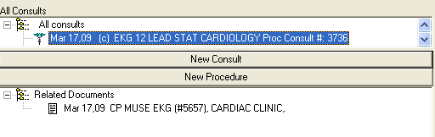
Figure 4-15

On the Consults tab in Computerized Patient Record System (CPRS), the technician can create an addendum to the note and enter the encounter form information. Highlight the note that was administratively closed. Use the “Action” pull down menu and select Consult Results and then select Make Addendum.
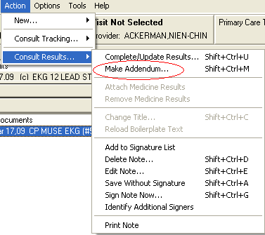
Figure 4-16

Click on the Encounter button to bring up the Encounter form for the workload.
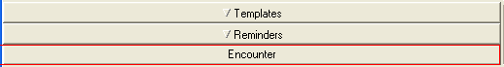
Figure 4-17

Clinical Procedures Process, Part 2

If you used a Consults title for the note, the note will appear in both the Notes and Consults tab. On the Notes tab, you will be able to see the individual note without the procedure request. You can highlight the note and click the “Encounter” button to launch the Encounter form.

Note: If you used a Consult title for the note, the Procedure Summary Code and Date/Time Performed will not be displayed on the note.
Figure 4-18

LOCAL TITLE: CP TEST TITLE
STANDARD TITLE: CARDIOLOGY ATTENDING NOTE
DATE OF NOTE: MAR 17, 2009@09:42:05 ENTRY DATE: MAR 17, 2009@09:42:05 AUTHOR: CLINICAL,DEVICE PRO EXP COSIGNER:
URGENCY: STATUS: COMPLETED

** DOCUMENT IN VISTA IMAGING ** SEE FULL REPORT IN VISTA IMAGING

SIGNATURE NOT REQUIRED
SEE SIGNATURE IN VISTA IMAGING

** (Muse EKG(Bi-Directional)) AUTO-INSTRUMENT DIAGNOSIS ** Procedure: 93000 12 Lead ECG

Clinical Procedures Process, Part 2

Date Verified: Oct 15, 1998@15:04:18 93000.2 Ventricular Rate: 67 BPM
Administrative Closure: 03/17/2009
by:
Clinical,Device Proxy Service

If you setup the procedure with the text to be entered as significant findings, you will see the Detailed Consult on the Consults tab and in the Procedure (local only) component on the Reports tab of CPRS.

Clinical Procedures Process, Part 2

Viewing Clinical Procedures Results
You can go to VistA Imaging to view results. If you as the interpreter did not interpret the result right after the procedure was performed, you may want to view the results before you enter an interpretation. In the colonoscopy example, the interpretation was entered in Figure 4-6.

    - Logon to CPRS.

    - Select Tools > VistA Imaging Display, Figure 4-19. The patient’s Abstract list is displayed, Figure 4-20.
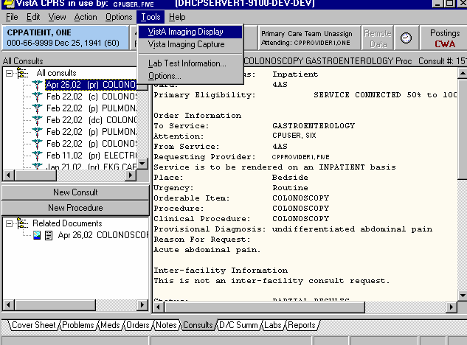
Figure 4-19

Clinical Procedures Process, Part 2

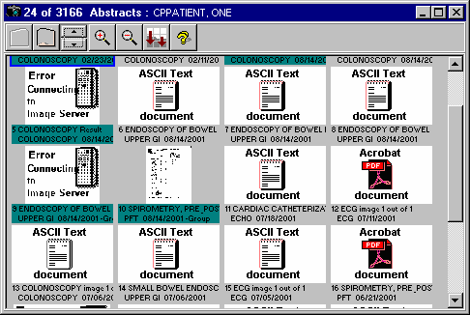
Figure 4-20

Note: VistA Imaging accepts procedure results in .bmp, jpg, jpeg, html, .pdf, .rft, tiff, and .txt formats.
- Select View > Clinical Procedures to view Clinical Procedures document titles. The list of CP documents for the patient is displayed. (Figure 4-21).
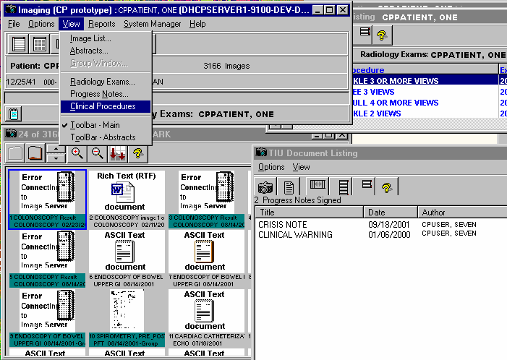
Figure 4-21

Clinical Procedures Process, Part 2

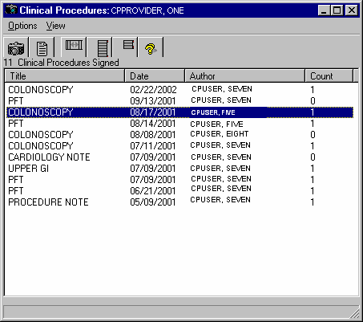
Figure 4-22

- Click a document title, and then click the camera icon to display the associated images for that CP document, Figure 4-22.

Clinical Procedures Process, Part 2

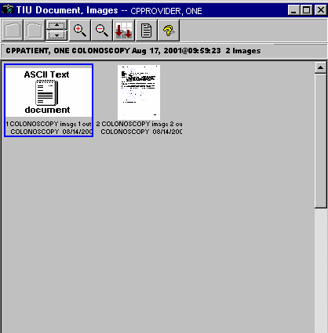
Figure 4-23

- Double-click the abstract to open the result file, (Figure 4-23).

- In the screen where the CP documents are listed, Figure 4-22, click the CP title, and then click the report icon next to the camera. The TIU Note is displayed, Figure 4-24.

Clinical Procedures Process, Part 2

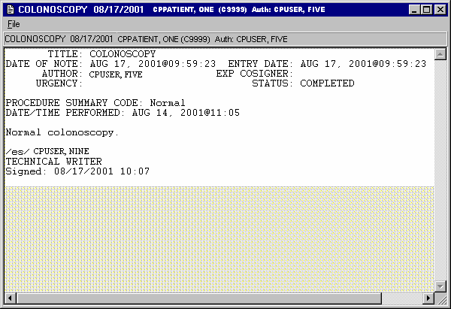
Figure 4-24

Figure 4-24 is an example of a document that has been interpreted and signed.

If you launch Imaging Display before the document is interpreted, the Author field is undefined and the status is UNDICTATED. Some users may want to view the results before interpreting.

Linking Consent Forms and Images to CP Documents
As the interpreter, you can link a consent form or other images to CP documents by using VistA Imaging Capture. VistA Imaging Capture software can capture clinical images or scanned documents and attach them to Clinical Procedures. Refer to the VistA Imaging 3.0 MAG*3.0*7 Patch Document at the following website: WEBSITE REDACTED -DOESN’T WORK

REDACTED
Viewing the Reports

- Here is an example of how to add a single field #204.5 to the Full GI Medicine View file (#690.2).
Select MEDICINE VIEW PRINT VIEW TEMPLATE NAME: Full GI
ENDOSCOPY/CONSULT
PRINT VIEW TEMPLATE NAME: Full GI// <RET> PRIMARY FILE: ENDOSCOPY/CONSULT// <RET> Select FIELD NUMBER: 37.1// <RET>
FIELD NUMBER: 37.1// <RET> ORDER ENTRY USAGE: <RET> ASTM: <RET>
VALUE TYPE: <RET> UNITS: <RET> RANGES: <RET> SEG: <RET>
PIECE: <RET>
CODING METHOD: <RET>
Select FIELD NUMBER: 204.5
Are you adding '204.5' as a new FIELD NUMBER (the 47TH for this MEDICINE VIEW)? No// Y (Yes)
FIELD NUMBER ASTM: <RET> ORDER ENTRY USAGE: <RET> ASTM: <RET>
VALUE TYPE: <RET> UNITS: <RET> RANGES: <RET> SEG: <RET>
PIECE: <RET>
CODING METHOD: <RET>
Select FIELD NUMBER: <RET>
Select SUB-FILE: 699.04// <RET> SUB-FILE: 699.04// <RET> Select SUB-FIELD: .01// <RET>
SUB-FIELD: .01// <RET> ORDER ENTRY USAGE: <RET> ASTM: <RET>
VALUE TYPE: <RET> UNITS: <RET> RANGES: <RET> SEG: <RET>
PIECE: <RET>
CODING: <RET>
Select SUB-FIELD: <RET>
Select SUB-FILE: <RET>
Select PROCEDURE: GEN// <RET>
Type: Full// <RET>

Select MEDICINE VIEW PRINT VIEW TEMPLATE NAME: <RET>

Viewing the Reports

1Ad Hoc Health Summary Components for CP Reports

A patient at a site can have multiple procedures performed. Over a certain period of time, this would make it difficult for the physician to search through the Clinical Reports for Medicine/CP Reports in CPRS. With patch MD*1*21, the site can setup an Ad Hoc Health Summary component for a specific procedure such as Electrocardiogram. The component would be used to group the CP reports for that procedure. This way, the physician can just look through the reports for a specific procedure. If your site has certain procedures that are high volume, you can set this up. Please contact your IRM programmer and Clinical Application Coordinator and have them refer to Step 3 – Create Ad Hoc Health Summary Component for CP of Chapter 10 - Setting Up CPRS for Clinical Procedures in the Clinical Procedures Implementation Guide for the setup.

The next few screen captures depict an example Ad Hoc HS component that was created for the EKG reports:

Select Reports tab in CPRS and select Ad Hoc Report within the Health Summary tree view.
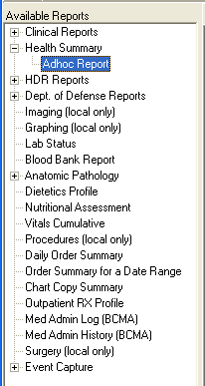
Figure 5-1

1 Patch MD*1.0*21 June 2010 – Ad Hoc Health Summary Components For CP reports.

Viewing the Reports

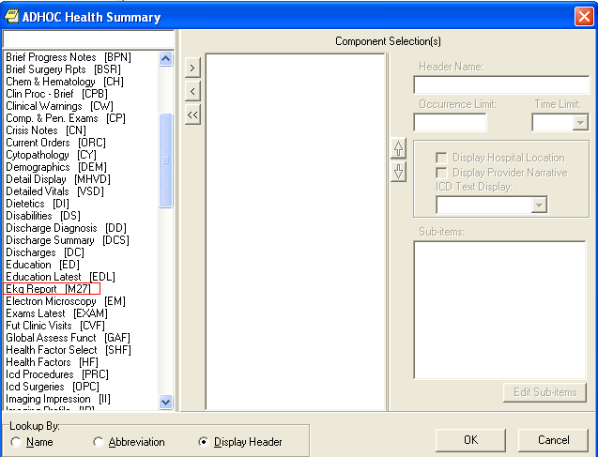
Once you click the Ad Hoc Report, an Ad Hoc Health Summary window opens as demonstrated below:
Figure 5-2

Find the Health Summary component that you want and select it. Enter the Occurrence Limit and Time Limit that you want. The Occurrence Limit field is the number of reports that you want displayed and the Time Limit is the date range to find the report such as 1Y (1 year). Once you clicked the “OK” button, you should generate only EKG reports found for that occurrence and time limit.

Viewing the Reports

1Report Options
The option Print list of Procedure with incomplete workload [MD PROC W/INCOMPLETE WORKLOAD] prints a list of procedures that have incomplete workload information for a date range. This date range used is the date/time performed of the CP Result Report. The list is sorted alphabetically by the Facility Treating Specialty and then alphabetically by the procedure name. Within the procedure, a list of records with the visit date/time, patient name (last four of the social security number), Consult request number, Text Integration Utility (TIU) note number, and the missing data (Diagnosis, Current Procedure Terminology (CPT), or Provider) is generated. This list can be used to let the Clinical Application Coordinator (CAC) know which study does not have the workload data entered. All missing data should be entered by the CAC for the incomplete procedures using the Patient Care Encounter (PCE) option PCE Encounter Data Entry – Supervisor [PXCE ENCOUNTER ENTRY SUPER].

The input information needed to run the option is the following:

  - Start Date – the starting date of the date/time performed of the CP Result Report.
  - End Date – the ending date of the date/time performed of the CP Result Report.
  - Facility Treating Specialty – enter a facility treating specialty or “ALL” for all Facility Treating Specialties.
  - List Printer – enter a printer device to print the list or “HOME” for on screen display.

Following is an example of running the option.

Select OPTION NAME: MD PROC W/INCOMPLETE WORKLOAD Print list of Procedure with incomplete workload
Print list of Procedure with incomplete workload Select Start Date: T-365 (APR 07, 2009)
Select End Date: T (APR 07, 2010)

Select Facility Treating Specialty (or ALL): ALL Select LIST Printer: HOME// 0;80;9999 TELNET
Apr 07, 2010 3:29:20 pm Page 1

P R O C E D U R E S W I T H I N C O M P L E T E W O R K L O A D

CARDIOLOGY

Visit D/T Patient Consult # TIU # MISSING
PROCEDURE: CARDIAC CATHETERIZATION

1 Patch MD*1.0*21 June 2010 Added Report Options chapter.

Report Options
07/14/05@17:19 | CPPATIENT,ONE | (0000) | 2618 | 4281 | Diagnosis CPT  Provider
07/15/05@09:56 | CPPATIENT,TWO | (0001) | 2620 | 4248 | Diagnosis CPT  Provider
Apr 07, 2010 3:29:20 pm Page 2

P R O C E D U R E S W I T H I N C O M P L E T E W O R K L O A D

CARDIOLOGY

Visit D/T Patient Consult # TIU # MISSING PROCEDURE: EKG, ROUTINE (12 LEADS)
04/13/09@09:37  04/13/09@10:22 | CPPATIENT,THREE (0002)  CPPATIENT,FOUR (0003) |  | 3757  3758 | 5694  5695 | Diagnosis CPT  Provider Diagnosis
 |  |  |  |  | CPT
04/20/09@09:46 | CPPATIENT,FIVE (0004) |  | 3760 | 5698 | Diagnosis CPT
04/20/09@10:25 | CPPATIENT,SIX (0005) |  | 3761 | 5699 | Diagnosis CPT
04/21/09@16:18 | CPPATIENT,SEVEN (0006) |  | 3762 | 5702 | Diagnosis CPT

The Clinical Procedures Studies List [MD STUDIES LIST] option generates a report which lists all studies associated with the consult requests. The report should be sent to a 132 column printer. This list includes consult requests that are in an active, pending, partial result, or complete status. Any consult request that has a complete status with a request date over a year ago will be screened out of the list. The list is sorted by Facility Treating Specialty and then by the medical device name. The report displays the following information:

- Patient – name of patient
- ID# - Patient last four numbers of the social security number.
- Consult # - consult request number
- Reqd. Date/Time – date/time of consult request
- Urgency – the consult urgency (routine, emergency, stat…etc.)
- Procedure –CP Definition name
- CP Status – the status of the CP study (Pending, Complete, Ready)

- Check-In Date/Time – date/time of study check-in

Report Options

The input information needed to run the option is the following:

- Facility Treating Specialty – enter a facility treating specialty or “ALL” for all facility treating specialties
- List printer – enter a 132 column printer for the report.
Clinical Procedures Studies List

Select Facility Treating Specialty (or ALL): GASTROENTEROLOGY GASTROENTEROLOGY GAS The report requires a 132 column printer.
Select LIST Printer: HOME// 0;132;9999 TELNET
Clinical Procedures Studies List
Select OPTION NAME: MD STUDIES LIST

The screen capture in the next page shows a sample run of the Clinical Procedures Studies List.

Report Options

r 07, 2010 4:16:34 pm C L I N I C A L P R O C E D U R E S S T U D I E S L I S T Page 1
 |  | GASTROENTEROLOGY
AXIOM Sensis (Bi-Directional)
=============================
Patient ID# | Consult # | Reqd.  Date/Time Urgency | Procedure | CP Check-In Status Date/Time
-
CPPATIENT,EIGHT 0007 | 3317 | 1/9/07 11:12:37 am Routine | COLONOSCOPY | Compl 1/9/07 11:18:14 am
CPPATIENT,NINE 0008 | 3318 | 1/9/07 11:22:22 am Routine | COLONOSCOPY | Compl 1/9/07 11:23:54 am
CPPATIENT,TEN 0009 | 3317 | 1/9/07 11:12:37 am Routine | COLONOSCOPY | Compl 1/9/07 11:24:43 am
CPPATIENT,ONE 0010 | 3317 | 1/9/07 11:12:37 am Routine | COLONOSCOPY | Compl 1/9/07 11:26:16 am
CPPATIENT,TWO 0011 | 3318 | 1/9/07 11:22:22 am Routine | COLONOSCOPY | Compl 1/9/07 11:28:45 am
CPPATIENT,THREE 0012 | 2725 | 9/2/05 12:30:59 pm Routine | COLONOSCOPY | Error 9/2/05 12:32:07 pm
CPPATIENT,FOUR 0013 | 2767 | 9/20/05 10:05:21 am Routine | COLONOSCOPY | Compl 9/20/05 10:05:51 am
CPPATIENT,FIVE 0014 | 3642 | 10/29/08 2:17:56 pm Routine | COLONOSCOPY | Compl 10/29/08 3:08:13 pm
CPPATIENT,SIX 0015 | 3794 | 5/1/09 11:04:33 am Routine | COLONOSCOPY | Ready 5/18/09 11:31:02 am
CPPATIENT,SEVEN 0016 | 1039 | 9/20/01 9:36:47 am Routine | COLONOSCOPY | Compl 9/21/01 11:53:01 am
CPPATIENT,EIGHT 0017 | 1602 | 8/2/02 1:26:03 pm Routine | COLONOSCOPY | Compl 8/2/02 1:41:48 pm
CPPATIENT,NINE 0018 | 2412 | 4/25/05 8:12:16 am Routine | COLONOSCOPY | Compl 5/19/05 11:11:28 am
CPPATIENT,TEN 0019 | 687 | 3/14/01 8:10:34 am Routine | COLONOSCOPY | Error 3/14/01 8:10:51 am
CPPATIENT,ONE 0020 | 716 | 3/21/01 10:04:54 am Routine | COLONOSCOPY | Compl 3/21/01 10:08:49 am
CPPATIENT,TWO 0021 | 731 | 3/22/01 8:43:03 am Routine | COLONOSCOPY | Compl 3/22/01 4:05:21 pm
CPPATIENT,THREE 0022 | 1480 | 4/19/02 1:14:29 pm Routine | COLONOSCOPY | Compl 4/19/02 1:17:11 pm
CPPATIENT,FOUR 0023 | 1500 | 4/24/02 1:25:38 pm Routine | COLONOSCOPY | Compl 5/7/02 1:18:31 pm
CPPATIENT,FIVE 0024 | 2073 | 5/21/04 10:23:36 am Routine | COLONOSCOPY | Ready 5/21/04 10:23:56 am
CPPATIENT,SIX 0025 | 3457 | 9/25/07 9:35:45 am Routine | COLONOSCOPY | Pendi 9/25/07 9:35:45 am
CPPATIENT,SEVEN 0026 | 3454 | 9/24/07 11:35:44 am Routine | COLONOSCOPY | Pendi 9/24/07 11:35:44 am
CPPATIENT,EIGHT 0027 | 912 | 6/19/01 8:07:11 am Routine | COLONOSCOPY | Compl 6/19/01 2:20:56 pm
CPPATIENT, NINE 0028 | 912 | 6/19/01 8:07:11 am Routine | COLONOSCOPY | Compl 6/19/01 2:22:06 pm
CPPATIENT,TEN 0029 | 926 | 6/22/01 2:11:39 pm Routine | COLONOSCOPY | Compl 6/22/01 2:20:50 pm

Report Options
Apr 07, 2010 4:16:34 pm
2
C L I N I C A L P R O C E D U R E S S T U D I E S L I S T
Page
GASTROENTEROLOGY
CTX (Bi-Directional)
====================
Reqd.
CP
Check-In
Apr 07, 2010 4:16:34 pm
3
C L I N I C A L P R O C E D U R E S S T U D I E S L I S T
Page

Patient | ID# | Consult # | Date/Time | Urgency | Procedure Status Date/Time
-  CPPATIENT,EIGHT | 0008 | 1602 | 8/2/02 1:26:03 pm | Routine | COLONOSCOPY Error 8/2/02 1:55:54 pm

 |  |  | GASTROENTEROLOGY
DMS (Bi-Directional)
====================
Patient | ID# | Consult # | Reqd.  Date/Time Urgency | Procedure | CP Check-In Status Date/Time
-
CPPATIENT,ONE | 0001 | 3866 | 6/24/09 9:10:57 am Routine | COLONOSCOPY | Compl 6/24/09 9:14:38 am
CPPATIENT,TWO | 0002 | 1359 | 1/28/02 9:16:32 am Routine | COLONOSCOPY | Pendi 7/1/09 2:33:46 pm
CPPATIENT,THREE | 0003 | 1870 | 8/19/03 1:03:29 pm Routine | COLONOSCOPY | Pendi 7/1/09 2:34:02 pm
CPPATIENT,FOUR | 0004 | 3900 | 7/1/09 2:34:03 pm Routine | COLONOSCOPY | Pendi 7/1/09 2:34:03 pm
CPPATIENT,FIVE | 0005 | 1240 | 12/3/01 3:09:21 pm Routine | COLONOSCOPY | Pendi 7/1/09 2:33:56 pm
CPPATIENT,SIX | 0006 | 1347 | 1/16/02 1:37:51 pm Routine | COLONOSCOPY | Pendi 7/1/09 2:33:48 pm
CPPATIENT,SEVEN | 0007 | 826 | 4/16/01 11:49:05 am Routine | COLONOSCOPY | Pendi 7/1/09 2:33:42 pm

Report Options

Glossary
Access Code A unique sequence of characters known by and assigned only to the user, the system manager and/or designated alternate(s). The access code (in conjunction with the verify code) is used by the computer to identify authorized users.

Action A functional process that a clinician or clerk uses in the TIU computer program. For example, “Edit” and “Search” are actions. Protocol is another name for Action.

ADP Coordinator/ADPAC/Application Coordinator Automated Data Processing Application Coordinator. The person responsible for implementing a set of computer programs (application package) developed to support a specific functional area such as clinical procedures, PIMS, etc.

Application A system of computer programs and files that have been specifically developed to meet the requirements of a user or group of users.

Archive The process of moving data to some other storage medium, usually a magnetic tape, and deleting the information from active storage in order to free-up disk space on the system.

ASU Authorization/Subscription Utility, an application that allows sites to associate users with user classes, allowing them to specify the level of authorization needed to sign or order specific document types and orderables. ASU is distributed with TIU in this version; eventually it will probably become independent, to be used by many VistA packages.

Attachments Attachments are files or images stored on a network share that can be linked to the CP study. CP is able to accept data/final result report files from automated instruments. The file types that can be used as attachments are the following:

.txt Text files
.rtf Rich text files
.jpg JPEG Images
.jpeg JPEG Images
.bmp Bitmap Images
.tiff TIFF Graphics (group 3 and group 4 compressed and uncompressed types)
.pdf Portable Document Format
.html Hypertext Markup Language

.DOC (Microsoft Word files) are not supported. Be sure to convert .doc files to .rtf or to
.pdf format.

Background Processing Simultaneous running of a "job" on a computer while working on another job. Examples would be printing of a document while working on another, or the software might do automatic saves while you are working on something else.

Glossary

Backup Procedures The provisions made for the recovery of data files and program libraries and for restart or replacement of ADP equipment after the occurrence of a system failure.

Boilerplate Text A pre-defined TIU template that can be filled in for Titles, Speeding up the entry process. TIU exports several Titles with boilerplate text which can be modified to meet specific needs; sites can also create their own.

Browse Lookup the file folder for a file that you would like to select and attach to the study. (e.g., clicking the “...” button to start a lookup).

Bulletin A canned message that is automatically sent by MailMan to a user when something happens to the database.

Business Rule Part of ASU, Business Rules authorize specific users or groups of users to perform specified actions on documents in particular statuses (e.g., an unsigned TIU note may be edited by a provider who is also the expected signer of the note).

Class Part of Document Definitions, Classes group documents. For example, “CLINICAL PROCEDURES” is a class with many kinds of Clinical Procedures notes under it. Classes may be subdivided into other Classes or Document Classes. Besides grouping documents, Classes also store behavior which is then inherited by lower level entries.

Consult Referral of a patient by the primary care physician to another hospital service/ specialty, to obtain a medical opinion based on patient evaluation and completion of any procedures, modalities, or treatments the consulting specialist deems necessary to render a medical opinion.

Contingency Plan A plan that assigns responsibility and defines procedures for use of the backup/restart/recovery and emergency preparedness procedures selected for the computer system based on risk analysis for that system.

CP Clinical Procedures.

CP Definition CP Definitions are procedures within Clinical Procedures.

1CP Procedure A procedure who’s data is stored in the Clinical Procedures package.

CP Study A CP study is a process created to link the procedure result from the medical device or/and to link the attachments browsed from a network share to the procedure order.

CPRS Computerized Patient Record System. A comprehensive VistA program, which allows clinicians and others to enter and view orders, Progress Notes and Discharge Summaries (through a link with TIU), Problem List, view results, reports (including health summaries), etc.

1 Patch MD*1.0*2 July 2004 New Glossary term added.

Glossary

Data Dictionary A description of file structure and data elements within a file.

Device A hardware input/output component of a computer system (e.g., CRT, printer).

Document Class Document Classes are categories that group documents (Titles) with similar characteristics together. For example, Cardiology notes might be a Document Class, with Echo notes, ECG notes, etc. as Titles under it. Or maybe the Document Class would be Endoscopy Notes, with Colonoscopy notes, etc. under that Document Class.

Document Definition Document Definition is a subset of TIU that provides the building blocks for TIU, by organizing the elements of documents into a hierarchy structure. This structure allows documents (Titles) to inherit characteristics (such as signature requirements and print characteristics) of the higher levels, Class and Document Class. It also allows the creation and use of boilerplate text and embedded objects.

Edit Used to change/modify data typically stored in a file. Field A data element in a file.
File The M construct in which data is stored for retrieval at a later time. A computer record of related information.

File Manager or FileMan Within this manual, FileManager or FileMan is a reference to VA FileMan. FileMan is a set of M routines used to enter, edit, print, and sort/search related data in a file, a database.

File Server A machine where shared software is stored.

Gateway The software that performs background processing for Clinical Procedures.

Global An M term used when referring to a file stored on a storage medium, usually a magnetic disk.
GUI Graphical User Interface - a Windows-like screen that uses pull-down menus, icons, pointer devices, and other metaphor-type elements that can make a computer program more understandable, easier to use, allow multi-processing (more than one window or process available at once), etc.

Glossary

Interpreter Interpreter is a user role exported with USR*1*19 to support the Clinical Procedures Class. The role of the Interpreter is to interpret the results of a clinical procedure. Users who are authorized to interpret the results of a clinical procedure are sent a notification when an instrument report and/or images for a CP request are available for interpretation. Business rules are used to determine what actions an interpreter can perform on a document of a specified class, but the interpreter themselves are defined by the Consults application. These individuals are ‘clinical update users’ for a given consult service.

IRMS Information Resource Management Service.

Kernel A set of software utilities. These utilities provide data processing support for the application packages developed within the VA. They are also tools used in configuring the local computer site to meet the particular needs of the hospital. The components of this operating system include: MenuMan, TaskMan, Device Handler, Log-on/Security, and other specialized routines.

LAYGO An acronym for Learn As You Go. A technique used by VA FileMan to acquire new information as it goes about its normal procedure. It permits a user to add new data to a file.

M Formerly known as MUMPS or the Massachusetts (General Hospital) Utility Multi- Programming System. This is the programming language used to write all VistA applications.

MailMan An electronic mail, teleconferencing, and networking system.

1Medicine Procedure A procedure who’s data is stored in the Medicine package.

Menu A set of options or functions available to users for editing, formatting, generating reports, etc.

Module A component of a software application that covers a single topic or a small section of a broad topic.

Namespace A naming convention followed in the VA to identify various applications and to avoid duplication. It is used as a prefix for all routines and globals used by the application.

Network Server Share A machine that is located on the network where shared files are stored. Notebook This term refers to a GUI screen containing several tabs or pages.
OI Office of Information, formerly known as Chief Information Office Field Office, Information Resource Management Field Office, and Information Systems Center.

Glossary

Option A functionality that is invoked by the user. The information defined in the option is used to drive the menu system. Options are created, associated with others on menus, or given entry/exit actions.

Package Otherwise known as an application. A set of M routines, files, documentation and installation procedures that support a specific function within VistA.

Page This term refers to a tab on a GUI screen or notebook.

Password A protected word or string of characters that identifies or authenticates a user, a specific resource, or an access type (synonymous with Verify Code).

Pointer A special data type of VA FileMan that takes its value from another file. This is a method of joining files together and avoiding duplication of information.

Procedure Request Any procedure (EKG, Stress Test, etc.) which may be ordered from another service/specialty without first requiring formal consultation.

Program A set of M commands and arguments, created, stored, and retrieved as a single unit in M.

Queuing The scheduling of a process/task to occur at a later time. Queuing is normally done if a task uses up a lot of computer resources.

RAID Redundant Array of Inexpensive Drives. Imaging uses this to store images.

1Remote Data Viewing The act of viewing a patient’s data from a remote facility.

Result A consequence of an order. Refers to evaluation or status results. When you use the Complete Request (CT) action on a consult or request, you are transferred to TIU to enter the results.

<RET> Carriage return.

Routine A set of M commands and arguments, created, stored, and retrieved as a single unit in M.

Security Key A function which unlocks specific options and makes them accessible to an authorized user.

Sensitive Information Any information which requires a degree of protection and which should be made available only to authorized users.

Glossary

Site Configurable A term used to refer to features in the system that can be modified to meet the needs of each site.

Software A generic term referring to a related set of computer programs. Generally, this refers to an operating system that enables user programs to run.

Status Symbols Codes used in order entry and Consults displays to designate the status of the order.

Task Manager or TaskMan A part of Kernel which allows programs or functions to begin at specified times or when devices become available. See Queuing.

Title Titles are definitions for documents. They store the behavior of the documents which use them.

TIU Text Integration Utilities.

User A person who enters and/or retrieves data in a system, usually utilizing a CRT.

User Class User Classes are the basic components of the User Class hierarchy of ASU (Authorization/Subscription Utility) which allows sites to designate who is authorized to do what to documents or other clinical entities.

User Role User Role identifies the role of the user with respect to the document in question (e.g., Author/Dictator, Expected Signer, Expected Cosigner, Attending Physician, etc.).

Utility An M program that assists in the development and/or maintenance of a computer system.

Verify Code A unique security code which serves as a second level of security access. Use of this code is site specific; sometimes used interchangeably with a password.

VistA Veterans Health Information Systems and Technology Architecture. Workstation A personal computer running the Windows 9x or NT operating system.

Index

Index

A
Ad Hoc Health Summary Components for CP Reports, 5- 26
Auto Check-In Without Appointment, 3-10 Auto Study Check in, 3-9
Auto Study Check-in With Appointment, 3-17

B
benefits, 1-6

C
checking in studies, 3-26
complete
status, 2-4
Confirm the Auto Study Check-in, 3-17 consent forms
linking, 4-26 consult procedures ordering, 3-1
CP process, 3-1, 4-1 CP results
viewing, 4-22
CP User, 2-1
Icons, 2-1
opening, 2-1
selecting a patient, 2-2 CPRS
ordering a consult procedure, 3-1

D
defining the CP User window, 2-3 deleting
study, 2-5

E
encounter information, 4-7 errors
status, 2-4
updating, 3-32

F
file types, 1-7

G
Glossary, 7-1
H
High Volume Procedures Resulting, 4-14
hospital location, 1-7

I
images
displaying, 4-22 imaging
capture, 4-26
display, 4-22 imaging file types, 1-7 intended audience, 1-6 interpretations
entering, 4-1
introduction, 1-1

M
Medicine/CP Reports, 5-1
Abnormal, 5-3
Brief Report, 5-7
Configuring, 5-23
Full Captioned, 5-8
Full Report, 5-13
Procedures, 5-21
Procedures (local only), 5-18

N
new
status, 2-3

O
ordering
consult procedures, 3-1

P
patient
selecting, 2-2
selecting in CP User, 2-2 pending instrument data
status, 2-4
process flow diagrams, 1-2

R
ready to complete status, 2-4
related manuals, 1-6 Report Options
Clinical Procedures Studies List, 6-2

Index

Print list of Procedure with incomplete workload, 6-1 Resulting High Volume Procedures, 4-14

S
sign off, 4-12 status
complete, 2-4
error, 2-4
types of, 2-3 study
checking in, 3-26
completing, 4-1
deleting, 2-5
fixing errors, 3-32
submitting, 3-29
updating status, 3-32 study status
types of, 2-3

submitted
status, 2-4 submitting
studies, 3-29

T
TIU
entering interpretations, 4-1

V
viewing results, 4-22

W
workload reporting, 1-7

