Clinical Flow Sheet CliO V2 User Manual

MD*1.0*23

December 2011

Department of Veterans Affairs Office of Information & Technology (OI&T)
Product Development (PD)

Revision History

Date | Description | Author
May 2011 | Patch MD*1.0*16 released. | REDACTED
July 2011 | Added section 5.4.2, How to Close an Optional or Supplemental View | REDACTED
July 2011 | Added two notes to section 5.4, Optional and Supplemental Pages. | REDACTED
November 2011 | Updated with language simplification throughout text. Updated screen captures. | REDACTED
November 2011 | Updated Section 7.2 to include new screen captures for change to Date/Time and Location boxes. | REDACTED
November 2011 | Updated Section 10.1 to include new screen capture and content for enable auto refresh feature. | REDACTED
December 2011 | Added section 4.1, Resending Outpatient Data to Medical Devices and section 4.2, Resending Inpatient Data to Medical Devices. | REDACTED

This page intentionally left blank for double-sided printing.

Table of Contents

- Introduction 1
  - Product Benefits 1
    - CliO Database 2
    - Terminology Mapping 2
  - CP Flowsheets 2
  - Intended Audience 2
  - Related Manuals 3
- CP Flowsheets Screen Elements 5
  - CP Flowsheets Menu Bar 5
    - Menu Bar Keyboard Access 5
    - File Menu 5
    - View Menu 6
    - Observation Period Menu 6
    - Dynamic Menu 7
    - Patient Information Area 9
    - Common Buttons 10
    - Status Bar 11
- CP Flowsheet Views 13
  - Defining the CP Flowsheets Screens 14
    - Switching View Styles 15
  - Flowsheet Controls 15
  - Flowsheet View Controls 16
- Selecting a Patient 19
  - Resending Outpatient Data to Medical Devices 20
  - Resending Inpatient Data to Medical Devices 21
- Flowsheet Workflows 23
  - Selecting a Flowsheet 23
  - Setting the Date Range 24
    - Setting the Date Range—Observation Period Menu Method 24
    - Setting the Date Range—Date Range Selector Method 25
    - Setting the Date Range—Drop-down List Method 26
  - Adding/Editing Flowsheet Data (Manually) 27
  - Optional and Supplemental Pages 29
    - Adding Optional or Supplemental Pages 30
    - How to Close an Optional or Supplemental View 32
- Alarms Screen 35
  - Setting an Alarm 35
    - Updating an Alarm 38
    - Clearing an Alarm 38
    - Deactivating an Alarm 39
- Reports Screen 41
  - Printing a Report 41
  - Writing a TIU Progress Note 42
- Log Files Screen 45
  - Reviewing Log File Data 46
  - Verifying Data 47
  - Purging Data 48
  - Rescinding Data 49
  - Recovering Data 50
- HL7 Monitor Screen 53
  - Viewing HL7 Messages 53
  - Matching Records to a Patient 54
  - Matching Records to an Instrument 55
  - Discarding a Record 56
- User Settings 57
  - Modifying General Settings 58
  - Modifying Flowsheet Colors 61
- Appendix A – Access Key Listing 63
- Glossary 69
- Index 79

Introduction

Product Benefits
The Clinical Flowsheets patch of the Clinical Procedures (CP) package provides an electronic representation of the traditional paper flowsheet maintained during each inpatient stay. Vitals, Intake/Output, Wound Documentation, etc., are examples of data types that can be recorded via Clinical Flowsheets into the Veterans Health Information System and Technology Architecture (VistA) system. Clinical Flowsheets provides a departure from its predecessor applications by storing collected information as discrete data. Some data elements, such as vital signs, are available to the Vitals Package and Computerized Patient Record System (CPRS). Various reports built on the other data elements are available for CPRS in the form of Text Integration Utilities (TIU) Notes.
There are two ways to enter data into Clinical Flowsheets: manually and via Health Level 7 (HL7) messaging. Any instrument or external system capable of sending HL7 messages can be considered a source of data for Clinical Flowsheets (provided that the HL7 messages conform to Clinical Flowsheets requirements).
Clinical Flowsheets uses VistA Data Extraction Framework (VDEF) support, HL7 messaging, and the CP Gateway service to notify the medical device of the patient’s admission, discharge, and transfer.
The Clinical Flowsheets patch consists of the following three Graphical User Interface (GUI) components and one Kernel Installation & Distribution System (KIDS) build:
CP Gateway Service CP Flowsheets
CP Console
MD1_0P16.KID
CP Gateway Service
The CP Gateway Service is the component that processes HL7 messages. Unlike the Legacy CP Gateway, the new CP Gateway Service is a Windows service that does not require a restart if the computer is shut down.
The CP Gateway Service is composed of two subsystems, one existing solely within VistA, and the other existing as a Windows service that interacts with VistA by way of the Remote Procedure Call (RPC) Broker. A vendor device sends an observation to VistA inside an HL7 (ORU^R01) inbound message. The message is received by the VistA HL7 system.
The VistA CP Gateway Service subsystem validates the patient-identifying information and the device identifier. When the patient information and device identifiers are correct, the Windows service is notified that a message is waiting to be processed in VistA. The Windows service calls into VistA via the RPC Broker to retrieve the HL7 message. The Windows service then validates the observation data and saves the information in the CliO data store.
For more information about the CP Gateway Service, refer to the Clinical Flowsheets (CP) V1.0 Flowsheets Module Installation Guide.

CliO Database
The CliO database provides a standardized terminology data store for all clinical observations throughout the Department of Veterans Affairs (VA).

Terminology Mapping
The CP Gateway Service provides extensive terminology mapping and translates proprietary labels so information is represented correctly and stored appropriately. Devices do not always use the same terms to describe the data transmitted. For example, one device may transmit the term “heart rate,” while another may transmit the term “pulse.” Terminology mapping is more efficient than expecting each medical device vendor to conform to standard terminology.
Using terminology mapping, CP Flowsheets can display data to the user with the preferred terminology used at a given unit or medical center. A flowsheet used by an MICU unit at one hospital can be
customized to display “Heart Rate,” while a flowsheet used by a step-down unit may display “HR” or “Pulse.”

CP Flowsheets
CP Flowsheets provides an electronic representation of a paper flowsheet. This user-friendly, customizable Graphical User Interface (GUI) provides functionality for data entry, validation and editing, as well as patient management.
Flowsheets can be custom designed for any clinical area of a Medical Center.
Flowsheets can be used by clinicians to standardize assessment templates nationwide. Flowsheets can report discreet observations data combined with progress notes.
Flowsheets creates a complete audit trail of patient documentation. CP Console
CP Console provides the tools to build the flowsheet views and layouts used in patient care areas for recording clinical data. CP Console also provides a means for configuring the CP Gateway, assigning permissions to CP Flowsheets users and system administration.
For more information about CP Console, refer to the Clinical Procedures (CP) V1.0 Flowsheets Module Implementation Guide.

Intended Audience
This User Manual is intended for use by clinicians, physicians, nurses, technicians, and the Information Resource Management Service (IRMS). Users should be familiar with the following:
Windows operating systems CPRS functionality

Related Manuals
Here is a list of related manuals that you may find helpful:
Clinical Procedures (CP) V1.0 Flowsheets Module Installation Guide
Clinical Procedures (CP) V1.0 Flowsheets Module Implementation Guide Clinical Procedures (CP) V1.0 Flowsheets Module User Manual
Clinical Procedures (CP) V1.0 Technical Manual and Package Security Guide Clinical Flowsheets (CP) V1.0 Flowsheets Module Release Notes
CPRS User Manual
Text Integration Utilities (TIU) Implementation Guide Text Integration Utilities (TIU) User Manual
Vitals/Measurements User Manual
You can locate these manuals in the VistA Documentation Library (VDL). Select Clinical from the VDL web page, select the package you want, and then select the manuals. For example, you can select CPRS on the left side of the page. The list of CPRS manuals is displayed.

This page intentionally left blank for double-sided printing.

CP Flowsheets Screen Elements
This chapter describes various screen elements contained in the CP Flowsheets application. The Flowsheet screen contains the following elements described below: menu bar, patient information area, buttons, additional flowsheet controls, and flowsheet views.

CP Flowsheets Menu Bar
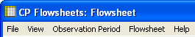
The menu bar displays at the top of the screen below the title bar. The menu bar contains five options: File, View, Observation Period, a dynamic (screen-specific) menu, and Help.
Figure 2-1, CP Flowsheets Menu Bar

Menu Bar Keyboard Access
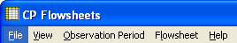
These menu options provide keyboard access to many of the features found on the GUI. To activate keyboard access, press <Alt>. Use the cursor keys to browse through the menu options. Highlight the function you want and press <Enter>, or type the underlined letter of the option you want. The underlined letters are shown on the menu titles in the following figure:
Figure 2-2, Menu Bar Keyboard Access
Context-Sensitive Help: On any Flowsheets tab, press the F1 key to gain access to help content for that screen.

File Menu
Open Patient: Displays the Open Patient window used to select a patient.
User Settings: Displays a dialog to change defaults, confirmations, GUI look and feel, and screen colors. For more information on changing User Settings, see Section 10, User Settings.
Break Link: Use to break the Clinical Context Object Workgroup (CCOW) link. VistA applications become un-synchronized, allowing you to work on two different patients when multiple CCOW- compliant applications are open.
Rejoin Context: Reconnects a broken CCOW link.
Show CCOW Status: Displays a dialog box showing the CCOW link status. Click OK to close the dialog box.

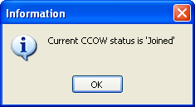

Figure 2-3, CCOW Status
Note: When the CCOW Broker does not connect with the CP Flowsheets application at startup, the File menu displays only three items: Open Patient, User Settings, and Exit. The CCOW link status also displays on the status bar to the right of the server information.
Figure 2-4, CCOW on Status Bar
Exit: Close the CP Flowsheets application.

View Menu
Flowsheet: Displays a screen containing the flowsheet views. This screen is used for entering, editing, and viewing patient data such as: vital signs, inputs, outputs, respiratory, pulmonary vascular (PV), and neurological data.
Alarms: Displays a screen for managing alarms.
Reports: Displays a screen for comparing and printing data.
Log Files: Displays a screen that shows data received from the instruments. Use this window to examine data and determine whether it is acceptable or not. When the data is verified (marked as acceptable) it displays in the flowsheet views. If the data is not acceptable it may be purged and kept from the patient’s permanent record.
HL7 Monitor: Displays the raw HL7 messages so you can review the content. This is used for troubleshooting.
Note: The HL7 Monitor option is only available to users with one of the following security keys: MD ADMINISTRATOR or MD HL7 MANAGER. (For more information about security keys, please see Chapter 14 of the Clinical Procedures (CP) V1.0 Technical Manual and Package Security Guide.)

Observation Period Menu
This menu provides access to the functions described in the section “Figure 5-2, CP Flowsheet List Setting the Date Range.” The following options are available:
Extend Date Back 1 Day: Start Date moves one day earlier. Stop Date stays the same.
Pan Date Back 1 Day: Start Date and Stop Date move one day earlier.
Set Date Range: Displays the Date Range Selector window.

Pan Date Forward 1 Day: Start Date and Stop Date move one day later.
Extend Date Forward 1 Day: Start Date stays the same. Stop Date moves one day later.
Today (start time – end time): Set the Start Date and Stop Date to today’s date, set the Start Time to 12:00 AM (midnight), and set the Stop Time to 11:59 PM.

Dynamic Menu
The dynamic menu allows easy access to available application options and assist users in navigating the system. The fourth menu item on the menu bar is a dynamic menu and changes based on your location in CP Flowsheets. The dynamic menu choices include: Flowsheet, Alarms, Reports, Logfiles, and HL7 Monitor.
Note: The HL7 Monitor option is only available to users with one of the following security keys: MD ADMINISTRATOR or MD HL7 MANAGER.
For demonstration purposes the next two figures (remove this one and add the figure with Flowsheet below) illustrate the Flowsheet option. Additional options are provided in a submenu if you switch to other dynamic menu choices such as Alarms or Reports.
Figure 2-5, CP Flowsheets Menu Bar
The Flowsheet screen-specific menu contains the following options: Refresh
Add Page Close Page
The Dynamic Flowsheet menu options are based on views contained in the selected flowsheet. For example, the following figure shows the MEDICAL UNIT flowsheet. This flowsheet contains views that include: Vital Signs, Intake, Output, and ADLs Medical Unit. Each menu option can be expanded to provide access to the six flowsheet view controls:
Add Data Pivot
Scroll Left Scroll Right Settings
Display Interval: This option expands to display the same options found in the Display Interval list. See 3.2, Flowsheet Controls.
If you access the dynamic menu using the keyboard, each dynamic option is automatically assigned a keyboard access key indicated by an underlined letter in the option.

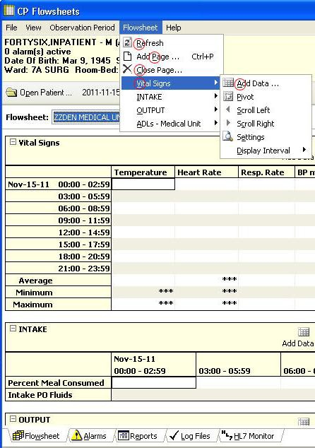

Figure 2-6, Flowsheet Dynamic Menus
Note: Following the menu shown above, press <Alt+r> to refresh the page, <Alt+p> to add a page, <Alt+c> to close a page, <Alt+v> to access vital signs. Press the right keyboard arrow to select Add Data, and press <Alt+a> to access add data.
The following lists show available options when you choose other dynamic menus. These options are fully described in other chapters.
The Alarms screen-specific menu contains the following options: Refresh
New Alarm Update
Clear Alarm Deactivate
The Reports screen-specific menu contains the following options: Refresh
Print
Write Note

First Prev Next Last
The Logfiles screen-specific menu contains the following options: Refresh
Select All
Clear Selection Purge
Verify Rescind Print
Print Selected
The HL7 Monitor screen-specific menu contains the following options: Refresh
Get Patient
Get Instrument View HL7
Resubmit Discard
Help Menu
Contents: Displays the CP Flowsheets online Help file.
About: Displays version information about the CP Flowsheets application.

Patient Information Area
The Patient Information Area displays below the menu bar. It contains the following information: Patient name – Lastname, Firstname
Gender Age
Active alarms

Date of Birth (DOB)
Last four numbers of the Social Security Number (SSN) Ward
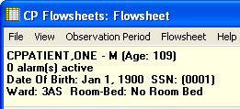
Room/Bed
Figure 2-7, Patient Information Area

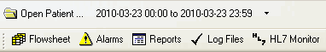
Common Buttons
Figure 2-8, Common Buttons
Common system buttons display in two rows below the Patient Information Area by default when the selected Look and Feel is the CP Toolbar.
Note: When the selected Look and Feel is set to CPRS Classic tab style, the second row of buttons does not appear. (For information on changing the Look and Feel, see “Modifying General Settings.”).
The following buttons are available:
Open Patient: Displays the Open Patient window to select a patient.
Date Range: Select the start and end dates for the data display. Click the drop-down arrow to pan and/or extend the date range.
Flowsheet: Displays a screen containing the flowsheet views. This screen is used for entering, editing, and viewing patient data such as: vital signs, inputs, outputs, respiratory, PV, and neurological data.
Alarms: Displays a screen for managing alarms.
Reports: Displays a screen for printing data.
Log Files: Displays a window that shows data received from the instruments. Use this window to examine data and determine whether it is acceptable or not. When data is verified (marked as acceptable), it displays in the flowsheet views. If data is not acceptable, it may be purged and kept from the patient’s permanent record.
HL7 Monitor: The HL7 Monitor screen is used to match records to a patient, match records to an instrument, and view HL7 message data.

Note: The HL7 Monitor button is only available to users with one of the following security keys: MD ADMINISTRATOR or MD HL7 MANAGER.

Status Bar
Figure 2-9, Status Bar
The Status Bar is the gray bar at the bottom of the screen. This information is for display only. It shows the following information from left to right:
User name and DUZ Facility
VistA Server Internet Protocol (IP) CCOW status
Ready status

This page intentionally left blank for double-sided printing.

CP Flowsheet Views
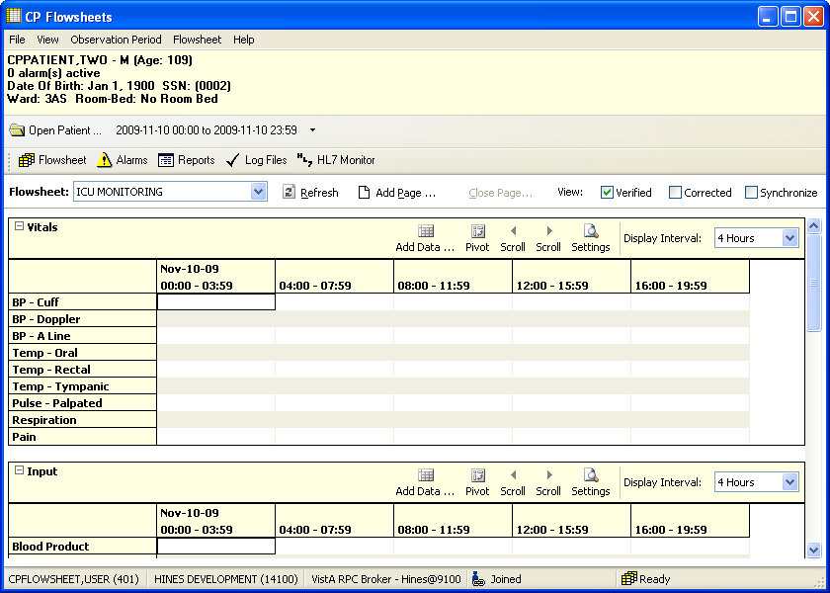
There are two ways to view CP Flowsheets, CP Toolbar Style and CP Classic Tab Style. CP Toolbar Style is the default when CP Flowsheets starts the first time. With CP Toolbar Style, buttons are below the Open Patient and Date Range items. You use these buttons to navigate through the system. With CP Classic Tab Style, tabs are on the bottom of the screen and used for navigating the system as well. The figure below shows the CP Toolbar style.
Figure 3-1, CP Toolbar Style
This close-up shows the Toolbar buttons. Click any button to display a different screen area.
Figure 3-2, CP Toolbar Buttons
The CP Classic Tab Style is shown in the figure below.

Defining the CP Flowsheets Screens
CP Flowsheets have five screens you use for patient tasks. The Toolbar buttons or tabs are similar to the tabs found on the CPRS GUI.
The five CP Flowsheets screens are: Flowsheet
Alarms
Reports Log Files
HL7 Monitor
Each screen is described in more detail in the following chapters.
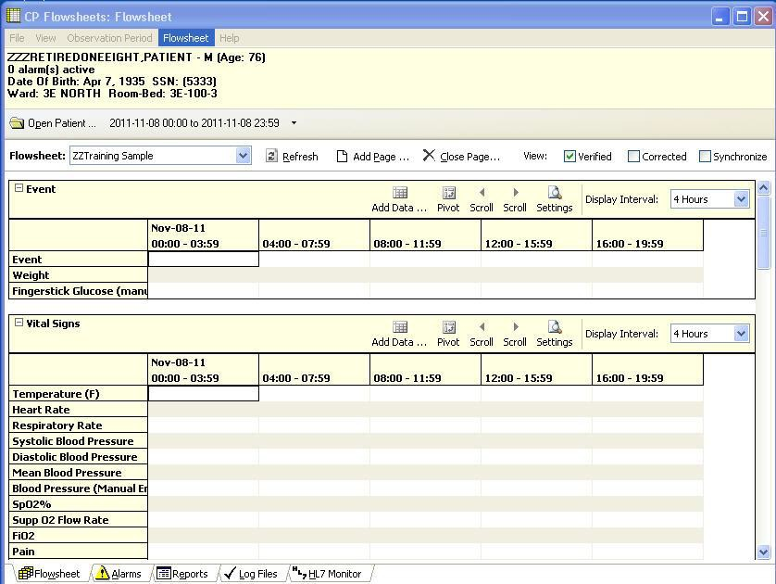
The following figure shows the CP Flowsheets GUI with the Flowsheet screen selected. The CPRS Classic Tab Style is shown.
Figure 3-3, CP Classic Tab Style
When CPRS Classic Tab Style is selected, the tabs are shown on the bottom of the screen above the status bar. Click any tab to display a different screen area.

Figure 3-4, Status Bar
Note: The MD ADMINISTRATOR or MD HL7 MANAGER security key is required to access the HL7 Monitor tab.

Switching View Styles
To switch View styles, do the following
- Select User Settings from the File menu. The CP Flowsheets Settings dialog box displays.
- Click the General plus sign to show the detail screen on the right.
- Click the radio button you want in the Look and Feel area of the User Settings dialog box: CP Toolbar or CPRS Classic Tab Style.
- Click OK. The CP Flowsheets Settings dialog box closes.

Flowsheet Controls
Below the toolbar buttons there are additional options:
Flowsheet drop-down list: Use this list to select a predefined flowsheet. The layouts for flowsheets are site configured by a designated flowsheet coordinator using the companion CP Console application.
Following the flowsheet list are three toolbar buttons:

Refresh | Used to update the data shown on the flowsheet.
Add Page | Used to add a supplemental or optional flowsheet view. This feature helps you to organize your information.
Close Page | Used to close a supplemental or optional page. This button is active only when a supplemental or optional page is activated.
Next to the toolbar button are three check boxes.

Verified | Used to display data marked as verified.
Corrected | Used for editing observation values. The updated values display in the flowsheet and the previous values are hidden when the Corrected box is unchecked. Checking the Corrected checkbox displays both the edited data values and the previous (incorrect) values.  Previous values show with a strikethrough.
Synchronize | Used to set the Display Interval for all flowsheet views to the same interval. To use this feature, select the interval you want from the Display Interval drop-down list for the first (topmost) flowsheet view. Click the Synchronize check box. When the box is checked, the Display Interval for all subsequent flowsheet views is updated to match the first, and all Display Interval checkboxes are unavailable. To change the interval, uncheck the Synchronize check box, change the first Display Interval setting, and recheck Synchronize.

Flowsheet View Controls
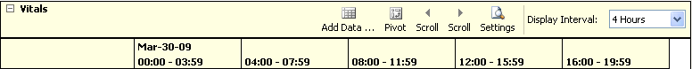
Flowsheet view controls are used to add, edit, and display data on the flowsheets. These controls are on the top of each flowsheet. Bold text identifies the type of data shown in this section of the flowsheet. The available data types are: Vital Signs, Inputs, Outputs, Respiratory, PV, and Neurological.
Figure 3-5, Flowsheet View Controls
Each flowsheet view contains the following controls:
Expand/Collapse Flowsheet view: Click the minus sign to the left of the title to collapse (hide) the flowsheet. Click the plus sign to expand (show) the flowsheet.
Add Data: Click to show the Add Data dialog to enter or edit data.
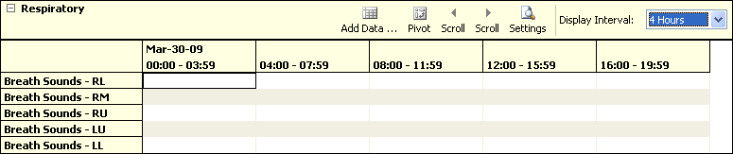
Pivot: Flip the x and y axes of the grid. You can arrange the grid so the date and time intervals show along the top of the grid (x-axis) and data types display down the first row (y-axis) as follows:
Figure 3-6, Pivot View Control
Or, you can display the grid so the data types display along the top of the grid (x-axis) and date and time intervals display down the first row (y-axis) as follows:
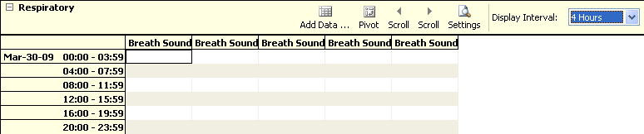
Figure 3-7, Pivot View Control
Note: Pivot view is a site configurable option. If the Pivot button appears dimmed it is unavailable and the Pivot function is not permitted.
Scroll L: Scroll the flowsheet grid to the left.
Scroll R: Scroll the flowsheet grid to the right.
Settings: Display flowsheet view properties: View ID and Page Type (e.g., Mandatory, Optional, or Supplemental). The View ID is used for IT troubleshooting only.

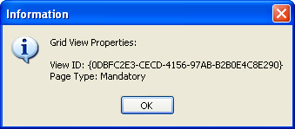

Figure 3-8, Settings
Display Interval: Set the amount of time for each column or row depending on the pivot setting.
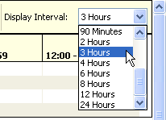
Figure 3-9, Display Interval List
This drop-down list contains the following options:

1 Minute | 90 Minutes
2 Minutes | 2 Hours
5 Minutes | 3 Hours
10 Minutes | 4 Hours
15 Minutes | 6 Hours
20 Minutes | 8 Hours
30 Minutes | 12 Hours
1 Hour | 24 Hours

The shorter interval settings can improve readability when a large amount of data is documented over a short period of time. Longer interval settings allow you to view longer periods of time while reducing the amount of scrolling necessary to view all columns.
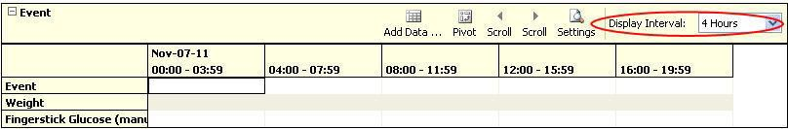
In the following example note that the Display Interval is set to 4 Hours.
Figure 3-10, Display Interval – 4 Hours

The first column shows values from midnight (00:00) through 03:59 (a.m.). The next column shows data for the next four hours etc. Only five columns fit on the screen. Click the Scroll R button to display the final column (20:00 – 23:59).
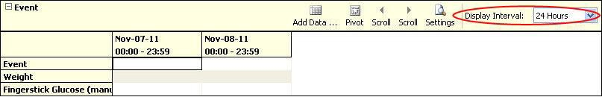
In this figure, the Display Interval is set to 24 Hours. Several days may be easily viewed on a single screen.
Figure 3-11, Display Interval – 24 Hours

Selecting a Patient
After starting and logging on to CP Flowsheets, the Open Patient dialog box displays. Use this box to search for a patient by:
patient name (Lastname, Firstname)
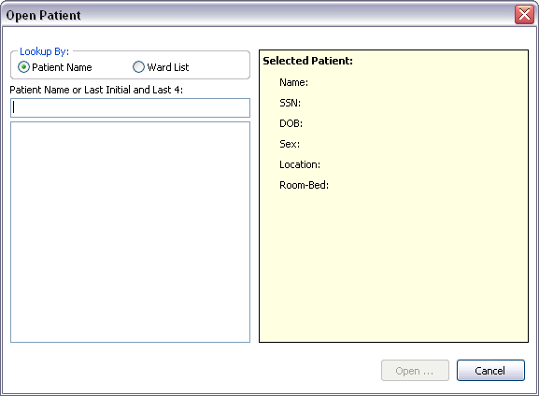
last initial and last four digits of the patient’s Social Security Number (SSN) ward list

Figure 4-1, Open Patient
- Type the patient’s last initial followed by the last four digits of their SSN or type at least three characters of the patient’s last name in the field below Patient Name or Last Initial and Last 4.
When three characters are entered, the list below the Patient Name field shows names starting with the letters you entered. As you enter more characters, the display automatically updates to reflect the changes.
Note: To enter all or part of the patient’s first name, type a comma after the last name and then enter the first name without a <Space>.
- Highlight a name in the list, then click Open or press <Enter>. The Open Patient dialog box closes and the main screen of the Clinical Flowsheets application displays. The Flowsheet screen displays first by default.
Note: You can highlight a name using the keyboard in two ways:

Click a name with the mouse.
Press <Tab> to move the cursor from the Patient name field to the names shown on the list. Use the <Up> and <Down> arrow keys to highlight a patient, then press <Enter> to select a patient name.
Note: An opened patient record is released as soon as you click Open Patient. That means that if you were already working on a patient’s record and clicked Open
Patient, and then you clicked Cancel, you return to the main screen with no patient selected.
- To start the Open Patient window from other CP Flowsheet screens, click the Open Patient button on any Flowsheets screen, or select Open Patient from the File menu. The keyboard shortcut is

<Ctrl> + <O>.

Resending Outpatient Data to Medical Devices
Within CP Flowsheets, you can re-transmit outpatient settings without having to manually enter patient data on the device.
To resend outpatient data, complete the following steps:
- From the file menu, select Send PII to Monitor, then select the name of the device you would like to send the data to. For example, in the screen below, select MDPHL_ADT_A08.
Note: Your CAC or ADPAC should work with your local IRM support to determine which logical link should be used to send patient data to your medical device. IRM support should be able to provide this information to you.
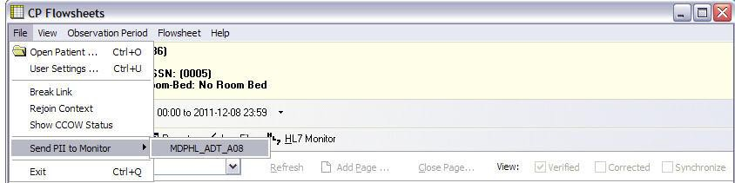
Figure 4-2, Resending Outpatient Data
- Your outpatient data will then be sent to your medical device.

Resending Inpatient Data to Medical Devices
Selecting a Patient

Within CP Flowsheets, you can re-transmit inpatient settings without having to manually enter patient data on the device.
To resend inpatient data, complete the following steps:
- From the file menu, select Resend Last Message to Monitor.
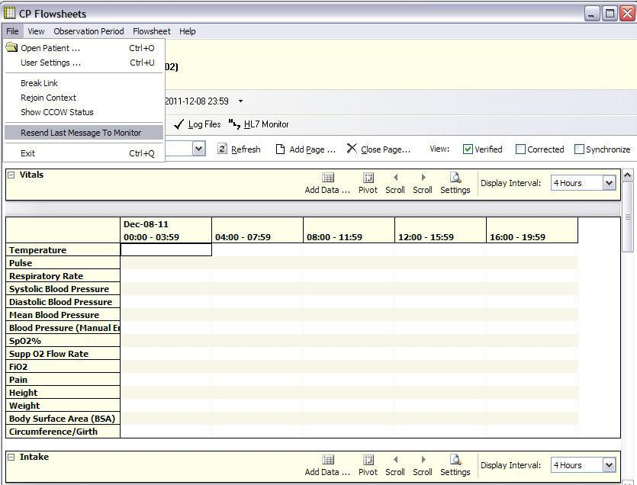
Figure 4-3, Resending Inpatient Data

- Your inpatient data will then be sent to your medical device.

This page intentionally left blank for double-sided printing

Flowsheet Workflows
A flowsheet is a predefined layout of one or more flowsheet views. With flowsheets, you can set date and time ranges, add or edit flowsheet data and create supplemental/optional pages. Choose a flowsheet to get started with the following tasks.

Selecting a Flowsheet
After you select a patient, and the CP Flowsheets screen displays, you must select a flowsheet before you proceed.
You use flowsheet views to enter and view observation data. The figure below shows an ICU MONITORING flowsheet with two flowsheets views, Vitals and Input.
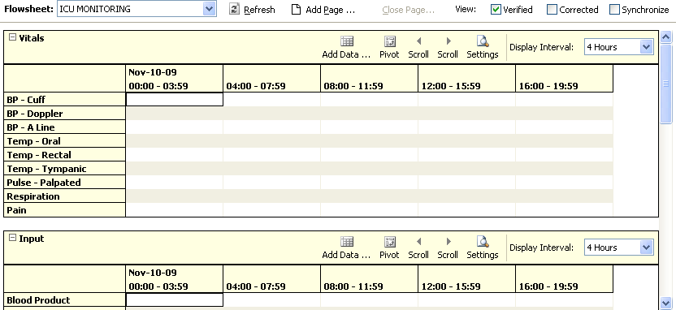
Figure 5-1, Selecting a Flowsheet
The flowsheet and flowsheet view layouts are configured by a designated flowsheet coordinator using the companion CP Console application. Flowsheet configuration allows the coordinator? IT person to define the following items:
Title – each defined flowsheet has a title
Type of data contained in the flowsheet view Default display units
To select a flowsheet, do the following:
1. Select one of the Flowsheets from the drop-down list. The screen displays the selected flowsheet layout (see figure below).

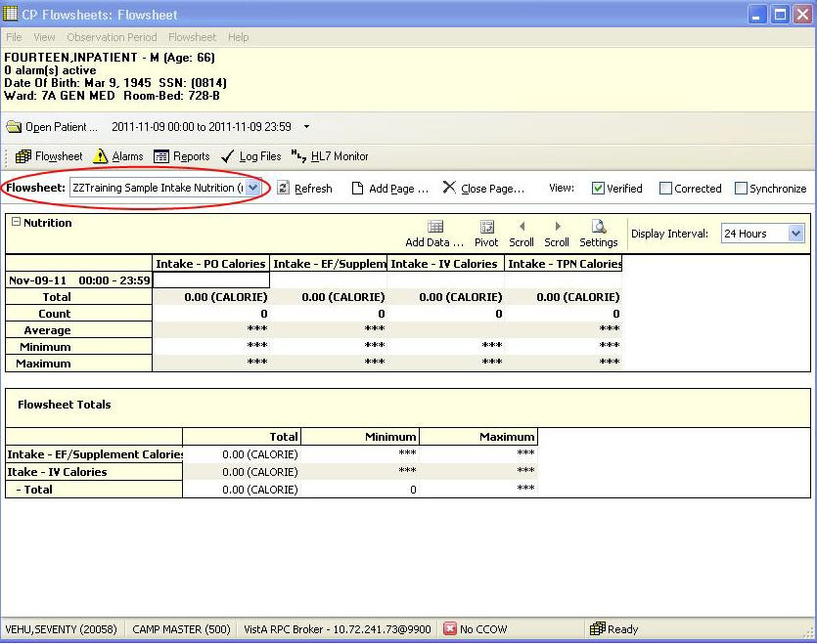

Figure 5-2, CP Flowsheet List

Setting the Date Range
The date range is used to determine how much information is available for display on the screen. There are three ways to set the date range.

Setting the Date Range—Observation Period Menu Method
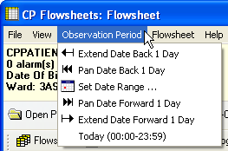
The date range can be set from any tab by using the Observation Period menu (see figure below). This method is described in section “2.1.4 Observation Period Menu.”
Figure 5-3, Date Range Menu Method

Setting the Date Range—Date Range Selector Method
- From the Observation Menu, click Set Date Range. The Date Range Selector window displays (see figure below).
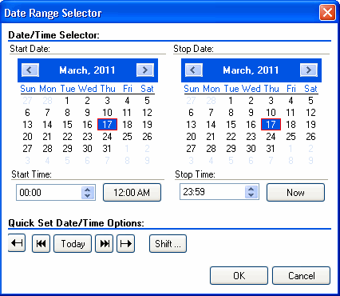
The default Start Date/Time is the current date (March 17, 2011/00:00 AM, shown in the example below). The default Stop Date/Time is the current date (March 17, 2011/23:59 PM). When you change the date range, CP Flowsheets remembers the date/time if you switch screens. When you close CP Flowsheets and restart the application, the date range resets to the default.
Figure 5-4, Date Range Selector Method
- Choose the Start Date and Stop Date. The Date Range Selector functions as follows: Click the Left Arrow or Right Arrow buttons to select the month.

Figure 5-5, Date Range Arrows
Click a day of the month from the calendar.
Select the Start/Stop Time in the time box. Press <Tab> to highlight the hour, then use the
<Up> and <Down> arrow keys or your mouse to adjust the hour. You can also type the time using the keyboard. Press the <Right> arrow key to move the cursor and set the minutes, then press the <Right> arrow key again to move the cursor to select AM or PM.
- Use the Quick set buttons to set the time:
12:00 AM: Set the Start Time to midnight.

Now: Set the Stop Time to the current time.
Shift: Set time by selecting a shift from a list (defined in CP Console).
- Use the Quick set buttons to set the date:
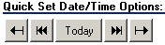
Figure 5-6, Quick Set Buttons
Extend Date Back 1 Day: Start Date moves one day earlier. Stop Date stays the same.
Pan Date Back 1 Day: Start Date and Stop Date both move one day earlier.
Today: Set the Start Date and Stop Date to today’s date, set the Start Time to 12:00 AM (midnight), and set the Stop Time to 23:59 PM.
Pan Date Forward 1 Day: Start Date and Stop Date both move one day later.
Extend Date Forward 1 Day: Start Date stays the same. Stop Date moves one day later.
Click OK. The Date Range Selector and the Date Range display area and the flowsheets are updated.

Setting the Date Range—Drop-down List Method
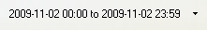
Use the date display drop-down list to adjust the date range without using the Date Range Selector.
Figure 5-7, Date Range List Method
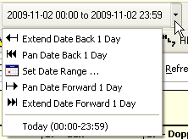
- Click the drop-down arrow to the right of the date display. A list displays options similar to the Quick set buttons described above (see the figure below).
Figure 5-8, Date Range List
- Click an option to adjust the date range.
Extend Date Back 1 Day: Start Date moves one day earlier. Stop Date stays the same.
Pan Date Back 1 Day: Start Date and Stop Date both move one day earlier.

Set Date Range: Display the Date Range Selector.
Pan Date Forward 1 Day: Start Date and Stop Date both move one day later.
Extend Date Forward 1 Day: Start Date stays the same. Stop Date moves one day later.
Today: Set the Start Date and Stop Date to today’s date, set the Start Time to 12:00 AM (midnight), and set the Stop Time to 23:59 PM.
Note: All totals in the flowsheet are based on the time period in the flowsheet Date Range Selector.

Adding/Editing Flowsheet Data (Manually)
Not all data will come directly from Instruments; some data can be entered manually. To add data manually, do the following:
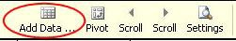
- Click Add Data from a specific flowsheet view.
Figure 5-9, Add Data Icon
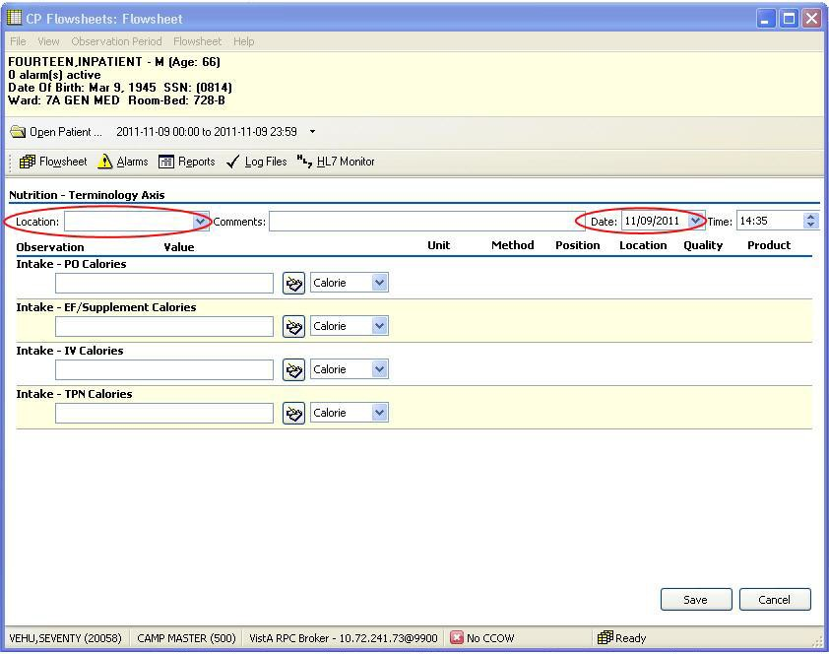
The data entry screen displays.
Figure 5-10, Data Entry Screen

- Select a location code from the Location list. This is a required field. The location list may be pre- populated if a default location was defined under the User Setting option. (See “10. User Settings.”)
- The Date box is set to today’s date by default. You can change it by selecting a new date from the calendar or by typing directly into the field.
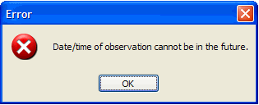
If you select a date in the future, the following dialog box appears:
Figure 5-11, Date/Time Error

Note: Press <Tab> to place the cursor in the box. Revise the date using the keyboard numbers or arrow keys.
- The time box is set to the current time by default. You can change the time by typing directly in the field.
Note: Press <Tab> to place the cursor in the box. Revise the date using the keyboard numbers or arrow keys.
- Enter data values in the observation fields and select appropriate qualifiers from the drop-down lists.
Note: Different observations have different related qualifiers. Qualifier fields without drop-down lists are predefined and may not be edited. Flowsheets can be customized to display default qualifiers using CP Console. The following is a partial list of available qualifiers.
Unit (f=degrees Fahrenheit, c=degrees Celsius, bpm=beats per minute, rpm=respirations per minute, etc.)
Method (Cu=cuff BP, Dop=Doppler BP, etc.)
Position (Ly=lying, Si=sitting, St=standing, etc.)
Location (La=left arm, LL=left leg, RA=right arm, RL=right leg, etc.) Quality (A=accurate, E=Estimated)
Product
Null Reason
- Click Save to store the data, or click Cancel to exit without saving. When you click Save, the data displays on the flowsheet.
Note: Data entered with the MD TRAINEE key (for example, nursing student, preceptee) does not display on the flowsheet until it is verified on the Log Files tab by an authorized user with the correct security key.

Optional and Supplemental Pages
Optional and Supplemental Pages are flowsheet views that can be added at your discretion to help track a specific condition in its own section of a flowsheet.
For example, if a patient has a pressure wound that must be closely monitored, you can open a Supplemental Page for that pressure wound and record data related specifically to the wound. If the patient develops additional pressure wounds, simply add a Supplemental Page for each wound. Once a pressure wound heals and no longer requires close monitoring, you can close the supplemental page and leave other supplemental pages open.
An Optional Page differs from a Supplemental Page. An Optional Page displays only once.
If a patient has a pacemaker, you can open an Optional Page to record data related to the pacemaker. Since a patient would never have more than one pacemaker, you would not add more than one of the same Optional Page.
Note: For example, if the pacemaker is discontinued and the optional view is closed, the historical documentation on the pacemaker is no longer available in the flowsheet view. A closed pacemaker optional view means that the pacemaker documentation cannot be included in a new CPRS note. The pacemaker flowsheet data for a closed optional view are viewable through the Log Files tab. Set the applicable date range to view the historical data. The closed optional view pacemaker can be re-opened and data made viewable on the Flowsheet tab. You can include data in a new CPRS note.
Note: The CP Flowsheet Coordinator must take the above view behavior into consideration before creating Optional views. Consider whether the pacemaker documentation can be managed better by creating a Supplemental view instead of an Optional View.
To add an Optional or Supplemental page to a flowsheet, first define the page as part of a particular flowsheet. Flowsheets are defined using the CP Console application. For information about adding Optional or Supplemental pages to a flowsheet, refer to the Clinical Procedures (CP) V1.0 Flowsheets Module Implementation Guide.
Note: If you use CP Console to change an existing Optional or Supplemental Page (i.e., one already used for a patient), the changes are not shown on the Flowsheet tab. Those changes appear on any newly-created Optional or Supplemental pages.

Adding Optional or Supplemental Pages
To add Optional or Supplemental views, complete the following steps:
- At the Flowsheet tab, click the Add Page button. The Flowsheet Page Management window displays.
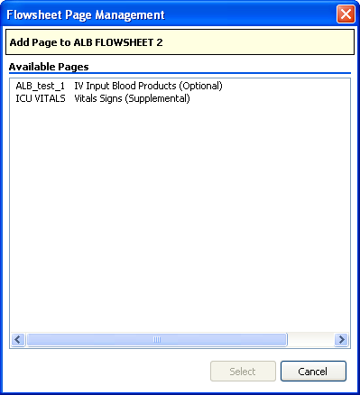
Note: If the Add Page button is inactive no Optional or Supplemental pages are defined for the current flowsheet. Select a flowsheet that has Optional or Supplemental pages defined, or ask the designated flowsheet coordinator to edit the flowsheet you want to allow for the addition of Optional or Supplemental pages.
Figure 5-12, CP Flowsheet Page Management

- Double-click the page you want from the list. The Add Page dialog box displays.

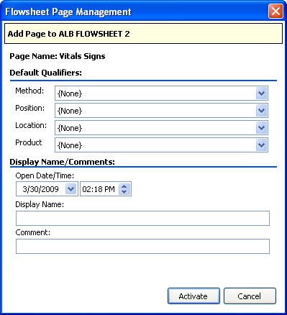

Figure 5-13, Add Page

- Select Default Qualifiers you want.
- Select the starting Date/Time. Also note the relevant “start” time.
- Enter the Display Name and a Comment. These are required fields.
- Note: This is the only area of Flowsheets where Comment is a required field.
- Click Activate. The New Flowsheet Page dialog box closes and the flowsheet reloads to display the Optional or Supplemental Page.

How to Close an Optional or Supplemental View
Caution: When an OPTIONAL view is closed, the data is no longer viewable nor is the data available for sending to a report (TIU progress note). You reopen the OPTIONAL view in order to access the data. This suggests limited use of optional views. Be careful with configuring optional views! Never close an optional view!
After you create an Optional or Supplemental page (or view), you can easily close it. To close an optional or supplemental view, complete the following steps:
- From the Flowsheet menu, lists of Optional and Supplemental pages are currently open.
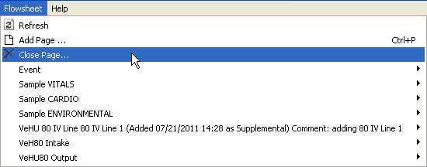
- Select Close Page.
Figure 5-14, Close Page
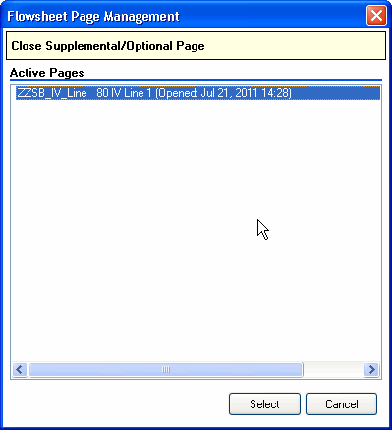
The Close Supplemental/Optional Page dialog box appears.
Figure 5-15, Close Supplemental/Optional Page
- Click the active page, and click Select.

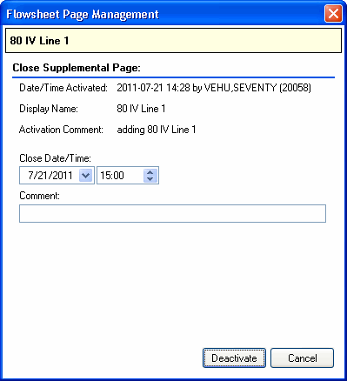
The Close Supplemental page dialog box appears. You must enter a comment before you click deactivate.
Figure 5-16, Close Supplemental Page
- Click Deactivate.
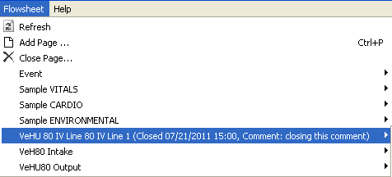
You will see the supplemental page listed from the Flowsheet menu. The item now notes the date it was closed, and the comment associated with it.
Figure 5-17, Closed Date/Comment

This page intentionally left blank for double-sided printing.

Alarms Screen
An alarm displays a visual warning when an observation reaches a certain threshold. For example, you can define an alarm to show when a patient’s temperature rises above a certain level, or when a blood pressure drops below a certain rate.
Note: Alarms are not tracked or audited. Any alarm you create affects the selected patient ONLY. It will not apply to other patients in the ward. You must define an alarm for each individual patient.
CP Flowsheets do not have preset alarms. The Alarm list is blank until you define the alarms.
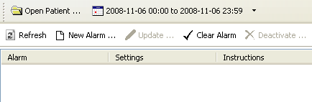
Figure 6-1, Define Alarms

Setting an Alarm
To set an alarm, do the following:
- Click the Alarms button. The Alarms screen displays.
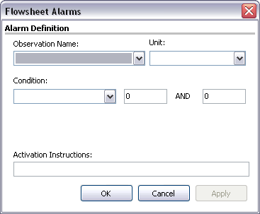
- Click New Alarm. The Flowsheet Alarms dialog box displays.
Figure 6-2, Flowsheet Alarms
- Select the type of observation from the Observation Name list.

Note: This list contains many items. You can click in the Observation Name field and use the Up/Down buttons to scroll through the list. If you know the name of the item you want, click in the Observation Name field and type the name to jump to the item.
- Select the Unit, if there is more than one choice in the list.
- Select a condition from the Condition list, and then select appropriate modifiers from the fields to the right.
Note: The available options vary depending on the Observation Name selected.
See the examples of available conditions and modifiers below: Condition: Value BETWEEN.
Modifiers: Enter low and high numeric values.
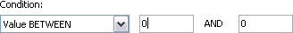
Figure 6-3, Value Between
Condition: Value NOT BETWEEN. Modifiers: Enter low and high numeric values.

Figure 6-4, Value Not Between
Condition: Value GREATER THAN. Modifiers: Enter a numeric value.

Figure 6-5, Value Greater Than
Condition: Value LESS THAN.
Modifiers: Enter a numeric value.

Figure 6-6, Value Less Than
Condition: Value IN LIST.
Modifiers: Check one or more box (es) from the modifiers list.

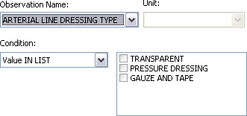

Figure 6-7, Value In List
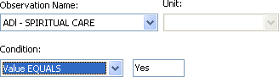Condition: Value EQUALS. Modifiers: Enter YES or NO.

Figure 6-8, Value Equals
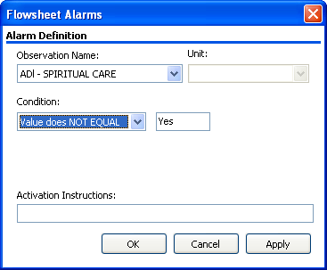
Condition: Value does NOT EQUAL. Modifiers: Enter YES or NO.

Figure 6-9, Value Does Not Equal
- Type the alarm message in the Activation Instructions field. This is the message that displays when the alarm is triggered.

- Click OK (see figure below). The Flowsheet Alarms window closes. You return to the Patient Alarms screen and the new alarm displays in the list.
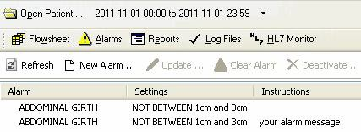
Figure 6-10, New Alarm Displayed

Updating an Alarm
As the patient’s condition changes, you may edit or deactivate an alarm. To edit an alarm, do the following:
- On the Patient Alarms screen, click the row of the alarm to change and click Update. The Flowsheet Alarms dialog box displays.
Shortcut: Double-click the Alarm row to display the Flowsheet Alarms window.
- You may change any active fields.
- Click OK. The Flowsheet Alarms window closes and the Patient Alarms screen displays.

Clearing an Alarm
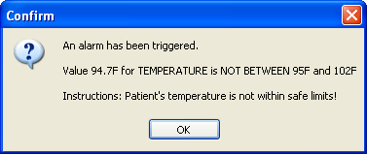
When an alarm is triggered, a Confirm dialog box displays. The dialog box is similar to the following:
Figure 6-11, Clearing An Alarm Confirmation
The Information message shows the following information:
The first line is a standard message: An alarm has been triggered.
The next line shows the value that triggered the alarm and a description of the alarm. The last line shows you what was written when the alarm was created.
Click OK to close the Information window, but notice the alarm isn’t cleared. Note the icon on the Alarms button is red not yellow. This is another indicator that an alarm was triggered.
Figure 6-12, Red Alarm Icon
To clear the alarm, you must do the following:

- Click the Alarms button to display the Patient Alarm screen. The red Alarm icon displays to the left of the triggered alarm.
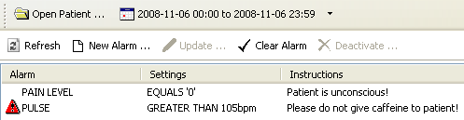
Figure 6-13, Patient Alarm
- Click to select the alarm row and click Clear Alarm. The red Alarm icon clears.

Deactivating an Alarm
You can deactivate an alarm that is no longer needed. A deactivated alarm no longer displays on the CP Flowsheets application.
To deactivate an alarm, do the following:
- Click the Alarms button. The Patient Alarms screen displays.
- Click the row of the alarm you want to delete.
Press <Ctrl> + click to select multiple alarms.
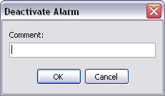
- Click the Deactivate button. A pop-up dialog box displays.
Figure 6-14, Deactivate Alarm
- Enter a note into the Comment field and click OK. This is a required field. The dialog box closes and the deactivated alarm is removed from the Alarm list.

Reports Screen
Use the Reports Screen to print data reports and submit TIU Progress Notes. Reports are based on predefined flowsheets and print the same information displayed on the Flowsheet screen.
Note: The items in the Flowsheet drop-down list on this screen are identical to those in the Flowsheet list on the Flowsheet tab.

Printing a Report
To print a report, do the following:
- Click the Reports button. The Report screen displays.
- Choose a report layout from the Flowsheet list.
- To change the Date Range, click the date range or select Set Date Range from the Observation Period menu.
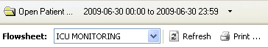
Figure 7-1, Set Date Range/Refresh
- Click Refresh to display recently-added data.
- Check the Include Comments box to display comments added during manual data entry.
- Review the data in the report. Header information displays at the top of the report, including Flowsheet name, date range, patient information, page number, location and the date/time you clicked the Report button. Each flowsheet view displays in a section below (see figure below).
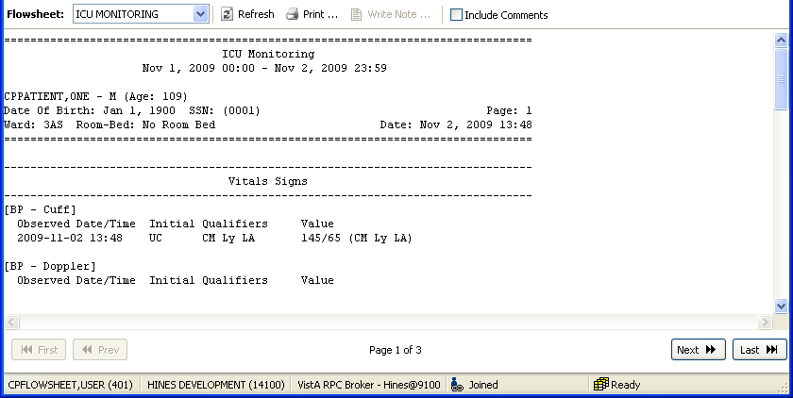
Figure 7-2, Review Data
- Click Print to display the Print dialog box.

Note: Each field defined in the selected flowsheet prints, even when no data is available for a particular observation. For example, the figure above shows values for a “BP
- Cuff” observation, but “BP – Doppler” is followed by a blank line indicating no data for that observation category.
- Select your printer and make any other changes you want on the Print dialog box. Click OK to print the report.

Writing a TIU Progress Note
The Write Note button on the Reports screen allows you to submit a TIU Progress Note that displays on the CPRS Notes screen. The TIU Progress Note contains the full text of the selected report and any additional notes.
To submit a TIU Note, complete the following steps:
- Click the Reports button. The Report screen displays.
- Choose a report layout from the Flowsheet list.
- To change the Date Range, click the date range or select Set Date Range from the Observation Period menu.
- Click Refresh to display recently-added data.
- Check the Include Comments box if you want the TIU Progress Note to include comments added during manual data entry.
- Review the data in the report. Header information displays at the top of the report, including flowsheet name, date range, patient information, and the date/time you clicked the Report button. Each flowsheet view displays in a section below.
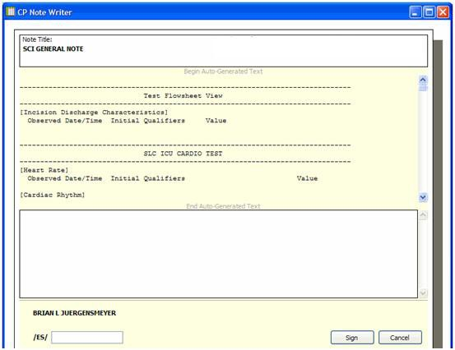
- Click Write Note. The CP Note Writer screen displays.
Figure 7-3, CP Note Writer

Reports Screen

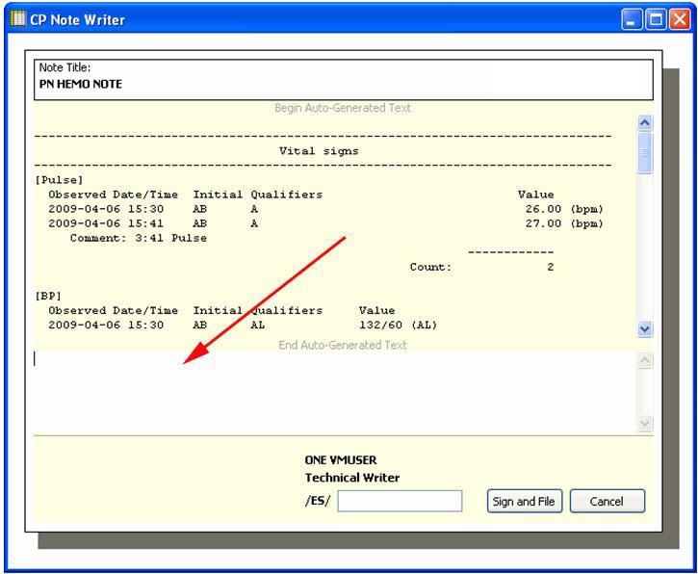
- Type a note in the field at the bottom of the CP Note Writer screen. This note will display at the bottom of the TIU Note.
Figure 7-4, Type A TIU Note
- Enter your electronic signature in the /ES/ field, then click Sign and File. An information box displays the message, “TIU Document has been signed and filed.
- Click OK to close the information box. CP Note Writer closes. You may view the TIU Note in CPRS on the Notes tab.

Log Files Screen
You can use the Log Files screen to review data, delete unneeded records, and verify unverified data.
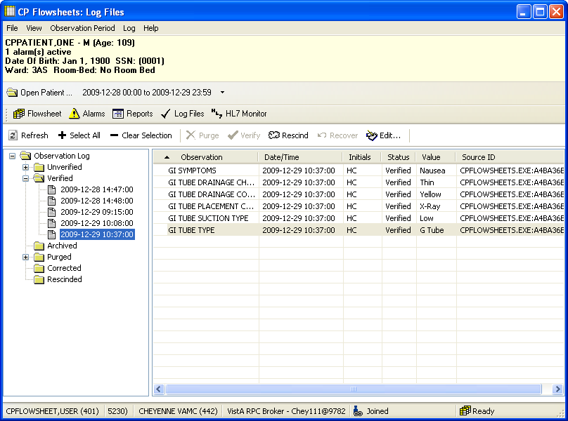
The Log Files screen contains two panels. The left panel displays the Observation Log used to select the data type and the date/time when data is entered. The right panel displays detailed information about the data selected in the Observation Log. The information includes observation type, date/time, and initials of the data entry person, status, observation value and source ID.
Figure 8-1, Log Files

Reviewing Log File Data
To review data, do the following:
- Select a patient.
- Select the date range you want.
- Select the Log Files. The Observation Log on the left side of the screen lists the different data types: unverified, verified, archived, purged, corrected, and rescinded. A plus sign (+) displays to the left of a data type when data is available for review.
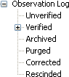
Figure 8-2, Log File Data Types
- In the Observation Log, double-click one of the data types or click the plus sign. The item expands to display the dates and times for data that is available to review.
Note: If you do not see the date(s) you want, make sure you selected the correct date range.
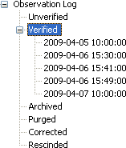
Figure 8-3, Verified Dates
- In the Observation Log, click a date/time. Observation data matching the selected type, date and time display in the panel to the right for your review.
Note: There may be delays with data display in cases where large quantities of data are received from the instrument.

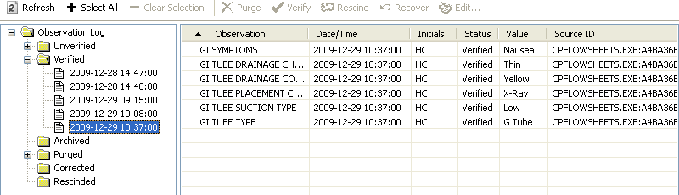
Figure 8-4, Log Files For Specific Date

Verifying Data
Data is verified after you determine it is valid data, and mark it as verified. Unverified data i.e. data coming from an untrusted device or manually entered by a user assigned the MD TRAINEE key, will not go directly from the source to the flowsheet views. Unverified data remains in an unverified folder until an authorized user reviews and marks it verified.
Note: Data entered manually by an authorized user is automatically considered verified data. This data displays in the flowsheet as soon as it is saved. Data entered with the MD TRAINEE key (for example, nursing student, preceptee) does not display on the flowsheet until it is verified on the Log Files tab by an authorized user with the correct security key.
To verify data, do the following:
- Select a patient.
- Select the date range you want.
- Click Log Files.
- In the Observation Log, double-click the Unverified folder. If any unverified data shows, the dates/times of entry display below the Unverified folder. Click a date/time to display the unverified data in the detail list. The list contains the following headings:
Observation Date/Time Initials
Status Value
Source ID
- Review the data to determine what you want to keep or discard.
Note: Click Refresh to check for recent data at any time.
- Select the records you want in one of the following ways:
<Ctrl> + click to select multiple items.

Click Select All to select each record in the list. Click Clear Selection to deselect all records.
- Click Verify to mark the selected data trusted and move it to the flowsheet views.

Purging Data
You can purge unverified data to prevent it from displaying on the flowsheet and becoming a part of the patient’s permanent medical record.
To purge data, do the following:
- Select a patient.
- Select the date range you want.
- Click Log Files.
- In the Observation Log, double-click Unverified. If any unverified data exists, the dates/times of entry display below the Unverified folder. Click a date/time to display the unverified data in the detail list. The list contains the following headings:
Observation Date/Time Initials
Status Value
Source ID
- Review the data to determine what you want to keep or discard. Click Refresh to check for recent data at any time.
- Select the records you want in one of the following ways: <Ctrl> + click to select multiple items.
Click Select All to select each record in the list.
Click Clear Selection to deselect all records.
- Click Purge to delete data you want to discard.
- A confirmation dialog box displays (see figure below). Click Yes to confirm.

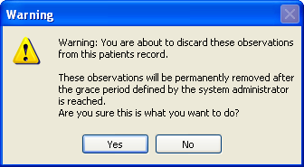

Figure 8-5, Confirm Discard Warning

Rescinding Data
The Rescind function allows data to be hidden after it is entered on the flowsheet in error. Data that is already a part of the patient’s record cannot be permanently deleted. Rescinded data will no longer
display on the patient’s flowsheet, but a user with appropriate access rights can review it in the Log Files.
An authorized user may rescind data entered. An authorized user can rescind data entered by an MD TRAINEE (for example, nursing student, preceptee) only if the user has an MD MANAGER or MD ADMINISTRATOR key. The Rescind function will remove an observation from the permanent record after it is verified and possibly reported in a TIU note or had clinical decisions made regarding its value.
To rescind data, do the following:
- Select a patient.
- Select the date range you want.
- Select the Log Files tab.
- Use the Observation Log to locate and select the data you want to rescind.
Note: You can press Ctrl + click to select multiple data.
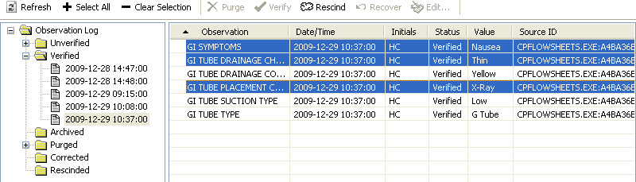
Figure 8-6, Select Multiple Data

- Click the Rescind button.
Figure 8-7, Rescind Button
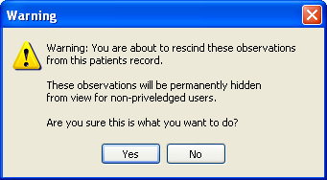
- A warning dialog box displays. Click Yes to confirm.
Figure 8-8, Confirm Rescind Data Warning
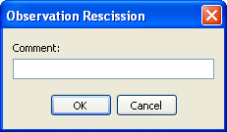
- A dialog box displays for your comment. Enter a reason for rescinding the data, and click OK.
Figure 8-9, Rescind Comment
The dialog box closes and the data row is removed from the Verified folder in the Observation Log. The data row displays under the Rescinded folder of the Observation Log.

Recovering Data
Use the Recover function to restore unverified data that is purged.
Note: A grace period for purging data is defined by the system administrator. Purged data will be permanently removed after the grace period is reached. Data can no longer be recovered after a grace period. The system administrator defines the length of the grace period in CP Console, using the Background Task options. For more information, see the Clinical Procedures (CP) V1.0 Flowsheets Module Implementation Guide.
To recover purged data, do the following:
- On the Log Files screen, expand the Purged folder to display the dates/times of purged data available for recovery (see figure below).

Note: The dates/times listed indicate when the data was entered, not purged.
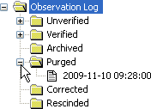
Figure 8-10, Data Entered, Date/Time
- Select the date/time of the data you want to restore. The observations display in the detail area on the right.
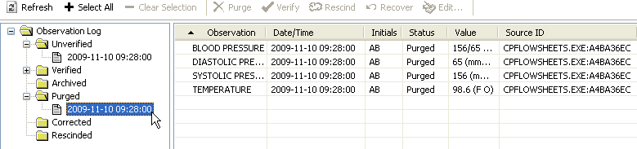
Figure 8-11, Restore Data, Date/Time
- In the detail area, select the observation(s) you want to restore. Press <Ctrl> + click to select multiple observations.
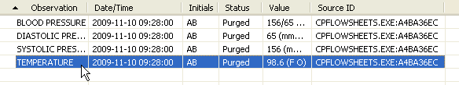
Figure 8-12, Observation To Restore
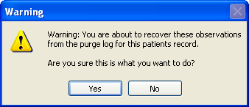
- Click the Recover button. A Warning dialog box displays.
Figure 8-13, Confirm Recover Observation Warning

- Click Yes to restore the data, or click No to cancel. When data is restored, it returns to the original state of unverified data. Data must be verified by an authorized user with an MD MANAGER or MD ADMINISTRATOR key to display on the flowsheet. Data cannot be verified by a user with the MD TRAINEE key (for example, nursing student, preceptee).

HL7 Monitor Screen
The HL7 Monitor view is used to perform the following functions: match records to a patient
match records to an instrument
view the original HL7 message resubmit a message
discard a message
Note: This option is available only for users with the MD ADMINISTRATOR and/or HL7 MANAGER keys.

Viewing HL7 Messages
To view the HL7 message of a particular data row, do the following:
- Select a patient.
- Click HL7 Monitor.
- Highlight a single data row.
Note: This list allows selection of multiple data rows. If you select more than one row, the View HL7 button is inactive.
- Click one of the following buttons:
Refresh: Reload HL7 message data.
Get Patient: Match the record to a patient. (See below for instructions.)
Get Instrument: Match the record to an instrument. (See below for instructions.)
View HL7: Display the HL7 message text. To return to the HL7 Monitor screen, click the HL7 Log
button.
Note: You may also double-click the row to view the HL7 message.
Resubmit: When you identify the instrument or patient or make changes to a mapping table, click
Resubmit to reprocess the message.
Note: After you resubmit a message, and the message is properly matched to a patient or instrument, the message data displays in the appropriate flowsheet view.
Discard: Set the message status to processed and remove the message from the user’s view. The message will be physically deleted later during a nightly cleanup.

Matching Records to a Patient
In the event that the patient identifying information (PID) from the instrument doesn’t match the PID information in the CP Flowsheets application, you can use the HL7 Monitor screen to match the data manually to a patient.
Note: Data not matched to a patient can be either verified or unverified.
To match records to patients, do the following:
- Select a patient.
- Click HL7 Monitor.
- Select the record(s) you want as follows: <Ctrl> + click to select multiple items.
Click Select All to select each record in the list. Click Deselect All to clear record selections.
- 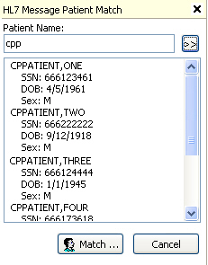Click Get Patient. The HL7 Message Patient Match search field displays.
Figure 9-1, HL7 Message Patient Match
- Type at least one letter in the Patient Name box, and click the button arrows. The list below the search field displays all names that match the search criteria.
Note: If your database is large, typing fewer letters increases the length of the search.
- Select a patient from the search list and click Match. A confirmation dialog box displays.
- Click Yes. The confirmation dialog box closes and the Patient Name list displays.
- Repeat steps 3-7 as needed.
- When records are matched, click Resubmit to reprocess the information.
- A confirmation dialog box displays. Click Yes.

Matching Records to an Instrument
HL7 Monitor Screen

The workflow for matching records to an instrument is slightly different than matching records to a Patient.
Note: Data not matched to an instrument can be either verified or unverified.
To match records to an instrument, do the following:
- Select a patient.
- Click HL7 Monitor.
- Highlight Select the desired record(s) as follows: <Ctrl> + click to select multiple items.
Click Select All to select each record in the list. Click Deselect All to clear record selections.
- 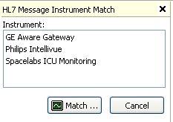Click Get Instrument. The HL7 Message Instrument Match area displays.
Figure 9-2, HL7 Message Instrument Match
- The list displays all available instruments.
- Select an instrument from the list and click Match.
- A confirmation dialog box displays. Click Yes.
- Repeat steps 3-7 as needed.
- When records are matched, click Resubmit to reprocess the information.
- A confirmation dialog box displays. Click Yes.

  - Discarding a Record
To discard a record, do the following:
- Select a patient.
- Click HL7 Monitor.
- Select the record(s) you want as follows: <Ctrl> + click to multi-select items.
Click Select All to select each record in the list. Click Deselect All to clear record selections.
- Click Discard. A confirmation dialog box displays.
- Click Yes.

User Settings
CP Flowsheets allows the configuration of certain user settings (e.g., defaults, confirmations and screen colors). You configure settings on the CP Flowsheets Settings dialog box.
To access the CP Flowsheets Settings dialog box, select User Settings from the File menu, or press

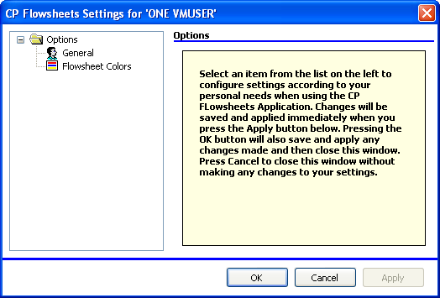
<Ctrl> + <U>.
Figure 10-1, User Settings
The image above shows the CP Flowsheets Settings dialog box. The Options folder allows you access to the two Options areas: General and Flowsheet Colors.
Note: If the General and Flowsheet Colors items aren’t visible, click the Plus Sign (+) next to the Options folder to expand the folder.

Modifying General Settings
To modify General settings:
- From the CP Flowsheets File menu, select User Settings, General.
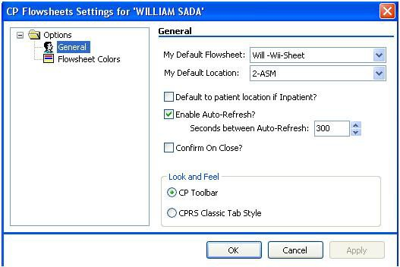
- The area on the right provides control over several General options.
Figure 10-2, User Settings, General
You can modify the following display options in the General and Look and Feel areas of this screen:
My Default Flowsheet: Choose the initial flowsheet when CP Flowsheets is launched. Choose {None} if you do not want to select a flowsheet automatically.
My Default Location: The location selected here defaults to the Location field when you click Add Data on the Flowsheet screen. This location also defaults to the Select Ward Location field on the Open Patient window.
Default to patient location if Inpatient?: Click this check box if you want the Location list to automatically display a value when you manually add data to a flowsheet view. Checking this box activates the next option.
Enable Auto-Refresh?: Click this check box to enable auto-refresh of CP Flowsheets. You can adjust the seconds between each auto-refresh directly underneath this checkbox.
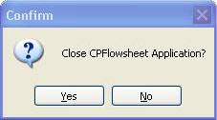
Confirm On Close?: Check this box to display a confirmation dialog box before you exit the CP Flowsheets application. (See figure below).
Figure 10-3, Confirm Close Application
Look and Feel radio buttons: Select a radio button to control the appearance of the toolbar buttons and screens (for example, Flowsheet, Alarms, Reports, Log Files, HL7 Monitor).
If you select the “CP Toolbar” radio button, the tab buttons display in a row below the Open Patient button. Click a button to change screen areas.

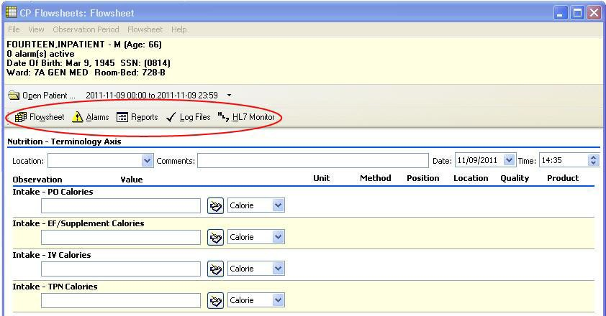

Figure 10-4, CP Flowsheet Buttons
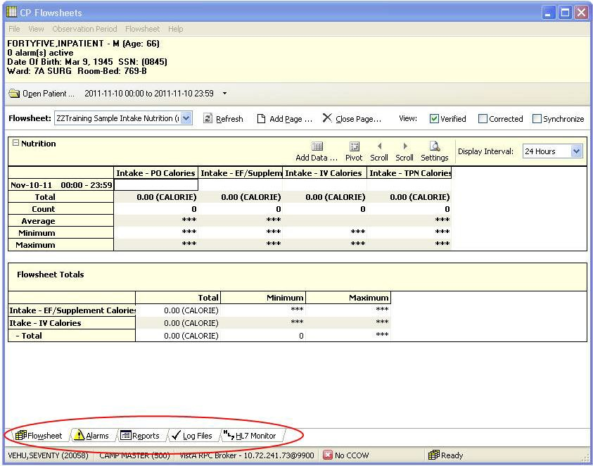
If you select the “CPRS Classic Tab Style” radio button, the tabs display in a row above the status line at the bottom. With this setting selected, the application performs like CPRS. Click a tab to change screen areas.
Figure 10-5, CP Flowsheet Tabs
OK button: Click OK to apply changes and close the CP Flowsheets Settings dialog box.

Cancel button: Click Cancel to discard changes and close the CP Flowsheets Settings window.
Apply button: Click Apply to save and implement changes without closing the CP Flowsheets Settings window.

Modifying Flowsheet Colors
This option controls how observation values display on the flowsheet views. Observation values can be described at Low, Normal, or High depending on the preset range specified for a particular term.
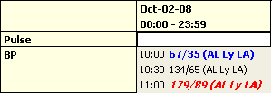
The image below shows how these values can appear in a flowsheet view.
Figure 10-6, Modify Flowsheet Colors
The 10:00 value is a low blood pressure. The observation value and its qualifiers display in bold blue text. The 10:30 value is normal and displays in normal black text. The 11:00 value is a high blood pressure and displays in bold, italicized red text.
To modify color settings, do the following:
- Select User Settings from the File menu. The CP Flowsheets Settings dialog box displays.
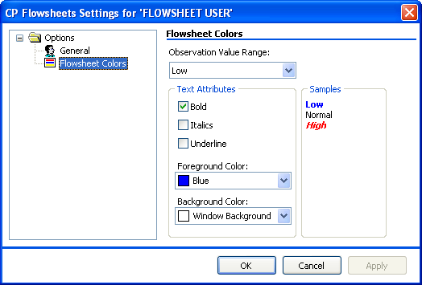
- Click Flowsheet Colors on the CP Flowsheets Settings dialog box. The Flowsheet Colors area on the right provides control over several screen color options.
Figure 10-7, Flowsheet Color Settings
- From the Observation Value Range list, select the range to modify: Low, Normal, or High.
- Use the controls in the Text Attributes area to modify the selected range. The following text attributes can be controlled using this screen:

Bold Italics
Underline
Foreground Color Background Color
As you change the text attributes, the Samples area changes automatically to provide a preview.
- Repeat steps 3 and 4 as needed to modify the other Observation Value ranges.

Appendix A – Access Key Listing
The following is a listing of access keys for the CP Flowsheets application.
To use an Access Key, press <Alt>, release it, and then press the designated Access Key.
To use a Shortcut Key, press and hold <Ctrl> or <Alt> (as indicated below), then press the designated Shortcut Key.

Screen | Option / Button Text | Access Key | Shortcut Key #1 | Shortcut Key #2
Flowsheet |  |  | Ctrl + F | Alt + F
 | File menu | F
 | Open Patient | O | Ctrl + O
 | User Settings | U | Ctrl + U
 | Break Link | B
 | Rejoin Context | R
 | Show CCOW Status | S
 | Exit | X | Ctrl + Q | Ctrl + X
 | View menu | V
 | Flowsheet | F | Ctrl + F
 | Alarms | A | Ctrl + A
 | Reports | R | Ctrl + R | Alt + E
 | Log Files | L | Ctrl + L
 | HL7 Monitor | H | Ctrl + H
 | Observation Period menu | O
 | Extend Date Back 1 Day | E
 | Pan Date Back 1 Day | P
 | Set Date Range | S
 | Pan Date forward 1 Day | A

Screen | Option / Button Text | Access Key | Shortcut Key #1 | Shortcut Key #2
 | Extend Date Forward 1 Day | X
 | Today (00:00-23:59) | T
 | Flowsheet menu | L
 | Refresh | R
 | Add Page | P | Ctrl + P
 | Close Page | C
 | Flowsheet Views: There will be a dynamic submenu for each active flowsheet view. | The access keys are automatically generated, as described in the Dynamic Menu section.  Expand the menus using the keyboard to display the access keys.
 | Flowsheet View submenus
 | Add Data | A
 | Pivot | P
 | Scroll Left | S
 | Scroll Right | C
 | Settings | E
 | Display Interval | D
 | Display Interval submenu | D
 | 1 Minute | 1
 | 2 Minutes | 2
 | 5 Minutes | 5
 | 10 Minutes | 0
 | 15 Minutes | M
 | 20 Minutes | I

Screen | Option / Button Text | Access Key | Shortcut Key #1 | Shortcut Key #2
 | 30 Minutes | 3
 | 1 Hour | H
 | 90 Minutes | 9
 | 2 Hours | O
 | 3 Hours | U
 | 4 Hours | 4
 | 6 Hours | 6
 | 8 Hours | 8
 | 12 Hours | R
 | 24 Hours | S
 | Help menu | H
 | Contents | C
 | About | A
 | View checkboxes
 | Verified | No shortcut keys. Press <Tab> to highlight a checkbox. Press  <Space> to check/uncheck it.
 | Corrected
 | Synchronize
Alarms |  |  | Ctrl + A
 | All other menus are the same as on the Flowsheet screen.
 | Alarms menu
 | Refresh | R
 | New Alarm | N
 | Update | U

Screen | Option / Button Text | Access Key | Shortcut Key #1 | Shortcut Key #2
 | Clear Alarm | C
 | Deactivate | D
Reports |  |  | Ctrl + R | Alt + E
 | All other menus are the same as on the Flowsheet screen
 | Reports menu | E
 | Refresh | R
 | Print | P
 | Write Note | W
 | First | F
 | Prev | E
 | Next | N
 | Last | L
 | Include Comments checkbox | Press <Tab> to highlight the  checkbox. Press <Space> to check/uncheck it.
Log Files |  |  | Ctrl + L
 | All other menus are the same as on the Flowsheet screen.
 | Log menu | L
 | Refresh | R
 | Select All | S
 | Clear Selection | C
 | Purge | P
 | Verify | V
 | Rescind | E

Screen | Option / Button Text | Access Key | Shortcut Key #1 | Shortcut Key #2
 | Edit | D
 | Print | I
HL7 Monitor |  |  | Ctrl + H
 | All other menus are the same as on the Flowsheet screen.
 | HL7 Monitor menu | L
 | Refresh | R
 | Get Patient | G
 | Get Instrument | E
 | View HL7 | V
 | Resubmit | S
 | Discard | D

This page intentionally left blank for double-sided printing.

Glossary
This glossary is used for the Clinical Flowsheets project and may include terms and definitions not used in this specific document.

Term | Description
<RET> | Carriage return.
Access Code | A unique sequence of characters known by and assigned only to the user, the system manager and/or designated alternate(s). The access code (in conjunction with the verify code) is used by the computer to identify authorized users.
Action | A functional process that a clinician or clerk uses in the TIU computer program. For example, “Edit” and “Search” are actions. Protocol is another name for Action.
ADP | Automated Data Processing
ADP Coordinator/- ADPAC/Application Coordinator | Automated Data Processing Application Coordinator. The person responsible for implementing a set of computer programs (application package) developed to support a specific functional area such as clinical procedures, PIMS, etc.
ADT | Advanced Data Type (InterSystems Cache). Also Admissions, Discharges, Transfers.
AP | Arterial pressure
API | Application Programming Interface. An interface that a computer system, library, or application provides in order to accept requests for services from other programs, and/or to allow data to be exchanged between them.
Application | A system of computer programs and files that have been specifically developed to meet the requirements of a user or group of users.
Archive | The process of moving data to some other storage medium, usually a magnetic tape, and deleting the information from active storage in order to free-up disk space on the system.
Assessment | Assessment is the documentation of a clinician’s observations and interpretation of a patient’s clinical state based on a particular set of  observations. The documentation is in the form of name-value pairs with values selected from a predetermined set, of name-value pairs in which the value is a number or set of numbers, or of free text.  Examples of assessments from paper ICU flowsheets are coma scale, patient opens eyes, pupil size, reaction to light, and so on.
ASU | Authorization/Subscription Utility. An application that allows sites to associate users with user classes, allowing them to specify the level of authorization needed to sign or order specific document types and orderables. ASU is distributed with TIU in this version; eventually it will probably become independent, to be used by many VistA packages.

Term | Description
Attachments | Attachments are files or images stored on a network share that can be linked to the CP study. CP is able to accept data/final result report files from automated instruments. The file types that can be used as attachments are the following:  .txt - Text files  .rtf - Rich text files  .jpg - JPEG Images  .jpeg - JPEG Images  .bmp - Bitmap Images  .tiff - TIFF Graphics (group 3 and group 4 compressed and uncompressed types)  .pdf - Portable Document Format  .html - Hypertext Markup Language  .DOC (Microsoft Word) files are not supported. Be sure to convert .doc files to .rtf or to .pdf format.
Background Processing | Simultaneous running of a "job" on a computer while working on another job. Examples would be printing of a document while working on another, or the software might do automatic saves while you are working on something else.
Background Task | A job running on a computer while simultaneously working on a second job.
Backup Procedures | The provisions made for the recovery of data files and program libraries and for restart or replacement of ADP equipment after the occurrence of a system failure.
Boilerplate Text | A pre-defined TIU template that can be filled in for Titles, Speeding up the entry process. TIU exports several Titles with boilerplate text which can be modified to meet specific needs; sites can also create their own.
BP | Blood Pressure.
Broker | Software which mediates between two objects, such as a client and a server or a repository and a requestor.
Browse | Lookup the file folder for a file that you would like to select and attach to the study. (e.g., clicking the “...” button to start a lookup).
Bulletin | A canned message that is automatically sent by MailMan to a user when something happens to the database.
Business Rule | Part of ASU, Business Rules authorize specific users or groups of users to perform specified actions on documents in particular statuses (e.g., an unsigned CP note may be edited by a provider who is also the expected signer of the note).
CAC | Clinical Application Coordinator.
Care Action | Care action is an intervention scheduled on a patient that may or may not be ordered.
CCB | Change Control Board.
CCDSS | Clinical Care Delivery Support System.
CCOW | Clinical Context Object Workgroup. An HL7 standard protocol through which applications can synchronize in real-time, enabling Single Sign On and Context Management.
CDR | Clinical Data Repository.

Term | Description
CIS | Clinical Information System. An ICU Clinical Information System is any hardware/software system that works in concert to collect, store, display, and/or enable manipulation of potential, clinically relevant information. A CIS also acts as an HL7 Gateway. Vendors of monitors and other instruments used in an ICU provide the CIS. The primary distinguishing feature of this CIS is its ability to manually select a subset of all available data and send it to the EMR.
Class | Part of Document Definitions, Classes group documents. For example, “CLINICAL PROCEDURES” is a class with many kinds of Clinical  Procedures notes under it. Classes may be subdivided into other Classes or Document Classes. Besides grouping documents, Classes also store behavior which is then inherited by lower level entries.
Clinical Flowsheets | A module of the Clinical Procedures package that allows the collection of discrete data from medical devices or a Clinical Information System. It is a complete HL7 standardized instrument interface developed and owned by the Department of Veterans Affairs. This module is comprised of three components: the CP Flowsheets application, the CP Console application, and the CliO Generic Interface.
Clinical Reminders | A system which allows caregivers to track and improve preventive healthcare and disease treatment for patients and to ensure timely clinical interventions.
CliO | Clinical Observations database.
CM | Configuration Management.
Consult | Referral of a patient by the primary care physician to another hospital service/ specialty, to obtain a medical opinion based on patient evaluation and completion of any procedures, modalities, or treatments the consulting specialist deems necessary to render a medical opinion.
Contingency Plan | A plan that assigns responsibility and defines procedures for use of the backup/restart/recovery and emergency preparedness procedures selected for the computer system based on risk analysis for that system.
CP | Clinical Procedures.
CP Console | An application used by Administrators to configure the CP Flowsheets application and its interface settings.
CP Definition | CP Definitions are procedures within Clinical Procedures.
CP Flowsheets | A GUI component of the Clinical Flowsheets package. Its primary functions are to provide a means to display data collected from a medical device and to allow manual entry of data. Additional functionality is provided to display and print reports, verify incoming observational data, add comments, correct erroneous information, and submit TIU Progress Notes to CPRS.
CP Gateway | The service application that prepares the data contents of HL7 messages for use in CP Hemodialysis. It requires no direct user interaction.
CP Manager | The CP Manager application is no longer supported after the installation of MD*1.0*16; it has been superseded by. CP Console.
CP Study | A CP study is a process created to link the procedure result from the medical device or/and to link the attachments browsed from a network share to the procedure order.

Term | Description
CPRS | Computerized Patient Record System. A comprehensive VistA program, which allows clinicians and others to enter and view orders, Progress Notes and Discharge Summaries (through a link with TIU), Problem List, view results, reports (including health summaries), etc.
Data Dictionary | A description of file structure and data elements within a file.
DBIA | Database Integration Agreement.
Delphi | A programming language, also known as Object Pascal.
Device | A hardware input/output component of a computer system (e.g., CRT, printer).
Display Interval | The amount of time that displays in each column of a flowsheet view. Display interval is configurable from 1 minute to 24 hours. Shorter interval settings can improve readability when a large amount of data is received over a short period of time. Longer interval settings allow you to view longer periods of time while reducing the amount of horizontal scrolling necessary to view all columns.
DLL | Dynamically Linked Library. These files provide the benefit of shared libraries.
DOB | Date of Birth.
Document Class | Document Classes are categories that group documents (Titles) with similar characteristics together. For example, Cardiology notes might be a Document Class, with Echo notes, ECG notes, etc. as Titles under it. Or maybe the Document Class would be Endoscopy Notes, with Colonoscopy notes, etc. under that Document Class.
Document Definition | Document Definition is a subset of TIU that provides the building blocks for TIU, by organizing the elements of documents into a hierarchy structure. This structure allows documents (Titles) to inherit characteristics (such as signature requirements and print characteristics) of the higher levels, Class and Document Class. It also allows the creation and use of boilerplate text and embedded objects.
DUZ | Designated user. This is the internal FileMan number for a particular user.
Edit | Used to change/modify data typically stored in a file.
EMR | Electronic Medical Record. HealtheVet, is the permanent medical record for a patient in VistA
Field | A data element in a file.
File | The M construct in which data is stored for retrieval later. A computer record of related information.
File Manager or FileMan | Within this manual, FileManager or FileMan is a reference to VA FileMan. FileMan is a set of M routines used to enter, edit, print, and sort/search related data in a file, a database.
File Server | A machine where shared software is stored.
Flowsheet | A flowsheet is a table, chart, spreadsheet, or other method of displaying data on two axes. One axis represents time intervals and the other axis represents the readings from an ICU monitor documented at the various time intervals.

Term | Description
Flowsheet view | A customizable subsection (or page) of a flowsheet. Flowsheet views are created by adding and arranging terms and choosing their default qualifiers. Flowsheet views can be set up to display observations, provide a way to manually enter observations, and display reports.
Fluid off | Cumulative volume of fluid removed from patient.
Gateway | The software that performs background processing for Clinical Procedures.
Global | An M term used when referring to a file stored on a storage medium, usually a magnetic disk.
GUI | Graphical User Interface. A Windows-like screen that uses pull-down menus, icons, pointer devices, and other metaphor-type elements that can make a computer program more understandable, easier to use, allow multi-processing (more than one window or process available at once), etc.
HDR | Health Data Repository.
HEP (CUM) | Cumulative heparin infusion
HFS | Host File System.
HIPAA | Health Insurance Portability and Accountability Act.
HL7 | Health Level 7. A language which various healthcare systems use to interface with one another.
HL7 Gateway | Hardware or software provided by a vendor that is able to receive information in a vendor’s proprietary format from one or more ICU monitors and other instruments, to translate the data into standardized HL7 message format, and to pass the messages to other systems.
HR | Heart Rate.
HSD&D | Office of Information (OI), Health Systems Design & Development.
HSITES | Health Systems Implementation, Training, Education, and Support.
ICU | Intensive Care Unit.
IEN | Internal Entry Number.
IJ | Internal Jugular.
Instrument | An instrument is a device used to perform a medical function on a patient. In Clinical Flowsheets instrument refers to ICU monitors, which are electronic devices that collect and/or display information concerning the physical state of a patient. Usually, the monitor attaches to a patient and takes readings over time without requiring intervention for each reading.
Interpreter | Interpreter is a user role exported with USR*1*19 to support the Clinical Procedures Class. The role of the Interpreter is to interpret the results of a clinical procedure. Users who are authorized to interpret the results of a clinical procedure are sent a notification when an instrument report and/or images for a CP request are available for interpretation. Business rules are used to determine what actions an interpreter can perform on a document of a specified class, but the interpreter themselves are defined by the Consults  application. These individuals are „clinical update users‟ for a given consult service.
IRM | Information Resource Management.
IRMS | Information Resource Management Service.

Term | Description
JCAHO | Joint Commission on Accreditation of Healthcare Organizations.
Kernel | A set of software utilities. These utilities provide data processing support for the application packages developed within the VA. They are also tools used in configuring the local computer site to meet the particular needs of the hospital. The components of this operating system include MenuMan, TaskMan, Device Handler, Log-on/Security, and other specialized routines.
Key | A level of access assigned to a Flowsheets user that determines which Flowsheets functions the user may perform. Refer to “User Role” in this Glossary.
LAYGO | An acronym for Learn As You Go. A technique used by VA FileMan to acquire new information as it goes about its normal procedure. It permits a user to add new data to a file.
LPES/CPS | Legacy Product Enterprise Support/Clinical Product Support. Enterprise Product Support (formerly Enterprise VistA Support).
log | A list that provides the time and description of events as they occur.
M | Formerly known as MUMPS or the Massachusetts (General Hospital) Utility Multi-Programming System. This is the programming language used to write all VistA applications.
MailMan | An electronic mail, teleconferencing, and networking system.
MAP | Mean Arterial Pressure.
Menu | A set of options or functions available to users for editing, formatting, generating reports, etc.
Module | A component of a software application that covers a single topic or a small section of a broad topic.
MUMPS | Massachusetts General Hospital Utility Multi-Programming System. Obsolete; now known as "M" programming language.
Namespace | A naming convention followed in the VA to identify various applications and to avoid duplication. It is used as a prefix for all routines and globals used by the application.
Network Server Share | A machine that is located on the network where shared files are stored.
Notebook | This term refers to a GUI screen containing several tabs or pages.
NTE | Not To Exceed.
OI | Office of Information. Formerly known as Chief Information Office Field Office, Information Resource Management Field Office, and Information Systems Center.
option | A functionality that is invoked by the user. The information defined in the option is used to drive the menu system. Options are created, associated with others on menus, or given entry/exit actions.
optional page | One of two special types of flowsheet views which provides a way to track a specific condition (e.g., a pacemaker) on its own flowsheet view. An Optional Page can display only once in a given flowsheet. If an optional page is closed and then redisplayed, any data previously entered still displays.
Package | Otherwise known as an application. A set of M routines, files, documentation and installation procedures that support a specific function within VistA.

Term | Description
page | This term refers to a tab on a GUI screen or notebook.
Password | A protected word or string of characters that identifies or authenticates a user, a specific resource, or an access type (synonymous with Verify Code).
PCE | Patient Care Encounter.
Permission | Setting that can be used to allow access to particular views, flowsheets, etc. to one or more specific users and to control the type of access each user has.
PIMS | Patient Information Management System.
Pivot | Swap the axes of a table or chart. This causes the values that were displayed along the vertical axis to be displayed along the horizontal axis and the values that were displayed along the horizontal axis to be displayed along the vertical axis.
PM | Project Manager.
Pointer | A special data type of VA FileMan that takes its value from another file. This is a method of joining files together and avoiding duplication of information.
PRN | As needed.
Procedure Request | Any procedure (EKG, Stress Test, etc.) which may be ordered from another service/specialty without first requiring formal consultation.
Program | A set of M commands and arguments, created, stored, and retrieved as a single unit in M.
Protocol | A set of rules governing communication within and between computing endpoints.
PS | Provider Systems.
PV | Pulmonary Vascular.
QG | Quality Gate.
Qualifiers | A word or phrase that provides specific information about an observation. For example, an observation could have qualifiers such as Unit (f=degrees Fahrenheit, c=degrees Celsius, bpm=beats per minute, rpm=respirations per minute, etc.), Method (Cu=cuff BP, Dop=Doppler BP, etc.), Position (Ly=lying, Si=sitting, St=standing, etc.), Location (La=left arm, LL=left leg, RA=right arm, RL=right leg, etc.), Quality (A=accurate, E=Estimated), etc.
Queuing | The scheduling of a process/task to occur later. Queuing is normally done if a task is a heavy user of computer resources.
RAID | Redundant Array of Inexpensive Disks. A data storage scheme using multiple hard drives to share or replicate data among the drives.
Result | A consequence of an order. Refers to evaluation or status results. When you use the Complete Request (CT) action on a consult or request, you are transferred to TIU to enter the results.
Routine | A set of M commands and arguments, created, stored, and retrieved as a single unit in M.
RPC | Remote Procedure Call. A protocol that allows a computer program running on one host to cause code to be executed on another host.
Rx | Prescription.
SAC | Standards And Conventions.

Term | Description
Security Key | A function which unlocks specific options and makes them accessible to an authorized user.
Sensitive Information | Any information which requires a degree of protection and which should be made available only to authorized users.
Service | A long-running executable designed to perform specific functions without user intervention. Windows services can be configured to restart automatically when the operating system is rebooted.
SGML | Standard Generalized Markup Language.
Shift | A period of time that can be defined in CP Flowsheets. This often corresponds to the time an individual an individual works.
Site Configurable | A term used to refer to features in the system that can be modified to meet the needs of each site
Software | A generic term for a related set of computer programs, such as an operating system that enables user programs to run.
SQA | Software Quality Assurance.
SRS | Software Requirements Specification.
SSN | Social Security Number.
Status Symbols | Codes used in order entry and Consults displays to designate the status of the order.
STS | Standards and Terminology Services. An initiative to create and maintain standardized terminology throughout the VA by assigning a code to every term.
Supplemental page | One of two special types of flowsheet views which provides a way to track a specific condition (e.g., a pressure wound) on its own flowsheet view.  Multiple supplemental pages can be added to a single flowsheet in order to track numerous specific conditions. If a supplemental page is closed and then a new supplemental page is added, the new supplemental page is blank.
Screen (move for alphabetical order) | One of the five primary GUI screens of the CP Flowsheets application: Flowsheet, Alarms, Reports, Log Files, and HL7 Monitor.
Task Manager or TaskMan | A part of Kernel which allows programs or functions to begin at specified times or when devices become available. See Queuing.
Term | As used in Flowsheets, a term is any piece of relevant data. A term, like “Blood Pressure” will typically have one or more associated measures, modifiers, or qualifiers.
Terminology | Standardization of words and terms used in Flowsheets.
Title | Titles are definitions for documents. They store the behavior of the documents which use them.
TIU | Text Integration Utilities.
TMP | Trans Membrane Pressure.
UFR | Ultrafiltration Rate.
UI | User Interface.
UNC | Universal Naming Convention.

Term | Description
Untrusted device | A medical instrument which has not been mapped for use with the Clinical Flowsheets package. Data sent from an untrusted device will not display in a flowsheet view until someone reviews it (on the CP Flowsheets Log Files tab) and marks it as verified.
URL | Uniform Resource Locator. A means of finding a resource (such as a web page or a device) on the Internet.
URR | Urea Reduction Ratio. The reduction in urea as a result of dialysis.
User | A person who enters and/or retrieves data in a system, usually utilizing a CRT.
User Class | User Classes are the basic components of the User Class hierarchy of ASU (Authorization/Subscription Utility) which allows sites to designate who is authorized to do what to documents or other clinical entities.
User Role | User Role (in a documentation context). The role of the user with respect to the document in question (e.g., Author/Dictator, Expected Signer, Expected Cosigner, Attending Physician, etc.).
User Role | User Role (in a Flowsheets setup context). The role of a Flowsheets user with respect to which Flowsheets functions the user will have permission to perform. Flowsheets User Role include the following.  - MD ADMINISTRATOR  - MD MANAGER  - MD HL7 MANAGER  - MD READ-ONLY  - MD TRAINEE
Utility | An M program that assists in the development and/or maintenance of a computer system.
UUEncoded format | A form of binary to text encoding whose name derives from "Unix-to-Unix encoding”.
VA | Department of Veterans Affairs. Formerly the Veterans Administration.
VAMC | Department of Veterans Affairs Medical Center.
VDEF | VistA Data Extraction Framework.
Verify Code | A unique security code which serves as a second level of security access. Use of this code is site specific. This term is sometimes used interchangeably the term password.
VHA | Veteran Health Administration.
VistA | Veterans Health Information Systems and Technology Architecture.
VP | Venous Pressure.
VUID | Veterans Health Administration (VHA) Unique Identifier. A unique identifier that specifies individual data elements or observations. In Clinical Flowsheets, each term is assigned a VUID.
Workstation | A personal computer running the Windows 9x or NT operating system.
XML | Extensible Markup Language. A simplified subset of Standard Generalized Markup Language (SGML). Its primary purpose is to facilitate the sharing of data across different information systems.
XMS | Extended Memory Specification. The specification describing the use of extended memory in real mode for storing data.

This page intentionally left blank for double-sided printing

Index

A
Access Keys 61
Adding Optional or Supplemental Pages 28
Alarms
Clearing 36
Deactivating 37
Setting 33
Updating 36
Alarms Tab 33

C
CliO Database 2
Common Buttons 10
Configuring Settings 55
CP Console 2
CP Flowsheets 2
CP Gateway 1
CP Gateway Service 1

D
Discarding a Record 54
Display Interval 17
Dynamic Menu 7

F
Flowsheet
Choosing a 21
Flowsheet Tab 21
Flowsheet Tab Controls 15
Flowsheet View Grid Controls 16

G
Glossary 67

H
HL7 Messages Viewing 51
HL7 Monitor Tab 51

K
Keyboard Access 5

L
Log File Data
Reviewing 44

Log Files Tab 43
M
Manually adding Flowsheet Data 25
Matching Records to a Patient 52
Matching Records to an Instrument 53
Menu Bar 5
Modifying Flowsheet Colors 59
Modifying General Settings 56
O
Optional Pages 27
P
Patient Information Area 9
Product Benefits 1
Purging Data 46
R
Recovering Data 48
Related Manuals 3
Reports 39
printing 39
Rescinding Data 47
S
Selecting a Patient 19
Setting the Date Range 22, 23, 24
Shortcut Keys 61
Status Line 11
Supplemental Pages 27
Switching Tab View Styles 15
T
Tabs 14
Terminology Mapping 2
TIU Notes 40
U
User Settings 55
V
Verifying Data 45
W
Window Elements 5

