CLINICAL PROCEDURES (CP) V1.0 FLOWSHEETS MODULE
USER MANUAL

MD*1.0*26
August 2011

Department of Veterans Affairs Office of Information & Technology (OI&T)
Product Development (PD)

Revision History

Date | Description | Author
May 2011 | Patch MD*1.0*16 released. | REDACTED
July 2011 | Added section 5.4.2, How to Close an Optional or Supplemental View | REDACTED
July 2011 | Added two notes to section 5.4, Optional and Supplemental Pages. | REDACTED

This page intentionally left blank for double-sided printing.

Table of Contents

- Introduction 5
  - Product Benefits 5
    - CP Gateway Service 5
    - CliO Database 6
    - Terminology Mapping 6
  - CP Flowsheets 6
  - CP Console 6
  - Intended Audience 6
  - Related Manuals 7
- CP Flowsheets Window Elements 9
  - Common Screen Elements 9
    - CP Flowsheets Menu Bar 9
      - Menu Bar Keyboard Access 9
      - File Menu 9
      - View Menu 10
      - Observation Period Menu 10
      - Dynamic Menu 11
      - Help Menu 13
    - Patient Information Area 13
    - Common Buttons 14
    - Status Line 15
- CP Toolbar Style View 17
  - Defining the CP Flowsheets Screens 18
    - Switching Tab View Styles 19
  - Flowsheet Controls 19
  - Flowsheet View Controls 20
- Selecting a Patient 23
- Flowsheet Workflows 25
  - Choosing a Flowsheet 25
  - Setting the Date Range 26
    - Setting the Date Range—Observation Period Menu Method 26
    - Setting the Date Range—Date Range Selector Method 27
    - Setting the Date Range—Drop-down List Method 28
  - Adding/Editing Flowsheet Data (Manually) 30
  - Optional and Supplemental Pages 32
    - Adding Optional or Supplemental Pages 33
    - How to Close an Optional or Supplemental View 35
- Alarms Screen 39
  - Setting an Alarm 39
    - Updating an Alarm 42
    - Clearing an Alarm 42
    - Deactivating an Alarm 43
- Reports Screen 45
  - Printing a Report 45
  - Writing a TIU Progress Note 46
- Log Files Screen 49
  - Reviewing Log File Data 50
  - Verifying Data 51
  - Purging Data 52
  - Rescinding Data 53
  - Recovering Data 54
- HL7 Monitor Screen 57
  - Viewing HL7 Messages 57
  - Matching Records to a Patient 58
  - Matching Records to an Instrument 59
  - Discarding a Record 60
- User Settings 61
  - Modifying General Settings 62
  - Modifying Flowsheet Colors 65
- Appendix A – Access Key Listing 67
- Glossary 73
- Index 81

Introduction

Product Benefits
The Clinical Flowsheets patch of the Clinical Procedures (CP) package provides an electronic representation of the traditional paper flowsheet maintained during each inpatient stay. Vitals, Intake/Output, Wound Documentation, etc., are examples of data types that can be recorded via Clinical Flowsheets into the Veterans Health Information System and Technology Architecture (VistA) system. Clinical Flowsheets provides a departure from its predecessor applications by storing collected information as discrete data. Some date elements, such as vital signs, are available to the Vitals Package and Computerized Patient Record System (CPRS). Various reports built on the other data elements are available for CPRS in the form of Text Integration Utilities (TIU) Notes.
There are two ways to enter data into Clinical Flowsheets: manually and via Health Level 7 (HL7) messaging. Any instrument or external system capable of sending HL7 messages can be considered a source of data for Clinical Flowsheets (provided that the HL7 messages conform to Clinical Flowsheets requirements).
Clinical Flowsheets uses VistA Data Extraction Framework (VDEF) support, HL7 messaging, and the CP Gateway service to notify the medical device of the patient‘s admission, discharge, and transfer.
The Clinical Flowsheets patch consists of the following three Graphical User Interface (GUI) components and one Kernel Installation & Distribution System (KIDS) build:
CP Console
CP Flowsheets
CP Gateway Service MD1_0P16.KID

CP Gateway Service
The CP Gateway Service is the component that processes HL7 messages.
Unlike the Legacy CP Gateway, the new CP Gateway Service is a Windows service that does not require you to restart it each time the computer goes down.
The CP Gateway Service is composed of two subsystems, one existing solely within VistA, and the other existing as a Windows service that interacts with VistA by way of the Remote Procedure Call (RPC) Broker. A vendor device sends an observation to VistA inside an HL7 (ORU^R01) inbound message. The message is received by the VistA HL7 system.
The VistA CP Gateway Service subsystem parses and validates the patient-identifying information and the device identifier. If the patient information and device identifiers are valid, the Windows service is notified that there is a message waiting to be processed in VistA. The Windows service calls into VistA via the RPC Broker to retrieve the HL7 message. The Windows service then parses and validates the observation data and saves the information in the CliO data store.
For more information about the CP Gateway Service, refer to the Clinical Flowsheets (CP)V1.0 Flowsheets Module Installation Guide.

CliO Database
The CliO database provides a standardized terminology data store for all clinical observations throughout the Department of Veterans Affairs (VA).

Terminology Mapping
The CP Gateway Service provides extensive terminology mapping which translates proprietary labels so the information is understood to represent the same thing and, thus, be stored appropriately. Devices do not always use the same terms to describe the data they transmit. For example, one device may use the term ―heart rate,‖ while another may transmit the same information as ―pulse.‖ This mapping is more efficient than trying to compel each medical device vendor to conform to using standard terminology.
Similarly, CP Flowsheets can display the data to the user using the terminology that is preferred at a given unit or medical center. A flowsheet used by an MICU unit at one hospital can be customized to display
―Heart Rate,‖ while a flowsheet used by a step-down unit may display ―HR‖ or ―Pulse.‖

CP Flowsheets
CP Flowsheets provides an electronic representation of the traditional paper flowsheet. This user- friendly, customizable Graphical User Interface (GUI) provides functionality for data entry, validation and editing, as well as patient management.
Flowsheets provides electronic flowsheets that can be custom designed for any clinical area of a Medical Center.
Flowsheets is a tool that can be used by clinicians to standardize assessment templates nationwide.
Flowsheets provides the ability to report discreet observations data combined with progress notes. Flowsheets creates a complete audit trail of patient documentation.

CP Console
CP Console provides the tools to build the flowsheet views and layouts that are used in patient care areas, for recording clinical data as necessary. It also provides a means for configuring the CP Gateway, assigning permissions to CP Flowsheets users, and system administration.
For more information about CP Console, refer to the Clinical Procedures (CP) V1.0 Flowsheets Module Implementation Guide.

Intended Audience
This User Manual is intended for use by clinicians, physicians, nurses, technicians, , and the Information Resource Management Service (IRMS). End users should be familiar with the following:
Windows operating systems CPRS functionality

Introduction

Related Manuals
Here is a list of related manuals that you may find helpful:
Clinical Procedures (CP) V1.0 Flowsheets Module Installation Guide
Clinical Procedures (CP) V1.0 Flowsheets Module Implementation Guide Clinical Procedures (CP) V1.0 Flowsheets Module User Manual
Clinical Procedures (CP) V1.0 Technical Manual and Package Security Guide Clinical Flowsheets (CP) V1.0 Flowsheets Module Release Notes
CPRS User Manual
Text Integration Utilities (TIU) Implementation Guide Text Integration Utilities (TIU) User Manual
Vitals/Measurements User Manual
You can locate these manuals in the VistA Documentation Library (VDL). Select Clinical from the VDL web page, select the package you want, and then select the manuals. For example, you can select CPRS on the left side of the page. The list of CPRS manuals is displayed.

This page intentionally left blank for double-sided printing.

CP Flowsheets Window Elements
This chapter describes the uses of the various window elements contained in the CP Flowsheets application. The screen elements which are common to all of the CP Flowsheets screens are described.

Common Screen Elements
This section describes the screen elements common to all CP Flowsheets screens.
The Flowsheet screen contains the following elements, which are described below: menu bar, Patient Information Area, buttons, additional flowsheet controls, and flowsheet views.

CP Flowsheets Menu Bar
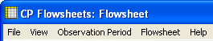
The menu bar displays along the top of the window, just below the Windows title bar. It contains five menu options: File, View, Observation Period, a dynamic (screen-specific) menu, and Help.
Figure 1

Menu Bar Keyboard Access
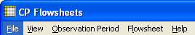
These menu options provide keyboard access to many of the features found on the GUI. To activate keyboard access, press <Alt>. You can then use the cursor keys to browse through the menus and their options. Highlight the desired function then press <Enter>, or else type the underlined letter of the desired option. The underlined letters are shown in the menu titles in the following figure:
Figure 2
Context-Sensitive Help: On any existing Flowsheets tab, you can now press the F1 key, and help content will appear on the section for that screen.
The menu bar contains the following options:

File Menu
Open Patient: Display the Open Patient window to select a patient.
User Settings: Display dialog to change defaults, confirmations, GUI look and feel, and screen colors. For more information on changing User Settings, see Section 10, User Settings.
Break Link: Break Clinical Context Object Workgroup (CCOW)link. VistA applications become un- synchronized, allowing you to work on two different patients when multiple CCOW-compliant applications are open.
Rejoin Context: Reconnect a CCOW link that was broken.

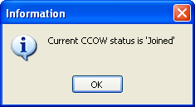
Show CCOW Status: Display a pop-up window containing CCOW link status. Click OK to close the popup.
Figure 3
Note: If the CCOW Broker does not connect when the CP Flowsheets application is started, the File menu only displays three items: Open Patient, User Settings, and Exit. CCOW link status also displays on the status bar, just right of the server information.
Figure 4
Exit: Close the CP Flowsheets application.

View Menu
Flowsheet: Display a screen containing the flowsheet views. This screen is used for entering, editing, and viewing patient data such as the following: vital signs, inputs, outputs, respiratory, pulmonary vascular (PV), and neurological data.
Alarms: Display a screen for managing alarms.
Reports: Display a screen for comparing and printing data.
Log Files: Display a screen which displays data received from the instruments. Use this window to examine data and determine whether it is acceptable or not. Once data is verified (marked as acceptable), it displays in the flowsheet views. If data is not acceptable, it may be purged, which will keep it from the patient‘s permanent record.
HL7 Monitor: Display the raw HL7 messages so you can review their contents. This is used for troubleshooting.
Note: The HL7 Monitor option is only available to users with one of the following keys: MD ADMINISTRATOR or MD HL7 MANAGER. (For more information about security keys, please see Chapter 14 of the Clinical Procedures (CP) V1.0 Technical Manual and Package Security Guide.)

Observation Period Menu
This menu provides access to the functions described in the section ―Setting the Date Range.‖ The following options are available:
Extend Date Back 1 Day: Start Date moves one day earlier. Stop Date stays the same.
Pan Date Back 1 Day: Start Date and Stop Date both move one day earlier.

Set Date Range: Display the Date Range Selector window.
Pan Date Forward 1 Day: Start Date and Stop Date both move one day later.
Extend Date Forward 1 Day: Start Date stays the same. Stop Date moves one day later.
Today (start time – end time): Set the Start Date and Stop Date to today‘s date, set the Start Time to 12:00 AM (midnight), and set the Stop Time to 11:59 PM.

Dynamic Menu
The fourth menu item changes based upon location in CP Flowsheets. The following choices are available: Flowsheet, Alarms, Reports, Logfiles, and HL7 Monitor.
Note: The HL7 Monitor option is only available to users with one of the following keys: MD ADMINISTRATOR or MD HL7 MANAGER.
The figure In section 2.1.1 illustrates Flowsheets as the fourth menu option because the Flowsheet screen was active at the time. If you switch to the Reports screen, the fourth menu option changes to Reports, as shown in the figure below:
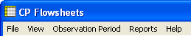
Figure 5
The options available for the five dynamic menus are as follows:
The Flowsheet screen-specific menu contains the following options: Refresh
Add Page Close Page
Dynamic options based on flowsheets views. The remaining Flowsheet menu options are based on the flowsheet views contained within the selected flowsheet. For example, the following figure shows that the selected flowsheet (named ICU MONITORING) contains five flowsheet views with the following names: Vitals, Input, Output, Respiratory, Neurological. As a result, the expanded Flowsheet menu contains options with the same names. Each one of those menu options can be further expanded to provide access to the six flowsheet view controls:
- Add Data
- Pivot
- Scroll Left
- Scroll Right
- Settings
- Display Interval: This option expands to display the same options found within the Display Interval drop-down list.
The figure below also shows that if you access the dynamic menu using the keyboard, each dynamic option is automatically assigned a keyboard access key, indicated by the underlined letter in the option.

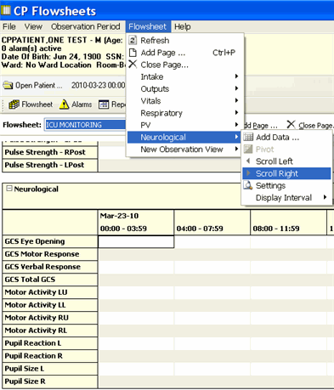

Figure 6
The Alarms screen-specific menu contains the following options: Refresh
New Alarm Update
Clear Alarm Deactivate
The Reports screen-specific menu contains the following options: Refresh
Print
Write Note First
Prev Next Last

The Logfiles screen-specific menu contains the following options: Refresh
Select All
Clear Selection Purge
Verify Rescind Print
Print Selected
The HL7 Monitor screen-specific menu contains the following options: Refresh
Get Patient
Get Instrument View HL7
Resubmit Discard

Help Menu
Contents: Display the CP Flowsheets online Help file.
About: Display version information about the CP Flowsheets application.

Patient Information Area
The Patient Information Area displays below the menu bar. It contains the following information: Patient name – Lastname, Firstname
Gender Age
Active alarms
Date of Birth (DOB)
Last four numbers of the Social Security Number (SSN) Ward
Room/Bed

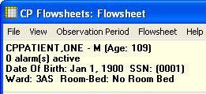

Figure 7

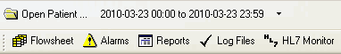
Common Buttons
Figure 8
By default, the buttons display in two rows below the Patient Information Area. (i.e., when the selected Look and Feel is the CP Toolbar).
Note: When the selected Look and Feel is set to CPRS Classic tab style, the second row of buttons does not appear. (For information on changing the Look and Feel, see
―Modifying General Settings.‖)
The button row can be moved by dragging it from the left-hand edge. The following buttons are available:
Open Patient: Display the Open Patient window to select a patient.
Date Range: Select the start and end dates for the data display. Click the drop-down arrow to pan and/or extend the date range.
Flowsheet: Display a screen containing the flowsheet views. This screen is used for entering, editing, and viewing patient data such as the following: vital signs, inputs, outputs, respiratory, PV, and neurological data.
Alarms: Display a screen for managing alarms.
Reports: Display a screen for printing data.
Log Files: Display a window which displays data received from the instruments. Use this window to examine data and determine whether it is acceptable or not. Once data is verified (marked as acceptable), it displays in the flowsheet views. If data is not acceptable, it may be purged, which will keep it from the patient‘s permanent record.
HL7 Monitor: The HL7 Monitor screen is used to match records to a patient, match records to an instrument, and view HL7 message data.
Note: The HL7 Monitor button is only available to users with one of the following keys: MD ADMINISTRATOR or MD HL7 MANAGER.

Status Line
Figure 9

The Status Line is the gray bar which runs along the bottom of the window. This information is for display only. It displays the following information, from left to right:
User name and DUZ Facility
VistA Server Internet Protocol (IP) CCOW status
Ready status

This page intentionally left blank for double-sided printing.

CP Toolbar Style View
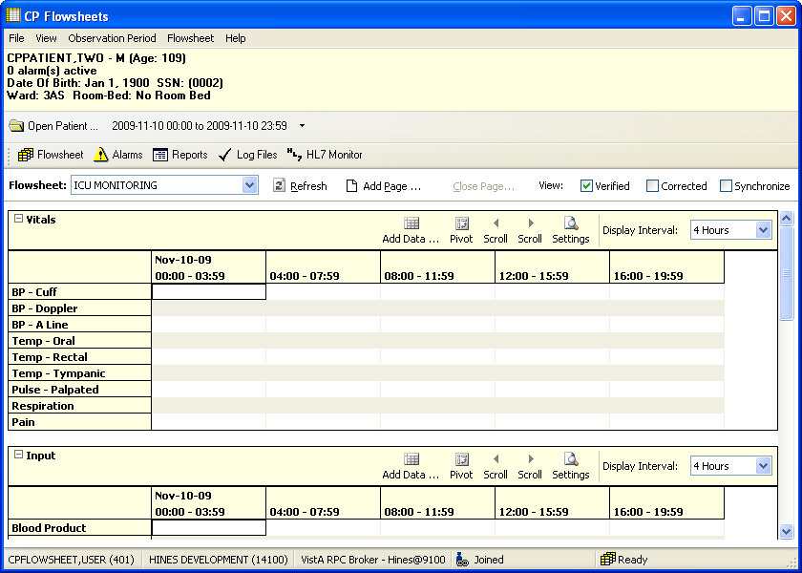
Another way to view the CP Flowsheets tabs is the CP Toolbar style. When the CP Toolbar style is selected, the tab-select buttons are arranged in a row below the Open Patient button. This style is the default style when you run CP Flowsheets for the first time. See the figure below which displays the CP Toolbar style.
Figure 10
Here is a close-up of the tab-select buttons:
Figure 11
Click one of the above buttons to display a different screen area.

Defining the CP Flowsheets Screens
There are five main screen areas that make up the CP Flowsheets GUI. They are referred to as ―Toolbar buttons‖ or optionally ―tabs‖ because of their functional similarity to the tabs found on the CPRS GUI.
The five CP Flowsheets screens are: Flowsheet
Alarms Reports Log Files
HL7 Monitor
Each screen is described in more detail in one of the following chapters.
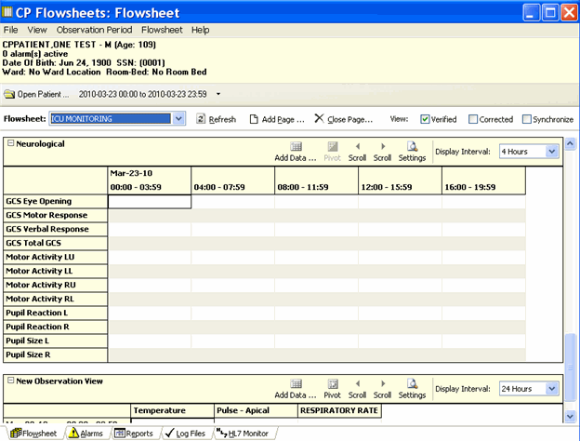
The following screen capture shows the CP Flowsheets GUI with the Flowsheet screen selected. This screen demonstrates the CPRS Classic Tab Style.
Figure 12

When CPRS Classic Tab Style is selected, the tabs themselves are arranged in a row along the bottom of the screen, just above the gray status bar. Click one of these tabs to display a different screen area.

Figure 13
Note: The MD ADMINISTRATOR or MD HL7 MANAGER key is required to access the HL7 Monitor tab. Users without that key will only see four tabs on the CP Flowsheets GUI, as shown below.

Figure 14

Switching Tab View Styles
To switch Tab View styles, do the following:

- Select User Settings from the File menu. The CP Flowsheets Settings window displays.
- Click the General treeview node. The General detail screen displays in the right-hand portion of the CP Flowsheets Settings window.
- Click the desired radio button in the Look and Feel area of the window: CP Toolbar or CPRS Classic Tab Style.
- Click OK. The CP Flowsheets Settings window closes.

Flowsheet Controls
Below the command buttons, there are several additional controls:
Flowsheet drop-down list: Use this list to select a predefined flowsheet. The layouts of the flowsheets are site configurable by designated flowsheet coordinator using the companion CP Console application.
Options: This area contains three additional command buttons:
Refresh: Update the data displayed in the flowsheet.
Add Page: Add a supplemental or optional flowsheet view. This feature helps you to organize your information.
Close Page: Close a Supplemental or Optional page. This button is active only when a supplemental or optional page is activated.
View Checkboxes: This area contains three checkboxes:
Verified: Display data that was marked as verified.

Corrected: For edited observation values, the updated values display in the flowsheet and the previous values are hidden when the Corrected box is left unchecked. Checking the Corrected checkbox displays both the edited data values and the previous (incorrect) values. Previous values display in a strikethrough font.
Synchronize: Set the Display Interval for all flowsheet views to the same interval. To use this feature, first select the desired interval from the Display Interval drop-down list for the first (topmost) flowsheet view, then click the Synchronize checkbox. Once that box is checked, the Display Interval for all subsequent flowsheet views are updated to match that of the first, and all Display Interval checkboxes are grayed out.
To change the interval, uncheck the Synchronize checkbox, change the first Display Interval
drop-down setting, then recheck the Synchronize box.

Flowsheet View Controls
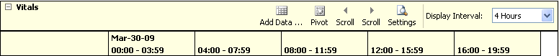
Flowsheet view controls are used to add, edit, and display data in the flowsheet views. A row of controls exists along the top of each flowsheet view. A boldfaced label identifies the type of data contained in this section of the flowsheet view. Here is a partial list of the available data types: Vital Signs, Inputs, Outputs, Respiratory, PV, and Neurological.
Figure 15
Each flowsheet view contains the following controls:
Expand/Collapse Flowsheet view: Click the minus sign left of the flowsheet view title to collapse (hide) the flowsheet view. Click the plus sign to expand (display) it.
Add Data: Click to display the Add Data dialog to enter or edit data.
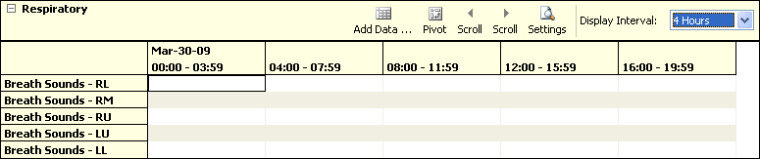
Pivot: Flip the x and y axes of the grid. You may arrange the grid so that the dates and time intervals display along the top of the grid (x-axis) and data types display down the first row (y-axis) as follows:
Figure 16
Or, you may display the grid so that the data types display along the top of the grid (x-axis) and dates and time intervals display down the first row (y-axis) as follows:

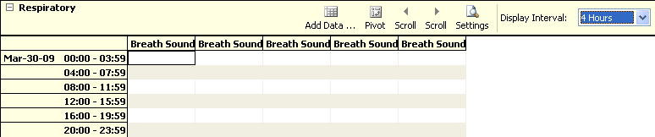

Figure 17

NOTE: Ability to Pivot a view is a site configurable option. If the Pivot button is grayed out, the Pivot function for that view is not permitted.

Scroll L: Scroll the flowsheet grid to the left along the x-axis (horizontally).
Scroll R: Scroll the flowsheet grid to the right along the x-axis.
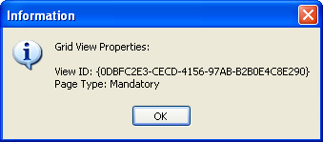
Settings: Display flowsheet view properties: View ID and Page Type (e.g., Mandatory, Optional, or Supplemental). The View ID is a unique, automatically-generated string associated with a flowsheet view. It is for developers‘ troubleshooting use only.
Figure 18
Display Interval: Set the amount of time to display per each column or row (depending on the pivot setting).
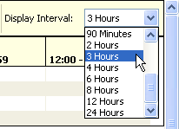
Figure 19
This drop-down list contains the following entries:
1 Minute  2 Minutes  5 Minutes | 90 Minutes  2 Hours  3 Hours

10 Minutes  15 Minutes  20 Minutes  30 Minutes  1 Hour | 4 Hours  6 Hours  8 Hours  12 Hours  24 Hours

The shorter interval settings can improve readability when a large amount of data is documented over a short period of time. Longer interval settings allow you to view longer periods of time while reducing the amount of horizontal scrolling necessary to view all columns.
In the following example, note that the Display Interval is set to 4 Hours.
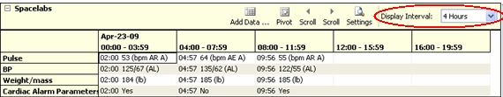
Figure 20
The first data column displays values from midnight (00:00) through 03:59 (a.m.). The next column displays data for the next four hours, and so on. Because only five data columns fit on the screen, you would have to click the Scroll R button to display the final column (20:00 – 23:59).
In this next example, the Display Interval is set to 24 Hours so that several days may be easily viewed within a single screen.
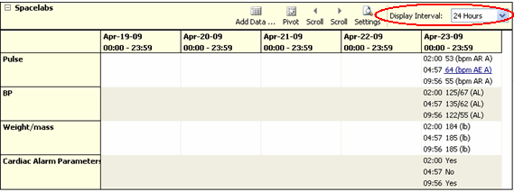
Figure 21

Selecting a Patient
After starting and signing onto CP Flowsheets, the Open Patient window displays. Use this window to search for a patient in one of the following ways:
by patient name (Lastname,Firstname)
by last initial and last four digits of the patient‘s Social Security Number (SSN) by ward list

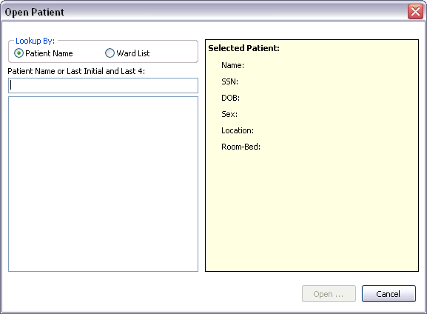
Figure 22

  - Type the patient‘s last initial followed immediately by the last four digits of the patient‘s SSN or type at least three characters of the patient‘s last name into the field below the label ―Patient Name or Last Initial and Last 4.‖
As soon as three characters are entered, the listview below the Patient Name field automatically displays names starting with the letters you entered. As you enter more characters, the display automatically updates to reflect the changes.
Note: To enter all or part of the patient‘s first name, type a comma after the last name and then start typing the first name without typing a <Space> in between.
  - Highlight a name in the listview, then click Open or press <Enter>. The Open Patient window closes and the main screen of the Clinical Flowsheets application displays in the foreground. The Flowsheet screen displays first by default.

Note about keyboard accessibility: You can highlight a name a couple of different ways: Click it with the mouse.
Press <Tab> to move cursor focus from the Patient name field to the name display listview. Use the <Up> and <Down> arrow keys to highlight a patient, then press
<Enter> to select it.
Note about clicking Cancel: An opened patient record is released as soon as you click Open Patient. That means that if you were already working on a patient‘s record and clicked Open Patient, and then you clicked Cancel, you return to the main screen with no patient selected.
To launch the Open Patient window from any other CP Flowsheets screen, click the Open Patient button, found on every Flowsheets screen, or select Open Patient from the File menu.
The shortcut combination is <Ctrl> + <O>.

Flowsheet Workflows

Choosing a Flowsheet
After you have selected a patient and the main CP Flowsheets screen displays, you must select a flowsheet before you can proceed.
A flowsheet is a predefined layout of one or more flowsheet views where you enter and view observation data. The figure below shows Flowsheet: ICU Monitoring with two flowsheets views, named Vitals and Input.

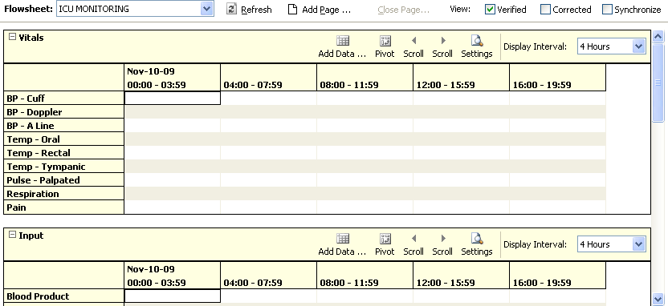
Figure 23
The flowsheet and flowsheet view layouts are configured by a designated flowsheet coordinator using the companion CP Console application. Flowsheet configuration allows you to define the following items:
Title – each defined flowsheet has a title Type of data contained in the flowsheet view Default display units
To select a flowsheet, do the following:

    - Select one of the Flowsheets from the drop-down list. The screen displays the selected flowsheet layout (see figure below).

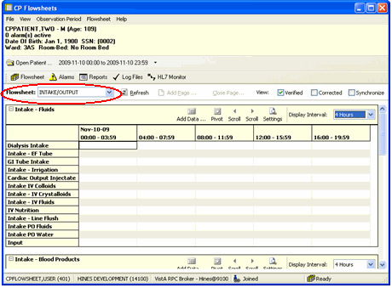

Figure 24

Setting the Date Range
The date range is used to determine how much information is available for display on the screen. There are three ways to set the date range, as described below.

Setting the Date Range—Observation Period Menu Method
The date range can be set from any tab by using the Observation Period menu (see figure below). This method is described in section ―2.1.1.4 Observation Period Menu.‖
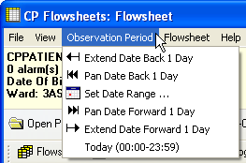
Figure 25

Setting the Date Range—Date Range Selector Method
      - From the Observation Menu, click Set Date Range. The Date Range Selector window displays (see figure below).
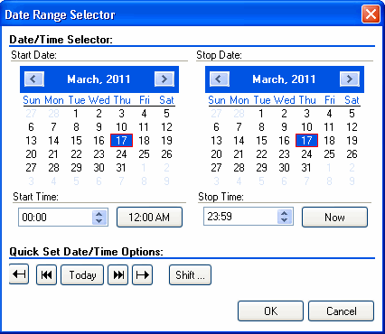
The default Start Date/Time is the current date (March 16, 2011/00:00 AM, as shown in the example below). The default Stop Date/Time is the current date (March 16, 2011/23:59 PM). Once you change the date range, CP Flowsheets remembers the date/time, even if you switch screens. Once you close CP Flowsheets and then restart the application, the date range resets to the default.
Figure 26
      - Choose the Start Date and Stop Date. The Date Range Selector works as follows:
Click the Left Arrow or Right Arrow buttons (on the blue background, flanking the month and year) to select the month.
Figure 27
Click a day of the month from the calendar.
Select the Start/Stop Time from the time control. (Press <Tab> to highlight the hour, then use the <Up> and <Down> arrow keys or your mouse to adjust the hour. You may also type the time using the keyboard. Press the <Right> arrow key to move your cursor focus to set the minutes, then press the <Right> arrow key again to move your cursor focus to select AM or PM.
Note: Three Quick Set buttons exist for setting the time:

12:00 AM: Set the Start Time to midnight.
Now: Set the Stop Time to the current time.
Shift: Set time by selecting a shift from a list (defined in CP Console).
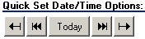Quick set buttons allow you to set the date:
Figure 28
Extend Date Back 1 Day: Start Date moves one day earlier. Stop Date stays the same.
Pan Date Back 1 Day: Start Date and Stop Date both move one day earlier.
Today: Set the Start Date and Stop Date to today‘s date, set the Start Time to 12:00 AM (midnight), and set the Stop Time to 23:59 PM.
Pan Date Forward 1 Day: Start Date and Stop Date both move one day later.
Extend Date Forward 1 Day: Start Date stays the same. Stop Date moves one day later.
Click OK. The Date Range Selector and the Date Range display area and the flowsheets are updated.

Setting the Date Range—Drop-down List Method
The date display (see the figure below) contains a drop-down list that allows you to adjust the date range without using the Date Range Selector.
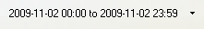
Figure 29
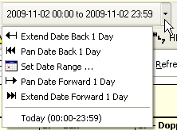
      - Click the drop-down arrow to the right of the date display. A drop-down list displays options (see the figure below) similar to the Quick set buttons described above.
Figure 30

      - Click an option to adjust the date range.
Extend Date Back 1 Day: Start Date moves one day earlier. Stop Date stays the same.
Pan Date Back 1 Day: Start Date and Stop Date both move one day earlier.
Set Date Range: Display the Date Range Selector.
Pan Date Forward 1 Day: Start Date and Stop Date both move one day later.
Extend Date Forward 1 Day: Start Date stays the same. Stop Date moves one day later.
Today: Set the Start Date and Stop Date to today‘s date, set the Start Time to 12:00 AM (midnight), and set the Stop Time to 23:59 PM.
Note: all totals in the flowsheet are based on the time period in the flowsheet Date Range Selector.

Adding/Editing Flowsheet Data (Manually)
Since not all data will come directly from Instruments, some data will need to be entered manually. To add data manually, do the following:

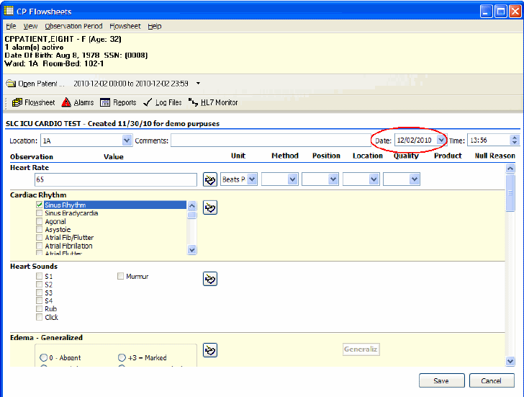
    - Click Add Data for a specific flowsheet view. The data entry screen displays.
Figure 31
    - Select a location code/abbreviation from the Location drop-down. This is a required field. This may be pre-populated if a default location was defined under the User Setting option. (See ―10. User Settings.‖)
    - Optionally enter comments in the Comment field.
    - The value in the Date field defaults to today‘s date. You can change it by selecting a new date from the drop-down calendar or by typing directly into the field.
If you select a date in the future, the following dialog appears:

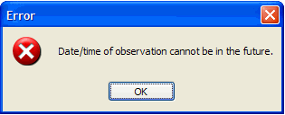

Figure 32

Note: Press <Tab> to place cursor focus in the field. Revise the date using the keyboard numbers or arrow keys.

    - The value in the time field defaults to the current time. You can change it by typing directly into the field.
Note: Press <Tab> to place cursor focus in the field. Revise the date using the keyboard numbers or arrow keys.

    - Enter data values into the observation fields and select appropriate qualifiers from the drop-down lists.
Note: Different observations have different related qualifiers. Qualifier fields without drop-down lists are predefined and may not be edited. Flowsheets can be customized to display default qualifiers using CP Console. Here is a partial list of available qualifiers.
Unit (f=degrees Fahrenheit, c=degrees Celsius, bpm=beats per minute, rpm=respirations per minute, etc.)
Method (Cu=cuff BP, Dop=Doppler BP, etc.) Position (Ly=lying, Si=sitting, St=standing, etc.)
Location (La=left arm, LL=left leg, RA=right arm, RL=right leg, etc.) Quality (A=accurate, E=Estimated)
Product Null Reason
    - Click Save to store the data, or click Cancel to exit without saving. Once you click Save,
the data displays on the flowsheet.
Note: Data entered by a user with the MD TRAINEE (for example, nursing student, preceptee) key does not display on the flowsheet until it has been verified (on the Log Files tab) by any user who was not assigned the MD TRAINEE key.

Optional and Supplemental Pages
Optional and Supplemental Pages are flowsheet views that can be added at the discretion of the user to help track a specific condition in its own section of a flowsheet.
An Optional Page differs from a Supplemental Page because an Optional Page can display only once.
For example, if a patient has a pressure wound that needs to be closely monitored, you can open a Supplemental Page for that pressure wound so that you can record data related specifically to that wound.
If the patient develops additional pressure wounds, you can add a Supplemental Page for each wound.
Once a pressure wound heals and no longer requires close monitoring, you can close its respective page while leaving the other supplemental pages open.
Likewise, if a patient has a pacemaker, you can open an Optional Page to record data related to it. Since a patient would never have more than one pacemaker, you would never need to add more than one of the same Optional Page.
Note: For example, if the [pacemaker; example topic provided] is discontinued and the optional view happens to be closed by a user, the historical documentation on [pacemaker] is no longer available in the flowsheet view. Having a closed [pacemaker] optional view also means that [pacemaker] documentation cannot be included in a new CPRS note. The [pacemaker] flowsheet data for a closed optional view are viewable through the Log Files tab where one would need to set the applicable date range for viewing that historical data. The closed optional view [pacemaker] could be re-opened to make data viewable on the Flowsheet tab and accessible to be included in a new CPRS note.
Note: The CP Flowsheet Coordinator must take the above view behavior into consideration before creating Optional views. Consider whether or not the topic [pacemaker documentation] can be managed well by creating it as a Supplemental view.
In order to add an Optional or Supplemental page to a flowsheet, it must first be defined as part of that particular flowsheet. Flowsheets are defined using the CP Console application. For information about adding Optional or Supplemental pages to a flowsheet, refer to the Clinical Procedures (CP) V1.0 Flowsheets Module Implementation Guide.
Note: If you use CP Console to change an existing Optional or Supplemental Page (i.e., one that has already been used for a patient), the changes will not be reflected on the Flowsheet tab. Those changes will appear on any newly-created Optional or Supplemental pages.

Adding Optional or Supplemental Pages
To add Optional or Supplemental views, complete the following steps:

      - At the Flowsheet tab, click the Add Page button. The Flowsheet Page Management window displays.
Note: If the Add Page button is inactive, it means no Optional or Supplemental pages have been defined for the currently-selected flowsheet. Select a flowsheet that has Optional or Supplemental pages defined, or request that the designated flowsheet coordinator edit the desired flowsheet to allow for the addition of Optional or Supplemental pages.
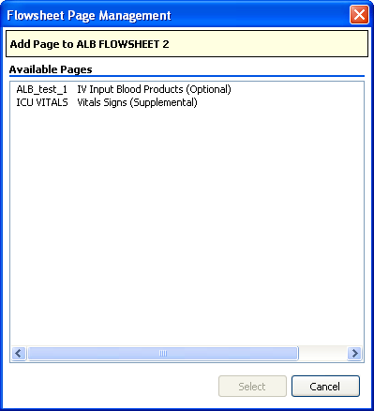
Figure 33

      - Double-click the desired page from the list (or click it, then click the Select button). The Add Page window displays.

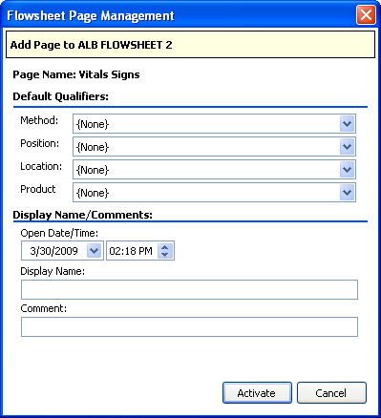

Figure 34
      - Select Default Qualifiers, if desired.
      - Select the starting Date/Time. Also note the relevant ―start‖ time.
      - Enter the Display Name and a Comment. Both of these fields are required. Note: This is the only area of Flowsheets where comment is a required field
      - Click Activate. The New Flowsheet Page window closes and the flowsheet reloads to display the Optional or Supplemental Page.

How to Close an Optional or Supplemental View
Caution: When an OPTIONAL view is closed, the data is no longer viewable nor is the data available for sending to a report (TIU progress note). You would have to reopen the OPTIONAL view in order to access the data. This suggests there are limited utilization of optional views. Be careful with configuring optional views! Never close an optional view!
Once you have created your Optional or Supplemental page (or view), you can easily close it. To close an optional or supplemental view, complete the following steps:
      - From the Flowsheet menu, you will see a list of Optional and Supplemental pages currently open.
      - Select Close Page.
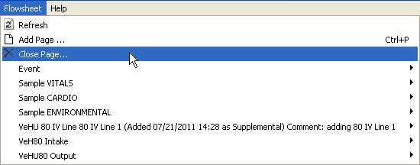
Figure 35
The Close Supplemental/Optional Page dialogue appears.

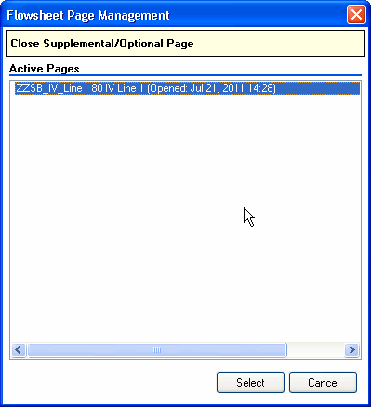

Figure 36
      - Click on the active page, and click Select.

The Close Supplemental page dialogue appears.
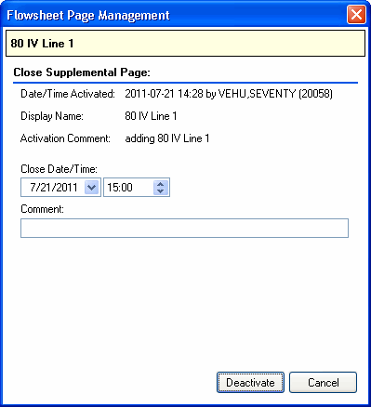
Figure 37
      - Click Deactivate.
Note: you must enter a comment first.
You will still see the supplemental page listed from the Flowsheet menu. The item will now note the date it was closed, as well as the comment associated with it.
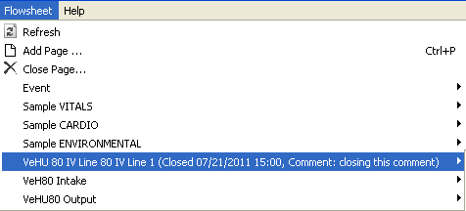
Figure 38

This page intentionally left blank for double-sided printing.

Alarms Screen
An alarm allows you to display a visual warning when an observation reaches a certain threshold. For
example, you can define an alarm to display when a patient‘s temperature rises above a certain level, or when a BP drops below a certain rate.
Note: Alarms are not tracked or audited. Any alarm you create affects the currently- selected patient ONLY. It will not apply to other patients in the ward. If you want an alarm to affect more than one patient, you must define an alarm for each patient.
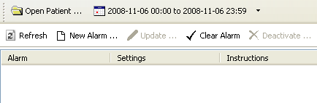CP Flowsheets does not come with predefined alarms, so the Alarm list is blank until you define some alarms.
Figure 39

Setting an Alarm
To set an alarm, do the following:

    - Click the Alarms button. The Alarms screen displays.
    - Click New Alarm. The Flowsheet Alarms window displays (see figure below).

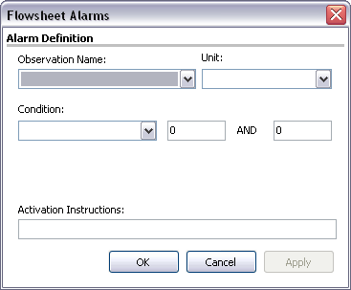

Figure 40
    - Select the type of observation from the Observation Name drop-down.
Note: This drop-down contains many items. You can click in the Observation Name field and then use the Cursor Up/Down arrows to scroll through the list. If you know the name of the item you want, click in the Observation Name field and then start typing the Observation Name to jump to the item.
    - Select the Unit, if there is more than one choice in the drop-down.
    - Select a condition from the Condition drop-down, then select appropriate modifiers from the fields to the right..
Note: The available options vary depending on the Observation Name that was selected. Here are examples of some of the available types of conditions and their modifiers:
Condition: Value BETWEEN
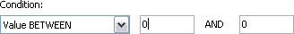
Modifiers: Enter low and high numeric values (see figure below).
Figure 41
Condition: Value NOT BETWEEN
Modifiers: Enter low and high numeric values (see figure below).
Figure 42
Condition: Value GREATER THAN

Modifiers: Enter a numeric value (see figure below).
Figure 43
Condition: Value LESS THAN
Modifiers: Enter a numeric value (see figure below).
Figure 44
Condition: Value IN LIST
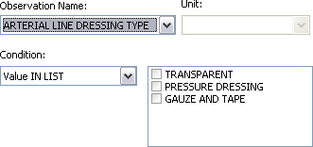Modifiers: Check one or more box from the modifiers list (see figure below).
Figure 45
Condition: Value EQUALS
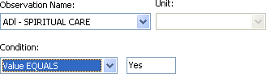
Modifiers: Enter a string, such as YES (see figure below).
Figure 46
Condition: Value does NOT EQUAL
Modifiers: Enter a string, such as YES (i.e., the answer is NO).

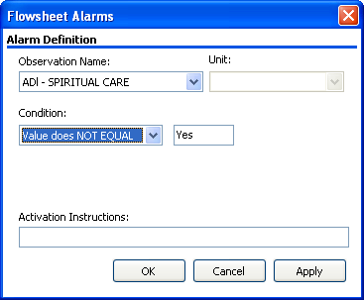

Figure 47

    - Type the alarm message in the Activation Instructions field. This is the message that will display when the alarm is triggered.
    - Click OK (see figure below). The Flowsheet Alarms window closes. You return to the Patient Alarms screen and the alarm you just defined displays in the list.

Updating an Alarm
As the patient‘s condition changes, you may edit or deactivate the alarm. To edit an alarm, do the following:

      - At the Patient Alarms screen, click the row of the alarm to be changed, then click Update. The Flowsheet Alarms window displays.
Shortcut: Double-clicking the Alarm row displays the Flowsheet Alarms window.
      - You may change any active fields.
      - Click OK. The Flowsheet Alarms window closes and the Patient Alarms screen displays.

Clearing an Alarm
When an alarm goes off, a Confirm pop-up window displays. The window looks similar to the following:

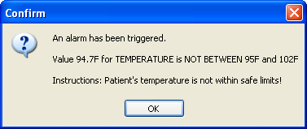
Figure 48

The Information message contains three main pieces of information:
The first line is a standard message: An alarm has been triggered!
The next information contains the value which triggered the alarm, as well as a description of the alarm.
The last piece of information is the instruction to the user that was written at the time that the alarm was created.
Click OK to close the Information window, but be aware that the alarm still isn‘t cleared. Note that the icon on the Alarms button is now red instead of yellow. That is another indicator that an alarm was triggered.
Figure 49

To clear the alarm, you must do the following:

      - Click the Alarms button to display the Patient Alarm screen. The red Alarm icon displays to the left of the alarm that was triggered.
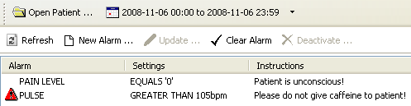
Figure 50

      - Click the alarm row to select it, then click Clear Alarm. The red Alarm icon clears.

Deactivating an Alarm
When an alarm is no longer needed, it can be deactivated. A deactivated alarm no longer displays in the CP Flowsheets application.
To deactivate an alarm, do the following:

      - Click the Alarms button. The Patient Alarms screen displays.
      - Click the row of the alarm to delete.

Note: Press <Ctrl> + click to multi-select alarms.
      - Click the Deactivate button. A pop-up window displays.

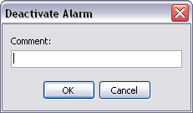

Figure 51
      - Enter a note into the Comment field, then click OK. This is a required field. The pop-up window closes and the deactivated alarm has been removed from the Alarm list.

Reports Screen
Use the Reports Screen to print data reports and submit TIU Progress Notes. Reports are based on your predefined flowsheets and they print the same information that is displayed on the Flowsheet screen.
Note: The items in the Flowsheet drop-down list on this screen are identical to those in the Flowsheet drop-down list on the Flowsheet tab.

Printing a Report
To print a report, do the following:

    - Click the Reports button. The Report screen displays.
    - Choose a report layout from the Flowsheet drop-down list.
    - 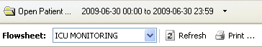To change the Date Range, click the date range or select Set Date Range from the Observation Period menu.
Figure 52
    - Click Refresh to display recently-added data.
    - Check the Include Comments box to display comments added during manual data entry.
    - Review the data in the report. Header information displays at the top of the report, including Flowsheet name, date range, patient information, page number, location, and the date/time that the Report button was clicked. Below that, each flowsheet view displays in its own section (see figure below).
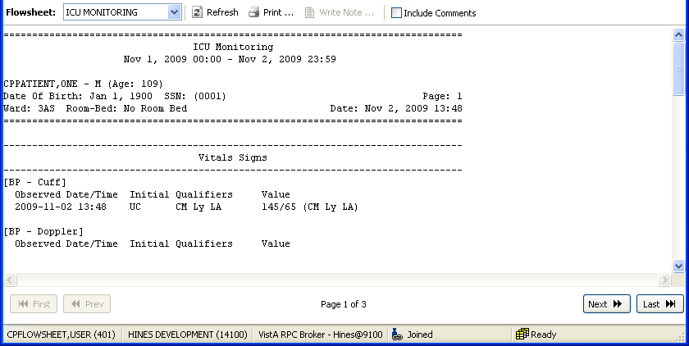
Figure 53

    - Click Print to display the standard Print dialogue.
Note: Each field defined in the selected flowsheet will print, even when no data is available for that particular observation. For example, the figure below shows values for a ―BP - Cuff‖ observation, but ―BP – Doppler‖ is followed by a blank line, indicating a lack of data for that observation category.
    - Select your printer, make any other desired changes on the Print dialogue, then click OK. The report prints.

Writing a TIU Progress Note
The Write Note button on the Reports screen allows you to submit a TIU Progress Note that displays on the CPRS Notes screen. The TIU Progress Note contains the full text of the selected report, along with additional notes.
To submit a TIU Note, complete the following steps:

    - Click the Reports button. The Report screen displays.
    - Choose a report layout from the Flowsheet drop-down list.
    - To change the Date Range, click the date range or select Set Date Range from the Observation Period menu.
    - Click Refresh to display recently-added data.
    - Check the Include Comments box if you want the TIU Progress Note to include comments added during manual data entry.
    - Review the data in the report. Header information displays at the top of the report, including flowsheet name, date range, patient information, and the date/time that the Report button was clicked. Below that, each flowsheet view displays in its own section.

Reports Screen

    - Click Write Note. The CP Note Writer screen displays.
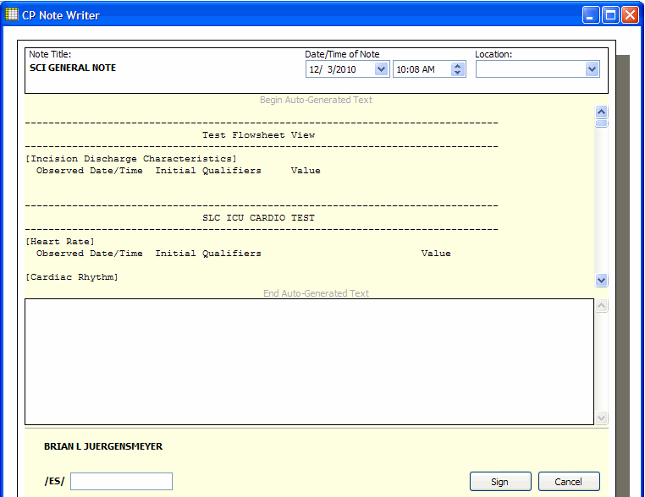
Figure 54

    - Optionally, type a note in the large white field towards the bottom of the CP Note Writer screen. This note will display at the bottom of the TIU Note.
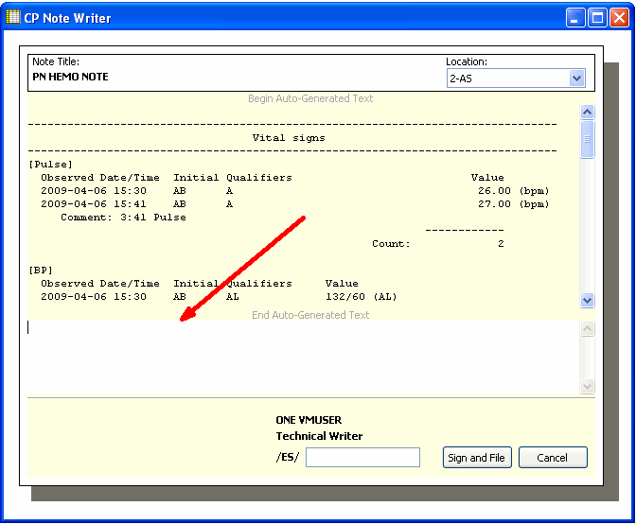
Figure 55

    - Enter your electronic signature in the /ES/ field, then click Sign and File. A popup information window displays the message, ―TIU Document has been signed and filed.
    - Click OK to close the information window. The CP Note Writer window closes. You may view the TIU Note in CPRS on the Notes tab.

Log Files Screen
You can use the Log Files screen to review data, delete unneeded records, and verify unverified data.
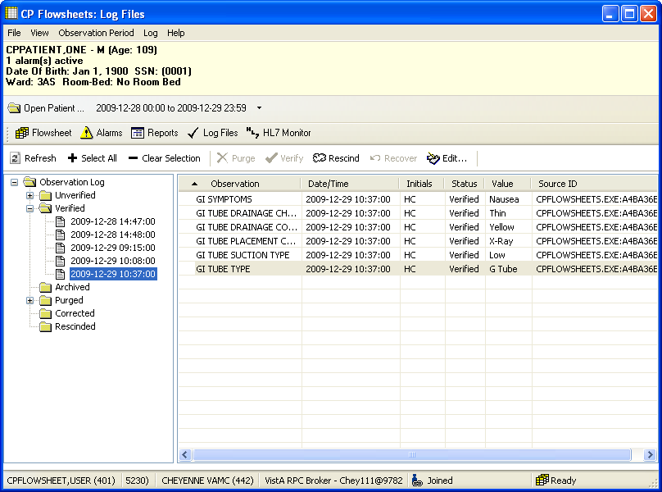
The Log Files screen contains two main panels. The left-hand panel displays the Observation Log treeview, which is used to select the data type and the date/time at which the data was entered. The right- hand panel displays detail information for the data selected in the Observation Log treeview. The detail includes observation type, date/time, initials of the user who entered the data, data status, and observation value.
Figure 56

Reviewing Log File Data
To review data, do the following:

    - Select a patient.
    - Select the desired date range.
    - 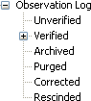Select the Log Files.. The Observation Log treeview (on the left-hand side of the screen) lists the different data types: unverified, verified, archived, purged, corrected, and rescinded. A plus sign (+) displays left of a data type when data of that type is available for review.
Figure 57
    - In the Observation Log treeview, double-click one of the data types (or click its plus sign). That treeview node expands to display the dates and times for which data is available for review.
Note: If you do not see the date(s) you are looking for, make sure that you selected the correct date range.

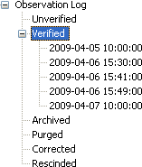
Figure 58
    - In the Observation Log treeview, click a date/time. Observation data matching the selected type, date, and time display in the detail panel to the right, for your review.
Note: There may be delays with data display in cases where large quantities of data are received from the instrument.

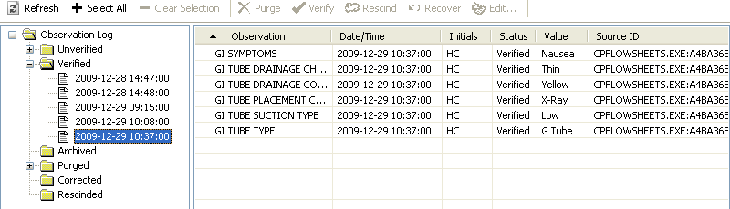
Figure 59

Verifying Data
Data becomes verified after a person looks at it, determines it to be valid data, and then marks it as verified. Unverified data—data which comes from an untrusted device or which was manually entered by a user who was assigned the MD TRAINEE key—will not go directly from the source to the flowsheet views. Instead, it will sit in a queue on the Log Files in an unverified folder until a user (who does not have the MD TRAINEE key assigned) reviews it and marks it as verified.
Note: Data that was entered manually by a user who does not have the MD TRAINEE key is automatically considered verified data. It displays in the flowsheet as soon as it is saved. Data entered by a user with the MD TRAINEE key does not display on the flowsheet until it has been verified (within the Log Files) by any user who was not assigned the MD TRAINEE key.
To verify data, do the following:
    - Select a patient.
    - Select the desired date range.
    - Click Log Files.
    - In the Observation Log treeview, double-click Unverified. If any unverified data exists, the dates/times of entry display below the Unverified treeview node. Click a date/time to display the unverified data in the detail listview. The listview contains the following headings:
Observation Date/Time Initials Status Value Source ID
    - Review the data to determine which you wish to keep and which you wish to discard.
Note: At any time you may click Refresh to check for recent data.
    - Select the desired records in one of the following ways:

<Ctrl> + click to multi-select items.
Click Select All to select each record in the list. Click Clear Selection to deselect all records.
    - Click Verify to mark the selected data as trusted and move it onto the flowsheet views.

Purging Data
You can purge unverified data to prevent it from displaying on the flowsheet and becoming a part of the patient‘s permanent medical record.
To purge data, do the following:

    - Select a patient.
    - Select the desired date range.
    - Click Log Files.
    - In the Observation Log treeview, double-click Unverified. If any unverified data exists, the dates/times of entry display below the Unverified treeview node. Click a date/time to display the unverified data in the detail listview. The listview contains the following headings:
Observation Date/Time Initials Status Value Source ID
    - Review the data to determine which you wish to keep and which you wish to discard.
Note: At any time you may click Refresh to check for recent data.
    - Select the desired records in one of the following ways:
<Ctrl> + click to multi-select items.
Click Select All to select each record in the list. Click Clear Selection to deselect all records.
    - Click Purge to delete data you don‘t wish to keep.
    - A confirmation popup displays (see figure below). Click Yes to confirm.

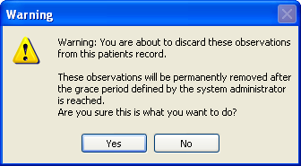

Figure 60

Rescinding Data
The Rescind function allows data to be hidden after it has already made it onto the flowsheet. This could be desirable if it has been determined that particular data was entered in error. Because the data is already a part of the patient‘s record, it cannot be permanently deleted. Rescinded data will no longer display on the patient‘s flowsheet, but a user with appropriate access rights can still review it in the Log Files.
A user may rescind data that he or she entered. A user can rescind data entered by someone else only if the user has the MD MANAGER or MD ADMINISTRATOR key. This is because Rescind will take an observation out of the permanent record after it has been verified and may have been reported in a TIU note or had clinical decisions made in regard to its value.
To rescind data, do the following:

    - Select a patient.
    - Select the desired date range.
    - Select the Log Files tab.
    - Use the Observation Log treeview to locate and select the data to be rescinded.
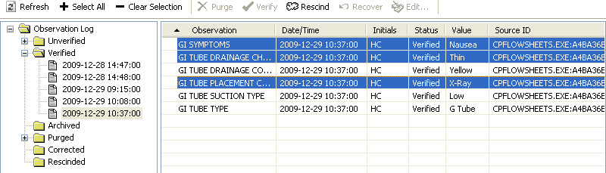Note: You can Ctrl + click to multi-select data.
Figure 61

    - Click the Rescind button.

Figure 62

    - A popup warning window displays. Click Yes to confirm the action.
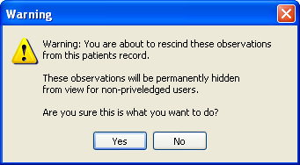
Figure 63
    - A popup window displays for your comment. Enter a reason for rescinding the data, then click

OK.
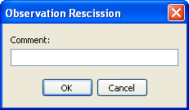
Figure 64
The popup window closes, and the data row is removed from the Verified node of the Observation Log treeview. The data row now displays under the Rescinded node of the treeview.

Recovering Data
Use the Recover function to restore unverified data that was purged.
Note: Purged data will be permanently removed after the grace period defined by the system administrator is reached. After that, the data can no longer be recovered. The system administrator defines the length of the grace period in CP Console, using the Background Task options. For more information, see the Clinical Procedures (CP) V1.0 Flowsheets Module Implementation Guide.
To recover purged data, do the following:
    - At the Log Files screen, expand the Purged node to display the dates/times of purged data that is still available to be recovered (see figure below).

Note: The dates/times listed indicate when the data was entered, not when it was purged.
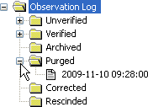
Figure 65
    - Select the date/time of the data to be restored. The observations display in the detail area to the right (see figure below).
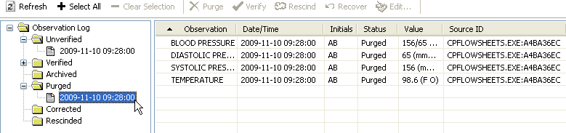
Figure 66
    - In the detail area (see figure below), select the observation(s) to be restored. Use <Ctrl> + click
to select multiple observations.
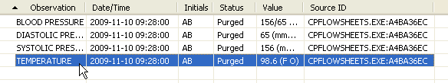
Figure 67
    - Click the Recover button. A Warning popup displays for you to confirm the restoration of the data (see figure below).
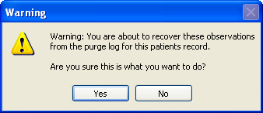
Figure 68

    - Click Yes to restore the data, or click No to cancel. Once data is restored, it returns to its original state of unverified data. It must be verified by a user without the MD TRAINEE key to display on the flowsheet.

HL7 Monitor Screen
The HL7 Monitor view is used to perform the following functions: match records to a patient
match records to an instrument view the original HL7 message resubmit a message
discard a message
Note: This option is available only for users with the MD ADMINISTRATOR and/or HL7 MANAGER keys. Users who do not have either one of those keys will not see the HL7 Monitor button.

Viewing HL7 Messages
To view the HL7 message of a particular data row, do the following:

    - Select a patient.
    - Click HL7 Monitor.
    - Highlight a single data row.
Note: This listview allows multi-selection of data rows; however, if you select more than one row, the View HL7 button is inactive.
    - Click one of the following buttons:
Refresh: Reload HL7 message data.
Get Patient: Match the record to a patient. (See below for instructions.)
Get Instrument: Match the record to an instrument. (See below for instructions.)
View HL7: Display the HL7 message text. To return to the HL7 Monitor screen, click the
HL7 Log button.
Note: You may also double-click the row to view the HL7 message.
Resubmit: Once you‘ve identified the instrument or patient or made changes to a mapping table, click Resubmit to reprocess the message.
Note: After you resubmit a message, its data displays in the appropriate flowsheet view, if the message was properly matched to a patient and an instrument.
Discard: Set the message status to processed and remove the message from the user‘s view. The message will be physically deleted later in a nightly cleanup job.

Matching Records to a Patient
In the event that the patient identifying information (PID) from the instrument doesn‘t match the PID information in the CP Flowsheets application, you can use the HL7 Monitor screen to match the data manually to a patient.
Note: Data which is not matched to a patient can be either verified or unverified.
To match records to patients, do the following:

    - Select a patient.
    - Click HL7 Monitor.
    - Highlight Select the desired record(s) as follows:
<Ctrl> + click to multi-select items.
Click Select All to select each record in the list. Click Deselect All to clear record selections.
    - 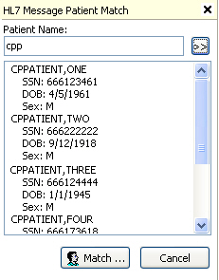Click Get Patient. The HL7 Message Patient Match search field displays.
Figure 69
    - Type at least one letter in the Patient Name field, then click the button with two right-facing arrows. The listview below the search field displays all names which match the search criteria.
Note: If your database is large, typing fewer letters will increase the length of the search.
    - Select a patient from the search list, then click Match. A confirmation window displays.
    - Click Yes. The confirmation window closes and the Patient Name list displays.
    - Repeat steps 3-7 as desired.

HL7 Monitor Screen

    - Once records have been matched, click Resubmit to reprocess the information.
    - A confirmation window pops up. Click Yes.

Matching Records to an Instrument
The workflow for matching records to an instrument is slightly different than that for matching records to a Patient.
Note: Data which is not matched to an instrument can be either verified or unverified.
To match records to an instrument, do the following:

    - Select a patient.
    - Click HL7 Monitor.
    - Highlight Select the desired record(s) as follows:
<Ctrl> + click to multi-select items.
Click Select All to select each record in the list. Click Deselect All to clear record selections.
    - Click Get Instrument. The HL7 Message Instrument Match area displays.
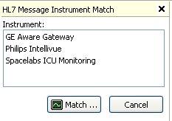
Figure 70
    - The list displays all available instruments.
    - Select an instrument from the list, then click Match.
    - A confirmation window pops up. Click Yes.
    - Repeat steps 3-7 as desired.
    - Once records have been matched, click Resubmit to reprocess the information.
    - A confirmation window pops up. Click Yes.

Discarding a Record
To discard a record, do the following:

    - Select a patient.
    - Click HL7 Monitor.
    - Highlight Select the desired record(s) as follows: <Ctrl> + click to multi-select items.
Click Select All to select each record in the list. Click Deselect All to clear record selections.
    - Click Discard. A confirmation window pops up.
    - Click Yes.

User Settings
CP Flowsheets allows the configuration of certain user settings (e.g., defaults, confirmations, and screen colors). This configuration occurs on the CP Flowsheets Settings window.
To access the CP Flowsheets Settings window, select User Settings from the File menu (or press <Ctrl>
+ <U>).

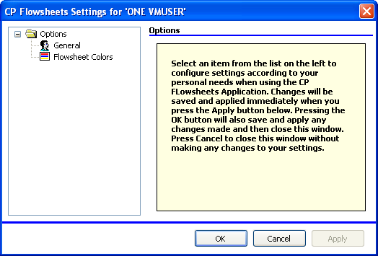
Figure 71
The image above shows the CP Flowsheets Settings window. The Options folder allows you access to the two Options areas: General and Flowsheet Colors.
Note: If the General and Flowsheet Colors items aren‘t visible, click the Plus Sign (+) to the left of the Options folder to expand the treeview.

Modifying General Settings
To modify General settings,
    - From the CP Flowsheets File menu, select General.
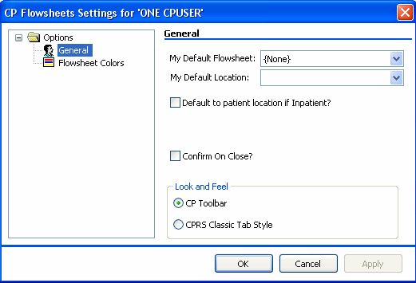
    - The area to the right of the treeview provides control over several general options (see below).
Figure 72
You can modify the following display options in the General and Look and Feel areas of this screen:
My Default Flowsheet: Choose the initial flowsheet when CP Flowsheets is launched. Choose {None} if you do not want to select a flowsheet automatically.
My Default Location: The location selected here defaults into the Location field when you click Add Data on the Flowsheet screen. This location also defaults into the Select Ward Location field on the Open Patient window.
Default to patient location if Inpatient?: Check the ―Default to patient location if Inpatient‖ checkbox if you want the Location drop-down list to automatically display a value when you manually add data to a flowsheet view. Clear the checkbox if you do not want the location to default in. Checking this box activates the next control.
Confirm on Close?: Check this box to display a confirmation popup before you exit out of the CP Flowsheets application.

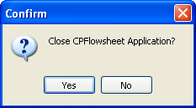

Figure 73
Look and Feel radio buttons: Select a radio button in this area to control the appearance of the toolbar buttons and screens (for example, Flowsheet, Alarms, Reports, Log Files, HL7 Monitor).
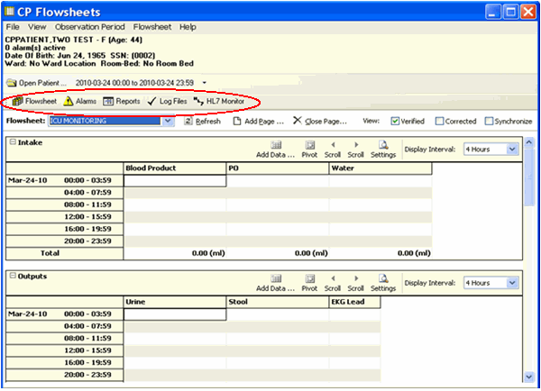
If you select the ―CP Toolbar‖ radio button, the tab buttons display in a row towards the top of the screen, below the Open Patient button. Click a button to change screen areas.
Figure 74

If you select the ―CPRS Classic Tab Style‖ radio button, the tabs display in a row along the bottom of the screen, just above the status line. This setting makes the application behave more like CPRS. Click a tab to change screen areas.

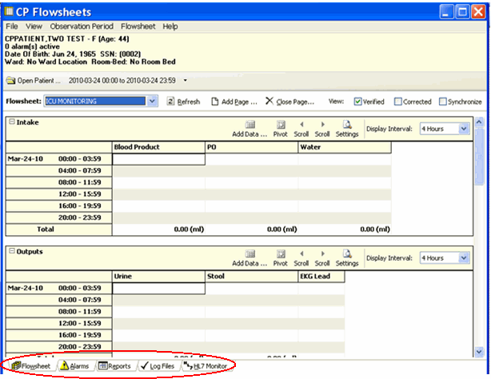

Figure 75
OK button: Click OK to apply changes and close the CP Flowsheets Settings window.
Cancel button: Click Cancel to discard changes and close the CP Flowsheets Settings window.
Apply button: Click Apply to save and implement changes without closing the CP Flowsheets Settings window.

Modifying Flowsheet Colors
This screen controls how observation values display on the flowsheet views. Observation values can be described at Low, Normal, or High, depending on the preset range specified for that particular term.
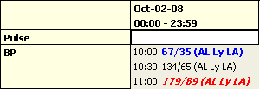
The image below demonstrates how these values can appear in a flowsheet view.
Figure 76
The 10:00 value is a low blood pressure, so the observation value, along with its qualifiers, display in bold blue text. The 10:30 value is normal, so it displays in normal black text. The 11:00 value is a high blood pressure, so it displays in bold, italicized red text.
To modify color settings, do the following:

    - Select User Settings from the File menu. The CP Flowsheets Settings window displays.
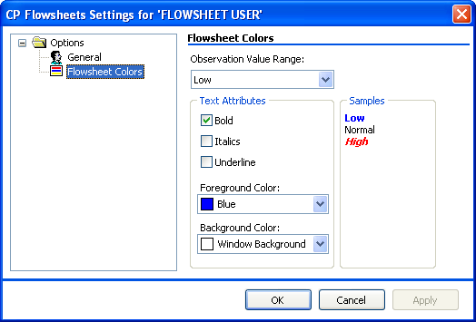
    - Click the Flowsheet Colors item on the CP Flowsheets Settings treeview. The detail area to the right of the treeview provides control over several options related to screen color.
Figure 77

    - From the Observation Value Range drop-down list, select the range to modify: Low, Normal, or High.
    - Use the controls in the Text Attributes area to modify the selected range. The following text attributes can be controlled using this screen:

Bold Italics
Underline
Foreground Color Background Color
As you change the text attributes, the labels in the Samples area change automatically to provide a preview.
    - Repeat steps 3 and 4 as needed to modify the other observation value ranges.

Appendix A – Access Key Listing
The following is a listing of access keys for the CP Flowsheets application.
Note: To use an Access Key, press <Alt>, release it, then press the designated Access Key.
To use a Shortcut Key, press and hold <Ctrl> or <Alt> (as indicated below), then press the designated Shortcut Key.

Screen | Option / Button Text | Access Key | Shortcut Key #1 | Shortcut Key #2
Flowsheet |  |  | Ctrl + F | Alt + F
 | File menu | F
 | Open Patient | O | Ctrl + O
 | User Settings | U | Ctrl + U
 | Break Link | B
 | Rejoin Context | R
 | Show CCOW Status | S
 | Exit | X | Ctrl + Q | Ctrl + X
 | View menu | V
 | Flowsheet | F | Ctrl + F
 | Alarms | A | Ctrl + A
 | Reports | R | Ctrl + R | Alt + E
 | Log Files | L | Ctrl + L
 | HL7 Monitor | H | Ctrl + H
 | Observation Period menu | O
 | Extend Date Back 1 Day | E
 | Pan Date Back 1 Day | P
 | Set Date Range | S
 | Pan Date forward 1 Day | A

Screen | Option / Button Text | Access Key | Shortcut Key #1 | Shortcut Key #2
 | Extend Date Forward 1 Day | X
 | Today (00:00-23:59) | T
 | Flowsheet menu | L
 | Refresh | R
 | Add Page | P | Ctrl + P
 | Close Page | C
 | Flowsheet Views: There will be a dynamic submenu for each active flowsheet view. | The access keys are automatically generated, as described in the Dynamic Menu section.  Expand the menus using the keyboard to display the access keys.
 | Flowsheet View submenus
 | Add Data | A
 | Pivot | P
 | Scroll Left | S
 | Scroll Right | C
 | Settings | E
 | Display Interval | D
 | Display Interval submenu | D
 | 1 Minute | 1
 | 2 Minutes | 2
 | 5 Minutes | 5
 | 10 Minutes | 0
 | 15 Minutes | M
 | 20 Minutes | I

Screen | Option / Button Text | Access Key | Shortcut Key #1 | Shortcut Key #2
 | 30 Minutes | 3
 | 1 Hour | H
 | 90 Minutes | 9
 | 2 Hours | O
 | 3 Hours | U
 | 4 Hours | 4
 | 6 Hours | 6
 | 8 Hours | 8
 | 12 Hours | R
 | 24 Hours | S
 | Help menu | H
 | Contents | C
 | About | A
 | View checkboxes
 | Verified | No shortcut keys. Press <Tab> to highlight a checkbox. Press  <Space> to check/uncheck it.
 | Corrected
 | Synchronize
Alarms |  |  | Ctrl + A
 | All other menus are the same as on the Flowsheet screen.
 | Alarms menu
 | Refresh | R
 | New Alarm | N
 | Update | U

Screen | Option / Button Text | Access Key | Shortcut Key #1 | Shortcut Key #2
 | Clear Alarm | C
 | Deactivate | D
Reports |  |  | Ctrl + R | Alt + E
 | All other menus are the same as on the Flowsheet screen
 | Reports menu | E
 | Refresh | R
 | Print | P
 | Write Note | W
 | First | F
 | Prev | E
 | Next | N
 | Last | L
 | Include Comments checkbox | Press <Tab> to highlight the  checkbox. Press <Space> to check/uncheck it.
Log Files |  |  | Ctrl + L
 | All other menus are the same as on the Flowsheet screen.
 | Log menu | L
 | Refresh | R
 | Select All | S
 | Clear Selection | C
 | Purge | P
 | Verify | V
 | Rescind | E

Screen | Option / Button Text | Access Key | Shortcut Key #1 | Shortcut Key #2
 | Edit | D
 | Print | I
HL7 Monitor |  |  | Ctrl + H
 | All other menus are the same as on the Flowsheet screen.
 | HL7 Monitor menu | L
 | Refresh | R
 | Get Patient | G
 | Get Instrument | E
 | View HL7 | V
 | Resubmit | S
 | Discard | D

This page intentionally left blank for double-sided printing.

Glossary
This glossary is used for the Clinical Flowsheets project and may include terms and definitions not used in this specific document.

Term | Description
<RET> | Carriage return.
Access Code | A unique sequence of characters known by and assigned only to the user, the system manager and/or designated alternate(s). The access code (in conjunction with the verify code) is used by the computer to identify authorized users.
Action | A functional process that a clinician or clerk uses in the TIU computer program. For example, ―Edit‖ and ―Search‖ are actions. Protocol is another name for Action.
ADP | Automated Data Processing
ADP Coordinator/- ADPAC/Application Coordinator | Automated Data Processing Application Coordinator. The person responsible for implementing a set of computer programs (application package) developed to support a specific functional area such as clinical procedures, PIMS, etc.
ADT | Advanced Data Type (InterSystems Cache). Also Admissions, Discharges, Transfers.
AP | Arterial pressure
API | Application Programming Interface. An interface that a computer system, library, or application provides in order to accept requests for services from other programs, and/or to allow data to be exchanged between them.
Application | A system of computer programs and files that have been specifically developed to meet the requirements of a user or group of users.
Archive | The process of moving data to some other storage medium, usually a magnetic tape, and deleting the information from active storage in order to free-up disk space on the system.
Assessment | Assessment is the documentation of a clinician‘s observations and interpretation of a patient‘s clinical state based on a particular set of observations. The documentation is in the form of name-value pairs with values selected from a predetermined set, of name-value pairs in which the value is a number or set of numbers, or of free text.  Examples of assessments from paper ICU flowsheets are coma scale, patient opens eyes, pupil size, reaction to light, and so on.
ASU | Authorization/Subscription Utility. An application that allows sites to associate users with user classes, allowing them to specify the level of authorization needed to sign or order specific document types and orderables. ASU is distributed with TIU in this version; eventually it will probably become independent, to be used by many VistA packages.
Attachments | Attachments are files or images stored on a network share that can be linked to the CP study. CP is able to accept data/final result report files from automated instruments.  The file types that can be used as attachments are the following:  .txt - Text files  .rtf - Rich text files  .jpg - JPEG Images  .jpeg - JPEG Images  .bmp - Bitmap Images  .tiff - TIFF Graphics (group 3 and group 4 compressed and uncompressed types)  .pdf - Portable Document Format  .html - Hypertext Markup Language  .DOC (Microsoft Word) files are not supported. Be sure to convert .doc files to .rtf or to .pdf format.

Term | Description
Background Processing | Simultaneous running of a "job" on a computer while working on another job. Examples would be printing of a document while working on another, or the software might do automatic saves while you are working on something else.
Background Task | A job running on a computer while simultaneously working on a second job.
Backup Procedures | The provisions made for the recovery of data files and program libraries and for restart or replacement of ADP equipment after the occurrence of a system failure.
Boilerplate Text | A pre-defined TIU template that can be filled in for Titles, Speeding up the entry process. TIU exports several Titles with boilerplate text which can be modified to meet specific needs; sites can also create their own.
BP | Blood Pressure.
Broker | Software which mediates between two objects, such as a client and a server or a repository and a requestor.
Browse | Lookup the file folder for a file that you would like to select and attach to the study. (e.g., clicking the ―...‖ button to start a lookup).
Bulletin | A canned message that is automatically sent by MailMan to a user when something happens to the database.
Business Rule | Part of ASU, Business Rules authorize specific users or groups of users to perform specified actions on documents in particular statuses (e.g., an unsigned CP note may be edited by a provider who is also the expected signer of the note).
CAC | Clinical Application Coordinator.
Care Action | Care action is an intervention scheduled on a patient that may or may not be ordered.
CCB | Change Control Board.
CCDSS | Clinical Care Delivery Support System.
CCOW | Clinical Context Object Workgroup. An HL7 standard protocol through which applications can synchronize in real-time, enabling Single Sign On and Context Management.
CDR | Clinical Data Repository.
CIS | Clinical Information System. An ICU Clinical Information System is any hardware/software system that works in concert to collect, store, display, and/or enable manipulation of potential, clinically relevant information. A CIS also acts as an HL7 Gateway. Vendors of monitors and other instruments used in an ICU provide the CIS. The primary distinguishing feature of this CIS is its ability to manually select a subset of all available data and send it to the EMR.
Class | Part of Document Definitions, Classes group documents. For example, ―CLINICAL PROCEDURES‖ is a class with many kinds of Clinical Procedures notes under it. Classes may be subdivided into other Classes or Document Classes. Besides grouping documents, Classes also store behavior which is then inherited by lower level entries.
Clinical Flowsheets | A module of the Clinical Procedures package that allows the collection of discrete data from medical devices or a Clinical Information System. It is a complete HL7 standardized instrument interface developed and owned by the Department of Veterans Affairs. This module is comprised of three components: the CP Flowsheets application, the CP Console application, and the CliO Generic Interface.
Clinical Reminders | A system which allows caregivers to track and improve preventive healthcare and disease treatment for patients and to ensure timely clinical interventions.
CliO | Clinical Observations database.
CM | Configuration Management.

Term | Description
Consult | Referral of a patient by the primary care physician to another hospital service/ specialty, to obtain a medical opinion based on patient evaluation and completion of any procedures, modalities, or treatments the consulting specialist deems necessary to render a medical opinion.
Contingency Plan | A plan that assigns responsibility and defines procedures for use of the backup/restart/recovery and emergency preparedness procedures selected for the computer system based on risk analysis for that system.
CP | Clinical Procedures.
CP Console | An application used by Administrators to configure the CP Flowsheets application and its interface settings.
CP Definition | CP Definitions are procedures within Clinical Procedures.
CP Flowsheets | A GUI component of the Clinical Flowsheets package. Its primary functions are to provide a means to display data collected from a medical device and to allow manual entry of data. Additional functionality is provided to display and print reports, verify incoming observational data, add comments, correct erroneous information, and submit TIU Progress Notes to CPRS.
CP Gateway | The service application that prepares the data contents of HL7 messages for use in CP Hemodialysis. It requires no direct user interaction.
CP Manager | The CP Manager application is no longer supported after the installation of MD*1.0*16; it has been superseded by. CP Console.
CP Study | A CP study is a process created to link the procedure result from the medical device or/and to link the attachments browsed from a network share to the procedure order.
CPRS | Computerized Patient Record System. A comprehensive VistA program, which allows clinicians and others to enter and view orders, Progress Notes and Discharge Summaries (through a link with TIU), Problem List, view results, reports (including health summaries), etc.
Data Dictionary | A description of file structure and data elements within a file.
DBIA | Database Integration Agreement.
Delphi | A programming language, also known as Object Pascal.
Device | A hardware input/output component of a computer system (e.g., CRT, printer).
Display Interval | The amount of time that displays in each column of a flowsheet view. Display interval is configurable from 1 minute to 24 hours. Shorter interval settings can improve readability when a large amount of data is received over a short period of time. Longer interval settings allow you to view longer periods of time while reducing the amount of horizontal scrolling necessary to view all columns.
DLL | Dynamically Linked Library. These files provide the benefit of shared libraries.
DOB | Date of Birth.
Document Class | Document Classes are categories that group documents (Titles) with similar characteristics together. For example, Cardiology notes might be a Document Class, with Echo notes, ECG notes, etc. as Titles under it. Or maybe the Document Class would be Endoscopy Notes, with Colonoscopy notes, etc. under that Document Class.
Document Definition | Document Definition is a subset of TIU that provides the building blocks for TIU, by organizing the elements of documents into a hierarchy structure. This structure allows documents (Titles) to inherit characteristics (such as signature requirements and print characteristics) of the higher levels, Class and Document Class. It also allows the creation and use of boilerplate text and embedded objects.
DUZ | Designated user. This is the internal FileMan number for a particular user.
Edit | Used to change/modify data typically stored in a file.

Term | Description
EMR | Electronic Medical Record. HealtheVet, is the permanent medical record for a patient in VistA
Field | A data element in a file.
File | The M construct in which data is stored for retrieval later. A computer record of related information.
File Manager or FileMan | Within this manual, FileManager or FileMan is a reference to VA FileMan. FileMan is a set of M routines used to enter, edit, print, and sort/search related data in a file, a database.
File Server | A machine where shared software is stored.
Flowsheet | A flowsheet is a table, chart, spreadsheet, or other method of displaying data on two axes. One axis represents time intervals and the other axis represents the readings from an ICU monitor documented at the various time intervals.
Flowsheet view | A customizable subsection (or page) of a flowsheet. Flowsheet views are created by adding and arranging terms and choosing their default qualifiers. Flowsheet views can be set up to display observations, provide a way to manually enter observations, and display reports.
Fluid off | Cumulative volume of fluid removed from patient.
Gateway | The software that performs background processing for Clinical Procedures.
Global | An M term used when referring to a file stored on a storage medium, usually a magnetic disk.
GUI | Graphical User Interface. A Windows-like screen that uses pull-down menus, icons, pointer devices, and other metaphor-type elements that can make a computer program more understandable, easier to use, allow multi-processing (more than one window or process available at once), etc.
HDR | Health Data Repository.
HEP (CUM) | Cumulative heparin infusion
HFS | Host File System.
HIPAA | Health Insurance Portability and Accountability Act.
HL7 | Health Level 7. A language which various healthcare systems use to interface with one another.
HL7 Gateway | Hardware or software provided by a vendor that is able to receive information in a  vendor‘s proprietary format from one or more ICU monitors and other instruments, to translate the data into standardized HL7 message format, and to pass the messages to other systems.
HR | Heart Rate.
HSD&D | Office of Information (OI), Health Systems Design & Development.
HSITES | Health Systems Implementation, Training, Education, and Support.
ICU | Intensive Care Unit.
IEN | Internal Entry Number.
IJ | Internal Jugular.
Instrument | An instrument is a device used to perform a medical function on a patient. In Clinical Flowsheets instrument refers to ICU monitors, which are electronic devices that collect and/or display information concerning the physical state of a patient. Usually, the monitor attaches to a patient and takes readings over time without requiring intervention for each reading.

Term | Description
Interpreter | Interpreter is a user role exported with USR*1*19 to support the Clinical Procedures Class. The role of the Interpreter is to interpret the results of a clinical procedure.  Users who are authorized to interpret the results of a clinical procedure are sent a notification when an instrument report and/or images for a CP request are available for interpretation. Business rules are used to determine what actions an interpreter can perform on a document of a specified class, but the interpreter themselves are defined by the Consults application. These individuals are ‗clinical update users‘ for a given consult service.
IRM | Information Resource Management.
IRMS | Information Resource Management Service.
JCAHO | Joint Commission on Accreditation of Healthcare Organizations.
Kernel | A set of software utilities. These utilities provide data processing support for the application packages developed within the VA. They are also tools used in configuring the local computer site to meet the particular needs of the hospital. The components of this operating system include MenuMan, TaskMan, Device Handler, Log-on/Security, and other specialized routines.
Key | A level of access assigned to a Flowsheets user that determines which Flowsheets functions the user may perform. Refer to ―User Role‖ in this Glossary.
LAYGO | An acronym for Learn As You Go. A technique used by VA FileMan to acquire new information as it goes about its normal procedure. It permits a user to add new data to a file.
LPES/CPS | Legacy Product Enterprise Support/Clinical Product Support. Enterprise Product Support (formerly Enterprise VistA Support).
log | A list that provides the time and description of events as they occur.
M | Formerly known as MUMPS or the Massachusetts (General Hospital) Utility Multi- Programming System. This is the programming language used to write all VistA applications.
MailMan | An electronic mail, teleconferencing, and networking system.
MAP | Mean Arterial Pressure.
Menu | A set of options or functions available to users for editing, formatting, generating reports, etc.
Module | A component of a software application that covers a single topic or a small section of a broad topic.
MUMPS | Massachusetts General Hospital Utility Multi-Programming System. Obsolete; now known as "M" programming language.
Namespace | A naming convention followed in the VA to identify various applications and to avoid duplication. It is used as a prefix for all routines and globals used by the application.
Network Server Share | A machine that is located on the network where shared files are stored.
Notebook | This term refers to a GUI screen containing several tabs or pages.
NTE | Not To Exceed.
OI | Office of Information. Formerly known as Chief Information Office Field Office, Information Resource Management Field Office, and Information Systems Center.
option | A functionality that is invoked by the user. The information defined in the option is used to drive the menu system. Options are created, associated with others on menus, or given entry/exit actions.
optional page | One of two special types of flowsheet views which provides a way to track a specific condition (e.g., a pacemaker) on its own flowsheet view. An Optional Page can display only once in a given flowsheet. If an optional page is closed and then redisplayed, any data previously entered still displays.

Term | Description
Package | Otherwise known as an application. A set of M routines, files, documentation and installation procedures that support a specific function within VistA.
page | This term refers to a tab on a GUI screen or notebook.
Password | A protected word or string of characters that identifies or authenticates a user, a specific resource, or an access type (synonymous with Verify Code).
PCE | Patient Care Encounter.
Permission | Setting that can be used to allow access to particular views, flowsheets, etc. to one or more specific users and to control the type of access each user has.
PIMS | Patient Information Management System.
Pivot | Swap the axes of a table or chart. This causes the values that were displayed along the vertical axis to be displayed along the horizontal axis and the values that were displayed along the horizontal axis to be displayed along the vertical axis.
PM | Project Manager.
Pointer | A special data type of VA FileMan that takes its value from another file. This is a method of joining files together and avoiding duplication of information.
PRN | As needed.
Procedure Request | Any procedure (EKG, Stress Test, etc.) which may be ordered from another service/specialty without first requiring formal consultation.
Program | A set of M commands and arguments, created, stored, and retrieved as a single unit in M.
Protocol | A set of rules governing communication within and between computing endpoints.
PS | Provider Systems.
PV | Pulmonary Vascular.
QG | Quality Gate.
Qualifiers | A word or phrase that provides specific information about an observation. For example, an observation could have qualifiers such as Unit (f=degrees Fahrenheit, c=degrees Celsius, bpm=beats per minute, rpm=respirations per minute, etc.), Method (Cu=cuff BP, Dop=Doppler BP, etc.), Position (Ly=lying, Si=sitting, St=standing, etc.), Location (La=left arm, LL=left leg, RA=right arm, RL=right leg, etc.), Quality (A=accurate, E=Estimated), etc.
Queuing | The scheduling of a process/task to occur later. Queuing is normally done if a task is a heavy user of computer resources.
RAID | Redundant Array of Inexpensive Disks. A data storage scheme using multiple hard drives to share or replicate data among the drives.
Result | A consequence of an order. Refers to evaluation or status results. When you use the Complete Request (CT) action on a consult or request, you are transferred to TIU to enter the results.
Routine | A set of M commands and arguments, created, stored, and retrieved as a single unit in M.
RPC | Remote Procedure Call. A protocol that allows a computer program running on one host to cause code to be executed on another host.
Rx | Prescription.
SAC | Standards And Conventions.
Security Key | A function which unlocks specific options and makes them accessible to an authorized user.
Sensitive Information | Any information which requires a degree of protection and which should be made available only to authorized users.

Term | Description
Service | A long-running executable designed to perform specific functions without user intervention. Windows services can be configured to restart automatically when the operating system is rebooted.
SGML | Standard Generalized Markup Language.
Shift | A period of time that can be defined in CP Flowsheets. This often corresponds to the time an individual an individual works.
Site Configurable | A term used to refer to features in the system that can be modified to meet the needs of each site
Software | A generic term for a related set of computer programs, such as an operating system that enables user programs to run.
SQA | Software Quality Assurance.
SRS | Software Requirements Specification.
SSN | Social Security Number.
Status Symbols | Codes used in order entry and Consults displays to designate the status of the order.
STS | Standards and Terminology Services. An initiative to create and maintain standardized terminology throughout the VA by assigning a code to every term.
Supplemental page | One of two special types of flowsheet views which provides a way to track a specific condition (e.g., a pressure wound) on its own flowsheet view. Multiple supplemental pages can be added to a single flowsheet in order to track numerous specific conditions. If a supplemental page is closed and then a new supplemental page is added, the new supplemental page is blank.
Screen (move for alphabetical order) | One of the five primary GUI screens of the CP Flowsheets application: Flowsheet, Alarms, Reports, Log Files, and HL7 Monitor.
Task Manager or TaskMan | A part of Kernel which allows programs or functions to begin at specified times or when devices become available. See Queuing.
Term | As used in Flowsheets, a term is any piece of relevant data. A term, like ―Blood Pressure‖ will typically have one or more associated measures, modifiers, or qualifiers.
Terminology | Standardization of words and terms used in Flowsheets.
Title | Titles are definitions for documents. They store the behavior of the documents which use them.
TIU | Text Integration Utilities.
TMP | Trans Membrane Pressure.
UFR | Ultrafiltration Rate.
UI | User Interface.
UNC | Universal Naming Convention.
Untrusted device | A medical instrument which has not been mapped for use with the Clinical Flowsheets package. Data sent from an untrusted device will not display in a flowsheet view until someone reviews it (on the CP Flowsheets Log Files tab) and marks it as verified.
URL | Uniform Resource Locator. A means of finding a resource (such as a web page or a device) on the Internet.
URR | Urea Reduction Ratio. The reduction in urea as a result of dialysis.
User | A person who enters and/or retrieves data in a system, usually utilizing a CRT.
User Class | User Classes are the basic components of the User Class hierarchy of ASU (Authorization/Subscription Utility) which allows sites to designate who is authorized to do what to documents or other clinical entities.

Term | Description
User Role | User Role (in a documentation context). The role of the user with respect to the document in question (e.g., Author/Dictator, Expected Signer, Expected Cosigner, Attending Physician, etc.).
User Role | User Role (in a Flowsheets setup context). The role of a Flowsheets user with respect to which Flowsheets functions the user will have permission to perform. Flowsheets User Role include the following.  - MD ADMINISTRATOR  - MD MANAGER  - MD HL7 MANAGER  - MD READ-ONLY  - MD TRAINEE
Utility | An M program that assists in the development and/or maintenance of a computer system.
UUEncoded format | A form of binary to text encoding whose name derives from "Unix-to-Unix encoding‖.
VA | Department of Veterans Affairs. Formerly the Veterans Administration.
VAMC | Department of Veterans Affairs Medical Center.
VDEF | VistA Data Extraction Framework.
Verify Code | A unique security code which serves as a second level of security access. Use of this code is site specific. This term is sometimes used interchangeably the term password.
VHA | Veteran Health Administration.
VistA | Veterans Health Information Systems and Technology Architecture.
VP | Venous Pressure.
VUID | Veterans Health Administration (VHA) Unique Identifier. A unique identifier that specifies individual data elements or observations. In Clinical Flowsheets, each term is assigned a VUID.
Workstation | A personal computer running the Windows 9x or NT operating system.
XML | Extensible Markup Language. A simplified subset of Standard Generalized Markup Language (SGML). Its primary purpose is to facilitate the sharing of data across different information systems.
XMS | Extended Memory Specification. The specification describing the use of extended memory in real mode for storing data.

Index

A
Access Keys 67
Adding Optional or Supplemental Pages 33
Alarms
Clearing 42
Deactivating 43
Setting 39
Updating 42
Alarms Tab 39

C
CliO Database 6
Common Buttons 14
Common Screen Elements 9
Configuring Settings 61
CP Console 6
CP Flowsheets 6
CP Gateway 5
CP Gateway Service 5

D
Discarding a Record 60
Display Interval 21
Dynamic Menu 11

F
Flowsheet
Choosing a 25
Flowsheet Tab 25
Flowsheet Tab Controls 19
Flowsheet View Grid Controls 20

G
Glossary 73

H
HL7 Messages Viewing 57
HL7 Monitor Tab 57

K
Keyboard Access 9

L
Log File Data
Reviewing 50
Log Files Tab 49

M
Manually adding Flowsheet Data 30
Matching Records to a Patient 58
Matching Records to an Instrument 59
Menu Bar 9
Modifying Flowsheet Colors 65
Modifying General Settings 62

O
Optional Pages 32

P
Patient Information Area 13
Product Benefits 5
Purging Data 52

R
Recovering Data 54
Related Manuals 7
Reports 45
printing 45
Rescinding Data 53

S
Selecting a Patient 23
Setting the Date Range 26, 27, 28
Shortcut Keys 67
Status Line 15
Supplemental Pages 32
Switching Tab View Styles 19

T
Tabs 18
Terminology Mapping 6
TIU Notes 46

U
User Settings 61

V
Verifying Data 51

W Window Elements 9

