August 2014

This distribution contains change pages for patch MD*1.0*29 of the User Manual for the Clinical Procedures Module.

File Name: | Patch:
MD_1_P29_UM_CP.PDF | MD*1.0*29

Patch MD*1.0*29 pages:

Replace Pages: | With Pages:
Title page | Title page
Revision History | Revision History
3-24  4-2 | 3-24 (For Summary Tab: Added ICD-10 code and note)  4-2 (Added ICD-10 code)

Clinical Procedures (CP) User Manual

Version 1.0
May 2008

Revised August 2014

Department of Veterans Affairs
Office of Information and Technology (OI&T) Product Development

Revision History

Description | Date | Author
1Patch MD*1.0*29 – Updated for ICD-10 release. Updated Title page  Added Revision History pp. i-ii  pp. 3-24: Updated Summary Tab section to include ICD- 10 code and added a note and updated screenshot.  pp.4-2: Updated to include ICD-10 code reference. | August 2014 | REDACTED
2Patch MD*1.0*20 released.  Updated Figure 10-1, 10-9, and 10-12 with new screen captures to show Procedure description text. Add PCE Data content description in Confirming PCE Data Without Changing Anything section in Chapter 10. | November 2010 | REDACTED
3Patch MD*1.0*19 released.  Added notes regarding Recent Postings & Infectious Diseases (Chapter 4).  Added list of lab tests that display on the Rx and Lab tab (Chapter 5). | March 2009 | REDACTED
4Patch MD*1.0*6 released. | May 2008 | REDACTED

1 MD*1.0*29 August 2014 ICD-10 Patch 29 release added.
2 MD*1.0*20 November 2010 Patch 20 release added.
3 MD*1.0*19 March 2009 Patch 19 release added.
4 MD*1.0*6 May 2008 Patch 6 release added.
August 2014 Clinical Procedures V. 1.0 i User Manual
MD*1.0*29

Revision History

ii Clinical Procedures V. 1.0 August 2014 User Manual
MD*1.0*29

Working with Hemodialysis

Post-Treatment Tab
The Post-Treatment tab is used to enter vitals, observations, and pain assessment after the dialysis treatment has completed (Figure 3-21). Notes dealing with post-treatment assessment can be entered into the Comments area.
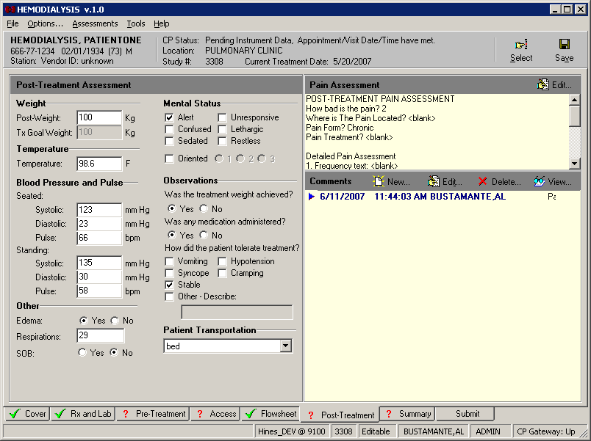
For more detailed information about the Post-Treatment tab, see “Chapter 9: Entering Post- Treatment Information.”
Figure 3-1

May 2008 Clinical Procedures V.1.0 3-23
User Manual

Working with Hemodialysis

Summary Tab
You can enter/view summary information, vascular access monitoring, and billing information about the dialysis treatment on the Summary tab (Figure 3-22). Under Billing Information, you can enter associated CPT and ICD-9 or ICD-10 codes, clinical indicators and associate providers with this treatment session. Notes dealing with billing and environmental conditions can be entered into the Comments area.
Note: Upon the ICD-10 activation date, the Patch MD*1.0*29 allows the user to add/edit/store ICD-10 diagnosis codes (up to 8 alphanumeric characters including the decimal point that follows the third character) from the CP Hemodialysis Patient Data Page Summary Tab Diagnosis tab window, as well as ICD-9 diagnosis codes, depending on the Current Treatment Date field.
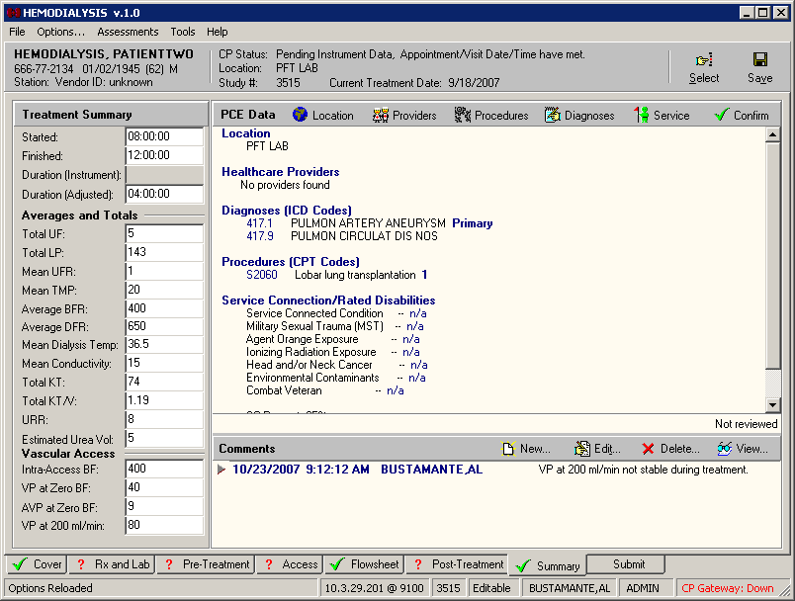
For more detailed information about the Summary tab, see “Chapter 10: Viewing Summary Information.”
Figure 3-2

  - Clinical Procedures V.1.0 August 2014 User Manual
MD*1.0*29

    - Editing/Viewing Information on the Cover Tab
The Cover tab is the first tab you see after selecting a patient. Information on the current treatment along with past treatment information can be found on this tab.
The following information is displayed on the Cover tab:
      - Current Treatment Information
      - Recent Postings
      - Infectious Diseases
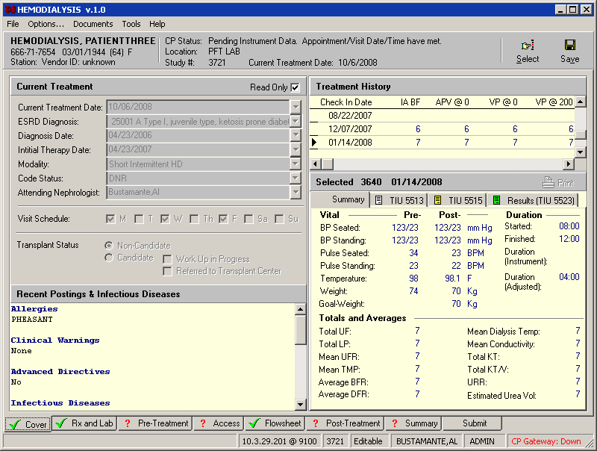
      - Treatment History
Figure 4-1
Current Treatment Information
The first time you open a study, the Read Only checkbox will be unchecked so you can enter the treatment information. Each time you open the study again, the Read Only checkbox will be checked, so you can view the previously entered treatment information. If you want to edit this information, you can uncheck the Read Only checkbox and edit the information (Figure 4-2).
Note: If you want the Treatment Information to default as Read Only for new studies, ADMIN users can set the “Set the new study Cover to Read Only” option to TRUE (Options menu > Preferences > System Preferences > Set the new study Cover to Read Only).

May 2008 Clinical Procedures V.1.0 4-1
User Manual

Editing/Viewing Information on the Cover Tab

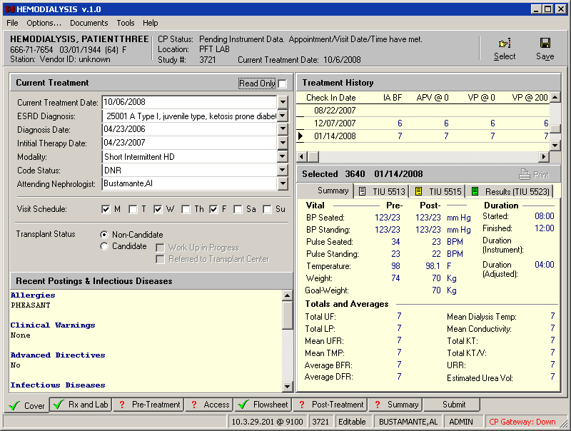
Figure 4-2
Edit the information for the following fields:
Current Treatment Date: Select the date of the current treatment (defaults to Check-in date).
ESRD Diagnosis: Select the ICD-9 or ICD-10 Code associated with the ESRD diagnosis.
Diagnosis Date: Select the date the patient was first diagnosed with ESRD.
Initial Therapy Date: Select the date of the first Hemodialysis treatment for this patient.
Modality: Select the type of dialysis treatment to be performed. This dropdown list is site configurable for ADMIN users. (See “Customizing Drop-down List Items.”)
Code Status: Select either DNR, AD Signed or Full. This dropdown list is site configurable for ADMIN users. (See “Customizing Dropdown List Items.”)
Attending Nephrologist: Select the name of the attending Nephrologist. Choose the Nephrologist’s name in one of three ways:
Method 1: Find in VistA (Recommended)
Note: This method is recommended because the names get pulled from the VistA database. If the provider’s name does not appear in the list, use Method 2 or 3, below.
        - Unmark the Read Only checkbox.
        - Click the dropdown arrow to the right of the Attending Nephrologist field. The Select Provider window displays (Figure 4-3).

4-2 Clinical Procedures V.1.0 August 2014 User Manual
MD*1.0*29

