CLINICAL PROCEDURES V. 1.0
HEMODIALYSIS MODULE

INSTALLATION GUIDE

Patch MD*1.0*6
May 2008

Revised July 2008
for MD*1.0*18

Department of Veterans Affairs
Health Systems Design and Development
Provider Systems

Revision History

Description | Date | Author
Patch MD*1.0*6 released. | May 2008 | REDACTED
Patch MD*1.0*18 released.  “Caché Sites” section removed, p. 4.  Updated list of files included in MD1_0P6.zip, p. 5. | July 2008 | REDACTED

Table of Contents
Installation Guide 1
Overview 1
Hemodialysis Installation (General) 3
Pre-installation instructions 3
Hemodialysis Installation (M Server) 5
Installation Instructions 5
M Server Installation – Example Screen Listing 6
Hemodialysis Installation (Client) 10
Installing the Client for the First Time 11
Updating an Existing Client Installation 17
Post Installation Tasks on the M Server 19
VistA Client 22
Customizing the Client Installation 23
Assigning Administrator Rights to Users 24
Server Based Installation 28

Installation Guide

Overview
Hemodialysis is a new module of the Clinical Procedures (CP) package that provides features specific to hemodialysis treatment. The Hemodialysis module allows you to collect hemodialysis treatment information from the medical device and manually enter treatment data into the application.
Pre-dialysis vitals, information obtained during treatment, and post-dialysis vitals can be entered into the Hemodialysis data entry screens. A Treatment Summary is created and used to fill out Centers for Medicare & Medicaid Services (CMS)/End Stage Renal Disease (ESRD) forms.
• This is the initial release of the Hemodialysis module of Clinical Procedures.
The package namespace is MD. File numbers 702, 702.01, 702.09, and 703.1 are stored in the ^MDD and ^MDS globals. The range of 704.201 to 704.209 is stored in the ^MDK global.
Hemodialysis is dependent upon the CP TRANSACTION file (#702).
Hemodialysis is comprised of two parts, the M Server and the Client workstation. This guide addresses both the installation of the KIDS build on the M Server and the executable on the workstation.
• Requirements for M Server installation:
The M Server (disk) storage requirements for Hemodialysis are:
Global | Type of Data | Size | Journaling
^MDK | Hemodialysis studies | 25-75 k/ patient | Yes

The following describes the installation environment for Hemodialysis on the M server:
The only required package is Clinical Procedures V. 1.0 and released CP patches.
Note: The Vitals package must be installed if you want the Hemodialysis application to store vital signs data in the Vitals package.
Hemodialysis cannot be installed as a stand-alone application without CP.
• Requirements for VistA client installation:
The client (disk) storage requirements are:
Type of Data | Size
Application | 3 m
Help Files | 1 m

The following describes the installation environment for Hemodialysis on the VistA client workstation:
- Workstations must be running under Windows NT (V4 or later), Windows 2000, or Windows XP. Refer to http://vaww.vairm.vaco.va.gov/vadesktop for additional information on VA standard desktop configurations.
Note: While the Hemodialysis application complies with GUI standards and will work with a screen resolution of 800x600, it is recommended that you use a higher resolution--at least 1024x768.
- RPC Broker Workstation must be installed.
- The workstation must be connected to the local area network.

Hemodialysis Installation (General)

Pre-installation instructions
- Coordinate this installation with the Clinical Application Coordinator (CAC), Medicine Automated Data Processing Application Coordinator (ADPAC) and your Information Technology (IT) service.
- If CP is not already installed at your site, install CP, then update it by installing patches 1, 2, 4, 5, 10, 13 and 14. (See the Clinical Procedures Installation Guide for more information.)
IMPORTANT NOTE: Patch 4 MUST be installed before you install Hemodialysis.
If your site is already running CP, you must shut down the CP Gateway so that you can replace it, as described in the following section:
Replacing CP Gateway at a Site Already Running CP
If your site is already running CP, you must completely shut down the CP Gateway during non-peak hours and replace the executable. On the File menu, click Shutdown Gateway (Figure 1).
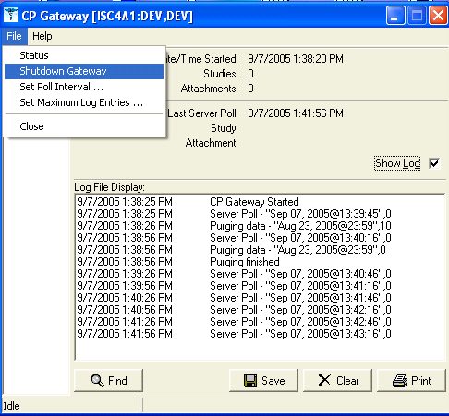
Figure 1

Important If you don't use the "Shutdown Gateway" action properly and just close the application, the Gateway is still running. You will not be able to start the new CP Gateway or shut down the old session.
If you are installing CP for the first time, this isn't an issue.
- By default, Hemodialysis does not save vital signs in the Vitals package. In order for Hemodialysis to store vitals in the Vitals package, you must meet two requirements: 1) your site must have the Vitals package installed, and 2) you must set at least one of the following Hemodialysis options to TRUE: Save Flowsheet Vitals and Save Vitals.
- Create, place, and set the journaling option for the global ^MDK on the volume set. This new global is released with Hemodialysis. Be sure to coordinate this task with the VistA systems manager to avoid placing the global in default locations and applying incorrect settings.

Translation Table Information
Globals | Type of Data | Size | Placement | Journaling | Protection
^MDK | Hemodialysis studies | 25-75 k/ study | Medicine volume set | Yes | RWP

Hemodialysis Installation (M Server)
Note 1: The M server installation must be done before the client installation.
Note 2: You must have programmer access and options in order to install the KIDS build.

Installation Instructions
1. Once the site has received the Hemodialysis software, move the files to the appropriate directory on your system.
The MD1_0P6.zip includes:
Hemodialysis.exe - Hemodialysis client installation (self-extracting executable)
The following files will be loaded into the pathway:
C:\Program Files\Vista\Hemodialysis directory by running Hemodialysis.exe:
Hemodialysis.cnt – Help File Table of Contents
Hemodialysis.exe – Hemodialysis executable
(A Hemodialysis shortcut will be added to the desktop)
Hemodialysis.hlp – Help File
CPManager.exe – CP Manager executable
CPGateway.exe – CP Gateway executable
MD1_0P6.kid - Hemodialysis server side installation (KIDS build)
Replace the old CP Manager and CP Gateway with the new executables.
The default location of the CP applications is in the following pathway:
C:\Program Files\VistA\Clinical Procedures\

Note: CPMANAGER.CNT and CPMANAGER.HLP can be retrieved separately from the ANONYMOUS.SOFTWARE directory.
The help files CPMANAGER.hlp and CPMANAGER.cnt should replace the existing CP Manager help files.

The default location of the help files is in the following pathway:
C:\Program Files\VistA\Clinical Procedures\Help

If the CP application was placed elsewhere, the pathway to the
applications and help files will be within that location.
2. Copy the MD1_0P6.kid from the directory selected above to the installation directory on the M Server.
Note: ASCII transfer format must be used for this file.
3. Programmer variables can be initiated by executing the command D ^XUP. Validate that DUZ(0)=”@”
4. Use the KIDS installation menu option [XPD MAIN] and select Installation and then Load a Distribution to load the MD1_0P6.kid file onto your M system.
5. Use the KIDS installation menu option [XPD MAIN] and select Installation and then Install Package(s) to install the distribution into your M system. Refer to the “M Server Installation – Example Screen Listing” (in the bottom of this page) for additional information.
6. Restart the CP Gateway.

M Server Installation – Example Screen Listing
(Installing MD1_0P6.KID for the first time)
Select OPTION NAME: XPD MAIN Kernel Installation & Distribution System

Select Kernel Installation & Distribution System Option: INstallation

Select Installation Option: LOAD a Distribution
Enter a Host File: SYS$USER:[XXX]MD1_0P6.KID

KIDS Distribution saved on Aug 11, 2006@18:18:31
Comment: Clinical Procedures Version 1.0 Patch 6

This Distribution contains Transport Globals for the following Package(s):
MD*1.0*6
Distribution OK!

Want to Continue with Load? YES//
Loading Distribution...

MD*1.0*6
Use INSTALL NAME: MD*1.0*6 to install this Distribution.

You have PENDING ALERTS
Enter "VA to jump to VIEW ALERTS option

Select Installation Option: INStall Package(s)
Select INSTALL NAME: MD*1.0*6 Loaded from Distribution 8/21/06@15:45:51
=> Clinical Procedures Version 1.0 Patch 6 ;Created on Aug 11, 2006@

This Distribution was loaded on Aug 21, 2006@15:45:51 with header of
Clinical Procedures Version 1.0 Patch 6 ;Created on Aug 11, 2006@18:18:31
It consisted of the following Install(s):
MD*1.0*6
Checking Install for Package MD*1.0*6

Install Questions for MD*1.0*6

Incoming Files:

702 CP TRANSACTION (Partial Definition)
Note: You already have the 'CP TRANSACTION' File.

702.01 CP DEFINITION (Partial Definition)
Note: You already have the 'CP DEFINITION' File.

702.09 CP INSTRUMENT (including data)
Note: You already have the 'CP INSTRUMENT' File.
I will MERGE your data with mine.

703.1 CP RESULT REPORT
Note: You already have the 'CP RESULT REPORT' File.

704.201 HEMODIALYSIS ACCESS POINTS

704.202 HEMODIALYSIS STUDY

704.209 HEMODIALYSIS SETTINGS

Want KIDS to Rebuild Menu Trees Upon Completion of Install? NO// NO

Want KIDS to INHIBIT LOGONs during the install? NO// NO
Want to DISABLE Scheduled Options, Menu Options, and Protocols? NO// NO

Enter the Device you want to print the Install messages.
You can queue the install by enter a 'Q' at the device prompt.
Enter a '^' to abort the install.

DEVICE: HOME// TELNET

Complete MD*1.0*6

Install Started for MD*1.0*6 :
Aug 21, 2006@15:46:10

Build Distribution Date: Aug 11, 2006

Installing Routines:
Aug 21, 2006@15:46:11

Installing Data Dictionaries:
Aug 21, 2006@15:46:11
Installing Data:
Aug 21, 2006@15:46:11

Installing PACKAGE COMPONENTS:

Installing REMOTE PROCEDURE

Installing OPTION

Installing PARAMETER DEFINITION
Aug 21, 2006@15:46:11

Running Post-Install Routine: ^MDPOST06

MDPOST-Setting compatible client versions...

Creating index definition ...
Executing set logic ...

Updating Routine file...

Updating KIDS files...

MD*1.0*6 Installed.
Aug 21, 2006@15:46:11

Install Message sent #48589
───────────────────────────────────────────────────────────────────────
┌────────────────────────────────────────────────────────────┐
100% │ 25 50 75 │
Complete └────────────────────────────────────────────────────────────┘

Install Completed

Select Installation Option:

Hemodialysis Installation (Client)
Hemodialysis utilizes the RPC Broker connection to the VistA server for operation. Before installing the application, insure that the workstation has connectivity to the required server via the RPC Broker. For help in setting up the RPC Broker on the workstation, refer to the Kernel RPC Broker documentation.
Caution: For best performance, do not install Hemodialysis.exe on the same server on which you installed the Gateway.
Note: When updating an existing installation of Hemodialysis, you are no longer required to uninstall the previous version as a separate step before installing the new one. Please follow one of the following workflows:
- Installing the Client for the First Time
- Updating an Existing Client Installation

Installing the Client for the First Time
Double-click Hemodialysis.exe from the sharable directory where you saved it and follow the installation steps that are presented.
- Select the location (i.e., Destination Folder in Figure 2.) on the client workstation where the application is to be installed, then click Next. By default, the installation will be stored in the
C:\Program Files\VistA\Hemodialysis
directory of the client workstation on which you are installing this application.
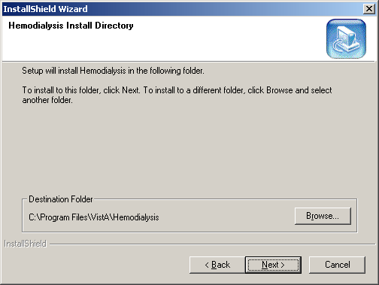
Figure 2
Note: It is recommended that you use this default as it is in compliance with the GUI SACC guidelines for the location of GUI application installations. The application will operate correctly if stored elsewhere on the client workstation, but this is not recommended. Use the Browse button to select another destination folder or directory.
- Select the type of setup you want, then click Next (Figure 3). It is recommended that you select the Typical setup.
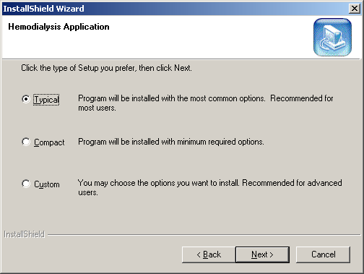
Figure 3
- The installation of Hemodialysis adds icons to both the Start Menu and the user’s desktop. By default, a Hemodialysis program folder is created and the icons are installed there. Click Next.
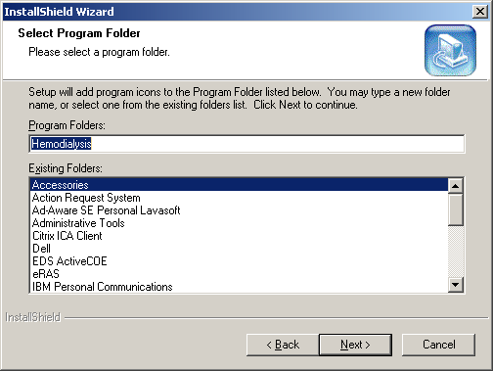
Figure 4
- Check the settings listed on this screen before you click Next to continue (Figure 5).
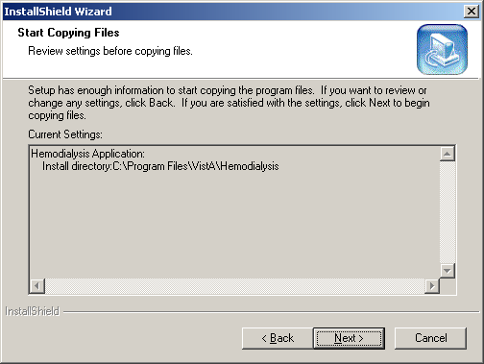
Figure 5
- Once all steps are completed, the installation begins and shows the progress as it installs (Figure 6). If the installation files are located on the client PC, the install screen should complete in less than one minute. Server and network connectivity for installations over the network may cause the installation time to increase.
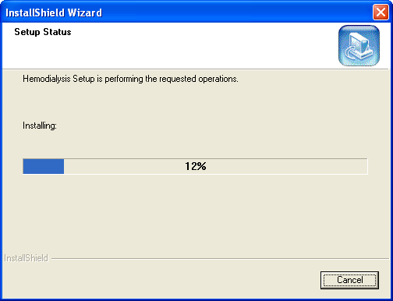
Figure 6
- Upon completion of the installation, the InstallShield Wizard Complete screen displays (Figure 7). Click the Finish button to finalize the installation.
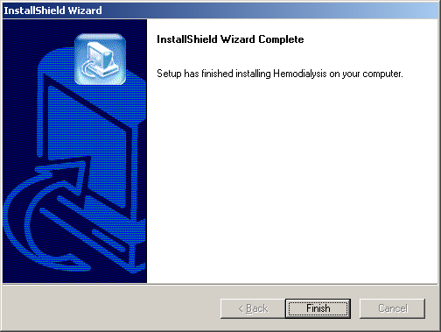
Figure 7

Updating an Existing Client Installation
- Double-click Hemodialysis.exe from the sharable directory where you saved it and follow the installation steps that are presented.
- The InstallShield Wizard screen allows you to update an existing installation of Hemodialysis without first uninstalling the previous version (Figure 8). To update, click the Repair radio button, then click Next.
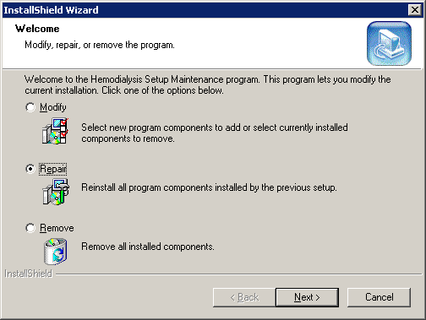
Figure 8
- Upon completion of the installation, the Maintenance Complete screen displays (Figure 9). Click the Finish button to finalize the installation.
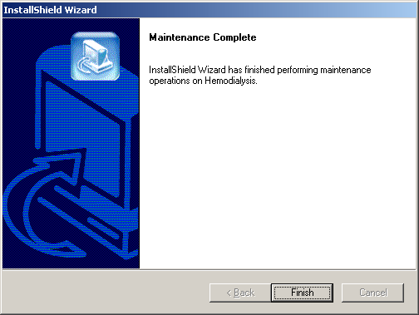
Figure 9

Post Installation Tasks on the M Server
- There are no routines to be mapped in Hemodialysis as of this release.
- Verify that the following global is journaled and place it in the UCI translation table for each CPU: ^MDK
- Move the MD* routines to all appropriate systems.
- IRM shall assign the option [MD HEMODIALYSIS USER] to the clinical staff (i.e., physicians, nurses, and technicians) who will be using Hemodialysis. If these options are not assigned, the user will not be able to launch and use the Hemodialysis application.
- Verify that the file security is correct for the following files:
DD RD WR DEL LAY AUD
NUMBER NAME GLOBAL NAME ACC ACC ACC ACC ACC ACC

704.201 HEMODIALYSISACCESS POINTS ^MDK(702.201, @ @ @
704.202 HEMODIALYSIS STUDY ^MDK(702.202, @ @ @
704.209 HEMODIALYSIS SETTINGS ^MDK(702.209, @ @ @

- All Hemodialysis procedures must be set up in CP Manager before they can be used by this application. Refer to the Clinical Procedures Implementation Guide for more information on setting up procedures. With patch MD*1*6, a new field has been added to the CP Definition file (#702.01) called PROCESSING APPLICATION (#.06). This field is used to indicate that the procedure will be using the Hemodialysis process; otherwise, the Default CP process setting will be used.
Make sure to set the Processing Application field to Hemodialysis for Hemodialysis procedures. Any other CP procedures will default to the Default setting, so you do NOT need to set the field.

If you have any questions concerning the installation, please log a Remedy Ticket for Clinical Procedures or contact the VA Service Desk (National Help Desk) at REDACTED. For a site wishing to implement Clinical Procedures, please contact your Implementation Manager.

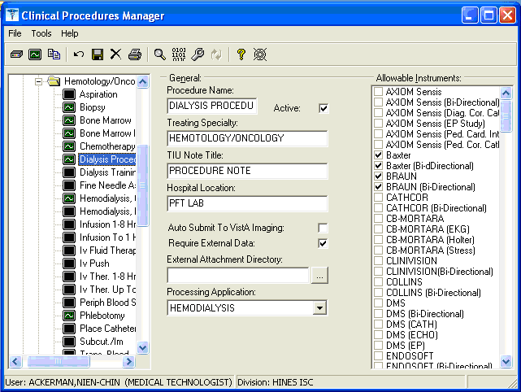
Figure 10
- Creating the “Hemo Dialysis” User to Assign Administrator rights
At least one local user must be assigned Administrator rights. Only an administrator can assign administrator rights to another user, but the first time the Hemodialysis application is run, there will be no administrator account set up. To work around this issue, a special system user account named “Hemo Dialysis” needs to be set up. The Hemo Dialysis user account has administrator rights by default. This account can be used to set up local administrators.
The site IRM Support person must add a DIALYSIS, HEMO user into the New Person File (#200). The following fields must be filled in:
- NAME: DIALYSIS, HEMO
- INITIAL: HD
- FILE MANAGER ACCESS CODE: #
- ACCESS CODE: Determined locally by IRM
- VERIFY CODE: Determined locally by IRM
- PRIMARY MENU OPTION: MD HEMODIALYSIS USER
- SERVICE/SECTION: Determined locally by IRM, but should be relevant to renal/dialysis.
The following screen capture details this procedure:

D ^XUP

Setting up programmer environment
This is a TEST account.

Terminal Type set to: C-VT100

Select OPTION NAME: XUSER
1 XUSER User Management
2 XUSER DIV CHG Change my Division
3 XUSER FILE MGR Manage User File
4 XUSER KEY RE-INDEX Reindex the users key's
5 XUSER PC BUILD User PC build Print
Press <RETURN> to see more, '^' to exit this list, OR
CHOOSE 1-5: 1 XUSER User Management

Select User Management Option: ADD a New User to the System
Enter NEW PERSON's name (Family,Given Middle Suffix): DIALYSIS,HEMO
Are you adding 'DIALYSIS,HEMO' as a new NEW PERSON (the 696TH)? No// Y (Yes)
Checking SOUNDEX for matches.
No matches found.
Now for the Identifiers.
INITIAL:HD
SSN: 666009999
SEX:

Edit an Existing User
NAME: DIALYSIS,HEMO
_______________________________________________________________________________
NAME... DIALYSIS,HEMO INITIAL: HD
TITLE: NICK NAME:
SSN: 666009999 DOB:
DEGREE: MAIL CODE:
DISUSER: TERMINATION DATE:
Termination Reason:

PRIMARY MENU OPTION: MD HEMODIALYSIS USER
Select SECONDARY MENU OPTIONS:
Want to edit ACCESS CODE (Y/N): FILE MANAGER ACCESS CODE: #
Want to edit VERIFY CODE (Y/N):

Select DIVISION:
SERVICE/SECTION: IRM FIELD OFFICE

Note: For security purposes, it is recommended that the “Hemo Dialysis” user be inactivated once local administrators have been assigned.
Additional information can be found in the Hemodialysis User Manual.
- Exported Kernel XPAR Parameters
There are four Kernel XPAR Parameters exported with this patch.
PARAMETER DEFINITION:
  - MD APPOINT END DATE
  - MD APPOINT START DATE
  - MD COMPL PROC DISPLAY DAYS
  - MD DAYS TO RETAIN COM STUDY
The users can edit the parameters using the Edit Parameter Values option, [XPAR EDIT PARAMETER].
Note: To see a screen sample of the parameter usage, please see the Clinical Procedures Implementation Guide – Chapter 6, “Step 5 – Exported Kernal XPAR Parameters.”
- Alert About Using Dashes/Hyphens with TIU
The hyphen character (“-” or en dash) has a special function in TIU. Please do not type this character into TIU as it will stop studies from processing if the character is encountered.
If your facility uses one or more hyphens to signify a blank response, please substitute a different character, such as @.

VistA Client
There are no post installation tasks for the VistA Client.

Customizing the Client Installation
The client installation by default installs and builds the icons and program folder items with command line switches /server, /port, and /nonsharedbroker. Hemodialysis utilizes the ServerList utility of the RPC Broker for selecting a server to connect to if it is configured on the client workstation. Instructions for configuration and utilization of the ServerList utility can be found in the RPC Broker documentation located on the VDL. If the ServerList utility has not been configured on the client, the applications by default will attempt to connect to the server identified in the users HOSTS file as BROKERSERVER on Listener Port 9200. Refer to “Appendix A – CP Application Startup Options and Command Line Switches” in the Clinical Procedures Implementation Guide for a list of usable command line switches.

Assigning Administrator Rights to Users
This section of the Installation Guide describes the process of assigning administrator rights to local users. Only an administrator can assign administrator rights to another user. The first time the Hemodialysis application is run, there will be no administrator accounts set up. To work around this issue, a special system user account named “Hemo Dialysis” needs to be set up by IRM. The Hemo Dialysis user account has administrator rights by default. This account can be used to set up local administrators.
Note: For security purposes, it is recommended that the “Hemo Dialysis” user be inactivated once the local administrators have been assigned.

Creating the “Hemo Dialysis” User in VistA
IRM must create the “Hemo Dialysis” user in VistA.
- Create a user with First Name “HEMO” and Last Name “DIALYSIS”
- Give user Hemo Dialysis an Access Code and Verify Code of your choosing.
- Give user Hemo Dialysis the following primary menu option:
- MD HEMODIALYSIS USER
IRM, refer to step 7 of the “Post Installation Tasks on the M Server” section of this Installation Guide for more information regarding this and other post-installation tasks on the M server.

Using the “Hemo Dialysis” User to Set Up Local Administrators
- Double click the Hemodialysis icon to launch the application.
- Choose the appropriate server from the Connect To screen, then click OK.
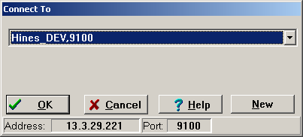
Figure 11
- Enter the “Hemo Dialysis” Access Code and Verify Code, then click OK.
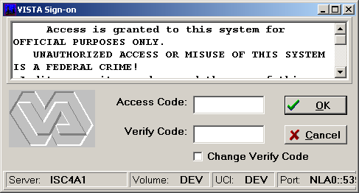
Figure 12
- The Study List displays. Click the Close button to display the Hemodialysis main screen.
- On the menu bar, click Options. The Hemodialysis screen changes to the Options screen.
- Click the Administrators node. The first time you view this screen, the list of Administrators is blank.
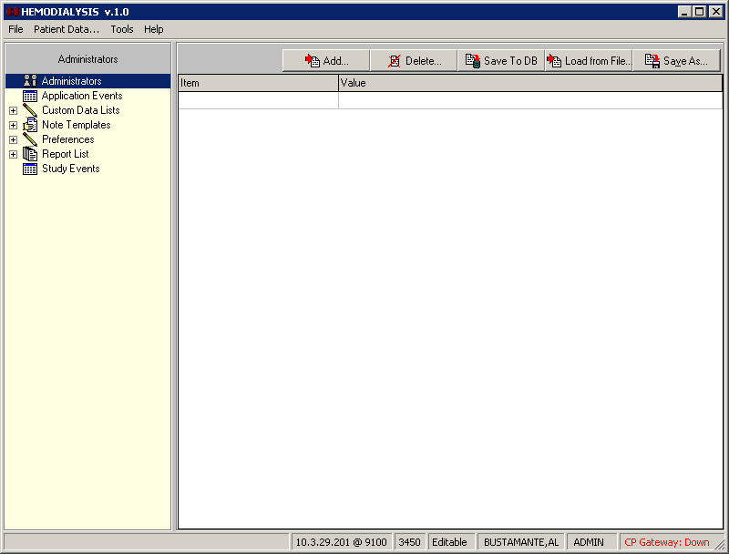
Figure 13
- Click the Add button towards the top of the screen.
Figure 14
- The Select Provider window displays. Type the first letters of the provider’s last name in the drop-down list (Figure 15), then press <Enter>. A list of providers displays in the large field with the yellow background.
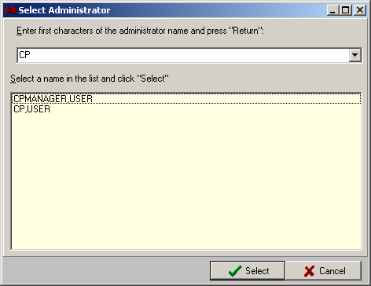
Figure 15
- Click a provider name from the list, then click Select. The Select Provider window closes and the new name displays in the Administrators list in the Value column. The Item column displays the provider’s DUZ.
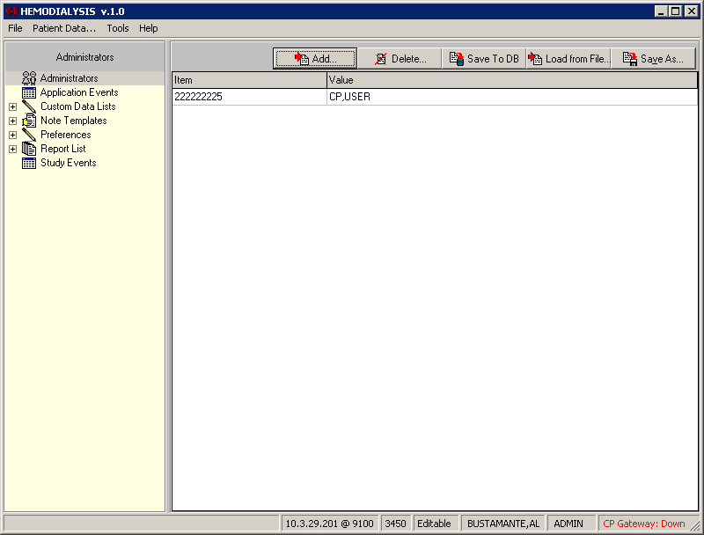
Figure 16
- Click Save To DB to apply the changes.
- Close Hemodialysis and then restart the application.
- Logon as the new administrator. If successful, the word ADMIN displays in the status bar at the lower right-hand corner of the screen, replacing the word USER (Figure 16).
Note: For security purposes, it is recommended that the “Hemo Dialysis” user be deleted or inactivated once the local administrators have been assigned. Future administrators should be added by a local administrator. The “Hemo Dialysis” user will not be needed again for this purpose.

Server Based Installation
Hemodialysis may be installed on a server share and accessed via shortcuts on the user’s desktop to minimize the impact of patching and installation. To do this simply perform a complete install of the application on a workstation and verify that the installation is working. Next, copy all files and sub directories from the target directory (default C:\Program Files\Vista\Hemodialysis\…’) to the server share.
On each individual workstation all that needs to be done is the creation of a shortcut pointing to the CP User.exe and/or CP Manager.exe applications on the server. To create a shortcut, right-click on the application and choose the option Create Shortcut, then move the shortcut onto the desktop of each workstation.
These shortcuts can be customized as discussed in the Customizing the Client Installation section. This allows for updates to occur on the single copy of the application on the server and does not require IRM going to each individual workstation to apply updates.
Here is the list of all files that need to be copied to the server share for server-based installations:
- C:\Program Files\VistA\Hemodialysis\Hemodialysis.exe
- C:\Program Files\VistA\Hemodialysis\Help\Hemodialysis.hlp
- C:\Program Files\VistA\Hemodialysis\Help\Hemodialysis.cnt
- C:\Program Files\VistA\Hemodialysis\Help\Roboex32.dll

MD*1.0*18 July 2008 Patch 18 release added.
MD*1.0*18 July 2008 “Caché Sites” section removed.
MD*1.0*18 July 2008 Updated list of files included in MD1_0P6.zip. Note added.

