Electronic Wait List for Scheduling and Primary Care Management Module (PCMM) Enhancements

Installation Guide Patches SD*5.3*263 & SD*5.3*264

November 2002

File Revision History

Initiated on 12/27/2004

Date | Description (Patch # if applic.) |  | Project Manager | Technical Writer
12/27/2004 | Manual updated to comply with SOP 192-352 Displaying Sensitive Data | REDACTED |  | REDACTED

Table of Contents

- Introduction 2
  - Purpose 2
  - Scope 2
- Install Requirements 4
  - Package Integration 4
  - Server Requirements 5
  - Resource Requirements 5
- Installation Instructions 6
  - Installation of Patch SD*5.3*263 6
  - Installation of SD*5.3*264 7
- Wait List Import Tool 9
- Transmission to National Patient Care Database in Austin… 19

Introduction

Purpose

The Purpose of this Installation Guide is to provide detailed instruction on the implementation of an Electronic Wait List (EWL) into the VistA Scheduling System and enhancements to the Primary Care Management Module (PCMM) Software.

The intended audience of this document includes IRM staff, National VistA Support, and Software Quality Assurance.

Scope

Currently, there is no national VHA software to list and track patients waiting for clinic appointments or primary care panel assignments. The EWL will assist VA Medical Centers, Community Based Outpatient Clinics (CBOCs,) and VHA Central Office in managing veterans’ access to outpatient health care. The EWL will assist clinics in identifying patients in need of appointments or panel assignments.

Within the EWL stand-alone software program, a patient may be placed on a waiting list for a Primary Care team, a Primary Care position, a Scheduling service/specialty, or a Scheduling specific clinic. The EWL software may be activated in the Appointment Management software, within the current VistA Scheduling package, when an appointment is not available. Within PCMM, the EWL software may be activated when a Primary Care team or provider is not available to a patient. Specifically, this is when the panel is at or above capacity. Reports will be available from an EWL Report option.

The EWL menu will only be accessible to users with the SDWL MENU security key. The EWL menu will provide the following functionality:
- 1. Enter a patient on the EWL and assign one of the following EWL TYPEs: a) Specific Clinic b) Service/Specialty. c) PCMM Team Assignment d) PCMM Position Assignment
- 2. Edit the EWL entry
- 3. Inquire (View) a patient’s EWL entries
- 4. Disposition the EWL entry
- 5. Produce reports in both summary and detail format.
- 6. Allow the setting of local parameters for clinics and service/specialties.

The EWL will also be invoked within the following options:
.    Make Appointment
.    PC Assign/Unassign
.    Appointment Management
.    Primary Care Management Module GUI

- Install Requirements

  - Package Integration

The following patches are needed to set up and run the EWL with the various packages. The Institution File Redesign follow-up patch XU*8*212 is a prerequisite patch for this package. This KERNEL patch requires the installation of the previous Institution File Redesign patches XU*8*206 and XU*8*209. It is also assumed the post-init routine from patch XU*8*206 has been run to completion. Additional patches required for EWL installation are SD*5.3*46, SD*5.3*241, and EAS*1*10. EAS*1*17 is included in the EWL KIDS build and will be installed with SD*5.3*263.

DG*5.3*273, Field Change Monitoring Utility, is a patch for Date of Death and will be noted as the Date of Death patch in all future references. It was not created within this package but is needed to run EWL and must be installed prior to installing SD*5.3*264. Patch SD*5.3*231, PCMM NOIS ISSUES, is also required for the installation of SD*5.3*264. EWL is released in patch SD*5.3*263 and is a requirement for SD*5.3*264.

File SD_53_P263.KID contains EWL patches SD*5.3*263 and EAS*1.0*17.

File SD_ 53_P263.ZIP is the Wait List Import Tool. It can be found on the FTP server. This is not included in the KIDS build.

SD*5.3*264 is a PCMM enhancement patch. It also contains the GUI PCMM executable file, SD_53_P264.ZIP.
For more details on the PCMM.EXE see step 9 under section 3.2 Installation of SD*5.3*264 within this guide.
Note: If you are using PCMM GUI you must install version 1.2.3.0

The patches will be installed in the following order:

- 1. SD*5.3*263 is the patch that installs EWL.
- 2. EAS*1.0*17 is an Enrollment patch that installs automatically with SD*5.3*263.
- 3. DG*5.3*273 is Date of Death patch.
- 4. SD*5.3*264 is a PCMM patch.

- 2.2 Server Requirements

Follows standard VA server configuration.

- 2.3 Resource Requirements
The following resources are part of the EWL (SD*5.3*263).

New Globals (1) ^SDWL Database Files (3) for patient data. Parameter Files (2)
Routines (46), subject to change. Options (13)
Security Keys (2)
Protocols (3)
RPC’s (22)
Required Build (4) SD*5.3*46, SD*5.3*241, XU*8*212, EAS*1*10 Associated Patches (1) EAS*1*17 install with SD*5.3*263

The following resources are part of the PCMM patch (SD*5.3*264).

Routines (8)
Options (3)
Protocols (1)
RPC’s (5)
Required Builds (2) DG*5.3*273, SD*5.3*231, SD5.3*263

Installation Instructions
The EWL patches, SD*5.3*263 and EAS*1.0*17 are not being distributed through the National Patch Module (NPM). The PCMM enhancement patch, SD*5.3*264, is being distributed through NPM. These EWL patches and associated GUI executable files are distributed as listed below. The following documentation and distribution files may be obtained using FTP from the ANONYMOUS.SOFTWARE directory at REDACTED or from specific servers at the Albany REDACTED, Hines (REDACTED, or Salt Lake City (REDACTED OI Field Office. This directory will contain the following:

KIDS Host File (SD*5.3*263 and EAS*1.0*17)- SD_53_P263.KID

Documentation- SD_53_P263_IG.PDF (Installation Guide), SD_53_P263_RN.PDF (Release Notes), and SD_53_P263_UM.PDF (User Manual)

Import Tool- SD_53_P263.ZIP PCMM GUI – SD_53_P264.ZIP
Note: The .PDF and .ZIP files are binary files and must be transferred in binary, not ASCII, mode. These .PDF files can be read on a PC using the Adobe Acrobat Reader program.

Installation of Patch SD*5.3*263

This patch may be installed with users on the system. Installation will take less than ten minutes. There is no post install.

Note: The following is a list of REQUIRED BUILDS for this KIDS Distribution. KIDS will not allow the installation of this
Patch without prior installation of them:

SD*5.3*46 SD*5.3*241 XU*8*212 EAS*1*10

- 1. Place global ^SDWL with appropriate default protections.
- 2. Use the 'LOAD A DISTRIBUTION' option on the Kernel Installation & Distribution menu. The Host File name is SD_53_P263.KID. Answer YES to the question: "Want to Continue with Load? YES//"
- 3. Review your mapped set. If any of the routines listed in the ROUTINE
SUMMARY section are mapped, they should be removed from the mapped set at this time.

- 4. From the Kernel Installation and Distribution System Menu, select the Installation menu.

.5. From this menu, you may elect to use the following options (when prompted for INSTALL NAME, enter SD*5.3*263):
.a. | Backup a Transport Global - this option will create a backup message of any routines exported with the patch. It will NOT backup any other changes such as DDs or templates.
.b. | Compare Transport Global to Current System - this option will allow you to view all changes that will be made when the patch
is installed. It compares all components of the patch (routines, DDs, templates, etc.).

.c.

. d.
Verify Checksums in Transport Global - this option will allow you to ensure the integrity of the routines that are in the transport global.

Print Transport Global - this option will allow you to view the components of the KIDS build.

6. Use the Install Package(s) option and select the package
SD*5.3*263.

- 7. When prompted 'Want KIDS to Rebuild Menu Trees Upon Completion of Install? YES//', respond NO.
- 8. When prompted 'Want KIDS to INHIBIT LOGONs during the install?
YES//', respond NO.
- 9. When prompted 'Want to DISABLE Scheduled Options, Menu Options, and protocols? YES//', respond YES.

OPTION : SDAM APPT MGT Appointment Management PROTOCOL: SDAM MENU Appointment Management

- 10. If routines were unmapped as part of step 2, they should be returned to the mapped set once the installation has run to completion.
- 11. Assign security key SDWL MENU to users of the EWL package. Assign security key SDWL PARAMETER to the package coordinator.

Installation of SD*5.3*264

Required Patches: DG*5.3*273, SD*5.3*231, & SD*5.3*263

- 1. Use the 'INSTALL/CHECK MESSAGE' option on the PackMan menu. This

option will load the KIDS package onto your system and will take less than 5 minutes. The Postinit will take additional time based on the number of patients with Date of Death (see section 8)
- 2. Review your mapped set. If any of the routines listed in the ROUTINE SUMMARY section are mapped, they should be removed from the mapped set at this time.
- 3. The patch has now been loaded into a transport global on your system. You now need to use KIDS to install the transport global. On the KIDS menu, under the 'Installation' menu, use the following options:

Verify Checksums in Transport Global Print Transport Global
Compare Transport Global to Current System Backup a Transport Global

- On the KIDS menu, under the 'Installation' menu, use the following option:

Select Installation Option: Install Package(s) Select INSTALL NAME: SD*5.3*264
==========
- Want KIDS to Rebuild Menu Trees Upon Completion of Install? YES// NO

- Do NOT inhibit users from login into the system.

- Answer 'YES' to 'Want to DISABLE Scheduled Options, Menu Options, and Protocols?

Disable the following options during installation

SDAM APPT MGT Appointment Management SCMC PATIENT ASSIGN/UNASSIGN Primary Care Team/Posn Assign or Unassign SCMC PCMM GUI WORKSTATION PCMM GUI WORKSTATION

- A postinit will run that will discharge patients from active
Team/Position Assignments who have a Date of Death. The program will update the display for each 5 year interval it starts and may take 10 minutes for each 100,000 entries in the patient file.

Deleting Traditional ASTAT CROSS REFERENCE from FILE 404.43

Setting up Date Of Death Inactivation Protocol Removing Patients with Date of Death from

Team/Position Assignments
Starting with Dates of Death in 1995 Starting with Dates of Death in 2000

- 9. If routines were unmapped as part of step 2, they should be returned to the mapped set once the installation has run to completion.
- 10. The following software file is exported as part of this patch:

File Name Contents Retrieval Format

---------
SD_53_P264.ZIP File(s) indented
bel
----------------
ow BINARY

- PCMM.EXE

The file listed above may be obtained via FTP. The preferred method is to FTP the files from:

download.vista.med.va.gov
This transmits the files from the first available FTP server. Sites may also elect to retrieve software directly from a specific server as follows:

CIO FIELD OFFICE FTP ADDRESS DIRECTORY

Albany REDACTED [anonymous.software]
Hines REDACTED [anonymous.software]
Salt Lake City REDACTED [anonymous.software]

PCMM.EXE will replace the existing Pcmm.EXE that is usually found in the Program File/VISTA/PCMM directory of the client workstation. Use program WinZIP to unzip SD_53_P263.zip in the directory noted. Workstations without an existing PCMM GUI application installed should first download and run SD_53_P204.EXE to install the previous version of PCMM. Then the PCMM.exe should be replaced with the new version.

Wait List Import Tool

Sites that currently keep waiting lists will be able to import their lists into the EWL via the Wait List Import Tool. This utility will convert local wait lists into a format acceptable by EWL.

  - Installation Instructions

- 1. Obtain by using FTP from the ANONYMOUS.SOFTWARE directory at DOWNLOAD.VISTA.MED.VA.GOV or from specific servers at the Albany
(REDACTED Hines REDACTED or Salt Lake City REDACTED) OI Field Office.
- 2. Use program WinZIP to unzip SD_53_P263.zip. Extract these files to the directory C:\Program Files\Vista\sdwl. The zip file contains 1 file (setup.exe).
- 3. Run setup.exe. Running this .exe will add an icon for sdwlit.exe to the desktop; sdwlit.exe and sdwlit.hlp will be placed in the directory, C:\Program Files\Vista\sdwl\.

Example of what the user sees when running setup.exe

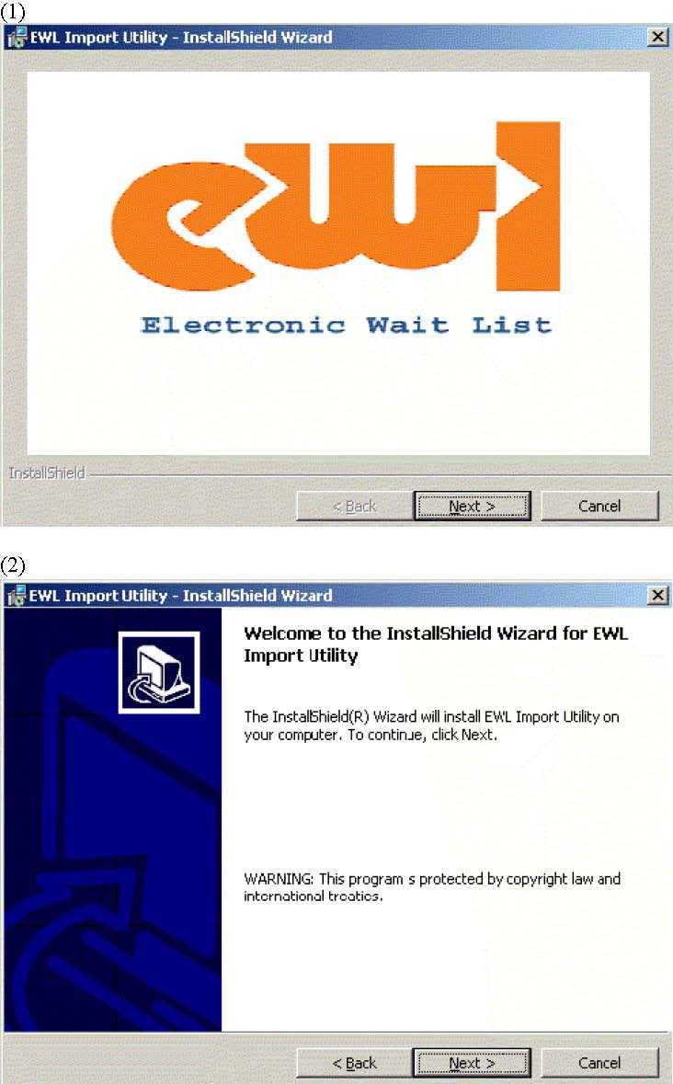

(3)

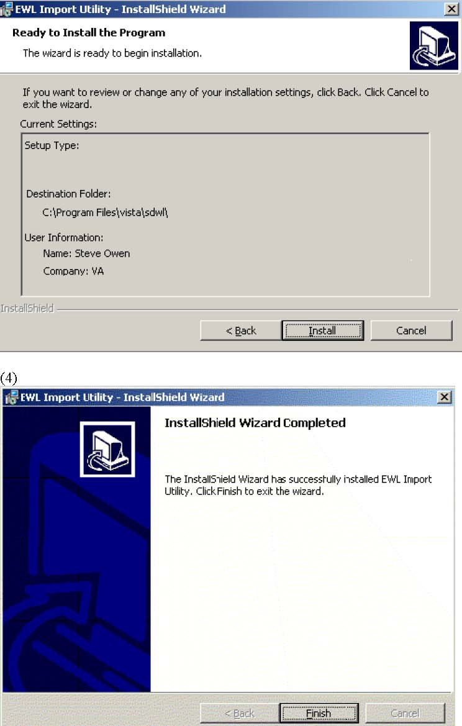

(5) To uninstall run setup.exe again

  - Using the Wait List Import Tool

Before using the Import Tool, please refer to the NOTE under Section V – Security in the Release Notes for additional information. This provides necessary set-up information for EWL before importing your wait list data.

To use the Wait List Import Tool sites must convert their wait lists from its current format into a comma delimited text file (.txt). This is the excepted format for the tool. This file is called the Import file. The Import file can be created from Vista using FileMan’s DATA EXPORT TO FOREIGN FORMAT options or from Excel using the CSV format. This text file must contain four fields:

-Social security number (SSN) (Entered as xxxxxxxxx or xxx-xx-xxxx)
-Institution Name (The name of the Institution from file 4)
.- Clinic Type {this numeric field is numbered 1-4, with 1 being file 404.51 (Team), 2 being file 404.57 (Team Position), 3 being file 409.31 (SD WL Service/Specialty), and 4 being file 409.32 (SD WL Clinic Location)}
.- Clinic Type Modifier {a specific choice within one of the clinic types. For example,
if clinic type 1 (Team) were chosen, the modifier would be a specific team.}

- Desired Date (Entered as the FileMan acceptable date. This is date for which the appointment is being requested. Applies only to Clinic Types 3 and 4.)(Note: If the desired date is requested then the priority is set to future and a date is automatically plugged in. If there is no desired date than the priority is set to ASAP, and the date the file is imported is automatically entered.

If there is no value for a field then a null value is entered (""). One row of five fields defines a single record for entry into the Electronic Wait List.

Note: To maintain the generic nature of the import tool, no validation check is made between institution and clinic. Sites should confirm the proper institution/clinic relationship.

Example #1:

Values are submitted for all fields

FIELDS

1 2 3 4 5 "123456789","VA","1","CLINIC","01/12/2003"

Example #2:
No value is submitted for field 5.
A null ("") is entered this field position.

FIELDS

1

2 3 4 5 "123456789","VA","1","CLINIC",""

- Select a server and Login to Vista.
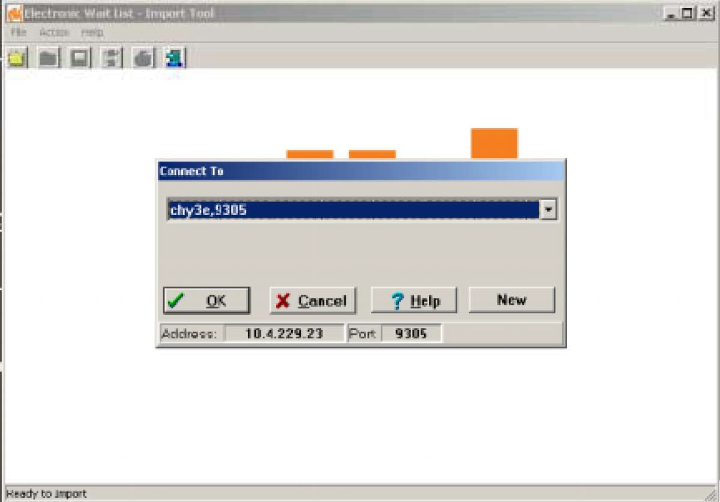

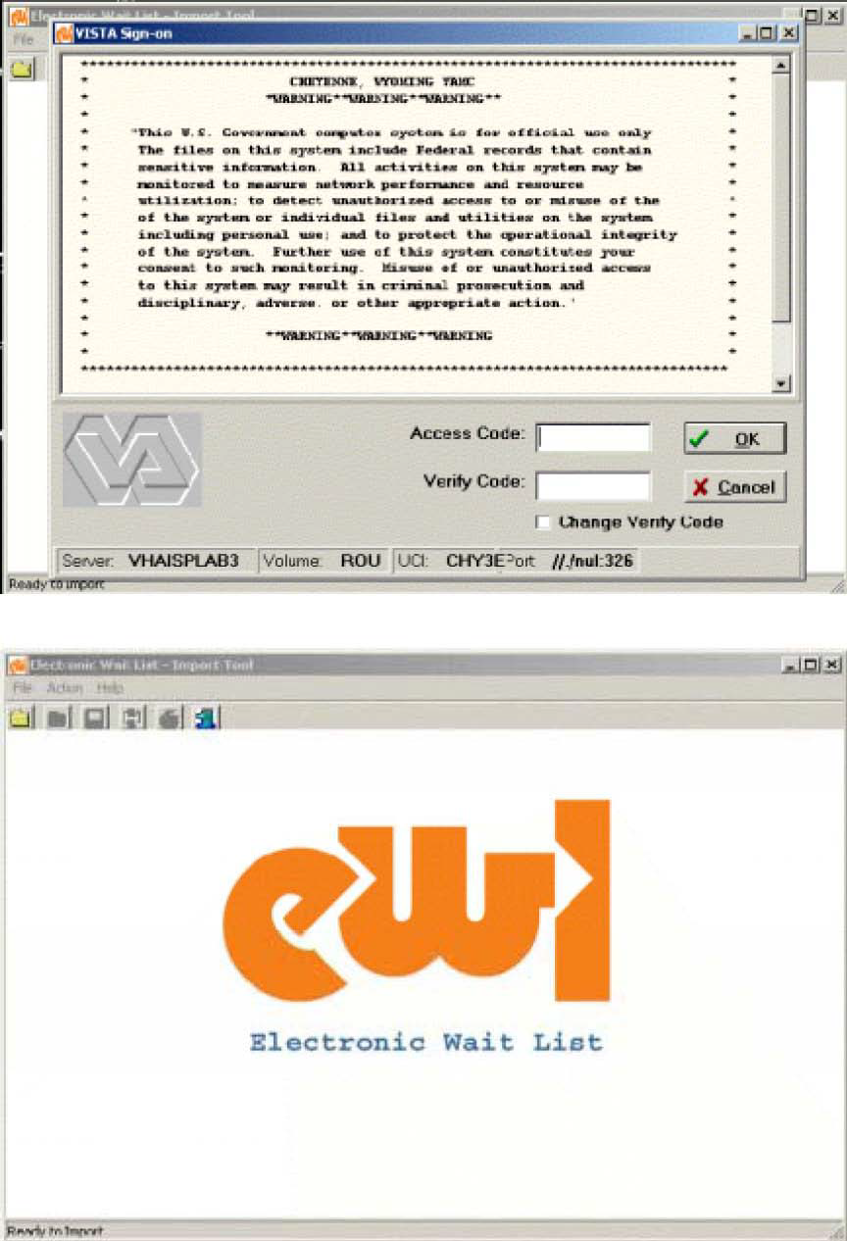
- Click on FILE, then OPEN or click the open folder icon on the toolbar.

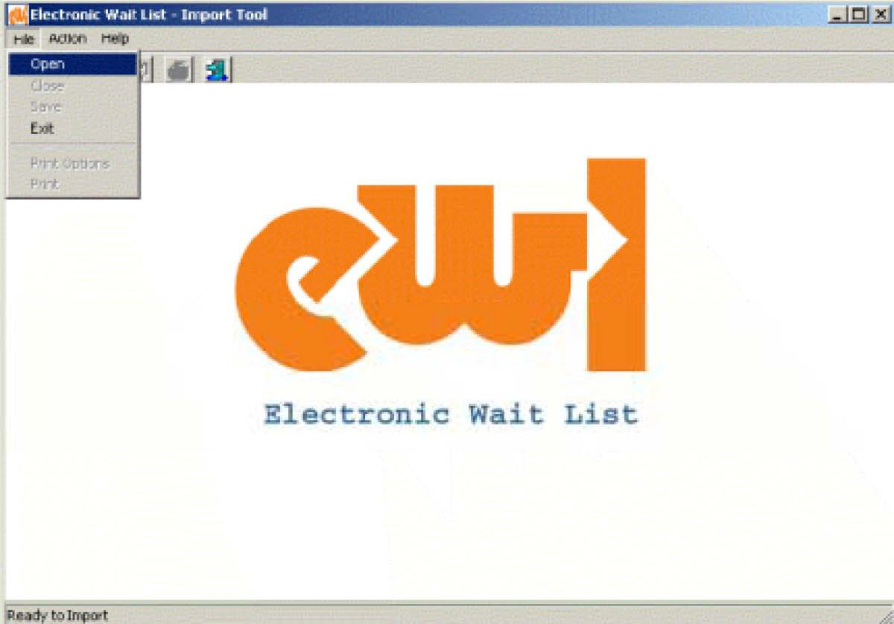
- 3. Select Import Options. Checking Pre-set Field Values will pre-set the Institution, Wait List Type, or Wait List Type Modifiers to the values the user selects and overwrite the values found for those fields in the IMPORT FILE. If the user leaves Pre-set Field Values unchecked no changes will be made to the IMPORT file. Click CONTINUE to accept the pre-set values or SKIP IT to cancel using pre-set values.
- 4. Select the IMPORT file.

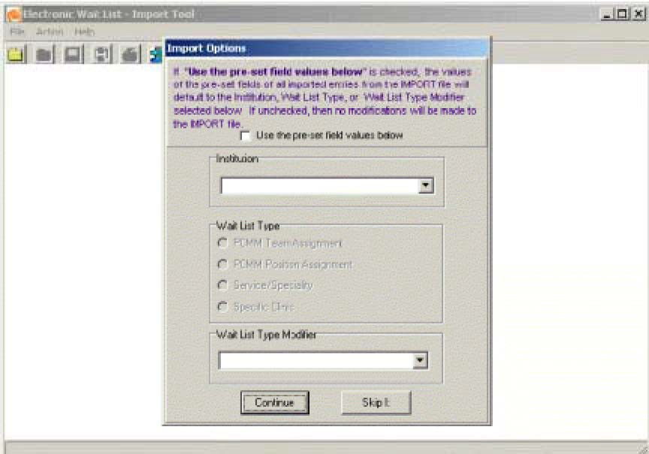
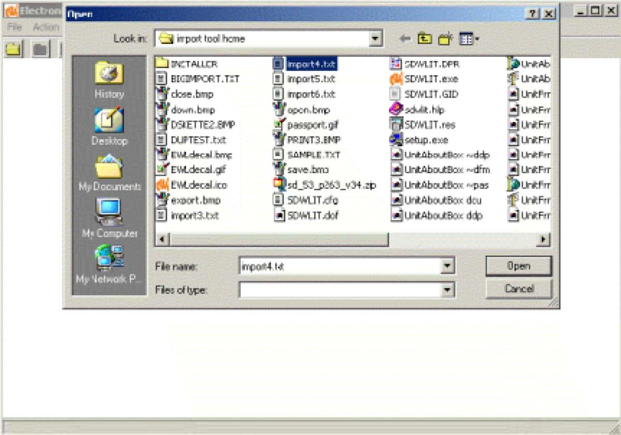

5. TheIMPORT file will be displayed in the grid. Entries can be reviewed or edited.

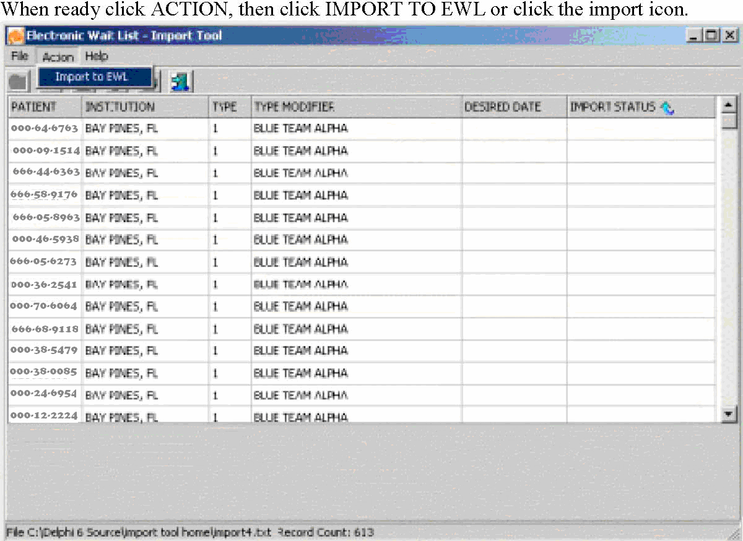
Each row of the grid is submitted to EWL as a new record. If the record is validated and accepted by EWL, the successful addition is noted at the bottom of the screen. If EWL cannot validate the record the reason for the failure is noted in the IMPORT STATUS column of the grid.

The rows of failed imports can be reviewed/edited and the import action can be repeated.

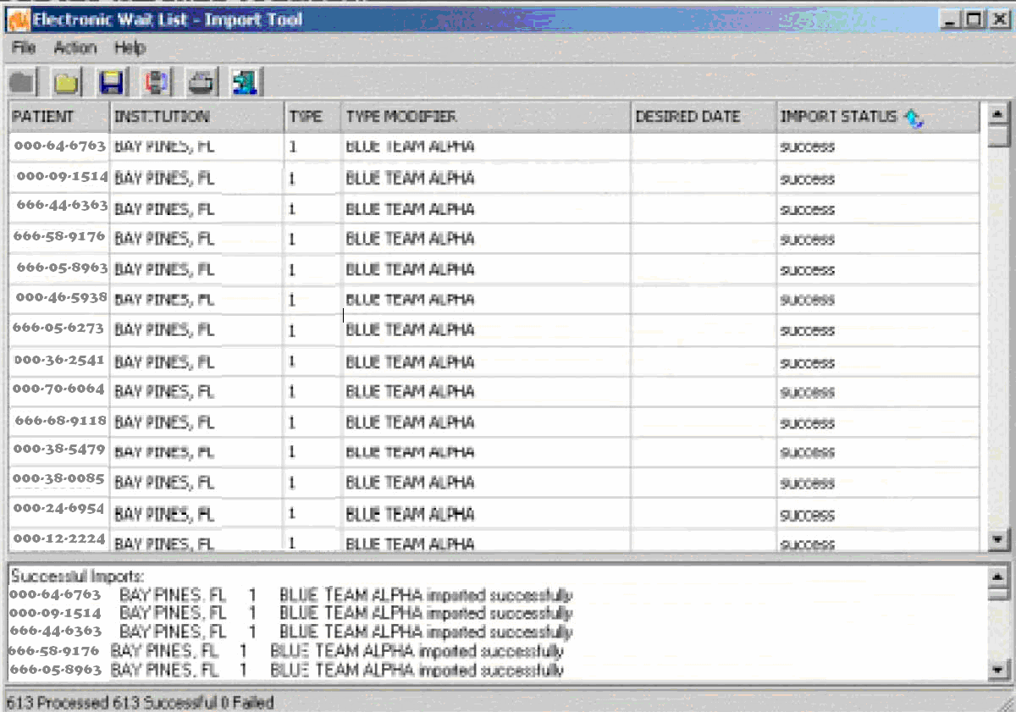

Note: Post import validation can be accomplished with the use of VA FileMan print options.

5. Transmission to National Patient Care Database in Austin.

Functionality is being created within this program to allow wait list data to be transmitted to the Austin Automation Center (AAC) on a bi-weekly basis. AAC will process the data and send it to the National Patient Care Data Base (NPCDB). This will aid in the assessing of the demand for services at VHA hospitals. This new functionality will also measure the amount of data that is being transmitted to the AAC from the sites. This functionality will be released with the upcoming patch SD*5.3*270.

