Electronic Wait List for Scheduling and PCMM And
Primary Care Management Module (PCMM) Enhancements

RELEASE NOTES

Patches SD*5.3*263 & SD*5.3*264

November 2002

File Revision History

Initiated on 12/27/2004

Date | Description (Patch # if applic.) | Project Manager | Technical Writer
12/27/2004 | Manual updated to comply with SOP 192-352 Displaying Sensitive Data | REDACTED | REDACTED

TABLE OF CONTENTS

Introduction… 3
- Description of Functionality 4

III. | Requesting Information… 6
IV. | Installation and Implementation… 6
V. | Security 6
VI. | Documentation… 9

- Technical Information 9
Menu Options… 10
Bulletins… 10
Background Jobs… 11
Protocols… 11
Templates… 11
Security Keys… 12
Database Integration Agreements… 12
Routine Summary… 12
- Using the Wait List Import Tool… 15

  - Introduction

The Electronic Wait List and the Patient Care Management Module Enhancement teams are pleased to announce the release of the Electronic Wait List package and PCMM enhancements Phase I.

The Electronic Wait List (EWL) will aid in the process of monitoring the demand and capacity for care at VA medical facilities. Currently, there is no national VHA software to list and track patients waiting for clinic appointments, primary care (PC) team assignments, or a primary care provider (PCP) assignments. The EWL will assist VA Medical Centers, Community Based Outpatient Clinics (CBOCs,) and the VHA Central Office in managing veterans’ access to outpatient health care. The EWL will assist clinics in identifying patients in need of appointments, PC Teams, and PCPs.

EWL is accessible within three separate programs: the EWL stand-alone program, the Patient Care Management Module (PCMM) GUI and VistA programs, and, in the Scheduling Appointment Management Module. EWL protocols may be added to a PCE List Manager menu if desired.

Within the Electronic Wait List (EWL) standalone software program, patients may be
added to a wait list for a Primary Care team, Primary Care Position, Service/Specialty, or a Specific Clinic. Activation of EWL software occurs in the Appointment Management software, within the current VistA Scheduling package, when an appointment is made, not available, or cancelled. Within PCMM, the EWL software may be activated when a Primary Care team or provider are not available for a patient, i.e. the team or position is over its panel capacity. Reports are available from the EWL report option.

For PCMM Phase I Enhancements, the user will be able to enter Primary Care Direct Patient Care Full Time Employee Equivalents for Primary Care providers (PC Direct Care FTEE) when assigning a provider to a PCMM position.

Description of Functionality

The Electronic Wait List (EWL) Menu is a standalone application available on the Scheduling Managers’ menu.

    - The EWL menu provides the following functionality.

      - Enter a patient on the EWL and select the Wait List type for which the patient is waiting.
        - Specific clinic
        - Service/Specialty.
        - Primary care team.
        - Primary care position.
      - Edit the EWL entry
      - Inquire on or display a patient’s EWL entries
      - Disposition an EWL entry
      - Produce reports in summary or detailed formats.
      - Add clinics and service/specialties and their institutions from the national institution file, through the Parameters option.

    - The EWL is available within the following options:

      - Make Appointment
      - Cancel Appointment
      - Unscheduled Visit
      - PC Assign/Unassign
      - Appointment Management
      - Primary Care Management Module – VistA and GUI

When assigning providers to a Primary Care position via the PCMM GUI screens, users may add the Primary Care Direct Patient Care FTEE (PC Direct Care FTEE) or the provider. This field is a value between 0 and 1 up to 2 decimal places. Under the Team menu in PCMM GUI, there is a new option PC Direct Care FTEE that allows entry/edit of this field value for

currently assigned providers on a team. A new report PCMM Direct Primary Care FTEE [SC PCMM DIRECT PC FTEE] is in the PCMM Reports [SC PCMM REPORTS MENU] to
show all the current Direct Primary Care FTEE values.

Requesting Information

In February of 2002, REDACTED, Deputy Under Secretary of Health, addressed the need to effectively track the demand for services at VA Hospitals versus their ability to meet this demand in a memo sent to Gary Christopherson, Deputy CIO for Health, VHA. The memo requested the development of the Electronic Wait List to meet this need. This is stated in an excerpt from that memo.

As you are aware, clinic-waiting times has become a high visibility issue with the Secretary’s office. We report data monthly during the Deputy Secretary’s Performance briefings. Current waiting time measures reflect the experience of veterans already “in the system” and do not accurately portray waiting time experiences of new enrollees or patients without a scheduled appointment. Whether due to absence of appointments or other reasons, ad hoc “waiting lists” of new veteran enrollees to be entered into the scheduling system are known to exist, and waiting times for new enrollees seeking care are anecdotally reported to be long. We will attempt to formalize an “electronic waiting list” in VistA to more consistently and accurately reflect demand across VHA, and reduce the risk to enrollees lost to follow-up due to clerical error.

The lead requestor for Electronic Wait List is REDACTED, Deputy Under Secretary for Health O & M.

Installation and Implementation

Specific information pertaining to the installation of this package is available in the EWL/PCMM Enhancements Installation Guide.

Security

To access the EWL menu option, users must have the SDWL MENU security key. To access the Parameter option and enter clinics and service/specialties to be used with the EWL system, users must have the SDWL PARAMETER key.

Access to the EWL routines, that are embedded in the Scheduling Package, are not controlled

by the above security keys. These routines are activated for clinics set up in the Parameter file whether or not a user has the SDWL Menu key.

The SDWL keys DO NOT block the following four prompts in the Scheduling software as requested by management. Each site must decide on use of the Wait List software at their site and implement the decision(s) through site-specific procedures and training. These decisions are particularly important to consider during the time of installation and local wait list cutover. There are the four prompts within the Scheduling routines that will require site- specific procedures and training to implement.

- In the Make Appointment option, if the Date/Time prompt is blank for the appointment the question will display, “Do you want to add this patient to the Wait List? NO//. No is the default answer. If users are not to use the EWL, a recommendation is to train them to always accept the “No” default. Only clinics set up in the Parameter file will trigger this Wait List prompt.
- If a clinic appointment is made for a patient who is on the Wait List, the user will be asked if they would like to remove the patient from the Wait List for that clinic. The default is yes but the response may be No and a reason given. Only clinics set up in the Parameter file will trigger this Wait List prompt.

- When canceling any appointment, if there are patients on the Wait List for that clinic, the user will see a Message on the screen that says there are patients on the Wait List for that clinic. The user cannot access the Wait List menu or Wait List Reports without the SDWL menu key. This message could prompt users, who are not to use the Wait List, to communicate with staff that manage the Wait List. Only clinics set up in the Parameter file will trigger this Wait List message.

- If an Unscheduled Visit is entered for a patient on the EWL for the same clinic, the user will be asked if they want to remove the patient from the Wait List for this clinic. Yes or No may be entered. Entering No requires entry of a reason code.
Only clinics set up in the Parameter file will trigger this Wait List prompt.

NOTE:
An institution must be entered for all Clinics and Service/Specialties that will use EWL. Active clinic division/institution assignments can be reviewed by running the FileMan sort/print template provided below. If the institution field is blank, FileMan Enter/Edit must be utilized to enter the appropriate institution from the national institution file.
Service/Specialties can be assigned an institution by utilizing the Wait List Parameter Enter/Edit option. The institution field points to the national institution file. If the site’s divisions are not entered in the national institution file, they need to be in order to be used with EWL.

FileMan Sort & Print Templates:

Select OPTION: PRINT FILE ENTRIES

OUTPUT FROM WHAT FILE: HOSPITAL LOCATION// SORT BY: NAME// TYPE="CLINIC"
WITHIN TYPE="CLINIC", SORT BY: INACTIVATE DATE="" WITHIN INACTIVATE DATE="", SORT BY: NAME
START WITH NAME: FIRST// WITHIN NAME, SORT BY:
STORE IN 'SORT' TEMPLATE:
FIRST PRINT FIELD: NAME THEN PRINT FIELD: DIVISION
THEN PRINT FIELD: INSTITUTION THEN PRINT FIELD:
Heading (S/C): HOSPITAL LOCATION LIST Replace STORE PRINT LOGIC IN TEMPLATE:
START AT PAGE: 1//
DEVICE: <select device>

OBSERVATION | ALBANY | VAMC ALBANY
OPC RADIOLOGY | ALBANY | VAMC ALBANY
ORTHO-CLINIC | ALBANY | VAMC ALBANY
OUTPATIENT LAB | ALBANY | VAMC ALBANY
PAT GM/SURG | ALBANY | VAMC ALBANY
PAT MH/NURS | ALBANY | ****missing institution****

FileMan Enter/Edit Example:

Select OPTION: ENTER OR EDIT FILE ENTRIES

INPUT TO WHAT FILE: HOSPITAL LOCATION// EDIT WHICH FIELD: ALL// INSTITUTION THEN EDIT FIELD:

Select HOSPITAL LOCATION NAME: PAT MH/NURS
INSTITUTION: VAMC ALBANY **enter appropriate institution

Documentation

The EWL Release Notes, Installation Guide, and User manual are available at the on-line VistA Documentation Library.

Technical Information

EWL, SD*5.3*263, contains the following new files:

409.3 SD Wait List
  - SD WL Service/Specialty
  - SD WL Clinic Location

EWL, SD*5.3*263, requires the following patches:

EAS*1*17 Enrollment Date API (which is included in EWL host file, SD*5.3*263.)
EAS*1*10 SD*5.3*46 SD*5.3*241 XU*8*212

PCMM Phase I, SD*5.3*264, requires the following patches:

DG*5.3*273 Date of Death (which is to be installed prior to SD*5.3*264, but is not included in the EWL files.)
DG*5.3*231

SD*5.3*263

For additional information on patch dependencies, please refer to the Electronic Wait List for Scheduling and Primary Care Management Module (PCMM) Enhancements Install Guide released with the EWL software.

Menu Options

EWL, SD*5.3*263, contains the following new, exported menu options:

SD WAIT LIST APPT REPORT Appointment (Sch/PCMM) Wait List Report SD WAIT LIST DISPOSITION ENTRY Disposition Wait List (Sch/PCMM) Entry
SD WAIT LIST ENROLL REPORT | Enrollment Wait List (Sch/PCMM) Statistic Report
SD WAIT LIST ENTER/EDIT | Enter/Edit Wait List (Sch/PCMM)
SD WAIT LIST GUI | GUI IMPORT MENU
SD WAIT LIST INQUIRY | Inquire Wait List (Sch/PCMM)
SD WAIT LIST MENU | Wait List (Sch/PCMM) Menu
SD WAIT LIST OVERDUE REPORT | Overdue Appointment Wait List (Sch/PCMM) Report
SD WAIT LIST PAR ENTER/EDIT | Wait List (Sch/PCMM) Parameter Enter/Edit
SD WAIT LIST PRM CARE/TEAM | PCMM Team/Position Wait List (Sch/PCMM) Report
SD WAIT LIST REPORTS MENU | Wait List (Sch/PCMM) Reports
SD WAIT LIST STAT REPORT | Wait List (Sch/PCMM) Statistic Report
PCMM, Patch SD*5.3*264, contains the following new, exported menu options: SC PCMM Direct PC FTEE
SC PCMM Reports Menu
SCMC PCMM GUI for Workstations (The previous version of PCMM GUI must be installed prior to the version in this release. See the EWL Install Guide for additional information.)

Bulletins

There are no bulletins for this package.

Background Jobs

There are no background jobs for this package.

Protocols
EWL, SD*5.3*263, contains the following new, exported protocols: SD WAIT LIST DISPLAY (DL)
SD WAIT LIST DISPOSITION (WD) SD WAIT LIST ENTRY (WE)

PCMM, Patch SD*5.3*264,contains the following new, exported protocol: SCMC PCMM INACTIVATE ON DATE OF DEATH

Templates

EWL, SD*5.3*263, contains no new templates.

PCMM, Patch SD*5.3*264, contains the following new, exported templates: Print Template SCMC DIRECT PC FTEE FILE #404.52 Sort Template SCMC DIRECT PC FTEE FILE #404.52

Security Keys
EWL, SD*5.3*263, contains the following security keys: SDWL MENU (Wait List Menu)
SDWL PARAMETER (Wait List Parameter)

PCMM, SD*5.3*264, PC Direct Care FTEE field, uses the current PCMM security key for Setting up PCMM teams and positions.

Database Integration Agreements

Patch EAS*1.0*17, installed with EWL, contains the following DBIA: DBIA #3624

Routine Summary

The following is a list of the routine(s) included in this patch. The second line of each of these routine(s) will look like:

SD*5.3*263

<tab>; 5.3;Scheduling;**[Patch List]**; Aug 13, 1993
CHECK^XTSUMBLD results

Routine name | Before Patch | After Patch | Patch List
============ | ============ | =========== | ==========
SDAMC | 6041698 | 6467782 | 20,28,32,46,
 |  |  | 263
SDM1 | 15196456 | 16439146 | 32,167,168,80,

 |  |  | 223,263
SDM1A | 13960584 | 13983173 | 26,94,155,206,
 |  |  | 168,223,241,263
SDM4 | 7146893 | 7445243 | 263
SDWLAPI | N/A | 1409932 | 263
SDWLD | N/A | 6835573 | 263
SDWLDISP | N/A | 12292965 | 263
SDWLE | N/A | 9691278 | 263
SDWLE1 | N/A | 2320484 | 263
SDWLE10 | N/A | 2017217 | 263
SDWLE11 | N/A | 2360208 | 263
SDWLE110 | N/A | 8213917 | 263
SDWLE111 | N/A | 8766353 | 263
SDWLE112 | N/A | 3331420 | 263
SDWLE113 | N/A | 4016554 | 263
SDWLE2 | N/A | 1184237 | 263
SDWLE20 | N/A | 1340520 | 263
SDWLE3 | N/A | 3224946 | 263
SDWLE4 | N/A | 1741593 | 263
SDWLE5 | N/A | 3560427 | 263
SDWLI | N/A | 14477762 | 263
SDWLKIL | N/A | 12348644 | 263
SDWLMR | N/A | 5257563 | 263
SDWLPE | N/A | 6837598 | 263
SDWLQOF | N/A | 10185970 | 263
SDWLQOI | N/A | 4115219 | 263
SDWLQSR | N/A | 3917128 | 263
SDWLR | N/A | 8491660 | 263
SDWLRAD | N/A | 8616814 | 263
SDWLRFA | N/A | 160725 | 263
SDWLRNE | N/A | 360634 | 263
SDWLROF | N/A | 11582212 | 263
SDWLROI | N/A | 27779818 | 263
SDWLROS | N/A | 12649876 | 263
SDWLRP1 | N/A | 9823827 | 263
SDWLRP2 | N/A | 2889372 | 263
SDWLRP3 | N/A | 1989681 | 263
SDWLRP4 | N/A | 12504936 | 263
SDWLRPS1 | N/A | 13775198 | 263
SDWLRPS2 | N/A | 13086917 | 263

SDWLRPT1 | N/A | 14744690 | 263
SDWLRPT2 | N/A | 12776563 | 263
SDWLRQ1 | N/A | 12714056 | 263
SDWLRQ2 | N/A | 11526495 | 263
SDWLRSR | N/A | 27494026 | 263

SD*5.3*264

<tab>; 5.3; Scheduling;**[patch list]**; May 01,2002

CHECK^XTSUMBLD results

Routine name | Before Patch | After Patch | Patch List
============ | ============ | =========== | ==========
SCMCHLX | 1291785 | 1327200 | 177,264
SCMCHLX1 | 2276272 | 2585631 | 177,264
SCMCPR1 | 1418188 | 2025212 | 41,45,264
SCMCQK1 | 12943271 | 15349148 | 148,177,231,264
SCMCTSK | N/A | 6567282 | 264
SCMCWAIT | N/A | 4971402 | 264
SCUTBK10 | 1865821 | 2134517 | 41,264
SCUTBK12 | 645912 | 676354 | 41,264

EAS*1.0*17

<tab>;;1.0;ENROLLMENT APPLICATION SYSTEM;**[patch list]**;MAR 15, 2001
CHECK^XTSUMBLD results

Routine name Before Patch
============ ============ EASWTAPI N/A
After Patch Patch List
=========== ========== 1730974 17

Using the Wait List Import Tool

To use the Wait List Import Tool sites must convert their wait lists from its current format into a comma delimited text file (.txt). This is the excepted format for the tool. This file is called the Import file. The Import file can be created from Vista using FileMan’s DATA EXPORT TO FOREIGN FORMAT options or from Excel using the CSV format. This text file must contain four fields:

- Social security number (SSN) (Entered as xxxxxxxxx or xxx-xx-xxxx)
- Institution Name (The name of the Institution from file 4)
- Clinic Type {this numeric field is numbered 1-4, with 1 being file 404.51 (Team), 2 being file 404.57 (Team Position), 3 being file 409.31 (SD WL Service/Specialty), and 4 being file 409.32 (SD WL Clinic Location)}
- Clinic Type Modifier {a specific choice within one of the clinic types. For example, if clinic type 1 (Team) were chosen, the modifier would be a specific team.}
- Desired Date (Entered as the FileMan acceptable date. This is date for which the appointment is requested. Applies only to Clinic Types 3 and 4.)(Note: If the desired date is requested the priority set to future and a date is automatically plugged in. If there is no desired date than the priority is set to ASAP, and the date the file is imported is automatically.

If there is no value for a field then a null value is entered (""). One row of five fields defines a single record for entry into the Electronic Wait List.

Note: To maintain the generic nature of the import tool, there is no validation check between the institution and clinic. Sites should confirm the proper institution/clinic relationship. Please refer to the Note under Section V – Security in the Release Notes manual for additional information.

Each row of the grid is submitted to EWL as a new record. If the record is validated and accepted by EWL, the successful addition is noted at the bottom of the screen. If EWL cannot validate the record, the reason for the failure is noted in the IMPORT STATUS column of the grid.

The rows of failed imports can be reviewed/edited and the import action can be repeated. An example is shown below.

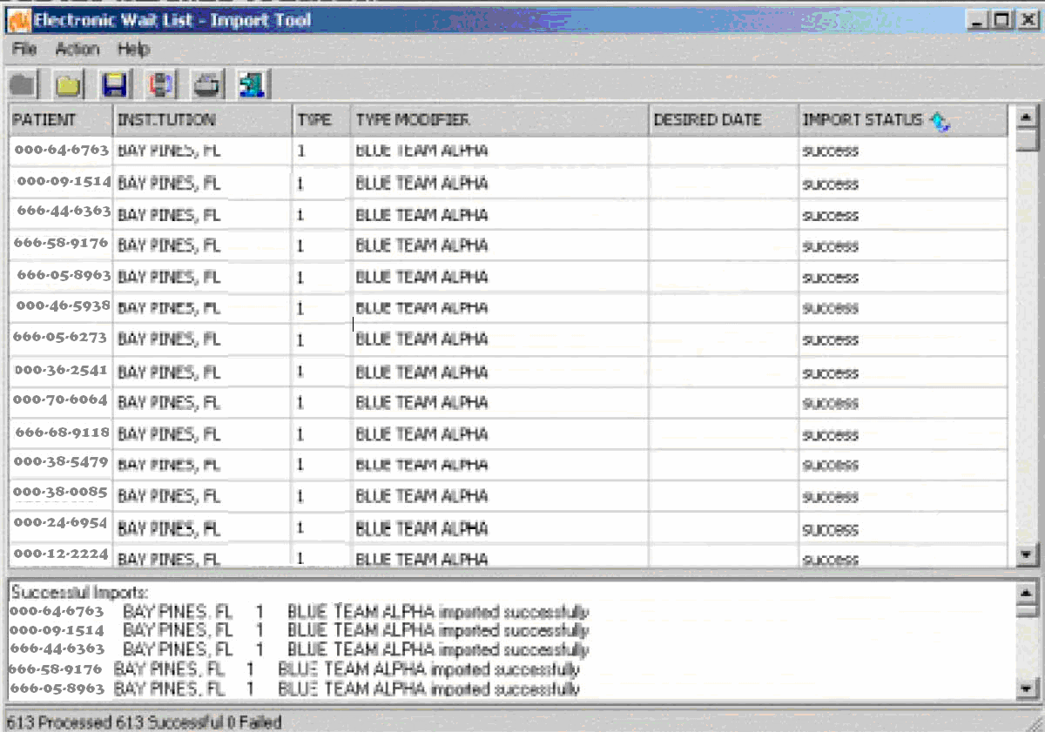

Note: Post import validation can be accomplished with the use VA FileMan print options.

See the EWL Installation Guide for additional information on the Import Tool.

