Group Notes/Encounter Collection

User Manual

June 2022

Department of Veterans Affairs
Office of Information and Technology (OIT)

(This page intentionally left blank)

Revision History
Date | Version | Description
06/2022 | 1.6 | Updates for Patch OR*3*455:  - Expanded Log In Section  - Add Signer Button  - Additional Signer steps  - Updated screen captures  - Updated Title Page, Revision History, Footers, and Table of Contents  - Removed irrelevant ICD-9 text from several screen captures.  - Post to GH.
10/2020 | 1.5 | Added information about a patient’s preferred name on the Patient Selection Screen
03/2017 | 1.4 | Updated Title Page, Revision History, and Table of Contents  Updated the Login section for use with two-factor authentication (2FA)
08/2014 | 1.3 | Updated Title Page, Revision History, Table of Contents and renumbered pages.  Updated Index.  Updated for ProPath template compliance. Made corrections to reference a generic Provider and Clinic in screenshots. Added ICD-10 information to screenshots on pages 14-20.  For patch OR*3*353, changed “ICD-9” to ICD-10, or just “ICD” where appropriate.
08/2014 | 1.2 | Updated for ProPath template compliance. Made corrections to reference a generic Provider and Clinic in screenshots. Added ICD-10 information to screenshots.  For patch OR*3*353, changed “ICD-9” to ICD-10, or just “ICD” where appropriate.
11/01/2004 | 1.1 | Name Sanitation
10/18/2004 | 1.0 | First Draft

(This page intentionally left blank)

Table of Contents
Purpose of Group Notes 1
Scope of the Manual 1
Audience 1
Using Group Notes 2
How Group Notes Works 2
Log In 3
Defining Group Encounter Information and a Patient List 6
Visit Information 6
Defining a List of Patients for the Encounter 7
Common Encounter Data Entry 10
Common Note Title 11
Common Note Text Entry 12
Common Encounter Entry 13
Individual Note Text Entry 15
Individual Encounter Entry 16
Group Signing 18
Repeat 21
Glossary 22

(This page intentionally left blank)

Introduction

Purpose of Group Notes
This program was designed to assist providers in documenting group therapy sessions and events such as immunization clinics. It allows the easy assembly of patient groups based on Clinics, Specialties, Wards, Teams, or Provider lists. It then allows the note author to specify parts of a note that apply to the entire group and parts that apply to individuals. It does the same with encounter data. After the note and encounter information is complete, it provides for a single signature for the entire group.

Scope of the Manual
Tasks associated with Group Notes: System setup, workstation setup, creation of notes for a group, and collection of encounter data. This manual provides information deemed necessary to conduct these functions.

Audience
Information in this manual is intended for end users. This usually means providers conducting group sessions and limited scope clinics such as for training or vaccination.

Using Group Notes

How Group Notes Works
Group Notes is a companion to the CPRS (Computerized Patient Record System) Notes tab. If you are familiar with creating clinical notes in CPRS you will have little trouble with Group Notes.
Creating notes for a group of patients who have just participated in a group therapy session, education, or an immunization clinic follows these steps:
- Set the visit location and the date/time for the encounter.
- Select the patients involved, compiling them into a list.
- Select a note title common for the group.
- Enter note information common for the group.
- Enter encounter data that is common for the group.
- Select individual patients and enter encounter and note information unique to each individual.
- Sign the notes.
- Go back to the patient selection screen and repeat for additional groups.
Note: If you are interrupted and exit the session before signing the note, Group Notes will file notes individually for each patient in an unsigned state and generate notifications that there are notes awaiting signature. Any work after exiting Group Notes must be accomplished in CPRS.

Log In
Users now use a more secure access method called two-factor authentication (sometimes called 2FA). Two-factor authentication simply means that you use your Personal Identification Verification (PIV) card and your Personal Identification Number (PIN) to gain access. If you experience a problem with two-factor authentication, you can select Cancel on the dialog that requests a certificate and enter your access and verify code to log in.
Note: To use the new two-factor authentication, each user’s Active Directory entry must be “Bound” for each VistA instance. So, if you can access one VistA system, but a different one that you access does not work, you will need to contact support to verify that your Active Directory entry has been bound to all the accounts you access.
To login with your PIV card, follow these steps: Double-click the Group Notes icon on your desktop or in your VA Apps folder.
If the Connect To dialog appears, click the down-arrow, select the appropriate account (if more than one exists), and click OK.
In the Windows Security dialog, select the certificate associated with your PIV card and press <Enter>. If there are multiple certificates, choose the one that is for “internal PIV authentication.” You can see that by hovering over the name for the certificate as shown below.
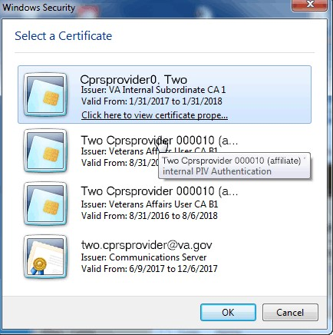

Note: If there is a problem with your PIV or PIN, you can select Cancel to revert to using your access and verify codes.
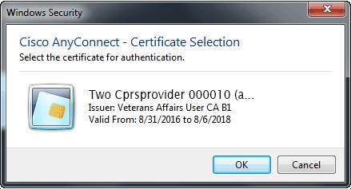
Type your PIN into the dialog that appears and press <Enter>.
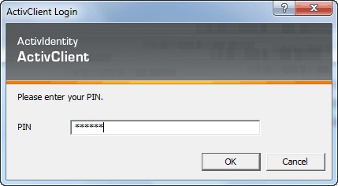
If you lose your PIV card or forget it, there is an alternative way to log into CPRS using your access and verify code. Each user should be assigned an access code and a verify code. You will need to check with your local facility to get your access and verify codes, if necessary.
To login to CPRS with your access and verify code, follow these steps:
- Double-click the CPRS icon on your desktop. The VistA logo window and the VistA Sign-on dialog will appear.
- If the Connect To dialog appears, click the down-arrow, select the appropriate account (if more than one exists), and click OK.
- Type your access code into the Access Code field and press the Tab key.
- Type the verify code into the verify code field and press the Enter key or click OK.

Note: You can also type the access code, followed by a semicolon, followed by the verify code. Once you have done this, press the Enter key or click OK.
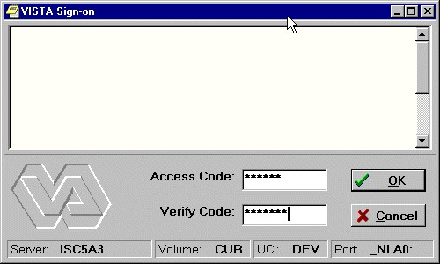
The VISTA Sign-on screen

Defining Group Encounter Information and a Patient List
On the same dialog, the user defines two things:
- the common Encounter Information that will apply to all patients in a group
- the list of patient names for the group note

Visit Information
Information filled in or provided in the Group fields (upper right corner) is carried forward by the program into the encounter fields.
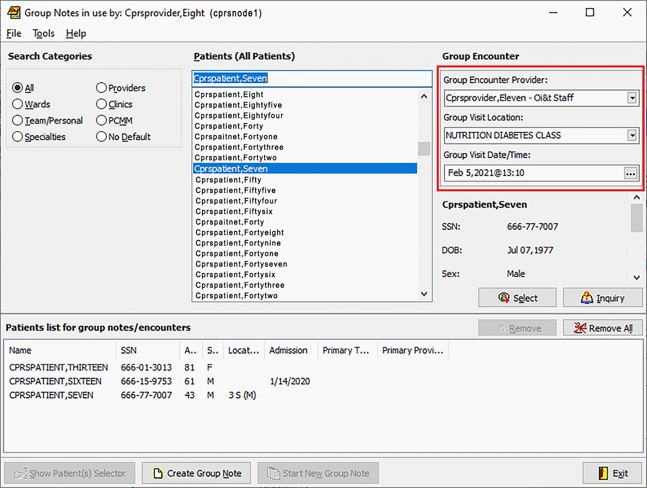
This is the initial Group Notes dialog. The user enters the Group Encounter Provider, the Group Visit Location, and the Group Visit Date/Time in the area on the upper right (red outline added).
Use these steps to define the Group Encounter information:
- In the upper right portion of the dialog, select the name of the Group Encounter provider from the drop-down list. (You can type the first few letters of the provider’s name to move to that area of the list.)
- Define the Group Visit Location from the drop-down list.
- The visit date/time defaults to the date/time when you launch the dialog or start a new group note. If the time is not correct, you can select the icon with three dots, and it will bring up a calendar. You can then set the date and time.
- You can edit the Encounter information until the group note is created.

Defining a List of Patients for the Encounter
From the main Group Notes dialog, the user can define the group of patients to which the common note text and encounter information will be applied. These patient selection fields and buttons are like the CPRS patient selection screen with a few fields and buttons added to facilitate creating group notes.
Note: If the patients are being selected from a clinic appointment list, the date and time of the visit MUST match exactly the date and time of the appointment. If there is a mismatch, you will create a duplicate encounter.
If the patient’s preferred name has been entered into VistA, it will display in parentheses after the patient’s first name in the “Patient list for group notes/encounters box,” as shown below.

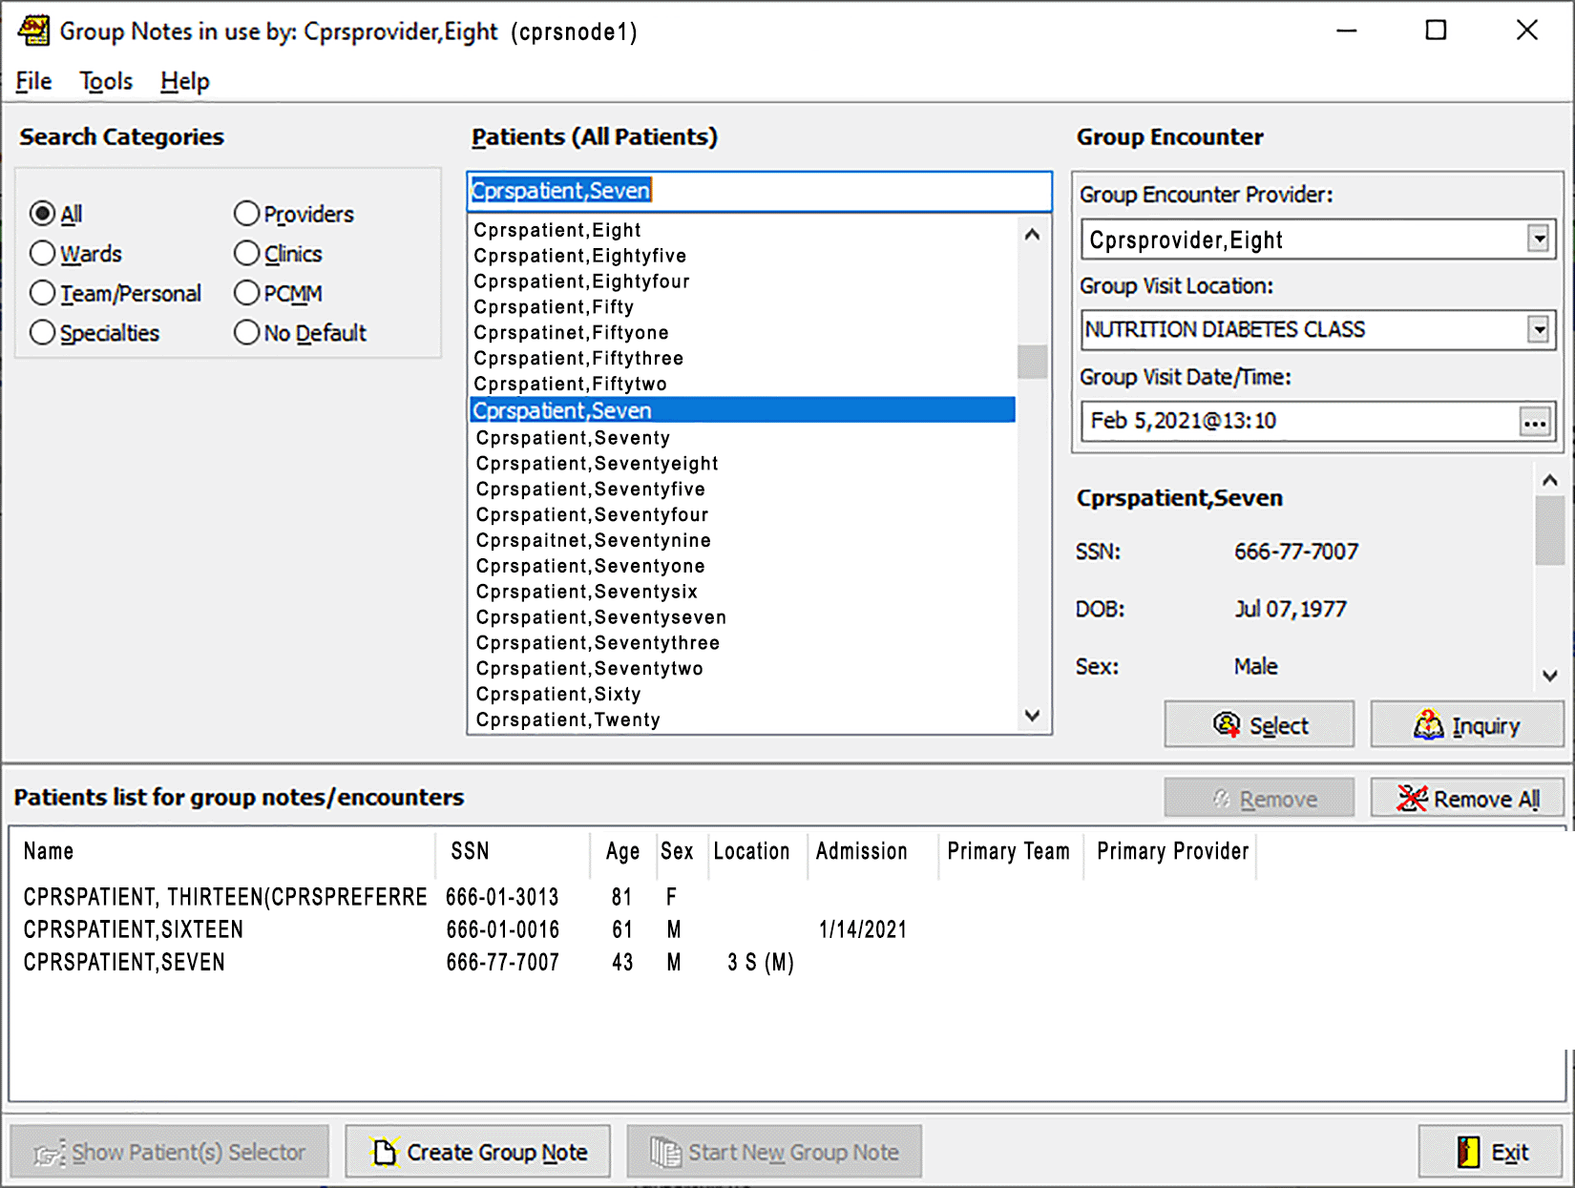

Note: From this dialog, users can create a list of patients. Users can search for patient names and add them to a list. There are buttons to add the name and do an inquiry to ensure it is the correct patient. The list of names is displayed below with preferred names, if defined, displaying in parentheses after the patient's name.

Use these following steps to define the Group of patients:
- If you want to narrow the list of patients, you can use the Search Categories choices.
- Select a category, such as Wards, Team/Personal lists, Specialties, Providers, Clinics, or PCMM teams
- When you select a Category, such as wards, a list of wards displays. Select an item to further narrow your search (such as a specific ward, team, or list) to display a list of patient names.
- Under the Patients box, locate the appropriate name. (You may type a few letters of the name to move to that area of the list, or you may scroll.)
- Highlight a name.
- When you highlight a name, basic demographic information is displayed below the Encounter information. If the user is still unsure whether this is the correct patient, the user can select the Inquiry button. When the user selects in the Inquiry button, Group Notes displays a dialog with detailed patient demographic information. The user can then close the dialog containing the detailed patient information and add the patient if that is the right person, or locate the correct patient if it is not. As each name is selected, using the Select button or double-clicking on a name, the name is added under the Patient list for Group Notes/Encounters in the lower portion of the dialog.
- Review the list. If any incorrect names are in the list, the user can remove individual names using the Remove button. If all names need to be removed, the user can select the Remove All button.
- Using the Select button (or double-clicking on a patient name), the Remove button, or the Remove All button, build the patient list.
- Once the user has the correct patient names, the user selects the Create Group Note button.

Common Encounter Data Entry
Note: Information common to the entire group must be entered before data for an individual patient.
Pressing the Group Notes button moves to the note-building dialog screen. To return to patient selection (to add or subtract patients) use the Show Patient Selector button.
Until you change it by selecting an individual patient, all actions will apply to the entire group.
Note: Use the Update button to modify visit and provider information
Note: Use the New Note button to select a note title
Note: Use the New Encounter button to enter group encounter information

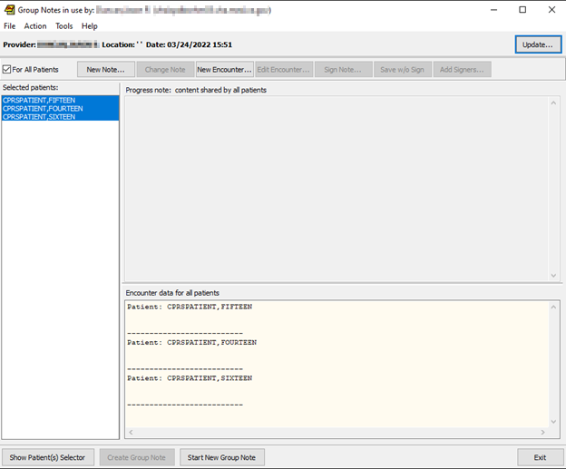
Note-building dialog screen

Common Note Title
Pressing the New Note button will allow you to select a note title. This will be the note title used for each member of the group:
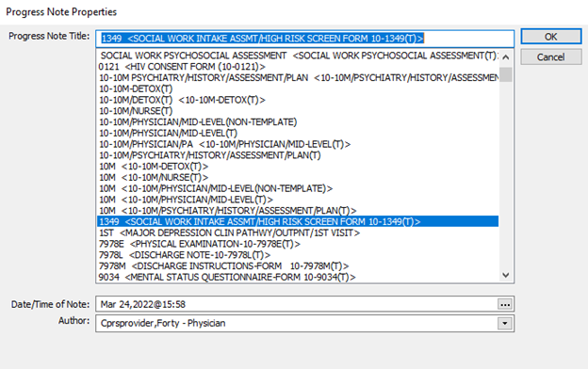

Note: If the provider requires a co-signer, the co-signer must be designated at the time of note title selection. The field for designating a co-signer appears only if the author of the note requires a co-signer. The requirement for co-signer is a product of the author’s User Class and the set-up of the document in TIU.
This is the “point of no return.” Once you select a title, a note will be created for each member of the group. If you exit the program without signing, unsigned notes are created for each member of the group and notifications will appear in CPRS that a note awaiting signature is available for each of these patients.
Warning: Objects in boilerplate are problematic for group notes. The first patient on the list gets filled in and then the note text is given to each patient. So, do not use objects in the boilerplate of these notes titles that would be different for each patient.

Common Note Text Entry
If the note title selected contains boilerplate text, it will appear in the Common note content pane. You may edit the contents of this boilerplate and/or add additional text.
Note: When ready, press the New Encounter button to continue to common
encounter data
Note: Add or modify common note text in the top panel on the right side

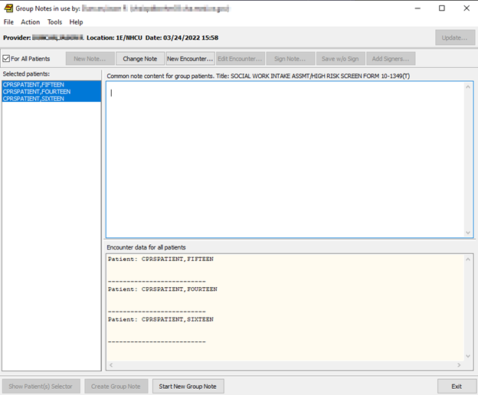

Note: For CACs and ADPACs: When setting up boiler plate that will be used in Group Notes be aware that inserted objects that import specific patient data will not work properly. Do not put TIU objects in this boiler plate. Exceptions to this rule are objects that are general in nature such as the current date.

Common Encounter Entry
The Group Notes encounter form is customized for group entry. At this point in the program only tabs that would be common to all patients are displayed:
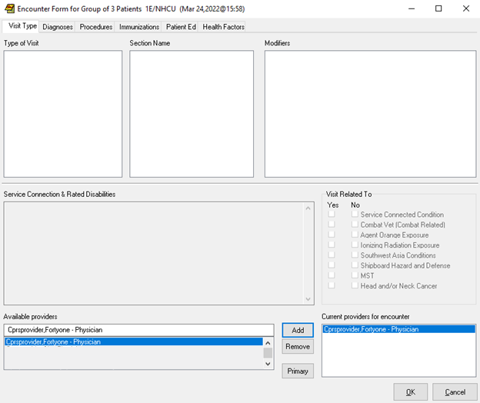
Encounter Form
Fill out the encounter form the way you would normally perform this operation, and then press the OK button. The following dialog will display:

The dialog below displays the Encounter information you entered in the Encounter Data for all patients pane.
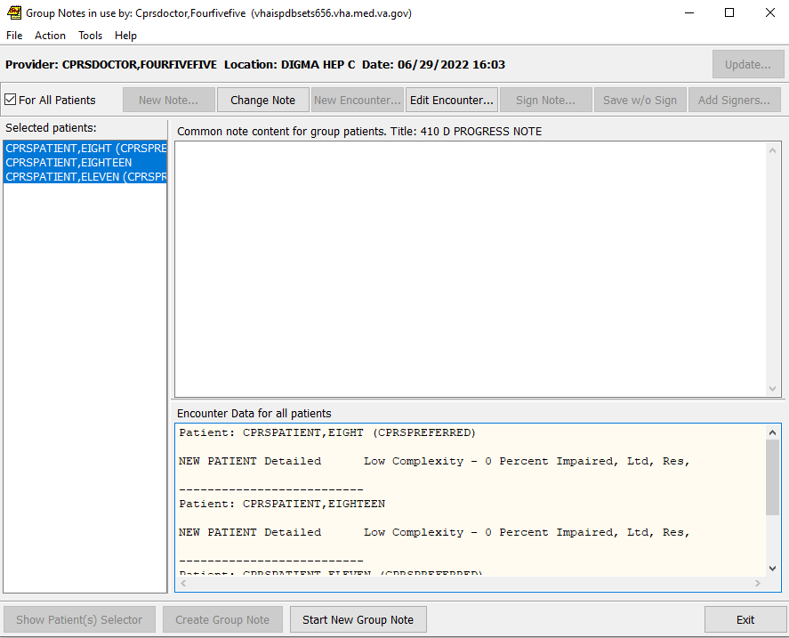

Note: Group encounter data appears in the pane below "Encounter Data for all patients"
Note: ICD-10-CM Diagnosis information will display if the encounter date is on or after the ICD-10 activation date
Note: If you need to enter Encounter data for an individual patient, please see Individual Encounter Entry

Individual Note Text Entry
When an individual patient is selected, the Additional note text pane becomes active.
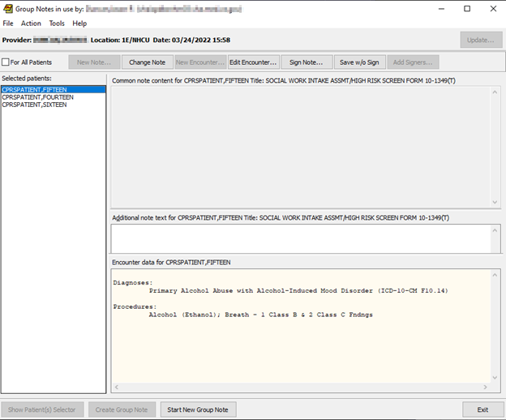

Note: When finished customizing individual notes, press the Edit Encounter button to customize individual encounter data
Note: Type information specific to the selected patient in the Additional Note text pane
Note: Click in the left pane to repeat for each patient that needs specific note text
Note: ICD-10-CM Diagnosis information will display in the pane below "Encounter Data for CPRSPATIENT…" if the encounter date is on or after the ICD-10 activation date

Individual Encounter Entry
When an individual patient is selected the encounter form now shows all tabs.
Note: Use the Encounter Form dialog to enter Encounter data that applies only to the specific patient

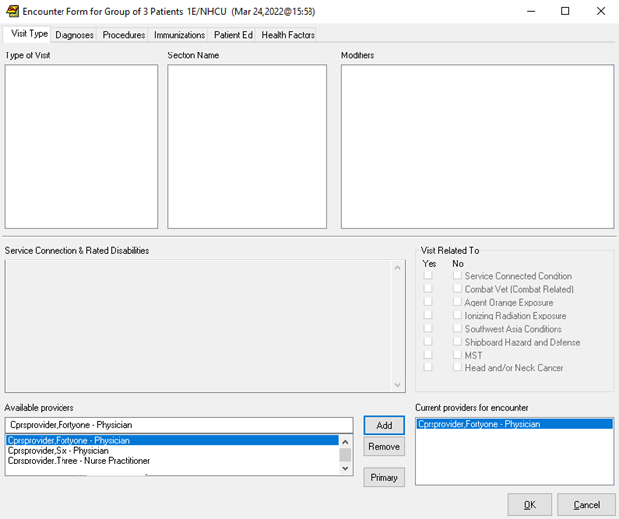

Note: ICD-10-CM Diagnosis information will display in the pane below
"Encounter Data for CPRSPATIENT…" if the encounter date is on or after the ICD-10 activation date
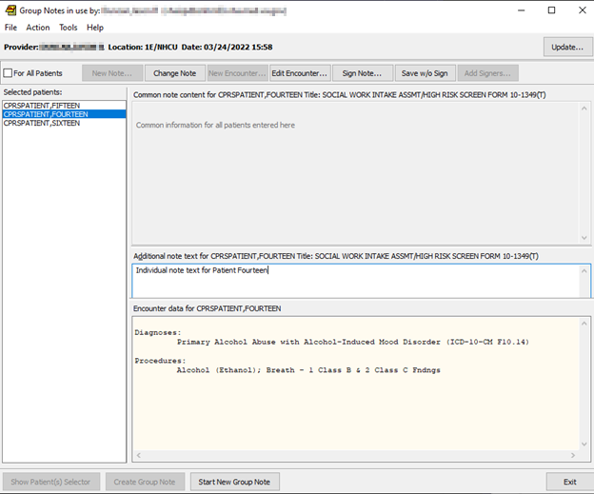

Note: When all data has been entered press the Sign Note button at the top of the screen to display the Sign Note window
Note: The individual encounter data in the bottom pane only appears when that patient is selected

Group Signing
When the Sign Note button is pressed the program automatically selects For All Patients. If any encounter data is missing such as service-connected status, the program will prompt you for it at this time.
Note: When you sign the note in the Sign Note dialog, you are signing
for every patient in the group
Note: ICD-10-CM Diagnosis information will display in the pane below
"Encounter Data for CPRSPATIENT…" if the encounter date is on or after the ICD-10 activation date

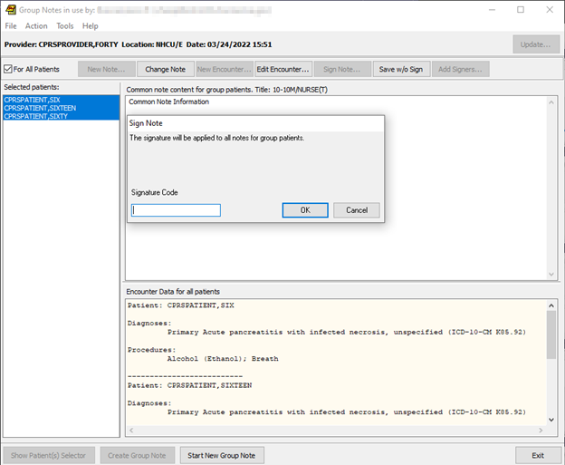
If business rules specify that you need a co-signer, notifications will appear in CPRS to the effect that the expected co-signer has notes ready to sign.

After the signature has been accepted, if the Group Note has been set up for additional signer(s), the Add Signers button becomes enabled.
Note: You can assign one patient or more than one patient
ICD-10-CM Diagnosis information will display in the pane below
"Encounter Data for CPRSPATIENT…" if the encounter date is on or after the ICD-10 activation date

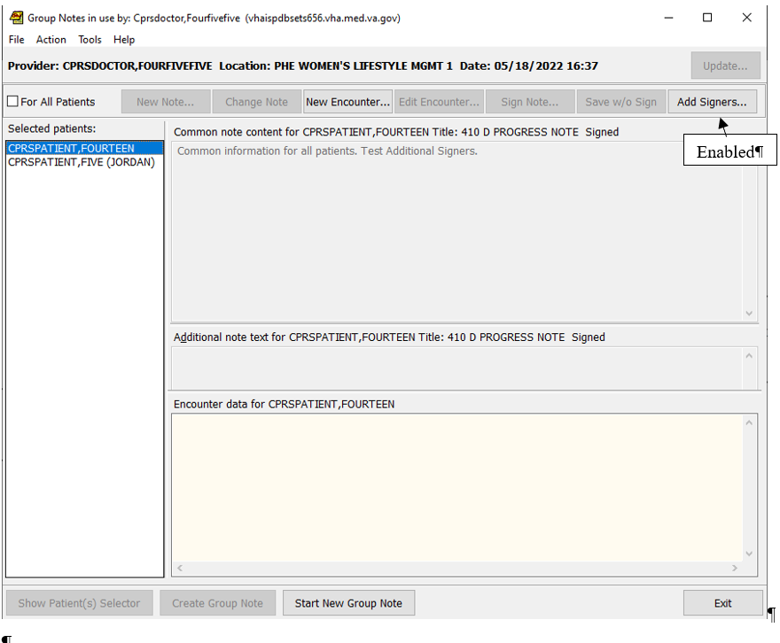

To add Additional Signer(s):
- Click the Add Signers button
- Select and add additional signer(s) from the Identify Additional Signers Dialog. When finished, click the OK button
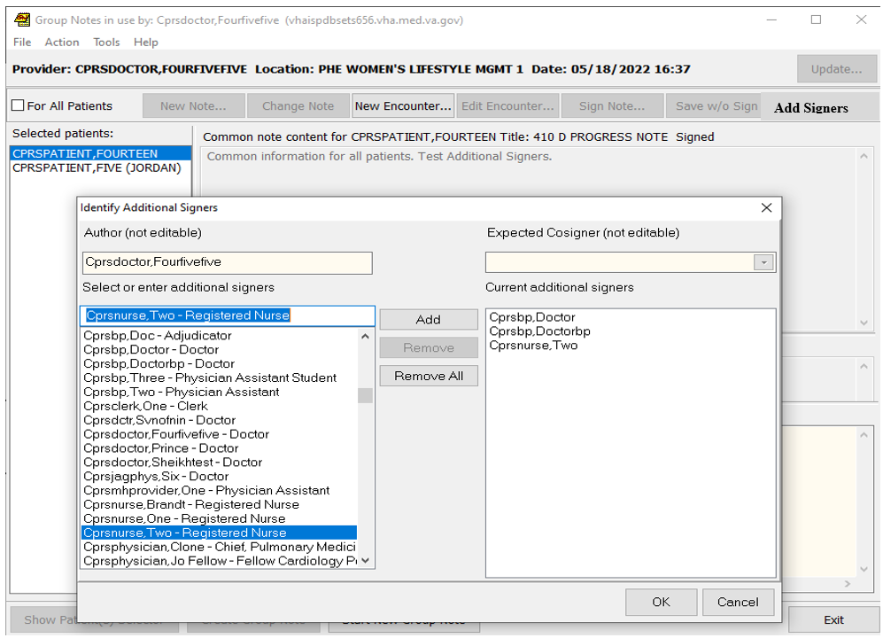
Identify Additional Signers Dialog

Repeat
To return to the patient selection dialog with a clean slate to enter another group note, press the Start New Group Note button. Otherwise press the Exit button
Note: Press the Start New Group Note button to start over on a new group
Note: ICD-10-CM Diagnosis information will display in the pane below
"Encounter Data for CPRSPATIENT…" if the encounter date is on or after the ICD-10 activation date
Patient Selection Dialog

Glossary
ADPAC Automated Data Processing Application Coordinator. A VistA software expert who usually works for IRMS.
Boilerplate A pre-defined TIU template that can be filled in for Titles, speeding up the text entry process. TIU exports several Titles with boilerplate text which can be modified to meet specific needs; sites can also create their own.
For Group Notes, a title with information that would be common for each member of the group works well. Any TIU objects used in boilerplate are filled in as if for the first patient, so avoid objects in Group Notes boilerplate.
CAC Clinical Application Coordinator. A software specialist who usually works for one of the medical center services.
CPRS Computerized Patient Record System. A front-end program that attempts to provide all VistA functionality in a Windows interface. Currently CPRS is being re-written to work in any windowing system that supports a web browser. This will allow users to access VistA from UNIX and Macintosh based systems. The target date for release of this advanced system is third quarter 2005.
IRMS Information Resource Management Service.
TIU Text Integration Utilities. An umbrella package with the purpose of combining all clinical note processing into a single entity. In CPRS, TIU is represented by the Notes tab.
VDL VistA Document Library. A service of the Department of Veterans Affairs to provide documentation to all users. Anyone can access the VDL at web address: www.va.gov/vdl/

