Enterprise Health Management Platform (eHMP)

USER
GUIDE
eHMP Version 1.2
Viewer Edition
August 2016

Contents

Chapter 1: Introduction to eHMP 1
About eHMP 1
System Requirements 1
eHMP User Interface (UI) 1
eHMP Help 2
Online Help Feature 2
National Service Desk (NSD) 2
eHMP Help Resources 2
The Organization of this User Guide 2
Chapter 2: Getting Started 3
Logging into eHMP via IE 11 3
Adding eHMP to Favorites in IE11 4
Accessing eHMP using IE11 Favorites 5
Accessing eHMP through CPRS 6
Logging Out of eHMP 7
Manual Sign Out 7
Auto Sign Out 7
Chapter 3: Patient Search and Selection 9
About Patient Search and Selection 9
Patient Search 9
General Patient Search 9
My Site Search 10
Nationwide Search 11
Selecting a Patient 12
Accessing an Unrestricted Patient Record 12
Accessing a Restricted Patient Record 13
Accessing a Flagged Patient Record 14
Main Application Window 15
Chapter 4: The eHMP Header 16
About the eHMP Header 16
Patient Selection Button 16
eHMP Banner Information 16
User Information Dropdown 17
Patient Photo 18
Patient Demographics 18
Patient Postings 19
Visit Information 20
Care Team Information 20
Chapter 5: Global Timeline Date Filter 22
About the Global Timeline Date Filter 22
Using the Preset Date Ranges 23
Using the Custom Date Range 24
Using the All Events Timeline 24
Using the Timeline Summary 25
Chapter 6: Applet Views 27
Active & Recent Medications 27
Active & Recent Medications: Trend View 27
Active & Recent Medications: Summary View 29
Active & Recent Medications: Detail View 30
Allergies 31
Allergies: Trend View 31
Allergies: Summary View 31
Allergies: Expanded View 32
Allergies: Detail View 32
Appointments & Visits 33
Appointments & Visits: Summary View 33
Appointments & Visits: Expanded View 33
Appointments & Visits: Detail View 34
Clinical Reminders 35
Clinical Reminders: Summary View 35
Clinical Reminders: Expanded View 35
Clinical Reminders: Detail View 36
Community Health Summaries 36
Community Health Summaries: Summary View 36
Community Health Summaries: Expanded View 37
Community Health Summaries: Detail View 37
Documents 38
Documents: Summary View 38
Documents: Expanded View 38
Documents: Detail View 39
Encounters 40
Encounters: Trend View 40
Encounters: Detail View 41
Immunizations 42
Immunizations: Trend View 42
Immunizations: Summary View 42
Immunizations: Expanded View 43
Immunizations: Detail View 43
Medications Review 44
Medications Review: Expanded View 44
Medications Review: Detail View 48
Military History 49
Military History: Summary View 49
Military History: Expanded View 49
Military History: Detail View 50
Military History: Edit Form 50
Narrative Lab Results 51
Narrative Lab Results: Summary View 51
Narrative Lab Results: Expanded View 52
Narrative Lab Results: Detail View 52
Numeric Lab Results 53
Numeric Lab Results: Trend View 53
Numeric Lab Results: Summary View 54
Numeric Lab Results: Expanded View 55
Numeric Lab Results: Detail View 55
Orders 56
Orders: Summary View 56
Orders: Expanded View 57
Orders: Detail View 57
Problems 58
Problems: Trend View 58
Problems: Summary View 59
Problems: Expanded View 60
Problems: Detail View 61
Reports 62
Reports: Summary View 62
Reports: Detail View 62
Stacked Graphs 63
Stacked Graphs: Expanded View 63
Add a Graph to Stacked Graphs Applet 64
Edit the Stacked Graphs Applet 65
Timeline 66
Timeline: Summary View 66
Timeline: Expanded View 66
Timeline: Detail View 67
VistA Health Summaries 67
VistA Health Summaries: Summary View 68
VistA Health Summaries: Detail View 68
Vitals 69
Vitals: Trend View 69
Vitals: Summary View 70
Vitals: Expanded View 71
Vitals: Detail View 72
Chapter 7: Applet Features 73
About Applets 73
Refresh Button 73
Online Help Button 73
Filter Button 74
User-Defined Applet Filters 74
Maximize Applet Button 75
Minimize Applet Button 76
Sortable Column Headers 76
Manual Tile Sort 76
Infobutton 77
Details Form Button 78
Quicklook Button 79
Submenu Button 79
Comment Indicators 80
Chapter 8: Workspaces 81
About Workspaces 81
Predefined Workspaces 81
Workspace Manager 81
Add a New Workspace 82
Workspace Filter 82
Default View 83
Workspace Title 83
Associated Conditions 83
Workspace Description 84
Duplicate Workspaces 84
Rearrange Workspace Listings 85
Delete Workspaces 85
Preview Workspace 86
Customize a New Workspace 86
Launch Workspaces 88
Chapter 9: Other eHMP Features 90
Search Record Field 90
Patient Record Refresh and Status Bar 92

Table of Figures
Figure 2-1 eHMP Login Screen 3
Figure 2-2 Log In Error Message 4
Figure 2-3 Star Button 4
Figure 2-4 Add a Favorite 5
Figure 2-5 Star Button 5
Figure 2-6 Selecting the eHMP Link 6
Figure 2-7 eHMP Link on the CPRS Tools Menu 6
Figure 2-8 Sign Out Button on Header Dropdown 7
Figure 2-9 Auto Logout Warning Message 7
Figure 2-10 Inactivity Logout Message 8
Figure 3-1 Patient Selection Screen 9
Figure 3-2 General Patient Search 10
Figure 3-3 My Site/Clinics 10
Figure 3-4 My Site/Wards 11
Figure 3-5 Nationwide Search 12
Figure 3-6 Too Many Results Have Returned 12
Figure 3-7 Patient Detail Dialog 13
Figure 3-8 Restricted Record Acknowledgement 13
Figure 3-9 Confirm Selection of Restricted Patient Record 14
Figure 3-10 Confirm Selection of Flagged Patient Record 14
Figure 3-11 Main Application Window 15
Figure 4-1 The eHMP Header 16
Figure 4-2 Detailed eHMP Banner Information 17
Figure 4-3 Sign Out Option 17
Figure 4-4 Patient Photo (Example) 18
Figure 4-5 Patient Demographics 18
Figure 4-6 Patient Demographics Bar with Broken Chain Link 18
Figure 4-7 Expanded Patient Information 19
Figure 4-8 Postings Icons 19

Figure 4-9 Expanded Postings Information 20
Figure 4-10 Visit Information 20
Figure 4-11 Care Team Information 21
Figure 4-12 Detailed Care Team Information 21
Figure 5-1 Global Timeline Date Filter 22
Figure 5-2 Expanded Global Timeline Date Filter 23
Figure 5-3 Preset Date Ranges 23
Figure 5-4 Calendar Dropdown 24
Figure 5-5 All Events Timeline 24
Figure 5-6 Filter Button 25
Figure 5-7 Patient Activity Detail Dialog Box 26
Figure 6-1 Active & Recent Medications Applet Trend View 27
Figure 6-2 Active & Recent Medications Applet Toolbar Menu – Trend View 28
Figure 6-3 Active & Recent Medications Quick View 29
Figure 6-4 Active & Recent Medications Applet Summary View 29
Figure 6-5 Active & Recent Medications Applet Toolbar Menu – Summary View 29
Figure 6-6 Active & Recent Medications Details Form Button 30
Figure 6-7 Active & Recent Medications Detail Dialog Box 30
Figure 6-8 Allergies Applet Trend View 31
Figure 6-9 Allergies Applet Summary View 31
Figure 6-10 Allergies Applet Expanded View 32
Figure 6-11 Allergy Detail Dialog Box 32
Figure 6-12 Appointments & Visits Applet Summary View 33
Figure 6-13 Appointments & Visits Applet Expanded View 34
Figure 6-14 Appointments & Visits Detail Dialog Box 34
Figure 6-15 Clinical Reminders Applet Summary View 35
Figure 6-16 Clinical Reminders Applet Expanded View 35
Figure 6-17 Clinical Reminders Detail Dialog Box 36
Figure 6-18 Community Health Summaries Applet Summary View 36
Figure 6-19 Community Health Summaries Applet Expanded View 37
Figure 6-20 Community Health Summaries Detail Dialog Box 37

Figure 6-21 Documents Applet Summary View 38
Figure 6-22 Documents Applet Expanded View 39
Figure 6-23 Documents Detail Dialog Box 39
Figure 6-24 Encounters Applet Trend View 40
Figure 6-25 Encounters List in Trend View (Expanded) 40
Figure 6-26 Encounters Applet Toolbar Menu 41
Figure 6-27 Encounters Detail Dialog Box 41
Figure 6-28 Immunizations Applet Trend View 42
Figure 6-29 Detail of an Immunization in Trend View 42
Figure 6-30 Immunizations Applet Summary View 42
Figure 6-31 Immunizations Applet Expanded View 43
Figure 6-32 Immunizations Detail Dialog Box 43
Figure 6-33 Medications Review Applet Expanded View 44
Figure 6-34 Medications Review Outpatient Meds 45
Figure 6-35 Outpatient Medications Graph Indicators 46
Figure 6-36 Medications Review Inpatient Meds 47
Figure 6-37 Medications Review Clinic Order Meds 48
Figure 6-38 Medications Review Applet Detail View 48
Figure 6-39 Military History Applet Summary View 49
Figure 6-40 Military History Applet Expanded View 50
Figure 6-41 Military History Detail Dialog Box 50
Figure 6-42 Edit Military History 51
Figure 6-43 Narrative Lab Results Applet Summary View 51
Figure 6-44 Narrative Lab Results Applet Expanded View 52
Figure 6-45 Narrative Lab Results Detail Dialog Box 53
Figure 6-46 Numeric Lab Results Applet Trend View 54
Figure 6-47 Numeric Lab Results Quick View 54
Figure 6-48 Numeric Lab Results Applet Summary View 54
Figure 6-49 Numeric Lab Results Applet Expanded View 55
Figure 6-50 Numeric Lab Results Detail Dialog Box 56
Figure 6-51 Orders Applet Summary View 56

Figure 6-52 Orders Applet Expanded View 57
Figure 6-53 Orders Detail Dialog Box 58
Figure 6-54 Problems Applet Trend View 58
Figure 6-55 Problems Applet Trend View Toolbar Menu 59
Figure 6-56 Problems Applet Quick View 59
Figure 6-57 Problems Applet Summary View 60
Figure 6-58 Problems Applet Summary View Toolbar Menu 60
Figure 6-59 Problems Applet Expanded View 61
Figure 6-60 Problems Detail Dialog Box 61
Figure 6-61 Reports Applet Summary View 62
Figure 6-62 Reports Detail Dialog Box 63
Figure 6-63 Stacked Graphs Applet Expanded View 64
Figure 6-64 Add Graph to Stacked Graphs Applet 64
Figure 6-65 Graph Added to Stacked Graphs Applet 64
Figure 6-66 Stacked Graphs Applet Toolbar Menu 65
Figure 6-67 Delete Stacked Graphs Warning 65
Figure 6-68 Timeline Summary View 66
Figure 6-69 Timeline Expanded View 66
Figure 6-70 Timeline Detail Dialog Box 67
Figure 6-71 VistA Health Summaries Summary View 68
Figure 6-72 VistA Health Summaries Detail Dialog Box 68
Figure 6-73 Vitals Applet Trend View 69
Figure 6-74 Vitals Applet Trend View Toolbar Menu 70
Figure 6-75 Vitals Applet Quick View 70
Figure 6-76 Vitals Applet Summary View 70
Figure 6-77 Vitals Detail Dialog Box 71
Figure 6-78 Vitals Applet Expanded View 72
Figure 6-79 Vitals Detail Dialog Box 72
Figure 7-1 Applet Feature Buttons 73
Figure 7-2 PDF Version of the eHMP User Guide 74
Figure 7-3 Filtered Applet 75

Figure 7-4 Filter Name 75
Figure 7-5 Sortable Column Header 76
Figure 7-6 Tile Sorting 77
Figure 7-7 Manual Tile Sorting 77
Figure 7-8 Infobutton in the Problems Applet 78
Figure 7-9 Detail Dialog Box for Selected Item 78
Figure 7-10 Quicklook Button 79
Figure 7-11 Selecting Submenu Button to List Associated Workspaces 79
Figure 7-12 Comment Indicator 80
Figure 7-13 Detailed Comment Information 80
Figure 8-1 Workspace Manager Window 82
Figure 8-2 Filter Workspaces 82
Figure 8-3 Workspace Title Field 83
Figure 8-4 Search Problems Field 83
Figure 8-5 Problems Search Results 84
Figure 8-6 Number of Associated Problems 84
Figure 8-7 Workspace Add Description Field 84
Figure 8-8 Duplicated Workspace 85
Figure 8-9 Rearrange Workspaces 85
Figure 8-10 Delete User-Defined Workspace Confirmation Message 86
Figure 8-11 Workspace Preview 86
Figure 8-12 Workspace Editor Screen 87
Figure 8-13 Select a View 87
Figure 8-14 Using Double Arrows to Modify Applet Size 88
Figure 8-15 Launch Workspaces 88
Figure 9-1 Search Record Field Dropdown 90
Figure 9-2 Search Record Results 90
Figure 9-3 Selected Keyword 91
Figure 9-4 Selected Keyword Detail Dialog Box 91
Figure 9-5 eHMP Status Bar 92
Figure 9-6 eHMP Data Sources 92

Chapter 1: Introduction to eHMP

About eHMP
The Enterprise Health Management Platform (eHMP) project is a multi-year effort to evolve a modern, service-oriented platform which provides a web-based user interface (UI), clinical data services (CDS), and assembles patient clinical data from federated Veterans Health Information Systems and Technology Architecture (VistA) repositories, Department of Defense (DoD), and private partner data sources, reflective of each location providing care to the patient. This federated data is aggregated into an enterprise patient record. eHMP service components will span all application layers, including presentation, business and core services, and data access.
Release 1.2 introduces critical viewer edition enhancements to provide new capabilities to the Department of Veterans Affairs (VA) beyond what is available today via Computerized Patient Record System (CPRS), Joint Legacy Viewer (JLV), and VistAWeb. The system will provide enhanced presentations of clinical data that will range from trend views that provide a quick snapshot of easily understandable data, to detailed views that provide the user with a full range of options for examining longitudinal patient medical records. Users will be able to configure these views into a limitless number of custom workspaces in order to support a variety of clinical workflows. There will also be multiple pre-configured workspaces available to the user, which are filtered for specific conditions. The workspaces will provide the appropriate clinical information for a selected condition (e.g., COPD, Diabetes). Further enhancements will include the Military History applet, improved text search, and online application help screens.
A significant step toward reaching interoperability goals is the incorporation of discrete, clinical information received from community health partners via C32 (Continuity of Care Document (CCD), which focuses on patient summary information) and Consolidated-Clinical Document Architecture (C-CDA) documents. The narrative portions of these documents are available in eHMP.

System Requirements

eHMP User Interface (UI)
eHMP is a web-based application, and is designed to run in a web browser. eHMP release v1.2 is optimized for use with Internet Explorer 11 (IE 11).

eHMP Help

Online Help Feature
There are online help buttons throughout the eHMP application. The online help feature
provides detailed information about specific system topics. Select the online help button to open context-specific help in a separate window.

National Service Desk (NSD)
The National Service Desk (NSD) is available to report any issues while using eHMP. REDACTED
Please note the following:
- The NSD sets priorities for tickets based on an accepted NSD Priority Matrix.
- Requesting support via an email is not as expedient as placing a phone call, as emails are deemed to be non-urgent. Emails are processed for support within 24 hours of receipt.
- Password resets cannot be achieved via email; you must contact NSD by phone.

eHMP Help Resources
The VA eHMP Deployment SharePoint site¹ and the eHMP Deployment page on VA Pulse² provides resources for more reference information on the eHMP application. Some of the available resources include frequently asked questions (FAQs), quick reference guides, and system demonstrations.
In addition, the VA Software Document Library³ (VDL) houses a variety of eHMP documents.

The Organization of this User Guide
This User Guide is organized to mimic the use of the application, beginning with how to log in to eHMP, and progresses by giving instructions for each of the features available within the application.

¹ REDACTED
² REDACTED
³ http://www.va.gov/vdl/

Chapter 2: Getting Started
eHMP can be accessed in two ways: through IE11, or through CPRS. The steps for accessing eHMP are described below.
Note: Not all sites have eHMP set up on the Tools Menu in CPRS.

Logging into eHMP via IE 11
- Open IE11. Enter the eHMP v1.2 web address⁴ into the address field, and the login screen displays.
The login screen displayed in Figure 2-1 is comprised of disclosure and warning language, with application information on the left side of the window, and credential entry fields on the right side of the window.

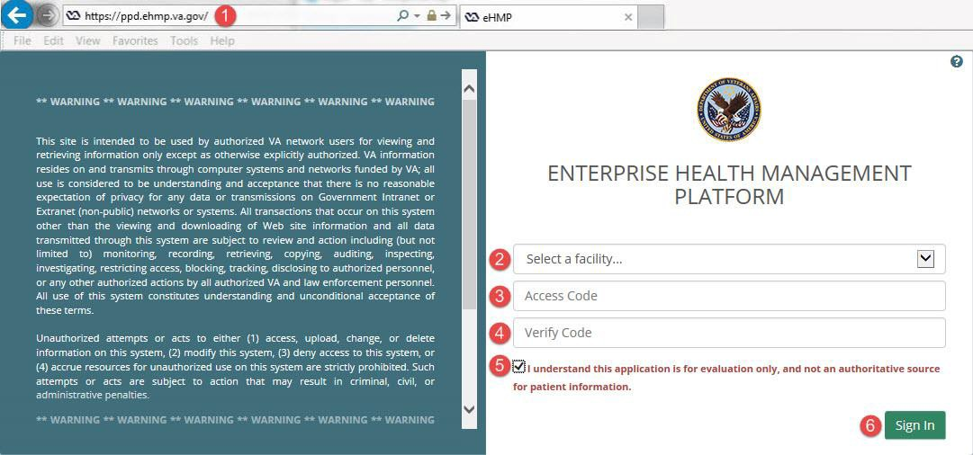Figure 2-1 eHMP Login Screen
- Select a facility from the Select a facility...dropdown menu.
- Enter your VistA access code into the Access Code field, and then press the Tab key to advance to the following field.
- Enter your VistA verify code into the Verify Code field.
Note: Select the Show icon to display the entered text in the Access Code and Verify Code fields.
- Review the acknowledgement and then select the checkbox.

⁴ https://ehmp.va.gov

Note: eHMP does not allow you to sign in unless the checkbox is selected.
- Select the Sign In button to display the Patient Selection screen.

Note: If you receive the message below (Figure 2-2) when trying to log in, you need to change the expired Verify Code using CPRS. The current version of eHMP does not allow you to change an expired Verify Code.

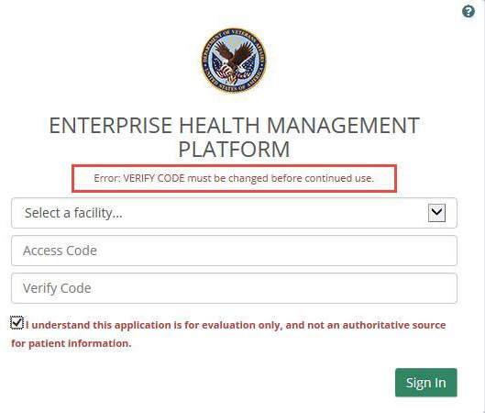Figure 2-2 Log In Error Message

Adding eHMP to Favorites in IE11
- Access eHMP.
- Select the star button (Figure 2-3) in the upper right corner of the application window.

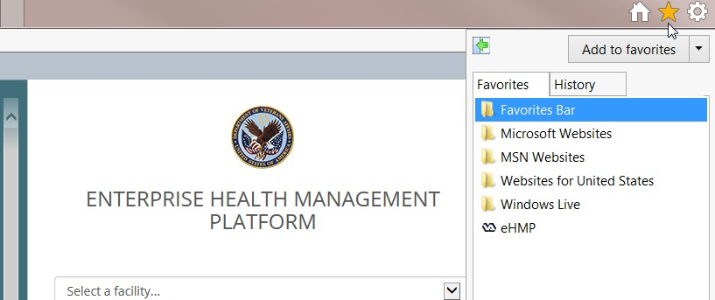Figure 2-3 Star Button

- Select Add to Favorites. The Add a Favorite dialog (Figure 2-4) pops up.

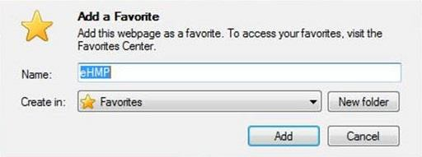Figure 2-4 Add a Favorite

- Select Add.

Accessing eHMP using IE11 Favorites
- Open IE11.
- Select the star button (Figure 2-5) in the upper right corner of the application window.

Figure 2-5 Star Button

- Select the eHMP link (Figure 2-6).

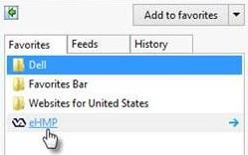Figure 2-6 Selecting the eHMP Link

- The eHMP application displays in the browser window.

Accessing eHMP through CPRS
- Access CPRS as usual.
- Select eHMP from the CPRS Tools dropdown menu (Figure 2-7).
Note: Not all sites have eHMP set up on the Tools Menu in CPRS.

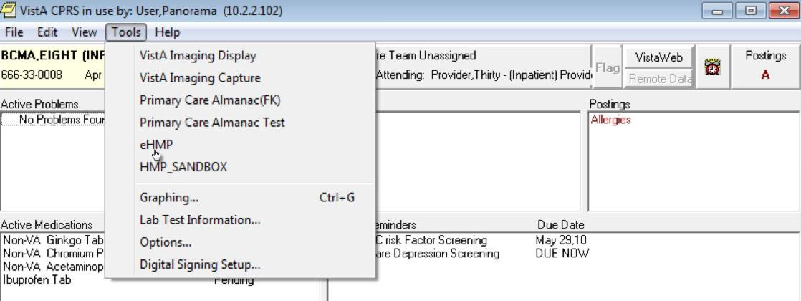Figure 2-7 eHMP Link on the CPRS Tools Menu

- The eHMP application opens.
Note: If you accessed a patient’s record in CPRS prior to logging into eHMP, that same patient’s record is the default patient view displayed when you are automatically logged into eHMP. Likewise, if you access a particular patient in eHMP, that patient’s record is the default view presented when you switch back to CPRS. This is available only if Sentillion client or CCOW has been installed on your workstation.

Logging Out of eHMP
There are two ways to log out of eHMP: signing out manually, or being automatically logged out due to inactivity.

Manual Sign Out
- Select your user name on the header in the upper right corner, and a dropdown displays.
- Select Sign Out (Figure 2-8) to log out of eHMP.

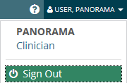Figure 2-8 Sign Out Button on Header Dropdown

Auto Sign Out
When you have been inactive for 12 minutes, a warning message informing you your session ends in 3 minutes (Figure 2-9) displays. You are given the option to stay logged in by selecting the Continue button, or to log out of the application by selecting the Logout button.

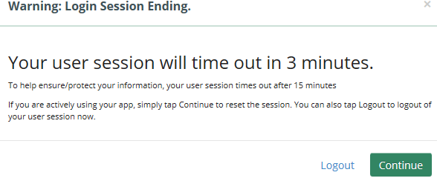Figure 2-9 Auto Logout Warning Message

When you have been inactive in the eHMP application for 15 minutes or more, you are automatically logged out of the application, and a warning message (Figure 2-10) displays.

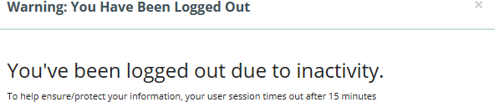Figure 2-10 Inactivity Logout Message

Chapter 3: Patient Search and
Selection

About Patient Search and Selection
If you accessed eHMP through IE11, the Patient Selection screen displays (Figure 3-1), where you have the option to search for a patient.

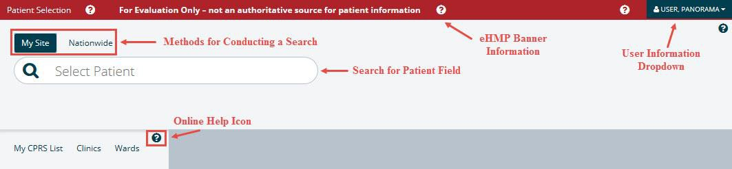Figure 3-1 Patient Selection Screen

Patient Search
In order to access patient information and the detailed views of the eHMP application, you must conduct a patient search.
There are a couple of methods for conducting a patient search in eHMP:
- General Patient search
- My Site search
- Nationwide search

General Patient Search
To run a general patient search:
- Enter the patient’s first initial of their last name followed by the last four digits of their social security number (SSN), or enter a generic name in the Select Patient field.
- Select the magnifying glass or press enter to run the search (Figure 3-2).

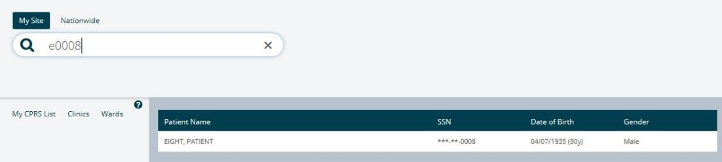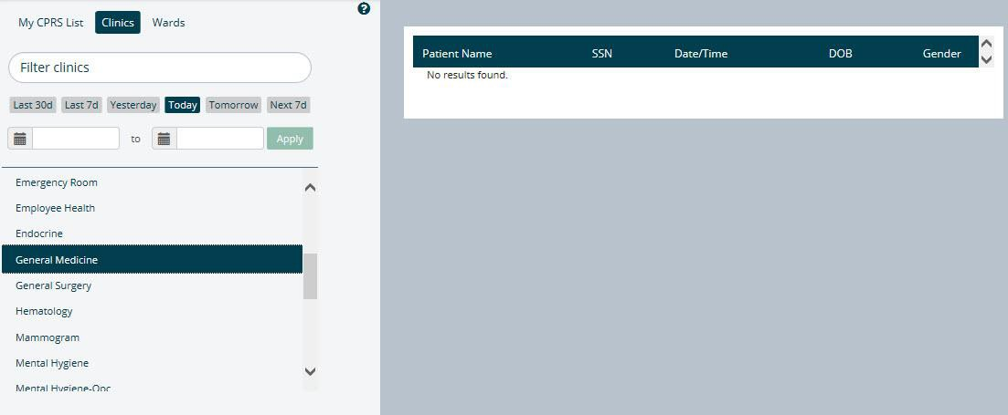Figure 3-2 General Patient Search

My Site Search
The My Site search allows you to search for a patient from several perspectives, including a comprehensive list of all patients, from your defined default patient selection list in CPRS, patients from a specific clinic, or patients in a specific ward at your local VA facility.

My CPRS List
If you have defined a default patient selection list in CPRS, that same list of patients is presented in eHMP.
- Select the My CPRS List tab. A list of patients displays.
- Select a patient from the list to display the Patient Detail Dialog.

Clinics
To search for a patient using the My Site/Clinics method:
- Select the My Site tab.
- Select the Clinics tab. A list of clinics at the local VA facility displays.
- Filter the list of results by entering the name of the clinic in the Filter clinics field. The results populate as you type.
- Select the clinic name from the list. The list of patients from that clinic are displayed (Figure 3-3).

Figure 3-3 My Site/Clinics

- Use the preset date range buttons to filter through the list of patients at the selected clinic.
- Select a patient’s name to display the Patient Detail Dialog.

Wards
To search for a patient (within a specific ward) using the My Site/Wards method:
- Select the My Site tab.
- Select the Wards tab. The list of wards at the local VA facility are displayed.
- Filter the list of results by entering the ward name in the Filter wards field.
- Select the ward name from the list. The list of patients in that ward are displayed (Figure 3-4).

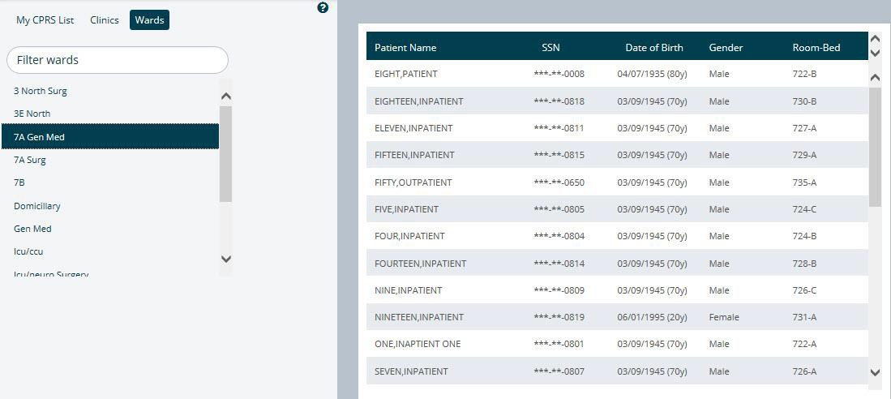Figure 3-4 My Site/Wards
- Select a patient’s name to display the Patient Detail Dialog.

Nationwide Search
The Nationwide search feature is used to run a patient search across the enterprise, including all VistA systems, as well as external systems, such as DoD and the Nationwide Health Information Network (NwHIN). This search allows you to enter the patient’s last name (required) and one or more fields to enable search (first name, date of birth (DOB), and SSN).
To run a Nationwide Patient search:
- Select the Nationwide tab (Figure 3-5).

Figure 3-5 Nationwide Search
- Enter the patient’s last name in the Last Name (required) field.
- Enter the patient’s first name in the First Name (req) field.
- Enter the patient’s SSN in the SSN: ###-##-#### (req) field.
- Select the Search button. The search results display below the search bar.
Note: Depending on the search results, the request may result in no patient found, 1 to 10 matching results found, or more than 10 records found, which returns a notification message in place of the records (Figure 3-6).

Figure 3-6 Too Many Results Have Returned

Selecting a Patient
Once the correct patient has been found, select that patient’s name from the search results list. If a patient record is not restricted, their record can be displayed after confirming the selection (as demonstrated in the Accessing an Unrestricted Patient Record section) of that patient.
If a patient record is restricted, a warning appears prior to accessing the record, requiring acknowledgement of the restricted nature of the record before accessing it (as demonstrated in the Accessing a Restricted Patient Record section).

Accessing an Unrestricted Patient Record
To access an unrestricted patient record:
- Select the name of the patient from the search results list. The Patient Detail Dialog appears (Figure 3-7).

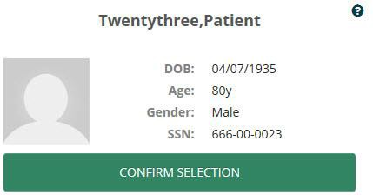Figure 3-7 Patient Detail Dialog
- Select the CONFIRM SELECTION button.
- The patient’s record displays in the Main Application Window.

Accessing a Restricted Patient Record
To access a restricted patient record:
- Select the name of the patient from the search results list.
Note: The word SENSITIVE displays instead of the patient’s SSN and DOB.
- The Restricted Record Dialog appears (Figure 3-8).

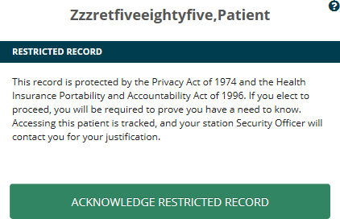Figure 3-8 Restricted Record Acknowledgement

The notification that appears in the dialog makes you aware that the patient’s record is restricted, and advises that if you proceed to “break the glass” and open the record, your activity is tracked. In addition, your station Security Officer will contact you for your justification in accessing the restricted patient record.
- Review the notification dialog, and select the ACKNOWLEDGE RESTRICTED RECORD button. The Restricted Record Patient Detail Dialog appears (Figure 3-9), displaying your acknowledgement of the restricted record.

Note: Select to display the warning again.

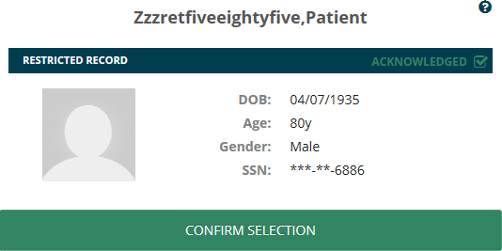Figure 3-9 Confirm Selection of Restricted Patient Record
- Select the CONFIRM SELECTION button.
- The patient’s record displays in the Main Application Window.

Accessing a Flagged Patient Record
There are patients in the system with flagged records. The purpose of a patient record flag is to alert providers about certain patients, such as patients with disruptive, threatening, and/or violent behaviors, or research patients. The patient record flags can be national (Category I), which are shared among the VA facilities, or local (Category II), which are only shared at the local site. You must review and acknowledge the patient record flag during patient selection before accessing the patient record.
To access a flagged patient record:
- Select the name of the patient from the search results list. The Patient Detail Dialog appears.
- Select the CONFIRM SELECTION button. The Patient Flag Dialog appears (Figure 3-10).
Note: Some patients may have more than one patient record flag. Scroll through the patient flag dialog to review all of the notifications associated with a patient.

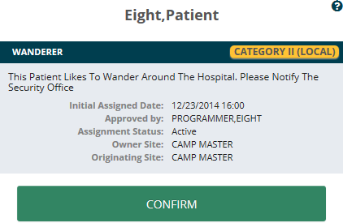Figure 3-10 Confirm Selection of Flagged Patient Record

- Review the notification dialog, and Select the CONFIRM button.
- The Main Application Window appears, displaying the patient record.

Main Application Window
Once the patient has been selected and confirmed, the patient record opens and you are navigated to the Main Application Window (Figure 3-11). The Main Application Window is comprised of the eHMP Header, Global Timeline Date Filter, Workspace Manager and listing, search record field, and the user workspace. Each of these areas is described in subsequent chapters.

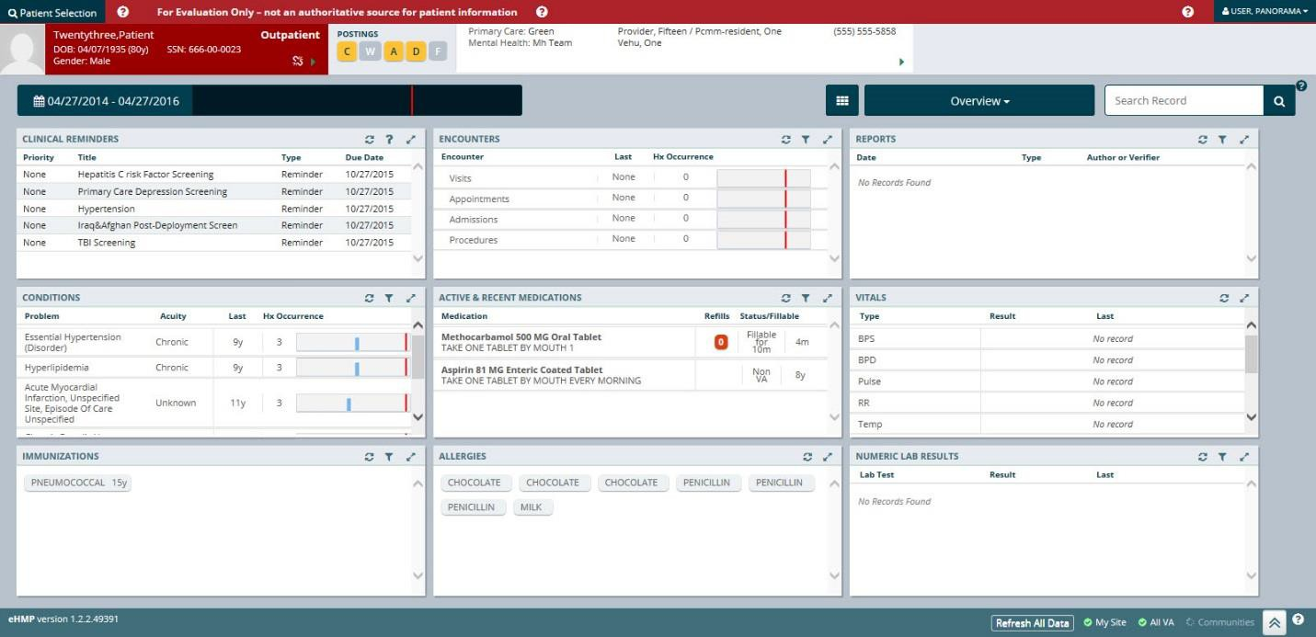Figure 3-11 Main Application Window

Chapter 4: The eHMP Header

About the eHMP Header
The eHMP Header (Figure 4-1) displays abbreviated information. It lists the logged in user, allows for another patient search, and presents demographics about the displayed patient, any postings associated with the patient, the visit information for a patient with an inpatient status, and the patient’s care team information.
The following elements make up the eHMP Header:
- Patient Selection button
- eHMP Banner Information
- User information dropdown
- Patient photo
- Patient demographics, inpatient/outpatient status, and clinical context object workgroup (CCOW) status
- Patient postings
- Visit Information (inpatient status only)
- Care team information
Figure 4-1 The eHMP Header

Patient Selection Button

The Patient Selection button Header.
is located in the top left corner of the eHMP

- Select the button to navigate back to the Patient Selection screen to search for another patient.
- Select the X in the upper right corner of the Patient Selection screen to cancel a search, and return to the current patient record.

eHMP Banner Information
The eHMP banner informs you that the application is for evaluation only, and should not be used as an authoritative source for patient information.

To display detailed information:
- Select the online help button next to the banner text. A Detail Dialog box displays with information regarding the eHMP banner (Figure 4-2).

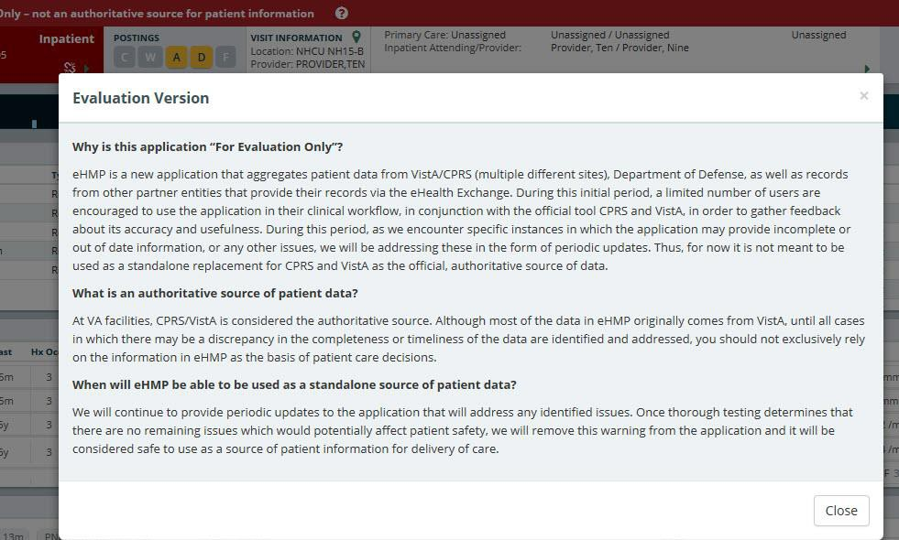Figure 4-2 Detailed eHMP Banner Information
- Select the Close button to close the Detail Dialog box and return to the patient record.

User Information Dropdown
Your user information displays in the upper right corner of the eHMP application. As depicted in Figure 4-3, selecting your name results in the display of a dropdown menu with the Sign Out option.
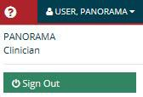Figure 4-3 Sign Out Option

Patient Photo
eHMP displays the patient image as found in VistA Imaging. The image is retrieved from the Veteran Health Identification Card (VHIC) system and is displayed in the header. If an image is unavailable for that patient, then a gender-neutral image displays (Figure 4-4).

Figure 4-4 Patient Photo (Example)

Patient Demographics
The selected patient is listed on the header in the upper left corner. By default, the patient’s name, DOB, age, SSN, and Gender display (Figure 4-5). In addition, a status of inpatient or outpatient, and the status of CCOW is indicated. When eHMP is in patient context, a green chain link icon displays as displayed in Figure 4-5. A red demographics bar with a broken chain link indicates that eHMP is not in patient context as displayed in Figure 4-6.

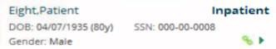Figure 4-5 Patient Demographics

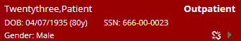Figure 4-6 Patient Demographics Bar with Broken Chain Link

To display expanded patient information:
- Select the dropdown arrow to open the Patient Demographics Dialog. The dialog contains sections with additional patient information.
- When the icon is displayed, non-local demographic data is available and can be displayed by selecting the section (Figure 4-7).

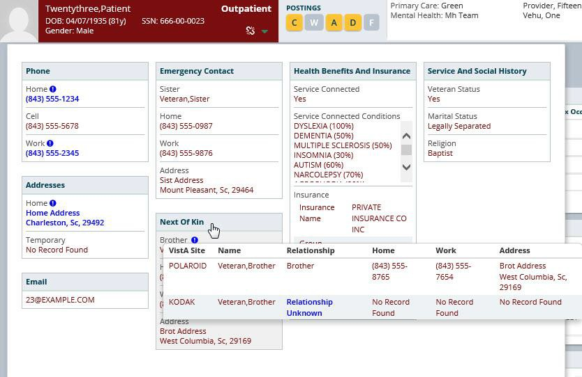Figure 4-7 Expanded Patient Information
- Select the dropdown arrow again or anywhere outside of the dialog box to exit the dialog and return to the previous view.

Patient Postings
The Postings section of the eHMP Header presents shortcuts to the following pieces of information:
- Crisis notes
- Warnings
- Allergies and Adverse Drug Reactions
- Directives
- Patient Record Flags
The Postings area of the eHMP header is depicted in Figure 4-8.

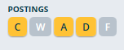Figure 4-8 Postings Icons

The highlighted letters in the Postings area indicate that detailed information can be accessed.
- Selecting a highlighted letter opens a dialog with detailed information (Figure 4-9).

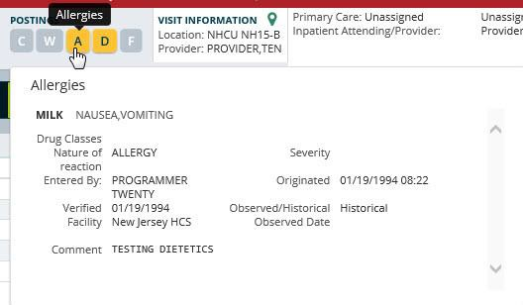Figure 4-9 Expanded Postings Information
- Selecting the highlighted letter again, or anywhere outside of the box, closes the dialog and returns to the previous view.

Visit Information
If the patient has an inpatient status, then the visit information displays with the ward location and the Attending Inpatient Provider (Figure 4-10). If the Attending Inpatient Provider does not exist, then it displays the Inpatient Provider.

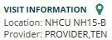Figure 4-10 Visit Information

Care Team Information
Abbreviated Care Team Information for the selected patient is displayed in the eHMP Header (Figure 4-11). The information displayed here includes:
- The primary care team and provider
- The associate name (if available)

- The team phone number
- The mental health treatment team and treatment coordinator (if available). If the patient has an inpatient status, the inpatient attending and provider are listed here instead of the mental health treatment team and treatment coordinator.

Figure 4-11 Care Team Information

To access detailed Care Team information:
- Select the dropdown arrow. Detailed information displays.
Note: If the patient has visited other VistA sites, you are able to review the listing for each care team by the site for which the patient has a VistA record (Figure 4-12).
- Select the dropdown arrow again to close the dialog.

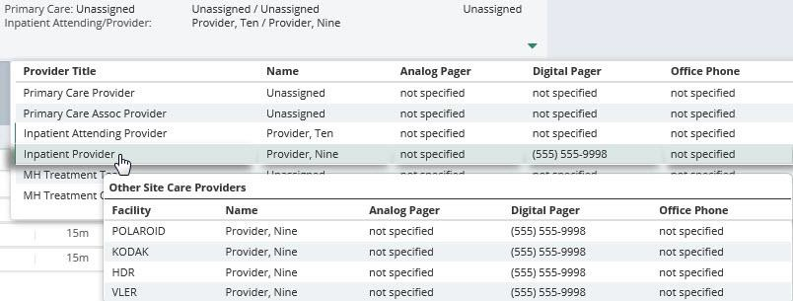Figure 4-12 Detailed Care Team Information

Chapter 5: Global Timeline Date
Filter

About the Global Timeline Date Filter
The Global Timeline Date Filter controls the amount of historical data displayed throughout the application. It displays two years of patient information by default, and allows you to modify the date range to allow for easier investigation of records.
The summary view of the Global Timeline Date Filter displays the date range selected with a graphical representation. The bars (blue denotes outpatient and green denotes inpatient) depict the number of patient activities recorded for a specific date (Figure 5-1). Hovering your cursor over the date displays a tool tip with detailed information for the specified date. The red line on the graph represents the current date.

Figure 5-1 Global Timeline Date Filter

The list below describes the elements of the expanded Global Timeline Date Filter as displayed in Figure 5-2:
- Preset date ranges
- Custom date range
- All Events timeline graph
- Timeline Summary

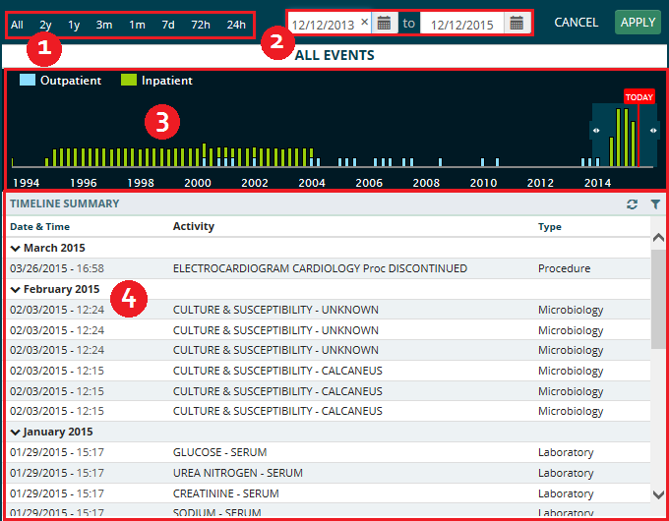Figure 5-2 Expanded Global Timeline Date Filter

Using the Preset Date Ranges
To use preset date ranges:
- Select the date range to open the Global Timeline Date Filter.
- Select the desired preset date range (Figure 5-3). The dropdown calendar, All Events timeline graph, and Timeline Summary update with the selected date range.

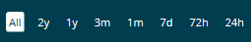Figure 5-3 Preset Date Ranges

- Select APPLY to set the date range or select CANCEL to exit the Global Timeline Date Filter without changing the dates. The patient information for the selected date range displays.
Note: If you select outside of the Global Timeline Date Filter box prior to selecting APPLY, the box closes and the selected dates are not applied.

Using the Custom Date Range
To use custom data ranges:
- Select the date range to open the Global Timeline Date Filter.
- Use the calendar dropdown (Figure 5-4) or enter the dates using the MM/DD/YYYY format to choose a custom date range.
Note: You can only select a start date that is in the past and an end date that is the current date or a date in the future.

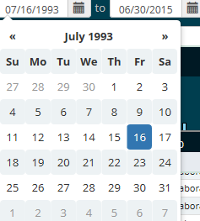Figure 5-4 Calendar Dropdown

- Select APPLY to set the date range, or select CANCEL to exit the Global Timeline Date Filter without changing the dates. The patient information for the selected date range displays.
Note: If you select outside of the Global Timeline Date Filter box prior to selecting APPLY, the box closes and the selected dates are not applied.

Using the All Events Timeline
The All Events Timeline (Figure 5-5) displays a graphical representation of events from the full patient historical record that includes both inpatient and outpatient information. It allows you to limit the data set more accurately to perform a quick analysis.

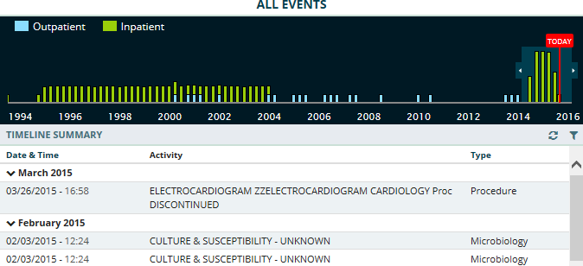Figure 5-5 All Events Timeline

To use the all events timeline:
- Select the date range to open the Global Timeline Date Filter.
- Select and drag the double arrows on the left of the shaded timeline area to select the
start date.
- Select and drag the double arrows on the right of the shaded timeline area to select the end date. The dates in the calendar boxes above, as well as the Timeline Summary, populate as you select the date range.
- Select APPLY to set the date range or select CANCEL to exit the Global Timeline Date Filter without changing the dates. The patient information for the selected date range displays.
Note: If there is no recent data, only the red Today reference line displays.
Note: If you select outside of the Global Timeline Date Filter box prior to selecting APPLY, the box closes and the selected dates are not applied.

Using the Timeline Summary
As the date range for the patient record changes, the Timeline Summary refreshes to display patient activities within the selected date range. The Timeline Summary is a list view grouped by month. The groups are collapsible and can be sorted by date and time, or type.
To use the timeline summary:
- Select the Filter button. The Enter your text filter field displays.
- Enter the filter text. The results populate as you enter the text (Error! Reference source not found.).

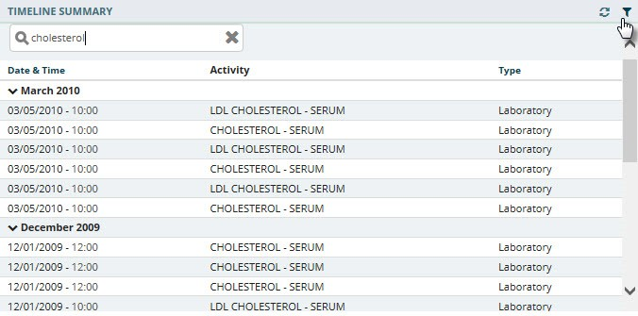Figure 5-6 Filter Button

- Select an activity in the Timeline Summary to display the Detail Dialog box (Error! Reference source not found.).

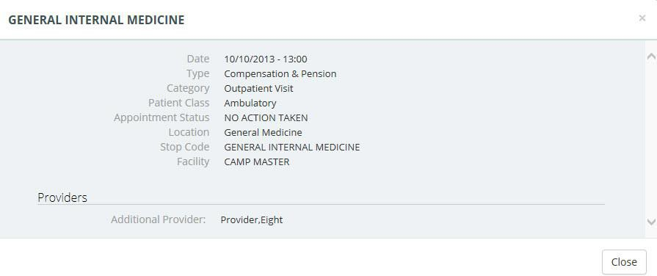Figure 5-7 Patient Activity Detail Dialog Box
- Select Close to close the Detail Dialog box and return to the previous view.

Chapter 6: Applet Views
Applets are small applications that run within eHMP and sorts patient data into segments throughout the patient record. Five applet views are available, which allows you to customize the display of patient data. The five applet views are described below:
- Trend View – a concise presentation of information pertinent to helping a clinician decide what to do next, often incorporating graphics or symbols to communicate at high level information.
- Summary View – a table format of the applet content.
- Expanded View – displays more columns and details than the trend and summary views.
- Detailed View – displays a popup window with detailed information for the selected item.
- Maximized View – displays in full screen with all information for the applet.
This chapter describes the different applets within eHMP and the available views for each applet. The applets are listed in alphabetical order.

Active & Recent Medications
The Active & Recent Medications applet provides you with a quick view of a patient’s active and recent medications. If the patient does not have any medications for the defined date range, then a message indicating that no records have been found displays.
Note: If a patient has an inpatient status, then only active inpatient medications and IVs display. If a patient has an outpatient status, then only active outpatient and non-VA medications display.

Active & Recent Medications: Trend View
Figure 6-1 displays the trend view that lists the active and recent medication and dosage, any refills, the status of the medication, and when the medication was last filled. It also includes all medications that have expired within the last six months.

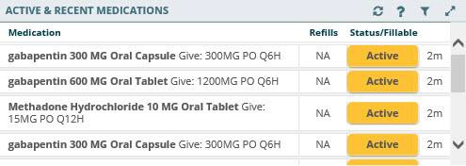Figure 6-1 Active & Recent Medications Applet Trend View

Refills Column
The refills column indicates the refill status for an active or recent medication.
- When there is no refill count information available, ‘NA’ displays (usually on DoD medications).
- When a medication has zero refills remaining, a ‘0’, surrounded by a red highlighted box, displays.
- If a medication has one refill left, a ‘1’, surrounded by an orange highlighted box, displays.
- Medications that have two or more refills remaining displays the number of refills left.

Status/Fillable Column
The status/fillable column indicates the status of an active or recent medication.
- ‘Active’ displays when the medication is active.
- ‘Expired’ displays in red for a medication that is about to expire, or has expired.
- ‘New’ displays if the medication is relatively recent and pending.
Note: Hover your cursor over the status button to display a tooltip with more information on the status of the medication.
To display more information for a medication in the trend view:
- Select the left side of the medication tile to display the applet toolbar menu (Figure 6-2).

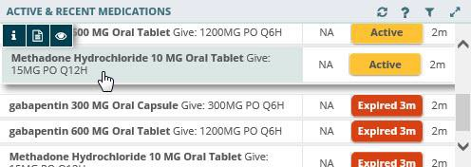Figure 6-2 Active & Recent Medications Applet Toolbar Menu – Trend View

- Select the Infobutton
medication information.
to open a new browser window that displays specific

- Select the Details form button to open the Detail Dialog box for the selected medication.
- Select the Quicklook button to display expanded information for the selected medication.
- Select the right side of the medication tile to display a quick view containing up to the last five fills for the selected medication consisting of the last update date, medication name with dosage, sig, and time since last change (Figure 6-3).

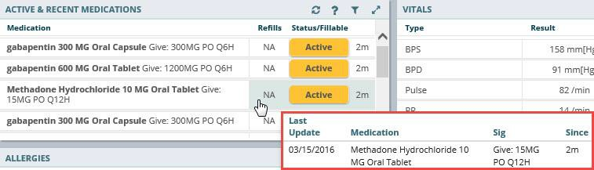Figure 6-3 Active & Recent Medications Quick View

Active & Recent Medications: Summary View
Figure 6-4 depicts the summary view listing the medication and dosage, and the facility where the medication was prescribed.

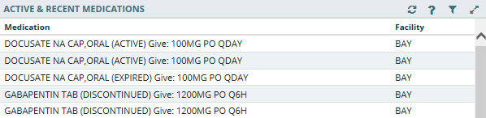Figure 6-4 Active & Recent Medications Applet Summary View
To display more information for a medication in the summary view:
- Select a medication to display the applet toolbar menu (Figure 6-5).

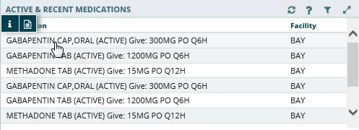Figure 6-5 Active & Recent Medications Applet Toolbar Menu – Summary View

- Select the Infobutton
medication information.
to open a new browser window that displays specific

- Select the Details form button medication.
to open the Detail Dialog box for the selected

Active & Recent Medications: Detail View
To display a detailed view of an active or recent medication from the trend or summary view:
- Select an active or recent medication from the list to display the Details form button (Figure 6-6).

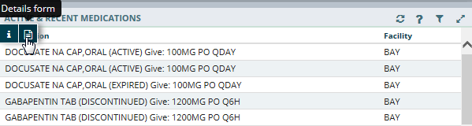Figure 6-6 Active & Recent Medications Details Form Button

- Select the Details form button Dialog box (Figure 6-7).
to open the Active & Recent Medication Detail

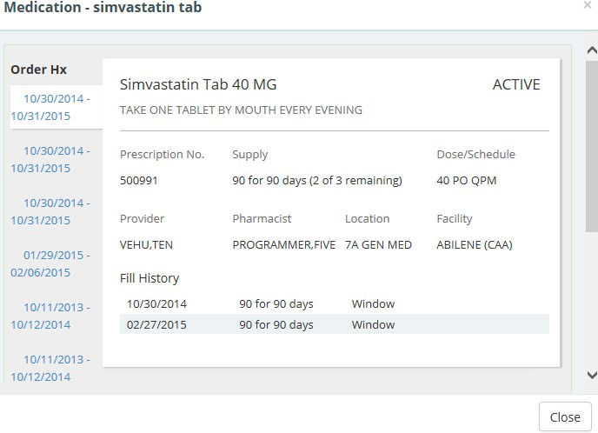Figure 6-7 Active & Recent Medications Detail Dialog Box

All available orders for the medication display on tabs to the left under Order Hx.
- Select a date tab below the Order Hx section to display detailed medication information for the selected date range.
- Select a resource link below the Links and Patient Education sections, to open a new window with more information on the selected medication.

- Select the Close button, the X in the upper right-hand corner, or anywhere outside of the Active & Recent Medication Dialog box, to return to the applet.

Allergies
The Allergies applet provides a trend, summary, and expanded view of identified patient allergies and adverse drug reactions, with standardized coding references from all sources. If the patient does not have any allergies, then a message indicating that no records have been found displays.
Note: It is common for a patient to have more than one instance of the same allergy listed.

Allergies: Trend View
Top allergy information for a given patient is displayed in pill format (Figure 6-8). A red pill indicates a severe allergy, an orange pill indicates a moderate allergy, a white pill indicates a mild allergy, and a gray pill indicates that the severity is not noted.

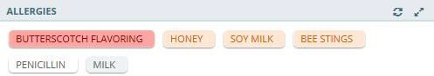Figure 6-8 Allergies Applet Trend View

Allergies: Summary View
The summary view (Figure 6-9) lists the allergen name, reaction, and level of severity for each allergen. The default summary view lists the allergies sorted first by severity, and then by the date the allergy was entered into the VA system.

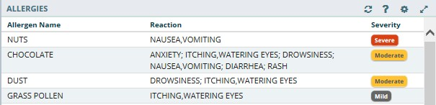Figure 6-9 Allergies Applet Summary View

Allergies: Expanded View
The default expanded view lists the allergies sorted first by severity, and then by the date the allergy was entered into the VA system.
The expanded view of Allergies (Figure 6-10) displays the following information in sortable columns:
- Allergen Name
- Standardized Allergen
- Reaction
- Severity
- Drug class
- Entered By
- Facility
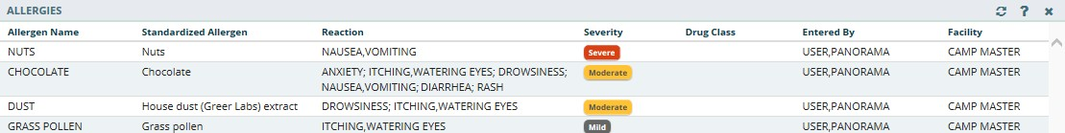Figure 6-10 Allergies Applet Expanded View

Allergies: Detail View
To display a detailed view of an allergy from the trend, summary, or expanded views:
- Select an allergy to display the applet toolbar menu.
- Select the Details form button to open the Allergy Detail Dialog box (Figure 6-11).

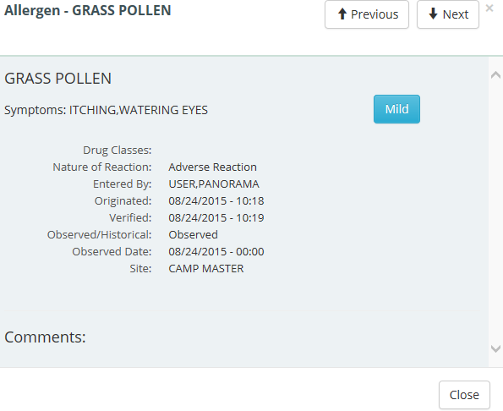Figure 6-11 Allergy Detail Dialog Box

- Select the Previous and Next buttons to navigate through the allergies.
- Select the Close button, the X in the upper right-hand corner, or anywhere outside of the Allergy Detail Dialog box, to return to the applet.

Appointments & Visits
The Appointments & Visits applet lists any future outpatient or specialty care appointments, and past clinic visits for a selected patient at VA and DoD facilities.

Appointments & Visits: Summary View
Figure 6-12 displays the summary view listing the appointment dates, encounter descriptions, the locations where the patient was seen, the status of the appointment, and the facility they visited.

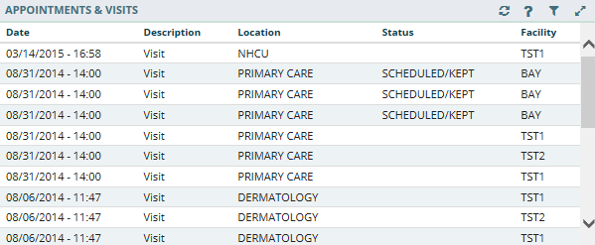Figure 6-12 Appointments & Visits Applet Summary View

Appointments & Visits: Expanded View
Figure 6-13 depicts the expanded view of the Appointments & Visits applet. The following information is displayed in sortable columns:
- Date
- Description
- Location
- Status
- Type
- Provider
- Reason
- Facility

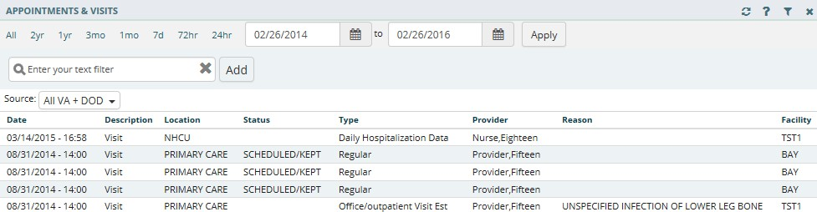Figure 6-13 Appointments & Visits Applet Expanded View

The default view contains both VA and DoD data, but you can change the Source to filter the results. The Source filtering labels include Local VA, All VA, and All VA + DoD.
To filter the data:
- Select the Source dropdown menu to review a list of data filtering labels.
- Select the desired source.
- Enter filter text in the Enter your text filter field.
- Use the preset date ranges or calendar dropdown to select a specific date range.

Appointments & Visits: Detail View
To display the details of an appointment or visit (Figure 6-14) from the summary or expanded applet:
- Select an appointment or visit from the list to display the Appointments & Visits Detail Dialog box.
- Select the Next and Previous buttons to navigate between appointments and visits.
- Select the Close button, the X button in the upper right-hand corner, or anywhere outside of the Appointments & Visits Detail Dialog box, to return to the applet.

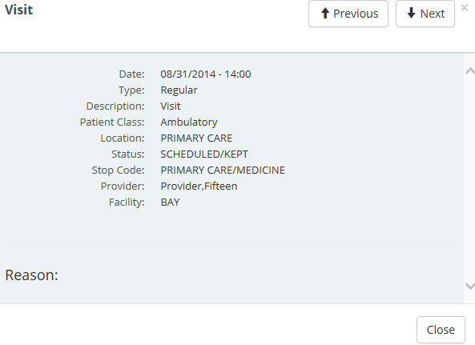Figure 6-14 Appointments & Visits Detail Dialog Box

Clinical Reminders
The Clinical Reminders applet provides a summary and expanded view of the clinical reminders in effect for a patient from all sites. These reminders advise you when upcoming events are due for the patient.

Clinical Reminders: Summary View
Figure 6-15 displays the summary view that lists the priority (if any), title, type, and due date for any clinical reminders.

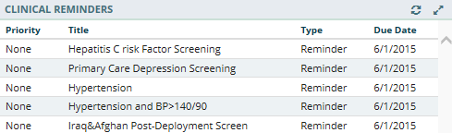Figure 6-15 Clinical Reminders Applet Summary View

Clinical Reminders: Expanded View
Figure 6-16 depicts the expanded view of the Clinical Reminders applet. The following information is displayed in sortable columns:
- Priority
- Title
- Type
- Due Date
- Done Date
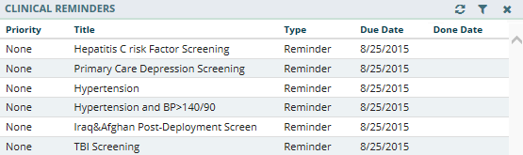Figure 6-16 Clinical Reminders Applet Expanded View

Clinical Reminders: Detail View
To display the details of a clinical reminder from the summary or expanded applet:
- Select a clinical reminder from the list to display the Clinical Reminders Detail Dialog box (Figure 6-17).

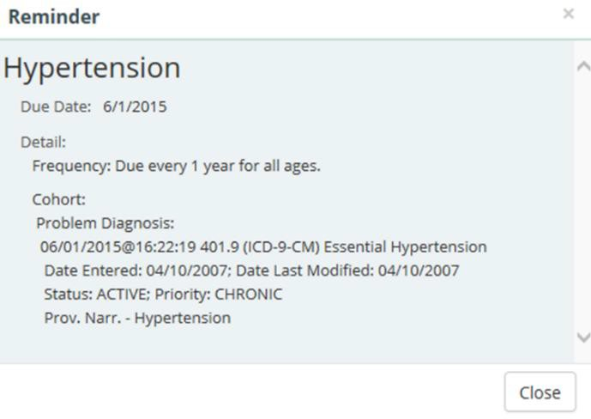Figure 6-17 Clinical Reminders Detail Dialog Box

- Select the Close button, the X button in the upper right-hand corner, or anywhere outside of the Clinical Reminders Detail Dialog box, to return to the applet.

Community Health Summaries
The Community Health Summaries applet displays the selected patient’s clinical health care summaries received from VA’s external Health Information Exchange (HIE) partners who participate in the NwHIN.

Community Health Summaries: Summary View
The summary view (Figure 6-18) lists the date of service and authoring institution(s) for each care summary.

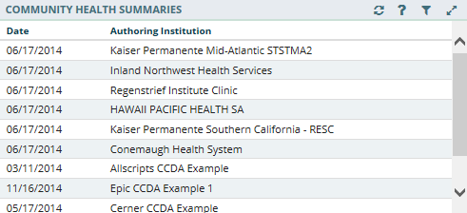Figure 6-18 Community Health Summaries Applet Summary View

Community Health Summaries: Expanded View
The expanded view of the Community Health Summaries applet (Figure 6-19) displays the following information in sortable columns:
- Date
- Description
- Authoring Institution
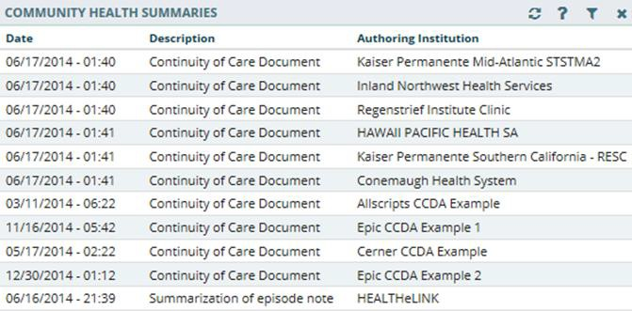Figure 6-19 Community Health Summaries Applet Expanded View

Community Health Summaries: Detail View
To display a detailed view of a Community Health Summary from the summary or expanded applet:
- Select a health summary item from the list, and the Community Health Summaries Detail Dialog box opens (Figure 6-20).

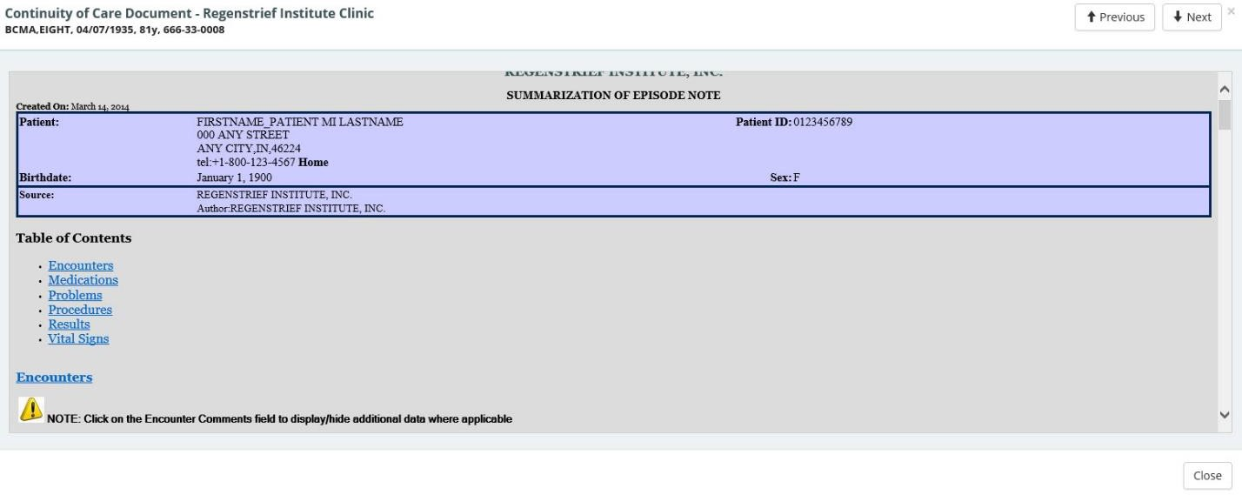Figure 6-20 Community Health Summaries Detail Dialog Box

- Scroll through the document or use the Table of Contents hyperlinks to go directly to a section.
- Select the Next and Previous buttons to navigate between Community Health Summaries.
- Select the Close button, the X in the upper right-hand corner, or anywhere outside of the Community Health Summaries Detail Dialog box, to return to the expanded applet.

Documents
The Documents applet lists multiple categories of documentation from various sources. The document categories include clinical notes, discharge summaries, advanced directives, crisis notes, warnings, lab results, and imaging and radiology reports.

Documents: Summary View
The summary view (Figure 6-21) lists the document date, type of document, and who entered the document in the system.

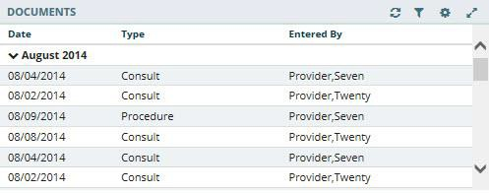Figure 6-21 Documents Applet Summary View

Documents: Expanded View
The expanded view of the Documents applet (Figure 6-22) displays the following information in sortable columns:
- Date
- Description
- Type
- Entered By
- Facility

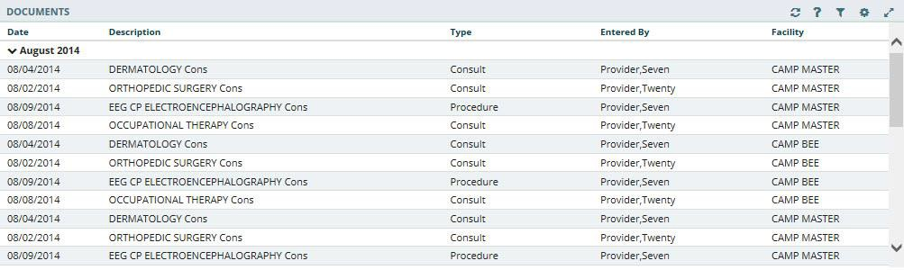Figure 6-22 Documents Applet Expanded View

Documents: Detail View
To display the details of an item in the summary and expanded list views:
- Select a document in the list. The Document Detail Dialog box (Figure 6-23) opens.

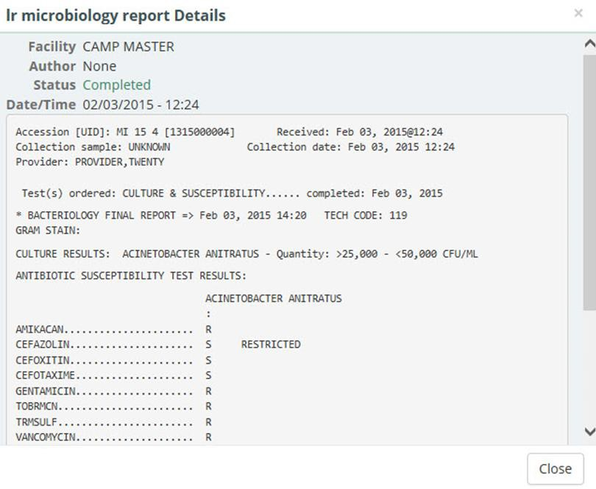Figure 6-23 Documents Detail Dialog Box

- Select the Close button, the X in the upper right-hand corner, to close the Documents Detail Dialog box, and return to the document list.

Encounters
The Encounters applet provides a high-level view of the patients’ encounters for outpatient visits, appointments, admissions, and procedures to quickly understand the types of care the patient has received.

Encounters: Trend View
Figure 6-24 displays the trend view of the Encounters applet, with data grouped by the following encounter type: visits, appointments, admissions, and procedures. In addition, it displays when the patient was last seen for the encounter, and the history for each encounter type, with a graphical representation.

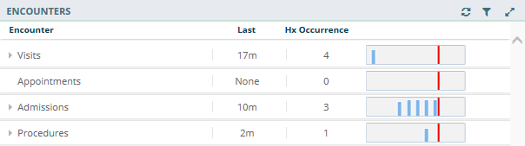Figure 6-24 Encounters Applet Trend View

Note: Select the dropdown arrow to display a list of encounters for the selected group (Figure 6-25).

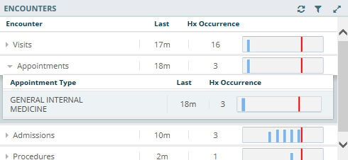Figure 6-25 Encounters List in Trend View (Expanded)

Encounters: Detail View
To display the details of an item in the trend list view:
- Select the Encounter group dropdown arrow.
- A list of encounter types for that group display.
- Select the desired encounter type and the applet toolbar menu displays (Figure 6-26).

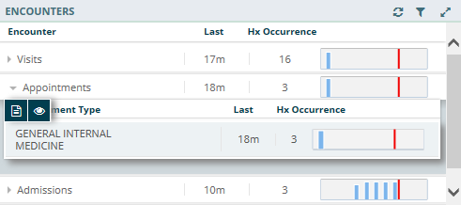Figure 6-26 Encounters Applet Toolbar Menu

- Select the Details form button to open the Encounters Detail Dialog box (Figure 6-27), or the Quicklook button to open the Encounters Detail list of the last five occurrences for the selected item.

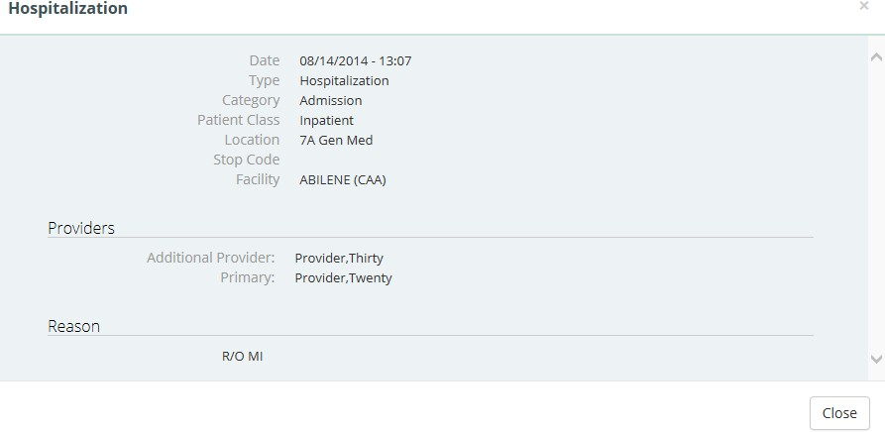Figure 6-27 Encounters Detail Dialog Box
- Select the Close button, the X in the upper right-hand corner, to close the Encounters Detail Dialog box and return to the previous view.

Immunizations
The Immunizations applet presents a list of vaccines from all sources for a given patient.

Immunizations: Trend View
Figure 6-28 displays the trend view of immunizations a patient has received. All immunizations are represented in pill format. Each pill displays the immunization name, the series number (if available), and the date the immunization was last administered.

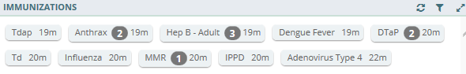Figure 6-28 Immunizations Applet Trend View
Detailed information for an immunization can be displayed by hovering your cursor over a pill (Figure 6-29).

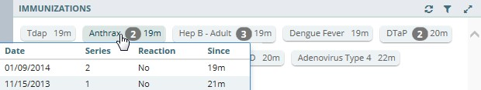Figure 6-29 Detail of an Immunization in Trend View

Immunizations: Summary View
Figure 6-30 displays the summary view that lists the vaccine name, reaction (if any), date administered, and facility.

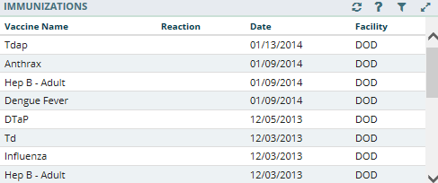Figure 6-30 Immunizations Applet Summary View

Immunizations: Expanded View
The expanded view of Immunizations (Figure 6-31) displays the following information in sortable columns:
- Vaccine Name
- Standardized Name
- Reaction
- Series
- Repeat Contraindicated
- Date
- Facility
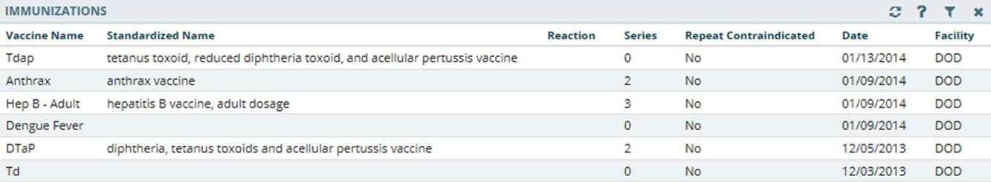Figure 6-31 Immunizations Applet Expanded View

Immunizations: Detail View
To display the details of an Immunization from the trend, summary, or expanded views:
- Select an Immunization from the list to display the applet toolbar menu.
- Select the Details form button to display the Vaccine Detail Dialog box (Figure 6-32).

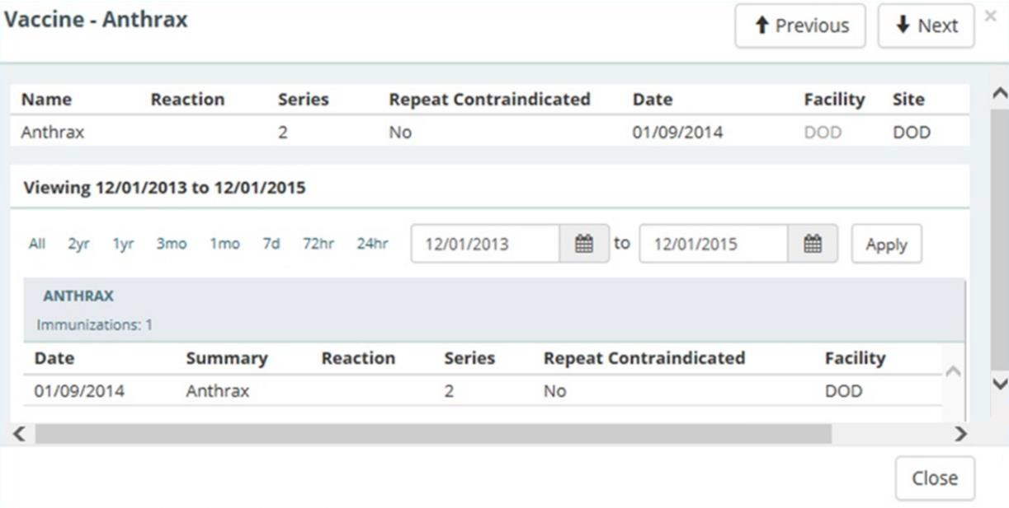Figure 6-32 Immunizations Detail Dialog Box

- To change the date range of the displayed vaccine, select either one of the preset date ranges, OR.
- Use the calendar dropdowns and select Apply to choose a custom date range.
- Select the Next and Previous buttons to navigate between immunizations.
- Select the Close button, the X in the upper right-hand corner, or anywhere outside of the Immunization Detail Dialog box, to return to the applet.

Medications Review
The Medications Review applet provides a single view of the medication list with additional graphical data to support analysis of the existing patient medical data in order to facilitate better clinical decisions.
Legend:
- ‘ = Minutes
- h = Hours
- d = Days
- m = Months
- y = Years
- N/A = Data is Not Available

Medications Review: Expanded View
The expanded view of the Medications Review applet (Figure 6-34) displays the selected
patient’s medication history in both list and graph formats grouped by Inpatient, Clinic Order, and Outpatient medications. When a category is selected, the group is expanded to display the list and graph of items.
Note: If a patient has an inpatient status, then the Inpatient group displays and the Outpatient group is collapsed. If a patient has an outpatient status, then the Outpatient group displays and the Inpatient group is collapsed.

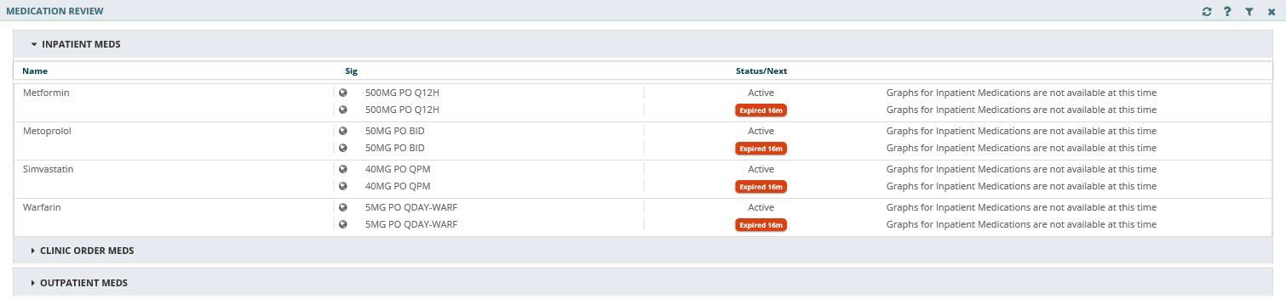Figure 6-33 Medications Review Applet Expanded View

Outpatient Medications
The outpatient medication types include Outpatient, supply, and non-VA (external). The data listed for each outpatient medication order consists of the following, as displayed in Figure
6-34:
- Medication name: represents the name of the medication ingredient
- Non-local indicator: an indication that the medication was not ordered at your home facility
- Sig column
  - First preference: Dose + Units + Route + Frequency
  - If any of the above are missing, then concatenation: Strength (i.e. size of tablet)
+ Product form + Sig
- Status/Fillable column
  - Active order – displays ‘Fillable’ and the amount of time the medication can be filled
  - Zero refills – displays ‘0 Refills’
  - Pending order – displays ‘Pending’
  - Expired order – displays the ‘Expired’ and the amount of time from the expiration date
  - Discontinued order – displays ‘Discontinued’ and the amount of time from the discontinued date
  - Time Annotations
    - >60 days to 24 months = ‘m’ (ex. 14m)
    - >47 hours to 60 days = ‘d’ (ex. 24d)
    - >24 months = ‘y’ (ex. 5y)
    - 60 minutes to 47 hours = ‘h’ (ex. 37h)
    - 0-59 minutes = The actual minutes expressed with quotations (ex. “48”)
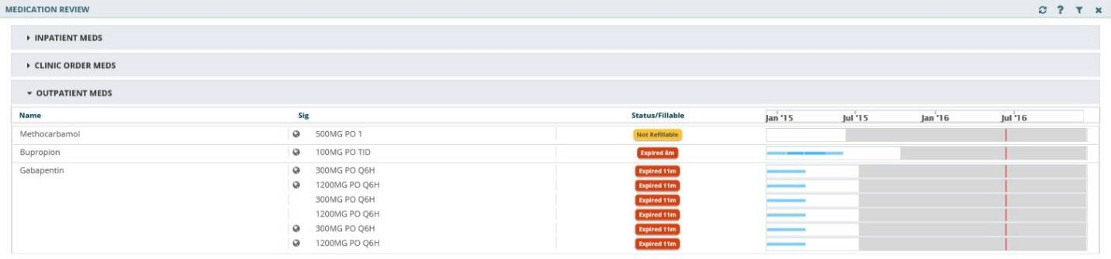Figure 6-34 Medications Review Outpatient Meds
OUTPATIENT MEDICATIONS REVIEW INDICATORS
The Outpatient Medications graph displays a medication’s start date, stop date, and the dispensing dates. The graph indicators for outpatient medications are displayed in Figure 6-35.

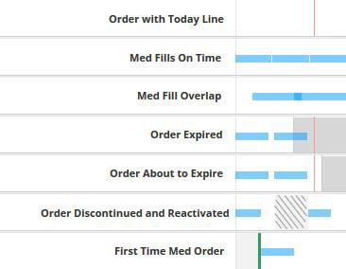Figure 6-35 Outpatient Medications Graph Indicators

Some tips for the Outpatient Medications graph:
- A white background depicts an active order
- A gray background depicts when a medication has expired
- A hashed gray background depicts when a medication has been discontinued
- If two orders overlap, an active order overrides a discontinued or expired order
- Active/Hold and Active/Suspend orders count as being active
- A green bar depicts when a medication has been filled for the first time

Inpatient Medications
The data listed for each inpatient medication order (Figure 6-36) consists of the following:
- Name Column: represents the name of the medication ingredient
- Non-local indicator : an indication that the medication was not ordered at your home facility
- Sig Column
  - First preference Dose + Units + Route + Frequency
  - If any of the above are missing, then concatenation: Strength (i.e. size of tablet)
+ Product form + Sig
- Status/Next Column: the medication status or the time of the next administration
  - Pending order – displays ‘pending’
  - Expired order – displays the ‘Expired’ and the amount of time from the expiration date
  - Discontinued order – displays ‘Discontinued’ and the amount of time from the discontinued date
  - Time Annotations
    - >60 days to 24 months = ‘m’ (ex. 14m)
    - >47 hours to 60 days = ‘d’ (ex. 24d)
    - >24 months = ‘y’ (ex. 5y)
    - 60 minutes to 47 hours = ‘h’ (ex. 37h)
    - 0-59 minutes = The actual minutes expressed with quotations (ex. “48”)

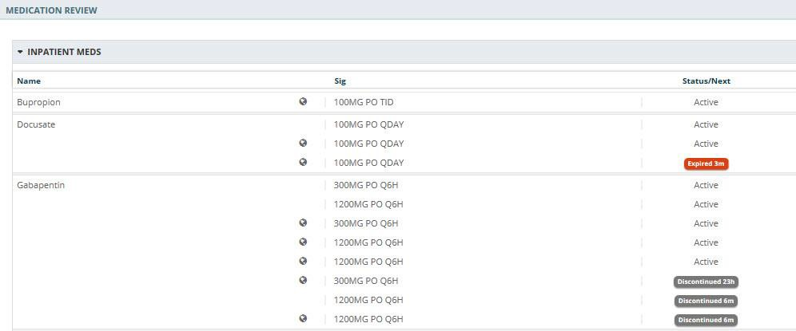Figure 6-36 Medications Review Inpatient Meds

Clinic Order Meds
The data listed for each clinic order medication (Figure 6-37) consists of the following:
- Name Column: represents the name of the medication ingredient
- Non-local indicator: an indication that the medication was not ordered at your home facility
- Sig Column
  - First preference Dose + Units + Route + Frequency
  - If any of the above are missing, then concatenation: Strength (i.e. size of tablet)
+ Product form + Sig
- Status/Next Column: the medication status or the time of the next administration
  - Active order – displays ‘Fillable’ and the amount of time the medication can be filled
  - Zero refills – displays ‘0 Refills’
  - Pending order – displays ‘pending’
  - Expired order – displays the ‘Expired’ and the amount of time from the expiration date
  - Discontinued order – displays ‘Discontinued’ and the amount of time from the discontinued date
  - Time Annotations
    - >60 days to 24 months = ‘m’ (ex. 14m)
    - >47 hours to 60 days = ‘d’ (ex. 24d)
    - >24 months = ‘y’ (ex. 5y)
    - 60 minutes to 47 hours = ‘h’ (ex. 37h)
    - 0-59 minutes = The actual minutes expressed with quotations (ex. “48”)

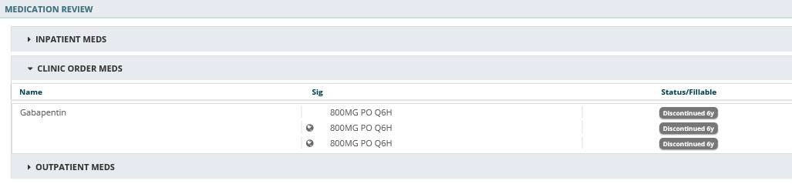Figure 6-37 Medications Review Clinic Order Meds

Medications Review: Detail View
What displays for the detail view of a medication depends on the status of the patient and if a VA or a Non-VA provider prescribed the medication.
To display a detailed view of a medication:
- Select the Inpatient Meds, Clinic Order Meds, or the Outpatient Meds category. The category expands to display a list of medications.
- Select a medication. The Infobutton and Details form button display.
- Select the Details form button and the detail view for the selected medication displays (Figure 6-38).

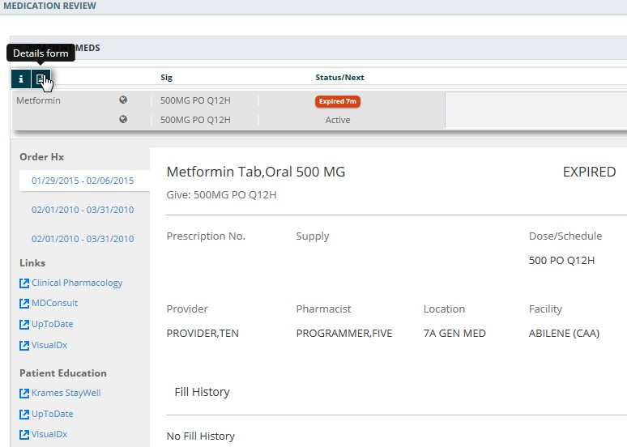Figure 6-38 Medications Review Applet Detail View

In addition to the detailed information for the selected medication, the Links and Patient Education sections provide access to external information and resources. This information is found on the bottom left-hand side of the Medications Detail Dialog box.
To use a resource link in the Links and Patient Education sections of the Medications Detail Dialog box:
- Select one of the resources under the Links or Patient Education sections to launch the external resource. The external resource opens in a new browser tab.
- Select the X on the external resource’s browser tab to close it, or select the VA eHMP browser tab to return to the eHMP application without closing the external resource tab.

Military History
The Military History applet displays the following military history items: branches of service, years of service, areas served, and military occupational specialties. It allows you to edit the text field information that is written back to the selected patient’s record and stored in eHMP.

Military History: Summary View
Figure 6-39 displays the summary view that lists the name and description for each section.

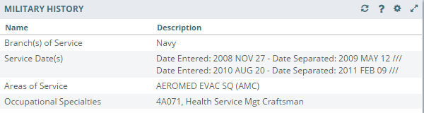Figure 6-39 Military History Applet Summary View

Military History: Expanded View
The expanded view of the Military History applet (Figure 6-40) displays the following information in sortable columns:
- Name
- Description
- Last Modified
- Location (VA site that modified military history information)
- Modified By

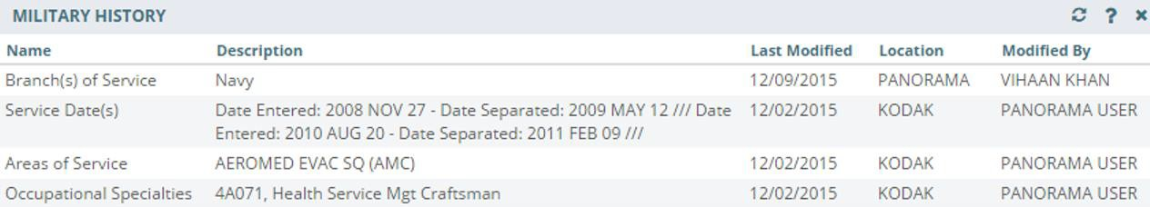Figure 6-40 Military History Applet Expanded View

Military History: Detail View
To display a detailed view of an available military history item from the summary or expanded applet:
- Select a list item and the applet toolbar menu displays.
- Select the Details form button to open the Military History Detail Dialog box (Figure 6-41).

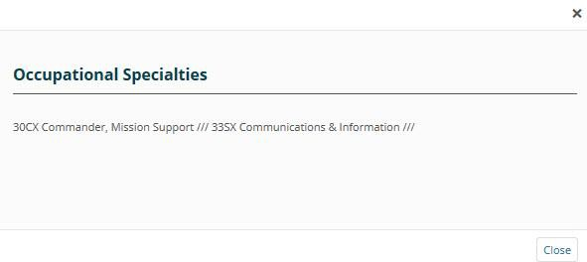Figure 6-41 Military History Detail Dialog Box
- Select the Close button or the X in the upper right-hand corner to return to the applet.

Military History: Edit Form
To edit a military history item from the summary or expanded applet:
- Select a list item and a set of buttons display.
- Select the Edit form button to open the Edit Military History box (Figure 6-42).

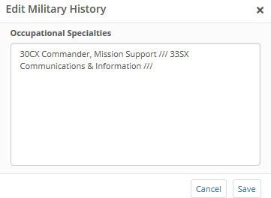Figure 6-42 Edit Military History
- Edit the information in the text box.
- Select either Save to save the information or Cancel to return to the applet without saving changes.

Narrative Lab Results
The Narrative Lab Results applet lists the reports of the patient’s recorded laboratory results.

Narrative Lab Results: Summary View
Figure 6-43 displays the summary view that lists the date and time taken, description, type, and facility.

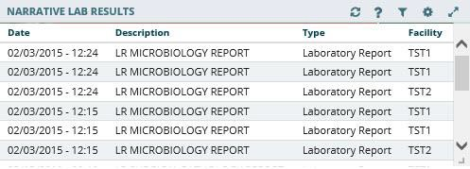Figure 6-43 Narrative Lab Results Applet Summary View

Narrative Lab Results: Expanded View
The expanded view of the Lab Results applet (Figure 6-44) displays the following information in sortable columns:
- Date
- Description
- Type
- Author or Verifier
- Facility
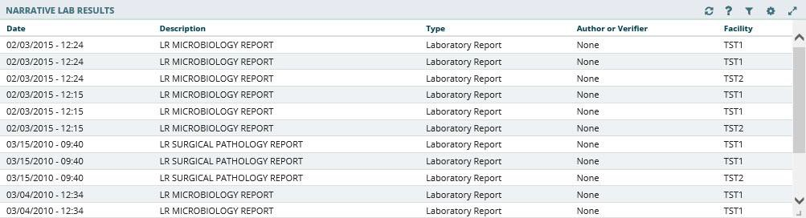Figure 6-44 Narrative Lab Results Applet Expanded View

Narrative Lab Results: Detail View
To display a detailed view of a lab result from the summary or expanded applet:
- Select a list item to display the applet toolbar menu.
- Select the Details form button to open the Narrative Lab Results Detail Dialog box (Figure 6-45).

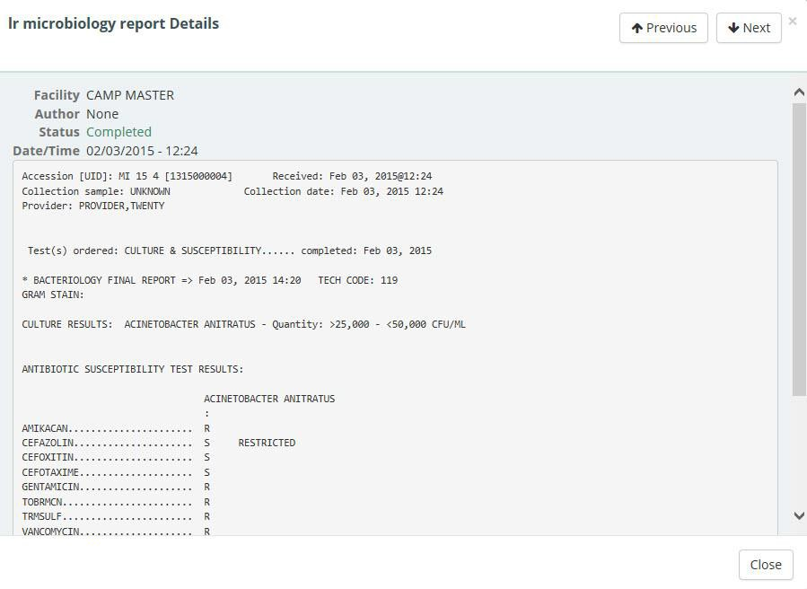Figure 6-45 Narrative Lab Results Detail Dialog Box

- Select the Next and Previous buttons to navigate between lab results.
- Select the Close button, the X in the upper right-hand corner, or anywhere outside of the Narrative Lab Results Detail Dialog box, to return to the applet.

Numeric Lab Results
The Numeric Lab Results applet lists a patient’s recorded laboratory results.

Numeric Lab Results: Trend View
Figure 6-46 displays the trend view that lists the following:
- Lab Test
- Results (numeric data value)
- When the lab result was last documented
- Data Range Graph that includes the following rules:
- Blue diamond - current normal
- Yellow diamond - current abnormal low/high
- Red star - current critical low/high
- Black dot with line attached to current flag - previous value and indicates low or high value in comparison to the current value
- Black dot inside current flag - no change between current and previous values

- White background depicts the reference range
- Gray background depicts outside of the reference range

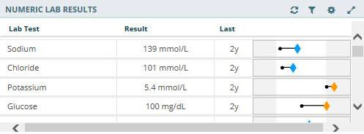Figure 6-46 Numeric Lab Results Applet Trend View

Select the data range graph to display a list of the five previous results of a given lab, including the test value, reference range, observed date and time, and facility (Figure 6-47).

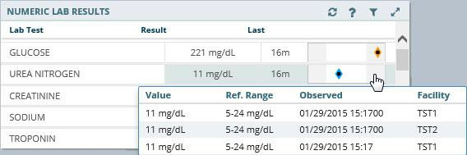Figure 6-47 Numeric Lab Results Quick View

Numeric Lab Results: Summary View
Figure 6-48 displays the summary view that lists the date and time taken, lab test (includes a Panel button that opens a test drawer where applicable), flag (yellow indicates abnormal
results and red indicates critical), and result of the patient’s lab results.

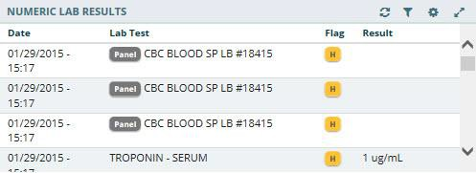Figure 6-48 Numeric Lab Results Applet Summary View

Numeric Lab Results: Expanded View
The expanded view of the Numeric Lab Results applet (Figure 6-49) displays the following information in sortable columns:
- Date
- Lab Test
- Flag
Note: The H, H+, L, and L+ icons indicate abnormal (yellow) and critical (red) highs and lows.
- Result
- Unit
- Ref Range
- Facility
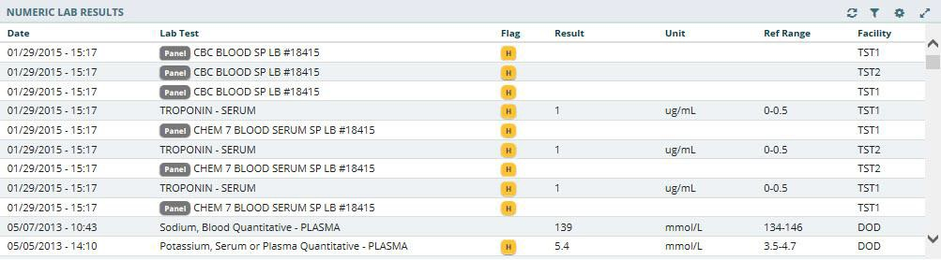Figure 6-49 Numeric Lab Results Applet Expanded View

Numeric Lab Results: Detail View
To display a detailed view of a numeric lab result from the trend, summary or expanded applet:
- Select a list item and the applet toolbar menu displays.
- Select the Details form button to open the Numeric Lab Results Detail Dialog box (Figure 6-50).
Note: If the Panel icon is displayed next to a list item, the Detail Dialog box does not open. Instead, select the item and the applet toolbar menu displays. Select the Details form button, and the specific tests run within the panel display, along with the results. Select a lab test under the panel and then the Details form button. The Lab Results Detail Dialog box displays a summary list and a historic graphical representation for the selected test that can be filtered by using the date filter.

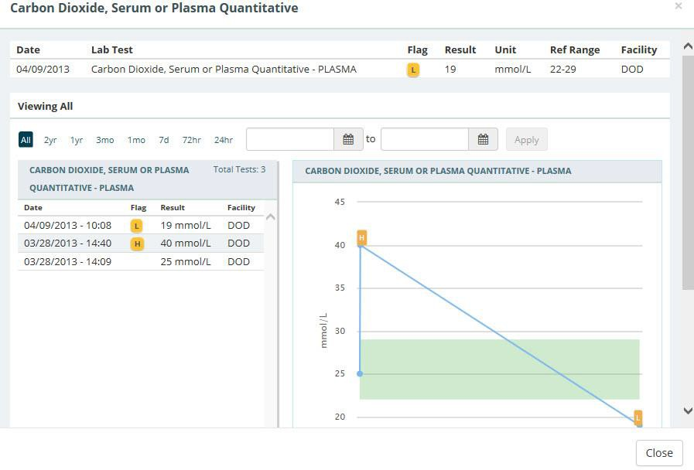Figure 6-50 Numeric Lab Results Detail Dialog Box

- Use the preset date ranges or the calendar dropdowns and select Apply to change the date range for the displayed lab result.
- Hover your cursor over different areas of the graph to display a tooltip with the Lab Result and Reference Range information.
- Select the Close button, the X in the upper right-hand corner, or anywhere outside of the Numeric Lab Results Detail Dialog box, to return to the applet.

Orders
The Orders applet displays all orders for the selected patient submitted from all sites.

Orders: Summary View
Figure 6-51 displays the Orders applet summary view that lists the order date, status, order, and facility. Orders can be filtered by type using the Order Type dropdown box within the applet.

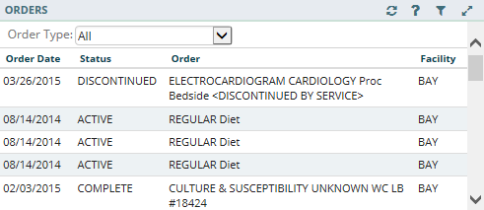Figure 6-51 Orders Applet Summary View

Orders: Expanded View
Similar to the Orders summary view, orders can be filtered by type using the Order Type dropdown in expanded view. The expanded view of Orders (Figure 6-52) displays the following information in sortable columns:
- Order Date
- Status
- Order
- Type
- Provider Name
- Start Date
- Stop Date
- Facility
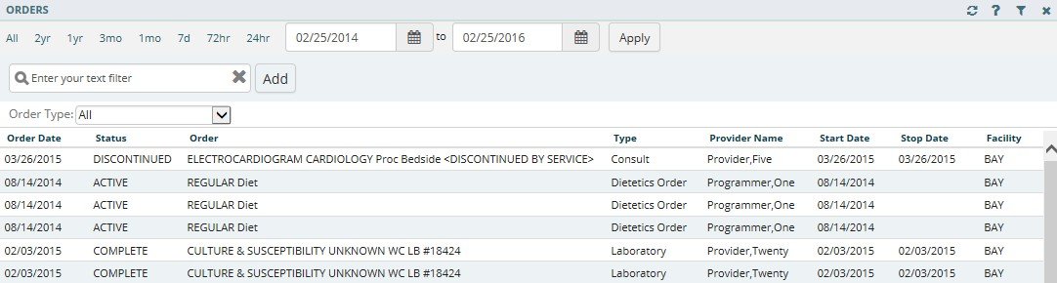Figure 6-52 Orders Applet Expanded View

Orders: Detail View
To display a detailed view of an order from the summary or expanded applet:
- Select an order from the list within the applet. The Orders Detail Dialog box opens (Figure 6-53).

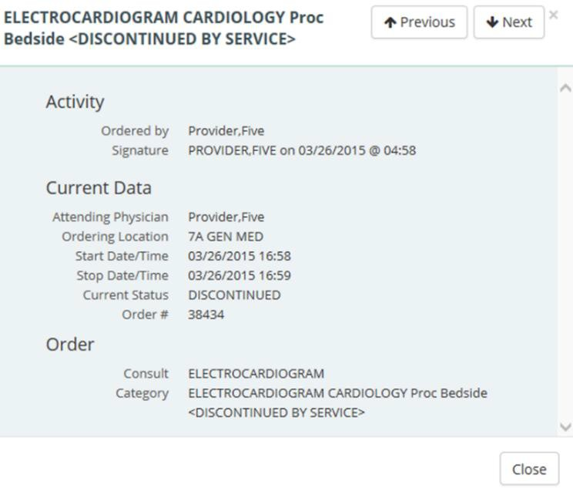Figure 6-53 Orders Detail Dialog Box

- Select the Next and Previous buttons to navigate between orders.
- Select the Close button, the X in the upper right corner, or anywhere outside of the Orders Detail Dialog box, to return to the applet.

Problems
The Problems applet displays a list of problems, with standardized coding references, that has been compiled by the patient’s providers.

Problems: Trend View
Figure 6-54 displays the trend view that lists the problem, acuity of problem, status of the problem, and the facility that documented the problem. If applicable, the problems are grouped by their standardization codes Systemized Nomenclature of Medicine Clinical Terms (SNOMED CT).

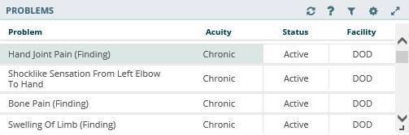Figure 6-54 Problems Applet Trend View

To display more information for a problem in the trend view:
- Select the left side of the problems tile to display the applet toolbar menu (Figure 6-55).

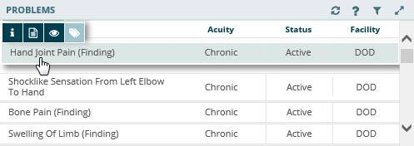Figure 6-55 Problems Applet Trend View Toolbar Menu

- Select the Infobutton
the selected problem.
to open a new browser window that displays information for

- Select the Details form button
- Select the Quicklook button problem.
to open the Problems Detail Dialog box.
to display expanded information for the selected

- Select the Submenu button (if applicable) to open a new workspace that is
associated with the selected problem.
- Select the right side of the problem tile to display a quick view containing up to the last five instances for the selected problem (Figure 6-56).

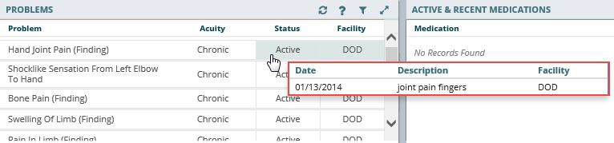Figure 6-56 Problems Applet Quick View

Problems: Summary View
Figure 6-57 displays the summary view that lists the description, the acuity of the patient’s problem, and the status of the problem.

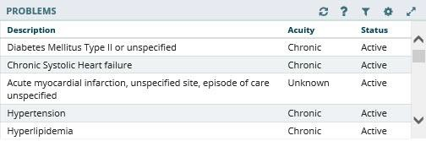Figure 6-57 Problems Applet Summary View

To display more information for a problem in the summary view:
- Select a problem to display the applet toolbar menu (Figure 6-58).

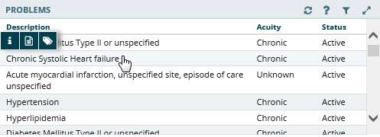Figure 6-58 Problems Applet Summary View Toolbar Menu

- Select the Infobutton
the selected problem.
to open a new browser window that displays information for

- Select the Details form button to open the Problems Detail Dialog box.
- Select the Submenu button (if applicable) to open a new workspace that is
associated with the selected problem.

Problems: Expanded View
The expanded view of the Problems applet (Figure 6-59) displays the following information in sortable columns:
- Description
- Standardized Description
- Acuity
- Status
- Onset Date
- Last Updated
- Provider
- Facility

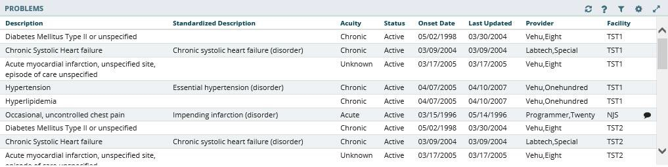Figure 6-59 Problems Applet Expanded View

Problems: Detail View
To display the details of a patient’s problem from a trend, summary, or expanded applet:
- Select a problem from the list and applet toolbar menu displays.
- Select the Details form button to display the Problems Detail Dialog box (Figure 6-60).

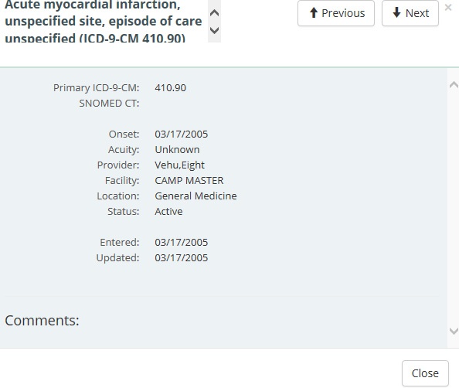Figure 6-60 Problems Detail Dialog Box

- Select the Next and Previous buttons to navigate between problems.
- Select the Close button, the X in the upper right-hand corner, or anywhere outside of the Problems Detail Dialog box, to return to the applet.

Reports

Reports: Summary View
Figure 6-61 displays the summary view of the Reports applet that lists available reports by date, type, and entered by. Reports are listed in reverse chronological order so that providers are able to find the most recent report.

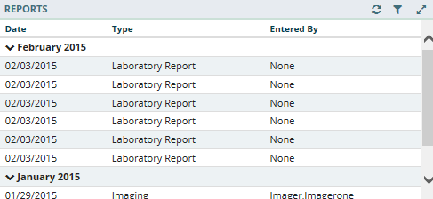Figure 6-61 Reports Applet Summary View

Reports: Detail View
To display a detailed view of a report from the summary applet:
- Select a report from the list within the applet. The Reports Detail Dialog box opens (Figure 6-62).

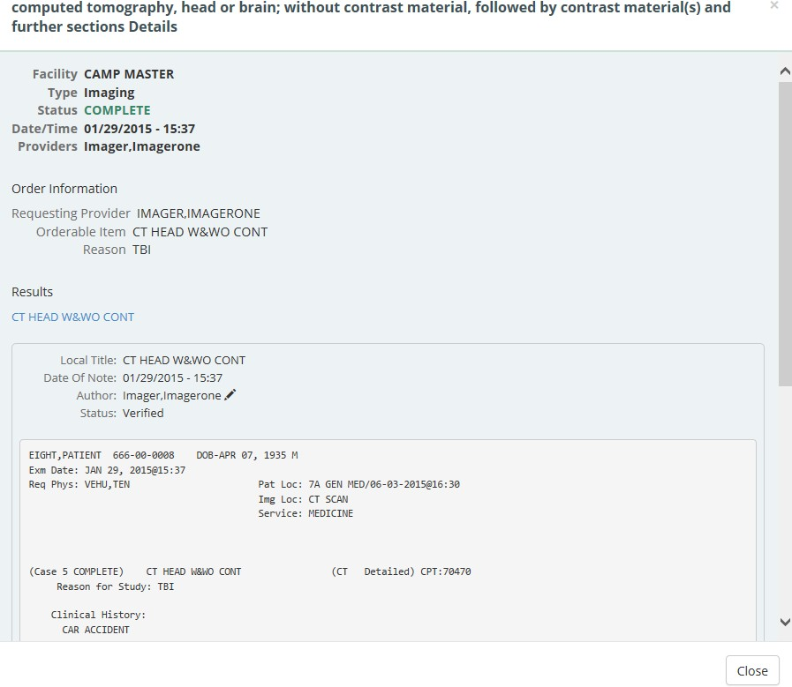Figure 6-62 Reports Detail Dialog Box

- Select the hyperlink (if available) or scroll down for more information.
- Select the Close button, the X in the upper right-hand corner, or anywhere outside of the Reports Detail Dialog box, to return to the applet.

Stacked Graphs

Stacked Graphs: Expanded View
The Stacked Graphs applet (Figure 6-63) is user defined, and provides graphing functionality. The applet enables you to graph different types of data to a standardized, x-axis timeline, similar to functionality currently available in CPRS.

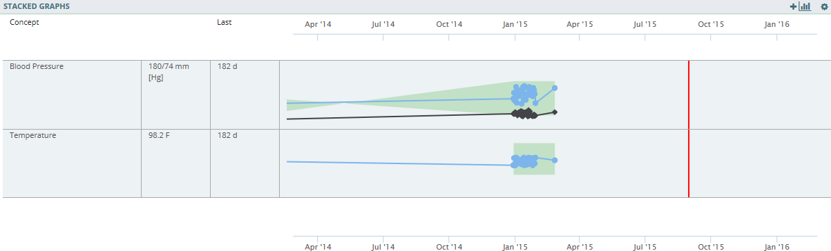Figure 6-63 Stacked Graphs Applet Expanded View

Add a Graph to Stacked Graphs Applet
To add graphs to the stacked graphs applet:
- Create a new workspace. Refer to Workspaces.
- Add the stacked graphs applet to the workspace.
- Open the workspace with the stacked graph applet.
- Select the Add a graph button .A Search field displays.
- Enter the name of the desired graph type (i.e., temperature, blood pressure, etc.). The results populate as you enter text (Figure 6-64).

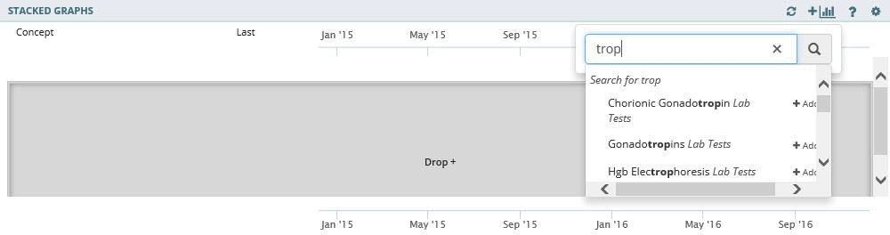Figure 6-64 Add Graph to Stacked Graphs Applet
- Select the desired graph. The graph displays in the Stacked Graphs applet (Figure 6-65).

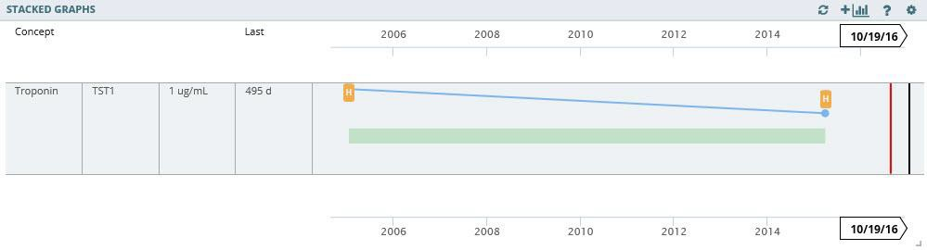Figure 6-65 Graph Added to Stacked Graphs Applet

- Repeat steps 4-6 to continue adding graphs to the applet.

Edit the Stacked Graphs Applet
Once a graph is added to the Stacked Graphs applet, you have the option to rearrange the graphs in the applet, review additional information for the graph, or delete the graph from the applet.
To edit the graphs:
- Select the graph you want to edit and the applet toolbar menu displays (Figure 6-66).

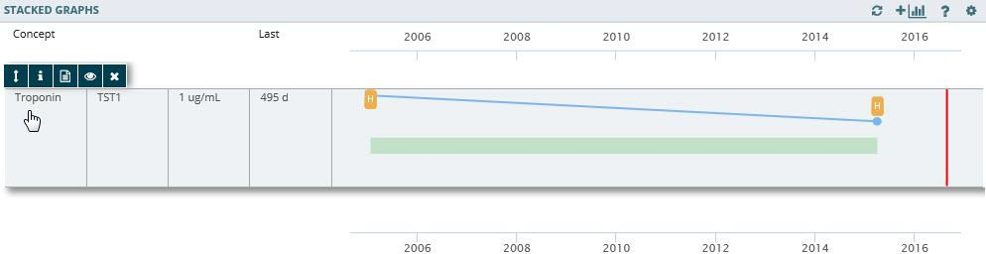Figure 6-66 Stacked Graphs Applet Toolbar Menu

- Select the Tile sort button to sort the order of the graphs in the applet.

- Select the Infobutton
the selected graph.
to open a new browser window that displays information for

- Select the Details form button
- Select the Quicklook button graph.
to open a Detail Dialog box.
to display expanded information for the selected

- Select the Delete stacked graph button to remove the graph from the Stacked
Graphs applet. A warning displays asking if you are sure you want to remove the graph (Figure 6-67).

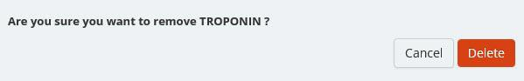Figure 6-67 Delete Stacked Graphs Warning
- Select Delete to remove the graph or Cancel to keep the graph in the Stacked Graphs applet.

Timeline
Timeline view provides detailed information of a patient’s visit history.

Timeline: Summary View
Figure 6-68 displays the Timeline applet in summary view. It lists the date and time, activity name, and type for each event.

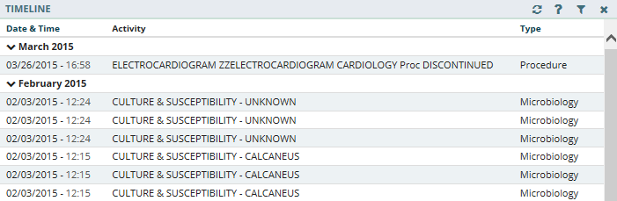Figure 6-68 Timeline Summary View

Timeline: Expanded View
Figure 6-69 displays the expanded view of Timeline that lists the date and time, activity, type, entered by, and facility for the event.
To display the expanded view for the Timeline applet:
1. Select Timeline from the Workspace dropdown menu. The patient’s historical visit data displays, grouped by month. The default view displays the date in reverse chronological order.

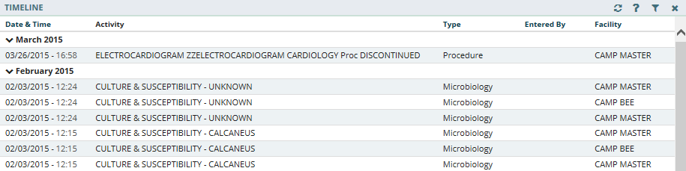Figure 6-69 Timeline Expanded View

Timeline: Detail View
To display a detailed view of a specific activity:
- Select an item from the list, and the Timeline Detail Dialog box displays (Figure 6-70).

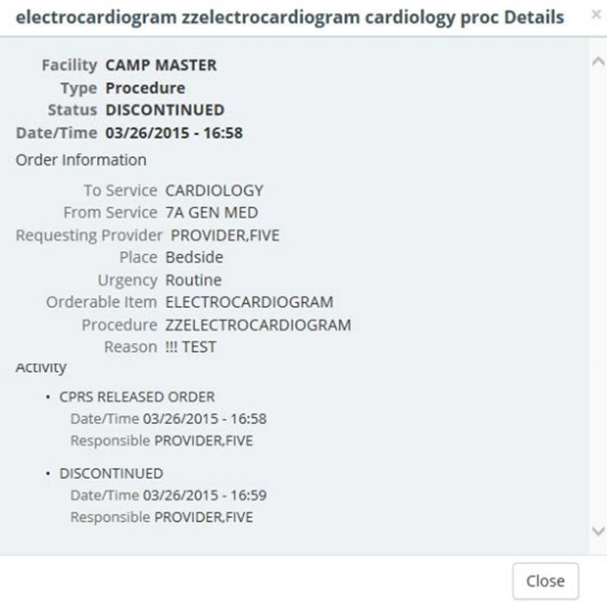Figure 6-70 Timeline Detail Dialog Box

- Select the Close button, the X located in the upper right-hand corner, or anywhere outside of the Timeline Detail Dialog box, to close the detailed visit information and return to the default Timeline view.

VistA Health Summaries
The VistA Health Summaries applet provides Health Summary Report functionality in eHMP. This is a re-creation of the reports available in the CPRS Reports tab under 'Health Summaries', a feature that is also provided in VistA Web, listed as 'Health Summaries', and representing each facility where the patient has a record.
A Health Summary is a clinically oriented, structured report that extracts many kinds of data from VistA web and displays it in a standard format. The individual patient is the focus of health summaries. The data displayed covers a wide range of health-related information such as demographic data, allergies, current active medical problems, and laboratory results.

VistA Health Summaries: Summary View
Figure 6-71 displays the summary view of the VistA Health Summaries applet that groups each facility where the patient has a record. The reports are listed under the collapsible facility name, with the number of reports available indicated.

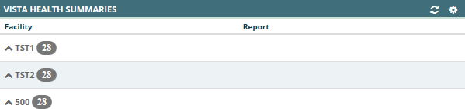Figure 6-71 VistA Health Summaries Summary View

VistA Health Summaries: Detail View
To display a detailed view of a VistA Health Summary:
- Select the dropdown arrow next to the facility name. A list of reports for that facility display.
- Select a report name and the Report Detail Dialog box opens (Figure 6-72).

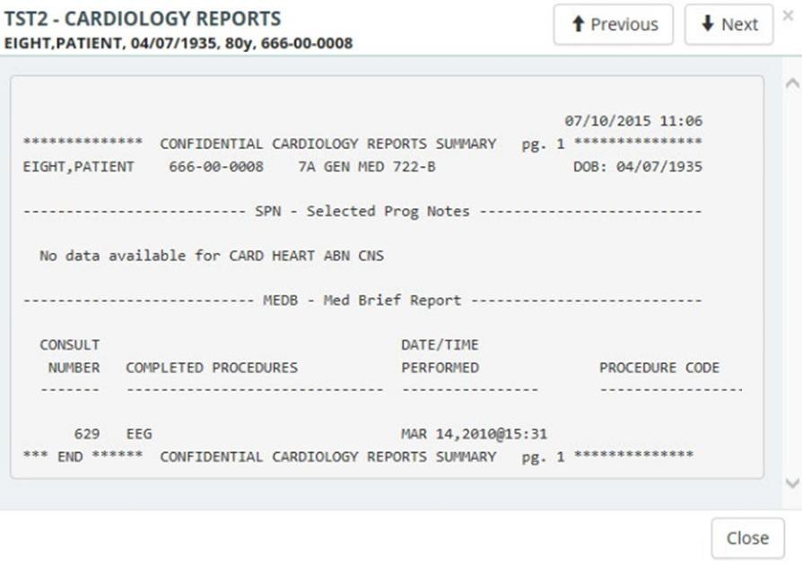Figure 6-72 VistA Health Summaries Detail Dialog Box

- Select the Next and Previous buttons to navigate between reports.
- Select the Close button, the X in the upper right-hand corner, or anywhere outside of the Report Detail Dialog box, to return to the applet.

Vitals
The Vitals applet displays the patient’s most recently recorded vitals. The information can be viewed both numerically and in graph form.

Vitals: Trend View
Figure 6-73 displays the trend view for Vitals with the following data:
- Type – type of vital collected, i.e. blood pressure, pain, weight
- Result – data captured in relation to the vital measured
- Last – timeframe vital was last collected
- Data Range Graph, which includes:
  - A diamond represents the last (current) value
    - Blue diamond indicates a current normal value
    - Orange diamond indicates a high/low value
- A dot represents previously recorded value
- A dot within a diamond indicates no change between previous entries. The current value is the same as previous.
- If a diamond is to the left of the dot, then the value of the diamond is lower than the dot
- If a diamond is to the right of the dot, then the value of the diamond is higher than the dot

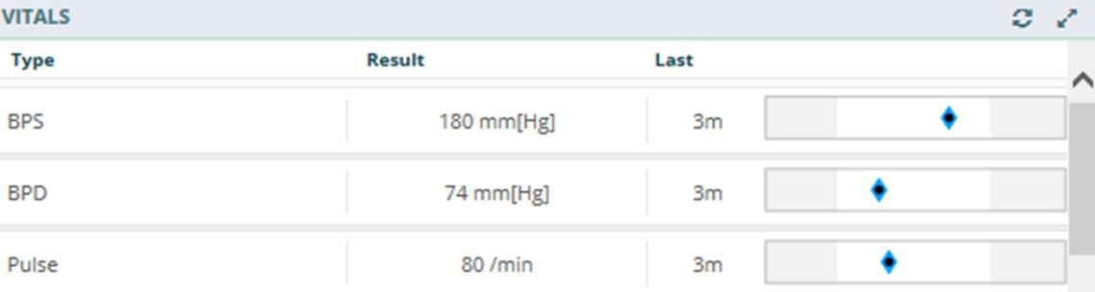Figure 6-73 Vitals Applet Trend View

To display more information for a vital in the trend view:
- Select the left side of the vitals tile to display the applet toolbar menu (Figure 6-74).

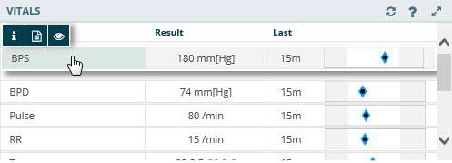Figure 6-74 Vitals Applet Trend View Toolbar Menu

- Select the Infobutton
the selected vital.
to open a new browser window that displays information for

- Select the Details form button to open the Vitals Detail Dialog box.
- Select the Quicklook button to display expanded information for the selected vital.
- Select the right side of the vitals tile to display a quick view containing up to the last five instances for the selected vital (Figure 6-75).

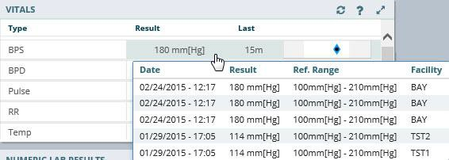Figure 6-75 Vitals Applet Quick View

Vitals: Summary View
Figure 6-76 displays the summary view that lists the patient’s blood pressure (BP), pulse (P), respiration (R), temperature (T), pulse oximetry (PO2), pain (PN), weight (WT), and body mass index (BMI).

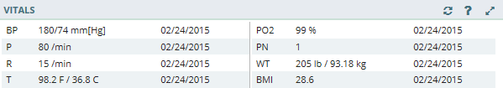Figure 6-76 Vitals Applet Summary View

To display more information for a vital in the summary view:
- Select a vital from the applet to open the Vitals Detail Dialog box (Figure 6-77).

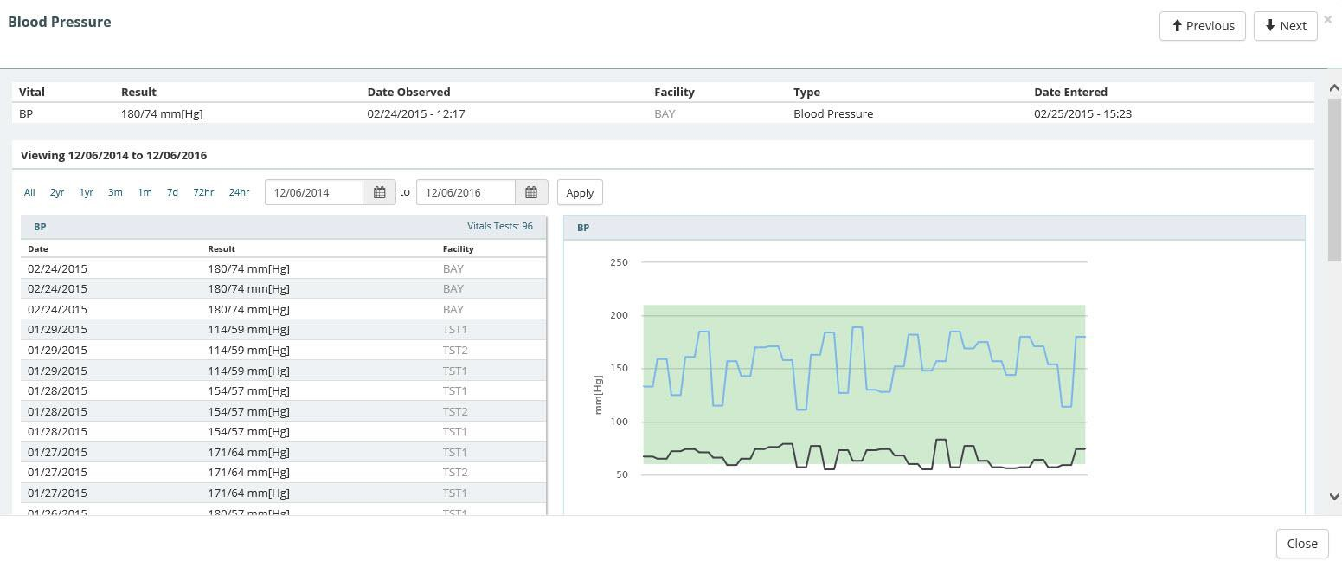Figure 6-77 Vitals Detail Dialog Box
- Select a preset date or use the calendar dropdowns and select Apply to filter the information.
- Hover your cursor over different areas of the graph to display a tooltip with the Vital Result and Reference Range information.
- Select the Next and Previous buttons to navigate between vitals.
- Select the Close button, the X in the upper right-hand corner, or anywhere outside of the Vitals Detail Dialog box, to return to the applet.

Vitals: Expanded View
The expanded view of the Vitals applet (Figure 6-78) displays the following information in sortable columns:
- Date Observed
- Type
- Result
- Date Entered
- Qualifiers
- Facility

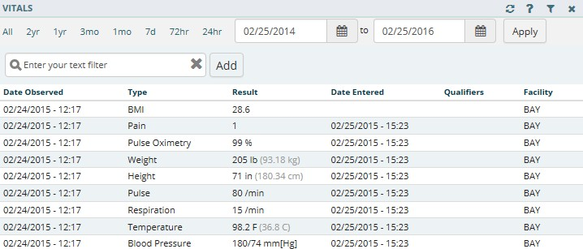Figure 6-78 Vitals Applet Expanded View

Use the preset dates or the calendar dropdowns to filter the vitals by date. Enter text filter in the Enter your text filter field to filter the information using a keyword.

Vitals: Detail View
To display a detailed view of vitals from the trend, summary or expanded applet:
- Select a vital (e.g., Blood Pressure) and the applet toolbar menu displays.
- Select the Details form button and the Vitals Detail Dialog box opens.
- A historical, detailed view of that vital is presented in list view and graph view. The shaded area on the graph depicts the reference range, if available, for that vital.
- Hovering over a time on the graph displays a tool tip with more information (Figure 6-79).

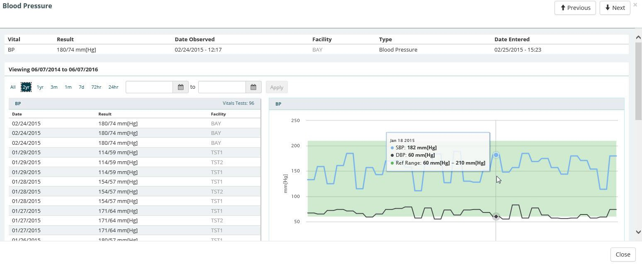Figure 6-79 Vitals Detail Dialog Box
- Select the Close button, the X in the upper right-hand corner, or anywhere outside of the Vitals Detail Dialog box, to return to the applet.

Chapter 7: Applet Features

About Applets
The applets in the eHMP application are widgets that sort patient data into segments throughout the patient record.
Most of the applets can be refreshed, filtered, maximized, and minimized (Figure 7-1) to
display various levels of detail, provide different views of an applet’s information, and open search capability.

Figure 7-1 Applet Feature Buttons

Refresh Button
The Refresh button found on each applet in eHMP updates patient data, and should be used after entering new patient information in CPRS.
To refresh patient data:
- After entering any new patient information in CPRS, access eHMP again.
- Select the Refresh button for an applet. The new information displays.

Online Help Button
The Online Help button allows you to easily access context-driven, application-oriented help information.
To access Online Help:
- Select the Online Help button for more information on a specific topic, and a new window displays with information on that topic.
- Select the PDF Version link to download the eHMP User Guide (Figure 7-2).

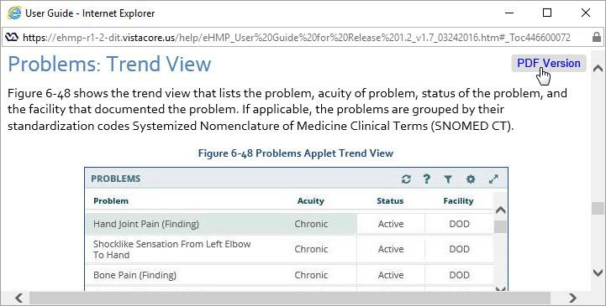Figure 7-2 PDF Version of the eHMP User Guide
- Close out of the Help window to return to eHMP.

Filter Button
The Filter button allows you to filter data, limiting the items displayed within an applet. To filter data for a particular applet:
- Select the Filter button to filter the data by entering key terms in the Enter your text filter field.
Note: If more than one word is used, the search results contain all of the filter words.
- Select the X next to the Enter your text filter field to return to the default list of items for that applet.
- Select the Filter button again to remove the filter field.

User-Defined Applet Filters
You can add more than one filter text to user-defined workspaces that persist from patient-to- patient and session-to-session.
To add filters to a user-defined workspace:
- Open the user-defined workspace.
- Select the Filter button and the Enter Filter field displays.
- Enter the filter text. The results populate as you enter text.
- Select Add or press the Enter key on the keyboard to add the filter text. The filter text displays with an x next to the text and the applet header becomes darker with the word Filtered added (Figure 7-3).

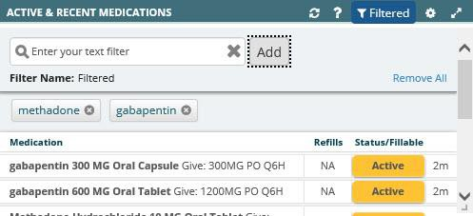Figure 7-3 Filtered Applet
- Repeat steps 3 and 4 to continue adding filter text to the applet.
- Select Filtered to the right of Filter Name to change the filter name.
- Enter the new filter name and press Enter on the keyboard. The new filter name displays to the right of Filter Name and in the applet header (Figure 7-4).

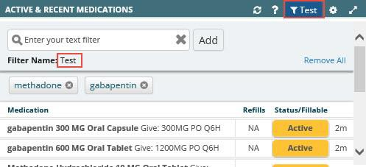Figure 7-4 Filter Name
- Select either the x to the right of the filtered text to remove it from the filtered data or
Remove All to remove all of the filtered text.

Maximize Applet Button
The Maximize Applet button allows you to expand the applet. The maximized view provides more detailed information for the applet. Select the Maximize Applet button located in the upper right corner of the applet to maximize it.

Minimize Applet Button
When viewing an applet in the maximized view, select the Minimize button to return to the previous view.

Sortable Column Headers
Most applet column headers can be selected in the trend, summary, maximized, or expanded views to sort the information in ascending or descending order.
To sort a column in an applet:
- Select the column name (e.g., Description or Facility). The list sorts in ascending order (Figure 7-5).

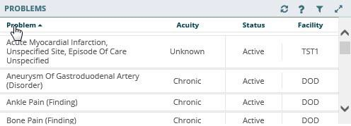Figure 7-5 Sortable Column Header
- Select the column name again and the list sorts in descending order.

Manual Tile Sort
Tiles are list items displayed when working in the trend view of an applet. Some applets provide the ability to manually sort tiles by dragging and dropping them to a new location in the list. Tiles can be sorted so that the order of display is more clinically relevant to the workspace. The sorted data within the workspace persists from session to session.
Note: The tile-sorting feature is available only for user-defined workspaces.
Tile sorting is available in the trend view for the following applets:
- Active & Recent Medications
- Numeric Lab Results
- Problems
- Vitals

To sort a tile in the Problems applet (example):
- Select the tile to be moved (Figure 7-6). The selected tile is highlighted and the applet toolbar menu displays.

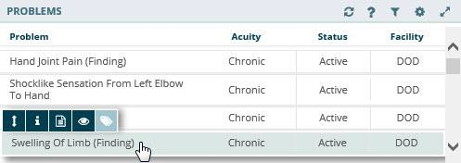Figure 7-6 Tile Sorting
- Drag and drop the tile to the desired location in the list. Once the tile has been moved, the word Manual appears in the header (Figure 7-7).

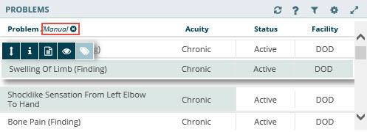Figure 7-7 Manual Tile Sorting
- Repeat steps 1 and 2 to reorder the remaining tiles in the applet.
- To delete the manual sort and revert to the default view, select the Clear your manual sort button next to Manual.

Infobutton
Some applets provide context-sensitive medical information specific to certain concepts, such as medications, immunizations, and labs. The Infobutton feature allows you to better assess and treat patients.
To access the Infobutton within the Problems applet (example):
- Select an item from the Problems applet. The applet toolbar menu displays.
- Select the Infobutton (Figure 7-8).

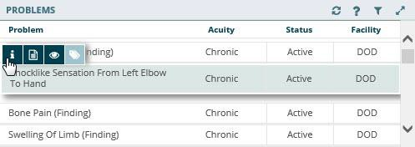Figure 7-8 Infobutton in the Problems Applet
- A new browser window opens that displays specific immunization information.
- Close the browser window to return to the previous view.

Details Form Button
The Details form button is an alternate shortcut to a detail dialog box for a selected item. To access the detailed dialog box using the Details form button:
- Select the row of the item and the applet toolbar menu displays.
- Select the Details form button . The detail dialog box for the selected item opens (Figure 7-9).

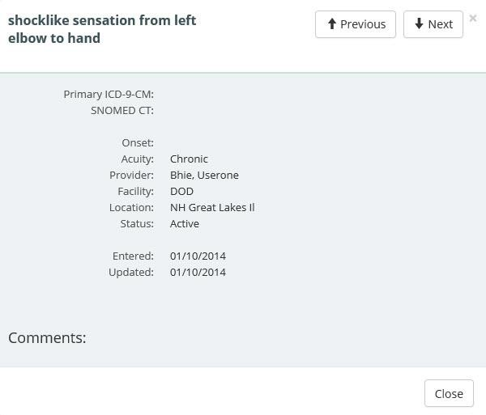Figure 7-9 Detail Dialog Box for Selected Item
- Select Close to close the dialog and return to the previous view.

Quicklook Button
The Quicklook button is a shortcut to a display of detailed information for a selected item for the trend view of an applet. The last five occurrences for the selected item are displayed in list format.
To access the Quicklook box:
- Select the row of the item and the applet toolbar menu displays.
- Select the Quicklook button and expanded information for the selected item displays (Figure 7-10).

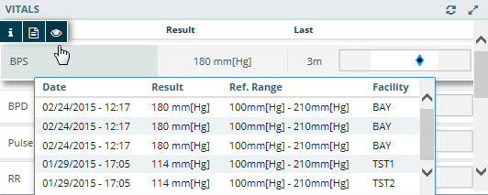Figure 7-10 Quicklook Button

- Select the Quicklook button again to close the expanded information.

Submenu Button
The Submenu button is available only for the Problems applet. It lists the workspaces that are associated with the selected problem to allow for easy navigation to specific patient data.
To access the associated workspace using the Submenu button:
- Select a problem from the Problems applet and the applet toolbar menu displays.
- Select the Submenu button and a list of associated workspaces for that problem display (Figure 7-11).

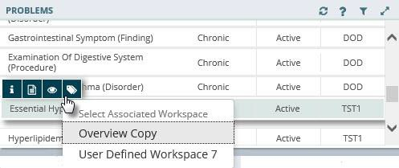Figure 7-11 Selecting Submenu Button to List Associated Workspaces
- Select the desired workspace to open in the Main Application Window.

Comment Indicators
A Comment Indicator displays when there is additional information about an item. (Figure 7-12).

Figure 7-12 Comment Indicator

To display a comment:
- Select an item with the Comment Indicator.
- Select the Details form button and the detail dialog box displays. The comment displays at the bottom of the dialog (Figure 7-13).

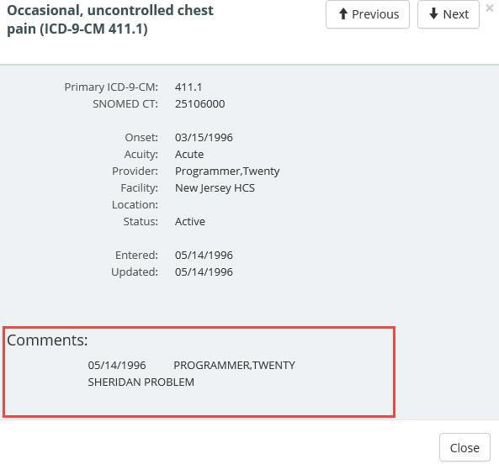Figure 7-13 Detailed Comment Information

Chapter 8: Workspaces

About Workspaces
Workspaces represent an area of activity with specific applets that support that activity. There are two types of workspaces for eHMP v1.2: predefined and user-defined workspaces.

Predefined Workspaces
Predefined workspaces have been created to provide you with different views of patient information. These workspaces cannot be edited or deleted. The Coversheet, Timeline, Overview, Meds Review, and Documents are all predefined workspaces.
The Depression, Diabetes Mellitus, Hypertension, and Pre-Procedure workspaces are also predefined and cannot be edited or deleted. These were developed for common conditions and expose a combination of concepts, graphing, and items to support clinical management of these conditions in an efficient and safe manner.

Workspace Manager
The Workspace Manager feature allows you to add, edit, arrange and delete user-defined workspaces within the patient record.

Select the Workspace Manager button to open the Workspace Manager window.
The following are the elements of the Workspace Manager (Figure 8-1):
- Add New Workspace
- Workspace Filter
- Default View
- Title
- Associated Conditions
- Description
- Author
- Duplicate
- Rearrange
- Locked/Delete
- Preview
- Customize/Launch

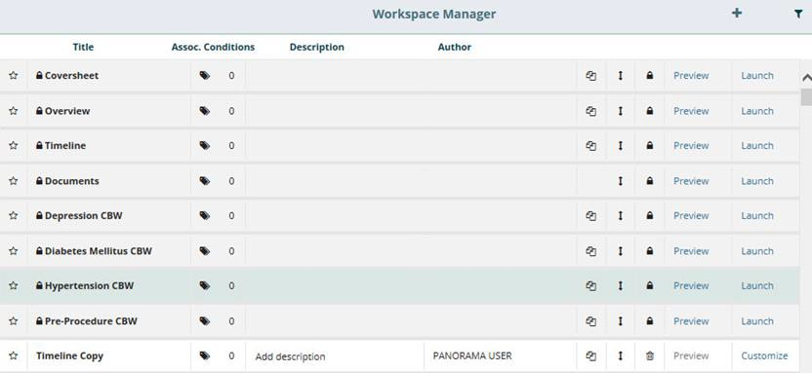Figure 8-1 Workspace Manager Window
Note: A shaded row with a lock icon beside the title indicates that workspace cannot be edited or deleted.

Add a New Workspace
The Workspace Manager allows you to create a new user-defined workspace that persists from patient to patient, and session to session.
To create a user-defined workspace:
1. Select the Add New Workspace button to add a user-defined workspace to the workspace manager listing.
Note: Once a workspace has been added to the Workspace Manager, you can customize the new workspace.

Workspace Filter
The Workspace Filter allows you to filter the workspaces by title or description in the Workspace Manager.
To filter through the list of workspaces:
- Select the Filter button . The Filter by title or description field displays (Figure 8-2).

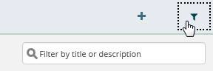Figure 8-2 Filter Workspaces

- Enter the desired workspace title or description. The results populate as you enter text.
- Select the x to remove the text and start a new filter.
- Select the filter button again, to remove the Filter by title or description field.

Default View
The Default View button allows you to select the workspace you want to set as your default view when you open eHMP. Select the Default View button to set the desired default view.
Note: The Overview workspace is the default view until another workspace has been selected.

Workspace Title
The Workspace Title field allows you to create or edit the title for a user-defined workspace. Enter or edit a workspace title in the Title field (Figure 8-3).

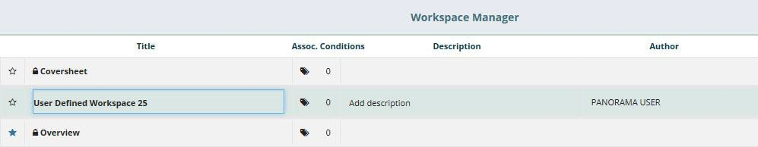Figure 8-3 Workspace Title Field
Note: The shaded rows cannot be edited.

Associated Conditions
The Associated Conditions feature allows you to associate a problem with a user-defined workspace. When a problem is associated to a workspace, you are able to select the problem in the Problems applet and access associated workspaces for treatment of that problem.
Note: You can only associate a problem to user-defined workspaces.
To add an associated condition to a workspace:

- Select the Assoc. Conditions button 8-4).
. The Search Problems field displays (Figure

Figure 8-4 Search Problems Field
- Enter a problem in the field. The results populate as you enter text (Figure 8-5).

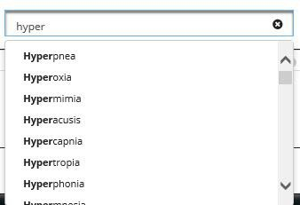Figure 8-5 Problems Search Results
- Select the problem from the list.
- You can add another problem by entering it in the Search Problems field, or exit by selecting the CLOSE button.
- The problem is now associated with that workspace and a number displays next to Assoc. Conditions button (Figure 8-6).

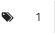Figure 8-6 Number of Associated Problems

Workspace Description
The Description field allows you to describe a user-defined workspace. This feature is associated with the workspace filter function. Select in the Add description field (Figure 8-7) to add a workspace description.
Note: The workspace description is optional and not required.

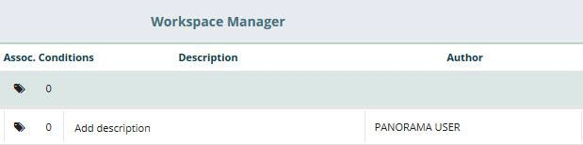Figure 8-7 Workspace Add Description Field
Note: A description cannot be added to the shaded rows.

Duplicate Workspaces
You are able to duplicate any workspace so that you can modify the cloned workspace.

To create a copy of an existing workspace:
1. Select the Duplicate button to create a duplicated workspace. A copy of that workspace displays in the Workspace Manager list, under the duplicated workspace (Figure 8-8).
Note: Refer to Customize a New Workspace for guidance on customizing a duplicated workspace.

Figure 8-8 Duplicated Workspace

Rearrange Workspace Listings
You are able to rearrange the workspaces so that you can order which workspaces you would like listed first in the Workspace Manager and the workspace dropdown listing.
To rearrange the Workspace Manager listing:
- Open the Workspace Manager.
- Select the Rearrange button . The selected row is highlighted (Figure 8-9).

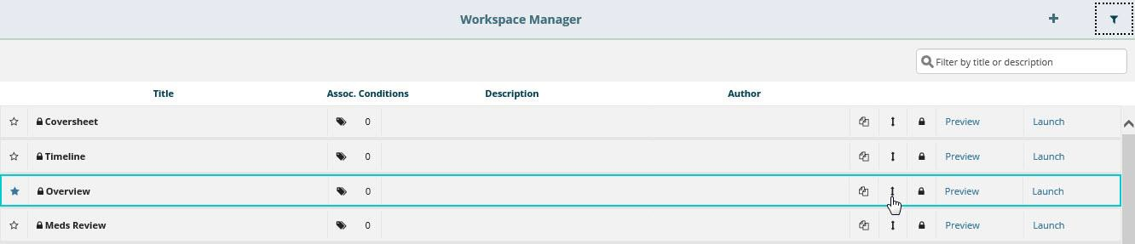Figure 8-9 Rearrange Workspaces
- Select and drag, or use the up and down arrow keys on the keyboard, to move the
workspace row to the desired spot.
- Repeat steps 2 and 3 to continue rearranging the workspace listing.

Delete Workspaces
You are able to delete any user-defined or duplicated workspace. Once deleted, these workspaces are no longer available.
To delete a user-defined or duplicated workspace:

- Select the Delete button . A confirmation message displays (Figure 8-10).

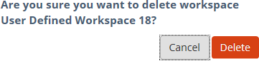Figure 8-10 Delete User-Defined Workspace Confirmation Message

- Select Delete to delete the workspace, or select Cancel to return to the Workspace Manager without deleting the workspace.
Note: You are not able to delete workspaces in shaded rows.

Preview Workspace
You can preview any workspace in the Workspace Manager. The preview link displays the workspace so you can review the layout prior to launching it in the Main Application Window.

- Select the Preview link in the Workspace Manager to open a preview of the
selected workspace in a new window (Figure 8-11).

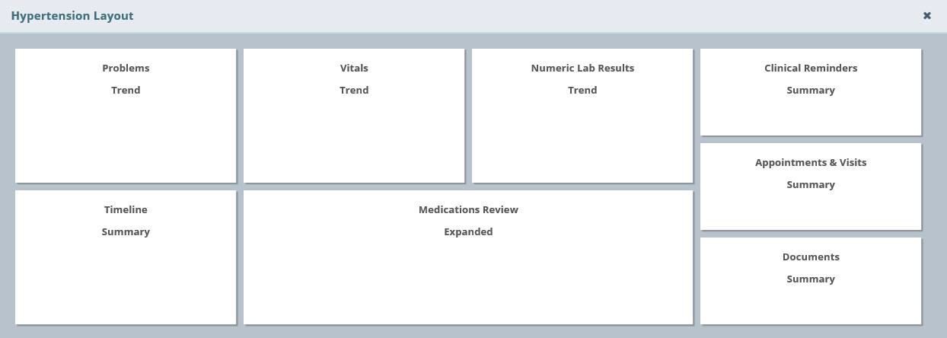Figure 8-11 Workspace Preview
Note: The Preview functionality is not available for user-defined workspaces that have not been customized. The Preview is shaded out to indicate the link is unavailable.
- Select the X to return to the Workspace Manager.

Customize a New Workspace
You can customize workspaces you create to enable unique experiences within the application.

To implement the customization of a new workspace:

- 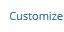Select the Customize link in the Workspace Manager to open the Workspace
Editor screen. The Workspace Editor screen displays with a listing of the applets in alphabetical order (Figure 8-12).

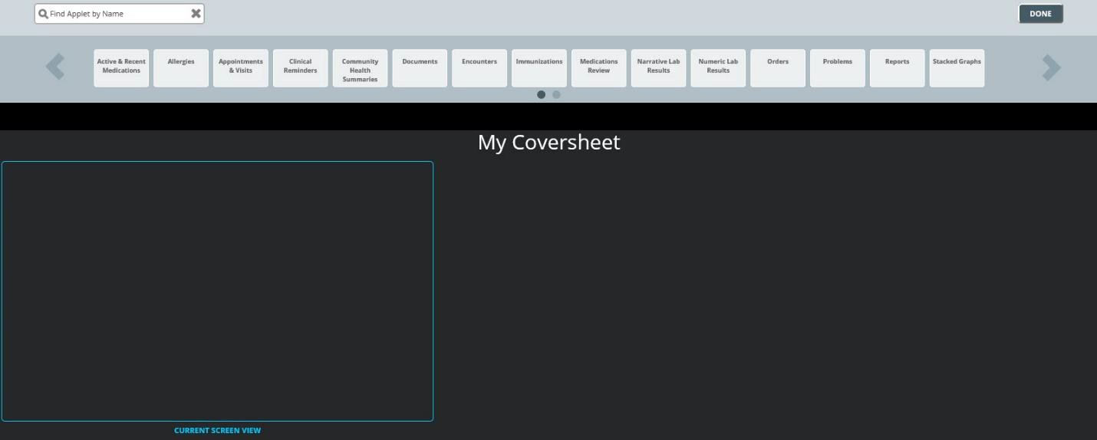Figure 8-12 Workspace Editor Screen
- Use the arrows to scroll through the applets, or enter the applet name in the Find Applet by Name field above the applets.
- Drag and drop the desired applet in the CURRENT SCREEN VIEW box.
Note: Any applets outside the CURRENT SCREEN VIEW box are included in the workspace. Use the scrollbar at the bottom of the screen to view applets outside of the box when viewing the workspace in the Main Application Window.
- Select a View option displays (Figure 8-13). Select the desired view for that applet. A box with the applet name and view displays in the CURRENT SCREEN VIEW box.

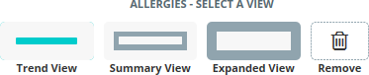Figure 8-13 Select a View

- Select and drag the applets to move them around on the screen.
- Use the double arrows to modify the size of the applet (Figure 8-14).

Figure 8-14 Using Double Arrows to Modify Applet Size

- Select the settings button workspace.
to change the applet view or to delete it from the

- Repeat steps 2-7 until the workspace layout is complete.
- Select the DONE button in the upper right hand corner of the screen to open the workspace in the Main Application Window.
Note: User-defined workspaces can be edited after they have been customized.

Launch Workspaces
Once the user-defined workspace has been customized, you are able to open the workspace in

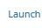the Main Application Window using the Launch link from the Workspace Manager.
You can also edit the user-defined workspace on the Main Application Window. To edit the user-defined workspace from the Main Application Window:
- Launch the workspace from the Workspace Manager, or from the Workspace dropdown menu. The workspace opens in the Main Application Window (Figure 8-15).

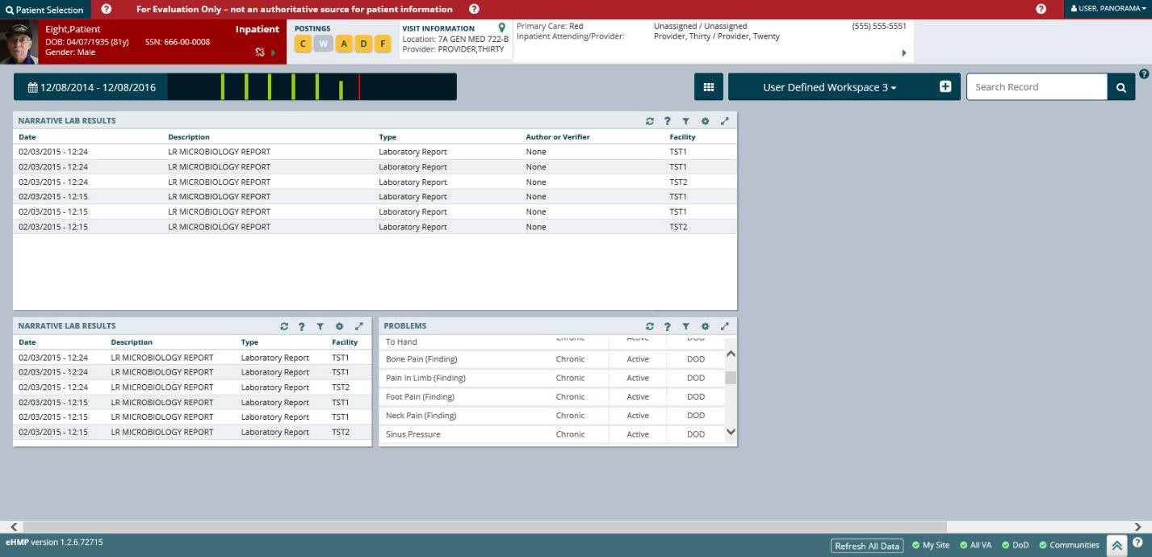Figure 8-15 Launch Workspaces
- Select and drag the applet to move it on the screen.

- Select the settings button on the applet to select a different view, or to delete the
applet from the workspace.
- Hover the mouse on the bottom left corner of the applet, then select and drag to re- size the applet.
- Select the Workspace Editor button to add applets to the workspace.
- Repeat steps 2-5 until the customization is complete.

Chapter 9: Other eHMP Features

Search Record Field
The Search Record field allows you to search within a selected patient’s record for specific information.
To search the selected patient’s record:
- Enter the specific item (i.e., medication, document, immunization) in the Search Record
field. A list of suggested terms drops down from the field as you enter the text (Figure 9-1).

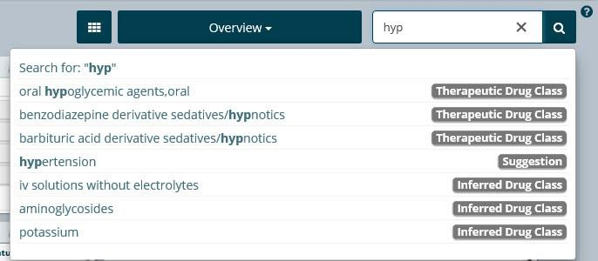Figure 9-1 Search Record Field Dropdown
- Select the item from the list, or press Enter to run the search.
- The number of results display and are categorized (Figure 9-2).

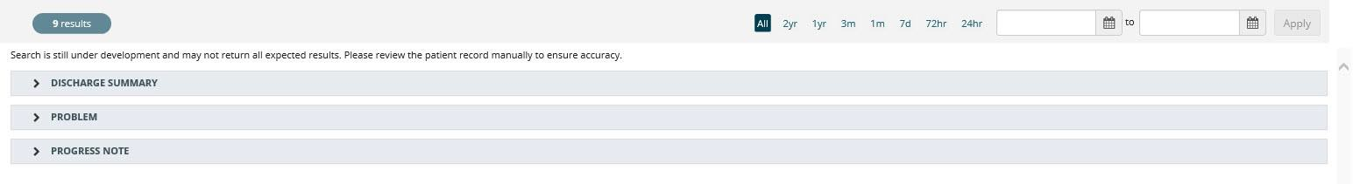Figure 9-2 Search Record Results
- Use the preset date ranges or the calendar dropdowns to filter the results for a specific timeframe.
- Select the dropdown arrows to display the results found within each category (Figure 9-3). The selected keyword is highlighted.

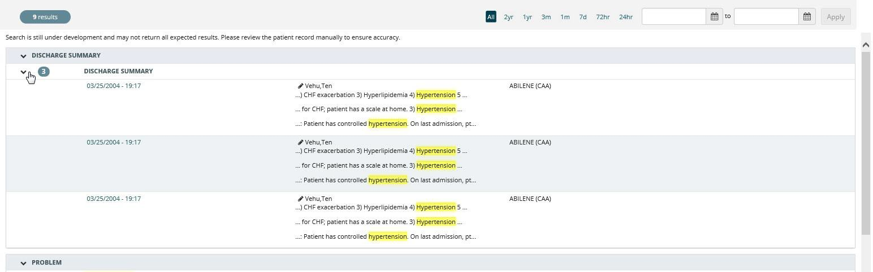Figure 9-3 Selected Keyword
- Select an item from the results list to open a detail dialog box with the selected term highlighted (Figure 9-4).

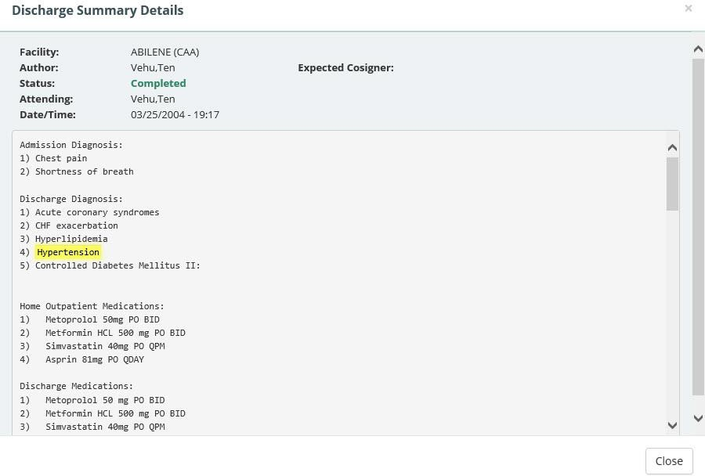Figure 9-4 Selected Keyword Detail Dialog Box
- Select CLOSE to close the detail dialog box and return to the results list.

Patient Record Refresh and Status Bar
The Refresh All Data button, Status Bar, and the eHMP Data Sources button appear in the bottom right-hand corner of the eHMP application (Figure 9-5). The Refresh All Data button provides the opportunity to refresh the selected patient’s data for the most up-to-date information from all sources. The status bar displays the status of each repository that contributes to the aggregated data displayed in eHMP. Green bullets with check marks indicate that data is being synced from that source.

Figure 9-5 eHMP Status Bar

The repositories used to aggregate data:
- My Site: Your current site
- All VA: All VA sites
- DoD: Department of Defense sites
- Communities: Community Health Partners of the VA
The eHMP Data Sources status screen (Figure 9-6) provides detailed information on the refresh status of data by source.

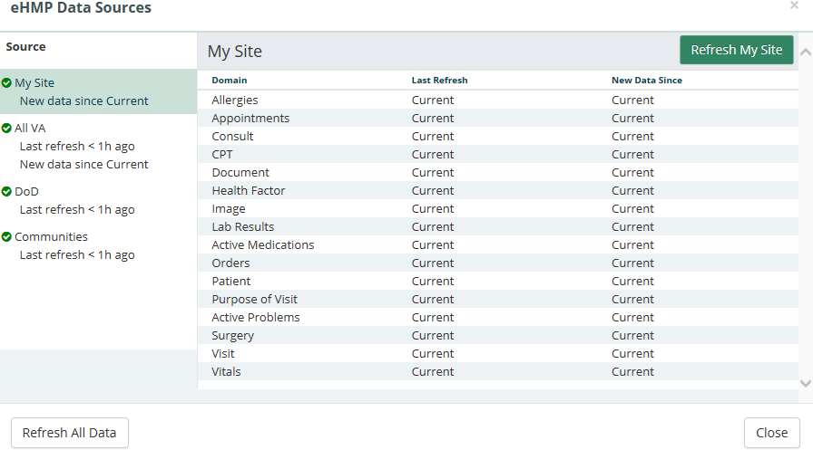Figure 9-6 eHMP Data Sources

To view the refresh status of patient data:

- Select the data sources button to open a new window with the sync statuses for all
sources. The new window displays the source, when the data was last refreshed, and if there is new data since the last refresh.
- Select the Source title to display the detailed status for that source. You can refresh all data, or refresh each source individually, from this window.
- Select the Close button to return to the current workspace.

