VistA Blood Establishment Computer Software (VBECS) - Echo Interface Configuration and Setup Guide, Version 6.0

December 2022

Department of Veterans Affairs
Enterprise Project Management Office

Table of Contents
Table of Contents 2
Introduction 3
Related Manuals and Reference Materials 4
Set Up Automated Instrument 5
1 Network Connectivity Setup 5
2 Testing Template Setup 5
3 User ID Setup 5
Set Up Instrument Manager 6
1 Instrument Manager Version 6
2 Instrument Manager to Automated Instrument Connectivity 6
3 Installing Instrument Driver 7
4 Set Up Instrument Side Configuration 7
4.1 Download Instrument Configuration Files 8
4.2 Import Instrument Side Configuration 10
4.3 Verify Test Code Mapping for Instrument Side Configuration 13
4.4 Verify Rules for Instrument Side Configuration 14
4.5 Configure Rules for Instrument Side Configuration 15
4.6 Import VBECS (HL7) Side Configuration 18
4.7 Verify Test Code Mapping for VBECS Side Configuration 21
4.8 Verify Rules for VBECS (HL7) Side Configuration 22
5 Set Up HL7 Connection to VBECS TEST 25
6 Set Up Instrument Connection 27
7 Test New Connections 29
8 Validate Instrument Connectivity to VBECS TEST 30
9 Set up HL7 Connection to VBECS PROD 30
Glossary 34
Appendices 35
Appendix A: Instrument Side Mapping 35
Appendix B: HL7 (VBECS) Side Mapping 36
Appendix C: Instrument Side Rules 37
Appendix D: VBECS (HL7) Side Rules 39
Appendix E: Echo Testing Templates 40
Appendix F: Validation Planning and Example Test Scenarios 41
Test Group One: AI interface disabled 42
Test Group Two: Verify AI individual test(s) 43
Test Group 2 Scenario 1: Verify AI TAS test 44
Test Group 2 Scenario 2: Verify AI serologic crossmatch test 45
Test Group 2 Scenario 3: Verify AI patient diagnostic tests 46
Test Group 2 Scenario 4: Verify AI blood unit tests 47
Revision History 48

Introduction

VBECS is a Blood Bank application that facilitates ongoing compliance with Food and Drug Administration (FDA) standards for medical devices and enhances the VA’s ability to produce high-quality blood products and services to veterans. The system follows blood bank standards, standards of national accrediting agencies, FDA regulations and VA policies.
VBECS 2.2.0 introduced a new interface for blood bank testing performed by blood bank instrumentation to VBECS. The implementation of the interface and its associated validation are described in this guide.
Unauthorized access or misuse of this system and/or its data is a federal crime. Use of all data must be in accordance with VA security and privacy policies.
The U.S. FDA classifies this software as a medical device. Unauthorized modifications will render this device an adulterated medical device under Section 501 of the Medical Device Amendments to the Federal Food, Drug, and Cosmetic Act. Acquiring and implementing this software through the Freedom of Information Act requires the implementer to assume total responsibility for the software and become a registered manufacturer of a medical device, subject to FDA regulations. Adding to or updating VBECS software without permission is prohibited.
Instructions in this Setup Guide must be followed for the interface to deliver information to VBECS. Local validation is required to confirm proper operation before use. Validation and verification is required to ensure connectivity to VBECS.
This guide is provided to assist you with the multi-faceted required setup of your local blood bank testing instrument(s), Data Innovations Instrument Manager (DI IM) and VBECS to electronically transmit instrument test results to VBECS for use in the transfusion service.
This guide includes download and install of a set of configuration files (.gsb files) as a starting point for your instrument setup. These configuration files are not created and validated by the VBECS team but are shared by other VBECS sites already using this instrument and are made available for installation from the VBECS SharePoint site. As noted above, local validation is required to confirm proper operations with the configurations implemented by your site.
There are specific setup requirements to test and transmit those testing results to VBECS for review using DI IM (Figure 1).
Figure 1: Hardware and Interface Configuration
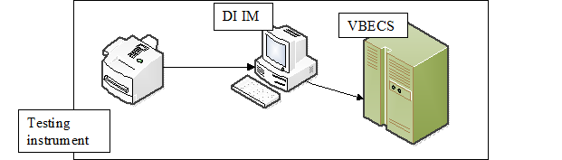
Your local testing instrument(s) communicates with DI IM via an instrument specific driver provided by DI that must be downloaded from DI and installed, locally.
DI IM communicates directly with VBECS via a generic HL7 interface driver that must be downloaded from DI and installed, locally. This driver is customized for VBECS by downloading and installing the driver configuration file.
VBECS has an interface that must be configured in VBECS Administrator to receive messages from DI IM (Figure 2).
Figure 2: Setup Path
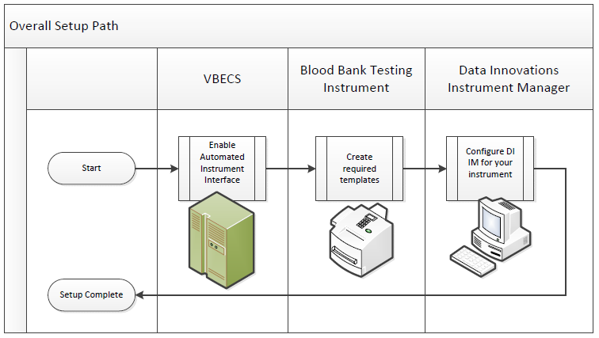

Related Manuals and Reference Materials
- VBECS Technical Manual-Security Guide
- Data Innovations Instrument Manager Manual
- Blood Bank Analyzer User’s Guide (Instrument Manual)

Set Up Automated Instrument

Network Connectivity Setup

In order to ensure proper functioning of an interface between an Automated Instrument and Instrument Manager the Instrument needs to be connected to the VA network. The static IP Address and Port number has to be assigned to the Instrument (further referred in this document as <Instrument IP> and <Instrument Port>). Please refer to the Instrument Manual or contact your vendor for the instructions about how to perform this setup. Check with Local IT staff to establish the connection to Instrument Manager.

Testing Template Setup
Test results sent using templates that are not supported will not be accepted in VBECS.
Please refer to Appendix E: Echo Testing Templates for the list of supported instrument templates.
AABB Standards require a serological XM to detect ABO incompatibility (5.16.1) and a local policy must be in place if the site is not performing an IS AHG as part of their serologic crossmatch test, manual or using an instrument.

User ID Setup
Failure to set up proper user IDs on an instrument will prevent instrument results from being accepted in VBECS.
In order for VBECS to properly recognize the person who performed testing on an Instrument, all users accessing the instrument must have their user IDs set up to match their network user IDs (e.g., REDACTED).

Please refer to the Instrument Manual or contact your vendor for the instructions about how to perform setup of user IDs.

Set Up Instrument Manager

Instrument Manager Version
Please verify that you are using Instrument Manager Version 8.13 or greater (Figure 3). In Instrument Manager, navigate to Help -> About Instrument Manager.
Figure 3: Instrument Manager Version Screen
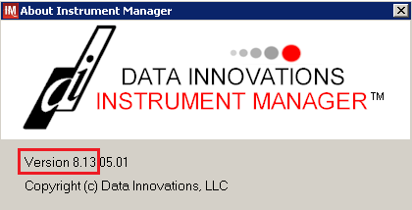
If your version of Instrument Manager is older than 8.13 STOP executing this guide and update the software first. Do not proceed until the issue is resolved.

If your Instrument Manager is greater than 8.13 you may proceed. The user must execute the instructions and validate functionality on newer versions. Discrepancies in the instructions must be reported as a service desk ticket.

Instrument Manager must have the Specimen Management Module licensed and activated. Do not proceed until this issue is resolved.

Instrument Manager to Automated Instrument Connectivity

Please contact your local network administrative staff and ensure that your local network allows two-way TCP/IP connectivity between <Instrument Manager IP> address and <Instrument IP> address on <Instrument Port>.

Installing Instrument Driver

Two drivers are required for the correct operation of the Automated Instrument interface to VBECS (Figure ):
Figure 4: Required Drivers
Driver | Name | Version | Description
Immure Galileo Echo/Arkonet | ibggecoi | 8.00.0007 | Instrument to DI IM driver
Data Innovations LLC, Configurable HL7 | diihl7ml | 8.00.0044 | DI IM to VBECS (HL7) driver

Please refer to the user’s manual for Instrument Manager or contact Data Innovations for the instructions on how to install drivers for Instrument Manager.

After successful installation of drivers please go to Report -> Available Drivers menu option in Instrument Manager and verify that the drivers listed in Figure 4 are present.

Set Up Instrument Side Configuration
Execute instructions in this section for each Echo instrument that will be connecting to VBECS.
Modifying rules or test code mappings as imported using this Instrument Manager configuration Setup Guide may lead to malfunction of the Automated Instrument to VBECS interface.
Prerequisites for the Instrument Manager Configuration files download:
- You must be an administrator on <Instrument Manager Server>.
- Once the above prerequisite is met you may proceed.

Download Instrument Configuration Files
Use local procedures for copying the instrument configuration files to the Instrument Manager server.

- Navigate to REDACTED (Figure 5).
Figure 5: Connecting to the VBECS SharePoint
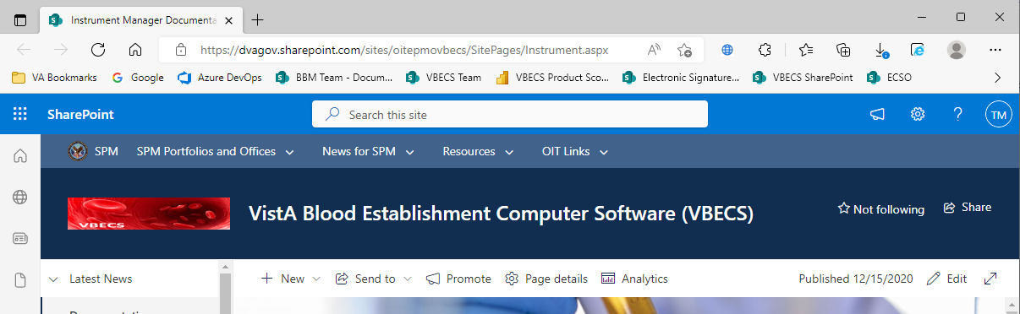

- To download a file from SharePoint, click the ellipses (...) and select Download (Figure 6).
Figure 6: Example of SharePoint Download
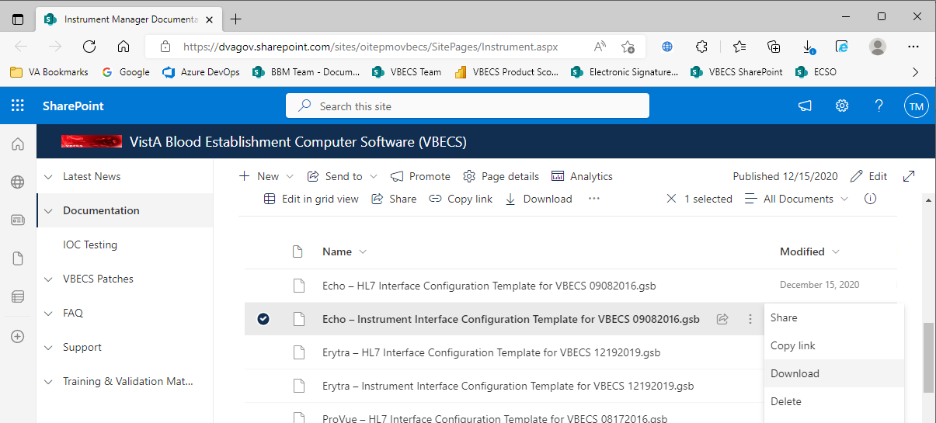
- In the Downloads screen, select Save as (Figure 7).
Figure 7: Example of Downloads
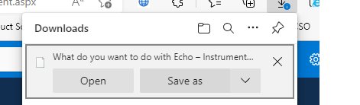
- In the next screen, specify the directory to save (Figure 8).
Figure 8: Example of Save As
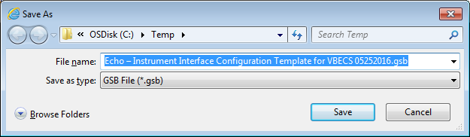
- Save both the Echo - HL7 Interface Configuration Template for VBECS 09082016.gsb and the Echo - Instrument Interface Configuration Template for VBECS 09082016.gsb files to the C:\temp directory.
- Per local procedures copy both files to C:\temp on the Instrument Manager server
- On the Instrument Manager server; Click Start, and in the “Search programs and files” box type Run and hit enter. Type powershell and click OK to launch PowerShell
- Copy and paste or type the following commands to generate checksums for configuration files:

certutil -hashfile “C:\Temp\Echo - HL7 Interface Configuration Template for VBECS 09082016.gsb” MD5 <press Enter>
certutil -hashfile “C:\Temp\Echo - Instrument Interface Configuration Template for VBECS 09082016.gsb” MD5 <press Enter>

To copy, highlight the lines in grey and enter CTRL-C.
To insert the copied line into a PowerShell window, right click in the PowerShell window and select “Paste”.
- Verify that checksums for both files match those shown in Figure 9.
Figure 9: Instrument Manager Configuration File Checksums
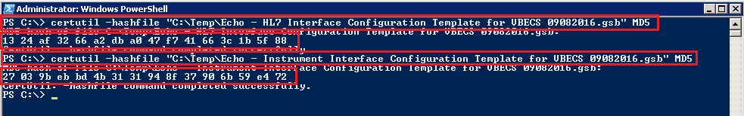
If the checksums do not match, stop and file a service desk ticket to coordinate assistance with installation. Do not proceed until the issue is resolved.
- Close the PowerShell window.

Import Instrument Side Configuration
- After downloading and verifying configuration files, open Instrument Manager and navigate to Configuration -> Configuration Editor.
- Click on the Import button (Figure 10).
Figure 10: Example of Configuration Editor
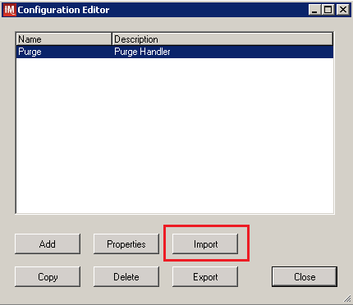

- Once the import screen opens, click the Browse button and select C:\Temp folder (Figure 11).
- Click OK.
Figure 11: Example of Configuration Import Screen
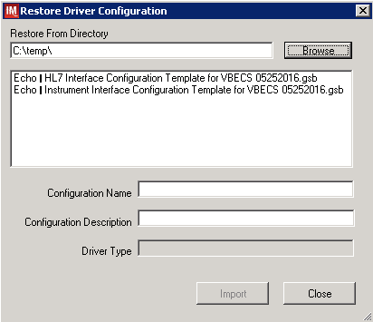

- Select Echo - Instrument Interface Configuration Template for VBECS 09082016.gsb file from the list.
- Enter Configuration Name that contains 3 letter location code of the instrument (e.g. HIN for Hines VAMC), word Echo and sequence number (1 for the first instrument, 2 for the second etc.). Example Configuration Name for instrument configuration located at Hines would be:

HIN_Echo_1

This configuration name will be further referred in this document as <Instrument Side Configuration>.

- Enter Configuration Description and click Import button. Verify that the following confirmation window displays (Figure 12).
Figure 12: Example of Successful Configuration Import
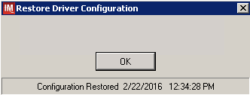
If you are using newer version of the driver than the one mentioned in section 3, the Instrument Manager will warn you about the discrepancy in driver versions. Please acknowledge this warning and continue.
- Click OK and then close the Restore Driver Configuration window.
- Verify that Configuration Editor shows the new configuration on the list (Figure 13)
Figure 13: Example of Configuration Editor Window Showing Newly Imported Configuration
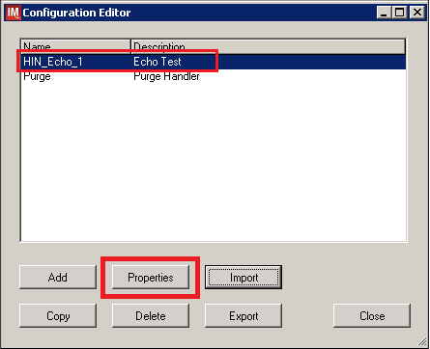

- Close the Configuration Editor window.

Verify Test Code Mapping for Instrument Side Configuration
- Navigate to Reports -> Configuration Options and Mappings.
- Select the <Instrument Side Configuration Name> from the pull down menu (Figure 14).
- Select the Results Test Code Mapping Tab (Figure 14).
- Verify the Results Test Code Mapping Report Tab matches the list in - Appendix A: Instrument Side mapping.
Figure 14: Example of Results Test Code Mapping Tab
REDACTED

If mismatches in Test Codes names, or missing or extra Test Codes are encountered, file a service desk ticket to coordinate assistance with installation. Do not proceed until the issue is resolved.

Verify Rules for Instrument Side Configuration
- Remaining in the Configuration Options and Mapping Window, select the Rules Tab (Figure 15).
- Verify the Rules Tab matches the list in Appendix C: Instrument Side Rules.
Figure 15: Example of Rules Tab
REDACTED

- Close the Configuration Options and Mappings window.
If problems are encountered, file a service desk ticket to coordinate assistance with installation. Do not proceed until the issue is resolved.

Configure Rules for Instrument Side Configuration
In this section your will establish the name of the instrument associated with test results for VBECS reports. If you are setting up multiple instruments, make sure that each has a unique name.

- Navigate to Configuration -> Specimen Management Configuration -> Rules Processing.
- Select <Instrument Side Configuration Name> from the pull down menu (Figure 16).
- Locate rule SetInstrumentID.
- Click on the Then line in the rule.
- Modify the rule by typing <Instrument Name> between the quotation marks in the lower box (Figure 15).
Figure 16: Example of Instrument Name Setup
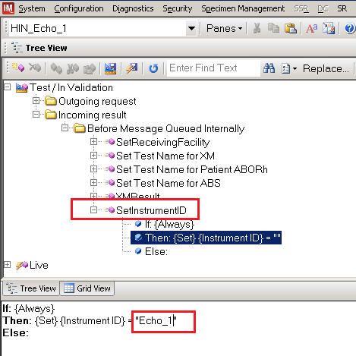
- Locate rule SetReceivingFacility. Click on Then line in the rule. Modify the rule by typing <Division Code> between the quotation marks as shown (Figure 17).
<Division Code> also known as Station Number in VistA is a unique alphanumeric code that is associated with each hospital (e.g., 589 for VA Heartland West VAMC). This code must match the division code configured in VBECS Administrator application for a given site.
Figure 17: Example of Division Code Setup
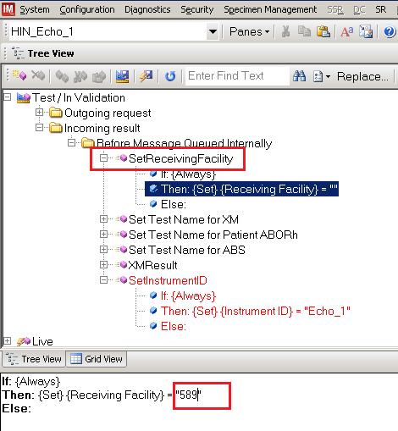

- Click on the Save Test / In Validation Rule Set button located in the toolbar above the rules (Figure 18).
Figure 18: Example of Save Rules Button
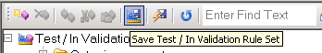
- Verify that the Test / In Validation Rule Set Saved message is received (Figure 19):
Figure 19: Example of Successful Rule Save
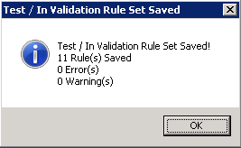
If problems are encountered, file a service desk ticket to coordinate assistance with installation. Do not proceed until the issue is resolved.

- Click on the Save Live Rule Set button located in the upper toolbar and click Yes to confirm (Figure 20).
Figure 20: Example of Save Rules in Live Set Button
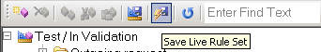

- Navigate to Reports->Configuration Options and Mappings and select the Rules Tab. Scroll down to Live - Incoming result - Before Message Queued Internally (Figure 20).
- Verify that the Live Rule Set matches Appendix C: Instrument Side Rules and includes changes made to SetReceivingFacility (Figure 21) and SetInstrumentID.
Figure 21: Example of Live Rules Set View
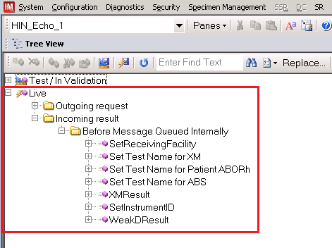
If problems are encountered, file a service desk ticket to coordinate assistance with installation. Do not proceed until the issue is resolved.
- Close the Configuration Options and Mappings window.

Import VBECS (HL7) Side Configuration
Only one HL7 configuration is needed even if you use multiple Echo instruments. All Echos will share the same HL7 configuration.
Modifying rules or test code mappings in the Instrument Manager configuration outside of this Setup Guide is not allowed and may lead to malfunction of the Automated Instrument to VBECS interface.

- Navigate to Configuration -> Configuration Editor (Figure 22).
- Click on the Import button.
Figure 22: Example of Configuration Editor Window
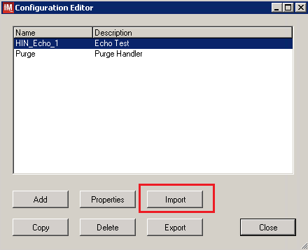
- Once the Restore Driver Configuration window opens, click the Browse button and select C:\Temp folder (Figure 23).
- Select Echo - HL7 Interface Configuration Template for VBECS 09082016.gsb file from the list. Enter Configuration Name that contains 3 letter location code of the instrument (e.g. HIN for Hines VAMC), word VBECS and sequence number (1 for the first configuration, 2 for the second etc.). Example Configuration Name for VBECS side configuration located at Hines would be:

HIN_VBECS_1

This configuration name will be further referred in this document as <HL7 Side Configuration>.
Figure 23: Example of Configuration Import Window
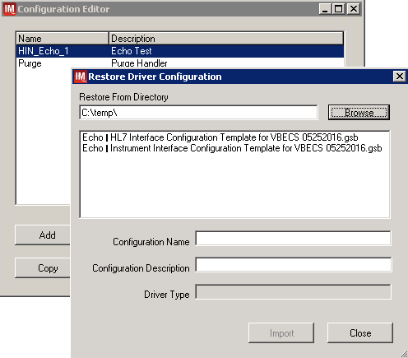

- Enter Configuration Description and click Import button. Verify that the confirmation window in Figure 24 displays.
Figure 24: Example of Successful Configuration Import
If you are using a newer version of the driver than the one mentioned in section 3, the Instrument Manager will warn you about the discrepancy in driver versions. Please acknowledge this warning and continue.

- Click OK and close the Restore Driver Configuration window.
- Verify that Configuration Editor shows the new configuration on the list (Figure 25).
Figure 25: Example of Newly Imported HL7 Configuration
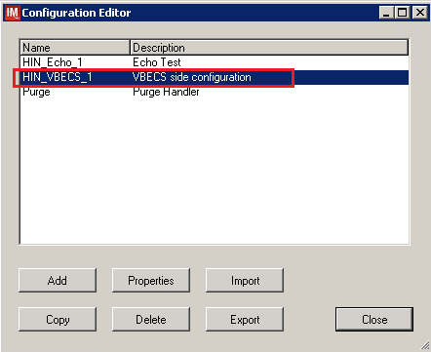

Verify Test Code Mapping for VBECS Side Configuration
- Navigate to Reports -> Configuration Options and Mappings.
- Select the <HL7 Side Configuration Name> from the pull down menu (Figure 26).
- Select the Results Test Code Mapping Tab (Figure 26).
- Verify the Results Test Code Mapping Report Tab matches the list in Appendix B: HL7 (VBECS) Side Mapping.
Figure 26: Example of HL7 Configuration Report Window
REDACTED

- Close Configuration Options and Mappings window.

If mismatches in Test Codes names, missing or extra Test Codes are encountered, file a service desk ticket to coordinate assistance with installation. Do not proceed until the issue is resolved.

Verify Rules for VBECS (HL7) Side Configuration
Modifying rules or test code mappings as imported using this Instrument Manager configuration Setup Guide may lead to malfunction of the Automated Instrument to VBECS interface.

- Navigate to Configuration -> Specimen Management Configuration -> Rules Processing.
- On the Rule Processing window, select <HL7 Side Configuration> from the drop-down in the upper left corner.
- Next, click on the Quick Filter icon located on the right side of the Configuration Name (Figure 27)
Figure 27: Example of Rules Processing Toolbar
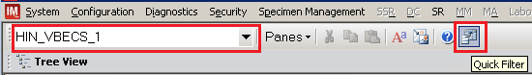

- On the Quick Filter window, check the box next to the Outgoing Result and click Close button (Figure 28).
Figure 28: Example of Quick Filter Window
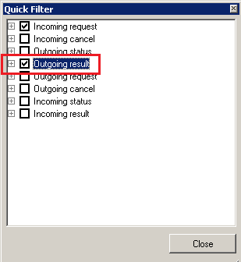

- Expand Outgoing Result section and Before Message Sent to this Connection sections (Figure 29).
Figure 29: Example of Rules Window
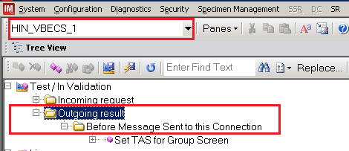

- Expand all rules and verify that they match rules listed in Appendix D: VBECS (HL7) Side Rules.
If mismatches in rules are encountered, file a service desk ticket to coordinate assistance with installation. Do not proceed until the issue is resolved.
- Click on the Save Live Rule Set button located in the upper toolbar and click Yes to confirm (Figure 30).
Figure 30: Example of Save Rules in Live Set Button

- Expand the Live Rule Set and verify that rule text matches Appendix D: VBECS (HL7) Side Rules. (Figure 31).
Figure 31: Example of Live Rules Set View
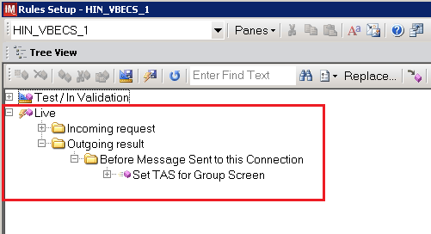

If problems are encountered, file a service desk ticket to coordinate assistance with installation. Do not proceed until the issue is resolved.

- Close the Rules Setup window.

Set Up HL7 Connection to VBECS TEST
Modifying connection settings in the Instrument Manager outside of this Setup Guide is not allowed and may lead to malfunction of the Automated Instrument to VBECS interface.
- Navigate to Configuration -> Connection Assignment.
- On the Connection Assignment window, click the Add button.
- On the Connection Properties window, enter the Connection Name. Enter a name that contains <HL7 Side Configuration> and word Connection. For example:

HIN_VBECS_1_Connection

- Select <HL7 Side Configuration> as Configuration Name.
- Check Include in Specimen Management check box.
- Select TCP/IP connection in Device. (Figure 32).
Figure 32: Example of Connection Properties Window
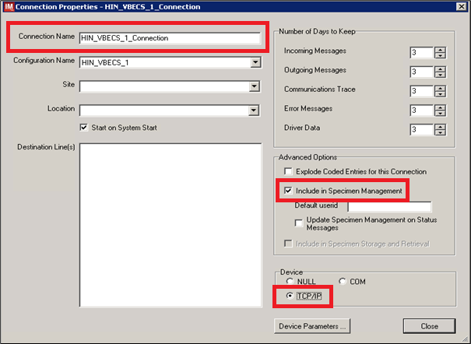

- Click on Device Parameters button.
- Enter TCP/IP Address and TCP/IP Port Number that matches VBECS TEST Application IP Address and IP Port Number configured in VBECS TEST Administrator application for Auto Instrument Interface (Figure 33). Please refer to VBECS Technical Manual Security Guide for instruction on how to configure interfaces for VBECS.
Figure 33: Example of TCP/IP Configuration Window
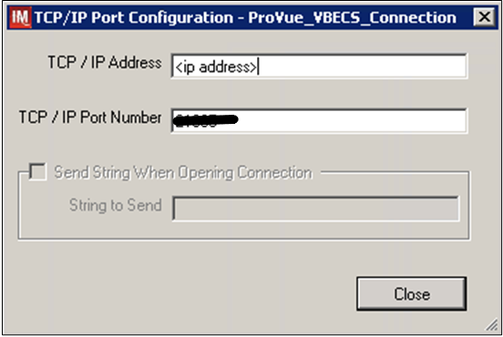

- Click close on the TCP/IP Port Configuration window and click Yes to save.
- Click close on the Connection Properties window and click Yes to save.
- Verify the newly created connection shows on Connection Assignment window (Figure 34).
Figure 34: Example of Newly Created Connection
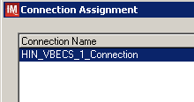

Set Up Instrument Connection

Execute instructions in this section for each instrument that will be connecting to VBECS.
Modifying connection settings in the Instrument Manager outside of this Setup Guide is not allowed and may lead to malfunction of the Automated Instrument to VBECS interface.
- On the Connection Assignment window, click the Add button.
- On the Connection Properties window, enter the Connection Name. Enter a name that contains <Instrument Side Configuration> and word Connection. For example:

HIN_Echo_1_Connection

- Select <Instrument Side Configuration> as Configuration Name.
- Check Include in Specimen Management check box.
- Select TCP/IP connection.
- On the Destination Lines list check the box next to connection configured in previous section (Figure 35).
Figure 35: Example of Connection Properties Window
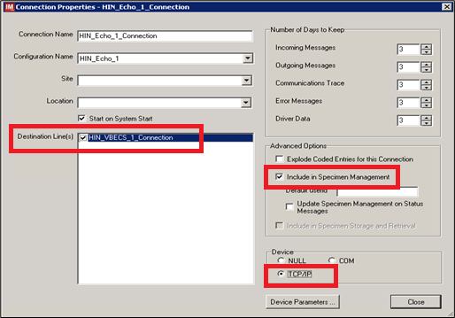
- Click on Device Parameters button.
- TCP/IP Address remains blank.
- Set TCP/IP Port Number to <Instrument Port> discussed in Section Network Connectivity Setup.
- Uncheck Send String When Opening Connection check box (Figure 36).
Figure 36: Example of TCP/IP Configuration Window
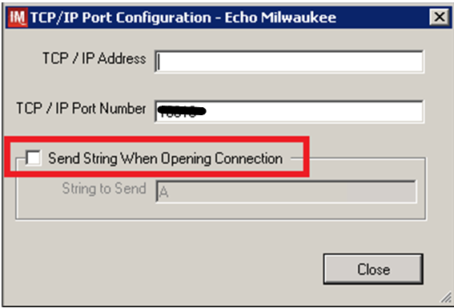

- Click close on the TCP/IP Port Configuration window and click Yes to save.
- Click close on the Connection Properties window and click Yes to save.
- Verify the newly created connection shows on Connection Assignment window (Figure 37).
- Close the Connection Assignment window.
Figure 37: Example of Newly Created Connection
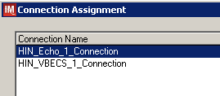

Test New Connections
- Navigate to System -> Status.
- Right-click each newly created connection and choose option to Start Selected Connections (Figure 38).
Figure 38: Example of Connection Status Window
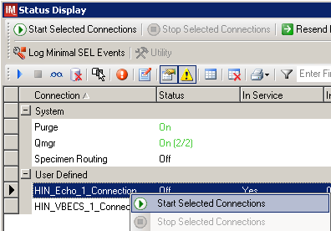
- Verify that all newly created connections are showing Status of On after about a minute or so. (Figure 39).
Figure 39: Example of Successful Connection Test
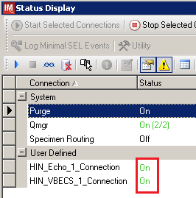
If one or more connections fail to start, file a service desk ticket to coordinate assistance with installation. Do not proceed until the issue is resolved.
- Close the Status Display.

Validate Instrument Connectivity to VBECS TEST
Execute validation instructions from Appendix F: Validation Planning and Example Test Scenarios to verify that Instrument is properly interfacing with VBECS.
If one or more validation scenarios fail, file a service desk ticket to coordinate assistance with installation. Do not proceed until the issue is resolved.

Set up HL7 Connection to VBECS PROD
- Navigate to System -> Status.
- Right-click <VBECS_Connection> and choose option to Stop Selected Connections (Figure 40).
Figure 40: Example of Stop Selected Connections
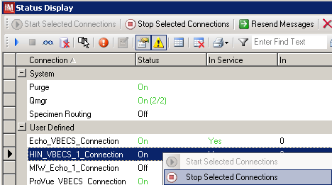
- Wait until connection status changes to Off. Navigate to Configuration -> Connection Assignment.
- Select <VBECS_Connection> and click Properties (Figure 41).
Figure 41: Example of Connection Assignment
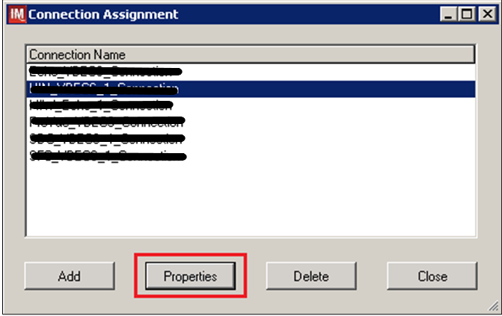
- On Connection Properties window click Device Parameters (Figure 42).
Figure 42: Example of Connection Properties
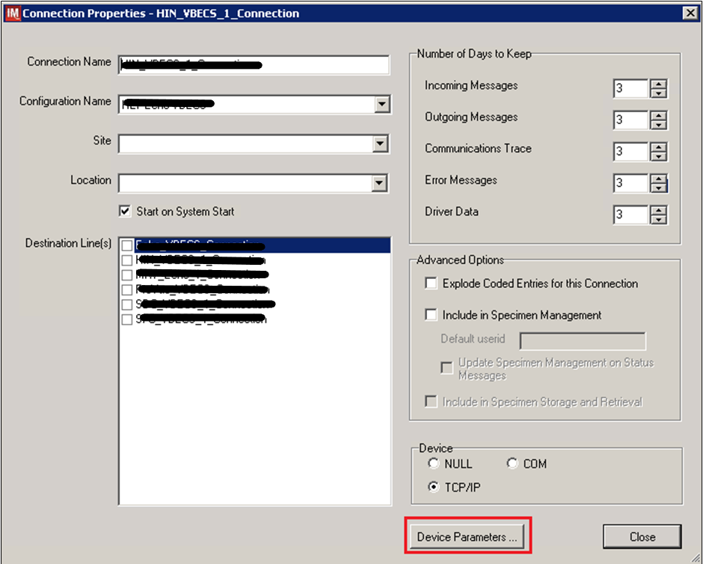
- Enter TCP/IP Address and TCP/IP Port Number that matches VBECS PROD Application IP Address and IP Port Number configured in VBECS PROD Administrator application for Auto Instrument Interface (Figure 43). Please refer to VBECS Technical Manual Security Guide for instruction on how to configure interfaces for VBECS.
Figure 43: Example of TCP/IP Configuration Window
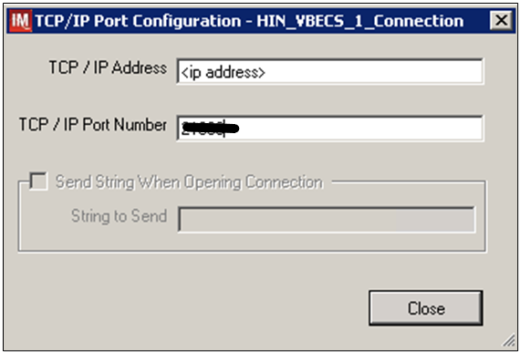

- Close the TCP/IP Port Configuration and click Yes to confirm changes.
- Close the Connection Properties window and click Yes to confirm changes.
- Close the Connection Assignment window.
- Navigate to System -> Status.
- Right-click <VBECS_Connection> and choose option to Start Selected Connections (Figure 44).
Figure 44: Example of Connection Status Window
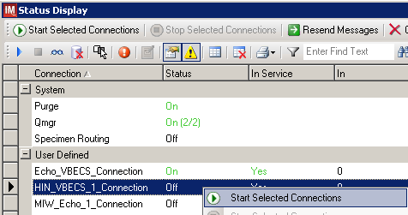
- Verify that <VBECS_Connection> is showing Status of On after about a minute or so. (Figure 45).
Figure 45: Example of Successful Connection Test
If connection fails to start, file a service desk ticket to coordinate assistance with installation. Do not proceed until the issue is resolved.
- Close the Status Display and Log Off the system.

Glossary
Acronym, Term | Definition
Automated Instrument | Blood Bank Analyzer that performs blood testing.
Division Code | Also known as Station Number in VistA is the unique alphanumeric code that is associated with each hospital (e.g. 589 for VA Heartland West).
Instrument Manager (IM) | Software created by Data Innovations that serves as a middleware between Automated Instrument and VBECS. It translates messages containing test results sent from an instrument into HL7 messages that are then parsed into VBECS.
VA | Department of Veterans Affairs.
VBECS | VistA Blood Establishment Computer Software.
VistA | Veterans Health Information Systems and Technology Architecture. VistA software, developed by the VA, is used to support clinical and administrative functions at VA Medical Centers nationwide. VistA is composed of packages that undergo a verification process to ensure conformity with name spacing and other VistA standards and conventions.

Appendices

Appendix A: Instrument Side Mapping
Table 1- Appendix A: Instrument Side mapping
REDACTED

Appendix B: HL7 (VBECS) Side Mapping
Table 2- Appendix B: HL7 (VBECS) Side Mapping
REDACTED

Appendix C: Instrument Side Rules
Figure 45: Instrument Side Rules
HIN_Echo_1 (Echo Test)
ibggecoi / Immucor Galileo Echo/Arkonet / v8.00.0007

--- Test / In Validation - Incoming result - Before Message Queued Internally ---

Rule # 1
Desc - SetReceivingFacility
If - {Always}
Then - {Set} {Receiving Facility} = ""

Rule # 2
Desc - Set Test Name for XM
If - {Test Code} {On Any Test} {Contains} "Crossmatch"
Then - {Set} {Test Code Sub ID} {On That Test} = "XM"

Rule # 3
Desc - Set Test Name for DAT
Child of Rule # 2 - Else
If - {Test Code} {On Any Test} {Contains} "DAT"
Then - {Set} {Test Code Sub ID} {On That Test} = "DAT"

Rule # 4
Desc - Set Test Name for Unit ABORh
Child of Rule # 3 - Else
If - {Test Code} {On Any Test} {Contains} "Confirm"
Then - {Set} {Test Code Sub ID} {On That Test} = "Unit ABORh"

Rule # 5
Desc - Set Test Name for Antigen Typing
Child of Rule # 4 - Else
If - {Test Code} {On Any Test} {Contains} "Ag_"
Then - {Set} {Test Code Sub ID} {On That Test} = "Antigen Typing"

Rule # 6
Desc - Set Test Name for Weak D
Child of Rule # 5 - Else
If - {Test Code} {On Any Test} {Contains} "Weak D"
Then - {Set} {Test Code Sub ID} {On That Test} = "Weak D"

Rule # 7
Desc - Set Test Name for Patient ABORh
If - {Test Code} {On Any Test} {Contains} "Group"
Then - {Set} {Test Code Sub ID} {On That Test} = "Patient ABORh" {AND} {Set} {Specimen User Field 15} = {Specimen User Field 15} {Concatenated With} " Group"

Rule # 8
Desc - Set Test Name for ABS
If - {Test Code} {On Any Test} {Contains} "Screen"
Then - {Set} {Test Code Sub ID} {On That Test} = "ABS" {AND} {Set} {Specimen User Field 15} = {Specimen User Field 15} {Concatenated With} " Screen"

Rule # 9
Desc - XMResult
If - {Result} {On Any Test} {Contains} "IgG Comp"
Then - {Set} {Result} {On That Test} = "Compatible"

Rule # 10
Desc - SetInstrumentID
If - {Always}
Then - {Set} {Instrument ID} = ""

Rule # 11
Desc - WeakDResult
If - {Result} {On Any Test} {Contains} "Positive"
Then - {Set} {Result} {On That Test} = "Positive"

Appendix D: VBECS (HL7) Side Rules
Figure 46: Rules: HL7 Side Rules
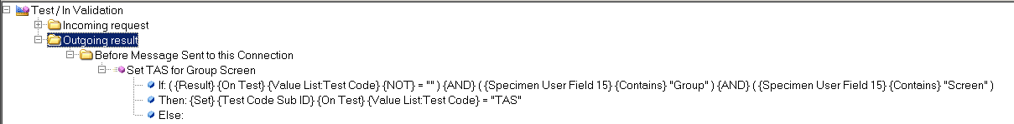

Appendix E: Echo Testing Templates
Table 3: Echo Testing Templates
Template Name | Selected Fields | VBECS Test | Test Component
Group | Group-Anti-A-EW  Group-Anti-B-EW  Group-A1 Cells-EW  Group-B Cells-EW  Group-Anti-D1-EW  Group-Anti-D2-EW  Group-Mono Ctrl-EW  Group-Group Interp | Patient ABO/Rh | Anti-A  Anti-B  A1 Cells  B Cells  Anti-D  D Control  ABO Interp Rh Interp
Group2 | Group2-Anti-A-EW  Group2-Anti-B-EW  Group2-A1 Cells-EW  Group2-B Cells-EW  Group2-Anti-D1-EW  Group2-Anti-D2-EW  Group2-Mono Ctrl-EW  Group2-Group Interp | Patient ABO/Rh | Anti-A  Anti-B  A1 Cells  B Cells  Anti-D  D Control  ABO Interp Rh Interp
Screen | Screen-Screen 1-EW  Screen-Screen 2-EW  Screen-Screen 3-EW  Screen-Screen Interp | Antibody Screen | Screening Cells1  Screening Cells2  Screening Cells 3  ABS Interp
Group Screen | Group-Anti-A-EW  Group-Anti-B-EW  Group-A1 Cells-EW  Group-B Cells-EW  Group-Anti-D1-EW  Group-Anti-D2-EW  Group-Mono Ctrl-EW  Group-Group Interp  Screen-Screen 1-EW  Screen-Screen 2-EW  Screen-Screen 3-EW  Screen-Screen Interp | Type and Screen | Anti-A  Anti-B  A1 Cells  B Cells  Anti-D  D Control  ABO Interp Rh Interp  Screening Cells1  Screening Cells2  Screening Cells 3  ABS Interp
DAT | DAT-DAT Rxn-EW  DAT-DAT Interp | DAT IgG | IgG  DAT IgG Interp
Crossmatch | Crossmatch-IgG XM-EW  Crossmatch-Crossmatch Interp | Crossmatch | AHG  XM Interp
Confirm | Confirm-Anti-A-EW  Confirm-Anti-B-EW  Confirm-Anti-D-EW  Confirm-Mono Ctrl-EW  Confirm-Confirm Interp | Unit ABO/Rh Confirmation | Anti-A  Anti-B  Anti-D  D Control  ABO Interp Rh Interp
Weak D | Weak D-Anti-D-EW  Weak D-Weak D Interp | Patient and Unit Weak D | Anti-D  Weak D Interp
Ag_CcEe | Ag_CcEe-Anti-C-EW  Ag_CcEe-Anti-E-EW  Ag_CcEe-Anti-c-EW  Ag_CcEe-Anti-e-EW | Patient and Unit Antigen Typing | Anti-C  Anti-E  Anti-c  Anti-e
Ag_C RH2 | Ag_C RH2-Anti-C-EW | Patient and Unit Antigen Typing | Anti-C
Ag_c RH4 | Ag_c RH4-Anti-c-EW | Patient and Unit Antigen Typing | Anti-c
Ag_E RH3 | Ag_E RH3-Anti-E-EW | Patient and Unit Antigen Typing | Anti-E
Ag_e RH5 | Ag_e RH5-Anti-e-EW | Patient and Unit Antigen Typing | Anti-e
Ag_Kell | Ag_Kell-Anti-Kell-EW | Patient and Unit Antigen Typing | Anti-K

Appendix F: Validation Planning and Example Test Scenarios

The following is a flowchart to help assess any one change and plan accordingly.

These are examples of test scenarios. Each site is responsible for evaluating changes for their intended use, assess risk, and for establishing additional validation test scenarios.
All test scenarios have a suggested user role, this may require adjustment to align with the patient or unit data selected to execute the scenario. Process any overrides as well, based on patient or unit selection.
*The Expected Outcome numbering corresponds to the Step number where the change verification appears.

Test Group One: AI interface disabled
Test Objective: Demonstrate that the system will reject test results sent from automated instrument if the Automated Instrument interface is disabled.
Option: VBECS Administrator, Automated Instrument Interface
At least one instrument available in any division and configured for connection with VBECS via Instrument Manager.
Note: This may be executed at only one division if VBECS is used in a multidivisional configuration as the interface is enabled/disabled for all or none.

Data | Before beginning, verify current configuration, activity, and status of the existing interfaces, VistALink, and CPRS in your test account.  Make sure that the VBECS-OERR HL7 link in VistA is NOT shutdown.  - Create RBC and TAS orders in CPRS and accept them in VBECS.
User | VBECS Administrator access is required to configure the AUTOMATED TESTING interface.  No specific user role is required to process TAS and RBC orders in VBECS.
Steps | - Log into VBECS Administrator:  - Disable the AUTOMATED TESTING interface using Configure Interfaces option.  - A message appears (You are about to disable Auto Instrument Interface. It will cause VBECS to stop sending and receiving messages via that interface. Continue?), Click Yes.  - Close the window as all fields are disabled.  - Perform TAS test on the instrument and send results of testing to VBECS
Expected Outcome | - Verify that after sending test results from an instrument fails it is possible to complete TAS test using manual testing grids and subsequently issue and transfuse blood unit to a patient.
Reports: | - Review the Audit Trail report for changes to the interface.

Test Group Two: Verify AI individual test(s)
Test Objective: Demonstrate that the system will allow the selected user role to perform normal workflow activities using your local blood bank testing instrument.

Note: Validate all tests that are performed at your site using an automated instrument.

Prior to initiating any testing of the automated instrument interface, see the VistA Blood Establishment Computer Software (VBECS) 2.2.0 Technical Manual-Security Guide for instructions for configuring your local instrument and Data Innovations Instrument Manager.

Configure your Test UID to clearly differentiate from a Production UID during your validation, for example, production is 1234567890, with 123 being your consistent prefix, change 123 or 12 to TS or TST or 999. Please change the Numeric Identifier for the Blood Bank Accession Area in your site Test Account.

Enable Automated Instrument Interface in VBECS Admin if it was disabled while performing testing in Test Group One.

Verify your VBECS processes with the Automated Instrument interface.
Your local test plan will demonstrate that the system will perform normal daily work per your local policies, procedures and local validation plan that may include:
Blood Units: Automated Instrument or via the short cut key
- ABO-Rh confirmation
- Unit Antigen Typing or Repeat
Patients: Automated Instrument or via the short cut key
- Perform a Type and Screen test (ABS and ABS with Auto-control only)
- Perform crossmatch tests: Serologic (Selected in Blood Units: Select Units before testing.*)
- Patient Tests:
ABO/Rh or Repeat
Antibody Screen or Repeat
Direct Antiglobulin Test or Repeat
Antigen Typing or Repeat
- Overrides, (ABO/Rh Discrepancy, Crossmatch incompatible: Give with Medical Director Approval)
- Report data from these actions is available for retrieval.
Testing Worklist Report
Patient History Report
Unit History Report
Exception Report (ABO/Rh Discrepancy, Give with Medical Director Approval)
*Remember to click NO to proceeding to the serologic crossmatch when selecting units for automated instrument testing.

Test Group 2 Scenario 1: Verify AI TAS test

Note: the Type and Screen (TAS) is a combination of two tests and may be saved as individual tests without completing the TAS as a whole.
Data | VBECS: Select a patient.  CPRS: Place a Type and Screen (TAS) order for the patient  LAB: Accession the order  VBECS: Accept the order. (Orders, Accept Orders)
User | No specific user role is required to process TAS order in VBECS.
Steps | - User checks the Patient testing list to make sure the order is accepted in VBECS and appears on the Pending Task List (PTL). (Patient, Patient Testing, Diagnostic Tests).  - Close the PTL.  - Process the specimen on the instrument using the recommended TAS template for that instrument. Complete all work needed to transmit the information to VBECS.  - Select Patients, Automated Instrument to review TAS results.  - Select the specimen UID, scanning the UID is preferred.  - Review TAS test results.  - Accept only the ABS or ABO/Rh test. Close the window.  - Open the PTL.  - Try to select TAS on PTL and complete testing on it manually.  - Open the Automated instrument window and accept the second part of TAS.  - Close the automated instrument window.  - Check Reports
Expected Outcome | - Verify that the specimen UID is selectable by scanning, entry or patient selection  - Verify that the correct test results appear on the Automated Instrument review list.  - Verify that the TAS appears on the PTL with a status of “Instrument Results Pending Review”.  - Verify that system prevents user from completing TAS since they are still pending results from an instrument for it.  - Verify that the results and comments appear as expected on the reports:  - Testing Worklist Report  - Patient History Report  - Exception Report

Test Group 2 Scenario 2: Verify AI serologic crossmatch test
Data | VBECS: Select a patient.  CPRS: Place a Type and Screen (TAS) order and Red Blood Cell order for the patient  LAB: Accession the orders  VBECS: Accept the order. (Orders, Accept Orders)  Process the TAS to completion.  Select a blood unit for a selected patient*:  - Previously entered into the division’s inventory (Blood Units, Incoming Shipment)  - ABO compatible  - May be available or selected for another patient (available, selected, crossmatched) status.  - May or may not trigger selection overrides  *Remember to click NO to proceeding to the serologic crossmatch when selecting units for automated instrument testing.
User | No specific user role is required to process crossmatch test in VBECS.
Steps | - Process the component unit’s specimen on the instrument using the recommended template for that instrument. Complete all work needed to transmit the information to VBECS.  - Select Patients, Automated Instrument to review crossmatch results.  - Select the specimen UID, scanning the UID is preferred.  - Review results, select compatibility and accept crossmatch result.  - Print or do not print tag as desired.  - Accept the test and close the automated instrument window.  - Check Reports.
Expected Outcome | - Verify that crossmatch results sent from an instrument show correctly on the screen.  - Verify that the results and comments appear as expected on the reports:  - Testing Worklist Report  - Patient History Report (interpretations only).  - Exception Report

Test Group 2 Scenario 3: Verify AI patient diagnostic tests
(ABO/Rh, Antibody Screen, Direct Antiglobulin Test, Patient Antigen Typing, and the reflex test)
Data | VBECS: Select a patient.  CPRS: Place a diagnostic test order for the patient  LAB: Accession the order  VBECS: Accept the order. (Orders, Accept Orders)
User | No specific user role is required to process diagnostic tests in VBECS.
Steps | - User checks the Patient testing list to make sure the order is accepted in VBECS and appears on the Pending Task List (PTL). (Patients, Patient Testing, Diagnostic Tests).  - Close the PTL.  - Process the specimen on the instrument using the recommended testing template for that instrument. Complete all work needed to transmit the information to VBECS.  - Select Patients, Automated Instrument to review test results.  - Select the specimen UID, scanning the UID is preferred.  - Review and accept test results  - Close the automated instrument window.  - Check reports.
Expected Outcome | - Verify that the specimen UID is selectable by scanning, entry or patient selection.  - Verify that patient test results sent from an instrument show correctly on the screen.  - Verify that the results and comments appear as expected on the reports:  - Testing Worklist Report  - Patient History Report  - Exception Report

Test Group 2 Scenario 4: Verify AI blood unit tests
Data | VBECS: Select a blood unit previously entered into the division’s inventory (Blood Units, Incoming Shipment).  For ABO/Rh Confirmation testing on the instrument, unit should be in a Limited status.  For Unit Antigen Typing, the unit may or may not have been confirmed.
User | No specific user role is required to process blood unit tests in VBECS.
Steps | - Process the component unit’s specimen on the instrument using the recommended template for that instrument. Complete all work needed to transmit the information to VBECS.  - Select Blood Units, Automated Instrument to review test results.  - Select the blood component unit’s Donor Identification Number (DIN), scanning the DIN is preferred.  - Select the product code (if there are multiple blood units with the same product code)  - Review the transmitted blood unit test.  - Accept the test and close the automated instrument window.  - Check Reports
Expected Outcome | - Verify that blood unit test results show correctly on the screen.  - Verify that the results and comments appear as expected on the reports:  - Testing Worklist Report  - Unit History Report (interpretations only).  - Exception Report

Revision History
Date | Revision | Description | Author
06-03-16 | 1.0 | Initial version. | BBM team
06-28-16 | 2.0 | Defect 337273  - Figure 4 Corrected driver name  Section 4.1  - Added information bar about using local procedures to download configuration files  - Removed Step 1 that had the user getting the configuration files directly from the Instrument Manager server  - Added step 5 to copy files to the Instrument Manager Server  - Updated step 6 to say on the Instrument Manager Server  - Added an information bar about copying and pasting into a PowerShell window  - Updated Figure 8 with new checksums  Section 4.3  - Changed Verify step to use a report instead of screen captures  - Figure 13 Updated to show Results Test Code Mapping Report Window  Section 4.4  - Changed Verify step to use a report instead of screen captures  - Figure 14: Updated to show Rules Report Window  Section 4.7  - Changed Verify step to use a report instead of screen captures  - Figure 25: Updated to show Results Test Code Mapping Report Window  Section 5  - Changed steps 9 and 10 to include save steps  - Removed step 12  - Appendix A: Reordered alphabetically by Instrument Test Code  - Appendix B: Reordered alphabetically by Instrument Test Code  - Appendix C: Changed to use the report instead of screen captures  - Appendix G: Updated validation scenarios  Updated Footer to include use of the Electronic Document Control System.  Moved Footer notes to Header, Updated Document to Version to 2.0 | BBM team
08-19-16 | 3.0 | Defect 355473:  - Added warning about discrepancy in driver versions in sections 4.2 and 4.6  - Added information about proper configuration of test Specimen UIDs to Test Group Two warning flag section  - Removed information about Event Log from Test Group One and replaced it with checking Audit Trail Report | BBM team
09-08-16 | 4.0 | Defect 372140:  - Set Up Automated Instrument, Testing Template Setup section: Added informational message that refers to AABB standards for crossmatch  - Updated names of configuration files and their checksums in section 4  - Updated Figures 18 and 20 to show the new rule  - Added new rule to Appendix C | BBM team
08-03-17 | 5.0 | Added information about requirement for Specimen Management Module being active (Defect 465496) | BBM team
12-29-22 | 6.0 | Header and Footer: Updated.  Throughout: Updated references from CA SDM ticket to service desk ticket and removed Appendix F CA SDM Support Ticket Template.  Introduction: Added fourth paragraph about configuration files.  Related Manuals and Reference Materials: Updated.  Section 4.1: Updated Steps 1 and 2, and added Step 3. Updated Figures 5 and 6, added Figure 7.  All figures: Added alternate text for 508 compliance. (Task 111163) | BBM team

This is the last page of VBECS - Echo Interface Configuration and Setup Guide.

