VistA Blood Establishment Computer Software (VBECS) - ProVue Interface Configuration and Setup Guide, Version 6.0

December 2022

Department of Veterans Affairs
Enterprise Project Management Office

Table of Contents
Table of Contents 2
Introduction 3
Related Manuals and Reference Materials 4
Set Up Automated Instrument 5
1 Network Connectivity Setup 5
2 Testing Template Setup 5
3 User ID Setup 5
Set Up Instrument Manager 7
1 Instrument Manager Version 7
2 Instrument Manager to Automated Instrument Connectivity 7
3 Installing Instrument Driver 8
4 Set Up Instrument Manager Configuration 8
4.1 Download Instrument Configuration Files 9
4.2 Import Instrument Side Configuration 11
4.3 Modify Test Code Mapping for Instrument Side Configuration (only for sites that perform 2 Cell Antibody Screen) 14
4.4 Verify Test Code Mapping for Instrument Side Configuration 16
4.5 Verify Rules 17
4.6 Configure Rules 18
4.7 Import VBECS (HL7) Side Configuration 21
4.8 Modify Test Code Mapping for VBECS Side Configuration (only for sites that perform 2 Cell Antibody Screen) 24
4.9 Verify Test Code Mapping for VBECS Side Configuration 26
5 Set Up HL7 Connection to VBECS TEST 27
6 Set Up Instrument Connection 29
7 Test New Connections 31
8 Validate Instrument Connectivity to VBECS TEST 32
9 Set up HL7 Connection to VBECS PROD 32
Glossary 36
Appendices 37
Appendix A: Instrument Side Mapping 37
Appendix B: HL7 (VBECS) Side Mapping 39
Appendix C: Rules 41
Appendix D: Testing Templates 43
Appendix E: Validation Planning and Example Test Scenarios 45
Test Group One: AI interface disabled 46
Test Group Two: Verify AI individual test(s) 47
Test Group 2 Scenario 1: Verify AI TAS test 48
Test Group 2 Scenario 2: Verify AI serologic crossmatch test 49
Test Group 2 Scenario 3: Verify AI patient diagnostic tests 50
Test Group 2 Scenario 4: Verify AI blood unit tests 51
Revision History 52

Introduction
VBECS is a Blood Bank application that facilitates ongoing compliance with Food and Drug Administration (FDA) standards for medical devices and enhances the VA’s ability to produce high-quality blood products and services to veterans. The system follows blood bank standards, standards of national accrediting agencies, FDA regulations and VA policies.
VBECS 2.2.0 introduced a new interface for blood bank testing performed by blood bank instrumentation to VBECS. The implementation of the interface and its associated validation are described in this guide.
Unauthorized access or misuse of this system and/or its data is a federal crime. Use of all data must be in accordance with VA security and privacy policies.
The U.S. FDA classifies this software as a medical device. Unauthorized modifications will render this device an adulterated medical device under Section 501 of the Medical Device Amendments to the Federal Food, Drug, and Cosmetic Act. Acquiring and implementing this software through the Freedom of Information Act requires the implementer to assume total responsibility for the software and become a registered manufacturer of a medical device, subject to FDA regulations. Adding to or updating VBECS software without permission is prohibited.
Instructions in this Setup Guide must be followed for the interface to deliver information to VBECS. Local validation is required to confirm proper operation before use. Validation and verification is required to ensure connectivity to VBECS.
This guide is provided to assist you with the multi-faceted required setup of your local blood bank testing instrument(s), Data Innovations Instrument Manager (DI IM) and VBECS to electronically transmit instrument test results to VBECS for use in the transfusion service.
This guide includes download and install of a set of configuration files (.gsb files) as a starting point for your instrument setup. These configuration files are not created and validated by the VBECS team but are shared by other VBECS sites already using this instrument and are made available for installation from the VBECS SharePoint site. As noted above, local validation is required to confirm proper operations with the configurations implemented by your site.
There are specific setup requirements to test and transmit those testing results to VBECS for review using DI IM (Figure 1).
Figure 1: Hardware and Interface Configuration
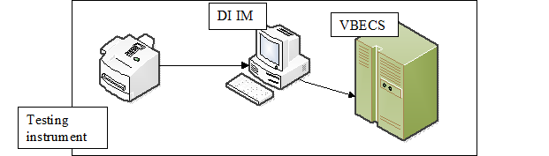
Your local testing instrument(s) communicates with DI IM via an instrument specific driver provided by DI that must be downloaded from DI and installed locally.
DI IM communicates directly with VBECS via a generic HL7 interface driver that must be downloaded from DI and installed, locally. This driver is customized for VBECS by downloading and installing the driver configuration file.
VBECS has an interface that must be configured in VBECS Administrator to receive messages from DI IM (Figure 2).
Figure 2: Setup Path
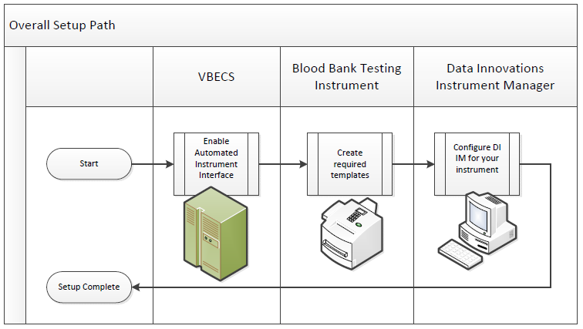

Related Manuals and Reference Materials
- VBECS Technical Manual-Security Guide
- Data Innovations Instrument Manager Manual
- Blood Bank Analyzer User's Guide (Instrument Manual)

Set Up Automated Instrument

Network Connectivity Setup

In order to ensure proper functioning of an interface between an Automated Instrument and Instrument Manager, the Instrument needs to be connected to the VA network. The static IP Address and Port number has to be assigned to the Instrument (further referred in this document as <Instrument IP> and <Instrument Port>). Please refer to the Instrument Manual or contact your vendor for the instructions about how to perform this setup. Check with Local IT staff to establish the connection to Instrument Manager.

Testing Template Setup
If testing templates are not configured properly it will be impossible for instrument results to be accepted in VBECS.

Please refer to Appendix D: Testing Templates for the list of instrument templates. These test templates must be set up on your Instrument before any results can be sent to VBECS. Always use them for results that are sent to VBECS. Any results sent that do not follow the above templates will be rejected. Please refer to the Instrument Manual or contact your vendor for the instructions about how to perform template setup.
Please note that Appendix D: Testing Templates contains definition of two Crossmatch templates:
VBECS Crossmatch.pln - template for blood banks that perform IS and IAT crossmatch together
VBECS Crossmatch IAT.pln- template for blood banks that perform IAT only crossmatch (no Immediate Spin)
These two templates are mutually exclusive so please select only one that is appropriate for your site.
AABB Standards require a serological XM to detect ABO incompatibility (5.16.1) and a local policy must be in place if the site is not performing an IS AHG as part of their serologic crossmatch test, manual or using an instrument.

User ID Setup
Failure to set up proper user IDs on an instrument will prevent instrument results from being accepted in VBECS.
In order for VBECS to properly recognize the person who performed testing on an Instrument, all users accessing the instrument must have their user IDs set up to match their network user IDs (e.g., REDACTED).
Due to the constraints of the ProVue messaging system, only 10 characters of the user name can be transferred with test results to VBECS. To ensure the uniqueness of all user names, please strip the front characters of network user ID to ensure that it is no longer than 10 characters long. For user IDs that are already 10 characters or shorter you can use full user ID in ProVue. For example:

Length of User ID | Example of User ID | ProVue ID
12 | VHASFCYOUNGS | SFCYOUNGS
11 | VHASFCTRANK | HASFCTRANK
10 or less | VHASFCTSTU | VHASFCTSTU
Please refer to the Instrument Manual or contact your vendor for the instructions about how to perform setup of user IDs.

Set Up Instrument Manager

Instrument Manager Version
Please verify that you are using Instrument Manager Version 8.13 or greater (Figure 3). In Instrument Manager navigate to Help -> About Instrument Manager.
Figure 3: Instrument Manager Version Screen
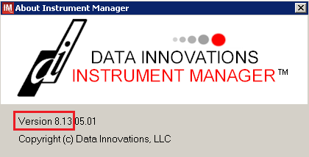
If your version of Instrument Manager is older than 8.13 STOP executing this guide and update the software first. Do not proceed until the issue is resolved.

If your Instrument Manager is greater than 8.13 you may proceed. The user must execute the instructions and validate functionality on newer versions. Discrepancies in the instructions must be reported as a service desk ticket.

Instrument Manager must have the Specimen Management Module licensed and activated. Do not proceed until this issue is resolved.

Instrument Manager to Automated Instrument Connectivity
Please contact your local network administrative staff and ensure that your local network allows two-way TCP/IP connectivity between <Instrument Manager IP> address and <Instrument IP> address on <Instrument Port>.

Installing Instrument Driver
Two drivers are required for the correct operation of the Automated Instrument interface to VBECS (Figure 4).
Figure 4: Required Drivers
Driver | Name | Version | Description
Diamed Diana | diadiani | 8.00.0009 | Instrument to DI IM driver
Data Innovations LLC, Configurable HL7 | diihl7ml | 8.00.0044 | DI IM to VBECS (HL7) driver
Please refer to the user’s manual for Instrument Manager or contact Data Innovations for the instructions on how to install drivers for Instrument Manager.
After successful installation of drivers go to Report -> Available Drivers menu option in Instrument Manager and verify that the drivers listed in Figure 4 are present.

Set Up Instrument Manager Configuration
Execute instructions in this section for each instrument that will be connecting to VBECS.
Modifying rules or test code mappings as imported using this Instrument Manager configuration Setup Guide may lead to malfunction of the Automated Instrument to VBECS interface.
Prerequisites for the Instrument Manager Configuration files download:
- You must be an administrator on <Instrument Manager Server>.
- Once the above prerequisite is met you may proceed.

Download Instrument Configuration Files
Use local procedures for copying the instrument configuration files to the Instrument Manager server.

- Navigate to REDACTED (Figure 5).
Figure 5: Connecting to the VBECS SharePoint
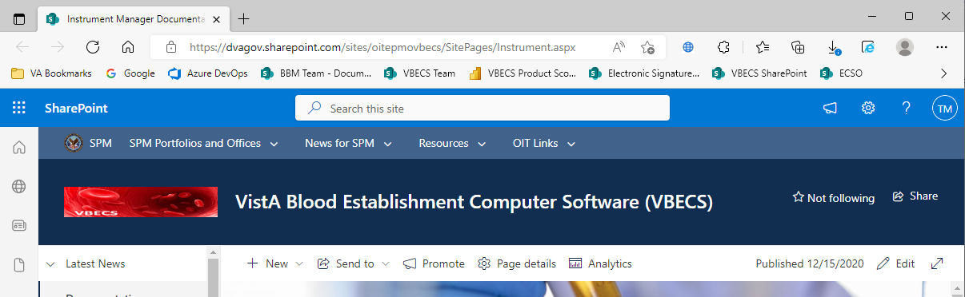

- To download a file from SharePoint, click the ellipses (...) and select Download (Figure 6).
Figure 6: Example of SharePoint Download
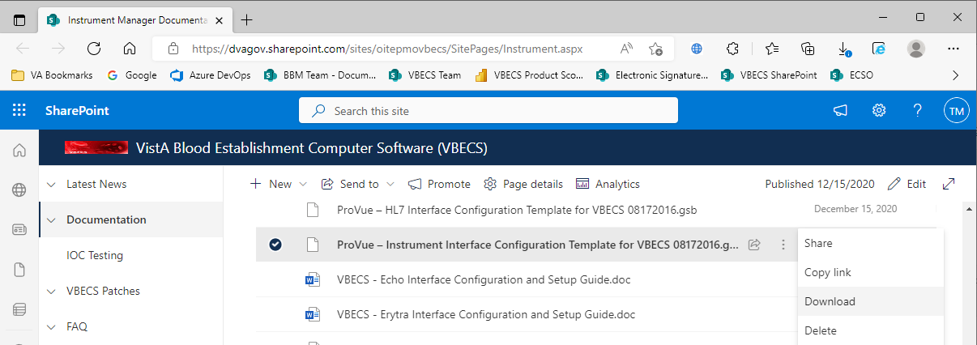
- In the Downloads screen, select Save as (Figure 7).
Figure 7: Example of Downloads
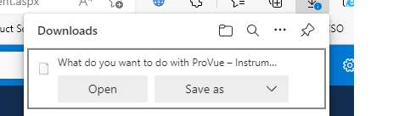
- In the next screen, specify the directory to save (Figure 8).
Figure 8: Example of Save As
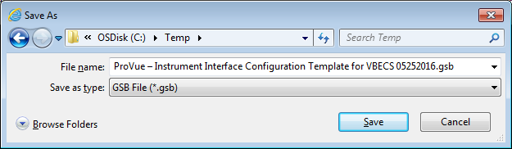

- Save both the ProVue - HL7 Interface Configuration Template for VBECS 08172016.gsb and the ProVue - Instrument Interface Configuration Template for VBECS 08172016.gsb files to the C:\temp directory.
- Per local procedures copy both files to C:\temp on the Instrument Manager server
- On the Instrument Manager server; Click Start, and in the “Search programs and files” box type Run and hit enter. Type powershell and click OK to launch PowerShell
- Copy and paste or type the following commands to generate checksums for configuration files:

certutil -hashfile “C:\Temp\ProVue - HL7 Interface Configuration Template for VBECS 08172016.gsb” MD5 <press Enter>
certutil -hashfile “C:\Temp\ProVue - Instrument Interface Configuration Template for VBECS 08172016.gsb” MD5 <press Enter>

To copy, highlight the lines in grey and enter CTRL-C.
To insert the copied line into a PowerShell window, right click in the PowerShell window and select “Paste”.
- Verify that checksums for both files match those shown in Figure 9.
Figure 9: Instrument Manager Configuration File Checksums
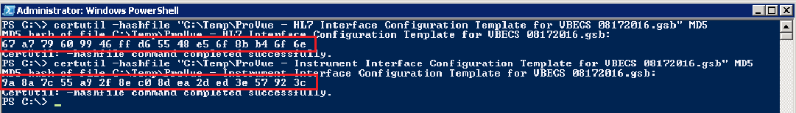
If the checksums do not match, stop and file a service desk ticket to coordinate assistance with installation. Do not proceed until the issue is resolved.

- Close the PowerShell window.

Import Instrument Side Configuration
- After downloading and verifying configuration files, open Instrument Manager and navigate to Configuration -> Configuration Editor.
- Click on the Import button (Figure 10).
Figure 10: Example of Configuration Editor
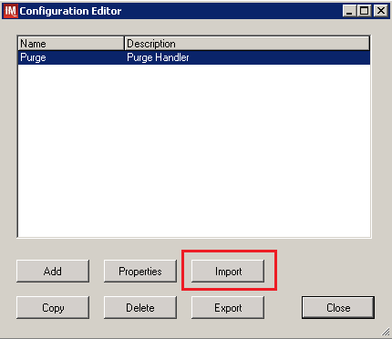
- Once the import screen opens, click the Browse button and select C:\Temp folder (Figure 11).
- Click OK.
Figure 11: Example of Configuration Import Screen
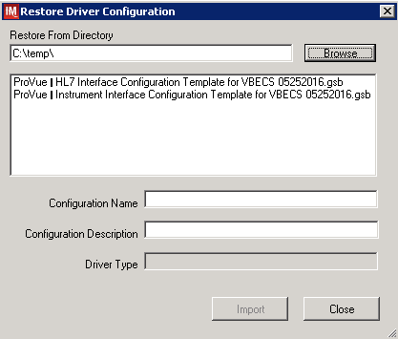

- Select ProVue - Instrument Interface Configuration Template for VBECS 08172016.gsb file from the list.
- Enter Configuration Name that contains 3 letter location code of the instrument (e.g., HIN for Hines VAMC), word ProVue and sequence number (1 for the first instrument, 2 for the second etc.). Example Configuration Name for instrument configuration located at Hines would be:

HIN_ProVue_1

This configuration name will be further referred in this document as <Instrument Side Configuration>.
- Enter Configuration Description and click Import button. Verify that the following confirmation window displays (Figure 12).
Figure 12: Example of Successful Configuration Import
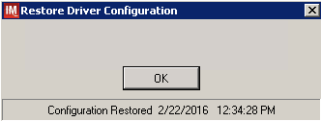

If you are using a newer version of the driver than the one mentioned in section 3, the Instrument Manager will warn you about the discrepancy in driver versions. Please acknowledge this warning and continue.

- Click OK and then close the Restore Driver Configuration window.
- Verify that Configuration Editor shows the new configuration on the list (Figure 13).
Figure 13: Example of Configuration Editor Window Showing Newly Imported Configuration
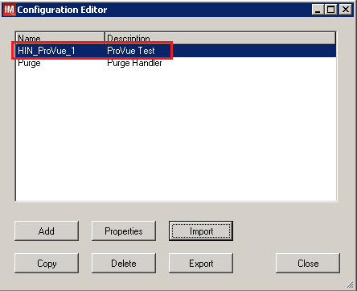

10. Close the Configuration Editor Window

Modify Test Code Mapping for Instrument Side Configuration (only for sites that perform 2 Cell Antibody Screen)
Execute instructions in this section only if you perform Antibody Screen with 2 Screening Cells instead of 3.
- In Instrument Manager navigate to Configuration -> Configuration Editor.
- Click on the Properties button (Figure 14)
Figure 14: Example of Configuration Editor Window
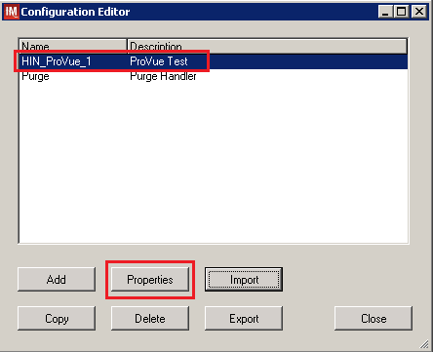

- On the Configuration Properties window click on Test Code Map (Figure 15)
Figure 15: Example of Configuration Properties Window
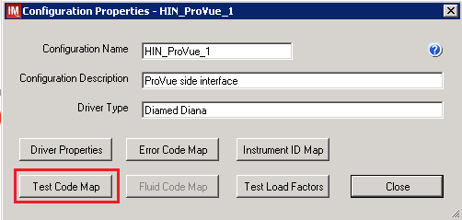
- Using the dropdown in the upper left corner of the Test Code Mapping window select test code ^VBECS ABS.pln^3 (SC3) and click Delete button (Figure 16)
Figure 16: Example of deletion of SC3 test code for Antibody Screen
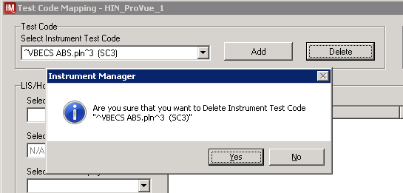
- Click Yes to confirm deletion
- Using the dropdown in the upper left corner of the Test Code Mapping window select test code ^VBECS TAS.pln^11 (SC3) and click Delete button (Figure 17)
Figure 17: Example of deletion of SC3 test code for Type and Screen
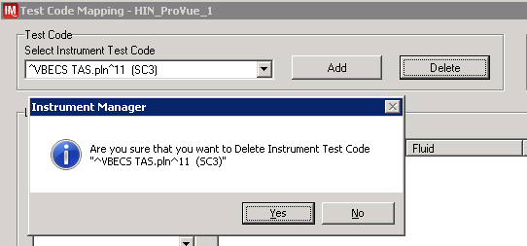
- Click Yes to confirm deletion
- Click Close on Test Code Mapping window
- Click Close on Configuration Properties window
- Click Close on Configuration Editor

Verify Test Code Mapping for Instrument Side Configuration
- Navigate to Reports -> Configuration Options and Mappings.
- Select the <Instrument Side Configuration Name> from the pull down menu (Figure 18)
- Select the Results Test Code Mapping Tab (Figure 18).
- Verify the Results Test Code Mapping Report Tab matches the list in Appendix A: Instrument Side Mapping.
Figure 18: Example of Results Test Code Mapping Tab
REDACTED

If mismatches in Test Codes names, or missing or extra Test Codes are encountered, file a service desk ticket to coordinate assistance with installation. Do not proceed until the issue is resolved.

- Close Configuration Options and Mappings window.

Verify Rules
- Next navigate to Reports -> Configuration Options and Mappings.
- Select the <Instrument Side Configuration Name> from the drop-down in the upper left corner. (Figure 19).
- Select the Rules Tab (Figure 18).
- Verify the Rules Tab matches all rules listed in Appendix C: Rules.
Figure 19: Example of Rules Tab
REDACTED

- Close the Configuration Options and Mappings window.

If mismatches in rules are encountered, file a service desk ticket to coordinate assistance with installation. Do not proceed until the issue is resolved.

Configure Rules
In this section your will establish the name of the instrument associated with test results for VBECS reports. If you are setting up multiple instruments, make sure that each has a unique name.
- Navigate to Configuration -> Specimen Management Configuration -> Rules Processing.
- Select <Instrument Side Configuration Name> from the pull down menu (Figure 20).
- Locate rule SetInstrumentID.
- Click on the Then line in the rule.
- Modify the rule by typing <Instrument Name> between the quotation marks in the lower box (Figure 20).
Figure 20: Example of Instrument Name Setup
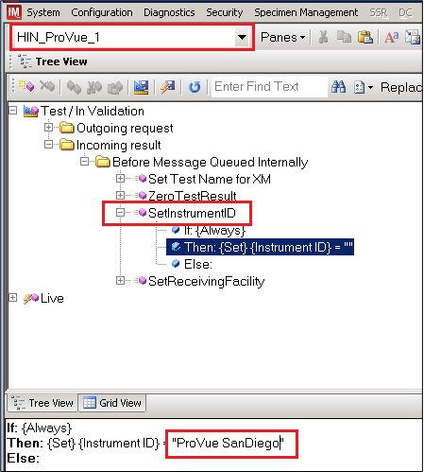
- Locate rule SetReceivingFacility. Click on Then line in the rule. Modify the rule by typing the <Division Code> between the quotation marks as shown (Figure 21).
<Division Code> also known as Station Number in VistA is a unique alphanumeric code that is associated with each hospital (e.g. 589 for VA Heartland West VAMC). This code must match the division code configured in VBECS Administrator application for a given site.
Figure 21: Example of Division Code Setup
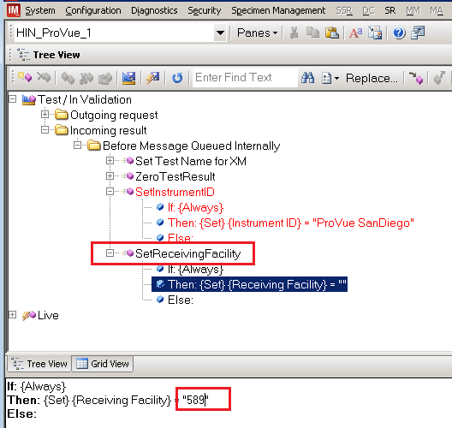
- After the change was made, both rules’ text should be displayed in red color on the screen.
- Click on Save Test / In Validation Rule Set button located in the toolbar above the rules (Figure 22).
Figure 22: Example of Save Rules Button
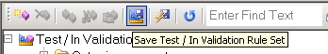

- Verify that the Test / In Validation Rule Set Saved message is received (Figure 23).
Figure 23: Example of Successful Rule Save
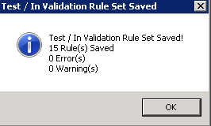

If errors while saving rules are encountered, file a service desk ticket to coordinate assistance with installation. Do not proceed until the issue is resolved.

- Click on the Save Live Rule Set button (Figure 24) located in the toolbar and click Yes to confirm.
Figure 24: Example of Save Rules in Live Set Button
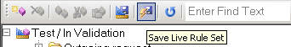
- Expand the Live Rule Set, and verify that rule text matches Appendix C: Rules and includes changes made to SetInstrumentID and SetReceivingFacility (Figure 25).
Figure 25: Example of Live Rules Set View
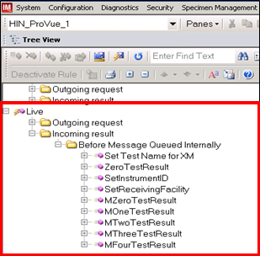
If differences in rules are encountered, file a service desk ticket to coordinate assistance with installation. Do not proceed until the issue is resolved.
- Close the Rule Setup window, returning to the main menu.

Import VBECS (HL7) Side Configuration
Only one VBECS side configuration is needed even if you use multiple ProVue instruments. All ProVues will share the same configuration.
Modifying rules or test code mappings in the Instrument Manager configuration outside of this Setup Guide is not allowed and may lead to malfunction of the Automated Instrument to VBECS interface.

- Navigate to Configuration -> Configuration Editor (Figure 26).
- Click on the Import button.
Figure 26: Example of Configuration Editor Window
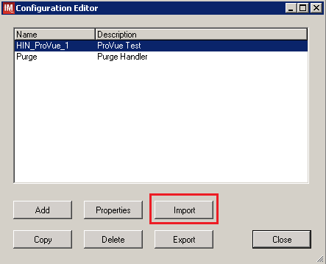
- Once the Restore Driver Configuration window opens, click the Browse button and select C:\Temp folder (Figure 27).
- Select ProVue - HL7 Interface Configuration Template for VBECS 08172016.gsb file from the list.
- Enter a Configuration Name that contains 3 letter location code of the instrument (e.g. HIN for Hines VAMC), word VBECS and sequence number (1 for the first configuration, 2 for the second etc.). Example Configuration Name for VBECS side configuration located at Hines would be:

HIN_VBECS_1

This configuration name will be further referred in this document as <HL7 Side Configuration>.
Figure 27: Example of Configuration Import Window
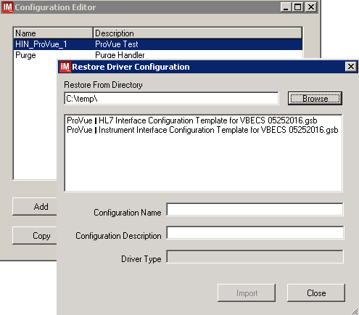
- Enter Configuration Description and click Import button. Verify that the following confirmation window (Figure 28) displays.
Figure 28: Example of Successful Configuration Import

If you are using a newer version of the driver than the one mentioned in section 3, the Instrument Manager will warn you about the discrepancy in driver versions. Please acknowledge this warning and continue.

- Click OK and close the Restore Driver Configuration window.
- Verify that Configuration Editor shows the new configuration on the list (Figure 29).
Figure 29: Example of Newly Imported HL7 Configuration
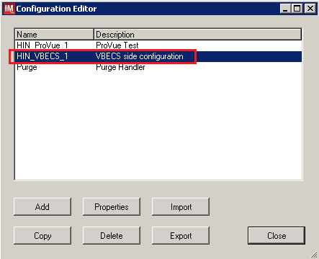

Modify Test Code Mapping for VBECS Side Configuration (only for sites that perform 2 Cell Antibody Screen)
Execute instructions in this section only if you perform Antibody Screen with 2 Screening Cells instead of 3.
- Select configuration imported in previous section and click on the Properties button (Figure 30)
Figure 30: Example of Configuration Editor Window
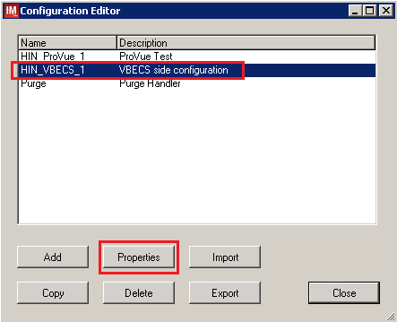
- On the Configuration Properties window click on Test Code Map (Figure 31)
Figure 31: Example of Configuration Properties Window
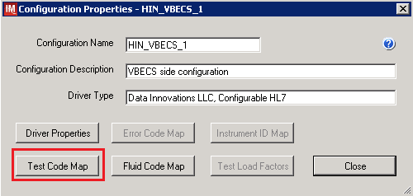

- Using the dropdown in the upper left corner of the Test Code Mapping window select test code ^VBECS ABS.pln^3 (SC3) and click Delete button (Figure 32)
Figure 32: Example of deletion of SC3 test code for Antibody Screen
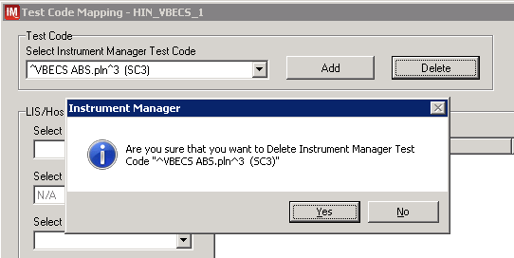
- Click Yes to confirm deletion
- Using the dropdown in the upper left corner of the Test Code Mapping window select test code ^VBECS TAS.pln^11 (SC3) and click Delete button (Figure 33)
Figure 33: Example of deletion of SC3 test code for Type and Screen
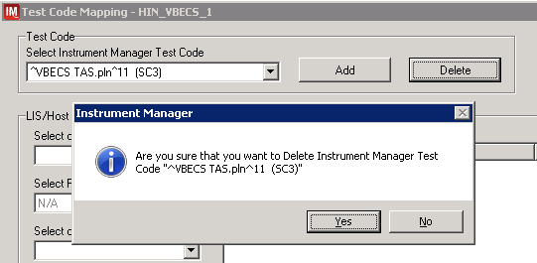
- Click Yes to confirm deletion
- Click Close on Test Code Mapping window
- Click Close on Configuration Properties window
- Click Close on Configuration Editor

Verify Test Code Mapping for VBECS Side Configuration
- Navigate to Reports ->Configuration Options and Mappings.
- Select the <HL7 Side Configuration Name> from the drop-down in the upper left corner (Figure 34).
- Select the Results Test Code Mapping Tab (Figure 34).
- Verify that the Results Test Code Mapping Tab matches all rules listed in Appendix B: HL7 (VBECS) Side Mapping.
Figure 34: Example of HL7 Configuration Report Window
REDACTED

- Close Configuration Options and Mappings window.

If mismatches in Test Codes names, missing or extra Test Codes are encountered, file a service desk ticket to coordinate assistance with installation. Do not proceed until the issue is resolved.

Set Up HL7 Connection to VBECS TEST
Modifying rules or test code mappings as imported using this Instrument Manager configuration Setup Guide may lead to malfunction of the Automated Instrument to VBECS interface.
- Navigate to Configuration -> Connection Assignment.
- On the Connection Assignment window click Add button.
- Select Configuration Name <HL7 Side Configuration> (Figure 35).
- Enter the Connection Name that matches the <HL7 Side Configuration> and word Connection. For example:

HIN_VBECS_1_Connection

- Check Include in Specimen Management check box (Figure 35).
- Select TCP/IP connection in Device (Figure 35).
Figure 35: Example of Connection Properties Window
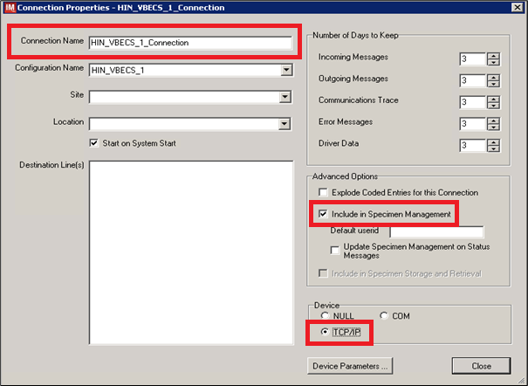

- Click on Device Parameters button.
- Enter TCP/IP Address and TCP/IP Port Number that matches VBECS TEST Application IP Address and IP Port Number configured in VBECS TEST Administrator application for Auto Instrument Interface (Figure 36). (Please refer to VBECS Technical Manual Security Guide for instruction on how to configure interfaces for VBECS.)
Figure 36: Example of TCP/IP Configuration Window
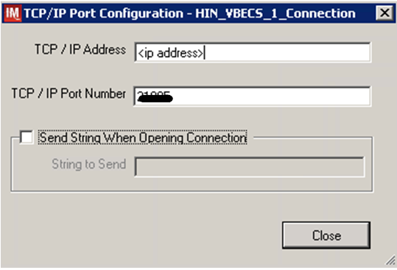

- Close the TCP/IP Port Configuration window and click Yes to save.
- Close the Connection Properties window and click Yes to save.
- Verify that the newly created connection shows on the Connection Assignment window (Figure 37).
Figure 37: Example of Newly Created Connection
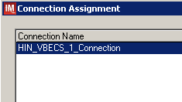

Set Up Instrument Connection
Execute instructions in this section for each instrument that will be connecting to VBECS.
Modifying connection settings in the Instrument Manager outside of this Setup Guide is not allowed and may lead to malfunction of the Automated Instrument to VBECS interface.
- On the Connection Assignment window, click Add button.
- On the Connection Properties window, enter the Connection Name. Enter a name that contains <Instrument Side Configuration> and word Connection. For example:

HIN_ProVue_1_Connection

- Select <Instrument Side Configuration> as Configuration Name.
- Check Include in Specimen Management check box.
- Select TCP/IP connection.
- On the Destination Lines list, check the box next to connection configured in previous section (Figure 38).
Figure 38: Example of Connection Properties Window
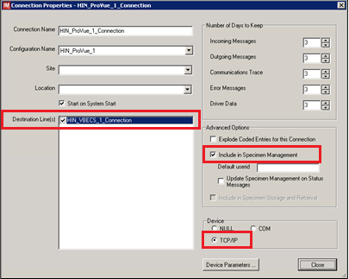
- Click on Device Parameters button.
- Enter TCP/IP Address and TCP/IP Port Number that matches <Instrument IP> and <Instrument Port> discussed in Section Network Connectivity Setup.
- Uncheck Send String When Opening Connection check box (Figure 39).
Figure 39: Example of TCP/IP Configuration Window
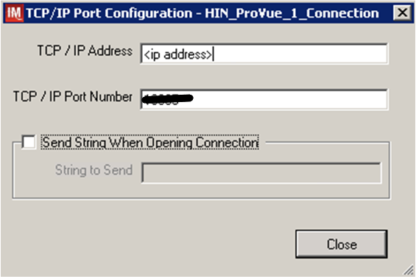

- Click close on the TCP/IP Port Configuration window and click Yes to save.
- Click close on the Connection Properties window and click Yes to save.
- Verify the newly created connection shows on Connection Assignment window (Figure 40).
- Close the Connection Assignment window.
Figure 40: Example of Newly Created Connection
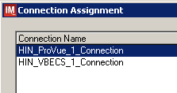

Test New Connections
- Navigate to System -> Status.
- Right-click on each newly created connection and choose option to Start Selected Connections (Figure 41).
Figure 41: Example of Connection Status Window
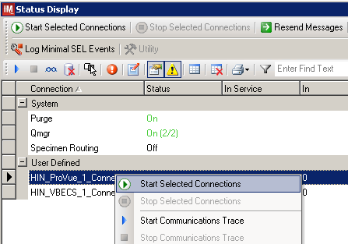

- Verify that all newly created connections are showing Status of On after about a minute or so. (Figure 42).
Figure 42: Example of Successful Connection Test
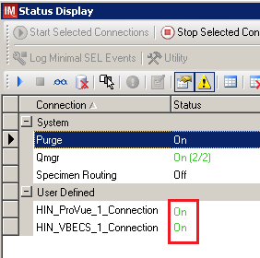
If one or more connections fail to start, file a service desk ticket to coordinate assistance with installation. Do not proceed until the issue is resolved.
- Close the Status Display.

Validate Instrument Connectivity to VBECS TEST
Execute validation instructions from Appendix E: Validation Planning and Example Test Scenarios to verify that Instrument is properly interfacing with VBECS.
If one or more validation scenarios fail, file a service desk ticket to coordinate assistance with installation. Do not proceed until the issue is resolved.

Set up HL7 Connection to VBECS PROD
- Navigate to System -> Status.
- Right-click <VBECS_Connection> and choose option to Stop Selected Connections (Figure 43).
Figure 43: Example of Stop Selected Connections
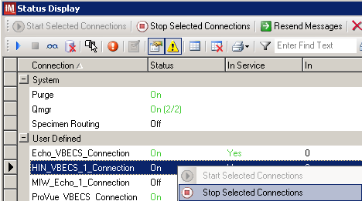
- Wait until connection status changes to Off. Navigate to Configuration -> Connection Assignment.
- Select <VBECS_Connection> and click Properties (Figure 44).
Figure 44: Example of Connection Assignment
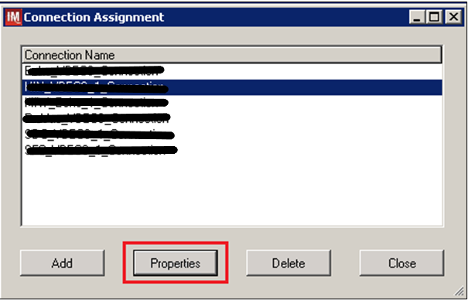
- On Connection Properties window click Device Parameters (Figure 45).
Figure 45: Example of Connection Properties
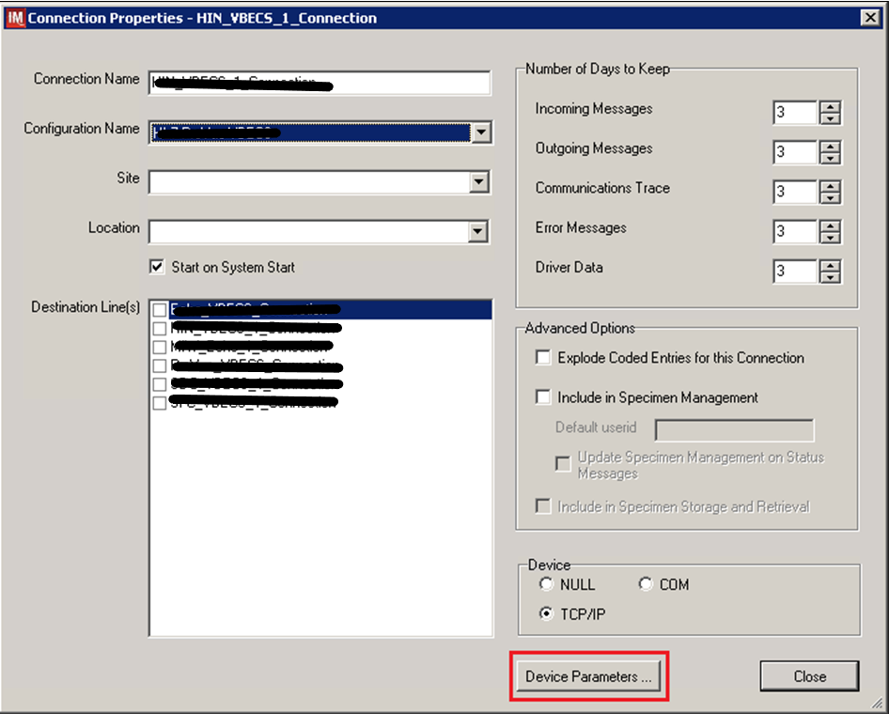

- Enter TCP/IP Address and TCP/IP Port Number that matches VBECS PROD Application IP Address and IP Port Number configured in VBECS PROD Administrator application for Auto Instrument Interface (Figure 46). Please refer to VBECS Technical Manual Security Guide for instruction on how to configure interfaces for VBECS.
Figure 46: Example of TCP/IP Configuration Window
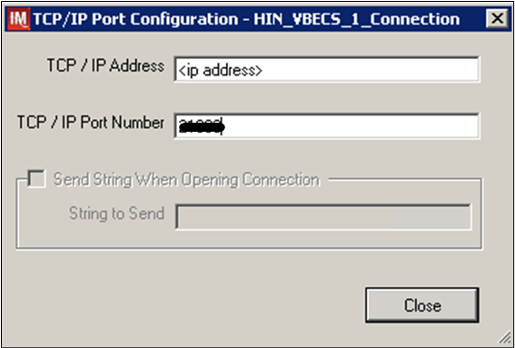
- Close the TCP/IP Port Configuration and click Yes to confirm changes.
- Close the Connection Properties window and click Yes to confirm changes.
- Close the Connection Assignment window.
- Navigate to System -> Status.
- Right-click <VBECS_Connection> and choose option to Start Selected Connections (Figure 47).
Figure 47: Example of Connection Status Window
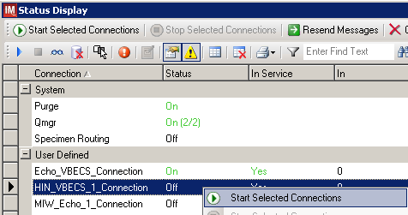
- Verify that <VBECS_Connection> is showing Status of On after about a minute or so. (Figure 48).
Figure 48: Example of Successful Connection Test
If connection fails to start, file a service desk ticket to coordinate assistance with installation. Do not proceed until the issue is resolved.
- Close the Status Display and Log Off the system.
Glossary

Acronym, Term | Definition
Automated Instrument | Blood Bank Analyzer that performs blood testing.
Division Code | Also known as Station Number in VistA is the unique alphanumeric code that is associated with each hospital (e.g. 589 for VA Heartland West).
Instrument Manager (IM) | Software created by Data Innovations that serves as a middleware between Automated Instrument and VBECS. It translates messages containing test results sent from an instrument into HL7 messages that are then parsed into VBECS.
VA | Department of Veterans Affairs.
VBECS | VistA Blood Establishment Computer Software.
VistA | Veterans Health Information Systems and Technology Architecture. VistA software, developed by the VA, is used to support clinical and administrative functions at VA Medical Centers nationwide. VistA is composed of packages that undergo a verification process to ensure conformity with name spacing and other VistA standards and conventions.

Appendices

Appendix A: Instrument Side Mapping
Table 1: Instrument Side Mapping
REDACTED

Appendix B: HL7 (VBECS) Side Mapping
Table 2: HL7 (VBECS) Side Mapping
REDACTED

Appendix C: Rules
Figure 48: Rules
--- Test / In Validation - Incoming result - Before Message Queued Internally ---

Rule # 1
Desc - Set Test Name for XM
If - {Test Code} {On Any Test} {Contains} "Crossmatch"
Then - {Set} {Test Code Sub ID} {On That Test} = "XM"

Rule # 2
Desc - Set Test Name for TAS
Child of Rule # 1 - Else
If - {Test Code} {On Any Test} {Contains} "TAS"
Then - {Set} {Test Code Sub ID} {On That Test} = "TAS"

Rule # 3
Desc - Set Test Name for DAT
Child of Rule # 2 - Else
If - {Test Code} {On Any Test} {Contains} "DAT"
Then - {Set} {Test Code Sub ID} {On That Test} = "DAT"

Rule # 4
Desc - Set Test Name for Patient ABORh
Child of Rule # 3 - Else
If - {Test Code} {On Any Test} {Contains} "ABDRev"
Then - {Set} {Test Code Sub ID} {On That Test} = "Patient ABORh"

Rule # 5
Desc - Set Test Name for ABS
Child of Rule # 4 - Else
If - {Test Code} {On Any Test} {Contains} "ABS"
Then - {Set} {Test Code Sub ID} {On That Test} = "ABS"

Rule # 6
Desc - Set Test Name for Unit ABORh
Child of Rule # 5 - Else
If - {Test Code} {On Any Test} {Contains} "Confirm
Then - {Set} {Test Code Sub ID} {On That Test} = "Unit ABORh"

Rule # 7
Desc - Set Test Name for Antigen Typing
Child of Rule # 6 - Else
If - {Test Code} {On Any Test} {Contains} "Phenotype"
Then - {Set} {Test Code Sub ID} {On That Test} = "Antigen Typing"\

Rule # 8
Desc - ZeroTestResult
If - {Result} {On Any Test} = "-"
Then - {Set} {Result} {On That Test} = "0"

Rule # 9
Desc - SetInstrumentID
If - {Always}
Then - {Set} {Instrument ID} = ""

Rule # 10
Desc - SetReceivingFacility
If - {Always}
Then - {Set} {Receiving Facility} = ""

Rule # 11
Desc - MZeroTestResult
If - {Result} {On Any Test} = "M-"
Then - {Set} {Result} {On That Test} = "0"

Rule # 12
Desc - MOneTestResult
If - {Result} {On Any Test} = "M1+"
Then - {Set} {Result} {On That Test} = "1+"

Rule # 13
Desc - MTwoTestResult
If - {Result} {On Any Test} = "M2+"
Then - {Set} {Result} {On That Test} = "2+"

Rule # 14
Desc - MThreeTestResult
If - {Result} {On Any Test} = "M3+"
Then - {Set} {Result} {On That Test} = "3+"

Rule # 15
Desc - MFourTestResult
If - {Result} {On Any Test} = "M4+"
Then - {Set} {Result} {On That Test} = "4+"

Appendix D: Testing Templates
Table 3: Testing Templates
Template Name | Selected Fields | VBECS Test | Test Component
VBECS ABDRev.pln | A  B  A1 Cell  B Cell  D  Ctl  Group  Rh  Remarks | Patient ABO/Rh | Anti-A  Anti-B  A1 Cells  B Cells  Anti-D  D Control  ABO Interp  Rh Interp  Comments
VBECS ABS.pln | Cell1  Cell2  Cell3  AbScr  Remarks | Antibody Screen | Screening Cells1  Screening Cells2  Screening Cells 3  ABS Interp  Comments
VBECS TAS.pln | A  B  A1 Cell  B Cell  D  Ctl  Group  Rh  Cell1  Cell2  Cell3  AbScr  Remarks | Type and Screen | Anti-A  Anti-B  A1 Cells  B Cells  Anti-D  D Control  ABO Interp  Rh Interp  Screening Cells1  Screening Cells2  Screening Cells 3  ABS Interp  Comments
VBECS DAT.pln | IgGC3  DAT  Remarks | DAT | AHG  DAT Interp  Comment
VBECS DAT IgG.pln | IgG  DAT IgG  Remarks | DAT IgG | IgG  DAT IgG Interp  Comment
VBECS Crossmatch IAT.pln** | XIAT  XM IAT  Remarks | Crossmatch | AHG  XM Interp  Comments
VBECS Crossmatch.pln** | XIS  XIAT  XM IS  XM IAT  Remarks | Crossmatch | IS  AHG  IS Interp  AHG Interp  Comments
VBECS Confirm.pln | A  B  AB  D  Fwd Gr  Rh  Remarks | Unit ABO/Rh Confirmation | Anti-A  Anti-B  Anti-A,B  Anti-D  ABO Interp  Rh Interp  Comments
VBECS Phenotype.pln | D Phen*  C  E  K  sm c  sm e  Ctl Phen*  Rh Phen*  Remarks | Patient and Unit Antigen Typing | N/A  Anti-C  Anti-E  Anti-K  Anti-c  Anti-e  N/A  N/A  Comment

*Test results not used in VBECS. They are on the template to allow users to print them if necessary.
** VBECS Crossmatch IAT.pln and VBECS Crossmatch.pln are mutually exclusive. Please setup only one that is appropriate for your site

Appendix E: Validation Planning and Example Test Scenarios

The following is a flowchart to help assess any one change and plan accordingly.

These are examples of test scenarios. Each site is responsible for evaluating changes for their intended use, assess risk, and for establishing additional validation test scenarios.
All test scenarios have a suggested user role, this may require adjustment to align with the patient or unit data selected to execute the scenario. Process any overrides as well, based on patient or unit selection.
*The Expected Outcome numbering corresponds to the Step number where the change verification appears.

Test Group One: AI interface disabled
Test Objective: Demonstrate that the system will reject test results sent from automated instrument if the Automated Instrument interface is disabled.
Option: VBECS Administrator, Automated Instrument Interface
At least one instrument available in any division and configured for connection with VBECS via Instrument Manager.
Note: This may be executed at only one division if VBECS is used in a multidivisional configuration as the interface is enabled/disabled for all or none.

Data | Before beginning, verify current configuration, activity, and status of the existing interfaces, VistALink, and CPRS in your test account.  Make sure that the VBECS-OERR HL7 link in VistA is NOT shutdown.  - Create RBC and TAS orders in CPRS and accept them in VBECS.
User | VBECS Administrator access is required to configure the AUTOMATED TESTING interface.  No specific user role is required to process TAS and RBC orders in VBECS.
Steps | - Log into VBECS Administrator:  - Disable the AUTOMATED TESTING interface using Configure Interfaces option.  - A message appears (You are about to disable Auto Instrument Interface. It will cause VBECS to stop sending and receiving messages via that interface. Continue?), Click Yes.  - Close the window as all fields are disabled.  - Perform TAS test on the instrument and send results of testing to VBECS
Expected Outcome | - Verify that after sending test results from an instrument fails it is possible to complete TAS test using manual testing grids and subsequently issue and transfuse blood unit to a patient.
Reports: | - Review the Audit Trail report for changes to the interface.

Test Group Two: Verify AI individual test(s)
Test Objective: Demonstrate that the system will allow the selected user role to perform normal workflow activities using your local blood bank testing instrument.
Note: Validate all tests that are performed at your site using an automated instrument.
Prior to initiating any testing of the automated instrument interface, see the VistA Blood Establishment Computer Software (VBECS) 2.2.0 Technical Manual-Security Guide for instructions for configuring your local instrument and Data Innovations Instrument Manager.
Configure your Test UID to clearly differentiate from a Production UID during your validation, for example, production is 1234567890, with 123 being your consistent prefix, change 123 or 12 to TS or TST or 999. Please change the Numeric Identifier for the Blood Bank Accession Area in your site Test Account.
Enable Automated Instrument Interface in VBECS Admin if it was disabled while performing testing in Test Group One.
Verify your VBECS processes with the Automated Instrument interface.
Your local test plan will demonstrate that the system will perform normal daily work per your local policies, procedures and local validation plan that may include:
Blood Units: Automated Instrument or via the short cut key
- ABO-Rh confirmation
- Unit Antigen Typing or Repeat
Patients: Automated Instrument or via the short cut key
- Perform a Type and Screen test (ABS and ABS with Auto-control only)
- Perform crossmatch tests: Serologic (Selected in Blood Units: Select Units before testing.*)
- Patient Tests:
ABO/Rh or Repeat
Antibody Screen or Repeat
Direct Antiglobulin Test or Repeat
Antigen Typing or Repeat
- Overrides, (ABO/Rh Discrepancy, Crossmatch incompatible: Give with Medical Director Approval)
- Report data from these actions is available for retrieval.
Testing Worklist Report
Patient History Report
Unit History Report
Exception Report (ABO/Rh Discrepancy, Give with Medical Director Approval)
*Remember to click NO to proceeding to the serologic crossmatch when selecting units for automated instrument testing.

Test Group 2 Scenario 1: Verify AI TAS test

Note: the Type and Screen (TAS) is a combination of two tests and may be saved as individual tests without completing the TAS as a whole.
Data | VBECS: Select a patient.  CPRS: Place a Type and Screen (TAS) order for the patient  LAB: Accession the order  VBECS: Accept the order. (Orders, Accept Orders)
User | No specific user role is required to process TAS order in VBECS.
Steps | - User checks the Patient testing list to make sure the order is accepted in VBECS and appears on the Pending Task List (PTL). (Patient, Patient Testing, Diagnostic Tests).  - Close the PTL.  - Process the specimen on the instrument using the recommended TAS template for that instrument. Complete all work needed to transmit the information to VBECS.  - Select Patients, Automated Instrument to review TAS results.  - Select the specimen UID, scanning the UID is preferred.  - Review TAS test results.  - Accept only the ABS or ABO/Rh test. Close the window.  - Open the PTL.  - Try to select TAS on PTL and complete testing on it manually.  - Open the Automated instrument window and accept the second part of TAS.  - Close the automated instrument window.  - Check Reports
Expected Outcome | - Verify that the specimen UID is selectable by scanning, entry or patient selection  - Verify that the correct test results appear on the Automated Instrument review list.  - Verify that the TAS appears on the PTL with a status of “Instrument Results Pending Review”.  - Verify that system prevents user from completing TAS since they are still pending results from an instrument for it.  - Verify that the results and comments appear as expected on the reports:  - Testing Worklist Report  - Patient History Report  - Exception Report

Test Group 2 Scenario 2: Verify AI serologic crossmatch test
Data | VBECS: Select a patient.  CPRS: Place a Type and Screen (TAS) order and Red Blood Cell order for the patient  LAB: Accession the orders  VBECS: Accept the order. (Orders, Accept Orders)  Process the TAS to completion.  Select a blood unit for a selected patient*:  - Previously entered into the division’s inventory (Blood Units, Incoming Shipment)  - ABO compatible  - May be available or selected for another patient (available, selected, crossmatched) status.  - May or may not trigger selection overrides  *Remember to click NO to proceeding to the serologic crossmatch when selecting units for automated instrument testing.
User | No specific user role is required to process crossmatch test in VBECS.
Steps | - Process the component unit’s specimen on the instrument using the recommended template for that instrument. Complete all work needed to transmit the information to VBECS.  - Select Patients, Automated Instrument to review crossmatch results.  - Select the specimen UID, scanning the UID is preferred.  - Review results, select compatibility and accept crossmatch result.  - Print or do not print tag as desired.  - Accept the test and close the automated instrument window.  - Check Reports.
Expected Outcome | - Verify that crossmatch results sent from an instrument show correctly on the screen.  - Verify that the results and comments appear as expected on the reports:  - Testing Worklist Report  - Patient History Report (interpretations only).  - Exception Report

Test Group 2 Scenario 3: Verify AI patient diagnostic tests
(ABO/Rh, Antibody Screen, Direct Antiglobulin Test, Patient Antigen Typing, and the reflex test)
Data | VBECS: Select a patient.  CPRS: Place a diagnostic test order for the patient  LAB: Accession the order  VBECS: Accept the order. (Orders, Accept Orders)
User | No specific user role is required to process diagnostic tests in VBECS.
Steps | - User checks the Patient testing list to make sure the order is accepted in VBECS and appears on the Pending Task List (PTL). (Patients, Patient Testing, Diagnostic Tests).  - Close the PTL.  - Process the specimen on the instrument using the recommended testing template for that instrument. Complete all work needed to transmit the information to VBECS.  - Select Patients, Automated Instrument to review test results.  - Select the specimen UID, scanning the UID is preferred.  - Review and accept test results  - Close the automated instrument window.  - Check reports.
Expected Outcome | - Verify that the specimen UID is selectable by scanning, entry or patient selection.  - Verify that patient test results sent from an instrument show correctly on the screen.  - Verify that the results and comments appear as expected on the reports:  - Testing Worklist Report  - Patient History Report  - Exception Report

Test Group 2 Scenario 4: Verify AI blood unit tests
Data | VBECS: Select a blood unit previously entered into the division’s inventory (Blood Units, Incoming Shipment).  For ABO/Rh Confirmation testing on the instrument, unit should be in a Limited status.  For Unit Antigen Typing, the unit may or may not have been confirmed.
User | No specific user role is required to process blood unit tests in VBECS.
Steps | - Process the component unit’s specimen on the instrument using the recommended template for that instrument. Complete all work needed to transmit the information to VBECS.  - Select Blood Units, Automated Instrument to review test results.  - Select the blood component unit’s Donor Identification Number (DIN), scanning the DIN is preferred.  - Select the product code (if there are multiple blood units with the same product code)  - Review the transmitted blood unit test.  - Accept the test and close the automated instrument window.  - Check Reports
Expected Outcome | - Verify that blood unit test results show correctly on the screen.  - Verify that the results and comments appear as expected on the reports:  - Testing Worklist Report  - Unit History Report (interpretations only).  - Exception Report

Revision History
Date | Revision | Description | Author
06-03-16 | 1.0 | Initial version. | BBM team
06-28-16 | 2.0 | Defect 338501  - Figure 4 Corrected driver name  Section 4.1  - Added information bar about getting files to the Instrument Manager server  - Removed Step 1 that had the user getting the files from the Instrument Manager server  - Added step 5 to copy files to the Instrument Manager Server  - Updated step 6 to say on the Instrument Manager Server  - Highlighted checksum command  - Added an information bar about copying and pasting into a PowerShell window  - Updated Figure 8 with new checksums  Section 4.3  - Changed Verify step to use a report instead of screen captures  - Figure 13 Updated to show Results Test Code Mapping Report Window  Section 4.4  - Changed Verify step to use a report instead of screen captures  - Removed “and what is listed in Figure 11” from what is now step 4  - Figure 14: Updated to show Rules Report Window  Section 4.7  - Changed Verify step to use a report instead of screen captures  - Figure 25: Updated to show Results Test Code Mapping Report Window  - Figure 18: Updated to show 15 rules  - Figure 20: Updated to show additional rules  Section 5  - Changed steps 9 and 10 to include save steps  - Removed step 12  - Appendix A: Reordered alphabetically by Instrument Test Code  - Appendix B: Reordered alphabetically by Instrument Test Code  - Appendix C: Changed to use the report instead of the screen captures  - Appendix D: Corrected spelling of VBECS  - Appendix F: Updated validation scenarios  Updated Footer to include the Electronic Document Control System.  Moved Footer notes to Header, Updated Document to Version to 2.0 | BBM team
08-19-16 | 3.0 | Defect 352802:  - Updated section Testing Template Setup to describe selection of only one crossmatch template  - Updated section User ID Setup to accommodate users with short user IDs  - Updated names and checksums of configuration files in section 4  - Added section 4.3 with instructions on how to remove test code mapping for Screening Cell 3 for instrument side configuration  - Added section 4.8 with instructions on how to remove test code mapping for Screening Cell 3 for VBECS side configuration  - Updated appendices A and B with new test codes for IAT only crossmatch  - Updated appendix D with new template for IAT only crossmatch  Defect 355473:  - Added warning about discrepancy in driver versions in sections 4.2 and 4.7  - Added information about proper configuration of test Specimen UIDs to Test Group Two warning flag section  - Removed information about Event Log from Test Group One and replaced it with checking Audit Trail Report | BBM team
09-07-16 | 4.0 | Set Up Automated Instrument, Testing Template Setup section: Added informational message that refers to AABB standards for crossmatch. (Defect 372140) | BBM team
08-03-17 | 5.0 | Added information about requirement for Specimen Management Module being active (Defect 465496) | BBM team
12-29-22 | 6.0 | Header and Footer: Updated.  Throughout: Updated references from CA SDM ticket to service desk ticket and removed Appendix E CA SDM Support Ticket Template.  Introduction: Added fourth paragraph about configuration files.  Related Manuals and Reference Materials: Updated.  Section 4.1: Updated Steps 1 and 2, and added Step 3. Updated Figures 4 and 6, added Figure 7.  All figures: Added alternate text for 508 compliance. (Task 111163) | BBM team

This is the last page of VBECS - ProVue Interface Configuration and Setup Guide.

