Lab Patch# LR*5.2*395
Release Notes

September 2009

Table of Contents
Table of Contents 2
Installation Requirements 3
Required Patches 3
New Functionality 3

Installation Requirements
Required Patches
Below is a list of patches that you must verify are properly installed on your system before LR*5.2*395 can be installed:
- LR*5.2*286
- LR*5.2*312
- LR*5.2*344
- LR*5.2*364
- LR*5.2*372

New Functionality
- Add Test Status to CPRS Lab Report APIs: In the Lab Results report on the Labs tab, CPRS used to display only verified lab results. CPRS did not display Lab Specimens that had been collected but not verified with the results.
Resolution: Three reports on the Lab Tab in CPRS have been modified to address this issue.
The following reports now display the collection status:
- Most Recent
- All Tests by Date
- Selected Tests by Date

These reports on the Labs Tab in CPRS will call a modified Lab API that will provide the status of a specimen that has been collected and in process in the Lab. This patch modifies the Lab routines used in this API to accomplish the desired functionality.
Examples of the changes as will be seen in specified lab reports on the CPRS Labs tab.
Most Recent
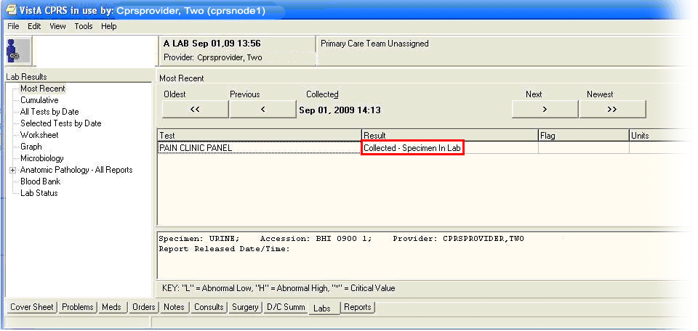
This shows the new status “Collected”. Another possible status is “On Collection List”.

All Tests by Date Collected and On Collection List
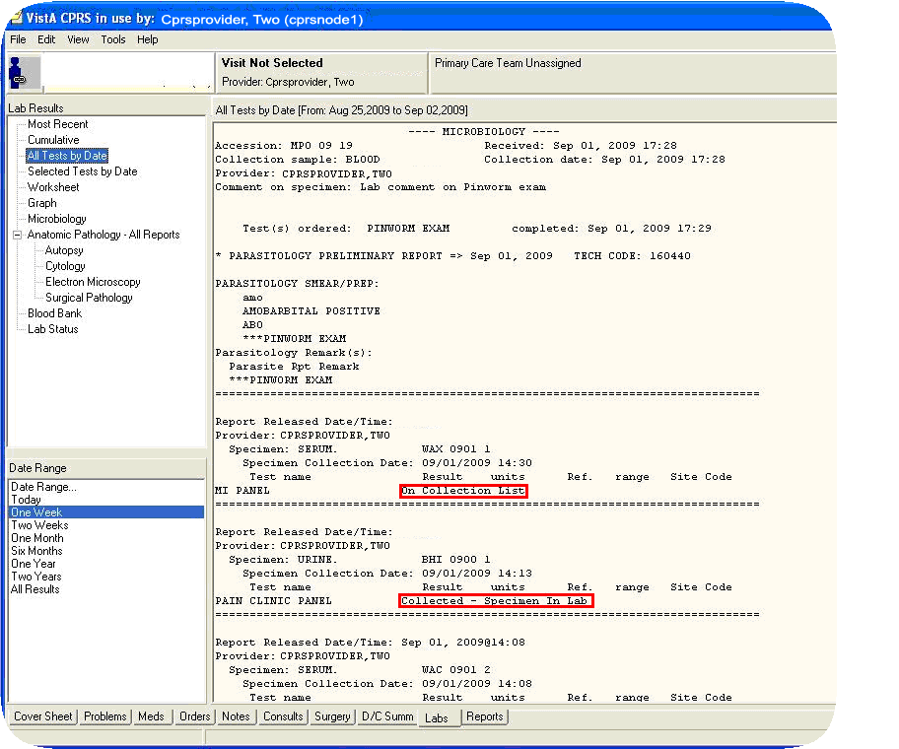
On the Labs tab, the All Tests by Date report shows the status of tests as “On Collection List” and “Collected – Specimen in Lab”.

Selected Tests by Date
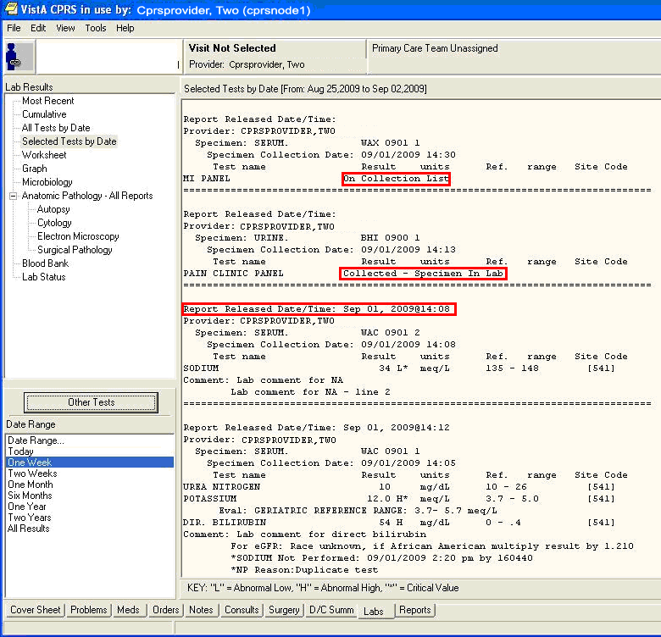
On the Selected Tests by Date report on the CPRS Labs tab shown here, the added red boxes show the status of the tests.

- New Completed/Release Date for Reports Added
Resolution: The date when a completed was released is now included in the report text as well. This was in response to a medical center requesting this change after an inspection.
Completed/Release Date on Most Recent
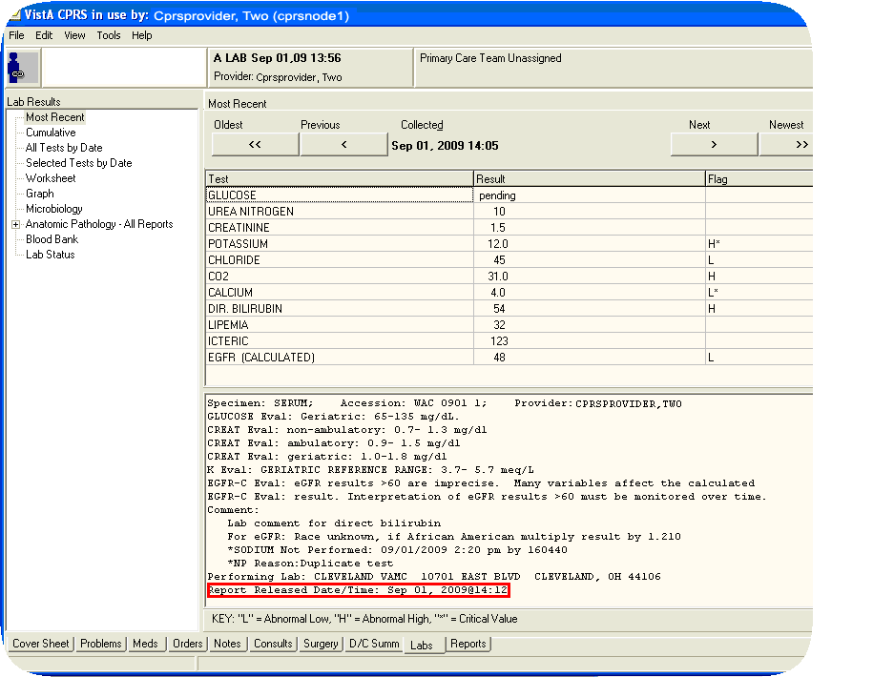
The Report Released Date/Time is now included in the Most Recent report as well (in red box).
Report Released Date on All Tests by Date
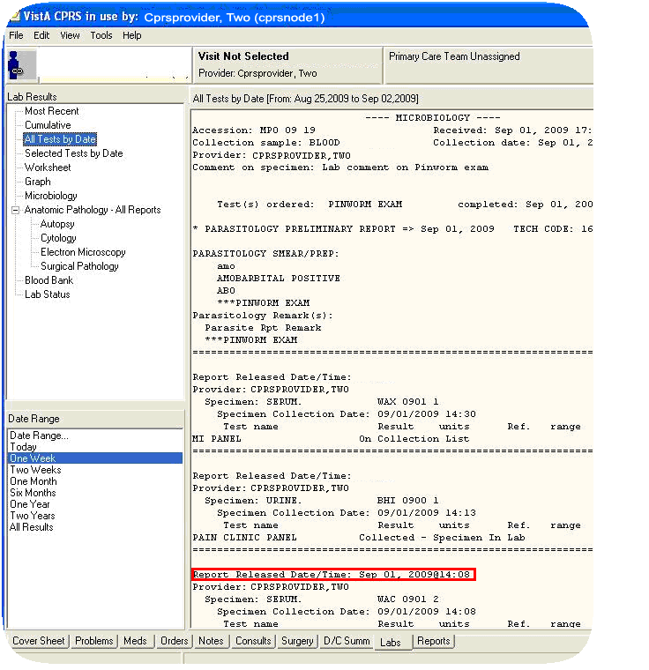
This screen capture shows where the Report Released Date/Time shows.
Selected Tests by Date
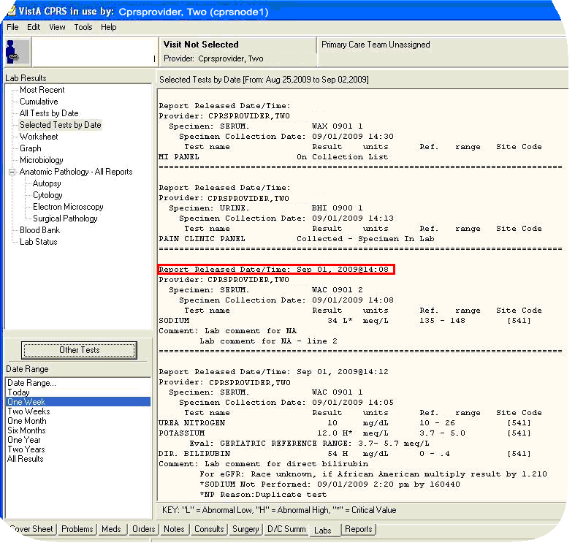
On the Selected Tests by Date report on the CPRS Labs tab shown here, the added red box shows the report’s Released Date/Time.

