MENTAL HEALTH ASSISTANT VERSION 3 (MHA3) INSTALLATION GUIDE

PATCH YS*5.01*85

Version 5.01

December 2007

Department of Veterans Affairs
VistA Health System Design & Development

Revision History

Date | Revisio n | Description | Author(s)
12/2007 | 1.0 | Initial version
04/2008 | 2.0 | Updated pages 24, 62 & 63 for changes in Patch YS*5.01*93 | REDACTED

THIS PAGE INTENTIONALLY LEFT BLANK

Table of Contents

Preface iv
Section 508 of the Rehabilitation Act iv
MHA3 overview iv
Software and Documentation Retrieval Information 1
MHA3 Documentation Website Locations 1
VistA Mental Health Version 5.01 Home Page: 1 VistA Documentation Library (VDL): 1 Anonymous Software Directory 1 MHA3 Software and Documentation Files Retrieval Formats 2
MHA3 Folders and Files 3
Introduction 5
Overview 5
Enhancements 6
VistA Mental Health Assistant NEW Features in MHA3 6
Security Information 7
Security Management 7
Security Features: 7 SecureDesktop 7 Mail Group: 7 YS MHA-MHNDB 7
Alerts: 7 Remote Systems: 8 Example: YTQ RPCs 8 Archiving/Purging: 10
Contingency Planning: 10
Interfacing: 10
Electronic Signatures: 10
Menus 10 Security Keys: 10 File Security: 11 References: 11
Official Policies: 11
Pre-Installation Information 11
Recommended Users 11
Information Resources Management (IRM) Staff 11 Mental Health Clinicians 11 Test Sites 11
Windows Conventions 13
VistA Operating System 13
VistA Operating System Performance Capacity 13
MHA Central Processing Unit (CPU) Requirement 13

MHA Software Application Installation Time 13
Users on the System 13
Backup Routines 13
Kernel Installation and Distribution System (KIDS) 13
Namespace 14
MHA3 Software Application Requirements 14
Required Patch 14
MHA3 Menu/Options Changes 14
YS Broker1 [YS BROKER1] Option 14
Database Integration Agreements (DBIAs) 14
New VistA Mental Health Files 17
MH TESTS AND SURVEYS file (#601.71) 17 MH QUESTIONS file (#601.72) 17 MH INTRODUCTIONS file (#601.73) 17 MH RESPONSE TYPES file (#601.74) 17 MH CHOICES file (#601.75) 17
MH CHOICETYPES file (#601.751) 18 MH INSTRUMENT CONTENT file (#601.76) 18 MH BATTERIES file (#601.77) 18 MH BATTERY CONTENTS file (#601.78) 18 MH BATTERY USERS file (#601.781) 18 MH SKIPPED QUESTIONS file (#601.79) 18 MH SECTIONS file (#601.81) 18
MH RULES file (#601.82) 19
MH INSTRUMENTRULES file (#601.83) 19
MH ADMINISTRATIONS file (#601.84) 19
MH ANSWERS file (#601.85) 19 MH SCALEGROUPS file (#601.86) 19 MH SCALES file (#601.87) 20
MH DISPLAY file (#601.88) 20 MH CHOICEIDENTIFIERS file (#601.89) 20 MH SCORING KEYS file (#601.91) 20 MH RESULTS file (#601.92) 20 MH REPORT file (#601.93) 20
Routine Summary 21
Installation Instructions 23
Server 23
MHA 3 Installation Example: 25
MHA3 Installation File Structure and Use 30
Post Installation Instructions 33
Create TIU Document Definitions 33
Client Software 34
IRM Staff 34
MHA3 Files Retrieval Locations and Formats 34

MHA3 Files Retrieval Locations 35 MHA3 Files Retrieval Formats 36
Mental Health Assistant Install Windows Illustrations 38
Installing Mental Health Assistant on your Computer 38
Choose Destination Location 39 Folder Does Not Exist 40 Select Start Menu Folder 41 Ready to Install 42 Installing Mental Health Assistant 3 43 Completing the Mental Health Assistant 3 Setup Wizard 44
Uninstalling MHA3 45
Installing SecureDesktop Functionality in MHA3 46
Uninstalling SecureDeskstop 55
Setting up VistA MHA3 on CPRS GUI Tools Menu 57
Setting up VistA so that individual MHA3 assessments are also listed on the CPRS GUI Tools Menu 59
Files with New Entries Added 61
PROTOCOL file (#101) New Entries 61
HL7 APPLICATION PARAMETER file (#771) New Entry 62

Preface
The Veterans Health Information Systems and Architecture (VistA) Mental Health Assistant Version 3 (MHA3) Installation Guide Patch YS*5.01*85 provides detailed instructions and requirements for installing and implementing the Graphical User Interface (GUI) software application.

Section 508 of the Rehabilitation Act

NOTE: The Veterans Health Administration (VHA) fully supports Section 508 of The Rehabilitation Act and is committed to equal access for all users. While every effort has been made to ensure Section 508 compliance, we realize that there may be other issues. If you have questions or would like to see a copy of the Compliance Action Plan for future releases, please contact:

REDACTED

MHA3 overview

Introduction: This section includes an overview of the major functions, purposes, and how the GUI software application accomplishes the objectives.

Enhancements: This section contains software changes exported by MHA Version 3, Patch YS*5.01*85.

Security Information: This section addresses any unique legal requirements and responsibilities pertaining to the Mental Health Assistant Version 3, software application and necessary security measures to protect the integrity of the software and its data.

Pre-installation Information: This section provides information needed prior to installing MHA Version 3, patch YS*5.01*85.

Installation Instructions: This section contains instructions and examples of MHA Version 3, patch YS*5.01*85 installation process.

Post Installation Instruction: This provides directions for implementing the VistA Mental Health Package enhancements to interact with the MHA Version 3, software application.

Software and Documentation Retrieval Information

MHA3 Documentation Website Locations

VistA MHA3 Installation Guide (i.e., YS50185_MHA3_IG.pdf and YS50185_MHA3_IG.doc), User Manual (i.e., YS50185_MHA3_UM.pdf and YS50185_MHA3_UM.doc) are available in MS Word Format (doc) and Portable Document Format (pdf) at the following Website locations:

VistA Mental Health Version 5.01 Home Page:
REDACTED

VistA Documentation Library (VDL):
http://www.va.gov/vdl/

Anonymous Software Directory

REDACTED

NOTE: All sites are encouraged to use the File Transfer Protocol (FTP) capability. Use the FTP address “download.vista.med.va.gov” (without the quotes) to connect to the first available FTP server where the files are located.

OIFOs | FTP ADDRESS | DIRECTORY
REDACTED | REDACTED | REDACTED
REDACTED | REDACTED | REDACTED
REDACTED | REDACTED | REDACTED
REDACTED | REDACTED | REDACTED
REDACTED | REDACTED | REDACTED

MHA3 Software and Documentation Files Retrieval Formats

MHA3 Patch YS*5.01*85 exports the following folders and files:

FILE NAMES | CONTENTS | RETRIEVAL FORMATS
YS_501_85.KID | MHA Server Components | ASCII
YS50185_SETUP_1_0_3_36.exe | Mental Health Assistant | BINARY  This file is the complete install for the Mental Health Assistant GUI  Version 1.0.3.36, client.
YS50185_SD_SETUP_1_0_2_77.exe | SecureDesktop for Mental Health Assistant | BINARY  This file is the complete install for the optional SecureDesktop component for Mental Health Assistant GUI Version  1.0.3.36, client.
YS_MHA.exe | MHA3 Executable | BINARY
YS_MHA_SD_INSTALLGINA.exe | Activate SecureDesktop Executable  DLL used by SecureDesktop | BINARY
YS_MHA.DLL | DLL interface to Clinical Reminders functions in CPRS. This DLL is deployed to C:\Program Files\vista\Common  Files | BINARY
MHA3_DLL_Scoring.dll | Required by YS_MHA.DLL | BINARY  DLL used by MHA3 for scoring complex instruments.
YS_MHA.JCF | JAWS screen-reader  configuration file for use with MHA3 | BINARY
dwlGina2.dll | Required security DLL | BINARY
YS_MHA_SD_UNINSTALLGINA.exe | Deactivate  SecureDesktop Executable | BINARY
YS_MHA_VASD.exe | SecureDesktop’s main executable | BINARY
YS_MHA.HLP | Online help file for the ASI | BINARY
YS_MHA.GID | Help file configuration. | BINARY  Index file used by YS_MHA.HLP.
ANSWER file folder | Offline records that have | FOLDER

 | not been uploaded | C:\Documents and Settings\<USER PROFILE>\Application Data\MHA3\Answer  Files
INSTRUMENT file folder | MH Instruments for Offline administration | FOLDER  C:\Documents and Settings\<USER PROFILE>\Application Data\MHA3\Instrument Files
YS50185_MHA3_IG.pdf | Mental Health Assistant  Version 3 (MHA3)  Installation Guide Patch YS*5.01*85 | BINARY
YS50185_MHA3_IG.doc | Mental Health Assistant  Version 3 (MHA3)  Installation Guide Patch YS*5.01*85 | BINARY
YS50185_MHA3_UM.pdf | Mental Health Assistant Version 3 (MHA3) User  Manual Patch YS*5.01*85 | BINARY
YS50185_MHA3_UM.doc | Mental Health Assistant Version 3 (MHA3) User Manual Patch  YS*5.01*85 | BINARY

MHA3 Folders and Files

Example: MHA3 Patch YS*5.01*85 folders and files.
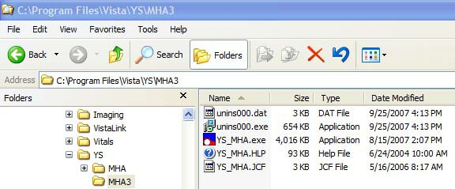

Example: Files installed by the YS50185_SETUP_1_0_3_36.exe installer and Files added to the MHA3 folder after installing the SecureDesktop functionality.

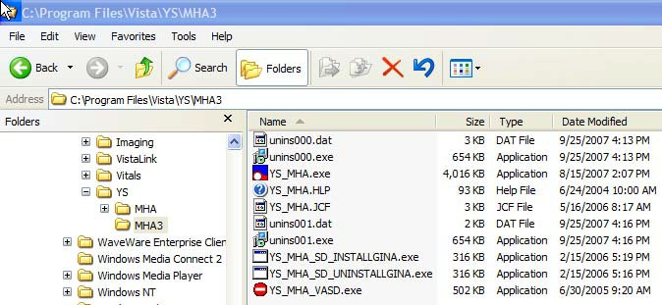

4 VistA MHA 3 Patch YS*5.01*85 December 2007

Introduction

Overview

The VistA Mental Health Assistant (MHA) is the graphical user interface (GUI) for the VistA Mental Health Package (MHP). MHA was developed to create an effective and efficient tool for mental health clinicians and their patients to use for the administration and scoring of assessment instruments and interviews. Additionally, results are displayed in report and graphical formats.
MHA and MHP support mental health assessments (e.g., psychological testing, structured interviews, and staff rating scales) that are not available elsewhere in the Computerized Patient Record System (CPRS)/Veterans Information System and Technology Architecture (VistA).
MHA has enjoyed widespread usage among mental health clinicians over the past several years, and the current revisions of MHA and MHP initiate steps toward re-engineering VistA Mental Health functionality.

The Veterans Health Administration (VHA) Action Agenda for implementing the President's New Freedom Commission on Mental Health recommendations regarding the use of information technology to enhance the care of Mental Health patients states, “VHA should make the integration of MHA and HealtheVet Desktop (HeVD) an explicit goal and should provide the OI with sufficient resources to accomplish this goal in collaboration with the Mental Health Strategic Healthcare Group (MHSHG) Informatics Section. The integration should eliminate the need for Mental Health clinicians to change applications. Further, the integration should make appropriate Mental Health assessment tools available to clinicians outside Mental Health (e.g., depression and alcohol screening instruments should be made available to primary care clinicians).”

This revision of MHA creates a closer integration with CPRS, by placing the MHA GUI on the CPRS Tools Menu. Additionally, functionality was created to allow a site to place an individual instrument on the Tools menu, allowing widespread access to that specific instrument without having to issue the menu for the MHP to all clinicians.

Additional functionality that strengthens the tie to the patient’s medical record is the creation of a progress note in CPRS when an instrument is completed through MHA.

Furthermore, MHA maintains and strengthens its ties to the Clinical Reminders program, which allows for the presentation of specific instruments through reminder dialogs to all clinicians who resolve reminders.

Additionally, the Psychological Instrument files of the MHP have been restructured to initiate the migration toward re-engineering and placing MHA as a component of HealtheVet Desktop when it is implemented.

To better meet the needs of clinicians and patients in different programs, particularly non- traditional settings, MHA can now run in a standalone mode to administer instruments offline for later uploading to VistA.

Enhancements
MHA3, Patch YS*5.01*85 is exporting the following software enhancements:

VistA Mental Health Assistant NEW Features in MHA3:

- Completely re-organized the VistA Mental Health database files to simplify migration to Health Data Repository (HDR).
- MHA3 must be invoked from the CPRS Tools menu, for interaction with VistA and patient selection.
- Patient-selection is done entirely by interaction with CPRS.
- MHA3 can run in standalone mode, but only for administering offline tests—which later must be uploaded to VistA
- MHA3 allows the CPRS Tools menu to invoke any number of single types of instruments, without the need to go directly to the MHA3 Main form. For instance, a CAGE menu item can be added to the Tools menu, which would invoke only a CAGE data entry form.
- Major functionality (GAF, ASI, Results, etc.) is now presented on individual forms, as opposed to as tabs on one main form.
- MHA3 provides a new Battery Wizard form to simplify creating batteries of instruments.
- There is a new & improved SecureDesktop component that now uses stronger code to prevent hacking.
- “Clerk entry” data-entry-mode form for psych tests has been removed.
- All completed administrations now automatically generate a progress note for review in CPRS.
- All test scores are now saved in VistA, instead of calculated on-the-fly.
- There is a hospital Location associated with an administered instrument, for progress notes purposes.
- The accompanying MHA3 help file is supplied only for describing the functions of the ASI Manager forms. All other tests and interview have built-in help that is retrieved directly from the MHP when using the “Description” pop-up menu function in the Instrument Manager.
- MHA3 recreates a debug log file named “mha3_debug.log” for each MHA3 session. This file can be emailed to developers to assist in remote debugging. No patient-identifying data is collected in this file.
- This patch includes 6 new instruments in MH TESTS AND SURVEYS file (#601.71). The instruments are the Braden Scale for Predicting Pressure Ulcer Risk (Braden Scale), Morse Fall Scale (Morse Fall Scale), the PTSD Screen (PTSD 4Q), BOMC: The Six-Item Blessed Orientation-Memory-Concentration Test, TBI 2ND LEVEL EVAL: Traumatic Brain Injury: 2nd Level Evaluation and the PHQ-2. Additionally, modifications have been made to the AUD-C to add skip logic and to the PHQ-9 to add a tenth question assessing impact of symptoms on overall functioning.

December 2007 VistA MHA 3 Patch YS*5.01*85 1

Security Information
This section addresses any unique legal requirements and responsibilities pertaining to the Mental Health Assistant Version 3, software application and necessary security measures to protect the integrity of the software and its data.

Security Management

There are no unique legal requirements pertaining to Mental Health Assistant software application with the exception that some of the psychological tests are copyrighted. Copyrighted tests are used by permission of the copyright holders. Use of these tests must be consistent with contracts between VHA and copyright holders.

Security Features:

SecureDesktop

SecureDesktop is a set of security features intended to prevent unattended patients taking on-line tests from using the Personal Computer (PC) for other purposes. The SecureDesktop features construct a screen to cover the entire PC desktop. Non-alphanumeric keys are trapped to keep the patient from using the task bar and operating system functions (such as Task Manager). The Patient Entry button on the Instrument Administrator form is the only instrument data entry method that activates the SecureDesktop features. The Patient Entry button should only be used for the on-line patient administration of data entry of forms, instruments and surveys. The SecureDesktop security features cannot be defeated once the Patient Entry button becomes active. Excessive non-alphanumeric keystrokes are interpreted as “hacking” efforts and MHA is terminated. At the conclusion of the patient’s data entry session, MHA is terminated. Upon termination of the Windows session the user is logged off and the PC is shut down, which means that the user has to enter their network user name and password to log back on to the desktop.

Mail Group:

YS MHA-MHNDB
This group receives error messages from the HL7 system when problems occur when sending messages to the Mental Health national database.

Alerts:
Alerts are not required for this release.

Remote Systems:

All GAF scores entered through the Mental Health Assistant GAF form are dynamically sent to the National Patient Care Database (NPCD) at the Austin Automation Center (AAC).

All Mental Health Assessment data entered through the Mental Health Assistant Instrument Administrator form are dynamically sent from local VistA servers to the NMHDS Oracle databases at the VA Pittsburgh Healthcare System (Highland Dr.).

VistA MHA3 contains the following Remote Procedures (RPCs):

Example: YTQ RPCs

YTQ ADMINS BOTH YTQ ALL ANSWERS YTQ ALL CHOICES YTQ ASI LISTER YTQ ASI SIGNOK YTQ BATTC
YTQ BATTDEL YTQ CAPIE
YTQ CHOICE ADD
YTQ CHOICE ORPHAN DELETE YTQ CHOICEIDENT
YTQ CHOICES
YTQ CHOICETYPE ADD YTQ CHOICETYPE DELETE
YTQ CHOICETYPE DESCRIBE
YTQ CHOICETYPE ORPHAN DELETE YTQ COPY TEST
YTQ DELETE SCALES AND GROUP YTQ DELETE TEST
YTQ DISPLAY YTQ EXPORT
YTQ EXPORTED MAIL YTQ FIRST WP
YTQ GAF HX
YTQ GENERIC LISTER
YTQ GET ADMINISTRATIONS YTQ GET REPORT
YTQ GET SCALES YTQ GETANS
YTQ HL7 YTQ IMPORT YTQ KEYS

Example: YTQ RPCs (Continued)

YTQ LEGACY REPORT YTQ PATIENT INFO YTQ PATIENT LOOKUP YTQ PN CREATE
YTQ PURGE YTQ QUESTALL YTQ RULEDEL YTQ RULES YTQ SAVE
YTQ SCALEGROUP YTQ SCORE ADMIN YTQ SCORE SAVE YTQ SECTION
YTQ SET ANSWER YTQ SET NATIONAL YTQ SKIP
YTQ TEST ADD YTQ TEST ORDER YTQ TSLIST
YTQ TSLIST1 YTQ USERQ YTQ VERSRV YTQ WP ALL YTQ WP FILER

Archiving/Purging:

MHA3 software does not include archiving and/or purging capabilities.

Contingency Planning:

Each facility using the MHA software application must develop a local contingency plan to be used in the event of application problems in a live environment. The facility contingency plan must identify procedures used for maintaining the functionality provided by the software in the event of a system outage.

Interfacing:

The non-menu option, YS BROKER1 [YS BROKER1] contains the context necessary to interface MHA Version 3, software application to the VistA database.

Electronic Signatures:

MHA Version 3, Addiction Severity Index (ASI) software component utilizes the electronic signature functionality.

Menus

MHA3 software does not contain any menu options of particular interest to Information Security Officers (ISOs).

Security Keys:

MHA3, software application did not release any new security keys. However, the YSP security key is required to control access to the results of “non-exempt” tests. Holders of the YSP security key are controlled (i.e., given out by the Chief of Psychology or a senior psychologist at a facility that does not have a Chief of Psychology). The Chief of Psychology or senior psychologist also determines which tests are “exempt” (i.e., the results can be seen by anyone), and which are
“non-exempt” (i.e., require the YSP key to see the results).

File Security:

There is no file security associated with the release of MHA Version 3 software application.

References:

Kernel V. 8.0 Systems Manual

Official Policies:

There is no official policy unique to the MHA Version 3 software application regarding the modification of the software and distribution of the product.

Pre-Installation Information
The following information contains recommendations and requirements that should be acknowledged prior to installing VistA Mental Health Assistant Version 3 Patch YS*5.01*85:

Recommended Users:

Information Resources Management (IRM) Staff
IRM staff is recommended for installing and supporting MHA3, Patch YS*5.01*85 requirements.

Mental Health Clinicians
It is recommended that Mental Health clinicians enter the MH patient demographics data and define the MH interviews parameters.

Test Sites

VistA MHA3 Patch YS*5.01*85 has been tested by the following Veteran Affairs Medical Centers (VAMCs) and Healthcare Network Systems (HCS):

Test Sites/Integrated | Operating System Platform | Test Site Size
Atlanta, GA VAMC | Cache/VMS | Large
Buffalo, NY (Upstate New  York HCS) | Cache/VMS | Large/Integrated
Honolulu, HI (VA Pacific

Islands HCS) | Cache/VMS | Medium
Martinez, CA (Northern  California Healthcare System) | Cache/VMS | Large

Windows Conventions
MHA3 software application uses a Graphical User Interface (GUI) for the startup, setup, and assignment functions.

VistA Operating System
Mental Health V. 5.01 Package currently runs on the standard hardware platforms used by the Department of Veterans Affairs Health Care System facilities. These systems consist of standard or upgraded Alpha AXP clusters, and run either Cache-VMS or Cache-NT and the Open M product.

VistA Operating System Performance Capacity
There are no significant changes in the performance capacity of the VistA operating system once the Mental Health Assistant Version 3 Patch YS*5.01*85 is installed. The software application should not create any appreciable global growth or network transmission problems. There are no memory constraints.

MHA Central Processing Unit (CPU) Requirement
MHA3 software application for Windows XP Operating System CPU requirement is a minimum of 133 MHz.

MHA Software Application Installation Time
MHA3 Patch YS*5.01*85 installation time takes at least 10 minutes during off peak hours

Users on the System
MHA users may remain on the system. However, installation of Patch YS*5.01*85, should be done during off peak hours.

Backup Routines
It is highly recommended that a backup of the transport global be performed before installing the VistA Mental Health Assistant Version 3, Patch YS*5.01*85.

Kernel Installation and Distribution System (KIDS)
Mental Health Assistant Version 3 Patch YS*5.01*85 distribution is using KIDS.

NOTE: For further instructions on using KIDS, please refer to the Kernel Version 8.0 Systems Manual.

Namespace
Mental Health Assistant Version 3 Patch YS*5.01*85 namespace is YS and YT.

MHA3 Software Application Requirements
The following software applications MUST be installed prior to installing MHA3 Patch YS*5.01*85:

SOFTWARE APPLICATIONS | VERSIONS
Kernel | 8.0
VA FileMan | 22.0
Mailman | 8.0
RPC Broker | 1.1
Toolkit | 7.3
Mental Health | 5.01
CPRS | 26

Required Patch
The following patch MUST be installed prior to installing MHA3 Patch YS*5.01*85:

Software Applications Patch

Mental Health V. 5.01 YS*5.01*76

MHA3 Menu/Options Changes

YS Broker1 [YS BROKER1] Option
The non-menu option, YS BROKER1 [YS BROKER1] contains the context necessary to interface the VistA Mental Health Assistant Version 3 software application to the VistA database.

Database Integration Agreements (DBIAs)

The following DBIAs were approved for the release of VistA MHA software application:

DBIA #3266
$$DOB^DPTLK1 YTQAPI11
Calling routine passes the Patient's DFN and obtains the corresponding date of birth for that patient. If the patient's primary eligibility is 'Employee' then "SENSISTIVE" is passed in place of the date of birth.
In SUBSCRIBING PACKAGE

DBIA #3267
$$SSN^DPTLK1 YTQAPI11
On a given patient will display the patient's ssn identifier; except for employees. In SUBSCRIBING PACKAGE

DBIA #1889
$$DATA2PCE^PXAPI YTQTIU
Provide a utility for ancillary packages such as Laboratory, Surgery, Medicine, Radiology, Text Integration Utility (TIU) and Computerized Patient Record System (CPRS) to non- interactively (silently) add/edit/delete data, including encounter, provider, diagnosis and procedure information.
In SUBSCRIBING PACKAGE

DBIA #4113
COMMSG^PXRMSXRM YTQPXRM
This API will send a MailMan message providing a notification that the indexing of a global is complete.
DETIME^PXRMSXRM YTQPXRM
This API will write out the elapsed time that it took to index a global. ERRMSG^PXRMSXRM YTQPXRM
This API will send a message if errors were found while Clinical Reminders were indexing the global.
In SUBSCRIBING PACKAGE

DBIA #3351
$$WHATITLE^TIUPUTU YTQTIU
Call the extrinsic function as follows, to determine the IEN of a given title:
S TIUTTL=$$WHATITLE^TIUPUTU("ADVERSE REACTION/ALLERGY")
I TIUTTL'>0 Q
where the single input parameter for the extrinsic function is the name of the title to be identified.
Note that the function will return the IEN of the specified title, or -1, if the text passed in the input parameter cannot be resolved as a valid TITLE.
In SUBSCRIBING PACKAGE

DBIA #3375
MAKE^TIUSRVP YTQTIU
Clinical Procedures will be using the MAKE^TIUSRVP API to create TIU Document records and the DELETE^TIUSRVP API to delete TIU DOCUMENT records.
In SUBSCRIBING PACKAGE

DBIA #3535
UPDATE^TIUSRVP YTQTIU

This API updates the record named in the TIUDA parameter, with the information contained in the TIUX(Field #) array. The
body of the modified TIU document should be passed in the TIUX("TEXT",i,0) subscript, where i is the line number (i.e., the "TEXT" node should be ready to MERGE with a word processing field). Any filing errors which may occur will be returned in the single valued ERR parameter (which is passed by reference).

DBIA #2944
TGET^TIUSRVR1 YTQTIU
This API returns the textual portion of a TIU document Record. It's also callable via RPC TIU GET RECORD TEXT.

DBIA# 325
ADM^VADPT2 YTQHL7
Used to determine if a patient is an inpatient on a specified date. In SUBSCRIBING PACKAGE

DBIA #4114
YTQPXRM7 calls –
^PXRMINDX(601.2,
Mental Health has the right to do a direct set and a direct kill on all entries with the first subscript number 601.2.
In SUBSCRIBING PACKAGE

DBIA# 3341
^XMB(3.8, 2 MEMBER XMB(3.8, Write w/Fileman In SUBSCRIBING PACKAGE

DBIA# 4290
This DBIA will allow any packages with the DBA approval to be able to read from the Clinical Reminders index.
GLOBAL REFERENCE: ^PXRMINDX(601.2,
The index is on file 601.2, Psych Instrument Patient. The structure is:
^PXRMINDX(601.2,"IP",INS,DFN,DATE,DAS)
^PXRMINDX(601.2,"PI",DFN,INS,DATE,DAS)
where INS is a pointer to the MH Instrument file. The API to retrieve the associated data is ENDAS^YTAPI10(.YSDATA,DAS). The API is documented in DBIA #4442
KEYWORDS: CLINICAL REMINDERS CLINICAL REMINDERS INDEX PXRM
PXRMINDX

New VistA Mental Health Files

The following files were created for the MHA GUI Version 3:

MH TESTS AND SURVEYS file (#601.71)
This file defines the interviews, surveys and tests available in the Mental Health Assistant. Attributes of the instruments include authoring credits, target populations, normative samples and copyright information. Actions available including privileging, reporting of full item content and transmission to the Mental Health National Database are also specified.

MH QUESTIONS file (#601.72)
This file contains a listing of all questions for all Psychological Interviews, Surveys and Tests. This allows usage of questions by multiple instruments. Each question can also linked to an entry in MH INTRODUCTIONS file (#601.73), MH CHOICES file (#601.75), MH CHOICETYPES
file (#601.751), and the Hint field (#8) in the MH QUESTIONS file (#601.72).

MH INTRODUCTIONS file (#601.73)
This file contains the introductory information given at the beginning of each instrument or at the beginning of a new section of an instrument. The introduction text motivates, gives instructions and sets the frame for the task the patient must complete. The same introduction text can be used by multiple instruments.

MH RESPONSE TYPES file (#601.74)
This file contains what type of response from the user is required for a question. Response types contained in the file include MCHOICE (multiple choice), Integers, Strings, Dates, Memos and Currency. These entries are pointed to the MH QUESTIONS file (#601.72).

MH CHOICES file (#601.75)
This file contains the individual selections possible in a multiple choice question.

Examples are:
Yes or No True or False
- Abraham Lincoln
- George Washington
- George W. Bush
- Richard Nixon
For instruments first defined in the legacy system MH INSTRUMENT file (#601), a single character is specified for a multiple choice answer. If George Washington was the choice selected the legacy value would be 2. Choices are pointed to by the MH CHOICETYPES file (#601.751) which is a collection of choices. Choices are referenced in the MH ANSWERS file (#601.85) as a pointer to the full response.

MH CHOICETYPES file (#601.751)
This file contains a collection of choices from MH CHOICES file (#601.75) and their display sequence. This allows sets of choices to be specified by the MH QUESTIONS file (#601.72). An example of an entry would be: 1. True, 2. False, 3. Undecided. Each multiple choice question must specify a ChoiceType. This way a ChoiceType can be used by multiple instruments and multiple questions.

MH INSTRUMENT CONTENT file (#601.76)
This file specifies which entries from the MH QUESTIONS file (#601.72) are parts of which instrument in the MH TESTS AND SURVEYS file (#601.71). It is the “table of contents” for an interview, survey or test. Also specified are the sequence of questions and display attributes for the introductions, questions and choices. Display attributes can be bold, underlined and font size for the introductions, questions and choices.

MH BATTERIES file (#601.77)
This file contains a list of interview, survey and test order sets.

MH BATTERY CONTENTS file (#601.78)
Ties the entries in the MH BATTERY CONTENTS file (#601.78) to the instruments in the MH TESTS AND SURVEYS file (#601.71).

MH BATTERY USERS file (#601.781)
This file contains a list of all interviews, surveys and tests associated with an entry in the MH BATTERIES file (#601.77). The order of presentation of the interviews, surveys and tests within a battery and which battery belongs to which user in the NEW PERSON file (#200) is also specified.

MH SKIPPED QUESTIONS file (#601.79)
This file specifies the questions to be skipped (by question IEN) if a rule is met for a given question in a given instrument.

MH SECTIONS file (#601.81)
This file specifies sections within an interview, survey and test. The first MH QUESTIONS file (#601.72) is specified along with captions (tab and overall). Display characteristics can also be set.

MH RULES file (#601.82)
This file contains the rules used in administering an interview, survey or test. A rule is an action that is performed when a specified question is answered in a specified manner. An example of a rule would be to enter ‘Not applicable’ to the Question, “Are you pregnant?” if the patient has had a hysterectomy. Rules are complex logic based entries that enables the user to create complex scripts.

MH INSTRUMENTRULES file (#601.83)
This file ties together an instrument in the MH TESTS AND SURVEYS file (#601.71), a question in the MH QUESTIONS file (#601.72) and a rule in the MH RULES file (#601.82). This allows a rule to be used in multiple instruments and for different questions.

MH ADMINISTRATIONS file (#601.84)
The MH ADMINISTRATIONS file (#601.84) contains the data collected during the administration of a specified instrument from the MH TESTS AND SURVEYS file (#601.71) given to a patient at a specific date and time. For each administration of a specified instrument from the MH TESTS AND SURVEYS file (#601.71) there will be an entry in this file. An entry in this file does not store the results of the instrument’s administration but is an index to the instrument’s administration. The entry indicates whether the instrument has been completed, who ordered the instrument, how many questions were answered and if the test has been electronically signed.

MH ANSWERS file (#601.85)
When a patient answers a question, the results are stored in this file. An entry for each question answered, in each administration is stored. Each entry has an MH ADMINISTRATON ID field(#.01) of the MH ADMINISTRATION file (#601.84), a Question NUMBER field (#.01) of the MH QUESTIONS file (601.72) and the response.

MH SCALEGROUPS file (#601.86)
ScaleGroups are collections of MH SCALES file (#601.87) that are logically displayed together. Information needed to graph the scales is stored here. This includes the ordinate title, minimum and maximum values, graph increments and grid lines. All scales need to be associated with a MH SCALEGROUP to be displayed. MH SCALEGROUPS file (#601.86) and MH SCALES file (#601.87) allow multiple scoring possibilities within a single instrument.

MH SCALES file (#601.87)
A MH SCALE is one dimension of measurement in an instrument. An example may simply be a TOTAL as in a spelling test or multiple scales in a personality disorder instrument (depression, anxiety, thought disorder etc.). Each scale has at least one associated entry in the MH SCALEGROUP file (#601.86) and an entry in the MH SCORING KEYS file (#601.91).

MH DISPLAY file (#601.88)
This file contains the entries to set the Windows display attributes for the MH QUESTIONS file (#601.72), MH INTRODUCTIONS file (#601.73), and the MH RESPONSE TYPES file
(#601.74). Windows display attributes include fonts, bolding, underline, colors, and columns.

MH CHOICEIDENTIFIERS file (#601.89)
This file specifies the displayed numeric options that go along with a multiple choice item. Choice type identifiers can be numbered starting from one, from zero or remain unnumbered.

MH SCORING KEYS file (#601.91)
This file contains the scoring keys. The scoring keys are the "answer sheet" for the specified scale entry in the MH SCALES file (#601.87). When an answer the matches the Target value (i.e., is correct) a specified value is added to the score. An example would be: if the question is “How much is 5 plus 3” the target value would be 8 and 10 points would be added to the total score (grade) in a ten question test to make a possible score of 100.

MH RESULTS file (#601.92)
This file contains results of the scored output of completed instruments.

MH REPORT file (#601.93)
This file contains the reporting format for a specified instrument. Input into this file must be entered only through the Mental Health Editor software.

Routine Summary

ROUTINE SUMMARY:
================
The following routines are included in this patch. The second line of each of these routines now looks like: ;;5.01;MENTAL HEALTH; **[Patch List]**;Dec 30, 1994

Checksums Values

Routine | Old | New | Patch List
YS85POST | 2059692 | 2059560 | **85**
YS85PRE | 813879 | 813879 | **85**
YTAPI5 | n/a | 12417658 | **62,85**
YTAUIRR | n/a | 14880327 | **37,85**
YTDOMR | n/a | 26438095 | **31,85**
YTKIL | n/a | 8970368 | **37,85**
YTPCL | n/a | 7363737 | **66,85**
YTQAPI | 15475641 | 15475641 | **85**
YTQAPI1 | 27189337 | 27189337 | **85**
YTQAPI10 | 24613112 | 24613112 | **85**
YTQAPI11 | 22157825 | 22157825 | **85**
YTQAPI12 | 20141561 | 20141561 | **85**
YTQAPI13 | 19997427 | 19997427 | **85**
YTQAPI14 | 6830812 | 6830812 | **85**
YTQAPI15 | 25671527 | 25671527 | **85**
YTQAPI16 | 13185422 | 13185422 | **85**
YTQAPI2 | 21244483 | 21244483 | **85**
YTQAPI3 | 23768089 | 23768089 | **85**
YTQAPI4 | 28692651 | 28692651 | **85**
YTQAPI5 | 23263110 | 23263110 | **85**
YTQAPI6 | 5268725 | 5268725 | **85**
YTQAPI7 | 18902958 | 18902958 | *85**
YTQAPI8 | 32413314 | 32771511 | **85**
YTQAPI9 | 22741073 | 22741073 | **85**
YTQHL7 | 31149138 | 31149138 | **85**
YTQKIL | n/a | 5269849 | **85**
YTQLIB | 8410129 | 8410129 | **85**
YTQPRT | 25124936 | 25124936 | **85**
YTQPXRM | 4498627 | 4498627 | **85**
YTQPXRM1 | 12743110 | 12743110 | **85**
YTQPXRM2 | 14658221 | 14658221 | **85**
YTQPXRM3 | 16585590 | 16585590 | **85**
YTQPXRM4 | 21974840 | 21974840 | **85**

Routine
Old
New
Patch List
List of preceding patches: 31, 37, 62, 66

YTQPXRM5 | 19969917 | 19969917 | **85**
YTQPXRM6 | 16689405 | 17034666 | **85**
YTQPXRM7 | 21919160 | 21919160 | **85**
YTQQI001 | 16371213 | 16371213 | **85**
YTQQI002 | 110963388 | 110963388 | **85**
YTQQI003 | 107420027 | 107420027 | **85**
YTQQI004 | 105189787 | 105189787 | **85**
YTQQI005 | 104556455 | 104556455 | **85**
YTQQI006 | 104012683 | 104012683 | **85**
YTQQI007 | 103468973 | 103468973 | **85**
YTQQI008 | 100582283 | 100582283 | **85**
YTQQI009 | 99865202 | 99888363 | **85**
YTQQI00A | 99888363 | 99132958 | **85**
YTQQI00B | 101279645 | 101279645 | **85**
YTQQI00C | 102188832 | 102188832 | **85**
YTQQI00D | 98549063 | 98549063 | **85**
YTQQI00E | 96890307 | 96890307 | **85**
YTQQI00F | 97231174 | 97231174 | **85**
YTQQI00G | 96151494 | 96151494 | **85**
YTQQI00H | 96468871 | 96468871 | **85**
YTQQI00I | 100432284 | 100432284 | **85**
YTQQI00J | 95575288 | 95575288 | **85**
YTQQI00K | 25448044 | 25448044 | **85**
YTQTIU | 11026585 | 11026585 | **85**

NOTE: Sites should use CHECK1^XTSUMBLD to verify checksums.

Installation Instructions
NOTE: VistA Mental Health Assistant Patch YS*5.01*85, uses the Kernel Installation and Distribution System (KIDS). For further instructions on using KIDS, please refer to the Kernel
V. 8.0 Systems Manual.

Server:

NOTE: This patch should be installed during ‘OFF PEAK’ hours when few or no users are on the system. Installation of the patch will take less than 5 minutes.

- Use the ‘LOAD A DISTRIBUTION’ option on the PackMan menu. The Host File name is YS_501_85.KID. Answer YES to the question:
“Want to Continue with Load? YES//”

- The patch has now been loaded into a Transport global on your system. You now need to use KIDS to install the Transport global. On the KIDS menu, under the ‘Installation’ menu, use the following options:
Print Transport Global
Compare Transport Global to Current System Verify Checksums in Transport Global Backup a Transport Global

- Users may remain on the system, but installation should be done at off peak hours.

- Installation will take MORE than five minutes.

- From the ‘Installation Menu’ of the KIDS menu, run the option ‘Install Package(s)’ Select the package ‘YS*5.01*85’ and proceed with install.

- When prompted “Want KIDS to INHIBIT LOGONs during the install//” respond NO. When prompted “Want to DISABLE Scheduled Options, Menu Options, and Protocols? YES//” respond NO.

- Place the MENTAL HEALTH ASSISTANT VERSION 3 USER MANUAL in a location that can be accessed by MHA users.

- Please refer to the INSTALL WINDOWS ILLUSTRATION section of the MENTAL HEALTH ASSISTANT VERSION 3 INSTALLATION GUIDE to install the MHA software.

- Place the option YS BROKER1 [YS BROKER1] on the Mental Health users secondary menu.

- The Secure Desktop feature in the MHA software is a security

feature that locks down computers when patients are completing assessments directly in MHA. Because it locks down all other applications on the computer when activated, it must be loaded directly on the PC where it will be used. It should only be loaded on machines that will be used for patient administered assessments. It should not be pushed out to all machines on the
network. More detailed information is found in the MHA VERSION 3 INSTALLATION GUIDE.

- Place the option YS BROKER1 [YS BROKER1] on the Mental Health users secondary menu.

- Enter appropriate members into the Mail Group YS MHA-MHNDB to the system, but installation should be done at off peak hours.

- Place the MHA application on the CPRS Tools menu.

- Create progress note title of "Mental Health Diagnostic Study Note" in the progress note hierarchy. This is needed for MHA to automatically pass a note to CPRS from instrument administrations completed within MHA.

- A new entry is also created in File 870, the HL Logical Link file.
This entry is YS MHAT. The logical link named YS MHAT is used by the HL7 package to send VistA ADT HL7 messages containing patient demographics, patient administration and patient answers.
secondary menu.

MHA 3 Installation Example:

Select Programmer Options Option: KIDS <ENTER> Kernel Installation & Distribution System

Edits and Distribution ... Utilities ...
Installation ...

Select Kernel Installation & Distribution System Option: INSTALL <ENTER>

  - Load a Distribution
  - Verify Checksums in Transport Global
  - Print Transport Global
  - Compare Transport Global to Current System
  - Backup a Transport Global
  - Install Package(s)
Restart Install of Package(s) Unload a Distribution
PU Patch Update

Select Installation Option: 1<ENTER> Load a Distribution Enter a Host File: USER$:[MH USER, One] YS_501_85.KID Use your site specific directory and path

KIDS Distribution saved on Dec 04, 2007@14:01:27 Comment: MHA3 INSTALL

This Distribution contains Transport Globals for the following Package(s):

YS*5.01*85 Install Completed
was loaded on Dec 04, 2007@14:01:27 OK to continue with Load? NO// YES

Distribution OK!

Want to Continue with Load? YES// Loading Distribution...

<CPM> Select Installation Option: 2<ENTER> Verify Checksums in Transport Global
Select INSTALL NAME: YS*5.01*85 Loaded from Distribution
This Distribution was loaded on Dec 04, 2007@16:24:16 with a headed of MHA INSTALL; Created on Dec 04, 2007@14:01:27
It consists of the following installs: YS*5.01*85

57 Routines checked, 0 failed.

Since we are providing screen shots lets include the results so sites can validate the routine checksums from running this option.

<CPM> Select Installation Option: 3<ENTER> Print Transport Global Select INSTALL NAME: YS*5.01*85 Loaded from Distribution 12/4/07@16:24:16
=> MHA3 INSTALL; Created on Dec 04, 2007@14:01:27
Select INSTALL NAME: YS*5.01*85 Loaded from Distribution
This Distribution was loaded on Dec 04, 2007@16:24:16 with a headed of MHA INSTALL; Created on Dec 04, 2007@14:01:27
It consists of the following installs: YS*5.01*85

<CPM> Select Installation Option: 5<ENTER> Backup a Transport Global Select INSTALL NAME: YS*5.01*85 Loaded from Distribution 12/4/07@16:24:16
=> MHA3 INSTALL; Created on Dec 04, 2007@14:01:27
Select INSTALL NAME: YS*5.01*85 Loaded from Distribution
This Distribution was loaded on Dec 04, 2007@16:24:16 with a headed of MHA INSTALL; Created on Dec 04, 2007@14:01:27
It consists of the following installs: YS*5.01*85

Subject: Backup of YS*5.01*85 install on Dec 4th, 2007 Replace
Loading Routines for YS*5.01*85............................................

<CPM> Select Installation Option: 6<ENTER> Install Package(s)
Checking Install for Package YS*5.01*85
Select INSTALL NAME: YS*5.01*85 Loaded from Distribution 12/4/07@16:24:16
=> MHA3 INSTALL; Created on Dec 04, 2007@14:01:27
Select INSTALL NAME: YS*5.01*85 Loaded from Distribution
This Distribution was loaded on Dec 04, 2007@16:24:16 with a headed of MHA INSTALL; Created on Dec 04, 2007@14:01:27
It consists of the following installs: YS*5.01*85 Install Questions for YS*5.01*85
Incoming Files:

601.6 MH MULTIPLE SCORING (including data) Note: You already have the 'MH MULTIPLE SCORING' File. I will OVERWRITE your data with mine.

  - MH TESTS AND SURVEYS (including data) Note: You already have the 'MH TESTS AND SURVEYS' File. I will OVERWRITE your data with mine.

  - MH QUESTIONS (including data) Note: You already have the 'MH QUESTIONS' File. I will OVERWRITE your data with mine.

  - MH INTRODUCTIONS (including data) Note: You already have the 'MH INTRODUCTIONS' File. I will OVERWRITE your data with mine.

  - MH RESPONSE TYPES (including data) Note: You already have the 'MH RESPONSE TYPES' File. I will OVERWRITE your data with mine.

  - MH CHOICES (including data) Note: You already have the 'MH CHOICES' File. I will OVERWRITE your data with mine.

601.751 MH CHOICETYPES (including data) Note: You already have the 'MH CHOICETYPES' File. I will OVERWRITE your data with mine.

  - MH INSTRUMENT CONTENT (including data) Note: You already have the 'MH INSTRUMENT CONTENT' File. I will OVERWRITE your data with mine.

  - MH BATTERIES
Note: You already have the 'MH BATTERIES' File.

  - MH BATTERY CONTENTS
Note: You already have the 'MH BATTERY CONTENTS' File.

601.781 MH BATTERY USERS
Note: You already have the 'MH BATTERY USERS' File.

601.79 MH SKIPPED QUESTIONS (including data) Note: You already have the 'MH SKIPPED QUESTIONS' File. I will OVERWRITE your data with mine.

  - MH SECTIONS (including data) Note: You already have the 'MH SECTIONS' File. I will OVERWRITE your data with mine.

  - MH RULES (including data) Note: You already have the 'MH RULES' File. I will OVERWRITE your data with mine.

  - MH INSTRUMENTRULES (including data) Note: You already have the 'MH INSTRUMENTRULES' File. I will OVERWRITE your data with mine.

  - MH ADMINISTRATIONS
Note: You already have the 'MH ADMINISTRATIONS' File.

  - MH ANSWERS
Note: You already have the 'MH ANSWERS' File.

  - MH SCALEGROUPS (including data) Note: You already have the 'MH SCALEGROUPS' File. I will OVERWRITE your data with mine.

  - MH SCALES (including data) Note: You already have the 'MH SCALES' File. I will OVERWRITE your data with mine.

  - MH DISPLAY (including data) Note: You already have the 'MH DISPLAY' File. I will OVERWRITE your data with mine.

  - MH CHOICEIDENTIFIERS (including data) Note: You already have the 'MH CHOICEIDENTIFIERS' File. I will OVERWRITE your data with mine.

  - MH SCORING KEYS (including data) Note: You already have the 'MH SCORING KEYS' File. I will OVERWRITE your data with mine.

  - MH RESULTS
Note: You already have the 'MH RESULTS' File.

  - MH REPORT (including data) Note: You already have the 'MH REPORT' File. I will OVERWRITE your data with mine.

Incoming Mail Groups:

Enter the Coordinator for Mail Group 'YS MHA-MHNDB':

Want KIDS to Rebuild Menu Trees Upon Completion of Install? NO//

Want KIDS to INHIBIT LOGONs during the install? NO//
Want to DISABLE Scheduled Options, Menu Options, and Protocols? NO//

YS*5.01*85
─────────────────────────────────────────────────────────────────────────────

Example: Installation of YS_501_85.KID
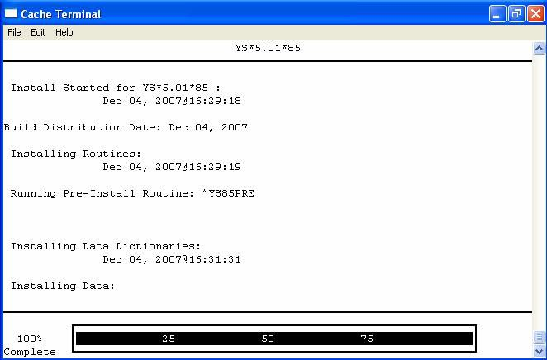
NOTE: SYSTEM HANGS WHILE INSTALLING DATA, COULD BE UP TO 10 MINUTES.

MHA3 Installation File Structure and Use

Files or Folder | Purpose
YS_MHA.exe | MHA3’s main executable program, which is invoked by CPRS Tools Menu (when running  online) or by the MHA3 desktop shortcut (when running offline).
YS_MHA.HLP | MHA3’s Help file, which only contains help  for the ASI module. Online instruments provide their own online help from Vista.
dwlGina2.dll | Critical component of the SecureDesktop system.  This DLL is responsible for preventing unauthorized users from using the CTRL- ALT-DEL keystroke combination to access system menus.  To activate this DLL and provide access to Patient Entry functions in MHA3, a user with Administrator privilege must run the YS_MHA_SD_INSTALLGINA.exe program. Driver is located in C:\Windows\System32 folder
YS_MHA.JCF | JAWS screen-reader configuration file for use with MHA3
YS_MHA.DLL  MHA3_DLL_Scoring.dll | DLLs that interface to Clinical Reminders  functions in CPRS. These DLLs are deployed to C:\Program Files\vista\ Common Files
YS_MHA_SD_INSTALLGINA.exe | Executable program that is used to activate the dwlGina.dll module and provide access to Patient Entry functions in all subsequent MHA3 sessions. Activation needs to occur  only once. ONLY ADMINISTRATORS SHOULD RUN THIS PROGRAM.
YS_MHA_SD_UNINSTALLGINA.exe | Executable program that is used to deactivate the dwlGina.dll module and remove access to Patient Entry functions in all subsequent MHA3 sessions. De-activation needs to occur only once. ONLY ADMINISTRATORS  SHOULD RUN THIS PROGRAM.
YS_MHA_VASD.exe | SecureDesktop’s main executable program, which is invoked by the MHA3 executable at the point when the user chooses Patient Entry mode.

Continued-----

Files or Folder | Purpose
Sub-folders | MHA3 relies on data contained in the following subfolders located in the Application Data folder under the user’s profile storage area. This is typically C:\Documents and Settings\<user name>\Application Data\MHA3.
Answer Files | This is the name of the subfolder used to temporarily store patient responses given during any off-line MHA3 sessions. These response files are removed as soon as their contents are uploaded to VistA. The answer files reside in this folder and the file names are based on the instrument-type and the time-date of  administration.
Instrument Files | This is the name of the subfolder containing definition files for all the various instruments that are available via MHA3. MHA3 uses these files to define the characteristics of questions and other elements that instruments have as they are presented to the user. The file names typically consist of a combination of the instrument acronym and the date-time of the last time that the definition was changed  The contents of these instrument definition files mirror the contents found in VistA, and are synchronized each time MHA3 is started on the PC.  The local files are encrypted and remain unchanged, until a newer version of an instrument definition is present on VistA. If a new or updated instrument definition is detected in VistA, the local equivalent file in this folder is updated automatically.

NOTE: These files are included in the installation archive.

Examples: A typical MHA3 file tree after installing MHA3:

C:\Program Files\Vista\YS\MHA3 YS_MHA.exe YS_MHA.HLP YS_MHA.JCF
Uninst000.dat uninst000.exe

C:\Program Files\Vista\Common Files YS_MHA.DLL
MHA3_DLL_Scoring.dll

NOTE: These files are included in the installation archive.

C:\Documents and Settings\VHAXXXCliniJ.VHAXX\Application Data\MHA3 is an example path. The actual path will vary with the current user’s configuration.

C:\Documents and Settings\VHAXXXCliniJ.VHAXX\Application Data\MHA3\Answer Files
This is usually empty, unless there are off-line records that haven’t been uploaded to VistA yet. Example filename: 2~3050623-134647~AUDIT.adm.

C:\Documents and Settings\VHAXXXCliniJ.VHAXX\Application Data\MHA3\ Instrument Files
There are usually a large number of files in this folder; all of them are instrument definition files. Example filename: AUDIT~3040624.res.

Example: Files added to the MHA3 file tree after installing the optional SecureDesktop software:

c:\Program Files\Vista\YS\MHA3 YS_MHA_SD_INSTALLGINA.exe YS_MHA_SD_UNINSTALLGINA.exe
YS_MHA_VASD.exe

C:\Windows\System32
dwlGina2.dll

NOTE: These files are included in the SecureDesktop installation archive.

After the VistA Mental Health Assistant Version 3 Patch YS*5.01*85, has been successfully installed the following instructions must be applied for the software application to function as designed:

Post Installation Instructions

Create TIU Document Definitions:

The following progress note title needs to be added to the TIU Document Definition hierarchy using the TIU option Create Document Definitions.
The title can be entered under the site-appropriate Document Class.
The title is needed in order to generate a progress note in CPRS from a test administration in MHA. The title was recommended by the Clinical Documents New Title Request Committee in order to be consistent with TIU standardization terminology.

- Mental Health Diagnostic Study

When the title is set up in TIU, a note will be automatically generated in CPRS, and the note will contain the results of the tests administered in that session of MHA. The note will be linked to the visit location selected at the onset of the testing session, and the visit will be passed as historical.

Exceptions to this would be any test that is restricted with the YSP key. Administrations of such tests will not pass a progress note to CPRS, in line with the restricted view of the test results to holders of the YSP key.

Additionally, if an instrument is administered through a clinical reminder dialog, the results that pass will be based on the clinical reminder dialog set up, and will be sent to the note that is active during the processing of reminder dialogs. A separate note will not be created for those results of MHA instruments administered through clinical reminder dialogs.

- Mental Health Assistant and Clinical Reminders

In the current released versions of MHA and clinical reminders, a limited number of MHA instruments can be placed in clinical reminder dialogs. Any MHA instrument can be used in the reminder logic as a finding.

Patch YS*5.01*85, MHA3, restructures the MH files and allows for usage of an increased number of types of responses in its instruments.

Clinical reminders has also written a patch, PXRM*2.0*6, that allows reminders to work with the new file structure in MHA. The clinical reminders patch will provide the functionality to use any MHA instrument in a reminder dialog. Some of the functionality won’t be available until version 27 of CPRS is released. Until then, any test that includes free text responses cannot be

included in a reminder dialog the Blessed Orientation Memory Concentration test (BOMC) and the Traumatic Brain Injury (TBI) 2nd Level Evaluation are two tests that include free text responses in MHA3).

If a MHA instrument is restricted to users holding the YSP key, then only those users could administer that test if presented in a clinical reminder dialog.

Clinical reminders also introduces a parameter with patch PXRM*2.0*6 that allows a site to set the maximum number of questions a test can have and still be used in a clinical reminder dialog. The concern is that longer tests really should be administered through the MHA GUI rather than a reminder dialog.

In version 27 of CPRS, a dll will be introduced that enhances how MHA instruments are handled in clinical reminder dialogs. When that is available, MHA instruments that include free text responses can be administered through clinical reminder dialogs.

With patch PXRM*2.0*6, clinical reminders will be able to work with MHA instruments at the level of the scale score and individual question response in the finding logic.

Additional features are described in more depth in the documentation for PXRM*2.0*6.

Client Software:

NOTE: This version of the client software must be installed as a new installation.

IRM Staff:

NOTE: USERS installing SecureDesktop software on a Windows XP environment must have Administrator privileges on the PC Workstation platform.

MHA3 Files Retrieval Locations and Formats

MHA Version 3, software files are available on the following OIFOs ANONYMOUS. SOFTWARE directories. All sites are encouraged to use their FTP capability to obtain these files. Use the FTP address “download.vista.med.va.gov” (without the quotes) to connect to the first available FTP server where the files are located.

MHA3 Files Retrieval Locations

OIFOs | FTP ADDRESS | DIRECTORY
REDACTED | REDACTED | REDACTED
REDACTED | REDACTED | REDACTED
REDACTED | REDACTED | REDACTED

MHA3 Files Retrieval Formats

FILE NAMES | CONTENTS | RETRIEVAL FORMATS
YS_501_85.KID | MHA Server Components | ASCII
YS50185_SETUP_1_0_3_36.exe | Mental Health Assistant | BINARY  This file is the complete install for the Mental Health Assistant GUI  Version 1.0.3.36, client.
YS50185_SD_SETUP_1_0_2_77.exe | SecureDesktop for Mental Health Assistant | BINARY  This file is the complete install for the optional SecureDesktop component for Mental Health Assistant GUI  Version 1.0.3.36, client.
YS_MHA.exe | MHA3 Executable | BINARY
YS_MHA_SD_INSTALLGINA.exe | Activate SecureDesktop Executable  DLL used by SecureDesktop | BINARY
dwlGina2.dll | Required security DLL | BINARY
YS_MHA.JCF | JAWS screen-reader configuration file for use  with MHA3 | BINARY
YS_MHA.DLL  MHA3_DLL_Scoring.dll | DLLs that interface to Clinical Reminders functions in CPRS. These DLLs are deployed to C:\Program  Files\vista\Common Files | BINARY
YS_MHA_SD_UNINSTALLGINA.exe | Deactivate SecureDesktop  Executable | BINARY
YS_MHA_VASD.exe | SecureDesktop’s main executable | BINARY
YS_MHA.HLP | Online help file for the  ASI | BINARY
ANSWER file folder | Offline records that not  been uploaded | FOLDER
INSTRUMENT file folder | MH Instruments for  Offline administration | FOLDER
YS50185_MHA3_IG.pdf | Mental Health Assistant Version 3 (MHA3) Installation Guide Patch  YS*5.01*85 | BINARY
YS50185_MHA3_IG.doc | Mental Health Assistant Version 3 (MHA3) Installation Guide Patch  YS*5.01*85 | BINARY

YS50185_MHA3_UM.pdf | Mental Health Assistant  Version 3 (MHA3) User Manual Patch YS*5.01*85 | BINARY
YS50185_MHA3_UM.doc | Mental Health Assistant  Version 3 (MHA3) User Manual Patch YS*5.01*85 | BINARY

- Copy the YS50185_SETUP_1_0_3_36.exe to an empty (temporary or scratch) directory.

- Run the YS50185_SETUP_1_0_3_36.exe file (i.e., double click on it). This starts the MHA3, installation process. (See the Mental Health Assistant Install Windows Illustrations section on the following pages).

- If the optional SecureDesktop functionality is desired, be sure to first install MHA3 running YS50185_SETUP_1_0_3_36.EXE file and then run the file named YS50185_SD_SETUP_1_0_2_77.exe

Mental Health Assistant Install Windows Illustrations

The following illustrates the Mental Health Assistant Install windows. When the default responses are accepted, MHA3 is installed into the appropriate VistA directory on the user’s workstation.

Installing Mental Health Assistant on your Computer

Double click on YS50185_SETUP_1_0_3_36.exe
Example: From the Mental Health Assistant Welcome dialog box, click on the Next command button (located at the bottom of the window) to continue with the install. The Choose Destination Location dialog box will appear.
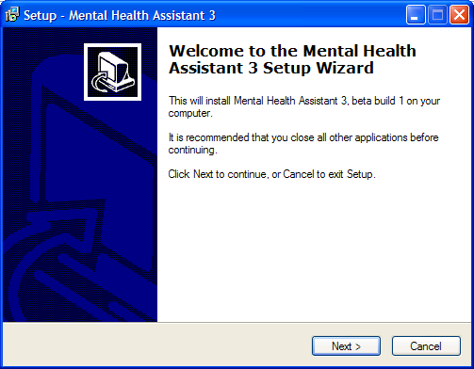

Choose Destination Location

Example: The Choose Destination Location dialog box text asks “Which directory do you want to install this program into? We strongly recommend that, while the drive may be modified, the default directory structure be used (Drive:\Program Files\Vista\YS\MHA3).

To install to the directory displayed below, click on the Next button.
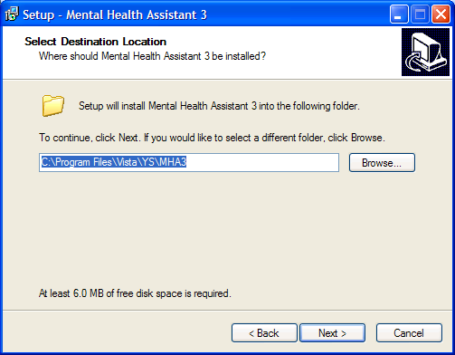

To install to a different directory, click Browse and select another directory.

Folder Does Not Exist

Example: The Folder Does Not Exist dialog box text asks “The folder: C:\Program Files\Vista\YS\MHA3 does not exist. Would you like the folder to be created?

To create the folder displayed below, click Yes.
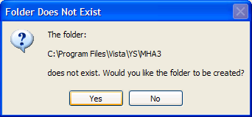

If the button No is clicked the folder is not created and you are returned to the Select Destination dialog box.

Select Start Menu Folder

Example: The Select Start Menu Folder dialog box text asks “Where should Setup place the program’s shortcuts? We strongly recommend that the program’s shortcuts be placed in the Start Menu Folder.

To install to the folder displayed below, click Next.

To install to a different folder, click Browse and select another directory.
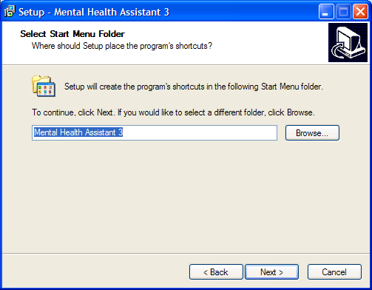

Ready to Install

Example: The Ready to Install dialog box text states “Setup is now ready to begin installing Mental Health Assistant 3 on your computer. Click Install to continue with the installation, or click Back if you want to review or change any settings. Destination location: C:\Program Files\Vista\YS\MHA3. Start Menu folder: Mental Health Assistant 3.

To continue the setup, Click Install.
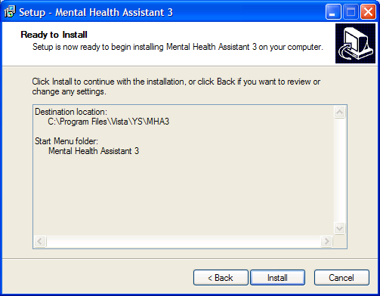

Installing Mental Health Assistant 3

Example: The Mental Health Assistant 3 Installing dialog box text states “Please wait while Setup installs Mental Health Assistant 3 on your computer.”
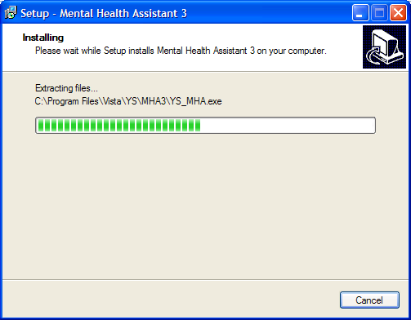

Completing the Mental Health Assistant 3 Setup Wizard

Click on the Finish command button (located within the Setup - Mental Health Assistant 3 dialog box bottom right side) to exit Setup.

Example: The Setup - Mental Health Assistant 3 dialog box text displays “Setup has finished installing Mental Health Assistant 3 on your computer. The application may be launched by selecting the installed icons.”

The first time “Instrument Administrator” is launched, it may take a couple of minutes to load all of the instruments. Subsequent launches of “Instrument Administrator” should be much quicker.
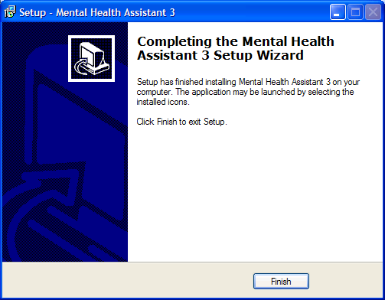

Uninstalling MHA3

  - Click on the Start Button
  - Click on All Programs
  - Find the Mental Health Assistant 3 icon group
  - Click on the Uninstall Mental Health Assistant entry, as shown below.

Example: MHA3 menu entries on the Windows Start menu. Click on the Uninstall Mental Health Assistant entry.

Example: Confirmation screen to remove Mental Health Assistant 3. Click on Yes.
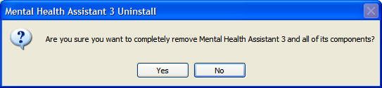

Example: Confirmation screen to that Mental Health Assistant 3 has been uninstalled. Click on the Ok button. MHA3 is now uninstalled.
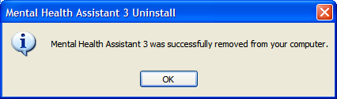

NOTE: YS_MHA.dll & MHA3_DLL_Scoring.dll from the Program Files\Vista\Common files folder DLLs are simply place-holders until a future YS patch is released to coincide with CPRS 27+
If the uninstall option is ran it removes the Mental Health dll files specifically. YS_MHA.DLL is needed to support PXRM*2*6 clinical reminders.

Installing SecureDesktop Functionality in MHA3
The optional Patient-Entry functions built into MHA3 are disabled by default and by design, and should only be enabled if there is a need to use MHA3 for patient-self-administered assessments. If SecureDesktop is installed, it must be installed after MHA3 is installed.

NOTE: Only users with Administrator Privilege are able to install or uninstall SecureDesktop.

SecureDesktop files are installed or uninstalled using a separate setup file than the one for installing MHA3. All the files necessary to use SecureDesktop are bundled in a single setup file. The SecureDesktop files MUST be installed to the same folder as the one containing the main MHA3 file (YS_MHA.exe)—this is why MHA3 must be installed first.

NOTE: MHA3 requires a custom version of SecureDesktop, which is distributed along with MHA3. No other distributions of SecureDesktop will work with MHA3 as of this writing.

PRIOR to installing the Secure Desktop, the Patient Entry button on MHA3’s Instrument Administrator form is disabled, and these functions are not available to the user.

Example: To start the installation process, execute the file named
YS50185_SD_SETUP_1_0_2_77.exe
This action will display the following Setup – SecureDesktop for Mental Health Assistant 3
screen. Click on the Next button to continue the installation process.

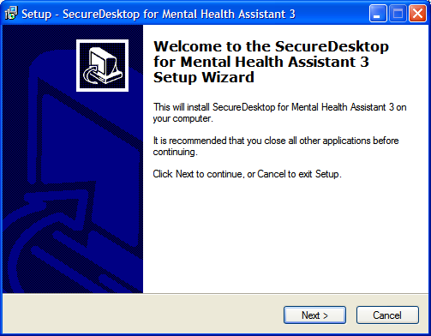

NOTE: SecureDesktop must be installed to the same folder where MHA3 was installed.

Example: Folder selection screen. Click on the Next button.
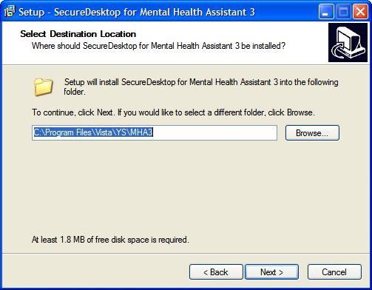

Example: Folder Exists screen. If MHA3 is already installed—as recommended, the Folder Exists confirmation dialog is shown. Click on the Yes button to install to that folder.
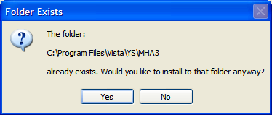

Example: Select Start Menu Folder screen. To continue creating the program’s shortcuts in the
Start Menu Folder - click on the Next button.
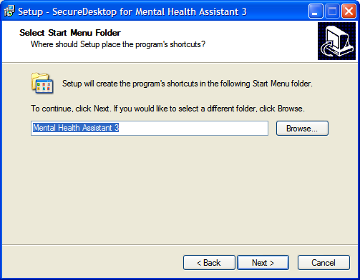

Example: Ready to Install screen. Click on the Install button to continue with installing SecureDesktop for Mental Health Assistant 3 on your computer.
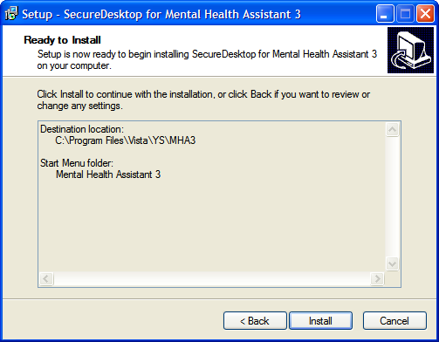

Example: Install progress screen.
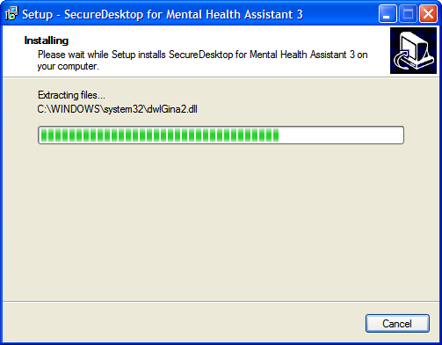

NOTE: Clicking on the Finish button will cause your computer to restart, so be sure to save any unsaved data before you click on Finish.

Example: Restart computer screen. Click Finish, to complete the installation procedure.
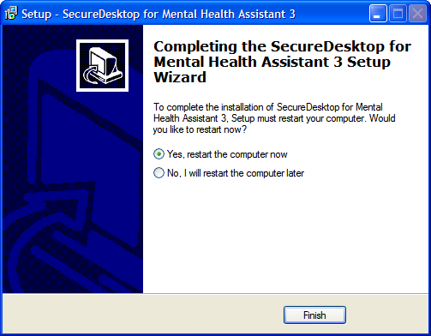

Example: Before installing SecureDesktop, the Patient Entry button on MHA3’s Instrument Administrator form is disabled, and these functions are not available to the user, as shown below.
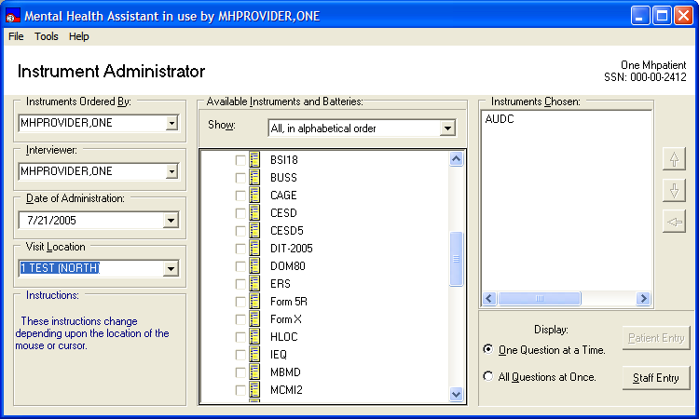

Example: After installing SecureDesktop and running YS_MHA_SD_INSTALLGINA.exe, the Patient Entry button on MHA3’s Instrument Administrator form is enabled, and these functions become available to the user, as shown below.
A test must also be selected in order to activate the Patient Entry button.
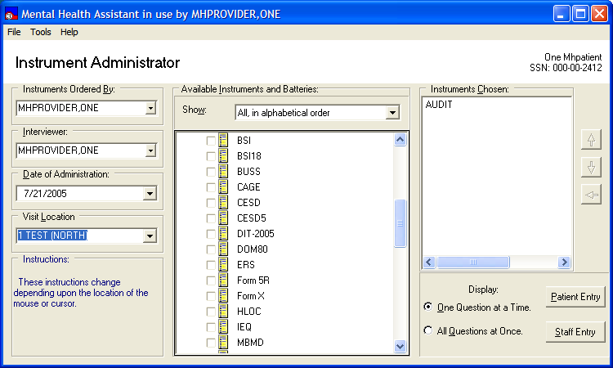

NOTE: These requirements must be met to activate SecureDesktop:

- MHA3 is properly installed.
- The PC’s operating system is Windows XP
- The dwlGina2 DLL has been installed successfully. This is done automatically, when installing SecureDesktop.
- The PC was rebooted after installing SecureDekstop

Uninstalling SecureDeskstop

- Click on the Start Button
- Click on All Programs
- Find the Mental Health Assistant 3 icon group
- Click on the Uninstall SecureDesktop for MHA3 entry, as shown below.

Example: MHA3 menu entries on the Windows Start menu. Click on the Uninstall SecureDesktop for MHA3 entry.
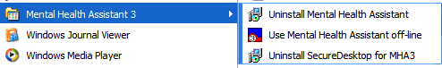

Example: Confirmation screen to remove SecureDesktop. Click on Yes.
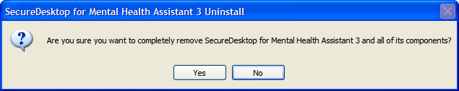

Example: Confirmation screen to restart computer. You must restart the computer after uninstalling SecureDesktop. Click on the Yes button. Be sure to save any unsaved data before you click on Yes. The Patient-Entry feature will no longer be available on MHA3.
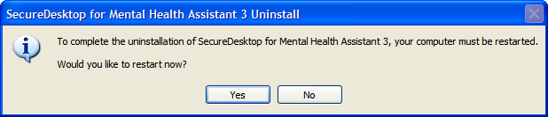

Setting up VistA MHA3 on CPRS GUI Tools Menu

WARNING: THIS STEP IS MANDATORY, TO COMPLETE THE VistA MHA3 INSTALLATION PROCESS.

This procedure configures VistA so that “Mental Health Assistant” appears as a choice on a user’s Tools menu on the CPRS desktop software. Unlike previous versions of MHA, where this was optional, Version 3 of VistA MHA MUST be started from the CPRS Tools Menu. Selecting this choice from the CPRS Tools menu will offer the user full MHA3 functionality, based on a user’s particular access permissions in VistA.

The basic steps for setting up VistA MHA3 on the Tools menu are no different from doing it for other applications. The main difference lies in how the Name=Command entry is formatted. The following text capture is taken from the CPRS Setup documentation, to serve as an example of how to perform this step for MHA3:

Example: Setting up VistA MHA3 on the CPRS Tools menu.

Select GUI Parameters Option: tm GUI<ENTER> Tool Menu Items CPRS GUI Tools Menu may be set for the following:<ENTER>
- User USR [choose from NEW PERSON]
- Location LOC [choose from HOSPITAL LOCATION]
- Division DIV [REGION 5]
- System SYS [OEX.ISC-SLC.VA.GOV]
Enter selection: 1<ENTER> User NEW PERSON
Select NEW PERSON NAME: MHPROVIDER,ONE<ENTER> CPF
------------- Setting CPRS GUI Tools Menu for User: MHPROVIDER,ONE----------
Sequence: ? <ENTER>
Enter the sequence in which this menu item should appear. Select Sequence: 2
Are you adding 2 as a new Sequence? Yes//<ENTER> YES
Sequence: 2// <Enter>
Name=Command: Mental Health Assistant=C:\Progra~1\Vista\YS\MHA3\YS_MHA.exe s=%SRV p=%PORT c=%DFN u=%DUZ m=%MREF
From the previous example, adjust according to your own system’s settings, such as New Person
Name and other parameters—consult the CPRS Setup Guide for the meaning of these parameters. The pertinent portion of the example is the “Name=Command:” field. This field should be entered exactly as shown, in a single line—no line-breaks allowed, including all the % parameters that follow the filename and path to the MHA3 executable file.

The path shown represents a typical path used during a default installation. If your path is different, adjust accordingly. ALL five parameters must be included as shown above, in the precise order in which they are found in the example. Here is what the Name=Command line should look like:

Example: Mental Health Assistant=C:\Progra~1\Vista\YS\MHA3\YS_MHA.exe s=%SRV p=%PORT c=%DFN u=%DUZ m=%MREF

Sequence number 2 is shown in the example, but, if you have other entries in the Tools Menu, then the next free sequence number will do just fine.

After this step is completed, a new choice will appear in the user’s CPRS Tools Menu labeled “Mental Health Assistant”. Clicking on this menu entry will start MHA3 with a selected patient synchronized to the one currently selected in CPRS.

Refer to the CPRS Setup Guide, dated August 2000, for more information about this procedure.

Setting up VistA MHA 3 on CPRS GUI Tools Menu

Setting up VistA so that individual MHA3 assessments are also listed on the CPRS GUI Tools Menu

NOTE: THIS STEP IS OPTIONAL

This procedure configures VistA so that you can add a variable number of individual, specific assessment-types choices, to the Tools menu in the CPRS GUI. This is in addition, or instead of, the Mental Health Assistant choice described above. This step is optional and will have no effect on the procedure described above.

The steps for setting up individual assessment types are identical to setting up MHA3, with one significant difference: The Name=Command line has one added parameter at the end of the parameter list. This parameter indicates the “code” name of the instrument to be added to the Tools menu. In this example, CAGE is added to the Tools menu. Here is what the Name=Command line should look like to add CAGE:

Example: Mental Health Assistant=C:\Progra~1\Vista\YS\MHA3\YS_MHA.exe s=%SRV p=%PORT c=%DFN u=%DUZ m=%MREF CAGE

As above, this entire Name=Command line should be on one line—no carriage returns, and the next open sequence number on the menu will work fine.

Example: Two new entries on the CPRS Tools menu; Mental Health Assistant and CAGE (individual assessment type).
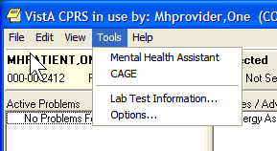

Files with New Entries Added
VistA Mental Health patch YS*5.01*85 is exporting new entries to the following files:

PROTOCOL file (#101) New Entries

PROTOCOL file (#101) contains the following two new protocols that support HL7 messaging for the Mental Health Assistant (MHA) GUI interface.

Example: PROTOCOL file (#101) two new protocol entries.
NAME: YS MHA A08 CLIENT CREATOR: MHCREATOR, ONE
TYPE: subscriber PACKAGE: MENTAL HEALTH
DESCRIPTION: HL7 A08 client protocol for sending messages to the MHNDB. SENDING APPLICATION: YS MHA RECEIVING APPLICATION: YS MHA EVENT TYPE: A08 LOGICAL LINK: YS MHAT
ACCEPT ACK CODE: AL APPLICATION ACK TYPE: AL
VERSION ID: 2.3.1 RESPONSE MESSAGE TYPE: ACK
NAME: YS MHA A08 EVENT
TYPE: event driver
CREATOR: MHCREATOR, ONE PACKAGE: MENTAL HEALTH
DESCRIPTION: This server will be used to send A08 HL7 messages to the MHNDB.
SENDING APPLICATION: YS MHA TRANSACTION MESSAGE TYPE: ADT EVENT TYPE: A08 LOGICAL LINK: YS MHAT
ACCEPT ACK CODE: AL APPLICATION ACK TYPE: AL VERSION ID: 2.3.1 RESPONSE PROCESSING ROUTINE: D ACKMHA^YTQHL7 SUBSCRIBERS: YS MHA A08 CLIENT

HL7 APPLICATION PARAMETER file (#771) New Entry

HL7 APPLICATION PARAMETER file (#771) contains the following new entry:

The Mental Health Assistant (MHA) GUI application uses the following entry to send messages to the National Mental Health Database.

Example: HL7 APPLICATION PARAMETER file (#771) new entry
NAME: YS MHA FACILITY NAME: 111 COUNTRY CODE: USA
HL7 FIELD SEPARATOR: | HL7 MESSAGE: ADT
HL7 SEGMENT: PID HL7 SEGMENT: MSH
ACTIVE/INACTIVE: INACTIVE MAIL GROUP: YS MHA-MHNDB
HL7 ENCODING CHARACTERS: ~^\&

PROCESSING ROUTINE: ACKMHA^YTQHL7 FIELDS USED IN THIS SEGMENT: 1,2 FIELDS USED IN THIS SEGMENT: 1
HL7 SEGMENT: MSA
FIELDS USED IN THIS SEGMENT: 1,3,7,8,9,10
The entry is distributed as inactive to allow testing without entry in the
national database.

Files with New Entries Added

HL LOGICAL LINK file (#870) new Entry

HL LOGICAL LINK file (#870) contains the following new entry:

The Mental Health Assistant GUI application uses the following entry to identify MHA related logical link interfaces on VistA. The logical link named YS MHAT is used by the HL7 package to send VistA ADT HL7 messages containing patient demographics, patient administration and patient answers.

Example: HL LOGICAL LINK file (#870) contains the following new entry:
NODE: YS MHAT
DEVICE TYPE: Non-Persistent Client QUEUE SIZE: 10
BLOCK SIZE: 245
ACK TIMEOUT: 40
EXCEED RE-TRANSMIT ACTION: ignore PERSISTENT: NO
LLP TYPE: TCP
AUTOSTART: Disabled
RE-TRANSMISSION ATTEMPTS: 110
READ TIMEOUT: 10 PROTOCOL ID VERSION: 2.3
TCP/IP SERVICE TYPE: CLIENT (SENDER)

