Mental Health YS*5.01*182

Deployment, Installation, Backout, and Rollback Guide

October 2021
Version 1.0

Department of Veterans Affairs

Office of Information and Technology (OIT)

Revision History
Date | Version | Description | Author
10/18/2021 | 1.0 | Initial Version | Liberty IT Solutions

Table of Contents
1 Introduction 5
1.1 Purpose 5
1.2 Dependencies 5
1.3 Constraints 5
2 Roles and Responsibilities 5
3 Deployment 6
3.1 Timeline 6
3.2 Site Readiness Assessment 6
3.2.1 Deployment Topology (Targeted Architecture) 6
3.2.2 Site Information (Locations, Deployment Recipients) 6
3.2.3 Site Preparation 6
3.3 Resources 6
3.3.1 Facility Specifics (optional) 6
3.3.2 Hardware 6
3.3.3 Software 6
3.3.4 Communications 7
4 Installation 7
4.1 Pre-installation and System Requirements 7
4.2 Platform Installation and Preparation 7
4.3 Access Requirements and Skills Needed for the Installation 7
4.4 Installation Procedure 7
4.5 Installation Verification Procedure 9
4.6 System Configuration 9
4.7 Database Tuning 9
5 Backout Procedure 9
5.1 Backout Strategy 9
5.2 Backout Considerations 10
5.3 Backout Criteria 10
5.4 Backout Risks 10
5.5 Authority for Backout 10
5.6 Backout Procedure 10
5.7 Backout Verification Procedure 10
6 Rollback Procedure 12
6.1 Rollback Considerations 12
6.2 Rollback Criteria 12
6.3 Rollback Risks 13
6.4 Authority for Rollback 13
6.5 Rollback Procedure 13
6.6 Rollback Verification Procedure 13
7 Appendix A - Acronyms 14

Introduction
This document describes how to deploy and install the patch YS*5.01*182 of the Mental Health package, as well as how to back out the product and roll back to a previous version or data set. This document is a companion to the project charter and management plan for this effort.

Purpose
The purpose of this plan is to provide a single, common document that describes how, when, where, and to whom Mental Health patch YS*5.01*182 will be deployed and installed, as well as how it is to be backed out and rolled back, if necessary. The plan also identifies resources, communications plan, and rollout schedule. Specific instructions for installation, back-out, and rollback are included in this document.

Dependencies
It is assumed that this patch is being installed into a fully patched Veterans Health Information System and Technology Architecture (VistA) system.

Constraints
There are no constraints beyond the installation into an up-to-date VistA system.

Roles and Responsibilities
The following describes the roles and responsibilities associated with the testing and release of YS*5.01*182. This is a VistA patch that will be deployed via the normal Mailman route.
Table 1: Deployment, Installation, Back-out, and Rollback Roles and Responsibilities
Team | Phase / Role | Tasks | Project Phase (See Schedule)
Project Manager | Deployment | Determine and document the roles and responsibilities of those involved in the deployment. | Design
Software Quality Assurance (SQA), Test Sites | Deployment | Test for operational readiness | Test
Project Manager, Release Manager | Deployment | Execute deployment | Release
Regional IT | Installation | Plan and schedule installation | Release
Release Manager | Back-out | Confirm availability of back-out instructions and back-out strategy (what are the criteria that trigger a back-out) | Release
Sustainment Team | Post Deployment | Hardware, Software and System Support | Sustain

Deployment
The deployment is planned as a simultaneous (National Release) rollout. Once approval has been given to nationally release, YS*5.01*182 will be available for installation and deployment at all sites.
Scheduling of test installs, testing, and production deployment will be at the site’s discretion. It is anticipated there will be a 30-day compliance period.

Timeline
The deployment and installation are scheduled to run during September 2021.

Site Readiness Assessment
This section discusses the locations that will receive the YS*5.01*182 deployment.

Deployment Topology (Targeted Architecture)
YS*5.01*182 will be deployed to each VistA instance. This includes local sites as well as regional data centers. A corresponding update to the MHA Web application will be made in the Azure VA Enterprise Cloud.

Site Information (Locations, Deployment Recipients)
The initial deployment will be to Initial Operating Capability (IOC) sites for verification of functionality. Once testing is completed and approval is given for national release, YS*5.01*182 will be deployed to all VistA systems.
The Production IOC testing sites are:
- Clement J. Zablocki VAMC (Milwaukee, WI)
- Orlando VAMC (Orlando, FL)

Site Preparation
YS*5.01*182 requires a fully patched VistA system.

Resources

Facility Specifics (optional)
No specific facility instructions needed.

Hardware
No hardware instructions needed.

Software
No software instructions needed.

Communications
When YS*5.01*182 is released, the released-patch notification will be sent from the National Patch Module to all personnel who have subscribed to notifications for the Mental Health package.

Installation

Pre-installation and System Requirements
There are no pre-installation requirements.

Platform Installation and Preparation
This patch can be loaded with users in the system. Installation time will be less than 5 minutes.
To ensure the integrity of the transport global, use the “Verify Checksums in Transport Global” to compare the checksums with the list that follows:
The checksums below are new checksums, and can be checked with CHECK1^XTSUMBLD.
Routine Name: YS182PST Before: n/a After: B6355081 **182**
Routine Name: YTQAPI Before: B18133059 After: B18593897 **85,130,141,182**
Routine Name: YTQRCAT Before: n/a After: B42497178 **182**
Routine Name: YTQREST Before: B16134782 After: B18216959 **158,178,182**
Routine Name: YTQREST0 Before: B7781538 After: B8623741 **130,178,182**
Routine Name: YTQRIS Before: B90480805 After: B99568712 **130,141,182**
Routine Name: YTQRQAD1 Before: B87154790 After: B94482754 **130,141,178,182**
Routine Name: YTQRQAD2 Before: B45041984 After: B46192834 **130,141,173,178,182**
Routine Name: YTQRQAD3 Before: B40827460 After: B42257210 **130,141,158,178,182**
Routine Name: YTQRQAD4 Before: B97950328 After: B99761746 **158,178,182**
Routine Name: YTQRQAD5 Before: B53729604 After: B48936796 **158,178,182**
Routine Name: YTSCAT Before: n/a After: B37650998 **182**

Access Requirements and Skills Needed for the Installation
Installation of YS*5.01*182 requires access to Kernel Installation and Distribution System (KIDS) options to be able to load and install the KIDS build.

Installation Procedure

Pre/Post Installation Overview:
The post-install will apply updates to mental health instrument files.
The post installation routine, YS182PST, may be deleted after the
installation completes

Pre-Installation Instructions:
This patch may be installed with users on the system although it is
recommended that it be installed during non-peak hours to minimize
potential disruption to users. This patch should take less than 5
minutes to install.

Installation Instructions:

1. Choose the PackMan message containing this build. Then select
the INSTALL/CHECK MESSAGE PackMan option to load the build.

2. From the Kernel Installation and Distribution System Menu,
select the Installation Menu. From this menu,

A. Select the Verify Checksums in Transport Global
option to confirm the integrity of the routines that
are in the transport global. When prompted for the
INSTALL NAME enter the patch or build name.
(YS*5.01*182)

NOTE: Using <spacebar><enter> will not bring up a
Multi-Package build even if it was loaded
immediately before this step. It will only
bring up the last patch in the build.

B. Select the Backup a Transport Global option to create
a backup message. You must use this option and specify
what to backup; the entire Build or just Routines.
The backup message can be used to restore the routines
and components of the build to the pre-patch condition.

i. At the Installation option menu, select Backup
a Transport Global
ii. At the Select INSTALL NAME prompt, enter your
build YS*5.01*182
iii. When prompted for the following, enter "R" for
Routines or "B" for Build.

Select one of the following:

B Build
R Routines

Enter response: Build

iv. When prompted "Do you wish to secure this message? NO//",
press <enter> and take the default response of "NO".
v. When prompted with, "Send mail to: Last name, First
Name", press <enter> to take default recipient. Add
any additional recipients.
vi. When prompted with "Select basket to send to: IN//",
press <enter> and take the default IN mailbox or select
a different mailbox.

C. You may also elect to use the following options:
i. Print Transport Global - This option will allow
you to view the components of the KIDS build.
ii. Compare Transport Global to Current System - This
option will allow you to view all changes that will
be made when this patch is installed. It compares
all of the components of this patch, such as
routines, DDs, templates, etc.

D. Select the Install Package(s) option and choose the
patch to install.

i. If prompted 'Want KIDS to Rebuild Menu Trees Upon
Completion of Install? NO//', answer NO.

ii. When prompted 'Want KIDS to INHIBIT LOGONs during the
install? NO//', answer NO.

iii. When prompted 'Want to DISABLE Scheduled Options, Menu
Options, and Protocols? NO//', answer NO.

Installation Verification Procedure
This patch adds support for Computerized Adaptive Testing (CAT). You may verify installation by looking in the MH TESTS AND SURVEYS file (#601.71) for new entries that begin with “CAT-“.

VA FileMan 22.2

Select OPTION: INQUIRE TO FILE ENTRIES

Output from what File: MH TESTS AND SURVEYS// (265 entries)
Select MH TESTS AND SURVEYS NAME: CAT-
1 CAT-ADHD
2 CAT-ANX
3 CAT-CAD Interview
4 CAT-DEP
5 CAT-MANIA-HYPOMANIA
etc. . . .

System Configuration
The application versions supported by this document are:
- MHA-Web v1.2.23a
- Mental Health Patient Entry v1.1.7a
Note that the Windows version of MHA, MHA 1.0.3.86, does not support the new instruments in this patch. The CAT instruments are only supported in a web browser.

Database Tuning
No database tuning required.

Backout Procedure

Backout Strategy
This patch updates the Mental Health database with all new records that support CAT. The backout procedure will leave these records in place, but inoperative since they pertain only to those instruments. If there is a compelling reason to back out the new instrument records themselves, you will need to contact the development team for a patch. The backout procedure below will restore MHA to its state prior to the patch installation.

Backout Considerations
If the routines related to this patch are removed, CAT will be unavailable in MHA Web and the installation of future patches may cause unpredictable results. Users will not have access to new CAT interviews.

Backout Criteria
A back-out should only be considered if there is a patient safety issue, if MHA or MHA Web no longer functions, or if there is some other catastrophic failure.

Backout Risks
The risks vary depending on what is causing the failure of the system. The main risk is that the new instruments will be unavailable.

Authority for Backout
The VistA system manager determines if a back-out of YS*5.01*182 should be considered.

Backout Procedure
To back out routines, you must have already selected the "Backup a Transport Global" option during the installation process. To restore the previous routines:
- Choose the PackMan message containing the backup you created during installation.
- Invoke the INSTALL/CHECK MESSAGE PackMan option.
- Answer YES when prompted: Warning: Installing this message will cause a permanent update of globals and routines. Do you really want to do this? NO// YES
- The routines that were saved in the message will now be restored.

Disable all entries that begin with “CAT-“ or “CAD-“ by editing the OPERATIONAL field (#10) and the LAST EDIT DATE field (#18) in the MH TESTS AND SURVEYS file (#601.71). Set OPERATIONAL to "Dropped" and set LAST EDIT DATE to "Now".

Backout Verification Procedure
To verify the backout procedure, use the option “First Line Routine Print” (XU FIRST LINE PRINT) to make sure the routines no longer show patch 182 in the patch list:
PRINTS FIRST LINES

All Routines? No => No

Routine: YTQAPI
Routine: YTQREST
Routine: YTQREST0
Routine: YTQRIS
Routine: YTQRQAD1
Routine: YTQRQAD2
Routine: YTQRQAD3
Routine: YTQRQAD4
Routine:
8 routines

(A)lpha, (D)ate ,(P)atched, OR (S)ize ORDER: A//
Include line (2), Include lines 2&(3), (N)one: None//2
DEVICE: HOME// PSEUDO-TERMINAL SLAVE Right Margin: 80//
FIRST LINE LIST UCI: SPPUAT,SPPUAT 07/28/2021
YTQAPI ;ASF/ALB - MHQ REMOTE PROCEEDURES ; 4/3/07 10:36am
;;5.01;MENTAL HEALTH;**85,130,141**;Dec 30, 1994;Build 85
YTQREST ;SLC/KCM - RESTful API front controller ; 1/25/2017
;;5.01;MENTAL HEALTH;**158,178**;Dec 30, 1994;Build 7
YTQREST0 ;SLC/KCM - RESTful API front controller v0 ; 1/25/2017
;;5.01;MENTAL HEALTH;**130,178**;Dec 30, 1994;Build 7
YTQRIS ;SLC/KCM - Instrument Selection RPC's ; 1/25/2017
;;5.01;MENTAL HEALTH;**130,141**;Dec 30, 1994;Build 85
YTQRQAD1 ;SLC/KCM - RESTful Calls to handle MHA assignments ; 1/25/2017
;;5.01;MENTAL HEALTH;**130,141,178**;Dec 30, 1994;Build 7
YTQRQAD2 ;SLC/KCM - RESTful Calls to set/get MHA administrations ; 1/25/2017
;;5.01;MENTAL HEALTH;**130,141,173,178**;Dec 30, 1994;Build 7
YTQRQAD3 ;SLC/KCM - RESTful Calls to set/get MHA administrations ; 1/25/2017
;;5.01;MENTAL HEALTH;**130,141,158,178**;Dec 30, 1994;Build 7
YTQRQAD4 ;ISP/MJB - RESTful Calls to handle MHA lists ; 1/25/2017
;;5.01;MENTAL HEALTH;**158,178**;Dec 30, 1994;Build 7

8 ROUTINES

Also, run MHA Web, select the + button to assign assessments, and verify that the instruments beginning with “CAT-“ or “CAD-“ do not appear in the list of checkboxes on the left:
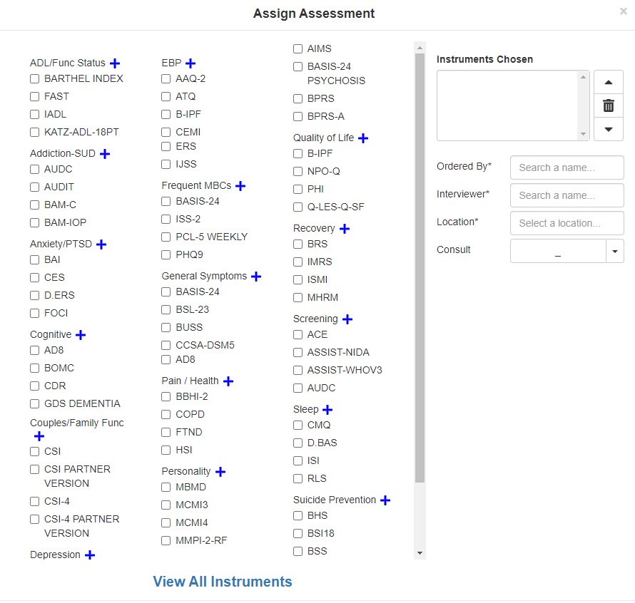

Rollback Procedure

Rollback Considerations
The only additional data that one might roll back after installation of this patch would be the results of CAT interviews administered after the patch is installed, this is not recommended. If it is necessary, please contact the development team for assistance and a possible patch.

Rollback Criteria
A rollback would be considered if there is erroneous patient data related to CAT interviews.

Rollback Risks
A rollback could cause the loss of patient information.

Authority for Rollback
The VistA system manager determines if a rollback of patient data created by CAT interviews because of YS*5.01*182 should be considered.

Rollback Procedure
Please contact the development team for assistance and a possible patch.

Rollback Verification Procedure
Verify the rollback by ensuring that the patient information is now correct.

Appendix A - Acronyms
Acronym | Definition
CAG | Citrix Access Gateway
CAD | Computerized Adaptive Diagnosis
CAT | Computerized Adaptive Testing
DIBRG | Deployment, Installation, Back-out, and Rollback Guide
IOC | Initial Operating Capability
KIDS | Kernel Installation and Distribution System
MHA | Mental Health Assistant
OIT | Office of Information and Technology
PIN | Personal Identification Number
PIV | Personal Identity Verification
SPP | Suicide Prevention Package
SQA | Software Quality Assurance
SSOi | Single Sign-On Integration
VA | Department of Veterans Affairs
VAMC | Veterans Affairs Medical Center
VIP | Veteran-focused Integration Process
VistA | Veterans Health Information System and Technology Architecture

